CareNet WhatsApp
Shopify WhatsApp Integration — App Documentation
CareNetSolutions | Effective date: May 31, 2026

1. App Overview
CareNet WhatsApp is an embedded Shopify app with a theme app extension. It adds a floating WhatsApp chat button to the storefront so customers can start a conversation with one click.
Merchants configure country, phone number, default message, button label, and on/off visibility from one dashboard. Settings apply store-wide when the App embed is enabled in the theme editor.

2. App Screenshots
Figure 1 — App dashboard overview (CareNet WhatsApp)
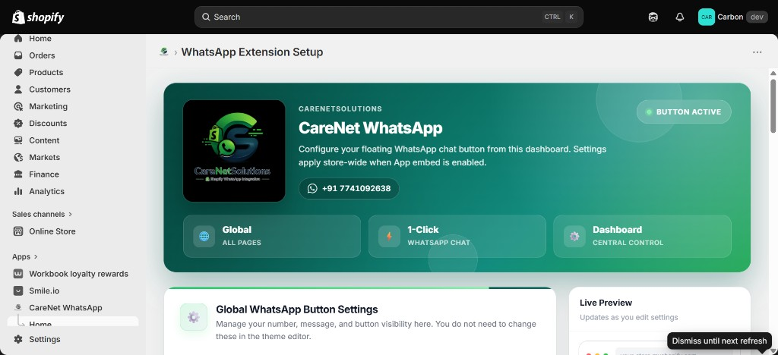

Figure 2 — Global WhatsApp Button Settings
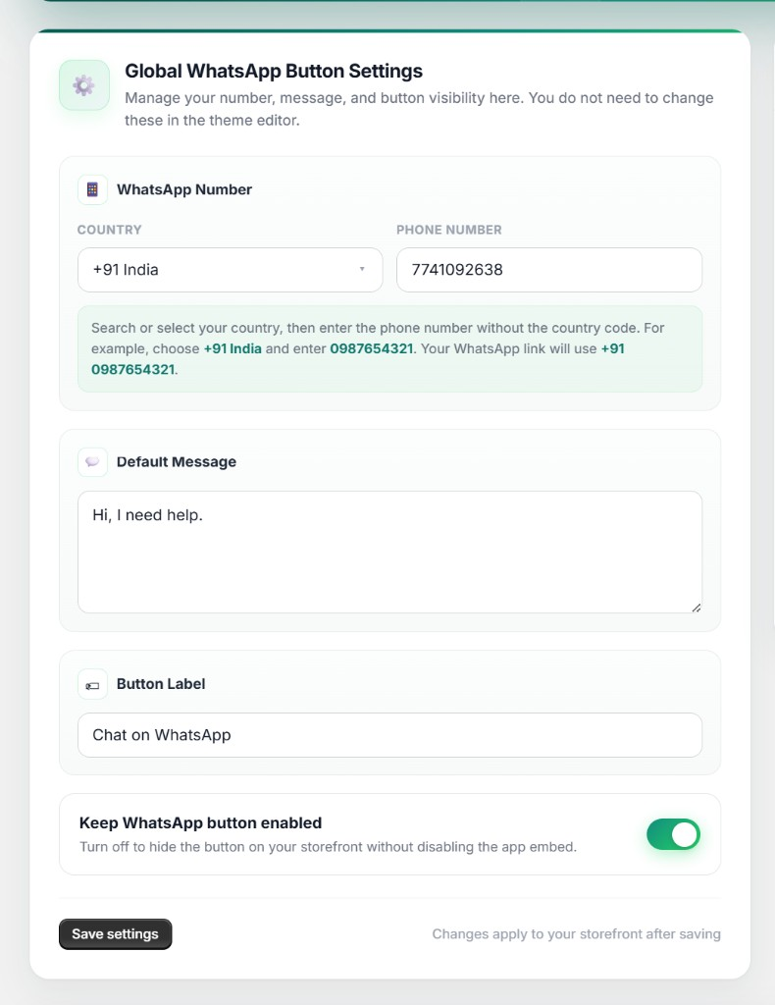

Figure 3 — Live Preview panel
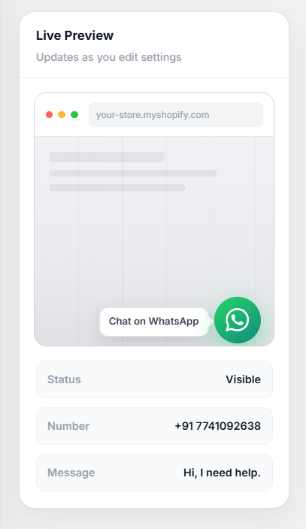

Figure 4 — Setup Guide (7 steps)
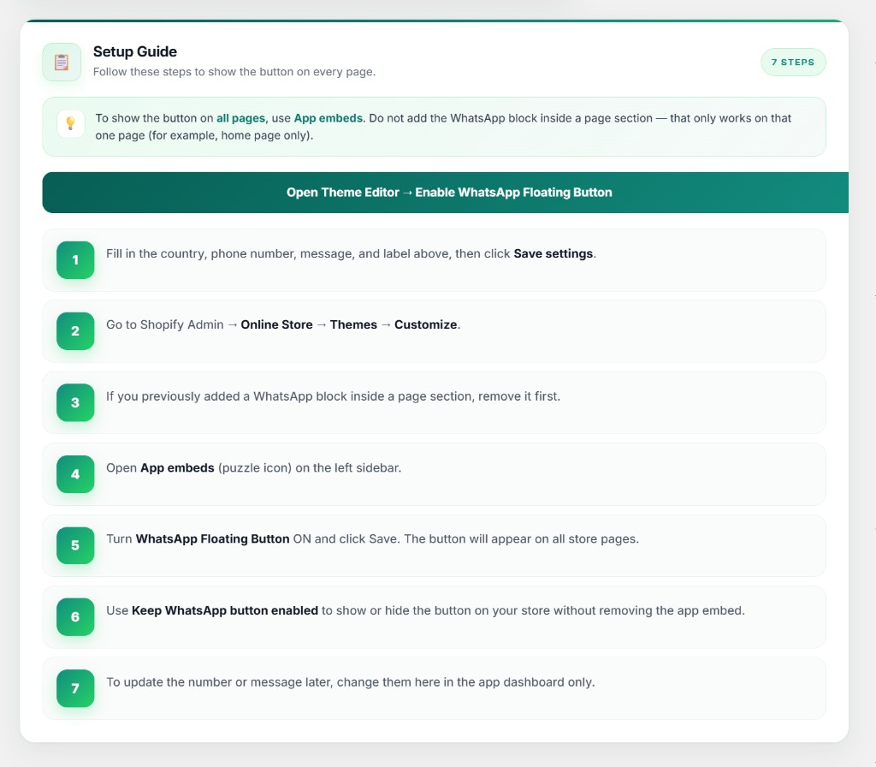

3. Merchant Setup Guide
- Install the app from Shopify Admin or the Shopify App Store.
- Open the app dashboard and set Country, Phone number, Default message, and Button label.
- Ensure Keep WhatsApp button enabled is ON, then click Save settings.
- Go to Online Store → Themes → Customize.
- Open App embeds (puzzle icon) and turn WhatsApp Floating Button ON.
- Save the theme and verify the button on all storefront pages.
- To hide the button temporarily, uncheck Keep WhatsApp button enabled and save.

4. Important Note
Use App embeds, not a WhatsApp block inside a page section. A page block only shows on that one page (for example, home page only).

5. Shopify App Review — Testing Instructions
- Install the app on the review development store.
- Open the app and set Country (+91 India or any valid country), Phone number, Default message (Hi, I need help.), and Keep WhatsApp button enabled ON.
- Click Save settings.
- Go to Online Store → Themes → Customize.
- Open App embeds and enable "WhatsApp Floating Button".
- Save the theme.
- View the storefront — the WhatsApp button should appear on all pages.
- Click the button to verify WhatsApp opens with the saved number and message.
- Uncheck "Keep WhatsApp button enabled", save, and confirm the button disappears.

6. Support & Privacy
Support email: support@carenetsolutions.com
Privacy policy URL: https://carenetsolutions.co.uk/whatsapp/privacy
Application URL: https://carenetsolutions.co.uk/whatsapp

