CareNet WhatsApp
Shopify App — Merchant Setup & Dashboard Guide
CareNetSolutions · Embedded Shopify app + Theme app extension · Effective date: May 31, 2026

1. App Overview
CareNet WhatsApp adds a floating WhatsApp chat button to your Shopify storefront. Merchants configure the phone number, default message, button label, and visibility from one admin dashboard. Settings apply store-wide when the App embed is enabled.

2. Dashboard Overview
After installing the app, open Apps → CareNet WhatsApp in Shopify Admin. The dashboard shows your current WhatsApp number, button status, and quick links to global settings.
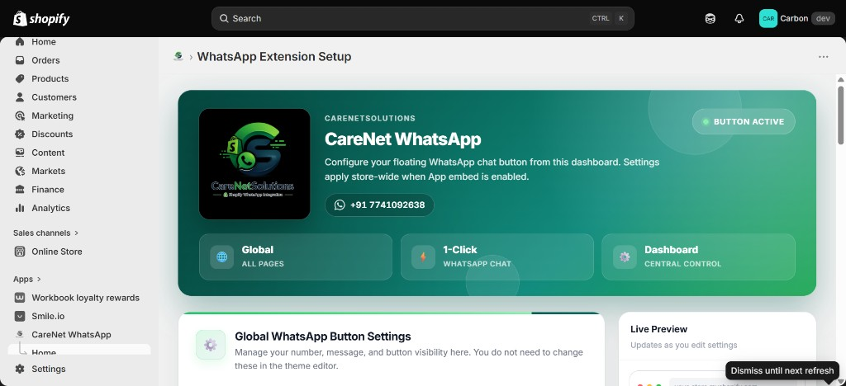
Figure 1 — App dashboard overview

3. Configure WhatsApp Settings
In Global WhatsApp Button Settings:
- Select Country (e.g. +91 India).
- Enter Phone number without country code (e.g. 7741092638).
- Set Default message (e.g. Hi, I need help.).
- Set Button label (e.g. Chat on WhatsApp).
- Toggle Keep WhatsApp button enabled ON or OFF.
- Click Save settings.
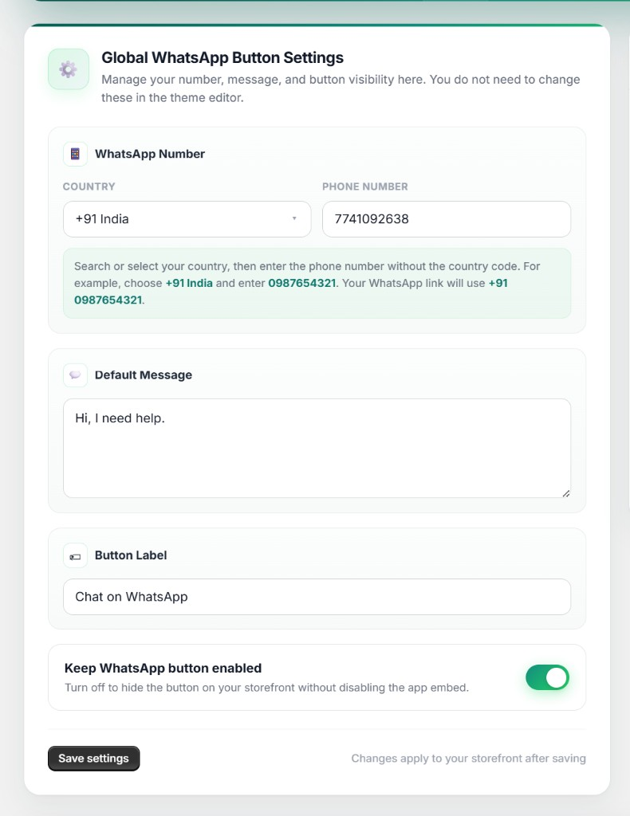
Figure 2 — WhatsApp settings form

4. Live Preview
The Live Preview panel updates as you edit settings and shows how the floating button will appear on your storefront.
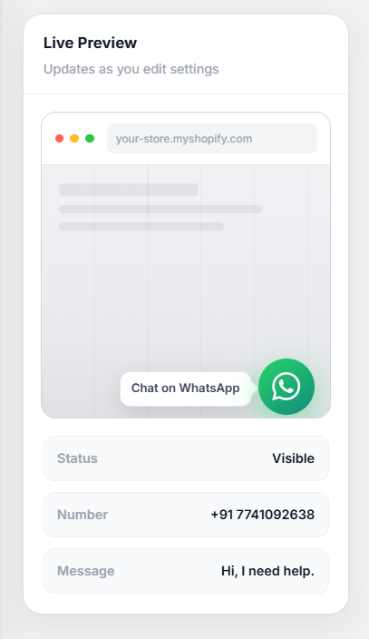
Figure 3 — Live preview panel

5. Setup Guide (Theme App Embed)
Important: Use App embeds, not a WhatsApp block inside a page section. A page block only shows on that one page (for example, home page only).
- Fill in country, phone number, message, and label, then click Save settings.
- Go to Shopify Admin → Online Store → Themes → Customize.
- If you previously added a WhatsApp block inside a page section, remove it first.
- Open App embeds (puzzle icon) on the left sidebar.
- Turn WhatsApp Floating Button ON and click Save.
- Use Keep WhatsApp button enabled to show or hide the button without removing the app embed.
- To update the number or message later, change them in the app dashboard only.
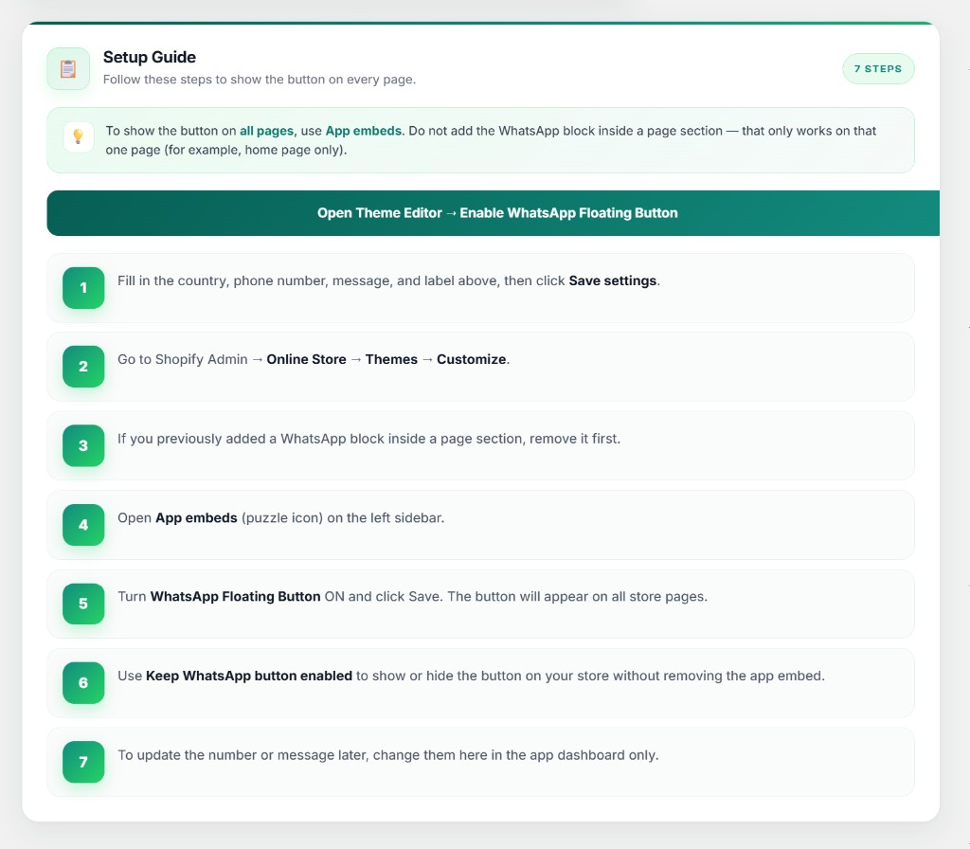
Figure 4 — In-app setup guide

6. Verify on Storefront
- Open your live storefront (home, product, collection pages).
- Confirm the green WhatsApp button appears bottom-right on all pages.
- Click the button and confirm WhatsApp opens with the saved number and message.

7. Support & Privacy
Support email: support@carenetsolutions.com
Privacy email: privacy@carenetsolutions.com
Privacy policy: https://carenetsolutions.co.uk/whatsapp/privacy

8. Shopify App Review Instructions
- Install the app on the review development store.
- Set Country: +91 India, Phone: valid WhatsApp number, Default message: Hi, I need help., Enable toggle: ON.
- Click Save settings.
- Go to Online Store → Themes → Customize → App embeds → enable WhatsApp Floating Button → Save.
- View storefront — button should appear on all pages.
- Click the button to verify WhatsApp opens with correct number and message.
- Uncheck Keep WhatsApp button enabled, save, and confirm button disappears.

