ELDY: A GOOD PROPOSAL FOR EMELIORATING ELDERLY ACCESSIBILITY TO INTERNET TECNOLOGIES.

Abstract:
“Eldy” is a software suite that allows navigation on the internet and basic interactions with a computer taking advantage of an interface design specifically addressed to elderly people. This software is part of the class of technologies oriented to improve accessibility of elderly people minority. It is argued that cognitive changes due to aging and the lack in the sharing of background knowledge between the new generations and the elderly make harder the approach to technologies for elderly population. Testing Eldy interface, built taking into consideration the international guidelines for elderly accessibility, it came out that some difficulties still persist for the elderly when using it and they can principally be ascribed to background knowledge differences between elderly and young people, these last trained to interfaces “language”.

KEYWORDS: elderly, accessibility, eye tracking, gaze-time, cognitive walkthrough.

Introduction
The diffusion of Web technologies made communication and information sharing-storage simpler and more efficient. Technologies are becoming a necessary medium in nowadays life. But elderly are often excluded as not costumed to the usage of it and not involved in the technological progress; the consequence is the increasing digital divide. The refusal of new technologies from elderly population is not only due to perceived inadequacy, but to impairments that characterize normal age advancing: perceptual, cognitive or motor impairments make the division deeper, being a challenge for the proposition of an accessible technology.
Aging determines changes on more aspects of individual life: social aspects (society have expectations about aging individuals), psychological aspects (aging individuals have to face the expectations of society, therefore they make experiences about how to face them and about self-efficacy) and neuro-biological aspects (changes in neural substrate and in functional correlates). In this sense aging is a multidimensional process (Rowe & Kahn, 1997).
If we want to encourage a “successful aging” we must consider the different factors that determine it (psychological, social, physical, economical and environmental), and the improvements that can take place in relation with these factors. Technologies can have an important role in ameliorating life style of elderly population and in reaching the desired goal of a “successful aging” (Charness & Schaie, 2003). In this direction geron-technology is a new research area whose aim is to develop new technologies to improve elderly population possibilities on different aspects: safety, assistance and communication.
Social interactions is a core aspect for a satisfying life, and technologies, specifically Internet technologies, can help with regard to this specific aspect (Charness and Schaie, 2003).
Attention has been pointed to the usage of the internet as a social supporting technology, but the internet as it is now is still inadequate to elderly users abilities; to overcome this phenomenon the World Wide Web consortium (W3C) proposes the goal of accessibility as a fundamental prerequisite for the sharing of resources. Accessibility is the "ability to access" the functionality of a product and “accessible” is a product that can reach different people (Hanson & Richards, 2005). Limits in accessibility are determined by the fact that usually interfaces are ideated and organized taking into account the capabilities and the expectations of the larger part of users and not of minorities. Therefore, although elderly participants could take advantage from the usage of web technologies, they find some difficulties approaching them (Czaja, 2005; Hanson, 2001, 2004).
Czaja & Lee (2003) report a review of studies about efficiency of older adults completing different tasks of electronic information seeking and overall the performance of older adults is worse than that of young participants in activities regarding information retrieval.
In order to adapt technologies to elderly users the perceptual-cognitive impairments related with aging must be taken into consideration and appropriate solutions provided (for a review of impairments related with age see Schieber, 2003).
Guide-lines for the improvement of accessibility on graphic interfaces are summarized by Nielsen (2000) and by Morrell et al. (2003) for elderly population in particular.
In what follows, a list of suggestions is reported for an appropriate development of interfaces in order to respond to the different categories of perceptual-cognitive impairments (for a review see Gamberini et al., 2006):

- Perception and aging:
In order to fulfill elderly users’ needs that are consequences of a reduced visual acuity and contrast sensitivity and an impoverishment of the peripheral vision, of motion and color perception some suggestions are to provide the possibility to the user to control and request the appropriate size of buttons and letters, to provide high color contrast between text and background and to make available the information exploiting multiple communicative channels (textual information supported by vocal synthesis softwares).

2) Attention and aging:
As attention is a multidimensional construct (Parasuraman & Davies, 1984) that refers to the distribution of the elaboration resources of the mind, the word attention is referred to a variety of processes and a further distinction is necessary.
a) Selective attention is the process of selecting the information to elaborate, filtering out the irrelevant one; this ability is partially lost with age, e.g. inhibitory processes decay in elderly people (Zacks & Hasher, 1997) and augmented probability to be distracted have been observed (McDowd & Shaw, 2000). Rogers (2000) suggests that the loss is task-specific and related to previous experience and familiarity with the objects used in the task. Some advices for developers are to reduce the possibility of attention being dragged by irrelevant information by positioning cues that address observer’s attention, avoid rich backgrounds that can distract the user, disturbing and slowing down the navigation and avoid animations, flashing text and icons which increment the requests to perceptual-attentive systems (perceptual load) diminishing visibility of relevant information
b) Divided attention is the distribution of processing resources among multiple simultaneous tasks and attentional switch is the rapid switching from one task to another (Rogers, 2000). These capacities also deteriorate with aging (McDowd & Craik, 1988). Therefore it is advisable to diminish perceptual complexity if multiple sources of information must be taken into consideration at once. .
c) Sustained attention is the maintainance of attentional focus on the same task under continuous stimulation, while keeping the focus on waiting for a rare event is called vigilance. Contradictory results have been reported pertaining to age-related deficits attributed to these functions: it was observed that when a deficit was present it was mainly related with other aspects of the task and was not strictly attentive (Rogers, 2000).
d) Automatic deployment of attention is not affected by aging, voluntary processes instead deteriorate with age. Practice can compensate the decrease in voluntary attentive capacities through a process of automatization (Rogers, 2000).

3) Learning, memory, and aging:
Learning is affected by the aging of memory but also by other factors like affective processes, motivation, strategic approach and metacognition (the knowledge of an individual about her own cognitive abilities): for instance, older people’s lack of confidence in their abilities can create obstacles to the efforts to approach new technologies (Marquié et al., 2002).
Memory is a heterogeneous category of processes, each one specifically affected by aging (Craik, 2000). Aging effects on memory are evident at specific tests, therefore the impairment is task-dependent.
a) Implicit and explicit memory and learning: implicit memory and learning (procedural and performance related) seem unaffected by aging (Light & La Voie, 1993), while declarative and conscious ones seem influenced by it. Specific training programs for technological tools have been studied by Mead & Fisk (1998): they contrasted two kinds of training for older adults, one “passive” based on the transmission of concepts and one based on action, and found that “action” trainees repeated errors less frequently than “concept” trainees on menu navigation tasks.
b) Working memory is conceptualized as a temporary and limited workspace for the manipulation of available fragments of information to accomplish a task (Craik, 2000). Craik et al. (1990) observed a great deterioration of working memory capabilities in older adults according to task complexity. To ameliorate elderly performance it can be useful to avoid irrelevant information and to reduce the number of options and the speed of item presentation in an interface menu.
c) Semantic memory: semantic long-term memory stores general knowledge (meaning of words, concepts, recognizing a location), regardless of when and where it has been acquired. Semantic memory is substantially preserved during the normal aging process (Light, 1992) and it is a strong help to build elderly-centered technologies. To help elderly people to cope with new technologies it can be useful to take advantage of this intact ability using a clear language that anyone without particular experience can understand and well-known concepts to convey meanings; it is difficult managing text material that is not familiar to the reader mostly when it is demanding in cognitive resources (Van Gerven et al., 2000); when necessary the use of metaphors to create a semantic-relevant context can guide the use of an interface.

4) Executive functions and aging:
The term executive refers to a group of functions directly related to programming and control, specifically the components individuated are: will, planning, aim-directed and emotional behaviour (Lezak, 1995). “Executive functions” is a gatherer name for all the activities related with these operations, and partially include processes that in this overview have been reported being part of other categories of cognitive functions (such as attention and memory). In fact, carrying out a task which involves executive functions requires also an interaction with information in working memory and the inhibition of irrelevant information. These capacities are necessary for successful problem-solving, reasoning and definition of strategies.
Salthouse et al. (2003) claims that age related cognitive decay is an effect of the impairment in executive functions. Elderly people have an impaired task-switching capacity (that consists in the inhibition of the previous and the undertaking of a subsequent task): the reason for it is that aging, although not determining a diminishing in attentive resources available, influences the capacity of inhibiting irrilevant sensory information, a modality-specific effect correlated with executive functions (Zacks & Hasher, 1997).

5) Everyday cognitive tasks and aging:
a) Processes related with space (like visuo-spatial attention and memory) or with its mental representations decline during the normal aging process (Salthouse, 1992).
Some useful tips are the implementation of Web site maps as an external support to the deteriorated spatial abilities of the user (Mayhorn et al., 2004) and the integration of the environment with cues that can support the losses in memory or attention (Sundstrom et al., 1996).
b) Decision-making: decision-making is an important cognitive process in everyday life. Older people seem to be prone to search and consider less relevant information when considering the alternatives to make a decision, and to perform more slowly in making the choices (Sanfey & Hastie, 2000). To ease decision making processes it is useful to avoid irrelevant information and redundancy.

Accessibility evaluation methods
The accessibility evaluation tests the efficacy and the efficiency in the performance of minorities when using a technological tool. In this study we tested the efficacy (completion of the tasks) and efficiency (quick completion of the tasks) when using the interface.
We decided to put side by side the cognitive walkthrough (Wharton et al., 1992; Rieman et al., 1995; Gamberini & Valentini, 2001), one of the classical methods of discount usability, with a measurement of efficiency of interaction with interfaces (Hilbert & Redmiles, 2000).
The Cognitive Walkthrough (CW) is focused on the fulfilment of the objectives predefined and the errors, discrepancies and problematic steps found during the navigation; during the completion of the task the errors are usually marked on a form and the experimenter can ask questions to the user about them, or the user could be asked to report what she/he is thinking or doing aloud during the navigation. Today it is a common practise to video-record the monitor in order to have the possibility to analyse the actions made by the user subsequently (Gabrielli et al., 2005).
An interesting approach is enriching the accessibility evaluation putting side by side a traditional qualitative methods, such as the CW, with a quantitative analysis. In this study we used as a quantitative measure the gaze-time. This measure provide quantifications of the difficulty found by the user in the comprehension and usage of the different subparts of the interface, the pages related to a specific task as it increases with the difficulty found from the user. Gaze time is the time effectively spent making fixations within a specific Area Of Interest (AOI); the concept of gaze-time is coincident with that of “gaze duration” which is used both in reading and scene perception research fields and represents the sum of the duration of all fixations in a region (Rayner, 1998; Henderson & Hollingworth, 1999). It can be said that gaze-time represents the time spent reading and interpreting the interface because information is drawn only during fixations, and not during saccadic eye movements (Matin, 1974), therefore the time spent fixating is increasing with the elaboration/comprehension time.

Hypotheses
It is to take into consideration the finding that, when comparing elderly performances with that of young/middle age people differences between populations survive to the usage of supportive technologies, although there is an improvement within the elderly population when using the device (Gregor et al., 2002).
In fact our hypothesis is that (hypothesis 1) elderly performance is overall worse than that of young people, as some of the impairments due to seniority can hardly be completely overridden by devices.
Moreover, in relation to the technologies used it is supposed that (hypothesis 2) young people performance is better when using Eldy with respect to another interface not specifically thought for elderly, but this difference should not be large; while for elderly people the usage of Eldy determines a large amelioration with respect to Windows in the efficacy and efficiency of the performance.

Method
Participants
Two Italian groups of volunteers took part at the experiment: 27 elderly participants and 16 young participants, from these 3 young and 13 elderly participants were discarded because of eye-signal lost during the registration, 1 elderly participant was discarded as totally lacking in basic knowledge about interaction modalities with a computer. The remaining participants were 13 elderly between 61 and 68 years of age (2 females and 11 males; M = 64.38 years), and 13 young between 21 and 28 years of age (4 females and 9 males; M = 23.15 years). Participants did not show evident perceptual, cognitive or motor impairments that could interfere with the experiment.
Participants were different scholarly. All the participants reported previous experiences with computer technologies. The experiment was undertaken with the written consent of each participant.

Apparatus
Eye movements were recorded with a video-based eye monitoring system (Tobii 1750, Tobii®). Tobii 1750 integrates the camera and infrared lighting into a TFT 17” monitor (1024x768 resolution). The system has an accuracy of 0.5°, a sampling frequency of 50 Hz and a reacquisition time inferior to 100 ms. The system permits a relatively high freedom of movements as the camera has a recording field of 20x16x20 cm. We used the Clearview 2.7.0 software (Tobii technology) to record data on x and y user’s gaze screen coordinates; the same software also recorded the video and the mouse logs.

Eldy interface
Eldy 1.3 is a software suite developed by a no-profit association; it allows the usage of the internet for communication and data management, in particular it provides an e-mail and chat service, a web-browser, a word-processing and an images management application, and the weather forecast.
Fig.1 shows the home-page of Eldy, “La piazza”, that appears when opening Eldy program. As the interface is addressed to Italian users, the names of the buttons are in Italian.
Eldy is specifically thought for elderly people; therefore the design choices try to ameliorate the users’ performance by taking into account some of the guide-lines proposed in the introduction: big icons or buttons, high colour contrasts between the written text and the background, simple, not overburdened or disturbing backgrounds, substitution of technical terms with more colloquial ones.
Therefore, the developers tried to create an interface taking into account the cognitive impairments of elderly population.

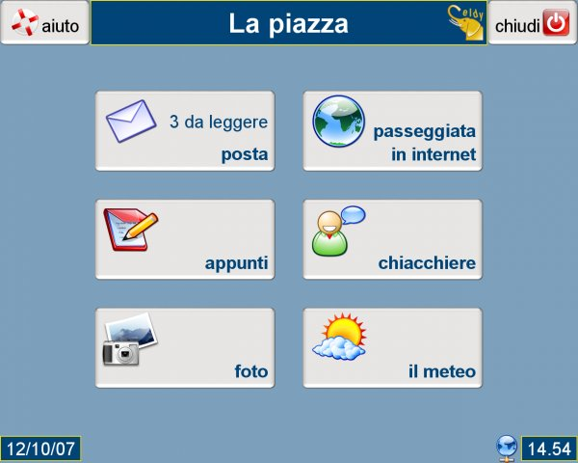

Fig.1. Eldy home-page. The applications proposed are: “posta” (mail), “passeggiata in internet” (walking through the internet), “appunti” (notes), “chiacchiere” (chatter), “foto” (photos), “il meteo” (weather forecast).

Participants had to complete the same task using two interfaces: the comparison was made between Eldy 1.3 and the applications available in WindowsXP to complete the same tasks. Table 1 reports the corresponding applications in Windows for each of the buttons present in Eldy home page. Both Eldy and Windows were presented in Italian to avoid language comprehension disparities. A set of five tasks was proposed consisting in the usage of some of these applications.

Table 1.
ELDY | WINDOWS
mail | Outlook Express
walking through the internet | Internet Explorer
notes | Word
chatter | Internet Explorer/Skype or Messanger
photos | FOLDERS MANAGEMENT
weather forecast | Internet Explorer/ Google Search
Table 1 reports the corresponding applications in Windows for each of the buttons present in Eldy home page

Experimental protocol
Participants were presented written instructions, afterwards the experimenter ascertained about the comprehension of the instructions and they were left near the experimental apparatus for further consultation, moreover the experimenter renewed at the end of each task which was the next one to be completed. Participants were assured that the aim of the experiment was to test how they behaved while using the interfaces but that there were no right or wrong actions they were judged on. When participants were not able to complete the task they were encouraged to go on to the next task.
Participants were asked to complete 5 tasks with one interface and then with the other, the presentation order of the two interfaces was counter-balanced; the list of the tasks is provided in Table 2, with the definition of the steps necessary to complete the tasks (ideal steps) for the two interfaces. Buttons’ names are inserted between inverted commas, in brackets there are translations (lower-case letters) and explanations (capital letters), actions are written in capital letters, when the button is made up of an icon without any specified name we report the name we assigned to the button in italics.

Task | Description | Eldy | Windows
task 1 | looking for the weather forecast | “Il Meteo” ( Weather Forecast ) / SELECT THE CITY | Internet Explorer / Google
task 2 | writing a text and saving it | “Appunti” (Notes) / WRITE THE TEXT / “Salva” (Save) / NAME / “Salva” (Save) | Microsoft Word / WRITE A TEXT / “Salva” (Save) / NAME / “Salva” (Save)
task 3 | looking for a specified on-line newspaper | “Passeggiata in internet” (Walking through the internet) / “Ultime notizie” (Latest News) / “La Repubblica” (NAME OF THE NEWSPAPER) | Internet Explorer / Google
task 4 | looking for a specified web-site | “Passeggiata in internet” (Walking through the internet) / “Portale” (Portal) / “Cerca in internet” (Search on the internet) / Google | Internet Explorer / Google
task 5 | write an e-mail and attach a file | “Posta” (Mail) / “Scrivi” (Write) / WRITE A TEXT / “Clicca qui per proseguire” (Click here to go on) / “Clicca per allegare” (Click here to attach) / SELECT FILE / “Apri” (Open) | Outlook Express / “Crea messaggio” (Create mail) / WRITE A TEXT / “Inserisci” (Insert) / “Allegato” (File Attachment) / SELECT FILE / “Allega” (Attach)
Table 2 shows the tasks participants were asked to complete and the steps necessary to complete them.

The interfaces evaluation is based on the amount of time spent for fixations and on the reports of the CW considering surplus/erroneous steps made by participants with respect to necessary/correct ones.
During the completion of the task the monitor was video-record in order to have the possibility to analyse the actions made by the user subsequently and eye movements registered.

Results
QUANTITATIVE ANALYSIS

Eye movements on the interface are influenced by the comprehension of the observer: when the time spent fixating on a page is long it means that a lot of time is required to analyse and to understand the page.
A three-way analysis of variance was performed, with System (Windows vs. Eldy) and Task as within-subjects factors and Age (young vs. elderly participants) as between-subjects factor. There was a significant effect of age, F (1, 24) = 20.11, p < .001, η_{p}² = .46; elderly people (M = 64.74 sec) employed a gaze-time greater than young people (M = 33.29 sec) while performing the tasks. The analysis of variance also revealed a significant main effect of the tasks, F (4, 96) = 4.44, p < .05, η_{p}² = .16; and a system-by-task-by-age interaction, F (4, 96) = 3.98, p < .05, η_{p}² = .14.

Table 3. Means (expressed by seconds) of gaze-time divided for Age Groups, Systems and Tasks
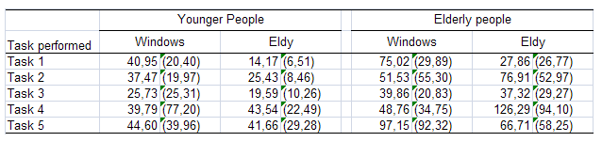
Note. Standard deviations are given in parentheses

HYPOTHESIS 1: DIFFERENCES BETWEEN YOUNG AND ELDERLY PEOPLE

A subsequent analysis was conducted splitting the analysis for Windows and Eldy.
For Windows system, the main effects were statistically significant both for the task, F (4,96) = 2.59, p < .05, η_{p}² = .10 and for the age, F (1,24) = 6.80, p < .001, η_{p}² = .22; the interaction was not significant.
For Eldy the situation is quite different; the main effect of the task was significant, F (4,96) = 9.09, p < .05, η_{p}² = .28; there was a significant effect of age, F (1,24) = 24.93, p < .001, η_{p}² = .51, and also the interaction was significant, F (4,96) = 3.02, p < .05, η_{p}² = .11.
The analysis revealed something unexpected: the performance of the elderly participants is strongly task-dependent; as Figure 2 shows, the performance of the young participants remains the same across the tasks, while the performance of elderly people is worse in the second, F (1,120) = 9.46, p < .05, and fourth tasks, F (1,120) = 24.44, p < .05, accomplished in the Eldy system. In Windows in order to compare the gaze time between young and elderly specifically in the fifth task the Mann-Whitney test was used, the analysis shows that the gaze time of elderly participants (Mdn = 77704.63 ms) is significantly longer than the gaze time of young participants (Mdn = 23246 ms), U = 38.00, p = .016, r = -0.47 (Rosenthal, 1991, pag.19).

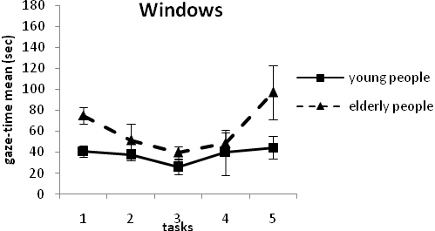
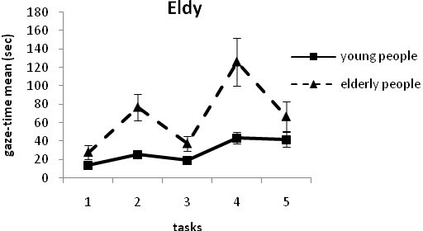

Fig. 2 Comparison between Windows and Eldy systems

Note that confidence intervals have a greater variability just for those tasks we define as critical for older participants.

HYPOTHESIS 2: DOES ELDY MAKE THE OLDER PEOPLE’S PERFORMANCE BETTER?

Afterwards the question regarding our second hypothesis is to be answered: are there differences between Windows and Eldy related to each Age group? We found that both for Windows and for Eldy systems young people generally perform better than elderly people, but is it true that especially elderly people perform better passing by Windows to Eldy system?
Regarding the gaze-time analysis, neither for the elderly nor for the young group a significant main effect of the factor “System” exists. Related to the group of elderly people the interaction System-by-Task is significant, F (4, 48) = 8.30, p < .05, η_{p}² = .40; this fact implies that, while young people perform equally well both for Windows and for Eldy regardless of tasks, elderly people are influenced both by tasks and by systems together.

Therefore the three-way interaction is resulting from the specificity of the tasks; it appears clear that if we want to evaluate Eldy as a whole we have to consider the peculiarities of its parts, and therefore an additional analysis task-by-task must be included. This analysis will point out what works and what does not work in Eldy system and what can be improved.
Starting by the first task (Figure 3a), we observe a significant main effect of Age, F (1, 24) = 11.32, p < .05, η_{p}² = .32 and of System, F (1, 24) = 46.79, p < .05, η_{p}² = .66; the effect size index denotes a great improvement of the performance with Eldy. The performance of participants in the first task is coherent with our hypotheses.
In the second task only the factor Age is statistically significant, F (1, 24) = 8.45, p < .05, η_{p}² = .26; moreover looking at Figure 3b we can notice a reverse in the pattern of elderly people when compared with that of young people: while Eldy is simpler to use than Windows for young participants it reverses to problematic for elderly.
In the fourth task the effect of age is significant, F (1,24) = 5.36, p<.05, η_{p}² = .18, as well as the effect of System, F (1,24) = 6.78, p < .05, η_{p}²= .22, and also the interaction is significant, F (1,24) = 5.59, p < .05, η_{p}²=.19. Figure 3c shows clearly the greater difficulty to perform the task especially for elderly people in Eldy; The analysis of the simple effects shows a significant effect only for the factor Age by Eldy level, F (1,48) = 10.77, p < .05, and a significant effect for the factor System by elderly people level, F (1,24)=12.35, p < .05.
We will take into consideration the fifth task subsequently when considering which problematic buttons determined performance.

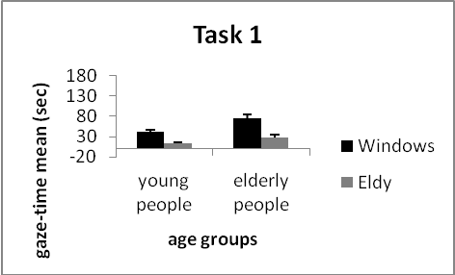
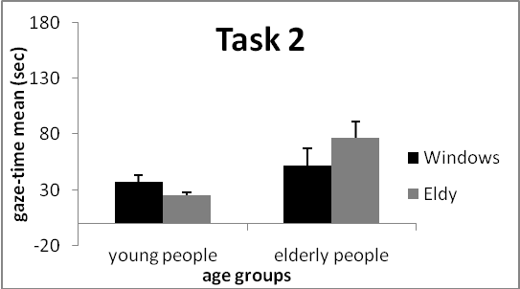
Fig. 3. gaze-time of the first, second and fourth tasks
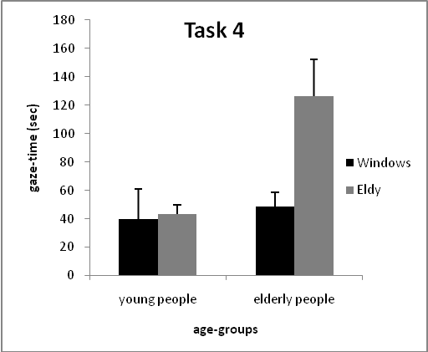

Summarizing the quantitative results: Age is a significant factor for the gaze-time, therefore, a real and spread difference between elderly and young people exists: generally, young people are faster and more accurate than elderly in tasks completion both in Eldy and in Windows. Another important but unexpected aspect is the task-dependency of performance when comparing Windows and Eldy: it depends on the easiness to find the appropriate commands and for this reason the results of the different tasks have not a regular pattern. Sometimes Eldy really works, like in the first task: less gaze-time both for the young and elderly people; other times, as for the second and the fourth tasks, something did not work and the performance of elderly participants drastically dropped; in this case we find a reverse pattern with respect to what expected: Eldy does not reduce the troubles found by the elderly instead it exacerbate them. Looking at the confidence intervals around the means, a great variability can be observed especially related to the Task 4 (Fig. 4).
This results show that something did not work with Eldy, specifically depending on the task. What determined the difference in the performance of young and elderly participants in the critical tasks? The qualitative analysis may help about the specific and technical problems which characterized the performance, in particular elderly people’s performance.

QUALITATIVE ANALYSIS

Cognitive walkthrough and gaze-time data on selected AOIs
Gaze-time analysis reported above shows which the most troublesome tasks are, providing a quantitative measure of the degree of difficulty found. The cognitive walkthrough technique highlights in detail which were the most problematic steps.
We report, joined to the CW description, some graphs showing the mean gaze-time calculated on selected pages extrapolated from tasks and on AOIs within the pages. AOIs contain the necessary buttons within a page to go on with the task. Gaze-time graphs give an idea of the influence that the different pages and buttons had on an efficient tasks completion.
CW analysis and mean gaze-time graphs are reported for three of the tasks.
During the task 2 (writing a text and saving it) elderly participants had difficulties to find the button “Salva” (Save) using Eldy and 2 elderly people did not find it, probably because of the absence of the button’s name on it. This difficulty led to a trial and error behaviour. In Eldy the button Save is positioned on the toolbar, the icon represents a floppy-disk and the name is not displaced like in Windows. Probably elderly participants did not considered Eldy interface as familiar and did not apply previous knowledge to it (in Windows they found the button easily).
In figure 5 it is evident that elderly participants spent a lot of time in Eldy looking for the button “Salva” (Save) that was quite easily found in Windows..

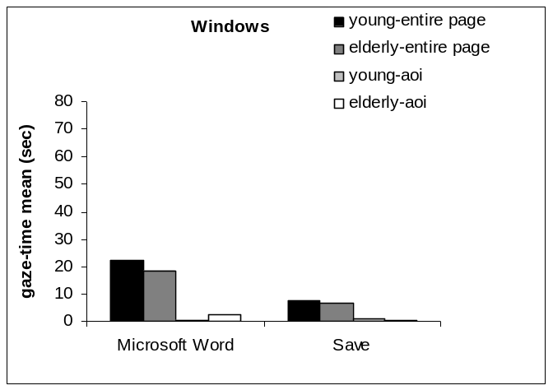 | 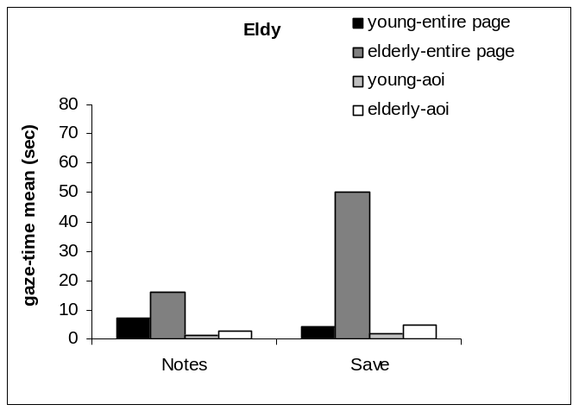
a) | b)

Figure 5. a) Windows: on the left of the Figure, the mean gaze time on the entire desktop and on the Microsoft Word button while searching for the Microsoft Word button is depicted. On the right, the Figure shows the mean gaze time on the entire Word page and on the Save button while trying to save the written text. b) Eldy: the mean gaze time on the entire home-page and on the “Notes” button (data on the left), mean gaze time on the entire page and on “Save” button while trying to save the written text (data on the right).

During task 4 (looking for a specified web-site) the majority of elderly participants continued to show a not-exhaustive query at the search engine when using Windows, while young participants did not repeat the same error. When performing two subsequent searches, as it happen with the 3rd and 4th tasks, Eldy reveals a relevant crack: when clicking “Passeggiata in internet” (Walking through the internet) for the second search, the previous visited page is visualized and the search box is absent; at this point the only possible way to make a new search is to click the button “Portale” (Portal) that is hardly recognizable. This was a common poser for elderly people and one participant did not complete the task. The button Portal is positioned on the toolbar and its icon represents a house, in this case the name of the button is displayed under the icon. Elderly people found the button considerably later than young participants, probably because they did not recognize the house as a symbol representing the return to the main page and the name was not meaningful for them.
Fig 6 shows the difficulty elderly participants had in finding the button “Portal” (note the difference in scale between the graphs).
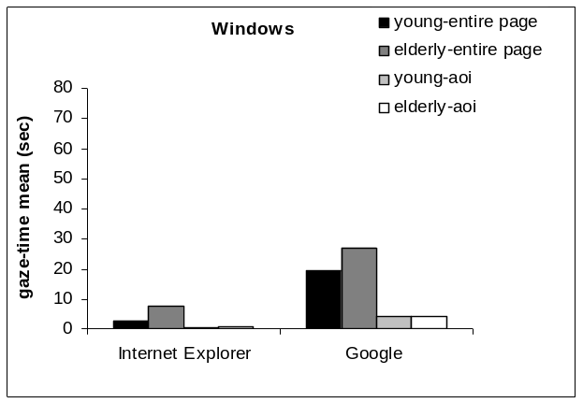 | 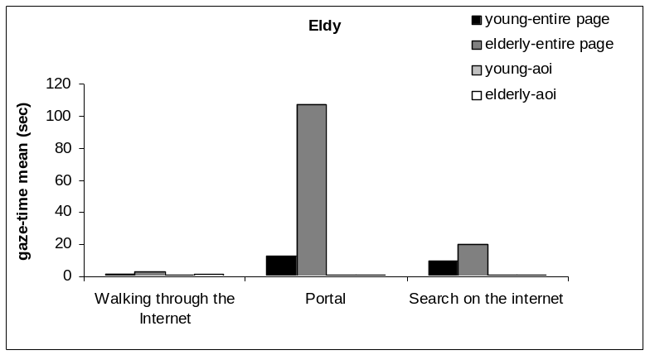
a) | b)

Figure 6. a) Windows: mean gaze time on the entire desktop and on the Internet Explorer button while searching for the Internet Explorer button (data on the left), mean gaze time on the entire Google page and on the Google search toolbar while making the query (data on the right). b) Eldy: mean gaze time on the entire home-page and on the “Walking through the Internet” button (data on the left), mean gaze time on the entire page (the previous visited one) and on Portal button while trying to go back to the portal (data in the centre), mean gaze time on the Portal and on the “Search on the Internet” button while looking for the button (data on the right).

During the task 5 (write an e-mail and attach a file) using Windows elderly participants had difficulties creating a new message and attaching a file to it, and did not take advantage from the existence of labels when passing with the mouse on a button. Four elderly participants did not complete the step. In this case the difficulty rised primarily from searching the attach button which was not immediately displayed but had to be found in the “Inserisci” (Insert) menu. Obviously participants had to know that they had to search for the button in a specific menu otherwise the search would have been far longer, as it actually was. The Eldy interface disoriented elderly participants in the last part of the task when it was necessary to click the button “Apri” (Open) to attach the file Elderly participants spent long time looking at the page and at the button but they did not recognized it although the name was reported (the icon represented a camera and a folder), the only explanation is that they did not know they had to press “Apri” to complete the attachment procedure. It was an unfamiliar procedure for them. The increased difficulty found by elderly participant in Windows is showed in Fig.7. In this task the benefit in the usage of Eldy is evident.

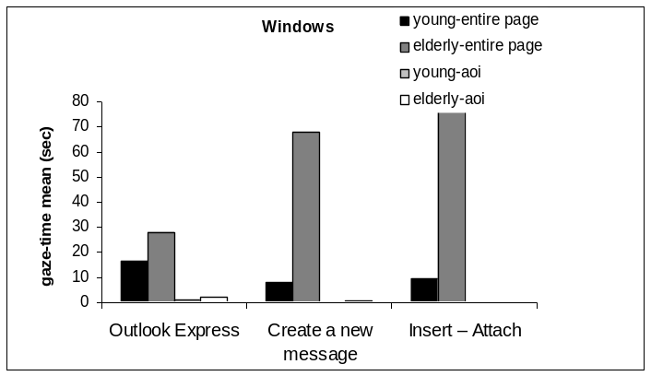 | 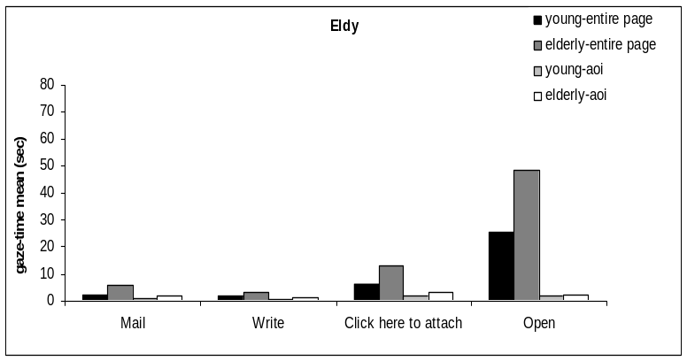
a) | b)

Figure 7. a) Windows: mean gaze time on the entire desktop and on the Outlook Express button while searching for the button (data on the left); mean gaze time on the entire Outlook Express page and on the “Create a new message” button while looking for the button (data in the center); ); mean gaze time on the entire e-mail page and on the “Insert-Attach” area while looking for the buttons (data on the right);. b) Eldy: mean gaze time on the entire home-page and on the “Mail” button (data on the left), mean gaze time on the entire page and on “Write” button while looking for it (data in the left-centre), mean gaze time on the entire page and on “Click here to attach” button while looking for it (data in the right-centre), mean gaze time on the “Attachment” page and on the “Open” button while looking for it (data on the right).

Discussion

A great part of our evaluation was centred on www search activity and we can compare our results with that of other www search studies. In the work of Westerman et al. (1995) on information retrieval, elderly users showed a slower but all the same accurate performance with respect to young users. The authors explained this result as a slowdown of the general processing speed rather than as a specific deficit in any cognitive ability; they also found that movement speed is a significant predictor of latency. The present research confirms previous findings of an overall worsening of elderly population’s performance with respect to that of young people when using electronic environments. Gaze-time provide an efficiency measures related with performance time but more appropriate than it as it is connected with cognitive processing not affected by movements speed and decisions of action.
Understanding the source of the difficulties found by elderly is the major concern if we want to design interfaces that meet the target characteristics.
Our analysis show that, although elderly people performance is worse than young participants’ one in most of the tasks, the amelioration using Eldy with respect to Windows depends on the task. And this is because the different subparts of Eldy have achieved at different grades the aim of making interaction simpler. Our hypotheses are partially verified as the amelioration of elderly participants performance when using Eldy is not observed in all tasks. The lacks observed in Eldy are due both to a not meticulous application of the guide-lines and to the absence of specific guiding principles in some cases. Therefore we make some suggestions that integrate the previously considered ones and whose aim is to obtain a further improvement of accessibility in elderly-oriented interfaces.
- The labels: elderly people are not used to the labels appearing when passing with the mouse on a button, and do not use this information, therefore all buttons should have the name clearly reported.
- The color and position: the color and position of buttons are very important, therefore they should be related with the functions buttons have.
- The names: the names of the buttons should be clear in meaning and aim.

This last suggestion depends on the fact that in most of the cases the problems found by elderly users are not related with their perceptual capacities but mainly with the absence of a shared background of knowledge between the users and the developers, elderly people who are not acquainted to technologicies miss the meanings of name and related concepts. Therefore for them more time is required to put in use the appropriate behaviour.
It seems that elderly participants fail to adapt previous acquired knowledge to novel contexts, therefore they appear as scarcely flexible/adaptable.
Some of elderly participants did not complete the steps, while all young participants completed it. This is expression of a different approach to technology, while young people are self-confident and do not give up, elderly people give in.
The development of accessible interface must take into consideration the multidimensional aspects of aging: cognitive but also psychological and social. Trying to render the interface as clear as possible is the major goal when developing accessible interfaces because the experience of inadequacy in elderly users should be absolutely avoided, this is imperative if a positive attitude towards the interface itself is to be obtained (Charness, 2003). It is probably the feeling of inadequacy the cause of the greater number of defections in elderly users with respect to young participants that we observed. When the usage of a technological product gives the opportunity to perceive self-efficacy and improve personal lifestyle, it is reasonable that the product will not be averted but instead searched.

References:
Charness, N. (2003). Access, motivation, ability, design, and training: necessary conditions for older adults success with technology. In: Charness, N. & Schaie, K.W., eds., Impact of technology on successful aging. Springer Publishing Company.
Charness, N. & Schaie, K.W. (2003). Impact of technology on successful aging. Springer Publishing Company.
Craik, F.I.M., Morris, R.G. & Gick, M.L. (1990). Adult age differences in working memory. In: Vallar, G. & Shallice, T., eds., Neuropsychological impairments of short-term memory. Cambridge, UK: Cambridge University Press.

Craik, F.I.M. (2000). Age-related changes in human memory. In: Park D.C. & Schwarz N., eds., Cognitive Aging: A Primer. Philadelphia, PA: Psychology Press.

Czaja, S.J. (2005). The impact of aging on access to technology, ACM SIGACCESS Accessibility and Computing, 83, 7-11.

Czaja S.J. & Lee C. (2003). The impact of the internet on older adults. In: Charness, N. & Schaie, K.W., eds., Impact of technology on successful aging. Springer Publishing Company.

Gabrielli, S., Mirabella, V., Kimani, S. & Catarci, T. (2005). Supporting cognitive walthrough with video data: a mobile learning evaluation study. MobileHCI '05: Proceedings of the 7th international conference on Human computer interaction with mobile devices & services, September 19–22, Salzburg, Austria.

Gamberini, L., Alcaniz, M., Barresi, G., Fabregat, M., Ibanez, F. & Prontu, L. (2006). Cognition, technology and games for the elderly: An introduction to ELDERGAMES Project. PsychNology Journal, 4(3), 285 -308.

Gamberini, L. & Valentini, E. (2001). Web usability today: theories, approach and methods. In: Riva, G. & Galimberti, C., Towards cyberpsychology: mind, cognition and society in the internet age. Amsterdam: IOS Press.

Gregor, P., Newell, A.F. & Zajicek, M. (2002). Designing for dynamic diversity - interfaces for older people. Assets '02: Proceedings of the fifth international ACM conference on Assistive technologies, July 8-10, Edinburgh, Scotland.

Hanson, V.L. (2001). Web access for elderly citizens. WUAUC' 01, Proceedings of the 2001 EC/NSF workshop on Universal accessibility of ubiquitous computing: providing for the elderly May 22-25, Alcàcer do Sal, Portugal.

Hanson, V.L (2004). The user experience: designs and adaptations. W4A’04: Proceedings of the 2004 international cross-disciplinary workshop on Web accessibility (W4A), May 18, New York, USA.

Hanson, V.L. & Richards J.T. (2005). Achieving a more usable World Wide Web. Behaviour and Information Technology, 24(3), 231-246.

Hilbert, D.M. & Redmiles, D.F. (2000). Extracting usability information from user interface events. ACM Computing Surveys, vol. 32 (4), 384-421.

Henderson, J.M. & Hollingworth, A. (1999). High-level scene perception. Annual Review of Psychology, 50, 243-271.

Lezak, M.D. (1995). Neuropsychological assessment. New York : Oxford University Press.

Light L., (1992). The organization of memory in old age. In: Craik F. I. M. & Salthouse T.A., eds., The handbook of aging and cognition. Hillsdale, N.J: Lawrence Erlbaum Associates.

Light, L. L., & LaVoie, D. (1993). Direct and indirect measures of memory in old age. In: Graf, P. and Masson M.E.J., eds., Implicit Memory. New directions in Cognition, Development, and Neuropsychology. Hillsdale, N.J: Lawrence Erlbaum Associates.

Marquié, J.C., Jourdan-Boddaert, L., & Huet, N. (2002). Do older adults underestimate their actual computer knowledge? Behaviour and Information Technology, 21 (4), 273-280.

Matin, E. (1974). Saccadic suppression: a review and an analysis. Psychological Bulletin, 81, 899-917.

Mayhorn, C.B., Rogers, W.A., & Fisk, A. D. (2004). Designing Technology Based on Cognitive Aging Principles. In: Burdick D.C. & Kwon S., eds., Gerotechnology: Research and practice in technology and aging. NY: Springer.

McDowd, J.M., & Craik. F. (1988). Effects of aging and task difficulty on divided attention performance. Journal of Experimental Psychology: Human perception and performance, 14(2), 267-80.

McDowd, J. M., & Shaw, R.J. (2000). Attention and aging: A functional perspective. In: Craik F. I. M. & Salthouse T.A., eds., The handbook of aging and cognition. Hillsdale, N.J: Lawrence Erlbaum Associates.

Mead, S.E., & Fisk, A.D. (1998). Measuring skill acquisition and retention with an ATM simulator: The need for age-specific training. Human Factors, 40, 516-523.
Morrell, R.W., Dailey, S.R. & Rousseau, G.K. (2003). Applying research: The NIHSeniorHealth.gov Project. In: Charness, N. & Schaie, K.W., eds., Impact of technology on successful aging. Springer Publishing Company.
Nielsen, J. (2000). Designing Web Usability: The Practise of Simplicity. New Riders Publishing, Indianapolis.

Parasuraman, R. & Davies, D. R. (1984). Varieties of Attention. Orlando, Florida: Academic Press.

Rayner, K. (1998). Eye movements in reading and information processing: 20 years of research. Psychological Bulletin, 124 (3), 372-422.

Rieman, J., Franzke, M. & Redmiles, D. (1995). Usability evaluation with cognitive walkthrough. Tutorial presented at CHI’95 Mosaic of Creativity, May 7-11, Denver, Colorado, USA.

Rogers, W.A. (2000). Attention and aging. In: Park D.C. & Schwarz N., eds., Cognitive Aging: A Primer. Philadelphia, PA: Psychology Press.

Rowe, J.W. & Kahn, R.L. (1997) Successful aging. The Gerontologist, 37(4), 433-440.

Salthouse, T.A., Atkinson, T.M. & Berish, D.E. (2003). Executive Functioning as a Potential Mediator of Age-Related Cognitive Decline in Normal Adults. Journal of Experimental Psychology: General, 132(4), 566-594.

Salthouse, T.A. (1992). Reasoning and spatial abilities. In: Craik F. I. M. & Salthouse T.A., eds., The handbook of aging and cognition. Hillsdale, N.J: Lawrence Erlbaum Associates.

Sanfey, A.G., & Hastie, R. (2000). Judgment and decision making across the adult life span: A tutorial review of psychological research. In: Park D.C. & Schwarz N., eds., Cognitive Aging: A Primer. Philadelphia, PA: Psychology Press.
Schieber, F. (2003). Human factors and aging: identifying and compensating for age-related deficits in sensory and cognitive function. In: Charness, N. & Schaie, K.W., eds., Impact of technology on successful aging. Springer Publishing Company.
Sundstrom, E., Bell, P.A., Bubsy, P.L., & Asmus, C. (1996), Environmental Psychology 1989- 1994. Annual Review of Psychology, 47, 485-512.

Van Gerven, P. W. M., Paas, F. G. W. C., Van Merriënboer, J. J. G., & Schmidt, H. G. (2000). Cognitive Load Theory and the acquisition of complex cognitive skills in the elderly: towards an integrative framework. Educational Gerontology, 26(6), 503-521.

Wharton, C., Bradford, J.. Jeffries, R. & Franzke, M. (1992). Applying cognitive walkthroughs to more complex user interfaces: experiences, issues, and recommendations. Proceedings of CHI ’92 Conference, May 3-7, Monterey, California, 381-388.

Westerman, S.J., Davies, D.R., Glendon, A.I., Stammers, R.B. & Matthews, G. (1995). Age and cognitive ability as predictors of computerized information retrieval. Behaviour and Information Technology, 14(5), 313-326.

Zacks, R. T., & Hasher, L. (1997). Cognitive gerontology and attentional inhibition: A reply to Burke and McDowd. Journal of Gerontology: Psychological Sciences, 52 (B), 274-283.

W3C and Web Accessibility Initiative, http://www.w3.org./WAI/

