CK12

Charles Laws

http://www.ck12.org/concept/Charles-Law#all

[Insert model midway down the page in the following section. Replace yellow text.]

**Amazing Motion**

Can you guess why the volume of a gas increases when it is heated? Heating a gas gives its particles more energy. With more energy, the particles move faster. You can see this in the simulation at the URL below. Drag the bar to increase the temperature, and you’ll be amazed at how fast the particles zigzag around inside the box! If the speedy particles had more room, they would spread out and the volume of the gas would increase.

Change the highlighted text above:

Use the slider below the model to change the temperature of the molecules. Watch how the molecules move around and collide with the piston.

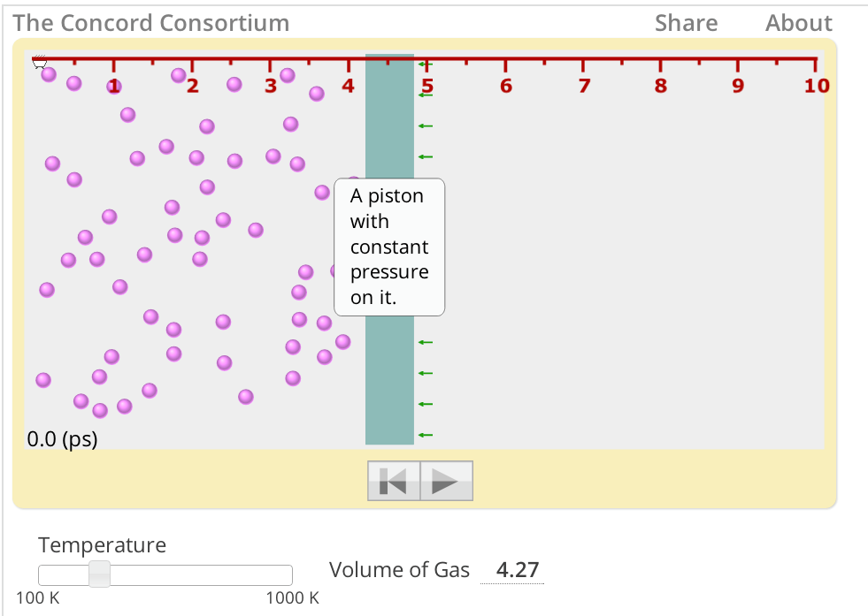

<http://lab-staging.concord.org/examples/interactives/interactives.html#interactives/sam/gas-laws/4-temperature-volume-relationship.json>

**Q:** Now that you know how a gas behaves when it is heated, can you explain how hot air causes a balloon to inflate?

**A:** As the air heats, its particles spread out and occupy more space, causing the balloon to inflate.

Change question to:

q. Why does the piston move when the temperature changes?