Integrated Member Experience GUI
For
[RightSource Pharmacy]
Clarity Number: [75654]
Release Type:
Version Number: [1.1]
Version Date: [03/10/2015]

Revision History
Date | Version | Description | Author
03/10/2015 | 1.0 | Initial Construction | Raghu Arabati
03/30/2015 | 1.1 | Updated with latest VSR, screenshots, database, security architectures | Raghu Arabati

Table of Contents
1. Introduction 5
1.1 Purpose 5
1.2 Scope 5
1.3 Definitions, Acronyms, and Abbreviations 5
2. Application Architecture 5
2.1 Integrated Member GUI High Level 6
2.2 IME Application Architecture 6
2.3 Person Mastering 7
2.3.1 Person Master Key set up 7
2.4 Presentation (UI) Tier 7
2.4.1 IME GUI 7
2.5 Presentation (UI) Tier 8
2.6 Technical information for UI 9
2.7 Integrated Member Search 9
2.7.1 Interface Type (Built) 9
2.7.2 Ownership 9
2.7.3 Description 9
2.7.4 Urls 9
2.7.5 Method Called 10
2.7.6 Required Inputs 10
2.7.7 Output 10
2.7.8 Method Called 11
2.7.9 Required Inputs 11
2.7.10 Output 11
2.8 SL Session Management Web Service 13
2.8.1 Interface Type (Built or Consumed) 13
2.8.2 Ownership 13
2.8.3 Description 13
2.8.4 Urls 13
2.8.5 Method Called 13
2.8.6 Required Inputs 13
2.8.7 Output 13
2.9 SL Access Control Driver Service 14
2.9.1 Interface Type (Built or Consumed) 14
2.9.2 Ownership 14
2.9.3 Description 14
2.9.4 Urls 14
2.9.5 Method Called 15
2.9.6 Output 15
2.9.7 Method Called 15
2.9.8 Required Inputs 15
2.9.9 Output 15
2.10 SDS Person and PersonPortfolio Services 15
2.10.1 Interface Type (Built or Consumed) 15
2.10.2 Ownership 15
2.10.3 Description 15
2.10.4 Method Called 16
2.10.5 Output 16
It will return the PersonId which is required for making call to PersonPortFolio service. 16
2.10.6 Description 16
2.10.7 Method Called 16
2.10.8 Output 16
2.10.9 SSIS Package 16
3. Process impact Assessment: 17
3.1 Interface Impact 17
3.2 STM Configuration 17
3.3 RSRA(RightSource Reporting and Analysis team) impact 17
4. Technical Specification 17
5. Deployment Architecture 17
5.1 Database Servers 17
5.2 Web Servers 17
6. Database Architecture 18
7. Network Architecture 21
8. Security Architecture 21

Software Architecture Document

Introduction
Humana eligibility system SDR generates an unique identifier for a given member and with this project we will be storing thatPerson Master key identifier in Epostrx and using new GUI we can able to review and correct any discrepancy between SDR and epostrx Person Master key.

Purpose
The purpose of the solution architecture is to identify in detail all the software and hardware technologies and paradigms that will be used in the proposed application or system. In addition, the solution architecture identifies interfaces between the proposed application or system, and other systems

Scope
This is a new Web app for Resolution specialist, This project will allow users to identify and resolve discrepancies PersonID between SDR and Epostrx.
This document will cover the design for the following major features in IME.
MF1: Person Master Key set up
MF2: GUI Search Functionality
MF3: Search Results
MF5: Temporary Address Functionality

To see the detailed requirement, please see the attached VSR.

Definitions, Acronyms, and Abbreviations

RS – RightSource
IME – Integrated Member Experience

Application Architecture

Integrated Member GUI High Level
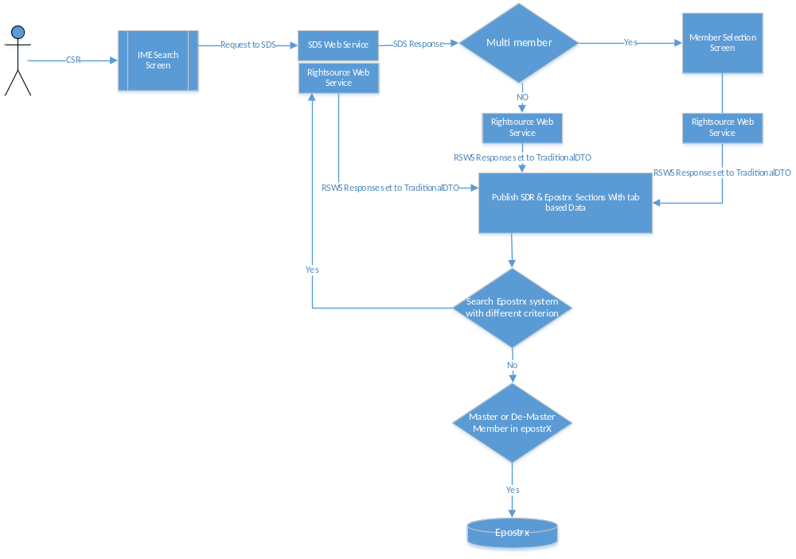

IME Application Architecture

The Layers which will be implemented in IME are as represented in the diagram below:

IME Application Architecture Diagram

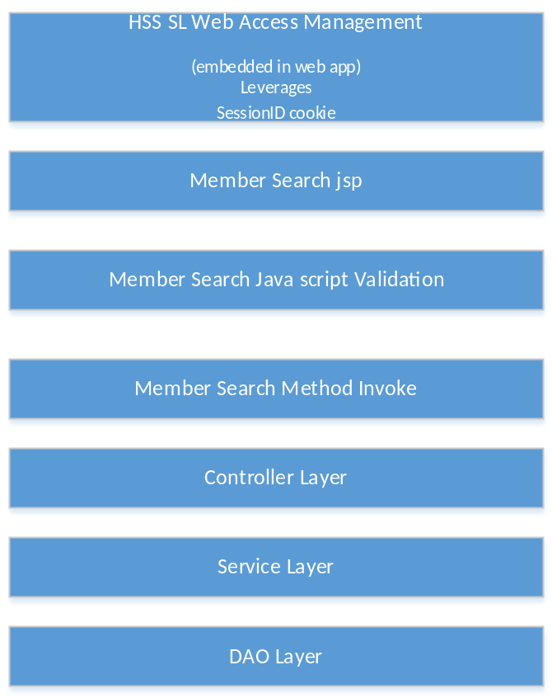

Person Mastering

Person Master Key set up

All active Epostrx members will be assigned with a Person Master Key and PSM is working on this process.

The new GUI is used to review common data between SDR and Epostrx and resolve any Person Master key discrepancy issues

GUI will have 2 sections for SDR and Epostrx with Multiple tabs.

Presentation (UI) Tier

MF2: GUI Search Functionality

IME GUI

User logs into hss Home page and as per the roles assigned to them, they will need to click Integrated Member Search link under Service operations section.

Intiail Search on SDR
Firstname, Lastname and DOB OR MemberID OR Medicareid

Initial search on Epostrx
Firstname, Lastname and DOB OR MemberID OR Medicareid

Subsequent searches on Epostrx
First Iteration – MemberID, DOB, First Name
Second Iteration – Medicare Id, DOB, First Name
Third Iteration – MemberID, DOB, Person Code
Fourth Iteration – Last Name, DOB , First Name
Fifth Iteration – Last Name, DOB , First Name, Home ZIP Code

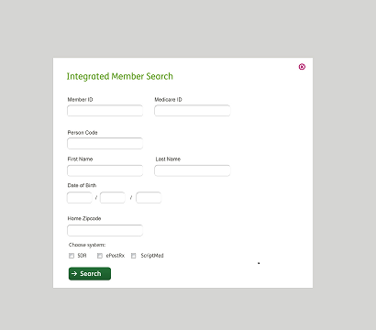

Presentation (UI) Tier

MF3: Search Results

- Search Results from SDR and Epostrx are published under 2 sections and common data from each system are aligned to a specific tab.
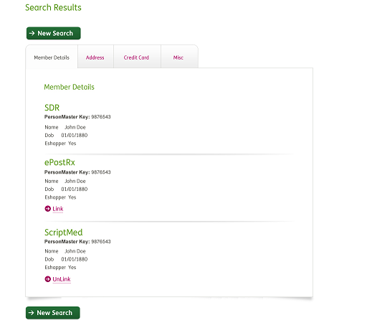

Technical information for UI

Integrated Member Search

Interface Type (Built)
Built

Ownership
Humana Pharmacy Systems

Description
The above screens will be used to search and identify PersonID discrepany between Humana Eligibilty and Humana Pharmacy systems.

Urls
Env | Url
Prod | http://hss.humana.com/RightSourceRxWebApp/Apps/MemberSearch.jsp?menuTempl=????&AKA_Name=Aka?????????
Qa | http://qa-hss.humana.com/RightSourceRxWebApp/Apps/MemberSearch.jsp?menuTempl=????&AKA_Name=Aka?????????
Test | http://test-hss.humana.com/RightSourceRxWebApp/Apps/MemberSearch.jsp?menuTempl=????&AKA_Name=Aka?????????

Method Called
MemberSearch

Required Inputs
- SL Session Id
- Akaname
- BusinessFunction

Output

When user eneters a Search criterion that input data is saved to SearchDTO which will be used to make calls to SDS and Epostrx services

SearchDTO
MemberID (String)
PersonCode (String)
MedicareID (String)
FirstName (String)
LastName (String)
DOB (String)
Zipcode (String)
SDRSystem (Boolean)
Traditional(Boolean)
Speciality(Boolean)

Method Called
IntegratedMember

Required Inputs
- SearchDTO

Output

If SDR fetches multiple members then publish multiple member selection list screen as follow

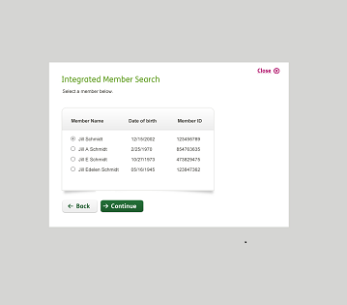

After selecting a specific member then that SDS response is saved to HumanEligibilityDTO and with that specific another call is made to epostrx and its response is saved to TraditionalMailDTO.

Following Jsp page will be published with HumanEligibilityDTO & TraditionalMailDTO object instantiated and set with SDR & Epostrx responses.

HumanEligibilityDTO
PersonID (String)
MemberID (String)
PersonCode (String)
MedicareID (String)
FirstName (String)
LastName (String)
DOB (String)
Zipcode (String)
WebEnrolled (String)
Addresses[]
CreditCards[]
Other TBD

TraditionalMailDTO
PersonID (String)
MemberID (String)
PersonCode (String)
MedicareID (String)
FirstName (String)
LastName (String)
DOB (String)
Zipcode (String)
Addresses[]
CreditCards[]
Other TBD

SL Session Management Web Service

Interface Type (Built or Consumed)
Consumed

Ownership
Enterprise Security Engineering

Description
This web service will be used to validate the incoming SL Session Id and return the associated Akaname and Port of origin.

Urls
Env | Url
Prod | https://slwebservices.humana.com:48022/SessionManagementWebService/SessionManagementWebService.asmx
Qa | https://qa-slwebservices.humana.com:48022/SessionManagementWebService/SessionManagementWebService.asmx
Test | http://test-slwebservices.humana.com/SessionManagementWebService/SessionManagementWebService.asmx

Method Called
GetAndExtendSessionEx

Required Inputs
- SL Session Id

Output

In the following screenshot, showing details of the object returned from GetAndExtendSessionEx, the pertinent fields are highlighted.
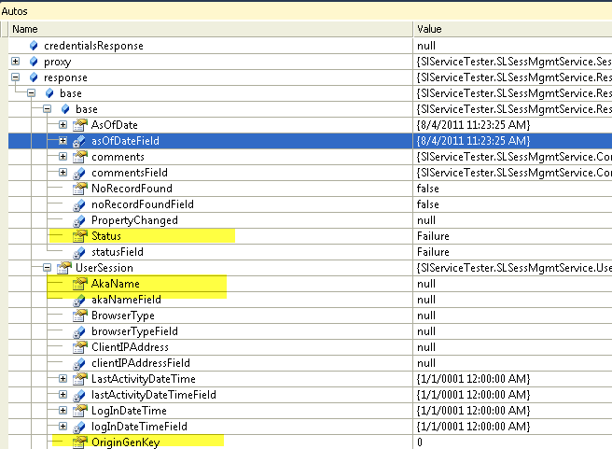

SL Access Control Driver Service

Interface Type (Built or Consumed)
Consumed

Ownership
Enterprise Security Engineering

Description
This web service will be used during the Secure Messenger SSO process to ensure that the user
Associated with the current session possesses the business function associated with the secure
messaging application.

Urls
Env | Url
Prod | https://slwebservices.humana.com:48022/AccessControlDriverWebService/AccessControlDriverWebService.asmx
Qa | https://qa-slwebservices.humana.com:48022/AccessControlDriverWebService/AccessControlDriverWebService.asmx
Test | https://test-slwebservices.humana.com/AccessControlDriverWebService/AccessControlDriverWebService.asmx

Method Called
IsUserAuthorizedEx,

Required Inputs
- Akaname – obtained from call to the session mgmt. web service.
- KeyType – value: “BusinessFunction”
- Key – value: business function for secure messaging. This value is specific to the origin gen key returned from the call to the session mgmt. web service.
- SL Session Id

Output

In the following screenshot, showing details of the object returned from IsUserAuthorizedEx, the pertinent value is highlighted. If ReplyFlag is true, then the user is assigned the business function and should be allowed in to Secure Messenger. Otherwise, they should be denied access.;

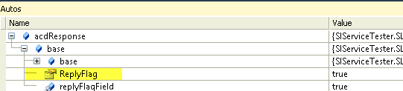

Method Called
GetUserFromAkaName

Required Inputs
- Akaname – obtained from call to the session mgmt. web service.

Output

Retrieves User ID for the given akaName

SDS Person and PersonPortfolio Services

Interface Type (Built or Consumed)
Consumed

Ownership
SDR

Description
This web service will be used to search Humana Insured members.

Protocol of the transmission
Need to use the Requested Member ID and Members date of birth to call 2 SDS web services, Person and PersonPortfolio. It returns the member demographics and the plan coverage.

Urls
Env | Url
Test | https://test-shareddata.enterpriseservices.humana.com:23185/PersonService/PersonService.svc
QA | https://qa-shareddata.enterpriseservices.humana.com:23185/PersonService/PersonService.svc
Prod | https://shareddata.enterpriseservices.humana.com:23185/PersonService/PersonService.svc

Method Called
MethodRead

Required Inputs
- MemberID – Humana Insured MemberID
or
- Member First name, Last name and DOB

Output

It will return the PersonId which is required for making call to PersonPortFolio service.

Description
This web service will be used search MemberDemographics using PersonID.

Urls
Env | Url
Test | https://test-shareddata.enterpriseservices.humana.com:23185/PersonPortfolio/PersonPortfolioService.svc
QA | https://qa-shareddata.enterpriseservices.humana.com:23185/PersonPortfolio/PersonPortfolioService.svc
Prod | https://shareddata.enterpriseservices.humana.com:23185/ PersonPortfolio/PersonPortfolioService.svc

Method Called
Need to be reviewed in HWS code

Required Inputs
- PersonID

Output

It returns member demographics and the plan coverage.

SSIS Package

Functional Validation
Define Success/Failure criteria here

- On First time search both SDR and Epostrx checkboxes should checked with read only
- First time search can be based on Member name & Dob or MemberID or MedicareID
- Subsequent searches should be only for epostrx

Process impact Assessment:

Interface Impact
New GUI

STM Configuration
No STM configurations are required for the current project.

RSRA(RightSource Reporting and Analysis team) impact
- None

Technical Specification
This section is meant for capturing the technology related aspects of the solution being proposed. This section is an optional section and is primarily meant for IT developers and Architects for articulating any technology related propositions as part of the design. If there is no paradigm shift in the technology usage, this section can remain blank.



Deployment Architecture
Any specific instructions to RightSource deployment team needs to be listed here. For example, Data Power configuration, Certificates, Any web server related instructions etc. need to be documented

Database Servers
Server (Production) | Database | Access
LOUSQLWPC81V01 | epostrx | DataReadwrite

Web Servers
The following table shows the application server names of ePostRx, Rightsource Webservices and Humana webservices:

ePostRx Production Servers:

BATCH | UI | INTERFACE (Core ANS services)
LOUAPPWPS514 | LOUAPPWPS515 | LOUAPPWPS522
LOUAPPWPS829 | LOUAPPWPS516 | LOUAPPWPS523
LOUAPPWPS850 | LOUAPPWPS517 | LOUAPPWPS524
LOUAPPWPS1122 | LOUAPPWPS518 | LOUAPPWPS525
LOUAPPWPS1123 | LOUAPPWPS519 | LOUAPPWPS526
 | LOUAPPWPS520 | LOUAPPWPS527
 | LOUAPPWPS521 | LOUAPPWPS528
 | LOUAPPWPS823 | LOUAPPWPS529
 | LOUAPPWPS824
 | LOUAPPWPS825
 | LOUAPPWPS826
 | LOUAPPWPS827
 | LOUAPPWPS828
 | LOUAPPWPS917
 | LOUAPPWPS918
 | LOUAPPWPS919
 | LOUAPPWPS930
 | LOUAPPWPS931
 | LOUAPPWPS932
 | LOUAPPWPS933

RightSource & Humana Web Services Production Servers:

- LOUWEBWPS171
- LOUWEBWPS172
- LOUWEBWPS173
- LOUWEBWPS213
- LOUWEBWPS214
- LOUWEBWPS215
- LOUWEBWPS216
- LOUWEBWPS271

Database Architecture
There are two databases used as below,
- ePostRx database
- ePostRx reporting database

Two Stor procs will be created one for subsequent searches of epostrx and other to update PersonMasterKey

MemberSearch SP

Select distinct Patient_num from patient_plans, patient_general, patient_address

With one of following predicates
Subsequent searches on Epostrx with following predicates
First Iteration – MemberID, DOB, First Name
Second Iteration – Medicare Id, DOB, First Name
Third Iteration – MemberID, DOB, Person Code
Fourth Iteration – Last Name, DOB , First Name
Fifth Iteration – Last Name, DOB , First Name, Home ZIP Code

A New Stor proc will be created for add or delete PersonID record from following tables

Operation Char(1)
PatientKey Int
PersonKey Int
UserID Char(7)
SourceName Char(3)

Declare @UserNum int
Declare @SystemNum int

@UserNum = select nullif(sys_user_num,1) from system_users with (nolock) where sys_user_login = @UserID

@SystemNum = select nullif(origination_num,20) from originations with (nolock) where origination_desc like ‘@SourceName%’

Case
When Operation = ‘I’
Insert into DBO.person_cross_reference values

(@PersonKey,@PatientKey,getdate(),@UserNum,@SystemNum)
PUBLISH SELECT STATEMENT

When Operation = ‘D’
Insert into LOGS.person_cross_reference from DBO.person_cross_reference table
PUBLISH SELECT STATEMENT

When Operation = ‘S’
SELECT from DBO.person_cross_reference table

Result set must continue following columns for Java to validate and Publsih for UI or web services
(@PersonKey
,@PatientKey
,@Operation

Two tables will be created to store key assignments, and history. The active key associations will be stored in the new table dbo.person. When records are updated or deleted in dbo.person, the prior state of the row will be written to a logging table called logs.person_log for completeness. Inserts will not be logged to avoid redundancy.

dbo.person_cross_reference

Column | Definition | Description
PersonID | bigint not null | Primary key from the Humana Shared Data Repository (SDR)
patient_num | numeric(20,0) not null | Primary key from epostrx.dbo.patient_general
updated | datetime2 not null | The date and time the record was inserted or last updated
update_user_num | numeric not null | A reference to the dbo.system_users table identifying the user that executed the update
update_origination_num | numeric(5,0) not null  references [origination_num] in dbo.originations | A reference to the dbo.originations table, specifying which system originated the update request.

Constraint | Type | Columns
PK_person(PersonID,patient_num) | Primary key | (PersonID,patient_num)
UQ_person(PersonID) | Unique | PersonID
UQ_person(patient_num) | Unique | patient_num

logs.person_cross_reference

Column | Definition | Description
log_id | bigint identity  primary key | Auto incrementing integer primary key
log_datetime | datetime2  not null  default getdate() | Date and time the log entry was created
PersonID | bigint  not null | Primary key from the Humana Shared Data Repository (SDR)
patient_num | numeric(20,0) not null | Primary key from epostrx.dbo.patient_general
sys_user_num | Numeric(16,0) not null | A reference to the dbo.system_users table identifying the user that executed the update
origination_num | Numeric(5,0) not null | A reference to the dbo.originations table, specifying which system originated the update request.

Network Architecture
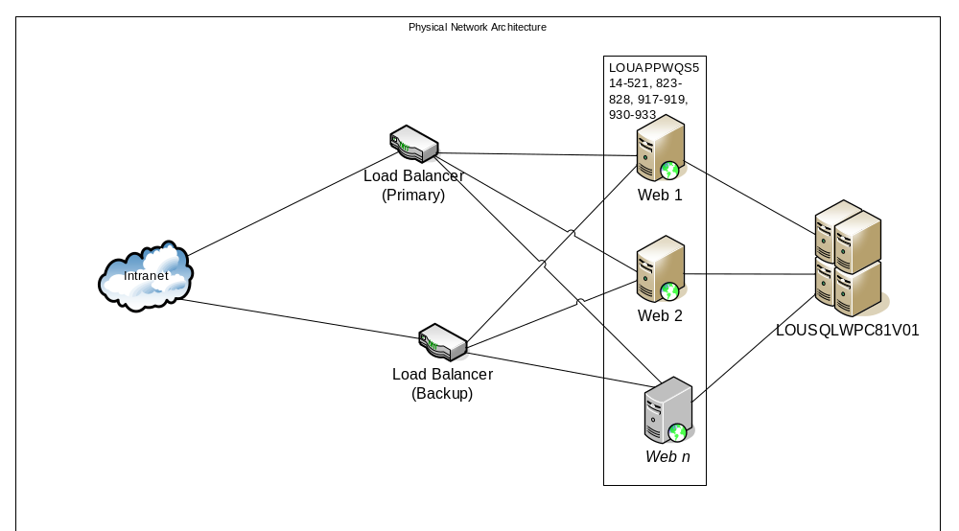

Security Architecture
Below diagram shows the security features of ePostRx application.

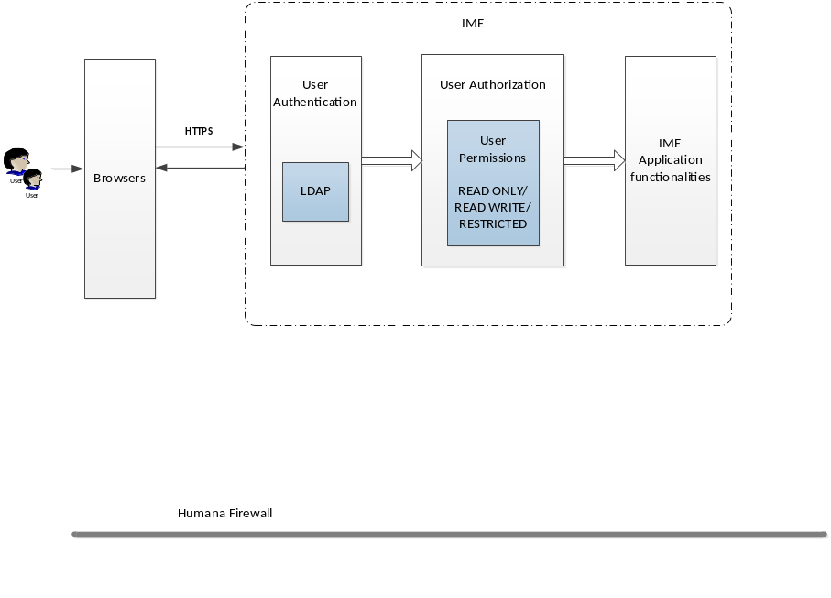

HTTP Secure (HTTPS):
Transactions to and from ePostRx application are done using HTTPS. ePostRx uses security certificate which validates if the requests come from HTTP/HTTPS. Corporate security standards are applicable and implemented as relevant throughout the application.
Lightweight Directory Access Protocol (LDAP):
User authentication for IME application is done through SL.
User Permissions:
Authorization is handled by validating the Permissions which are set by Web Security with new Business Functions. Throughout the application each request from user is authorized by validating the permissions which were set. There are 2 levels of Permissions,
- READ ONLY
- READ WRITE
File Transfer Protocol (FTP):
None

