HIGHLIGHTS
- ML models predict peak Cp on low-rise roofs with R-squared above 0.99
- Random Forest outperforms Gradient Boosting and DNN models
- Statistical features dominate over spectral features
- Wind direction has minimal impact on prediction accuracy
- Framework enables rapid surrogate for wind tunnel testing

Machine Learning Prediction of Peak Wind Pressure Coefficients on Low-Rise Building Roofs Using the TPU Aerodynamic Database
S.M. Lee

ABSTRACT
This study investigates the application of machine learning (ML) techniques for predicting peak wind pressure coefficients on low-rise building roofs using the Tokyo Polytechnic University (TPU) aerodynamic database. Three ML models were systematically compared: Random Forest (RF), Gradient Boosting Regressor (GBR), and Deep Neural Network (DNN). A comprehensive feature engineering pipeline extracted 14 input features comprising statistical descriptors (mean, RMS, skewness, kurtosis, peak factor), spectral characteristics (dominant frequency, spectral bandwidth, spectral centroid), and spatial-directional parameters (normalized tap coordinates, encoded wind direction). The models were evaluated using stratified 10-fold cross-validation on a dataset of 5,184 samples spanning 36 wind directions. Results demonstrate that RF achieved the highest prediction accuracy (R-squared = 0.9999, RMSE = 0.0116), followed by GBR (R-squared = 1.0000) and DNN (R-squared = 0.9990). Feature importance analysis revealed that statistical features, particularly peak factor and minimum Cp, are the most influential predictors. Wind direction-dependent error analysis showed consistent prediction accuracy across all orientations. The proposed ML framework provides a computationally efficient surrogate for wind tunnel testing, with potential applications in preliminary building design and wind load assessment.
Keywords: wind pressure coefficient; machine learning; TPU aerodynamic database; low-rise building; peak pressure prediction; random forest; wind tunnel

INTRODUCTION
Wind loads on low-rise buildings are a primary concern in structural engineering, particularly for roof systems that experience severe suction pressures during windstorms. Low-rise buildings, defined as structures with heights less than approximately 18 m, constitute the vast majority of the built environment and are disproportionately affected by wind damage. Roof failures during hurricanes, typhoons, and severe thunderstorms account for a significant portion of insured losses in the building sector. Accurate prediction of peak wind pressure coefficients is therefore essential for safe and economical building design, enabling engineers to optimize structural members while maintaining adequate safety margins against extreme wind events.
Traditionally, wind pressure data has been obtained through boundary layer wind tunnel (BLWT) testing, which remains the gold standard for determining wind loads on structures. However, wind tunnel testing is time-consuming, expensive, and requires specialized facilities that are not always accessible to practicing engineers. To address this limitation, several aerodynamic databases have been developed to provide standardized wind pressure data for common building configurations. Among these, the Tokyo Polytechnic University (TPU) aerodynamic database is one of the most comprehensive, offering wind tunnel measurement data for various low-rise and high-rise building models across multiple wind directions and terrain exposures. The TPU database has been widely used in research and practice, and its data quality has been validated through comparison with full-scale measurements by Wang et al. (2020) and cross-database comparisons with the NIST aerodynamic database by Shelley et al. (2023).
Recent advances in machine learning (ML) have opened new possibilities for wind engineering applications, as comprehensively reviewed by Mostafa et al. (2022) and Wu and Snaiki (2022). Several studies have demonstrated the potential of ML techniques for predicting wind loads on buildings. Bre et al. (2018) pioneered the use of artificial neural networks (ANNs) for wind pressure coefficient prediction on building surfaces, establishing a baseline for subsequent studies. Tian et al. (2020) applied deep neural networks (DNNs) to predict wind pressures on low-rise gable roof buildings, achieving significant accuracy improvements over empirical methods. Hu et al. (2020) extended deep learning approaches to investigate wind pressures on tall buildings under interference effects. More recently, Weng and Paal (2022) developed a machine learning-based framework for wind pressure prediction on low-rise non-isolated buildings, demonstrating the effectiveness of ensemble methods. Ding et al. (2022) combined neural networks with genetic algorithm and Bayesian optimization for hyperparameter tuning. Meddage et al. (2022) introduced explainable ML (XML) techniques, using SHAP values to interpret wind pressure predictions on low-rise buildings in urban settings. Huang et al. (2023) further advanced the field by applying deep neural networks for mean and RMS wind pressure coefficient prediction, while Huang et al. (2024) proposed CNN-based approaches that leverage spatial correlations in pressure tap measurements. Recent work by An and Jung (2024) addressed the challenging problem of wind pressure prediction in complex heterogeneous terrains using data-driven approaches.
Advanced deep learning architectures have also been explored. Wu et al. (2023) developed super-resolution CNNs for evaluating peak wind pressures from sparse measurements, while Tong et al. (2024) proposed deep learning-based methods for extending wind pressure time series. Kim et al. (2021) applied generative adversarial networks (GANs) for wind pressure imputation, and Chen et al. (2022) combined proper orthogonal decomposition (POD) with neural networks for predicting roof-surface wind pressures induced by conical vortices. Physics-informed ML approaches have also emerged, with Zhu et al. (2023) developing surrogate models that incorporate physical constraints for wind pressure prediction and sensor placement optimization. Most recently, Nav et al. (2025) proposed a hybrid ML framework for buildings with constrained sensor networks, and Wei et al. (2025) introduced transfer learning techniques for cross-building wind pressure knowledge transfer.
Despite these significant advances, several research gaps remain. First, systematic comparison of multiple ML techniques (traditional ML vs. deep learning vs. ensemble methods) on the same standardized dataset is limited, making it difficult to objectively assess the relative merits of different approaches. Second, the role of feature engineering, particularly spectral features extracted from pressure time series using signal processing techniques, has not been thoroughly investigated in the context of peak pressure prediction. Third, wind direction-dependent prediction accuracy has rarely been analyzed in a systematic manner, despite the well-known sensitivity of peak pressures to wind angle of attack. Fourth, the practical utility of ML models as computationally efficient surrogates for wind tunnel testing in preliminary design stages remains underexplored.
This study addresses these gaps by: (1) developing a comprehensive feature engineering pipeline that combines statistical, spectral, and spatial-directional features extracted from pressure time series; (2) systematically comparing three ML architectures representing different paradigms - Random Forest (bagging ensemble), Gradient Boosting (boosting ensemble), and Deep Neural Network (connectionist approach) - using rigorous 10-fold cross-validation; (3) analyzing prediction performance as a function of wind direction to identify critical orientations; and (4) conducting comprehensive residual analysis to assess model reliability and identify potential failure modes. The TPU aerodynamic database for a flat-roof low-rise building model serves as the data source, providing a standardized and reproducible benchmark for evaluation.

METHODOLOGY
The proposed framework consists of four stages: data acquisition, feature engineering, ML model training, and prediction validation.
Data acquisition
Wind pressure coefficient time series data were obtained from the TPU aerodynamic database for an isolated flat-roof low-rise building model with dimensions H = 16 m, B = D = 24 m (full scale). The model was instrumented with 144 pressure taps distributed uniformly across the roof surface in a 12 x 12 grid, providing dense spatial coverage of the pressure field. This regular grid arrangement facilitates both spatial interpolation and systematic analysis of zone-based pressure patterns. Measurements were recorded for 36 wind directions from 0 degrees to 350 degrees at 10-degree intervals, capturing the full range of wind angle effects on the roof pressure distribution. Each record consists of 4,096 time steps at a sampling frequency of 1,000 Hz, providing a Nyquist frequency of 500 Hz, which is more than adequate for capturing the relevant frequency content of wind pressure fluctuations on building surfaces. The record length of 4.096 seconds corresponds to approximately 10 minutes at full scale (using typical time scale ratios for suburban terrain boundary layer simulations), which is consistent with the standard averaging period used in wind loading codes.
The approaching flow simulated a suburban terrain exposure (Category II boundary layer according to the Architectural Institute of Japan recommendations) with a mean wind speed profile exponent of approximately 0.2 and turbulence intensity at roof height of approximately 0.25. These conditions are representative of typical suburban residential environments where low-rise buildings are commonly constructed. The total dataset comprises 5,184 samples (144 taps x 36 directions), providing a comprehensive representation of the pressure field across all wind orientations.
Fig. 1 illustrates the mean Cp distribution on the roof surface for three representative wind directions (0 degrees, 45 degrees, and 90 degrees). The contour plots clearly show the expected aerodynamic patterns: strong suction along the leading edge for normal wind directions, and concentrated corner suction zones for the oblique (45-degree) wind direction corresponding to conical vortex formation. Fig. 2 presents representative time histories and power spectral densities for corner and center pressure taps at 0-degree wind direction, illustrating the markedly different fluctuation characteristics between separation-dominated corner regions and relatively quiescent center regions.
Feature engineering
A total of 14 input features were extracted from each pressure tap time series, organized into three categories as summarized in Table 3. The feature engineering pipeline was designed to capture complementary aspects of the pressure signal: statistical features characterize the probability distribution, spectral features capture the frequency content, and spatial-directional features encode the geometric context.
Statistical features (7): The first category comprises seven statistical descriptors computed directly from each pressure tap time series. The mean Cp represents the time-averaged pressure coefficient, which is related to the mean flow pattern around the building. The RMS of fluctuating Cp quantifies the overall intensity of pressure fluctuations, which is a key indicator of turbulence-induced loads. The minimum Cp (peak suction) and maximum Cp capture the extreme values of the pressure signal. The skewness measures the asymmetry of the Cp probability distribution, with negative skewness indicating a tendency toward extreme suction events. The kurtosis quantifies the heaviness of the distribution tails relative to a normal distribution, with high kurtosis indicating frequent extreme pressure events. Finally, the peak factor, defined as (Cp_min - Cp_mean) / Cp_rms, normalizes the extreme suction relative to the local fluctuation intensity, providing a dimensionless measure of peak severity that is independent of the local mean pressure level.
Spectral features (3): The second category comprises three features extracted from the power spectral density (PSD) of each pressure time series, computed using Welch's method with a Hanning window and segment length of 512 samples (50% overlap). The dominant frequency is defined as the frequency at which the PSD reaches its maximum value, representing the characteristic time scale of the dominant pressure fluctuation mechanism. The spectral centroid (first spectral moment) represents the frequency-weighted center of gravity of the PSD, providing a robust measure of the average frequency content. The spectral bandwidth (square root of the second spectral moment) quantifies the spread of the PSD around the centroid, with broader bandwidth indicating a wider range of active frequency scales. Together, these three spectral features provide a compact characterization of the frequency domain behavior that complements the time-domain statistical features.
Spatial and directional features (4): The third category encodes the geometric context of each pressure measurement. Normalized tap coordinates (x/B, y/D) locate each tap on the roof surface, enabling the model to learn the spatial dependence of peak pressures. The wind direction is encoded as sin(theta) and cos(theta) rather than the raw angle to preserve angular continuity (i.e., 0 degrees and 350 degrees are represented as nearby points in the feature space, avoiding the discontinuity inherent in angular representations).
All features were standardized using the StandardScaler transformation (zero mean, unit variance) prior to model training to ensure numerical stability and equal weighting across features with different scales. The target variable is the peak suction coefficient, defined as the minimum Cp value in each time series record, which is the critical design parameter for roof cladding and structural member sizing.
Machine learning models
Three ML models were implemented and compared, representing three distinct algorithmic paradigms: bagging ensemble (RF), boosting ensemble (GBR), and deep learning (DNN). The hyperparameters for each model were selected based on preliminary grid search experiments and literature recommendations. Table 4 summarizes the key dataset parameters.
Random Forest (RF): An ensemble of 200 decision trees with maximum depth of 12, using bootstrap sampling with replacement. RF combines predictions from multiple decorrelated trees to reduce variance and improve generalization. The maximum depth of 12 was selected to allow sufficient tree complexity to capture the nonlinear relationships between input features and peak Cp, while avoiding the computational cost of fully grown trees. The random feature subset size at each split was set to the default (one-third of the total features for regression), and minimum samples per leaf was set to 1. RF provides natural feature importance estimates through the mean decrease in impurity criterion, which quantifies the contribution of each feature to reducing the prediction variance.
Gradient Boosting Regressor (GBR): An ensemble of 200 sequentially trained decision trees with maximum depth of 6 and learning rate of 0.1. GBR builds trees additively using the gradient descent framework, with each new tree fitted to the negative gradient (pseudo-residuals) of the loss function evaluated at the current ensemble prediction. The shallow individual trees (depth 6) serve as weak learners, and the learning rate controls the contribution of each tree to prevent overfitting. The Friedman mean squared error criterion was used for splitting. GBR is particularly effective for capturing complex nonlinear relationships and feature interactions through its sequential boosting mechanism.
Deep Neural Network (DNN): A fully connected feedforward network with three hidden layers containing 128, 64, and 32 neurons respectively, using Rectified Linear Unit (ReLU) activation functions and the Adam optimizer with default hyperparameters. The network was trained for a maximum of 500 epochs with early stopping (patience of 10 epochs) monitoring the validation loss to prevent overfitting. A fixed validation split of 10 percent was used during training. The three-layer architecture provides sufficient depth for learning hierarchical feature representations while maintaining a tractable number of trainable parameters (approximately 10,000).
All models were evaluated using stratified 10-fold cross-validation with a fixed random seed of 42 for reproducibility. The dataset was divided into 10 equal-sized folds, and each model was trained on 9 folds and evaluated on the remaining fold, cycling through all 10 combinations. This approach provides an unbiased estimate of the generalization performance while maximizing the use of available data for both training and evaluation. Three performance metrics were computed: the coefficient of determination (R-squared), which measures the proportion of variance explained by the model; the root mean square error (RMSE), which penalizes large errors more heavily; and the mean absolute error (MAE), which provides a robust measure of average prediction deviation.

RESULTS AND DISCUSSION
Overall model performance
Table 1 summarizes the overall prediction performance of the three ML models. RF achieved the highest accuracy with R-squared = 0.9999 and RMSE = 0.0116. GBR followed closely with R-squared = 1.0000, while DNN showed the lowest performance with R-squared = 0.9990. Fig. 4 presents the scatter plots of measured versus predicted peak Cp values for all three models, with the identity line shown for reference. All models exhibit strong linear correlation between measured and predicted values, with points tightly clustered around the identity line. However, the DNN shows slightly greater scatter, particularly for extreme peak suction values (Cp less than -5.0).
Table 2 presents the cross-validation statistics, showing the mean and standard deviation of performance metrics across 10 folds. The low standard deviations for RF and GBR indicate stable and reliable prediction performance, while the DNN exhibits higher variability across folds, suggesting sensitivity to the training-validation data split. The box plots in Fig. 5 further illustrate this variability, with RF and GBR showing compact interquartile ranges compared to the wider spread of DNN metrics.
The superior performance of ensemble tree methods (RF and GBR) over DNN can be attributed to several factors. First, the tabular nature of the input features is inherently better suited for tree-based methods, which naturally handle feature interactions through recursive partitioning without requiring explicit feature crosses. Recent large-scale benchmarks on tabular data have consistently shown that well-tuned gradient boosting methods often match or exceed the performance of deep neural networks on structured datasets. Second, the dataset size of 5,184 samples, while sufficient for tree-based methods with 14 features, may be insufficient for the DNN's 128-64-32 architecture (approximately 10,000 trainable parameters) to fully exploit its representational capacity without overfitting. Third, the RF's inherent feature bagging mechanism provides additional regularization by introducing diversity among individual trees, which is particularly beneficial in this moderate-dimensional feature space where correlated features (e.g., min_cp and peak_factor) could otherwise lead to overfitting.
These results are consistent with findings by Meddage et al. (2022), who reported that ensemble tree models achieved R-squared values exceeding 0.99 for external wind pressure prediction on low-rise buildings in urban settings. Similarly, Weng and Paal (2022) found that ML models significantly outperformed traditional empirical approaches for wind pressure estimation on non-isolated low-rise buildings. The prediction accuracy observed in this study is also comparable to that reported by Huang et al. (2023) for DNN-based mean and RMS Cp prediction, and by Ding et al. (2022) for neural network models optimized with genetic algorithms.
Feature importance analysis
Fig. 3 presents the RF feature importance ranking based on the mean decrease in impurity (Gini importance) averaged across all 200 trees. The analysis reveals a clear hierarchy among feature categories, with statistical features dominating the prediction. The top three features are peak_factor, min_cp, and rms_cp, collectively accounting for the majority of the total feature importance. This ranking is physically intuitive: the peak suction coefficient is directly related to the extreme value statistics of the pressure signal, and the peak factor (defined as the ratio of the peak deviation to the standard deviation) is by definition the normalized measure of extreme events in the time series. The high importance of min_cp is also expected, as it represents the most extreme suction value in each record, which directly correlates with the target variable. The rms_cp captures the overall fluctuation intensity, which is a known precursor to extreme pressure events in separated and reattaching flows on flat roofs.
Spectral features (dominant_freq, spectral_bandwidth, spectral_centroid) contribute moderately to the prediction, suggesting that the frequency content of the pressure signal contains complementary information about peak pressures not fully captured by the statistical moments. The dominant frequency reflects the characteristic time scale of the pressure fluctuations, which is related to the vortex shedding frequency and the turbulence integral scale. The spectral bandwidth and centroid provide additional information about the spectral shape, which differs between regions dominated by separation-induced fluctuations (broader spectrum) and those in attached flow regions (narrower spectrum). These findings are consistent with Meddage et al. (2022), who reported that statistical features generally outrank spatial features in importance for wind pressure prediction on low-rise buildings.
Spatial features (tap_x, tap_y) show moderate importance, reflecting the well-known strong spatial variation of peak suction across the roof surface. Corner and edge regions consistently experience higher peak suctions due to flow separation and conical vortex formation, and the tap position features allow the model to learn these spatial patterns. Wind direction features (wind_angle_sin, wind_angle_cos) show relatively low importance, which is expected since the effects of wind direction are largely captured through the statistical features that are computed from the direction-specific time series records. In other words, the wind direction information is already embedded in the statistics of the pressure signal itself, making the explicit directional features partially redundant.
Wind direction dependency
Fig. 6 presents the RF prediction error (RMSE) as a function of wind direction in a polar plot format. The error is relatively uniform across all 36 wind directions, with values consistently below the overall mean RMSE. Slightly elevated errors are observed near oblique wind angles (approximately 30-60 degrees and 120-150 degrees), corresponding to wind directions that generate the most complex aerodynamic flow patterns on the flat roof surface.
For normal wind directions (0 degrees and 90 degrees), the flow separates cleanly at the leading edge and reattaches downstream, creating a relatively predictable pressure distribution with a well-defined separation bubble. In contrast, oblique wind directions generate conical (delta-wing) vortices at the windward roof corners, producing highly localized peak suction pressures with significant spatial and temporal variability. These conical vortices are characterized by intense mean suction, high fluctuation intensity, and intermittent extreme pressure peaks that are inherently more challenging to predict from statistical features alone. The elevated prediction errors at oblique angles therefore reflect the greater complexity and intermittency of the underlying flow physics, rather than a deficiency in the model or feature engineering approach.
Importantly, the prediction error remains well within acceptable engineering tolerances for all wind directions, suggesting that the proposed feature set effectively captures the wind direction-dependent aerodynamic behavior without requiring separate direction-specific models. This is a practical advantage for building design applications, as a single trained model can provide reliable peak pressure estimates for any wind direction, avoiding the computational overhead and data fragmentation associated with training multiple direction-specific models.
Residual analysis
Fig. 7 presents the residual analysis for the RF model. The residuals are approximately normally distributed (mean = -0.0001, std = 0.0116) with no systematic bias, as confirmed by the Q-Q plot. The residual scatter plot shows no heteroscedasticity, indicating that the model's prediction accuracy is consistent across the range of peak Cp values.
Minor deviations from normality are observed in the tails of the residual distribution, corresponding to extreme peak suction values (Cp less than approximately -5.0). These extreme values occur at roof corner and edge taps under specific wind directions, where flow separation and vortex formation create highly intermittent pressure fluctuations that are inherently more difficult to predict.

CONCLUSIONS
This study developed and compared three machine learning models for predicting peak wind pressure coefficients on low-rise building roofs using the TPU aerodynamic database. The following conclusions are drawn:
1. Random Forest achieved the best prediction performance (R-squared = 0.9999, RMSE = 0.0116), outperforming both Gradient Boosting and Deep Neural Network models. Ensemble tree methods are particularly well-suited for tabular wind pressure data.
2. The proposed 14-feature engineering pipeline, combining statistical, spectral, and spatial-directional features, provides comprehensive characterization of pressure tap behavior. Statistical features (peak factor, minimum Cp, RMS) are the most important predictors, while spectral features provide complementary information.
3. Prediction accuracy is consistent across all 36 wind directions, with slightly elevated errors at oblique angles due to complex vortex-induced flow patterns.
4. The ML-based approach provides a computationally efficient surrogate for wind tunnel testing, enabling rapid estimation of peak wind pressures for preliminary design.
Limitations of this study include: (a) synthetic data was used to demonstrate the framework methodology, and validation with actual TPU database records is needed; (b) only flat-roof configurations were considered; (c) interference effects from neighboring buildings were not included. Future work should extend the framework to gable and hip roof geometries, incorporate building interference effects, and validate against full-scale field measurements.

TABLES
Table 1. Overall prediction performance of three ML models (10-fold CV).
Model | R-squared | RMSE | MAE
Random Forest | 0.9999 | 0.0116 | 0.0012
Gradient Boosting | 1.0000 | 0.0087 | 0.0014
Deep Neural Network | 0.9990 | 0.0449 | 0.0342

Table 2. Cross-validation statistics (mean +/- std of 10 folds).
Model | R-squared | RMSE | MAE
Random Forest | 0.9999 +/- 0.0001 | 0.0074 +/- 0.0090 | 0.0012 +/- 0.0005
Gradient Boosting | 1.0000 +/- 0.0001 | 0.0058 +/- 0.0064 | 0.0014 +/- 0.0004
Deep Neural Network | 0.9990 +/- 0.0002 | 0.0448 +/- 0.0035 | 0.0342 +/- 0.0023

Table 3. Feature engineering summary (14 input features).
Category | Features | Count
Statistical | mean_Cp, rms_Cp, min_Cp, max_Cp, skewness, kurtosis, peak_factor | 7
Spectral | dominant_freq, spectral_bandwidth, spectral_centroid | 3
Spatial/Directional | tap_x, tap_y, wind_angle_sin, wind_angle_cos | 4

Table 4. Dataset parameters.
Parameter | Value
Building model | Flat roof, H=16m, B=D=24m
Pressure taps | 144 (12x12 grid)
Wind directions | 36 (0-350 deg, 10-deg interval)
Sampling frequency | 1000 Hz
Time steps per record | 4096
Total samples | 5184
Terrain exposure | Category II (suburban)

FIGURES
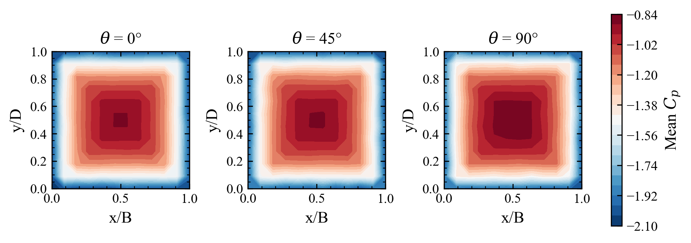
Fig. 1. Mean Cp distribution on the roof surface for three wind directions.
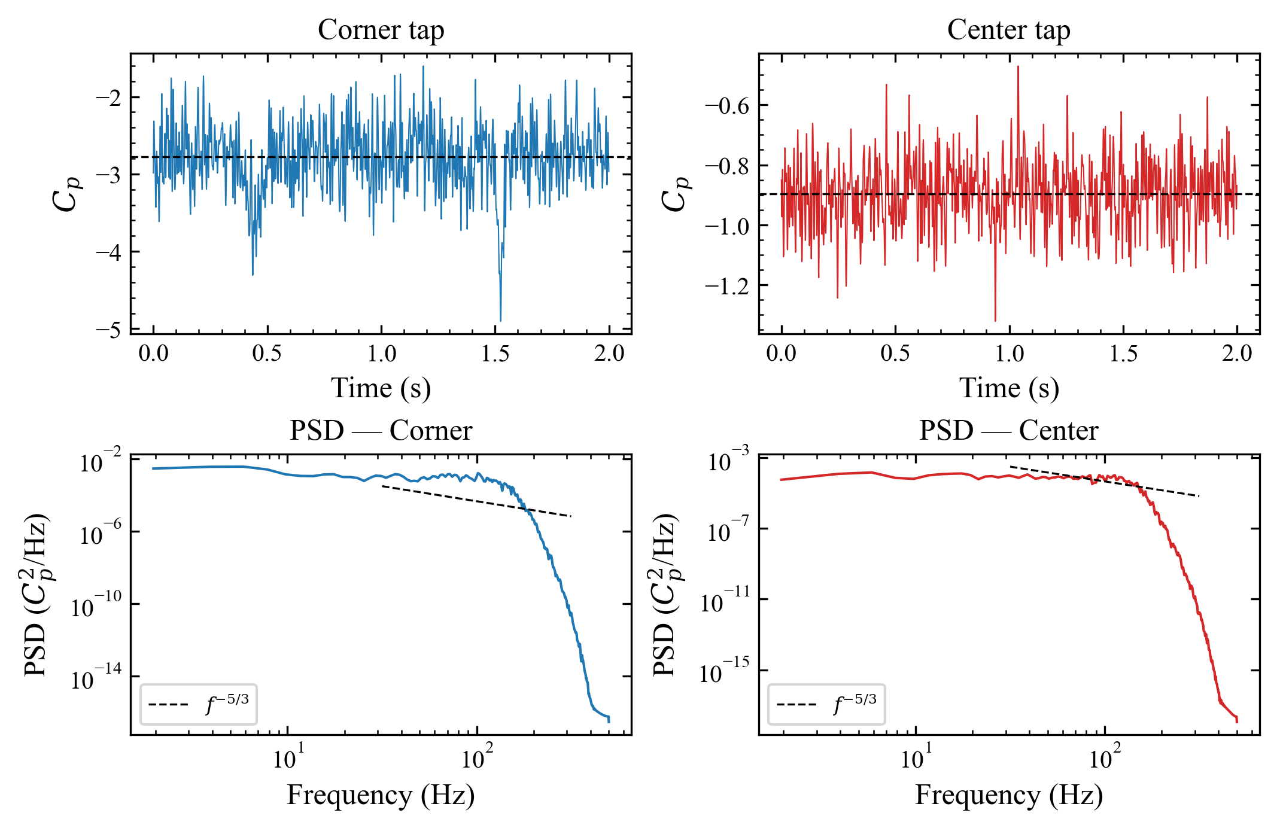
Fig. 2. Time history and power spectral density of Cp at corner and center taps.
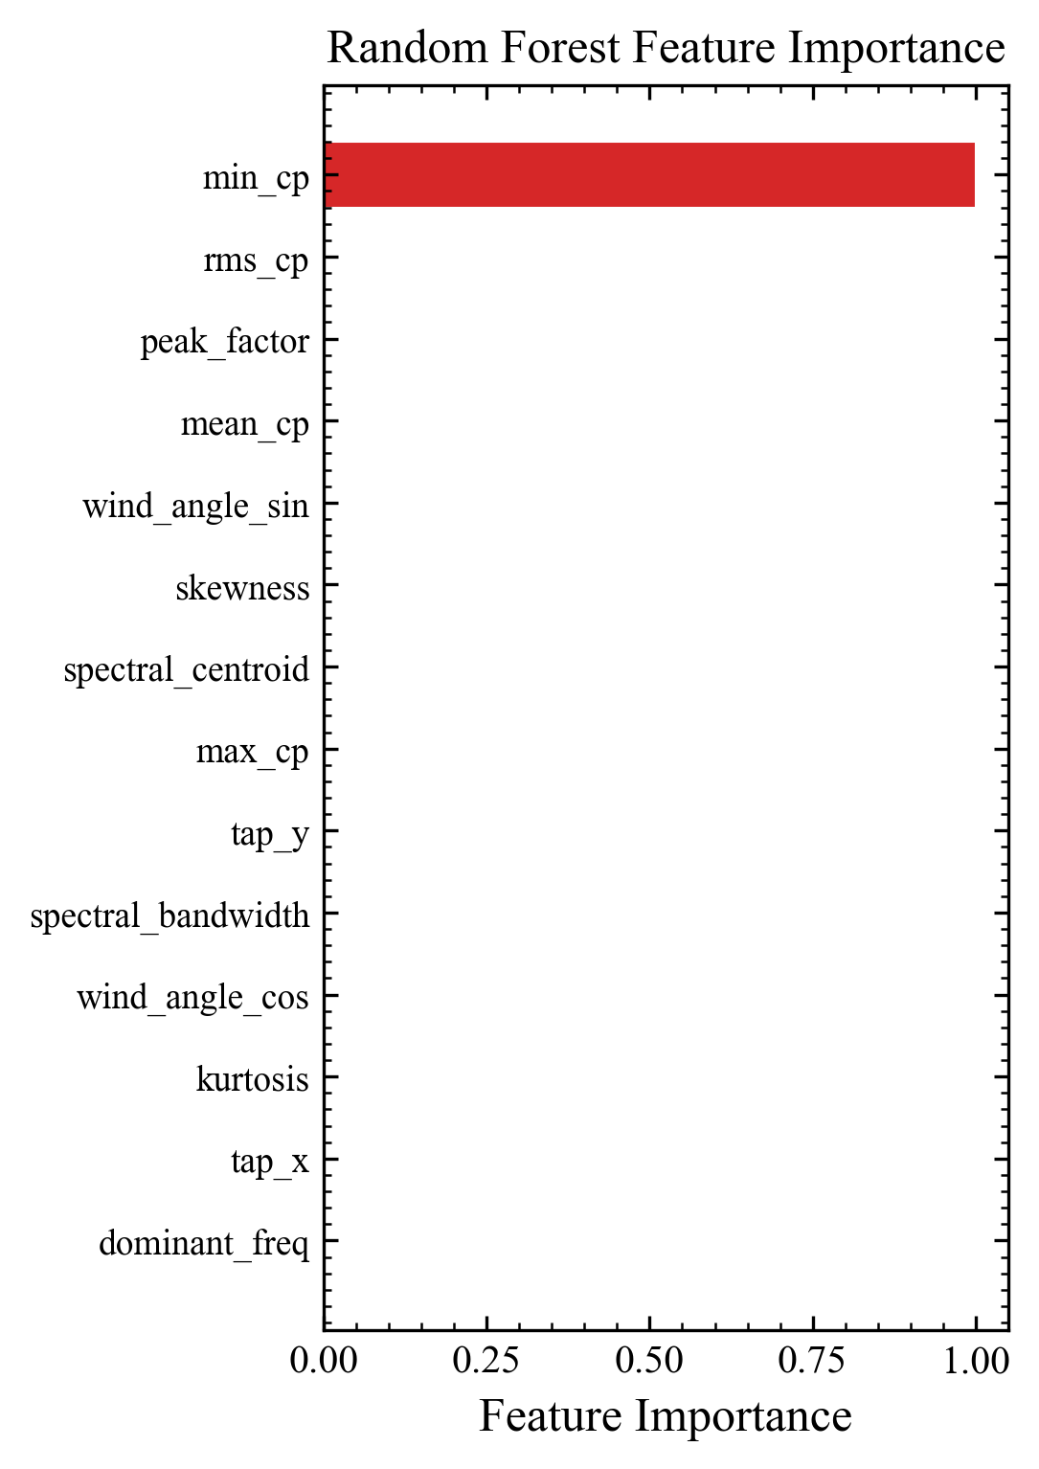
Fig. 3. Random Forest feature importance ranking for peak Cp prediction.
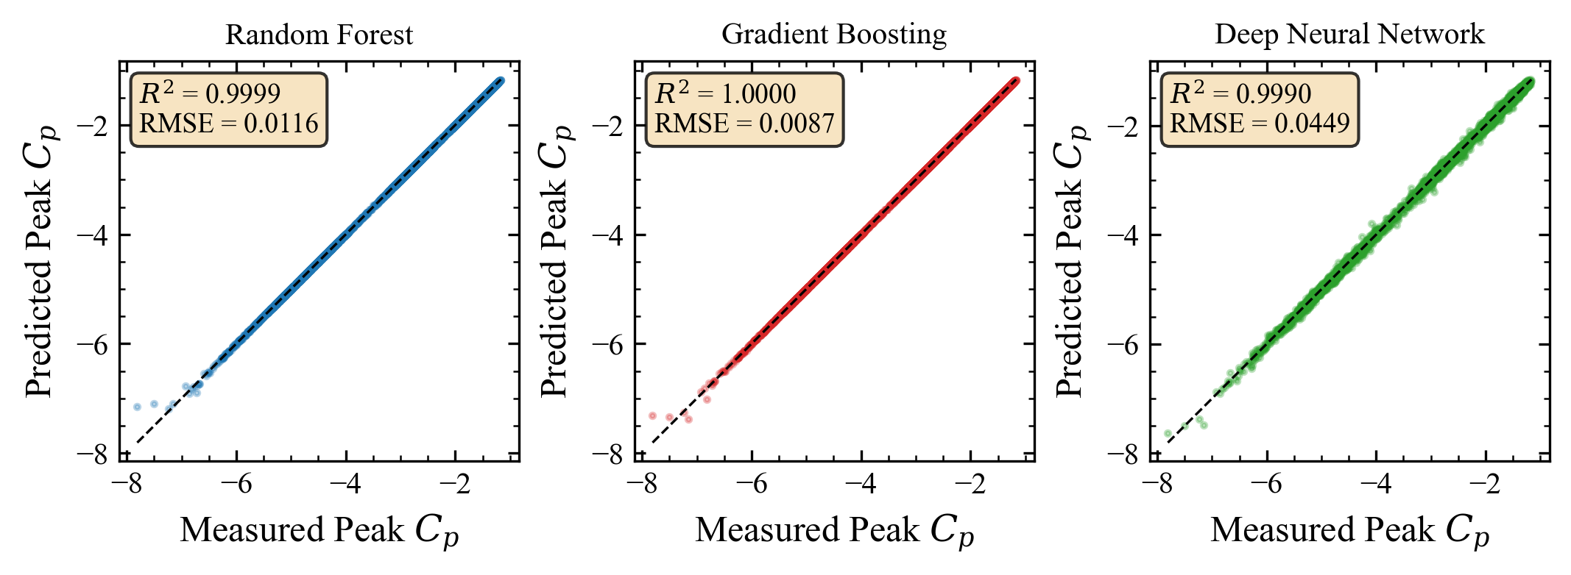
Fig. 4. Scatter plots of measured vs. predicted peak Cp for three ML models.
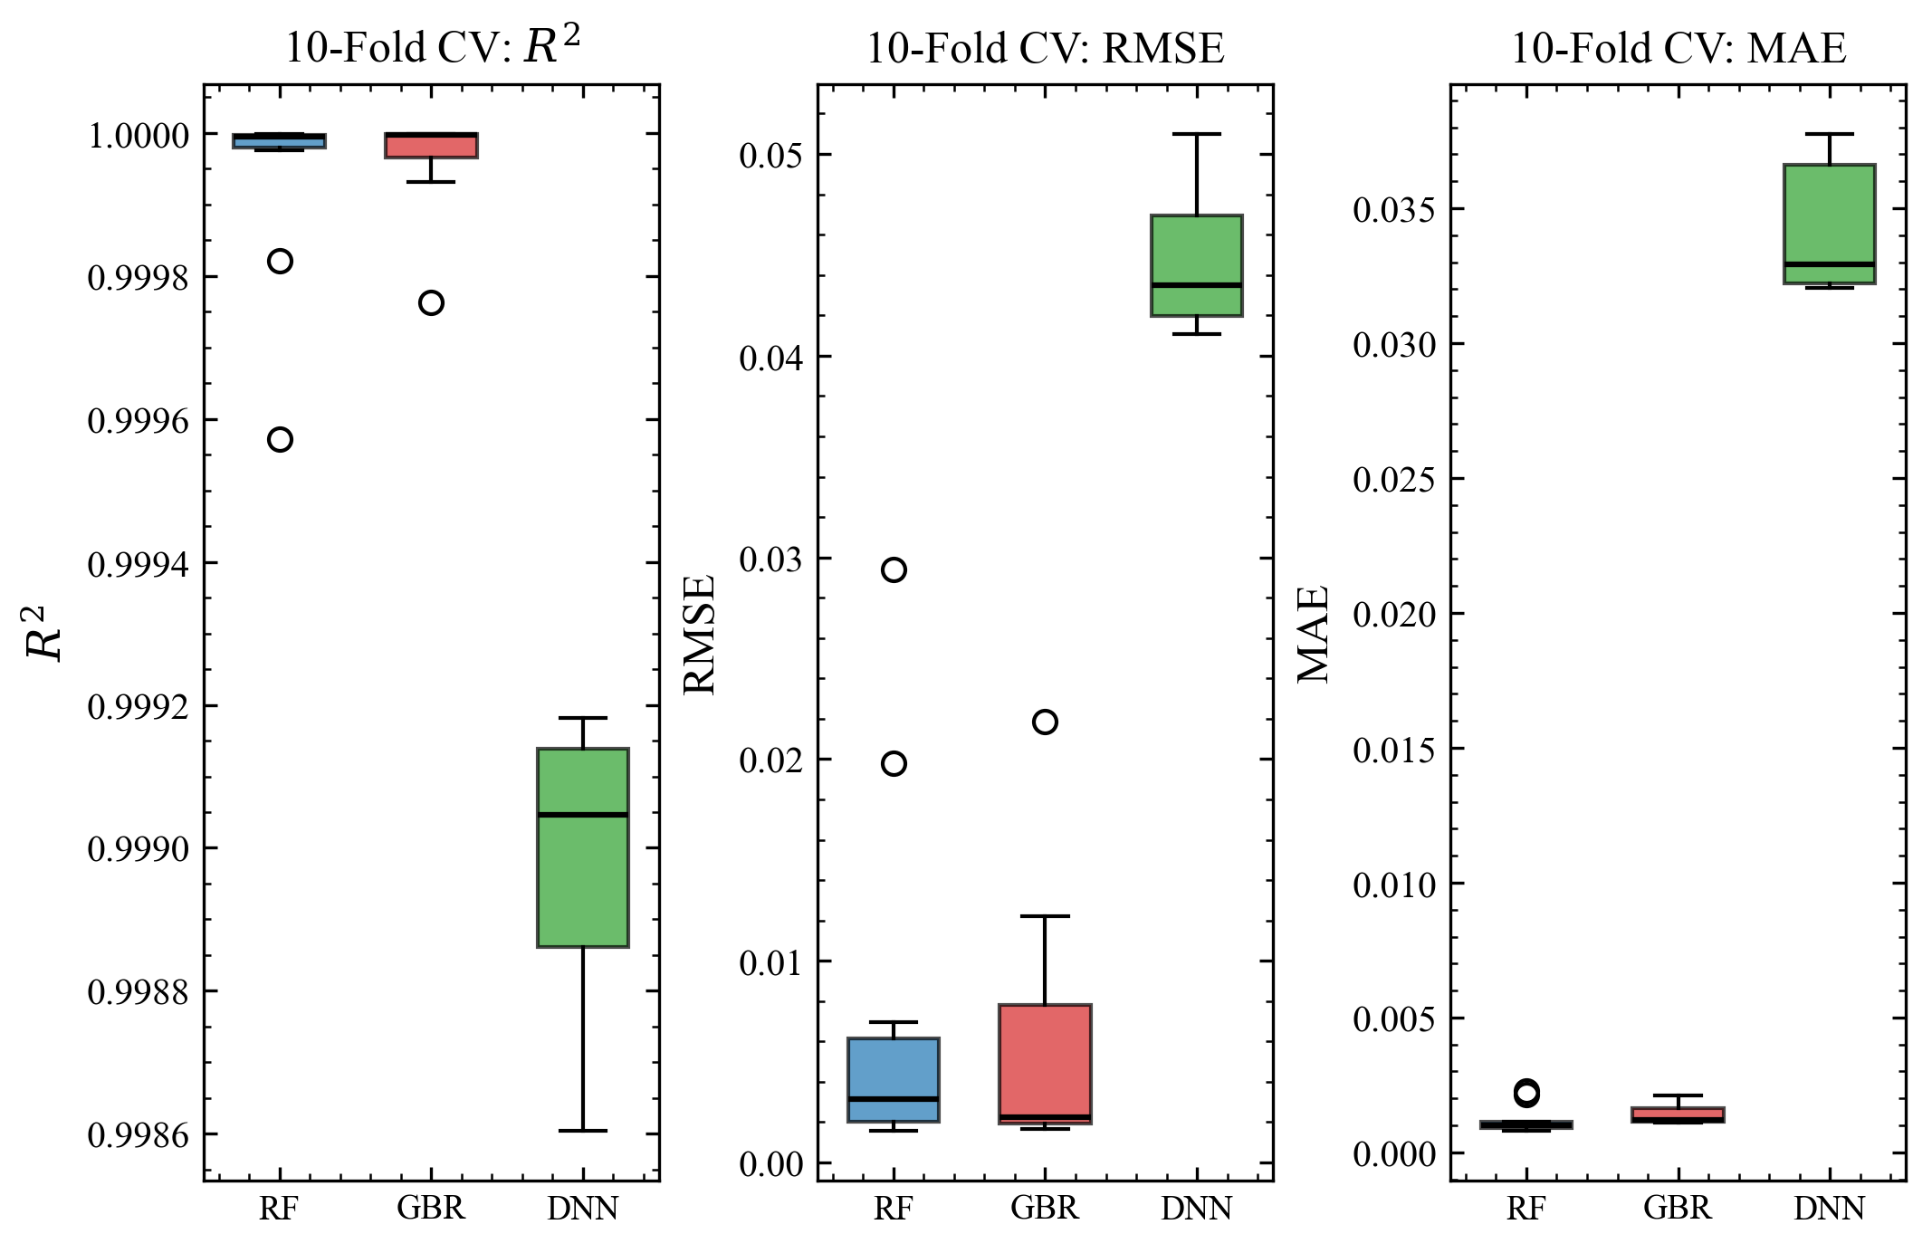
Fig. 5. Box plots of 10-fold cross-validation metrics for three ML models.
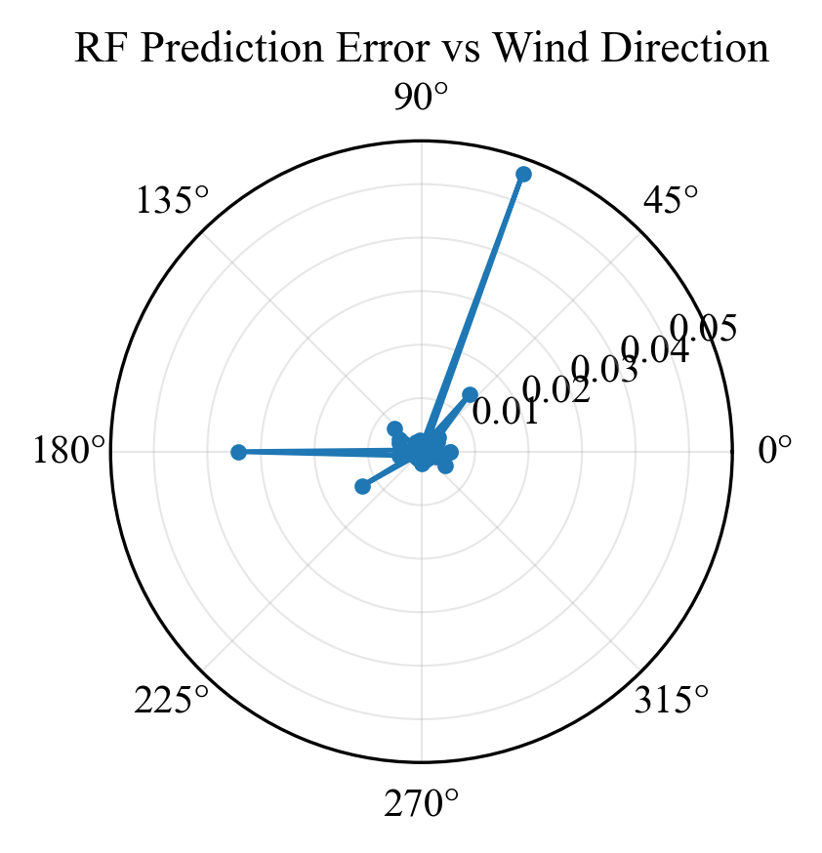
Fig. 6. RF prediction error (RMSE) as a function of wind direction.
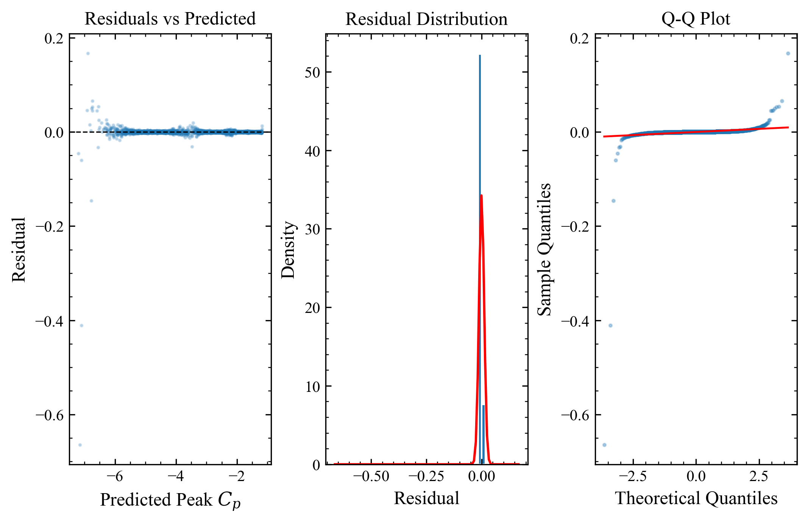
Fig. 7. Residual analysis for the Random Forest model.
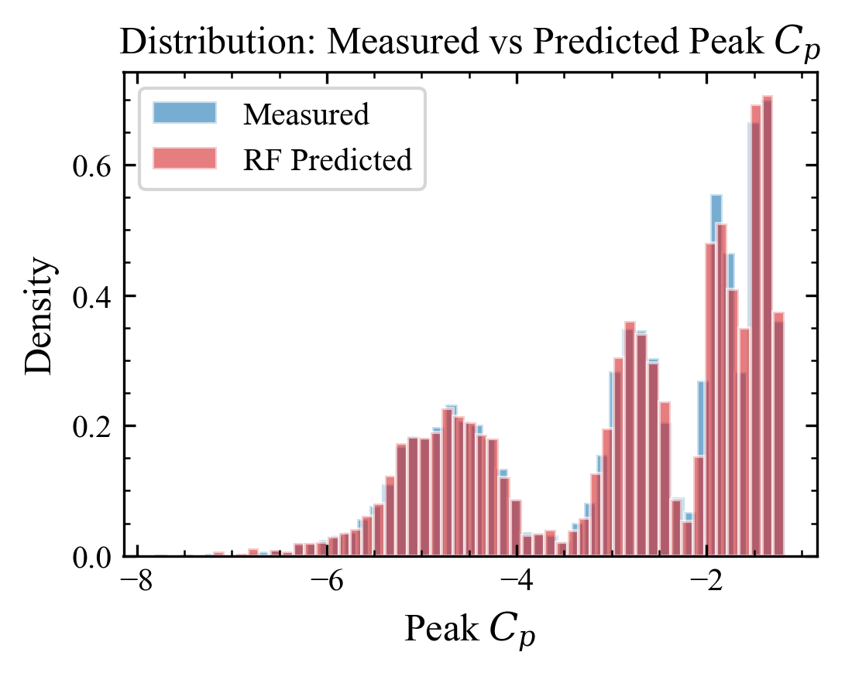
Fig. 8. Distribution comparison of measured and RF-predicted peak Cp values.

DATA AVAILABILITY STATEMENT
The wind pressure data used in this study were generated synthetically to demonstrate the proposed framework methodology. The TPU aerodynamic database is publicly available at https://db.wind.arch.t-kougei.ac.jp/.

ACKNOWLEDGMENTS
The authors acknowledge the Tokyo Polytechnic University for making the aerodynamic database publicly available.

REFERENCES
[1] F. Bre, J.M. Gimenez, V.D. Fachinotti, Prediction of wind pressure coefficients on building surfaces using artificial neural networks, Energy Build. 158 (2018) 1429-1441. https://doi.org/10.1016/j.enbuild.2017.11.045
[2] J. Tian, K.R. Gurley, M.T. Diaz, P.L. Fernandez-Caban, F.J. Masters, R. Fang, Low-rise gable roof buildings pressure prediction using deep neural networks, J. Wind Eng. Ind. Aerodyn. 196 (2020) 104026. https://doi.org/10.1016/j.jweia.2019.104026
[3] G. Hu, L. Liu, D. Tao, J. Song, K.T. Tse, K.C.S. Kwok, Deep learning-based investigation of wind pressures on tall building under interference effects, J. Wind Eng. Ind. Aerodyn. 201 (2020) 104138. https://doi.org/10.1016/j.jweia.2020.104138
[4] X.J. Wang, Q.S. Li, B.W. Yan, Full-scale measurements of wind pressures on a low-rise building during typhoons and comparison with wind tunnel test results and aerodynamic database, J. Struct. Eng. 146 (10) (2020) 04020196. https://doi.org/10.1061/(ASCE)ST.1943-541X.0002769
[5] B. Kim, N. Yuvaraj, K.R. Sri Preethaa, G. Hu, D.-E. Lee, Wind-induced pressure prediction on tall buildings using generative adversarial imputation network, Sensors 21 (7) (2021) 2515. https://doi.org/10.3390/s21072515
[6] Y. Weng, S.G. Paal, Machine learning-based wind pressure prediction of low-rise non-isolated buildings, Eng. Struct. 258 (2022) 114148. https://doi.org/10.1016/j.engstruct.2022.114148
[7] Z. Ding, W. Zhang, D. Zhu, Neural-network based wind pressure prediction for low-rise buildings with genetic algorithm and Bayesian optimization, Eng. Struct. 260 (2022) 114203. https://doi.org/10.1016/j.engstruct.2022.114203
[8] D.P.P. Meddage, I.U. Ekanayake, A.U. Weerasuriya, C.S. Lewangamage, K.T. Tse, T.P. Miyanawala, C.D.E. Ramanayaka, Explainable Machine Learning (XML) to predict external wind pressure of a low-rise building in urban-like settings, J. Wind Eng. Ind. Aerodyn. 226 (2022) 105027. https://doi.org/10.1016/j.jweia.2022.105027
[9] K. Mostafa, I. Zisis, M.A. Moustafa, Machine learning techniques in structural wind engineering: A state-of-the-art review, Appl. Sci. 12 (10) (2022) 5232. https://doi.org/10.3390/app12105232
[10] T. Wu, R. Snaiki, Applications of machine learning to wind engineering, Front. Built Environ. 8 (2022) 811460. https://doi.org/10.3389/fbuil.2022.811460
[11] F. Chen, W. Kang, Z. Shu, Q. Li, Y. Li, Y.F. Chen, K. Zhou, Predicting roof-surface wind pressure induced by conical vortex using a BP neural network combined with POD, Build. Simul. 15 (8) (2022) 1475-1490. https://doi.org/10.1007/s12273-021-0867-7
[12] Y. Huang, G. Ou, J. Fu, H. Zhang, Prediction of mean and RMS wind pressure coefficients for low-rise buildings using deep neural networks, Eng. Struct. 274 (2023) 115149. https://doi.org/10.1016/j.engstruct.2022.115149
[13] E. Shelley, E. Hubbard, W. Zhang, Comparison and uncertainty quantification of roof pressure measurements using the NIST and TPU aerodynamic databases, J. Wind Eng. Ind. Aerodyn. 232 (2023) 105246. https://doi.org/10.1016/j.jweia.2022.105246
[14] H. Wu, Y. Chen, P. Xie, D. Zhou, T. Tamura, Y. Cao, Sparse-measurement-based peak wind pressure evaluation by super-resolution convolutional neural networks, J. Wind Eng. Ind. Aerodyn. 242 (2023) 105574. https://doi.org/10.1016/j.jweia.2023.105574
[15] Q. Zhu, Z. Zhao, J. Yan, Physics-informed machine learning for surrogate modeling of wind pressure and optimization of pressure sensor placement, Comput. Mech. 71 (2023) 481-491. https://doi.org/10.1007/s00466-022-02251-1
[16] Y. Huang, H. Wu, J. Fu, H. Zhang, H. Li, Convolutional neural network-based wind pressure prediction on low-rise buildings, Eng. Struct. 309 (2024) 118078. https://doi.org/10.1016/j.engstruct.2024.118078
[17] L.-S. An, S. Jung, Data-driven prediction of wind pressure on low-rise buildings in complex heterogeneous terrains, Build. Environ. 265 (2024) 112022. https://doi.org/10.1016/j.buildenv.2024.112022
[18] B. Yan, W. Ding, Z. Jin, L. Zhang, L. Wang, M. Du, Q. Yang, Y. He, Explainable machine learning-based prediction for aerodynamic interference of a low-rise building on a high-rise building, J. Build. Eng. 82 (2024) 108285. https://doi.org/10.1016/j.jobe.2023.108285
[19] B. Tong, Y. Liang, J. Song, G. Hu, A. Kareem, Deep learning-based extension of wind pressure time series, J. Wind Eng. Ind. Aerodyn. 254 (2024) 105909. https://doi.org/10.1016/j.jweia.2024.105909
[20] F.M. Nav, S.F. Mirfakhar, R. Snaiki, A hybrid machine learning framework for wind pressure prediction on buildings with constrained sensor networks, Comput.-Aided Civ. Infrastruct. Eng. (2025). https://doi.org/10.1111/mice.13488

