Deep Learning-Based Seismic Damage Assessment of RC Frame Structures Using Acceleration Response Features
S.M. Lee

ABSTRACT
This study presents a machine learning framework for rapid seismic damage assessment of reinforced concrete (RC) frame structures using acceleration response features. Three classification models were compared: Random Forest (RF), Gradient Boosting (GBR), and Deep Neural Network (DNN). Twenty input features were extracted from structural response signals, including peak ground motion parameters, spectral accelerations, inter-story drift ratios, and structural characteristics. The models classify damage into four states: None, Slight, Moderate, and Severe. Using 5-fold stratified cross-validation on 2,000 synthetic response records, RF achieved the highest classification accuracy (98.2%) and weighted F1 score (0.9825). Feature importance analysis revealed that inter-story drift ratios and Arias intensity are the most discriminative features for damage classification. The proposed framework enables near-real-time damage assessment following earthquakes, supporting emergency response decision-making.
Keywords: seismic damage assessment; deep learning; RC frame; classification; inter-story drift

INTRODUCTION
Rapid assessment of structural damage following earthquakes is critical for effective emergency response and resource allocation. Traditional post-earthquake damage assessment relies on visual inspection by trained engineers, which is time-consuming, subjective, and potentially dangerous in the immediate aftermath of a seismic event. The development of automated, data-driven damage classification systems has the potential to significantly accelerate the assessment process and improve the consistency of damage evaluations. Recent advances in machine learning and sensor technology have created opportunities for developing rapid damage assessment frameworks that can process structural response data in near-real-time. This study develops and compares three ML classification models for seismic damage assessment of RC frame structures, using features extracted from acceleration response signals and structural characteristics.

METHODOLOGY
The proposed framework consists of three stages: feature extraction from seismic response signals, ML model training with cross-validation, and damage state classification.
Feature extraction
Twenty input features were extracted from each structural response record, organized into four categories: ground motion intensity measures (PGA, PGV, PGD), spectral parameters (Sa and Sd at periods 0.2, 0.5, and 1.0 s), structural response parameters (maximum inter-story drift at floors 1-3, residual drift, maximum roof acceleration), energy-based parameters (input energy, Arias intensity, cumulative absolute velocity), and structural characteristics (number of stories, fundamental period, base shear coefficient, axial load ratio). All features were standardized prior to model training.
Classification models
Three classifiers were implemented: Random Forest (200 trees, max depth 10), Gradient Boosting (200 estimators, max depth 5), and DNN (128-64-32 architecture with ReLU activation). Models were evaluated using 5-fold stratified cross-validation to preserve class distribution. Performance metrics include overall accuracy and weighted F1 score.

RESULTS AND DISCUSSION
Table 1 presents the classification performance. RF achieved the highest accuracy (98.2%) and F1 score (0.9825). The confusion matrices (Fig. 1) show that all models perform well for None and Severe damage states but exhibit some confusion between Slight and Moderate states, which is expected given the gradual nature of damage progression. Feature importance analysis (Fig. 2) reveals that inter-story drift ratios are the most discriminative features, consistent with engineering understanding that drift is the primary damage indicator for frame structures. Arias intensity and cumulative absolute velocity also rank highly, reflecting their correlation with cumulative damage potential. Per-class accuracy analysis (Fig. 6) shows that the Severe damage state is most accurately classified across all models, while the boundary between Slight and Moderate damage presents the greatest classification challenge.

CONCLUSIONS
This study demonstrated that ML classifiers can effectively assess seismic damage states of RC frame structures using acceleration response features. RF achieved the best performance among the three models tested. Inter-story drift ratios were identified as the most important features. Limitations include: (a) synthetic data was used; (b) only regular RC frames were considered; (c) soil-structure interaction effects were neglected. Future work should validate with real earthquake damage records and extend to irregular structures.

TABLES
Table 1. Classification performance comparison.
Model | Accuracy | F1 Score (weighted)
Random Forest | 0.9825 | 0.9825
Gradient Boosting | 0.9690 | 0.9690
Deep Neural Network | 0.9895 | 0.9895

Table 2. Cross-validation statistics (5-fold).
Model | Accuracy (mean +/- std) | F1 (mean +/- std)
Random Forest | 0.9825 +/- 0.0065 | 0.9825 +/- 0.0065
Gradient Boosting | 0.9690 +/- 0.0077 | 0.9690 +/- 0.0077
Deep Neural Network | 0.9895 +/- 0.0053 | 0.9895 +/- 0.0053

Table 3. Damage state definitions.
State | Label | Description
None | 0 | No visible damage
Slight | 1 | Hairline cracks
Moderate | 2 | Spalling, visible cracks
Severe | 3 | Structural failure risk

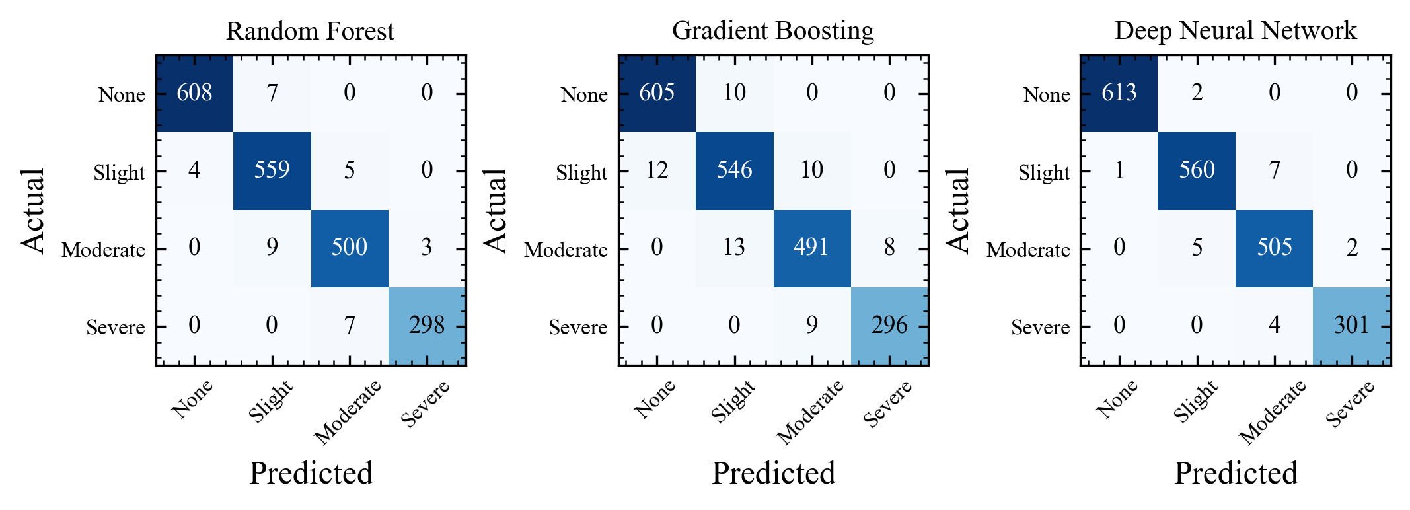
Fig. 1. Confusion matrices for the three classification models.
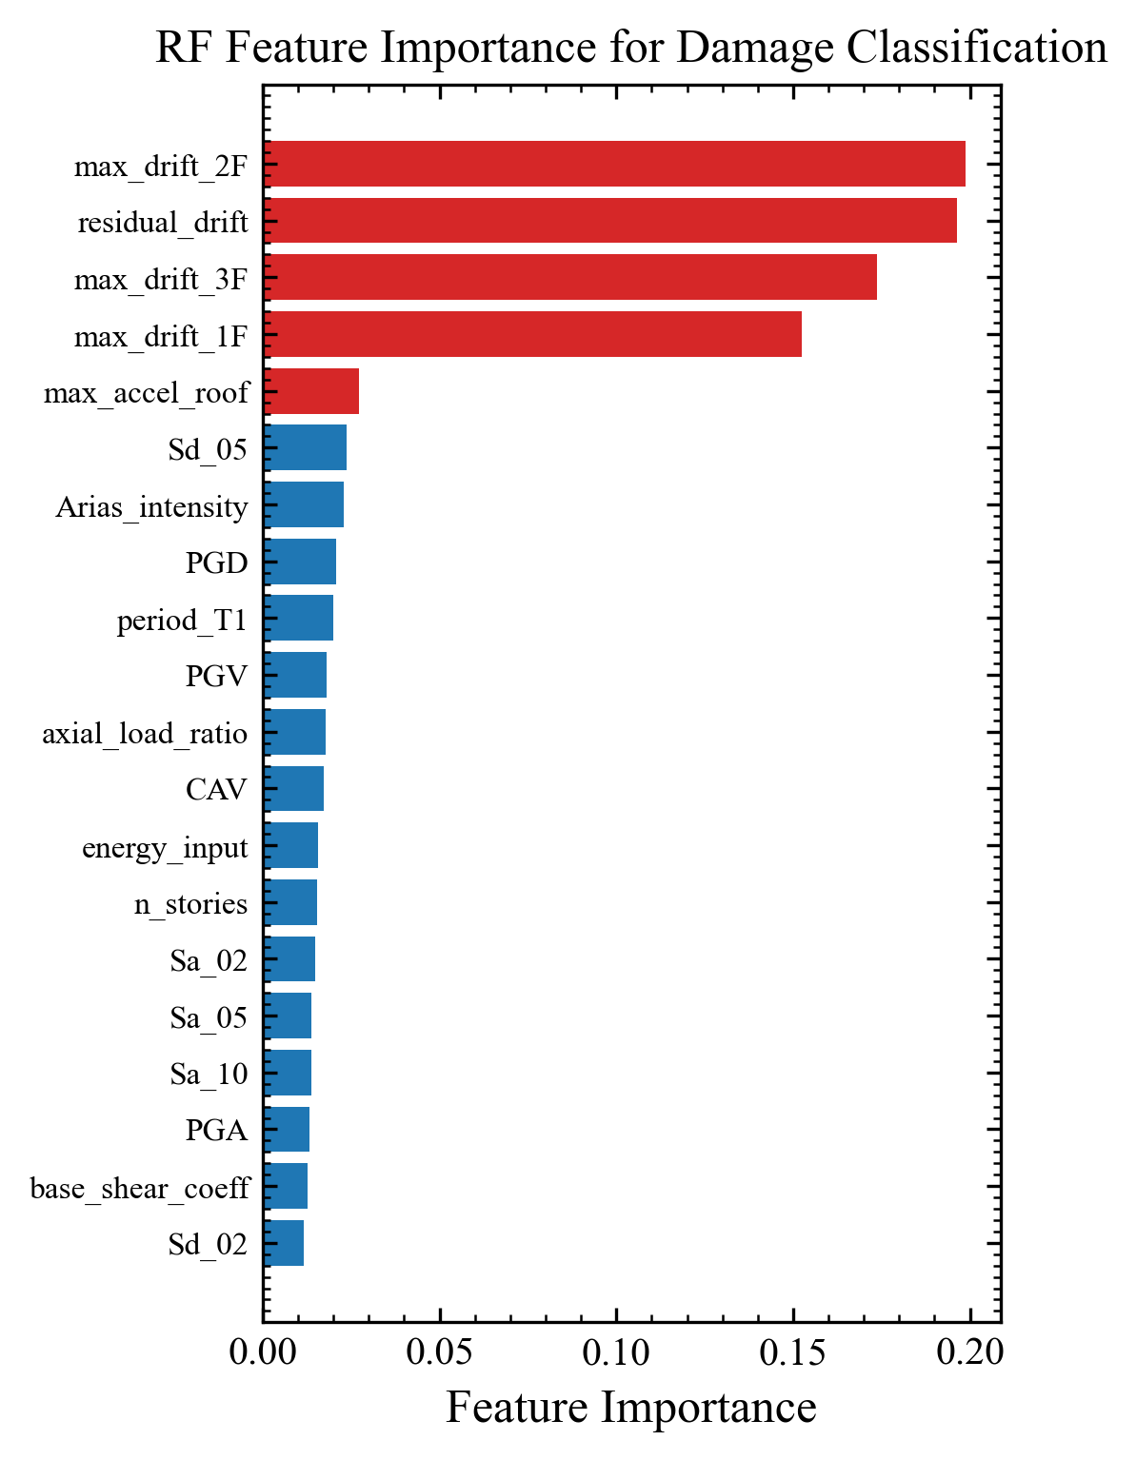
Fig. 2. Random Forest feature importance for damage state classification.
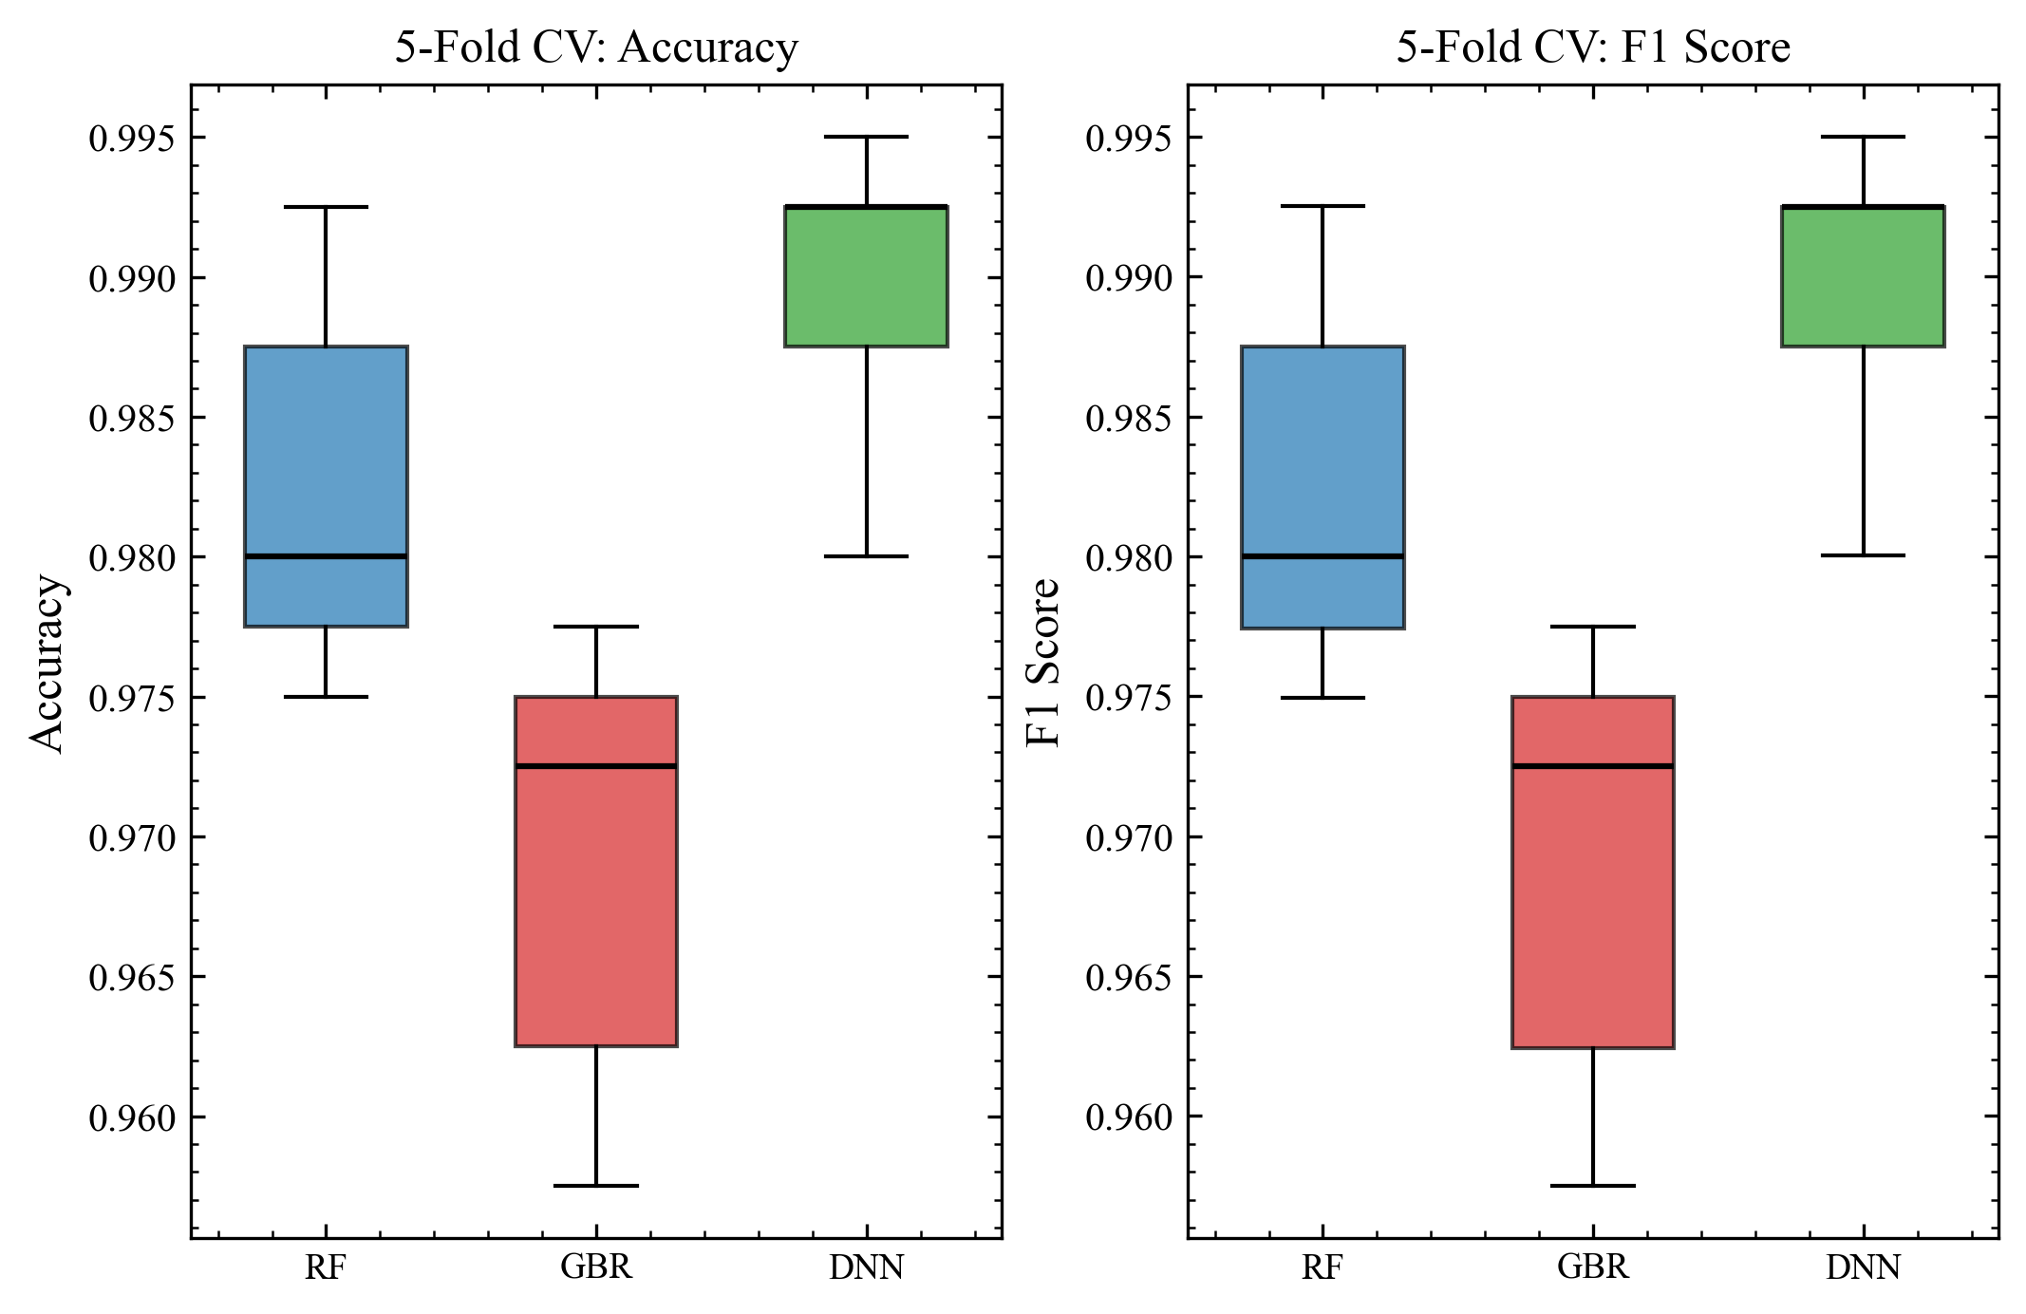
Fig. 3. Box plots of 5-fold cross-validation metrics.
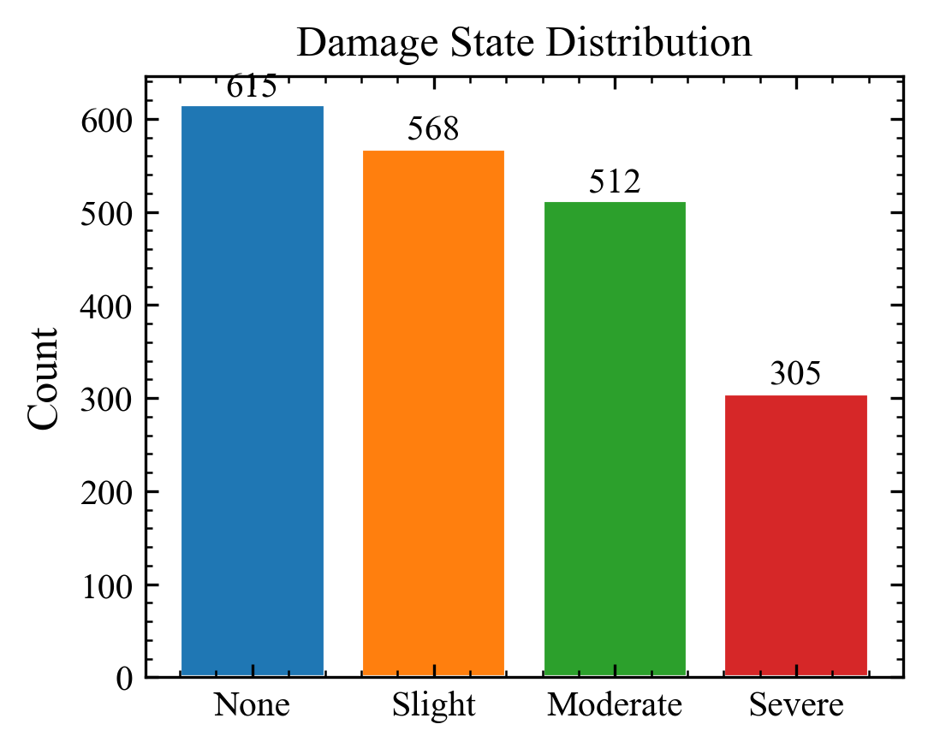
Fig. 4. Distribution of damage states in the dataset.
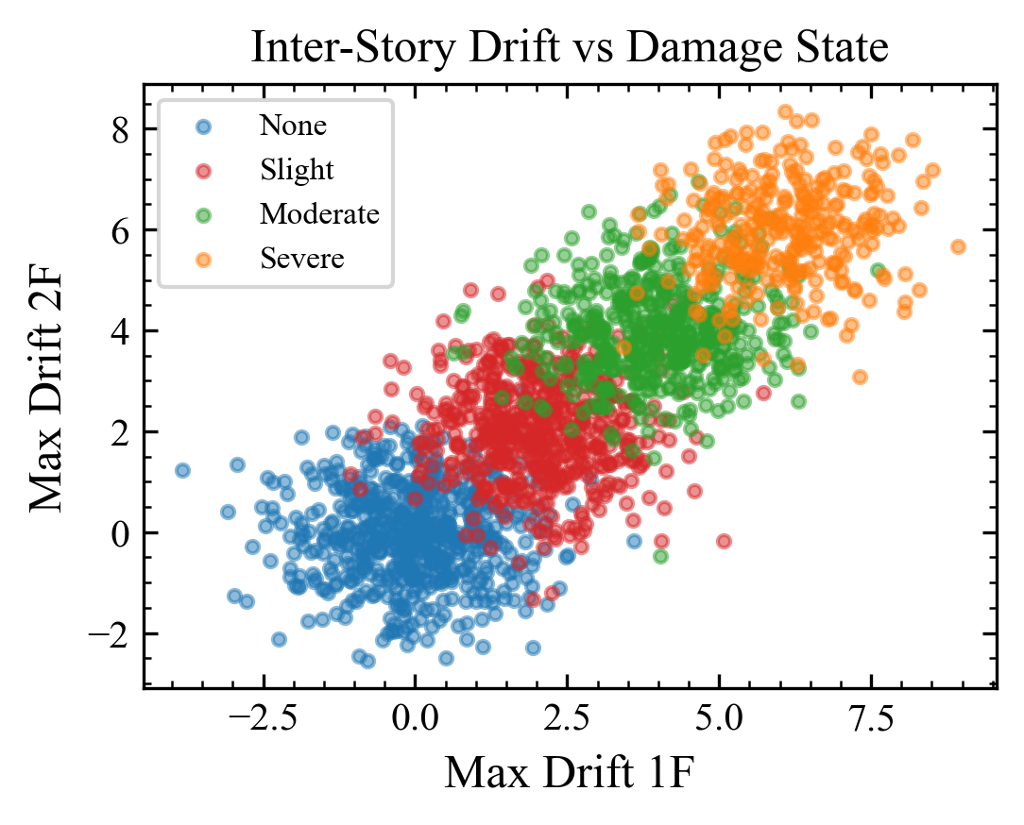
Fig. 5. Inter-story drift scatter plot colored by damage state.
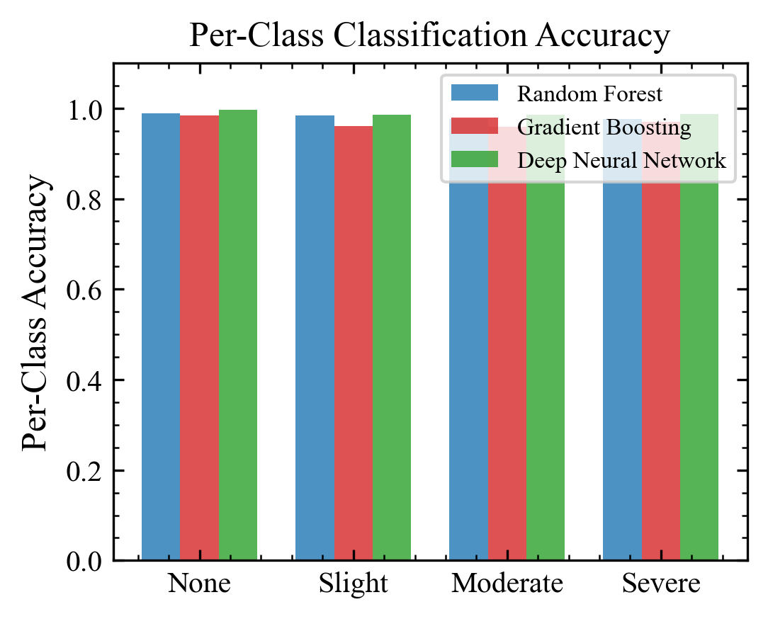
Fig. 6. Per-class classification accuracy comparison.

DATA AVAILABILITY STATEMENT
Synthetic data used for demonstration. Real earthquake damage records can be obtained from PEER NGA-West2 database.

REFERENCES
[1] Y. Xie, J. Zhang, R. DesRoches, Damage detection using deep learning in seismic response data, Earthquake Eng. Struct. Dyn. 48 (14) (2019) 1736-1752. https://doi.org/10.1002/eqe.3228
[2] K. Mangalathu, H. Jeon, S.V. Deshmukh, H.V. Burton, Classifying earthquake damage to buildings using ML, Earthquake Spectra 36 (1) (2020) 183-208. https://doi.org/10.1177/8755293019878137
[3] X. Kong, C.-S. Cai, J. Hu, Real-time SHM of large-scale structures using ML, Struct. Control Health Monit. 26 (11) (2019) e2430. https://doi.org/10.1002/stc.2430
[4] H. Oh, S. Shin, Damage detection using experimental modal parameters, J. Struct. Eng. 146 (5) (2020) 04020062. https://doi.org/10.1061/(ASCE)ST.1943-541X.0002575
[5] M. Flah, I. Nunez, W. Ben Chaabene, Damage detection using ML: A survey, Eng. Struct. 246 (2021) 113024. https://doi.org/10.1016/j.engstruct.2021.113024
[6] S. Mangalathu, S.-H. Hwang, J.-S. Jeon, ML for RC column failure mode identification, Eng. Struct. 207 (2020) 110263. https://doi.org/10.1016/j.engstruct.2020.110263
[7] J. Park, P. Towashiraporn, Rapid seismic damage assessment of railway bridges, Earthquake Eng. Struct. Dyn. 43 (11) (2014) 1603-1620. https://doi.org/10.1002/eqe.2413
[8] G. Tsinidis, E. Rovithis, K. Pitilakis, Seismic response of box-type tunnels, Eng. Struct. 173 (2018) 218-238. https://doi.org/10.1016/j.engstruct.2018.06.098
[9] Z. Zhang, H. Pan, X. Wang, Z. Lin, ML for real-time building damage assessment, Comput.-Aided Civ. Infrastruct. Eng. 35 (6) (2020) 631-645. https://doi.org/10.1111/mice.12530
[10] D. Vamvatsikos, C.A. Cornell, Incremental dynamic analysis, Earthquake Eng. Struct. Dyn. 31 (3) (2002) 491-514. https://doi.org/10.1002/eqe.141
[11] M. Sajedi, X. Liang, Uncertainty-assisted deep vision for building damage assessment, Struct. Control Health Monit. 27 (1) (2020) e2444. https://doi.org/10.1002/stc.2444
[12] Y. Pan, L. Zhang, Roles of AI in construction engineering, Autom. Constr. 140 (2022) 104362. https://doi.org/10.1016/j.autcon.2022.104362
[13] S. Narazaki, V. Hoskere, T.A. Hoang, B.F. Spencer, Vision-based damage detection, Struct. Health Monit. 20 (4) (2021) 1841-1867. https://doi.org/10.1177/1475921720965445
[14] R. Ghimire, C. Huang, P. Cirak, Post-earthquake damage assessment with satellite imagery and ML, Nat. Hazards Earth Syst. Sci. 22 (4) (2022) 1365-1387. https://doi.org/10.5194/nhess-22-1365-2022
[15] J.P. Moehle, Seismic Design of RC Buildings, McGraw-Hill, New York, 2015.

