OBT

Open Boat Tail Rocket Notes

General Points

So this document is just a few thoughts and pointers on building this OBT rocket… I really hope you build one, have fun flying it and let me know and send pictures! A couple of general points, the main body tube is made from an Estes BT50 size tube and the motor mount tube is a BT20 section. I’ve added the STL models for printing but they are calibrated for my machine and the shrinkage I am getting from my current roll of PLA! You may need to tweak them and as such the OpenSCAD files are there which can be edited with openscad or freecad. I have also provided a gcode (.nc) file for the fins.. (it would also be trivial to cut these with a craft knife!) the gcode provided is again made for my GRBL powered cnc and is set to use a 1.5mm endmill at feedrate of 400mm/min. There’s a PDF of a fin if you need to trace/print or create your own tool path.

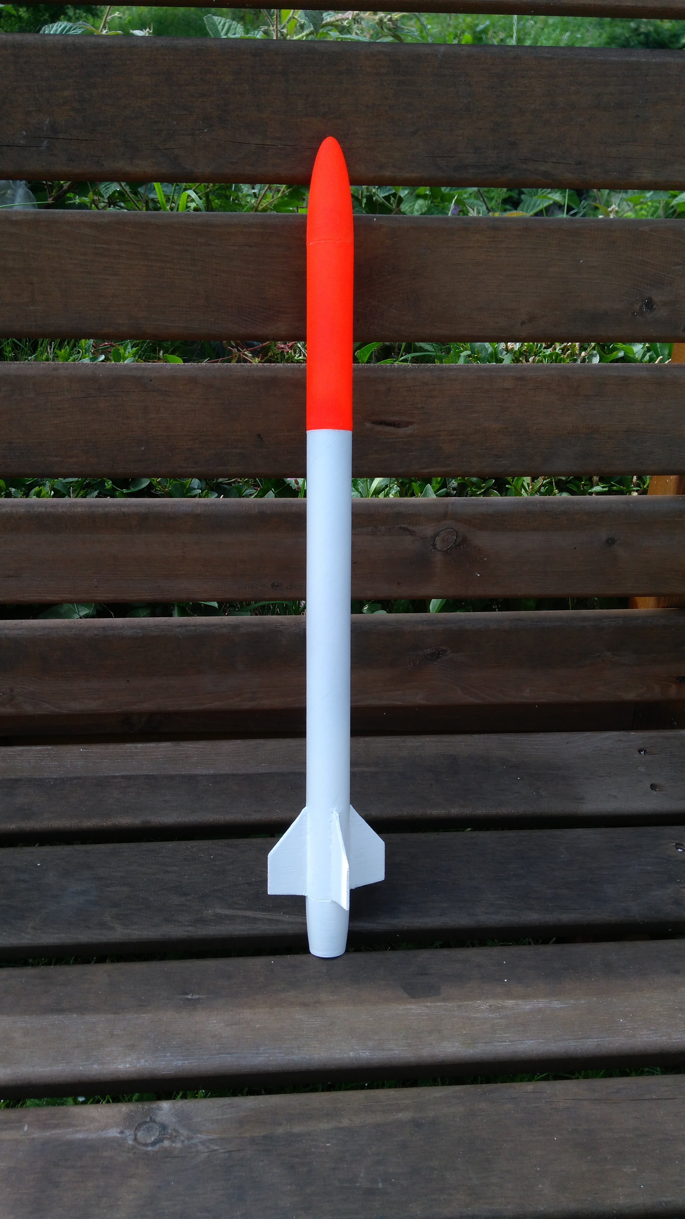

The Openrocket file

The Openrocket file is a pretty good rough approximation of the rocket but it is also quite quick and dirty (for example the ebay base/coupler is made up of numerous components to emulate what we are 3d printing). Lots of the masses of objects in the file are over ridden to match the mass of the components I have printed. Obviously your prints may differ so adjust as needed. I’ve left a small mass in the payload section to simulate a small altimeter I have. I have also printed a couple of nosecones for mine with different wall thicknesses, some empty and some with infill and these obviously have different masses which can be useful if flying with an empty payload section.

There is no launch lug on the openrocket model, on mine I’m working on some mini rail buttons for a mini 15mm rail I have. Again feel free to add your own launch stuff!

Motor mount and Boat Tail assembly

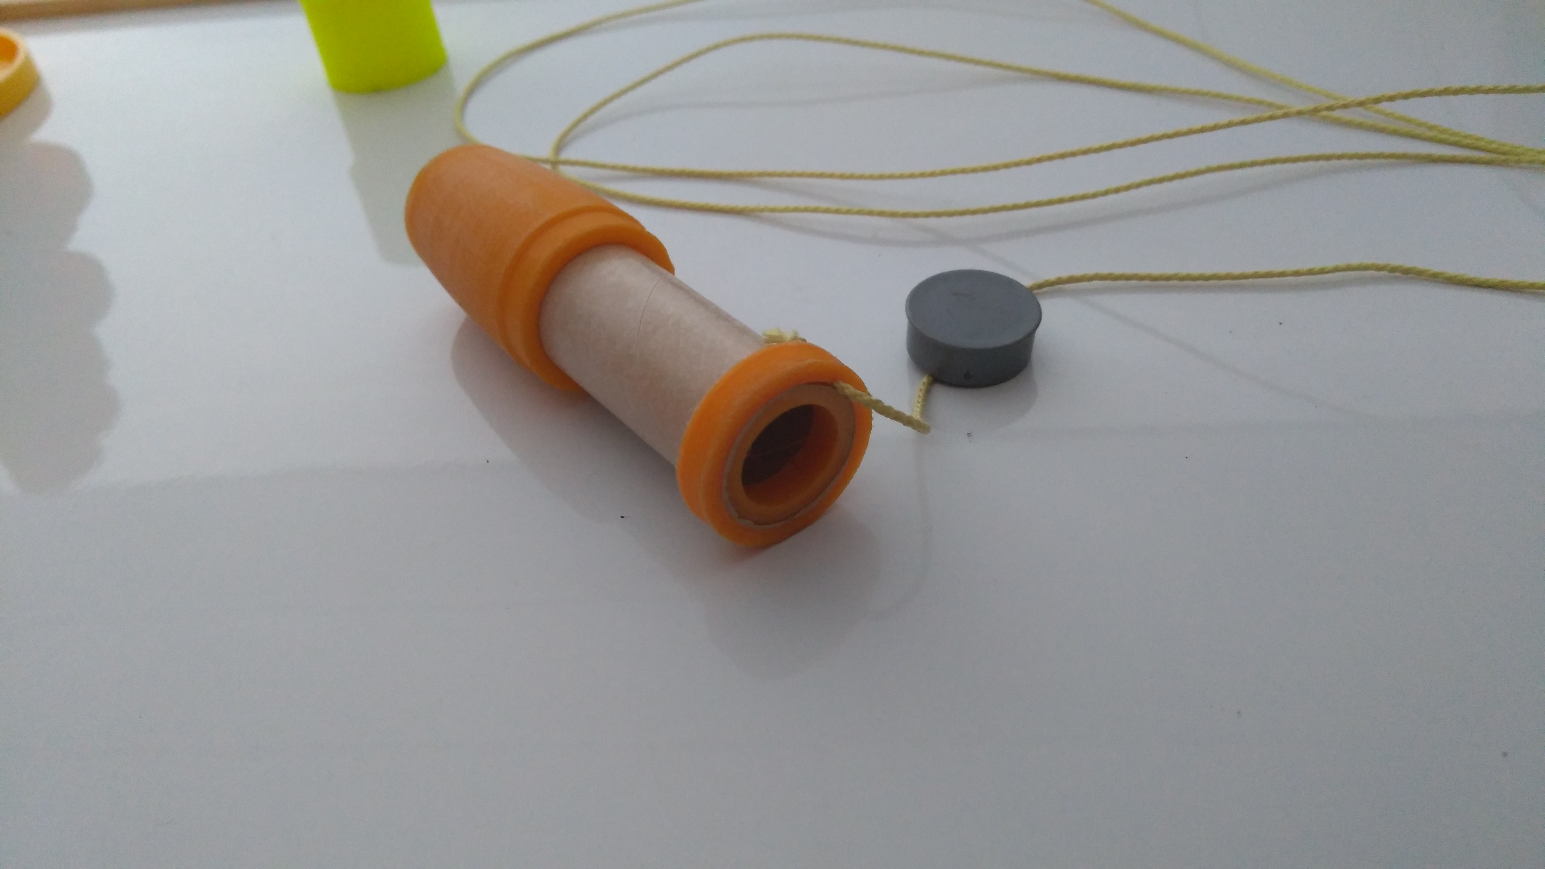
So you can see in the picture above how the motor/boattail section comes together. I made a small groove in the centering ring to allow the retention of the recovery string.. I used some thin kevlar I have for this. A knot is tied behind the ring and the whole assembly is epoxied on. I again used a small amount of epoxy to affix the boattail to the motor mount tube. I cut the motor mount to the eact length of a motor (70mm) plus the motor block, this means that ther is no active motor retention therefore I’ll be using friction fit by adding some small amounts of tape to the motor. This is a common and estabished practice, particularly in smaller low power rocketry.

Before glueing all the above assembly into the main body tube I also lightly brushed all exposed surfaces of the motor bloc and centering ring with a little thin coat of epoxy. This adds mass but does serve to flameproof the components a little!

Payload/Ebay section and recovery

Its not immediately apparent how I have attached the other end of the kevlar thread! Rather crudely but effectively I have drilled a 2mm hole through the bulkhead of the ebay base/coupler and then threaded the kevlar through and into the payload section. I again tied a knot to stop it pulling back through. I’ve then added some epoxy to both sides of the bulkhead to firmly attach the cord. Simple and strong! I have added 2.5 times the length of the entire airframe of kevlar to minimise the chance of it zippering through the tube.

