This is primarily a collection of notes taken from the MAGNIFICENT talk by Ed Moore at the 2015 UK High Altitude Society Conference, which I have written up. The main addition by me is the later section of this document takes us through an example of applying the various bits of math to establish the dimensions and design of a crossform parachute.

Ed’s excellent talk is online here

https://www.youtube.com/watch?v=X2egYw8kd3s

##### here follow the notes ########

A falling payload accelerates due to gravity acting on the mass of the payload resulting in a weight force. The drag force is created that opposes the weight force by the molecules of the fluid (air) that the payload is falling through hitting the payload.

When these two forces reach an equilibrium then the terminal velocity of the falling payload is reached.

So as the drag force is a function of the velocity, if we increase the drag force the velocity of the falling payload is decreased.

So we represent this equilibrium point as;

Weight = Drag

And we can state this as;

Where m= mass in kg, g = gravity in m/s² , rho= density of the fluid (air) in kg/m³, V² = velocity in m²/s², C_{d}= Drag coefficicent (a constant) and A= area in m².

We can sanity check the above equation and make sure the units on each side correspond. We can remove the terms which have no units (the ½ and C_{d}) to give;

Then collecting like terms and cancelling this returns

We need to rearrange the equation to work out the resulting velocity

First multiply both sides by 2 gives;

Then divide both sides by rho, C_{d} and A gives

Then finally take the square root of both sides and swap the sides to give

So we can plug in some of the values missing

Rho is the density of air at sea level so

Gravity

Note that at 30km altitude g is around 1% lower.

To understand the drag coefficient we can look at 2 objects each with the same frontal area A

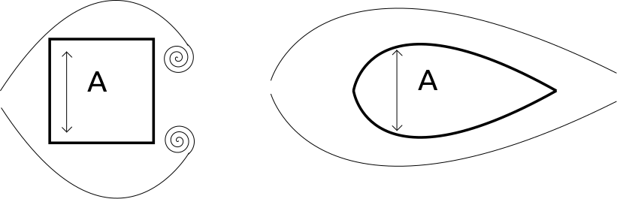

Despite the objects having the same frontal area we instinctively know that the object on the left is less aerodynamic than the object on the right. It follows therefore that the object on the left has a higher drag coefficient than the object on the right. So we can see that in a classic parachute design, the air hits the ground-facing side of the parachute, creating an area of high pressure inside the parachute and a relatively low pressure area above it.

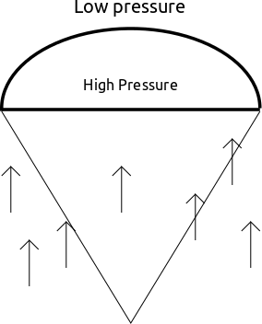

As the air moves from the area of high pressure towards the low pressure side this creates spills as the chute collapses/twists a section to release some air this creates movements in the parachute and can lead to coning or spinning on descent.

Another result can be that the parachute can find a stable position but off axis as below;

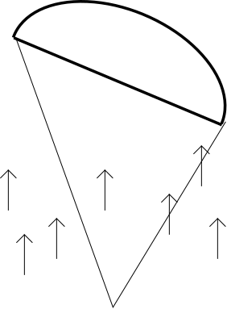

The result of which is that the payload will glide, possibly leading to its loss or at best a much longer recovery search and walk.

So the answer to overcome these issues is to increase the porosity of the parachute. Increasing the porosity enables the transfer of high to low pressure to happen in an even and distributed manner. Increased porosity can be achieved in numerous ways, the inclusion of a spill hole is commonly used in model rocketry but this is often applied ad hoc as a modification to an existing parachute which may reduce the parachutes strength and may cause the parachute to not inflate correctly leading to coning/spill induced turning etc.

Other ways are to generally increase the porousity of the material used, the defacto material for chute making is ripstop nylon which generally is non porous (some very lightweight examples from Ebay do display some porosity). Commercial designs increase porosity buy using a ring chute design as below
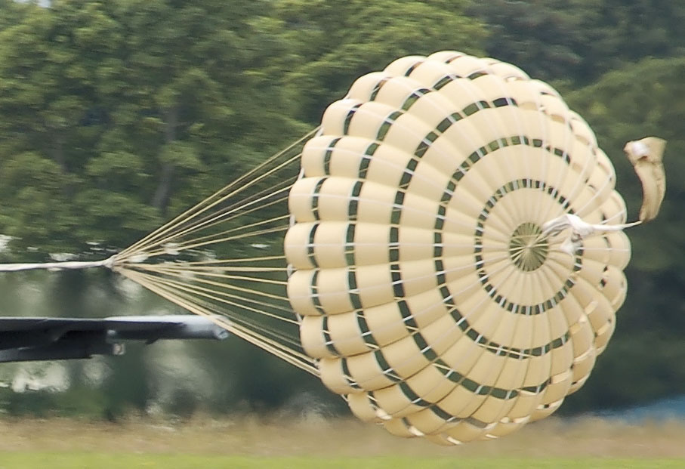

However these are difficult to fabricate for amateurs. An easier design to realise is a crossform parachute.

A crossform parachute doesn’t glide or oscillate, they can rotate but this can be mitigated with the addition of a reinforcement ring at the base of the inflated chute.The design of a crossform parachute is formed from 2 rectangles of fabric over each other to create the cross.

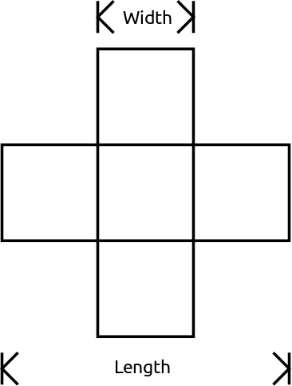

The formulae for the crossform chute are with W being the width in metres and L being the length in metres;

The drag coefficient (C_{d} ) for parachutes conforming to this design is given as 0.7

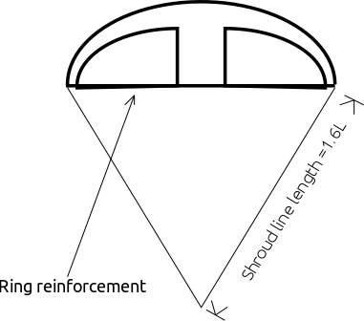

So in Ed’s talk he stops at this point but I thought it might be useful to work through an example.

###### ----- ######

It is more probable that we will have a rocket/payload of a particular mass and a desired terminal velocity (as in the speed we want the payload to strike the ground) and we will want to know the area of parachute required. To do this we begin with rearranging the formula from earlier which read;

First we clear the fraction by mutliplying both sides by 2

Then finally we divide each side by rho, V² and C_{d} and swap the sides to give

So this is the formula we will use. Let us imagine we have a payload of 0.5kg and we have a desired terminal velocity of 5m/s. This design of crossform parachute returns a drag coefficient of 0.7 so;

Therefore for a payload of 0.5kg and a desired terminal velocity of 5m/s the crossform parachute must have an area of 0.459m².

So we were also given equations pertaining to the dimensions the crossform chute the first being the ration of the width compared to length;

And the second relating to the area, this being given that the parachute is going to be made of 2 rectangles laid over each other resulting in the central section of the parachute having a double layer.

Maintaining the correct ratio of length to width is important as then the resulting design will perform with the stated drag coefficient of 0.7 and therefore should result in an accurate prediction of the terminal velocity.

So to continue with our example with a payload of 0.5kg and a terminal velocity of 5m/s firstly I am going to rearrange

To make L the subject so multiply both sides by 3.6 to give;

Now we are going replace A with our desired area of 0.459m² so and then rearrange the equation to make L the subject so;

Becomes

So first add W² to each side

Then divide both sides by 2W and swap the sides to give;

From our earlier formula we know we can state that L is equal to 3.6W so we can substitute in this for L and then solve to find W so;

So first lets multiply both sides by 2W returning;

Lets swap the sides and subtract 7.2W² from each side which gives;

Therefore subtracting 0.459 from both sides gives

Then dividing both sides by -6.2 gives

Therefore

Therefore

Now we know that W = 0.272m we can substitute this back into

To return that L = 0.979m (3 d.p.)

To double check our findings lets check that when we put these values of L and W we return a value close to the desired value of the area, in this case 0.459m².

So substituing in the known values gives

So we can verify that this is correct and the lengths and widths we have calculated will return the correct area and drag coefficient in the resulting parachute.

Happy landings!

