Original Copyright: https://flukeout.github.io/

1. Select the element by their type: A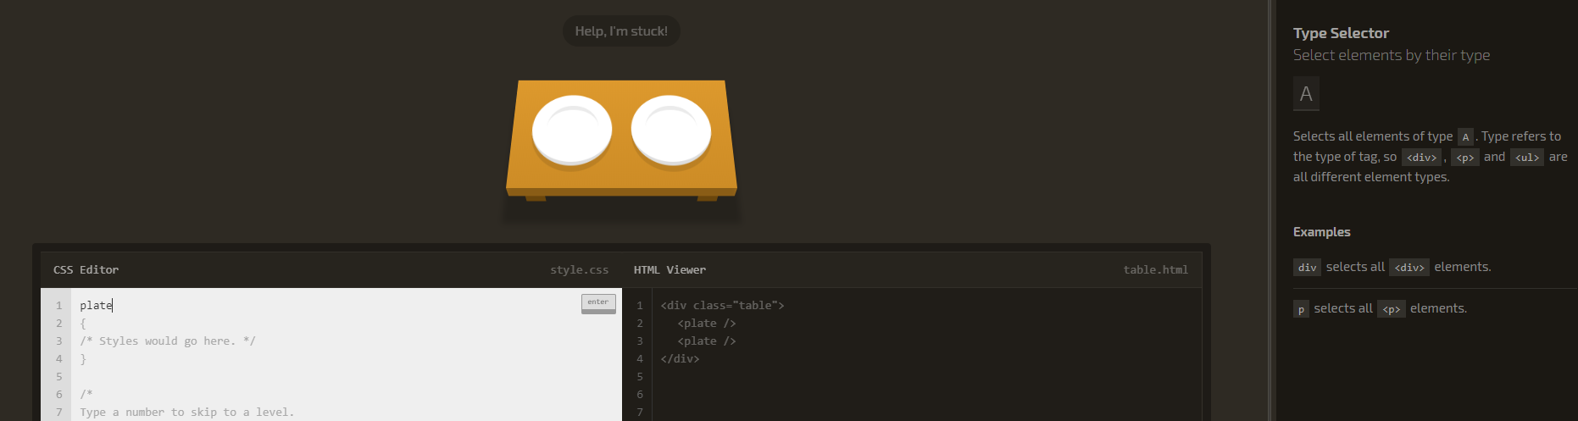

2. Select elements with an ID: #id

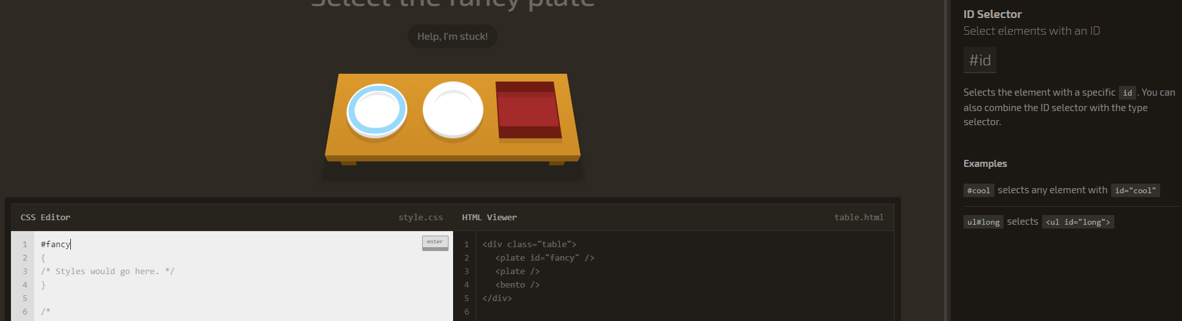

3. Select an element inside another element: A B

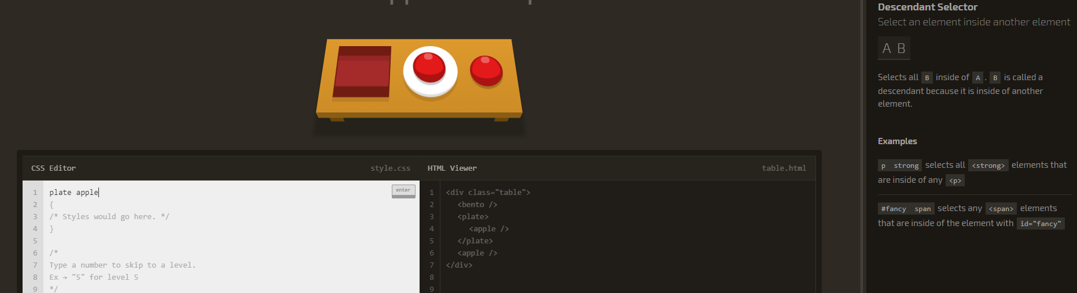

4. Combine the Descendant and ID Selectors: #id A

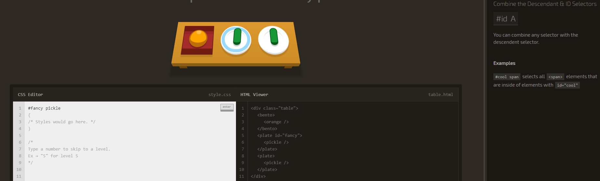

5. Select elements by their class: .small

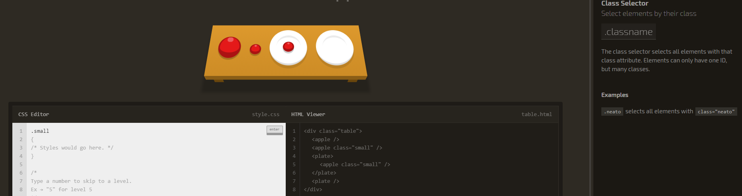

6. Combine the Class Selector: A.className

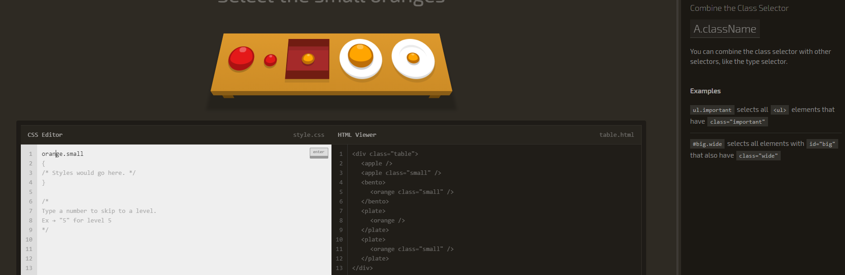

7. Select an element with a classname inside another element: A B.className

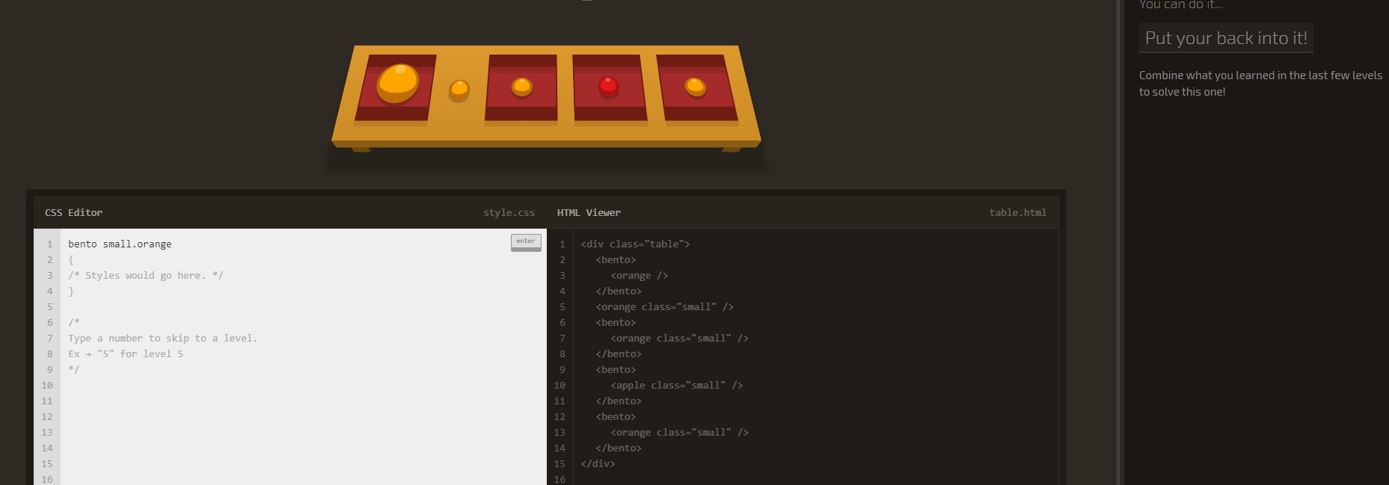

8. Combine, selectors, with…commas: A, B

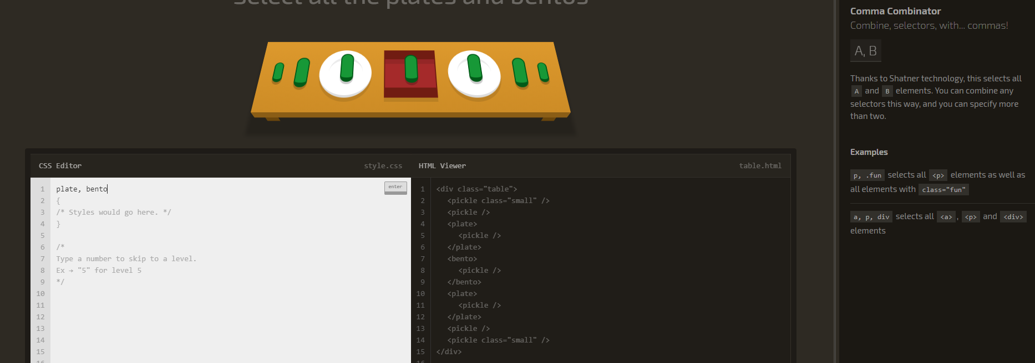

9. Select everything: *

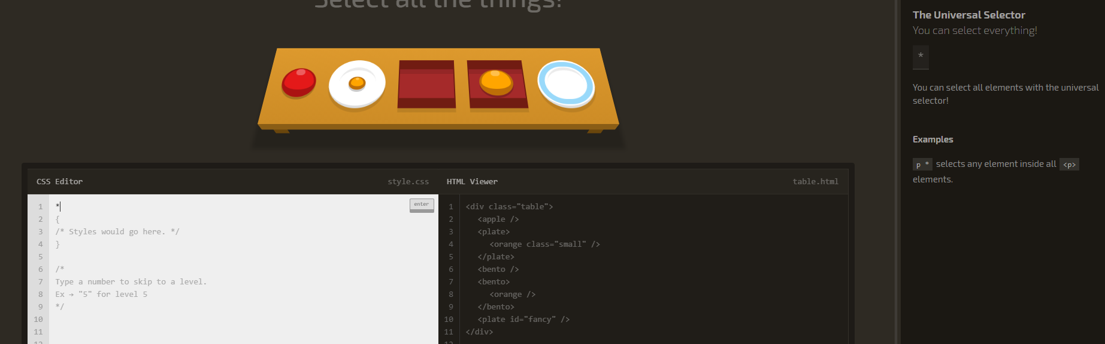

10. Combine the Universal Selector: A *

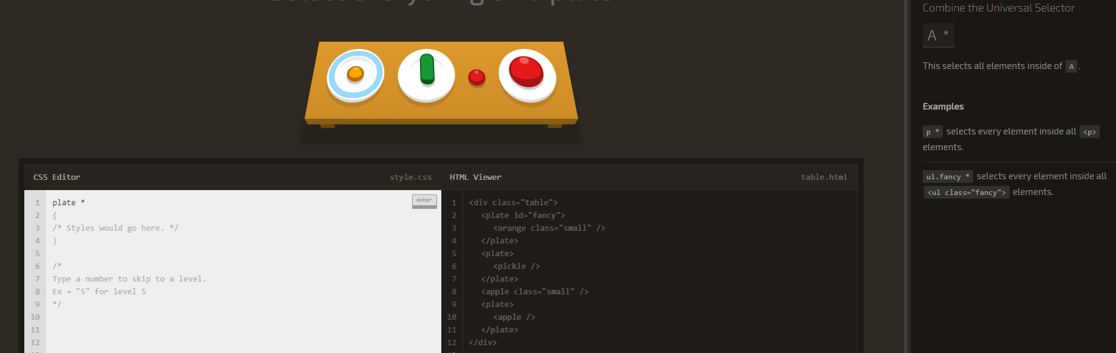

11. Select an element that directly follows another element: A + B

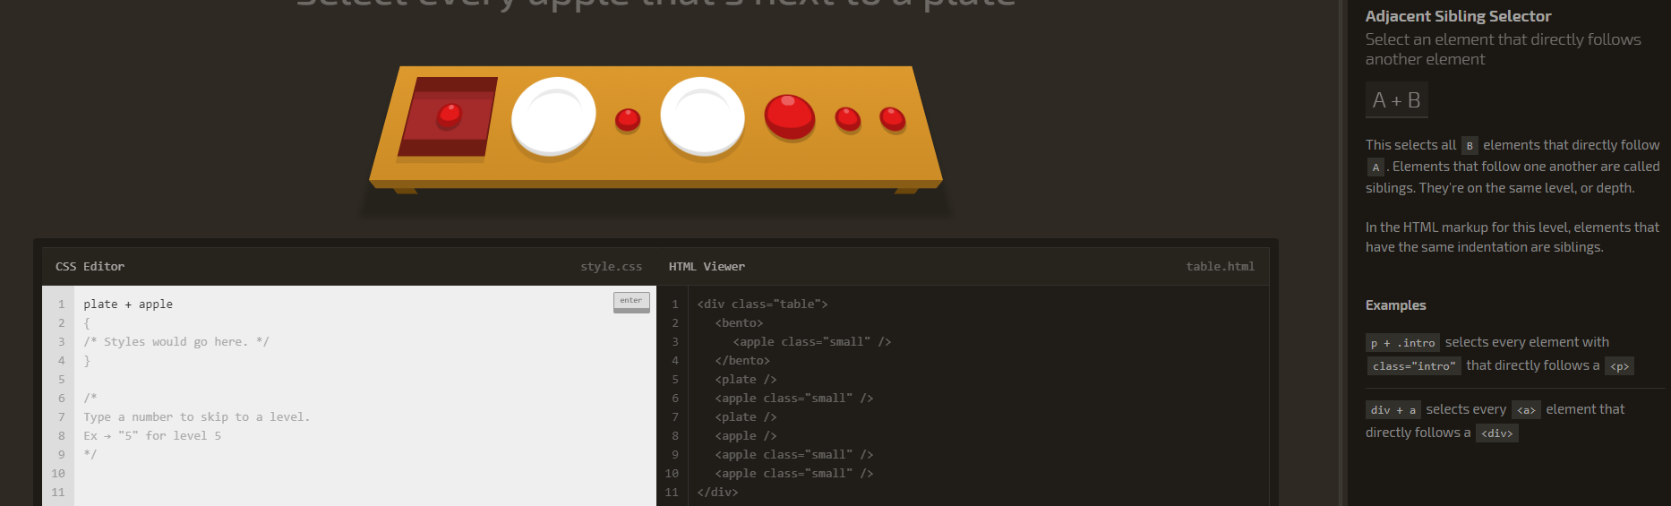

12. Select elements that follows another element: A ~ B

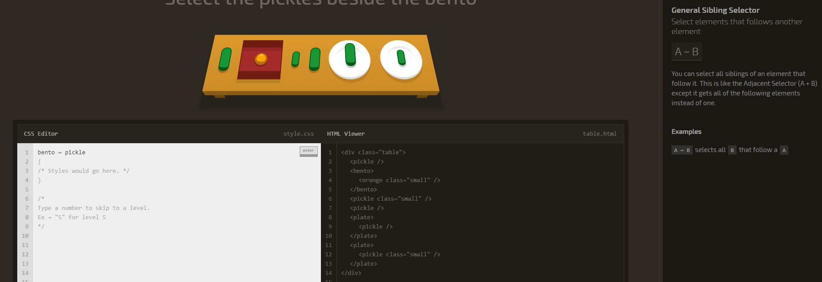

13. Select direct children of an element: A > B

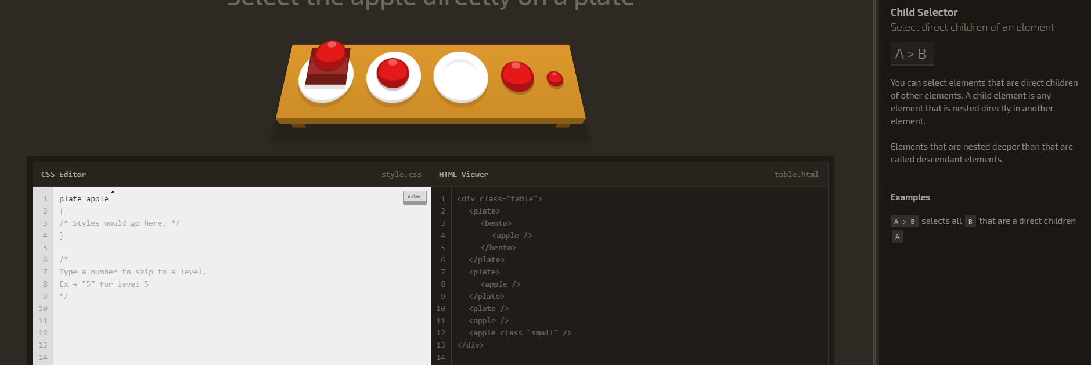

14. Select a first child element inside of another element: :first-child

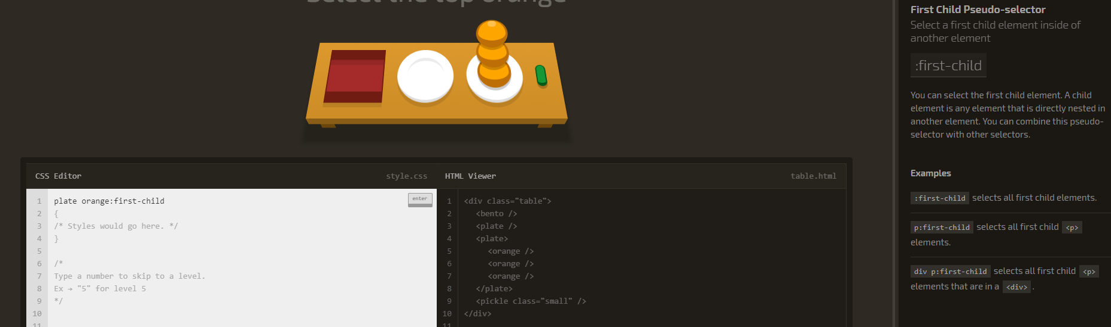

15. Select an element that are the only element inside of another one: :only-child

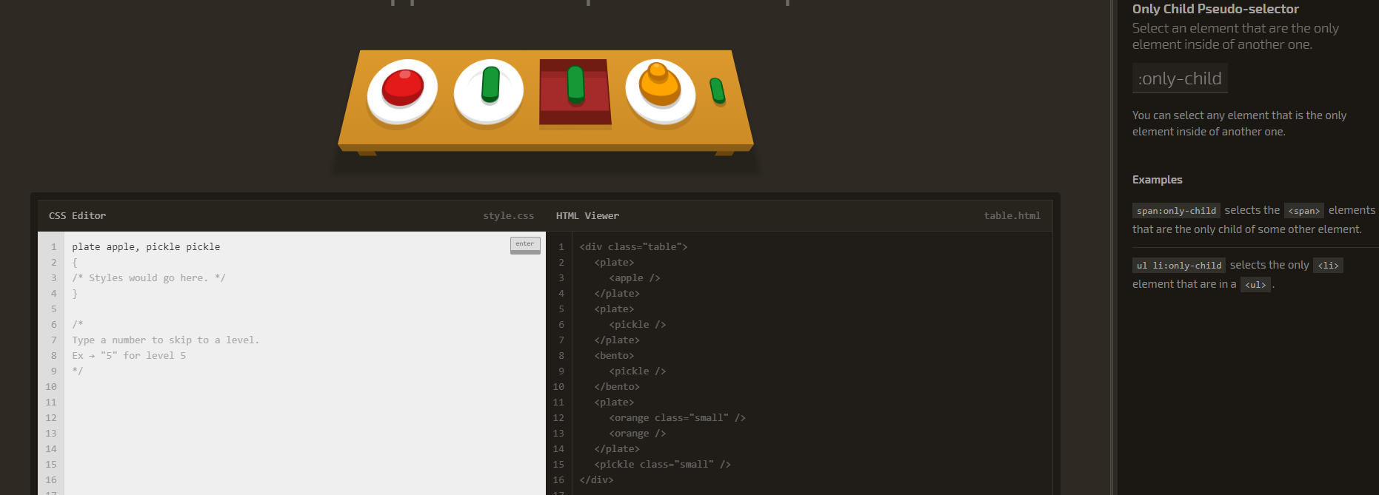

16. Select the last element inside of another element: :last-child

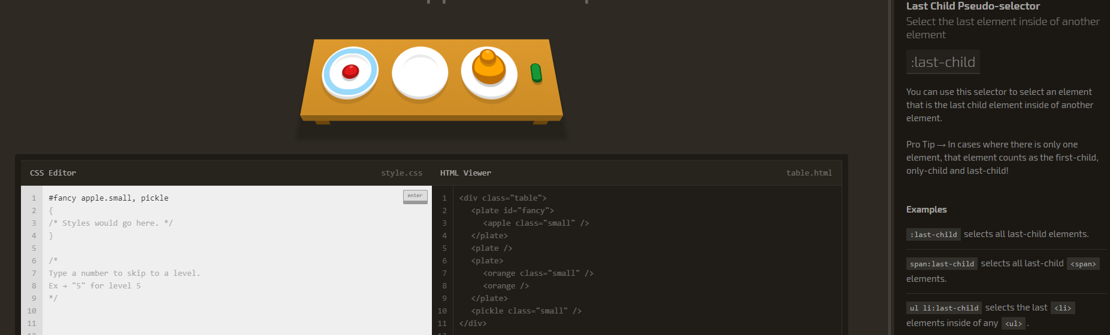

17. Select an element by its order in another element: :nth-child(A)

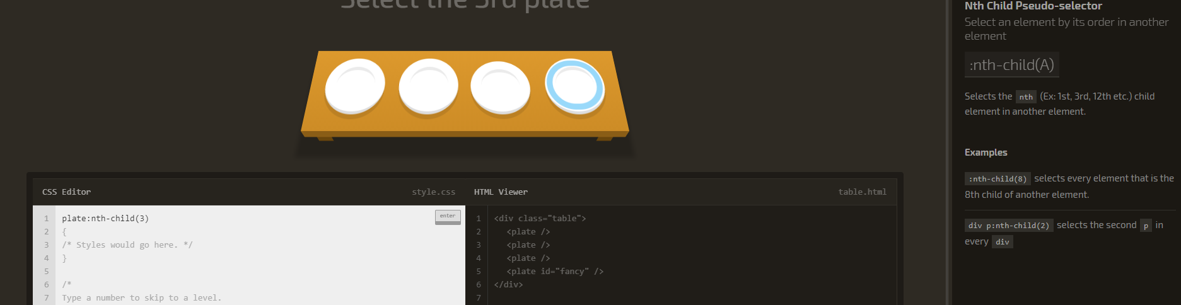

18. Select an element by its order in another element, counting from the back: :nth-last-child(A)

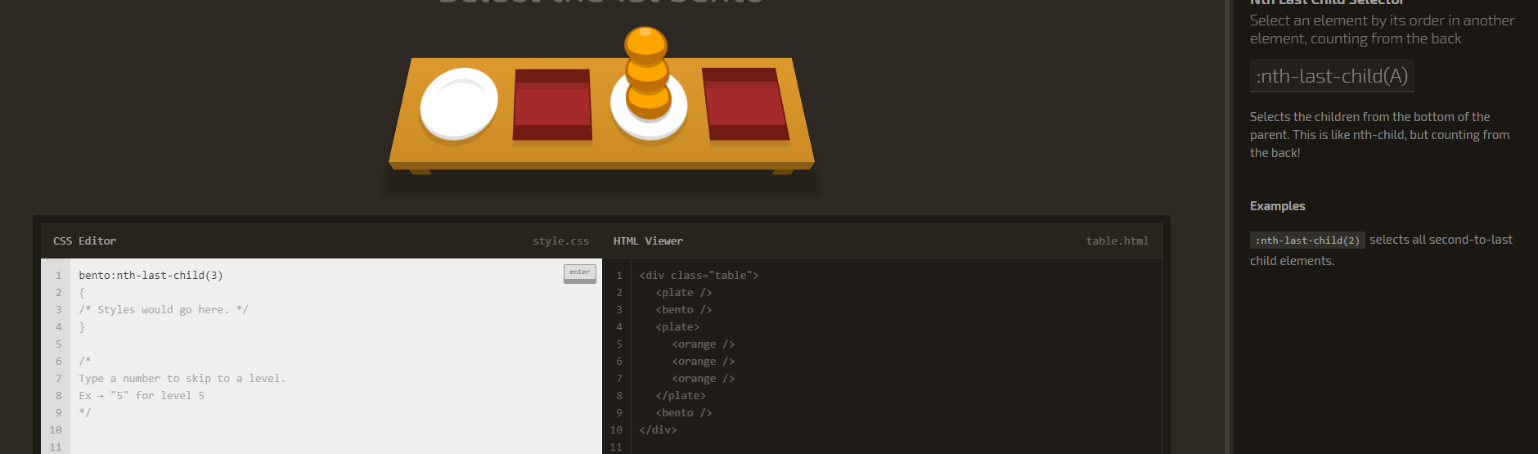

19. Select the first element of a specific type: :first-of-type

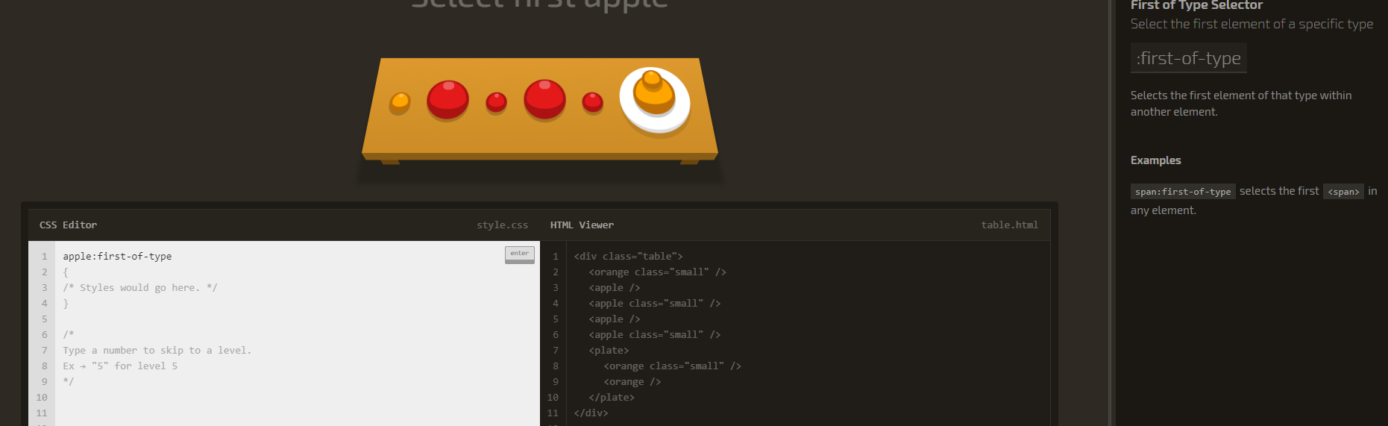

20. Select Nth of Type Selector: :nth-of-type(A)

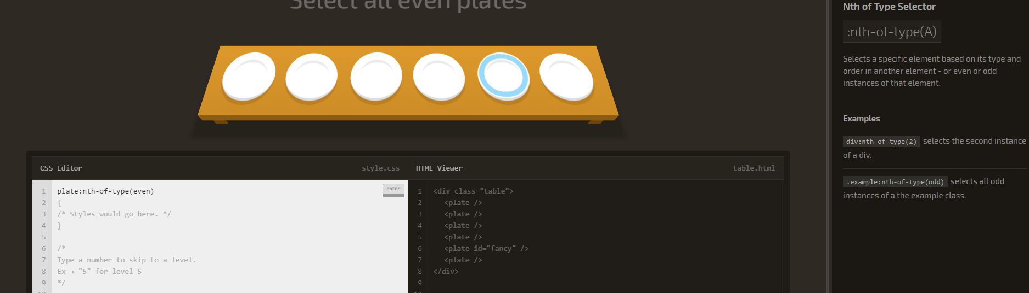

21. Select Nth-of-type Selector with Formula: :nth-of-type(An+B)

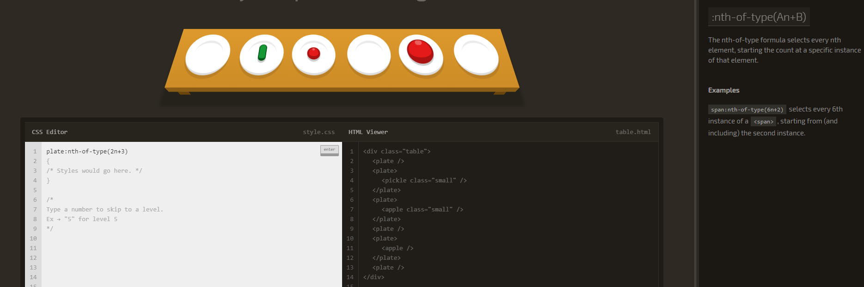

22. Select elements that are the only ones of their type within of their parent element: :only-of-type

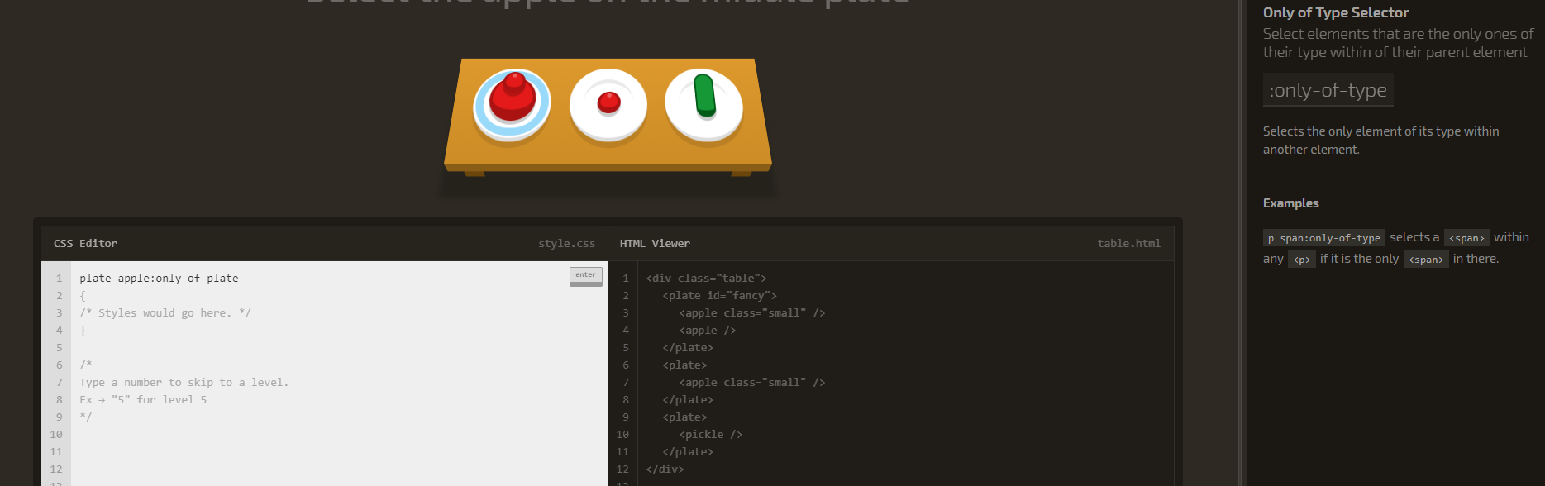

23. Select the last element of a specific type: :last-of-type

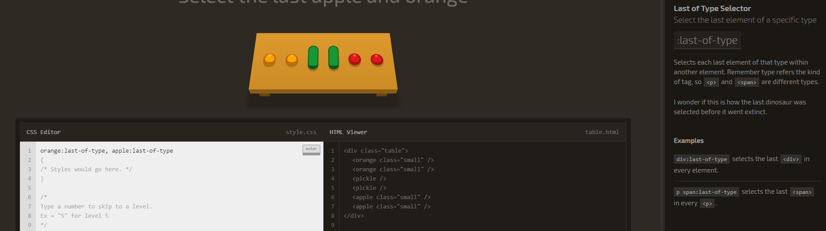

24. Select elements that don’t have children: :empty

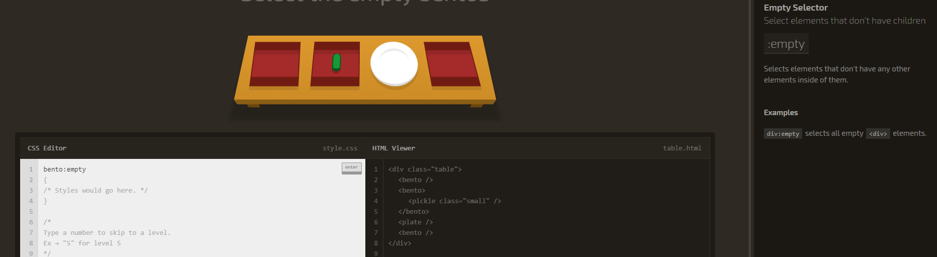

25. Select all elements that don’t match the negation selector: :not(X)

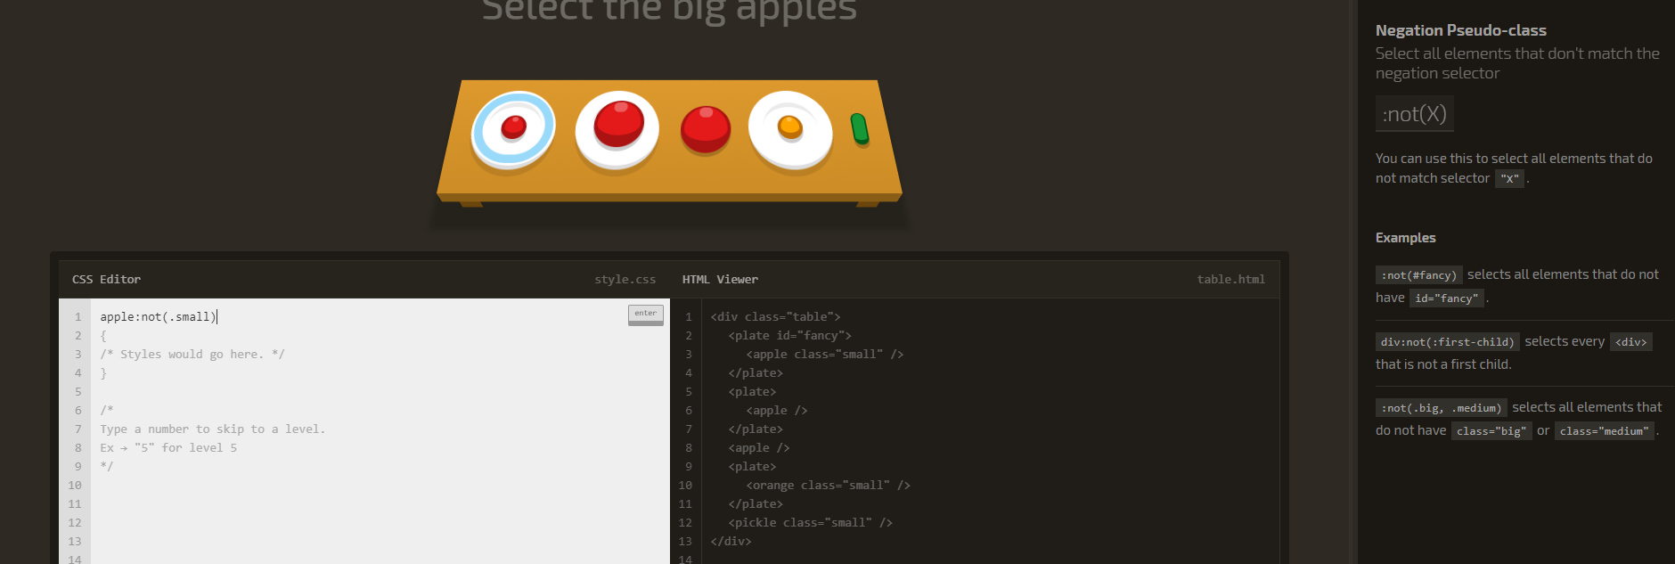

26. Select all elements that have a specific attribute: [attribute]

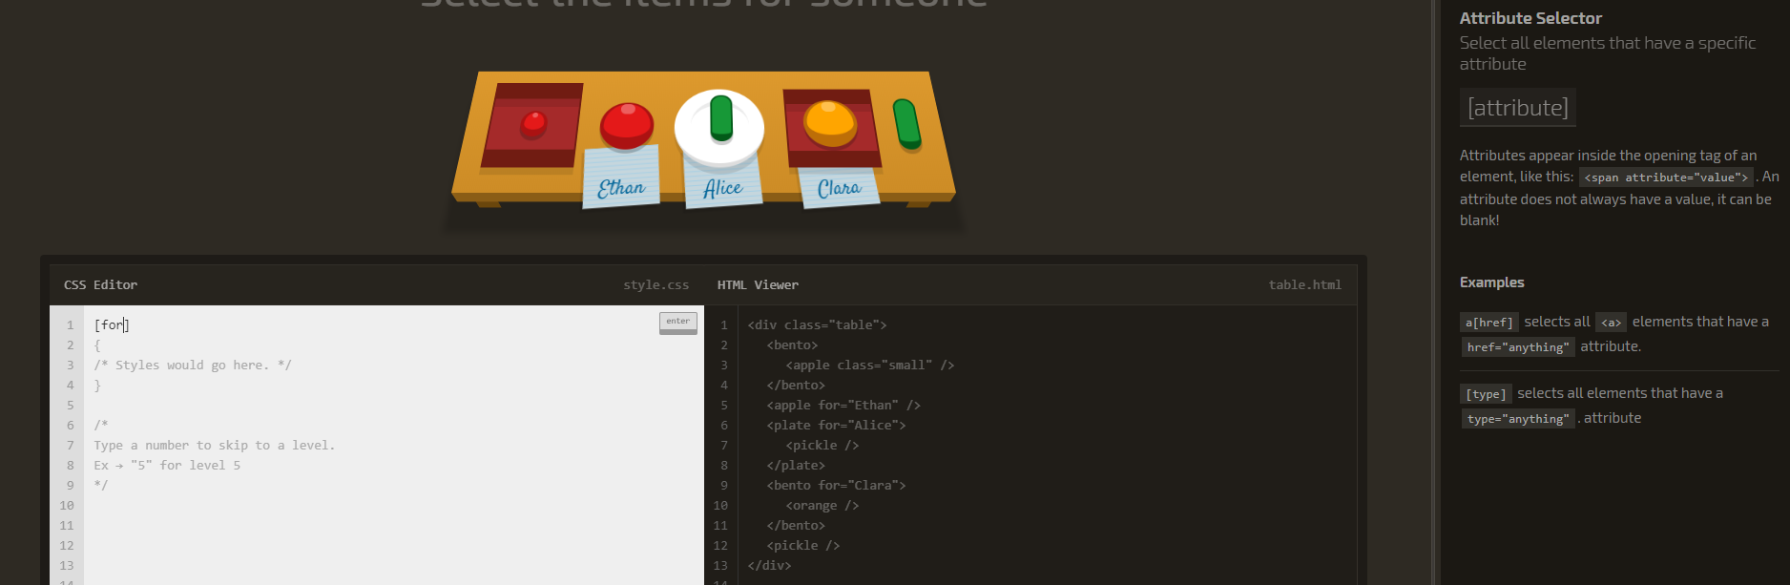

27. Select all elements that have a specific attribute: A[attribute]

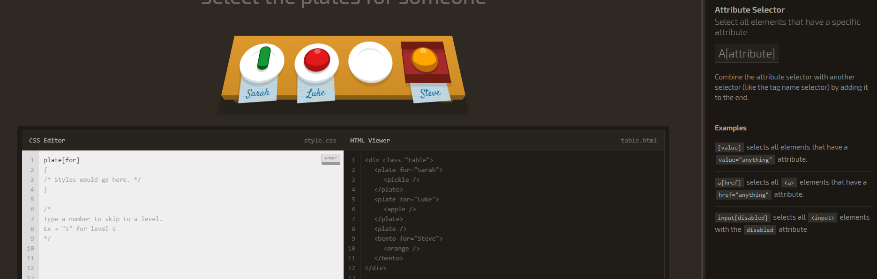

28. Select all elements that have a specific attribute value: [attribute=”value”]

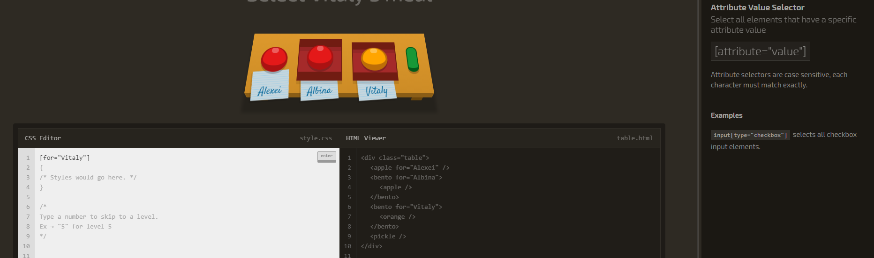

29. Select all elements with an attribute value that starts with specific characters: [attribute^="value"]

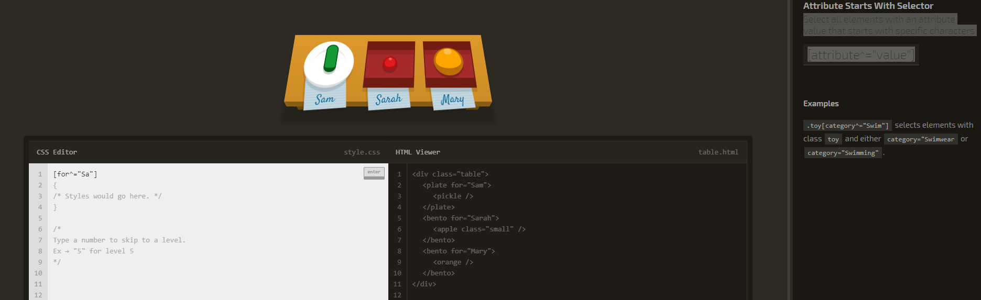

### 30. Select all elements with an attribute value that ends with specific characters: [attribute$="value"]

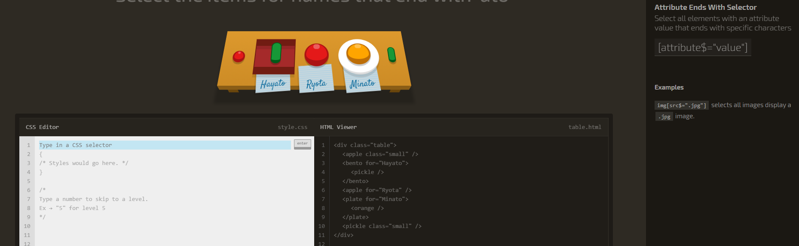

31. Select all elements with an attribute value that contains specific characters anywhere: [attribute*="value"]

