Reference: <https://www.youtube.com/watch?v=9RHO6jU--GU>

1. Binary Tree Traversal

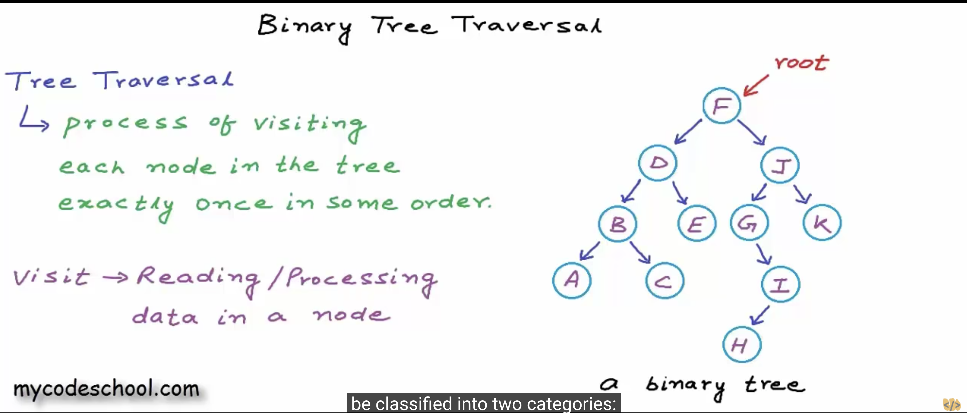

2.Two ways to traverse a tree

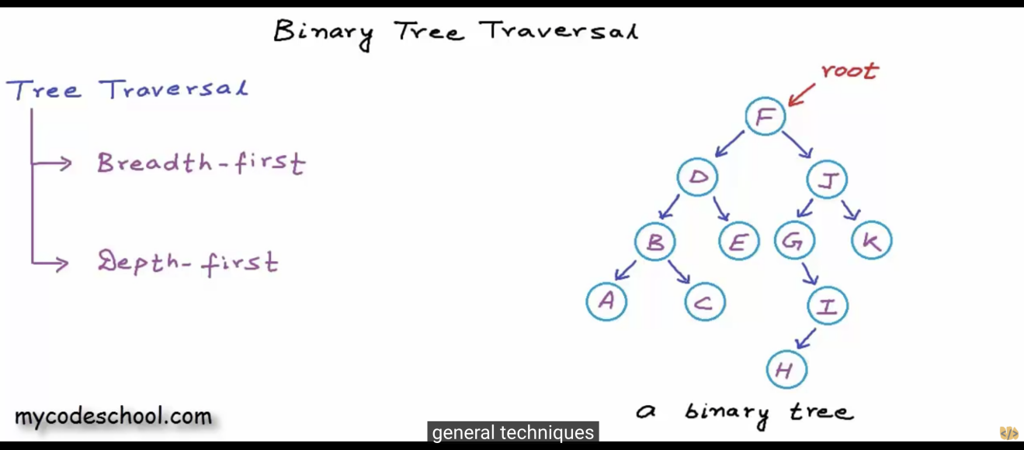

1. Breadth first search - Root, then from left to right in each level

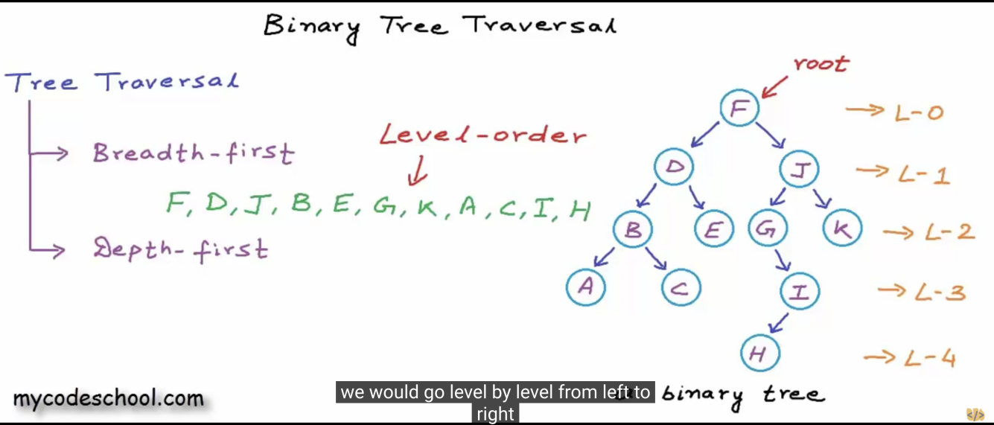

4.Preorder -> root,left,right Inorder -> left,root,right Postorder -> left, right, root

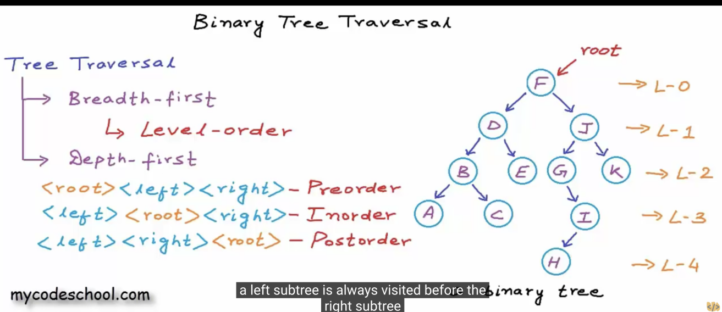

1. Preorder -> finish left subtree first

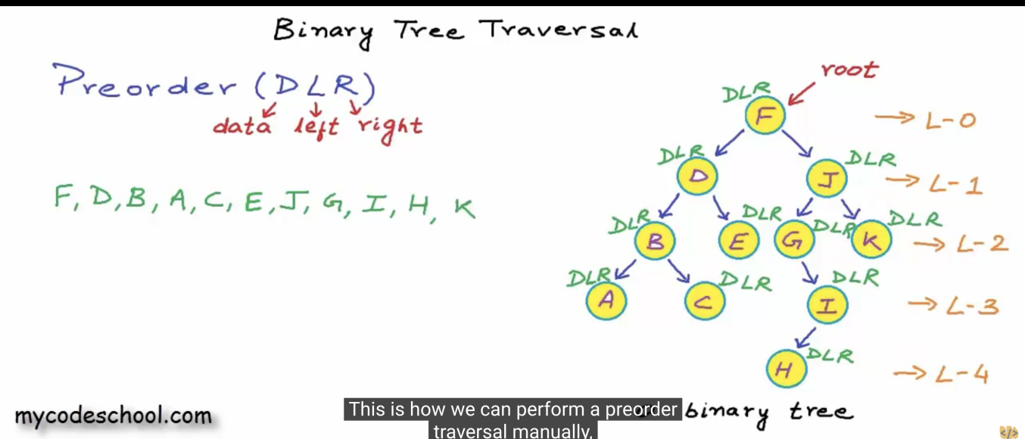

6.Postorder

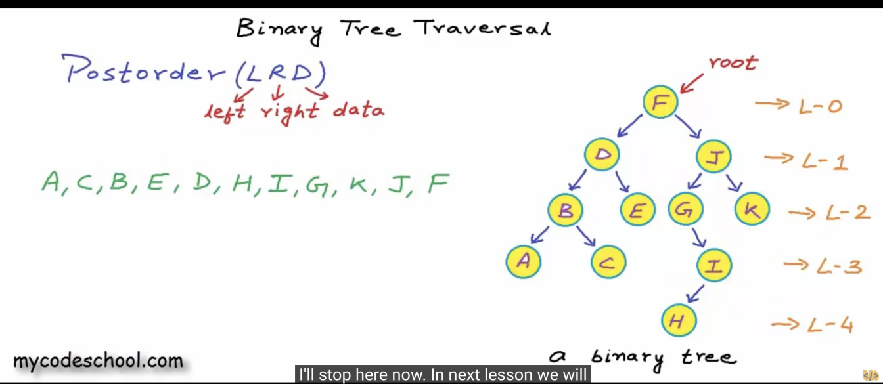

7.Inorder -> Because G doesn’t have left node, so F->G, then G’s right side, so H, I.

