1. Use docker-compose file to create two containers (project: github/othersProject/tutorials-master)

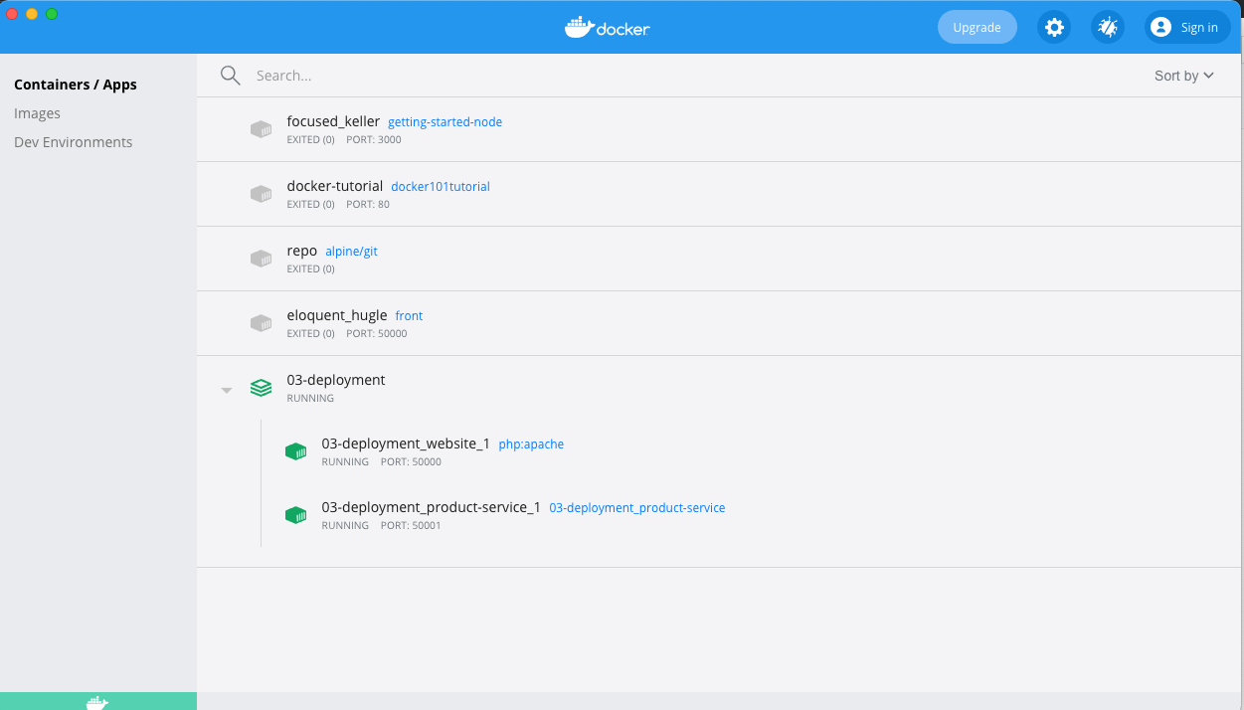

Get correct response

1. One container is started up outside docker compose. They can not talk to each other

