1.Create a new repo in github. Here ‘javascript_freeCodeCamp’ is created as repo name. Then, in local javascript_freeCodeCamp folder, enter ‘git remote add xxxxxxxxxxx’

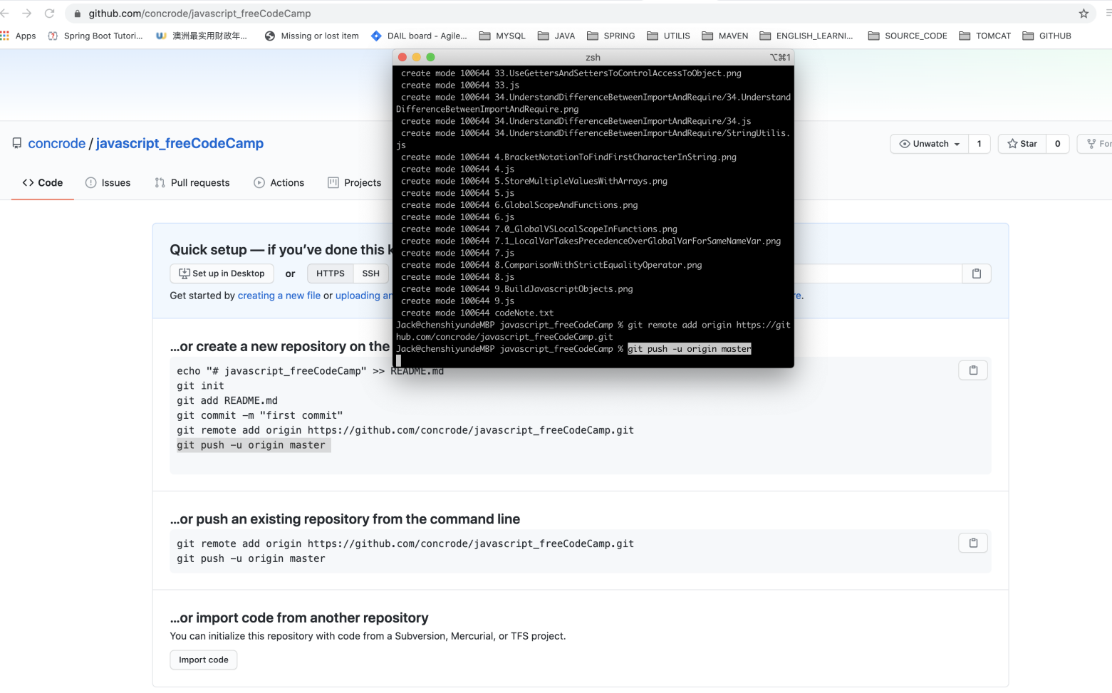

2. Push it to remote repo, enter ‘git push -u origin master’

