1. There are two branches for project spring-demo. One is master branch, the other is DAIL-3 branch.

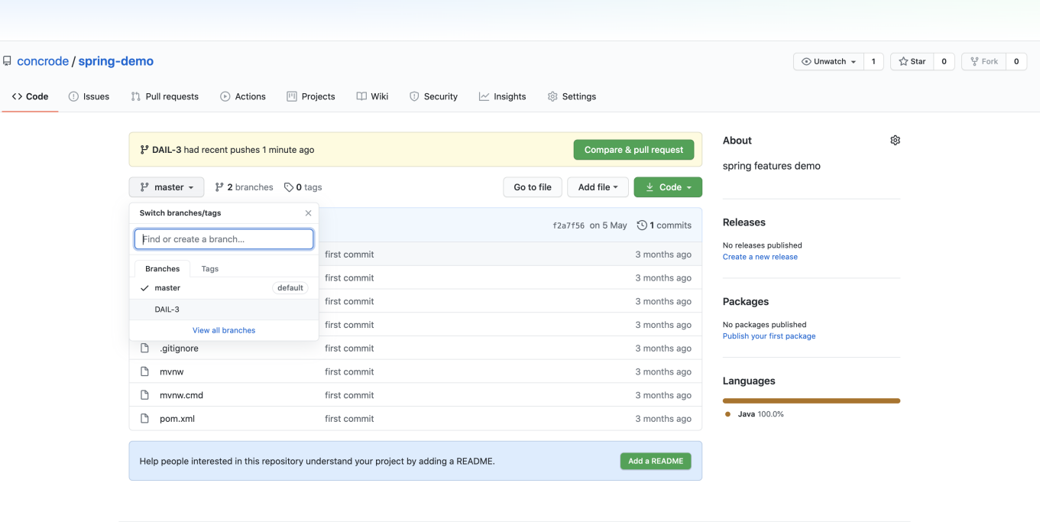

1. Create a new folder github in Downloads folder by using ‘mkdir github’

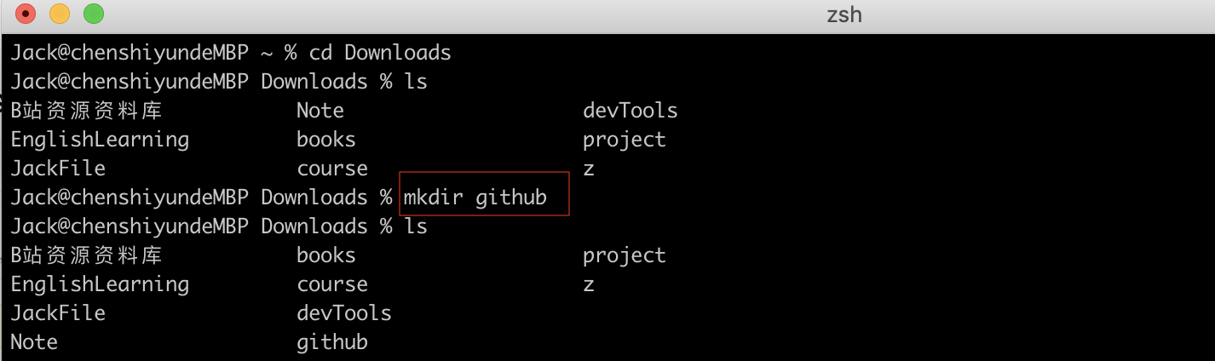

1. In github folder, enter ‘git clone -b DIAL-3 <https://github.com/concrode/spring-demo.git’> to clone DIAL-3 branch

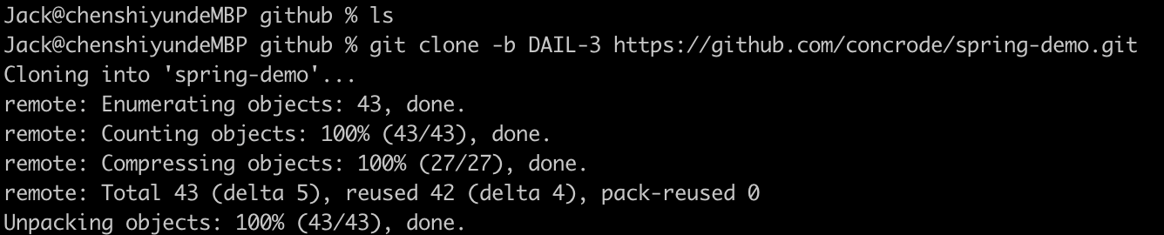

1. In spring-demo folder, enter ‘git status’

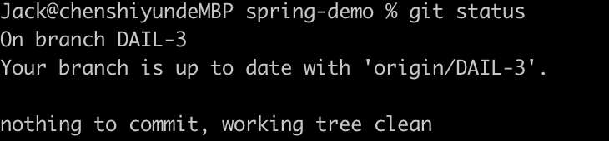

1. If changes made on project, then ‘git push’ to remote repo

