搭建一个 nostr 中继服务

原创 kimim [元宇宙物联网](javascript:void(0);) 2023-02-04 18:08

收录于合集

#分布式社交网络3个

#元宇宙3个

之前介绍过（[分布式社交网络 Nostr & Damus](http://mp.weixin.qq.com/s?__biz=MzA3NzA2NTgzNw==&mid=2449494490&idx=1&sn=89ebb1030b6a8cdff03b3a8744b7eec1&chksm=88a34ad8bfd4c3cedcd96adec56447bb60acd0258c4084c7cd607a2001240714eb385d808851&scene=21#wechat_redirect)） ，nostr 是一个相当简单的开放协议，可以在全球范围内搭建一个有趣的社交网络。因为协议本身很简单，所以大部分的加密、签名工作在客户端完成，而中继服务器 Relay 所做的事情只是接收事件消息，根据客户端订阅要求返回消息。

目前 relay 的实现也很多，比如 nostream 的搭建就很方便，只要安装好 docker，设置好域名，直接运行就可以啦。

以下记录一下 Relay 的搭建过程。

**1. 安装基础软件**

分配一台安装Ubuntu Server 20.04 LTS 操作系统的虚拟机，默认规格就够了。

首先，更新软件包列表。提示 30 个软件包需要升级，暂时先不管。

kimim@nostr:~$ sudo apt update

*# update package list from mirrors*

Fetched 25.5 MB in 4s (6240 kB/s)

Reading package lists... Done

Building dependency tree... Done

Reading state information...Done

30 packages can be upgraded. Run 'apt list --upgradable' to see them.

然后，安装以下软件包，用来运行编译 nostream，配置 relay 的证书。

kimim@nostr:~$ sudo apt install nodejs npm nginx certbot python3-certbot-nginx

*# list of packages need to be installed*

0 upgraded, 410 newly installed, 0 to remove and 30 not upgraded.

Need to get 168 MB of archives.

After this operation, 669 MB of additional disk space will be used.

Do you want to continue? [Y/n] Y

*# installation in progress*

**2. 安装 docker**

接下来，安装 docker，因为根据 nostream 官网要求，需要安装官方的 docker。就是按照官方操作指南 https://docs.docker.com/engine/install/ubuntu/ 安装 docker。

首先，删除已经安装的 docker（如果有，我的这台机器刚初始化，所以没有安装 docker）。

kimim@nostr:~$ sudo apt-get remove docker.io

Reading package lists... Done

Building dependency tree... Done

Reading state information... Done

Package 'docker.io' is not installed, so not removed

0 upgraded, 0 newly installed, 0 to remove and 30 not upgraded.

然后，安装 docker 需要的证书组件。

kimim@nostr:~$ sudo apt-get install ca-certificates curl gnupg lsb-release

Reading package lists... Done

Building dependency tree... Done

Reading state information... Done

lsb-release is already the newest version (11.1.0ubuntu4).

lsb-release set to manually installed.

ca-certificates is already the newest version (20211016ubuntu0.22.04.1).

ca-certificates set to manually installed.

curl is already the newest version (7.81.0-1ubuntu1.7).

curl set to manually installed.

gnupg is already the newest version (2.2.27-3ubuntu2.1).

gnupg set to manually installed.

0 upgraded, 0 newly installed, 0 to remove and 30 not upgraded.

接着，添加 docker 官方 GPG 证书。

kimim@nostr:~$ sudo mkdir -p /etc/apt/keyrings

kimim@nostr:~$ curl -fsSL https://download.docker.com/linux/ubuntu/gpg | sudo gpg --dearmor -o /etc/apt/keyrings/docker.gpg

添加 docker 官方源：

kimim@nostr:~$ echo \

"deb [arch=$(dpkg --print-architecture) signed-by=/etc/apt/keyrings/docker.gpg] https://download.docker.com/linux/ubuntu \

$(lsb_release -cs) stable" | sudo tee /etc/apt/sources.list.d/docker.list > /dev/null

再次更新软件包：

kimim@nostr:~$ sudo apt-get update

Get:1 https:*//download.docker.com/linux/ubuntu jammy InRelease [48.9 kB]*

Get:2 https:*//download.docker.com/linux/ubuntu jammy/stable amd64 Packages [12.7 kB]*

Fetched 61.6 kB in 1s (105 kB/s)

Reading package lists... Done

安装 docker 以及 cli，compose 插件。

kimim@nostr:~$ sudo apt-get install docker-ce docker-ce-cli containerd.io docker-compose-plugin

*# list of packages need to be installed*

0 upgraded, 11 newly installed, 0 to remove and 30 not upgraded.

Need to get 111 MB of archives.

After this operation, 397 MB of additional disk space will be used.

Do you want to continue? [Y/n] Y

*# installation in progress*

把当前用户添加到 docker 权限组：

kimim@nostr:~$ sudo usermod -a -G docker kimim

kimim@nostr:~$ newgrp docker

测试一下 docker 是否正常工作：

kimim@nostr:~$ docker run hello-world

Unable to find image 'hello-world:latest' locally

latest: Pulling from library/hello-world

2db29710123e: Pull complete

Digest: sha256:aa0cc8055b82dc2509bed2e19b275c8f463506616377219d9642221ab53cf9fe

Status: Downloaded newer image for hello-world:latest

Hello from Docker!

This message shows that your installation appears to be working correctly.

**3. 配置服务器证书**

修改 nginx 的配置文件。请根据自己的服务器域名修改 server_name 字段。

kimim@nostr:~$ sudo rm -rf /etc/nginx/sites-available/default

kimim@nostr:~$ sudo vi /etc/nginx/sites-available/default

*# 添加以下内容*

kimim@nostr:~$ cat /etc/nginx/sites-available/default

server{

server_name nostr.kimi.im;

location / {

proxy_set_header X-Forwarded-For $proxy_add_x_forwarded_for;

proxy_set_header Host $host;

proxy_pass http:*//127.0.0.1:8008;*

proxy_http_version 1.1;

proxy_set_header Upgrade $http_upgrade;

proxy_set_header Connection "upgrade";

}

}

重启 nginx，使配置生效。

kimim@nostr:~$ sudo service nginx restart

添加 A 域名记录，比如：

TYPE HOST ANSWER TTL

A nostr.kimi.im 192.30.252.153 300

等一两分钟，等域名记录生效，再用 certbox 配置服务器证书：

kimim@nostr:~$ sudo certbot *--nginx -d nostr.kimi.im*

Saving debug log to /var/log/letsencrypt/letsencrypt.log

Enter email address (used for urgent renewal and security notices)

(Enter 'c' to cancel): kimim@kimi.im  
- - - - - - - - - - - - - - - - - - - - - - - - - - - - - - - - - - - - - - - -

Please read the Terms of Service at

https://letsencrypt.org/documents/LE-SA-v1.3-September-21-2022.pdf. You must

agree in order to register with the ACME server. Do you agree?

- - - - - - - - - - - - - - - - - - - - - - - - - - - - - - - - - - - - - - - -

(Y)es/(N)o: Y

Successfully received certificate.

Certificate is saved at: /etc/letsencrypt/live/nostr.kimi.im/fullchain.pem

Key is saved at: /etc/letsencrypt/live/nostr.kimi.im/privkey.pem

This certificate expires on 2023-05-05.

These files will be updated when the certificate renews.

Certbot has set up a scheduled task to automatically renew this certificate in the background.

Deploying certificate

Successfully deployed certificate for nostr.kimi.im to /etc/nginx/sites-enabled/default

Congratulations! You have successfully enabled HTTPS on <https://nostr.kimi.im>

- - - - - - - - - - - - - - - - - - - - - - - - - - - - - - - - - - - - - - - -

If you like Certbot, please consider supporting our work by:

* Donating to ISRG / Let's Encrypt: <https://letsencrypt.org/donate>

* Donating to EFF: <https://eff.org/donate-le>

- - - - - - - - - - - - - - - - - - - - - - - - - - - - - - - - - - - - - - - -

**4. 运行 nostream**

获取 nostream 代码：

kimim@nostr:~$ git clone <https://github.com/Cameri/nostream.git>

Cloning into 'nostream'...

remote: Enumerating objects: 3287, done.

remote: Counting objects: 100% (1228/1228), done.

remote: Compressing objects: 100% (415/415), done.

remote: Total 3287 (delta 889), reused 984 (delta 803), pack-reused 2059

Receiving objects: 100% (3287/3287), 1.05 MiB | 7.90 MiB/s, done.

Resolving deltas: 100% (2036/2036), done.

用 docker 运行 nostream，大概用了两分钟，就看到一个漂亮的 NOSTREAM logo 了。

kimim@nostr:~$ cd nostream/

kimim@nostr:~/nostream$ npm run docker:compose:start

> nostream@1.21.0 docker:compose:start

> ./scripts/start

[+] Running 25/25

*# ...*

[+] Building 128.2s (16/16) FINISHED

*# ...*

[+] Running 6/5

*# ...*

Attaching to nostream, nostream-cache, nostream-db, nostream-migrate

*# ...*

nostream-db | CREATE DATABASE

*# ...*

nostream |

nostream | ███▄ █ ▒█████ ██████ ▄▄▄█████▓ ██▀███ ▓█████ ▄▄▄ ███▄ ▄███▓

nostream | ██ ▀█ █ ▒██▒ ██▒▒██ ▒ ▓ ██▒ ▓▒▓██ ▒ ██▒▓█ ▀▒████▄ ▓██▒▀█▀ ██▒

nostream | ▓██ ▀█ ██▒▒██░ ██▒░ ▓██▄ ▒ ▓██░ ▒░▓██ ░▄█ ▒▒███ ▒██ ▀█▄ ▓██ ▓██░

nostream | ▓██▒ ▐▌██▒▒██ ██░ ▒ ██▒░ ▓██▓ ░ ▒██▀▀█▄ ▒▓█ ▄░██▄▄▄▄██ ▒██ ▒██

nostream | ▒██░ ▓██░░ ████▓▒░▒██████▒▒ ▒██▒ ░ ░██▓ ▒██▒░▒████▒▓█ ▓██▒▒██▒ ░██▒

nostream | ░ ▒░ ▒ ▒ ░ ▒░▒░▒░ ▒ ▒▓▒ ▒ ░ ▒ ░░ ░ ▒▓ ░▒▓░░░ ▒░ ░▒▒ ▓▒█░░ ▒░ ░ ░

nostream | ░ ░░ ░ ▒░ ░ ▒ ▒░ ░ ░▒ ░ ░ ░ ░▒ ░ ▒░ ░ ░ ░ ▒ ▒▒ ░░ ░ ░

nostream | ░ ░ ░ ░ ░ ░ ▒ ░ ░ ░ ░ ░░ ░ ░ ░ ▒ ░ ░

nostream | ░ ░ ░ ░ ░ ░ ░ ░ ░ ░

nostream | v1.21.0

nostream | NIPs implemented: 1,2,4,9,11,12,15,16,20,22,26,28,33,40

nostream | Pay-to-relay disabled

nostream | Payments provider: zebedee

nostream | 2 client workers started

nostream | 1 maintenance worker started

nostream | Tor hidden service: disabled

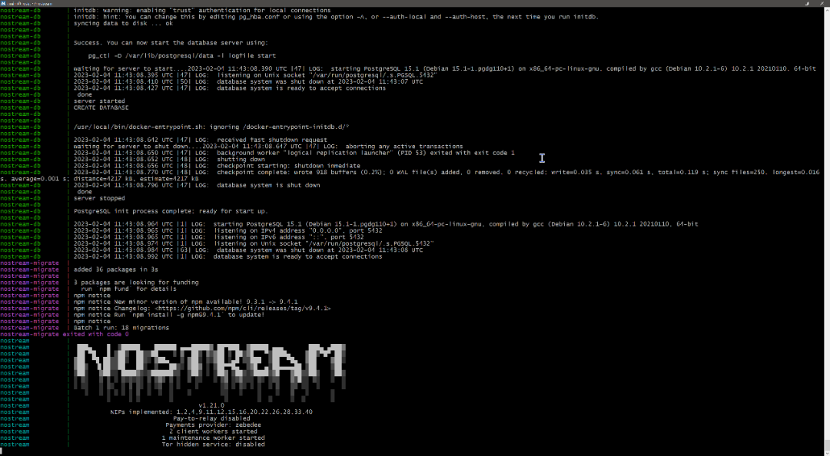

**5. 用 noscl 测试 relay 是否正常工作**

之前介绍过 noscl 的用法（[Nostr 协议，及命令行工具 noscl](http://mp.weixin.qq.com/s?__biz=MzA3NzA2NTgzNw==&mid=2449494495&idx=1&sn=3df976a73f4552139b654c32d2ffb010&chksm=88a34addbfd4c3cbf06f145c933d74657e4065a7ef6032aa3e576f9bc3fa6bee926b0bb2775e&scene=21#wechat_redirect)），那时忘记提供 noscl 的下载地址了，可以从这里下载： https://github.com/fiatjaf/noscl/releases

继续[Nostr 协议，及命令行工具 noscl](http://mp.weixin.qq.com/s?__biz=MzA3NzA2NTgzNw==&mid=2449494495&idx=1&sn=3df976a73f4552139b654c32d2ffb010&chksm=88a34addbfd4c3cbf06f145c933d74657e4065a7ef6032aa3e576f9bc3fa6bee926b0bb2775e&scene=21#wechat_redirect) 介绍的操作设置。

删除之前添加的 relay：

[kimim@virtualbox ~]$ ./noscl relay

wss:*//nos.lol: rw*

[kimim@virtualbox ~]$ ./noscl relay remove wss:*//nos.lol*

Removed relay wss:*//nos.lol.*

添加刚刚搭建的 relay：

[kimim@virtualbox ~]$ ./noscl relay add wss:*//nostr.kimi.im*

Added relay wss:*//nostr.kimi.im.*

发送消息 Bonjour tout le monde：

[kimim@virtualbox ~]$ ./noscl publish "Bonjour tout le monde"

Sent event a170e3f3c4f8cfb79cacccf28d5f7d51a5e17b4e40c0984593a692b83f9cf43c to 'wss://nostr.kimi.im'.

Seen a170e3f3c4f8cfb79cacccf28d5f7d51a5e17b4e40c0984593a692b83f9cf43c on 'wss://nostr.kimi.im'.

在 Damus 一开始收不测试帐号发送的消息，需要在 Damus 客户端也添加同样的 relay。

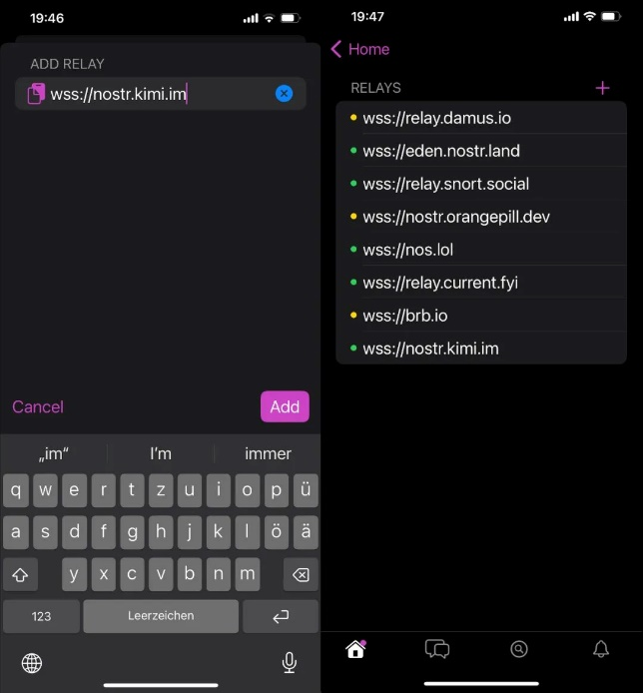

然后，就能看到测试帐号发的：Bonjour tout le monde

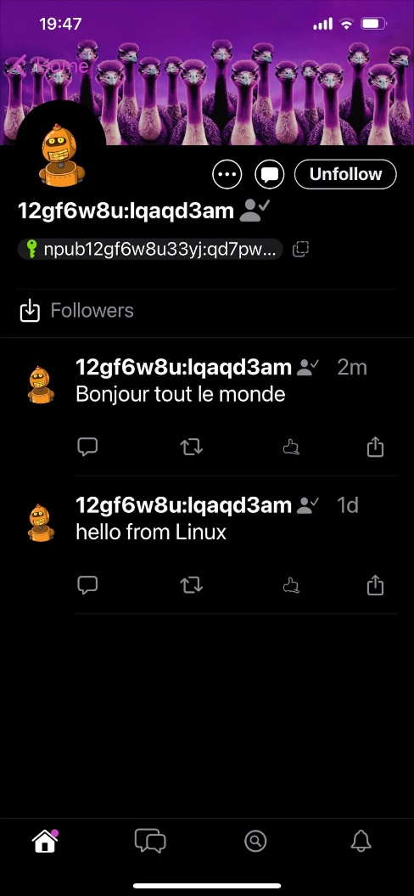

简单吧。真是 Pura Vida 啊！

