"La experiencia de InfoAndina: Metodologías de comunicación de bajo costo para el desarrollo sostenible de regiones rurales Alto-Andinas"

Ing. Ana Maria Ponce

InfoAndina Manager
Node Manager of the Latin American Mountain Forum
Av. La Universidad 795 - La Molina
P.O. Box 1558 , Lima 12, Peru
E-mail: A.Ponce@cgiar.org

Resumen

Abstract

Rural populations in the high-Andes are traditionally isolated from the communication advances available in lower zones. This represents a challenge to develop participatory applications over narrow-band communication channels. Due to the recent privatization of the communication providers in Latin America, Internet rates are getting lower and more competitive. This represents a challenge for rural development projects, to promote the use of Internet resources among individuals and institutions working on rural development in high-Andean regions.

Since 1995, InfoAndina has applied low-cost communication tools to facilitate information exchange among CONDESAN partners in secondary cities in the Andes. CONDESAN is the Consortium for Sustainable Development of the Andean Ecorregion, created in 1992 to address research issues related to poverty and loss of natural resources in rural areas in five Andean countries. However, many development issues cross borders between countries. Therefore, CONDESAN / InfoAndina provide "virtual spaces" for exchange information and debate topics among multidisciplinary teams from different countries. Some trans-Andean issues covered on CONDESAN forums are: soil biology, in-situ conservation, watershed management, improvement of graduate studies related to production systems and natural resources management.

InfoAndina: Regional Node of the Mountain Forum

Since the inception of the Mountain Forum in 1996, InfoAndina has operated the Latin American node of the Mountain Forum, a global communication network for information exchange on mountain conservation and development. The Mountain Forum was created through the collaboration of NGOs, universities, multi-lateral agencies and the private sector. This global network takes advantage of the expansion of the Internet into remote mountain regions. The Mountain Forum coordinates its activities through the Global Information Server Node (GISN) (www.mtnforum.org), and its regional nodes in Africa, Asia, Europe and Latin America (InfoAndina). The Mountain Forum uses the Internet in ways that minimize costs and technical requirements and maximize outreach to remote areas. All of the Internet resources, including the web archives and the on-line library, are available via plain email. Big effort is given into the email services, to ensure value added for users in remote mountain regions with limited access to Internet.

InfoAndina has enriched the Mountain Forum services, contributing with its experience in the organization of regional electronic conferences and specialized discussion lists in Spanish. The Mountain Forum services in Latin America reaches nowadays over 1000 subscribers in Latin America. InfoAndina has designed a WEB site (www.condesan.org) including a "virtual bookstore" of for advertising and selling publications of CONDESAN partners. The WEB include an electronic archive of specialized articles in Spanish on sustainable development and conservation in the Andes, submitted by CONDESAN partners. CONDESAN WEB pages contains also articles and comments of the electronic conferences moderated by specialists from the Andean countries.
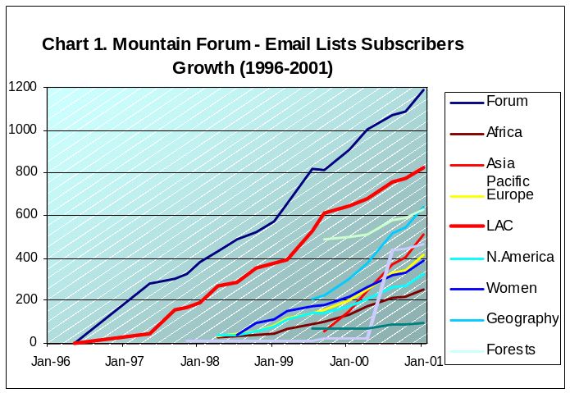
InfoAndina moderates the second largest list of the Mountain Forum. (See Chart 1), as well as thematic lists (ej. Paramos). Over its regional lists, InfoAndina disseminates periodic newsletters on sustainable development issues (InfoNotas). These include events, recent publications, announcements of new projects and job opportunities.

During 2001 and 2002, InfoAndina e-newsletters support the public awareness campaign on the International Year of the Mountains (IYM2002).

InfoAndina Membership

InfoAndina's membership is composed of a wide base of institutions, Universities, Governmental, non-governmental and private members (See Chart 3).
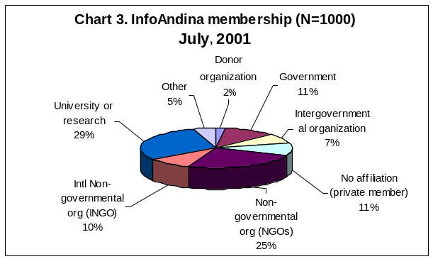
InfoAndina moderates several lists with over 1000 subscribers. These lists open space for thematic discussion in Spanish (e-conferences) and newsletters to disseminate announcements of regional interest, covering a wide range of topics such as: Andean biodiversity, production systems, and policy issues. Its membership has increased in the past few years as result of public awareness campaigns and travelling workshops in the Andes.
InfoAndina E-Conferences

Since 1997, InfoAndina has been a pioneer for the organization of electronic conferences in Latin America. These e-conferences cover topics of regional impact, such as: Paramos Conservation, In-Situ Conservation, the Challenges of Rural Agroindustries in the Andes, and Local Governments for Sustainable Development. The forums are bilingual: Spanish and English, and have an increased participation of specialists from Latin America and other developed countries.

To provide an example, the E-Conference on Rural Agroindustries had a participation of 500 members from diverse type of organizations: NGOs (40%), NARS (8%), Universities (20%), and the Private Sector (17%). During the second half of 2001, InfoAndina will organize its Fourth E-conference on InSitu Conservation (In-Situ 2001), and in 2002 the 2nd E-Conference "Local Governments and Sustainable Development in the Andes", and the 1st E-Conference on Soil Conservation and Management Issues, sponsored by the MOSANDES initiative.

Chart 2. E-Conferences organized by InfoAndina since 1997
Year | E-Conference | Moderator | Participants
1997 | "Strategies for Conservation of Paramos & Punas" | J.Recharte (TMI) | 150
1997 | "In-Situ 97" | M.Holle (CIP) | 100
1998 | InfoPapa: Potato Research in Latin America | A.Gonzalez (CIP) | 100
1998 | "Local Governments & Sustainable Development in the Andes" | H.Valencia (AME-Quito) | 200
1998 | "Experiences on Biosphere management in mountain regions of Latin America" | C.Ponce (CI-Peru) | 300
1999 | "Rural Agroindustries in the Andes and the Challenges of Globalization" | F.Boucher (PRODAR), S.Salas (CIP) | 450
1999 | "Improving education in Natural Resource Management in the Andes" | B.Rivera (U.Caldas) | 300
1999 | "Water Forum in Cochabamba" | J.Alurralde (CGIAB) | 200
1999 | "InSitu 99" | M.Holle (CIP) | 150
2000 | "2nd E-Conference on Páramos Conservation" | J.Recharte (TMI); J.Torres (UNALM); G.Medina (Ecociencia) | 450
2000 | "CONDESAN 21: Challenges of CONDESAN in XX! Century" | M.Mujica | 150

The key for the success of InfoAndina e-conferences in Latin America rely in the unique methodology developed by CONDESAN-InfoAndina for the organization of these forums. This methodology is based on a careful planning process, performed by CONDESAN Coordination and a specialized "Ad-Hoc Committee". This Committee provide valuable assistance in the selection of the conference topic, the agenda, and selection of the subject moderator(s). This process is supported by InfoAndina, responsible of the technical moderation, which starts with a wide dissemination of the e-conference announcements over specialized lists, registration of interested participants, setup of moderated lists for each conference, design of a dedicated WEB site, and WEB site maintainance in parallel with the conference. Both the thematic and the technical moderator's work should be well coordinated during the whole conference schedule, which should not exceed 4-5 weeks. The e-conference proceedings are edited easily in a printed version for wider dissemination, using the articles and comments archived in the WEB site.

InfoAndina Travelling Workshops

In order to increase participation of partners from secondary cities in the Andes, InfoAndina has incorporated low-cost "travelling workshops" to its outreach methodology. During 2000 and 2001, InfoAndina has organized 12 travelling workshops in 4 countries (Colombia, Ecuador, Peru and Bolivia). The workshops agenda include: Hands-on training sessions on the use of the on-line information resources, CD-ROM-based WEB resources for development, and the participants receive the "Moderator Manual", a guide to organize e-conferences. As result of these workshops, a total of 172 new members were incorporated to the Mountain Forum services from rural high-Andean cities. Table 1 below shows the geographic distribution of InfoAndina membership between 2000-2001.

Table 1. InfoAndina Membership between (2000-2001)
ECUADOR |  | PERU |  | BOLIVIA |  | COLOMBIA |  | TOTAL
Quito | 23 | Arequipa | 8 | Tarija | 12 | Tunja | 5
Carchi | 7 | Cusco | 17 | Cochabamba | 19 | Popayan | 4
Riobamba | 7 | Puno | 11 | La Paz | 6 | Cali | 19
Cuenca | 7 |  |  | Santa Cruz | 1 | Bogota | 16
Loja | 2 |  |  | Oruro | 6 | Santa Marta | 2
Sub Total | 46 |  | 36 |  | 44 |  | 46 | 172

Conclussions & Recommendations

In order to ensure sustainable development, it is not enough to provide internet connectivity, but also "close the circle" of the information, helping our partners in rural Andean locations to find adequate informatics’ resources to solve their needs or assist their work establishing contact with other specialized networks. The travelling workshops are a good and low-cost training and outreach tool, developed by InfoAndina. These are also complemented with hands-on demonstrative sessions on how to edit electronic newsletters and how to organize e-conferences. The information circle is closed when our partners develop the capacity to generate their own information, moderate e-conferences or edit local e-newsletters. This is what we call the "informatic culture".

In order to improve the "Informatic Culture", the among its partners at benchmark sites, InfoAndina supports the edition of local electronic newsletters via e-mail at remote Andean cities. For example, ASPADERUC, a local consortium in Cajamarca (Peru), prepare monthly editions of the "Cajachito Electronico", local electronic newsletter on rural development issues, which is disseminated over the regional InfoAndina lists, reaching a wider regional audience.

InfoAndina partners are now "closing this circle", starting to organize specialized E-conferences on water management issues (www.aguabolivia.com) in Bolivia, applying our methodology in behalf of the sustainable development in the Andes.

References

- Ponce, A.M.; E.Mujica; J.Posner: "Informatic Resources for Sustainable Development". InfoAndina Travelling Workshop in Manizales, Colombia, May 1999. CONDESAN.

- " MOUNTAIN FORUM - Membership Feedback Survey, 1999 - Part II" -Mtn-Forum On-Line Library Document

- Byers, E. 1997. The Mountain Forum: Learning to Communicate within a Pluralistic Network. Paper presented at the UN FAO Workshop on Pluralism and Sustainable Forestry and Rural Development, December 9-12, 1997, Rome, Italy. The Mountain Institute.

