[Name of organisation receiving ESOS audit]: Phase 4 ESOS recommendations

What is the Energy Savings Opportunity Scheme?
Energy Savings Opportunity Scheme (ESOS) is a mandatory energy assessment scheme for large UK organisations and their corporate groups. It requires an audit of the energy used by your buildings, industrial processes and transport to identify cost-effective energy saving measures. As part of your assessment, we have calculated your total energy consumption, identified your areas of significant energy consumption, and created recommendations to save energy. By reducing wasteful energy consumption, implementing ESOS recommendations can drive both cost savings and reduce carbon emissions.

Recommendations: benefits
[Organisation] consumes [X] kWh/yr of electricity, [X] kWh/yr of natural gas, and [X] litres of petrol, which amounts to [X] tCO2e/yr and £[X] per year in energy and other costs. Some of this spending could be avoided: the following recommendations will save £[X] per year on energy and other bills.

In summary, implementing the recommendations immediately will:
- Stop [organisation] from incurring the cost of inaction of wasted energy and fuel
- Reduce your annual carbon emissions by [X]%
- Maintain or improve [organisation’s] energy efficiency relative to peer organisations. Nine in ten organisations have planned or implemented an energy efficiency measure. To keep up, we suggest [organisation] follows through on the recommendations in this report.

Highlight nuances of any recommendations, e.g. some recommendations (e.g. electrification of heat, transport, or other gas-consuming processes) may not save money but are essential for decarbonisation, especially as electricity becomes progressively lower CO2e/kWh over the next decade.

Recommendation | Annual energy saving  (kWh) | Annual carbon savings (tCO2e) | Annual savings  (£ exc. VAT) | Total cost  (£ exc. VAT) | Net present value  (£)
Total package | Energy saving total | Carbon saving total | Total savings | Total cost | Total net present value
Recommendation 1  Describe recommendation | Present savings in kWh (or litres, etc.) and as % of total energy/fuel consumption | tCO2e and % of total footprint | Annual energy savings + non-energy benefits | Cost of implementing | Present value of all benefits, minus cost of implementation
Recommendation 2

Recommendation 3

Add rows for any additional high-priority recommendations

Why these energy savings matter
Relate recommendations to the organisation’s commitments/target(s), e.g.: [organisation’s] science-based target is to glide to [X] tonnes/yr by [year] and net zero emissions by [year]. The following recommendations have been identified as the highest impact to reach these goals. Implementing these immediately could reduce the organisation’s carbon emissions by [X]%.
- If the organisation does not have a GHG emissions target, consider suggesting one, e.g.: The UK Government has committed to reduce emissions by 78% by 2035. Initiative such as the Race to Zero and SBTi target 50% reductions by 2030. By setting targets of its own, [organisation] will be doing its part to ensure the UK meets its climate change mitigation goals and ensure its own low carbon-readiness.

Progress since previous audit
Progress since [organisation’s] previous audit: In ESOS Phase 3, [organisation] received [X] key recommendations, implemented [X] completely, and started or partially implemented [X]. We estimate that the implementation of recommended measures saved [X] kWh/yr of natural gas and [X] kWh/yr of electricity, equating to £[X]/year in energy costs and [X] tCO2e.
Key recommendation(s) implemented since last audit: [insert recommendation(s)].
Key outstanding or incomplete recommendation(s): [insert recommendation(s)].

Proposed plan for recommendations
Put any data visualisations, including energy pie charts, bar charts, marginal abatement cost curves, or waterfalls here, e.g. below.
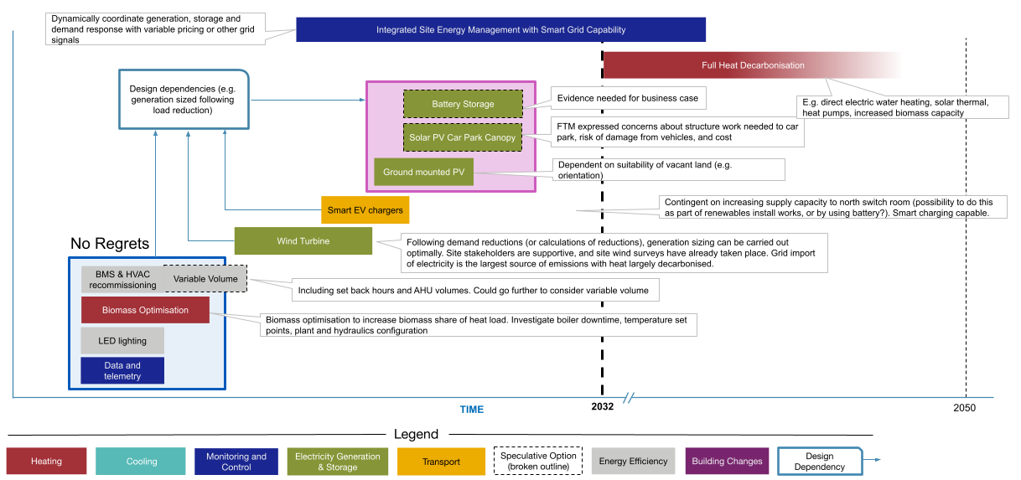

Recommendation 1: Description of recommendation in a bit more detail
Annual energy saving  (kWh) | Annual carbon savings (tCO2e) | Annual savings  (£ exc. VAT) | Total cost  (£ exc. VAT) | Net present value  (£)
Break down gas, electricity, and other energy savings | Carbon savings from energy reduction, energy switch, and non-energy carbon benefits | Energy (gas, electricity, other) cost savings + non-energy benefits (e.g. reduced maintenance costs, longer product lifetimes) at current prices | Total capital cost for procurement and installation based on commercial route and current prices. | Present value of all benefits, minus cost of implementation

Implementation
Non-financial benefits | e.g. improved workforce conditions, product quality, staff productivity and wellbeing, customer experience, maintenance and fault identification, reduced noise from production lines
Project timings | Suggested start date and duration, or note on whether recommendation is short / medium / long-term
Constraints | e.g. lease terms, site access, prerequisite steps
Risks and mitigations | e.g. rebound effects, disruptions
Best practice guidance | e.g. manufacturer or product recommendations, principles to consider, questions to ask suppliers
Sources of support | e.g. government grants, financing options, sources of independent advice
Responsible for implementation | e.g. who in the company receiving the ESOS assessment will be responsible for carrying out this change?

Next steps
Step | Owner of recommendation (key person/team) | Start date | Completion date
Step 1
Step 2
Step 3

Suggested progress review
Responsible for implementation | Name, title, team
Progress monitoring schedule | Weekly / bi-weekly / monthly / quarterly
Next review of progress meeting | DD/MM/YY

Recommendation 2: Description of recommendation in a bit more detail
Annual energy saving  (kWh) | Annual carbon savings (tCO2e) | Annual savings  (£ exc. VAT) | Total cost  (£ exc. VAT) | Net present value  (£)
Break down gas, electricity, and other energy savings | Carbon savings from energy reduction, energy switch, and non-energy carbon benefits | Energy (gas, electricity, other) cost savings + non-energy benefits (e.g. reduced maintenance costs, longer product lifetimes) at current prices | Total capital cost for procurement and installation based on commercial route and current prices. | Present value of all benefits, minus cost of implementation

Implementation
Non-financial benefits | E.g. improved workforce conditions, product quality, staff productivity and wellbeing, customer experience, maintenance and fault identification, reduced noise from production lines
Project timings | Suggested start date and duration, or note on whether recommendation is short / medium / long-term
Constraints | E.g. lease terms, site access, prerequisite steps
Risks and mitigations | E.g. Rebound effects, disruptions
Best practice guidance | E.g. manufacturer or product recommendations, principles to consider, questions to ask suppliers
Sources of support | E.g. government grants, financing options, sources of independent advice
Responsible for implementation | E.g. who in the company receiving the ESOS assessment will be responsible for carrying out this change?

Next steps
Step | Owner of recommendation (key person/team) | Start date | Completion date
Step 1
Step 2
Step 3

Suggested progress review
Responsible for implementation | Name, title, team
Progress monitoring schedule | Weekly / bi-weekly / monthly / quarterly
Next review of progress meeting | DD/MM/YY

Recommendation 3: Description of recommendation in a bit more detail
Annual energy saving  (kWh) | Annual carbon savings (tCO2e) | Annual savings  (£ exc. VAT) | Total cost  (£ exc. VAT) | Net present value  (£)
Break down gas, electricity, and other energy savings | Carbon savings from energy reduction, energy switch, and non-energy carbon benefits | Energy (gas, electricity, other) cost savings + non-energy benefits (e.g. reduced maintenance costs, longer product lifetimes) at current prices | Total capital cost for procurement and installation based on commercial route and current prices. | Present value of all benefits, minus cost of implementation

Implementation
Non-financial benefits | E.g. improved workforce conditions, product quality, staff productivity and wellbeing, customer experience, maintenance and fault identification, reduced noise from production lines
Project timings | Suggested start date and duration, or note on whether recommendation is short / medium / long-term
Constraints | E.g. lease terms, site access, prerequisite steps
Risks and mitigations | E.g. Rebound effects, disruptions
Best practice guidance | E.g. manufacturer or product recommendations, principles to consider, questions to ask suppliers
Sources of support | E.g. government grants, financing options, sources of independent advice
Responsible for implementation | E.g. who in the company receiving the ESOS assessment will be responsible for carrying out this change?

Next steps
Step | Owner of recommendation (key person/team) | Start date | Completion date
Step 1
Step 2
Step 3

Suggested progress review
Responsible for implementation | Name, title, team
Progress monitoring schedule | Weekly / bi-weekly / monthly / quarterly
Next review of progress meeting | DD/MM/YY

Appendix 1: Recommendations long list

Buildings
Recommendation type | Recommendation | Annual energy saving  (kWh) | Annual carbon savings (tCO2e) | Annual savings  (£ exc. VAT) | Total cost  (£ exc. VAT) | Net present value  (£)
Energy management, data quality, controls | Recommendation 1
Energy management, data quality, controls | Recommendation 2
Energy management, data quality, controls | Recommendation 3
Behaviour change interventions, training | Recommendation 4
Behaviour change interventions, training | Recommendation 5
Behaviour change interventions, training | Recommendation 6
HVAC
Renewable generation
Lighting and equipment
Building fabric
Other (including cross-cutting recs)

Industrial processes
Recommendation type | Recommendation | Annual energy saving  (kWh) | Annual carbon savings (tCO2e) | Annual savings  (£ exc. VAT) | Total cost  (£ exc. VAT) | Net present value  (£)
Energy management, data quality, controls | Recommendation 1
Energy management, data quality, controls | Recommendation 2
Energy management, data quality, controls | Recommendation 3
Behaviour change interventions, training | Recommendation 4
Behaviour change interventions, training | Recommendation 5
Behaviour change interventions, training | Recommendation 6
Process, HVAC and use of waste heat
Building energy use, lighting etc.
Other (including cross-cutting recs)

Transport
Recommendation type | Recommendation | Annual fuel saving  (litres) | Annual carbon savings (tCO2e) | Annual savings  (£ exc. VAT) | Total cost  (£ exc. VAT) | Net present value  (£)
Fleet fuel management, data quality | Recommendation 1
Fleet fuel management, data quality | Recommendation 2
Fleet fuel management, data quality | Recommendation 3
Behaviour change interventions, training | Recommendation 4
Behaviour change interventions, training | Recommendation 5
Behaviour change interventions, training | Recommendation 6
Fleet procurement
Fleet operations
Other (including cross-cutting recs)

Appendix 2: Key assumptions
Payback period / net present value calculations: Explain the approach taken to calculate net present value and/or payback period.
- DESNZ recommends using life-cycle cost analysis (LCCA) where appropriate.
- Simple payback period (SPP) may be the superior option for particular organisations or situations, however.
- An explanation of advantages and disadvantages of each approach and a worked example can be found in Annex A6 ‘Measuring the benefits of energy saving opportunities’ of the ESOS How to comply guidance. a worked example can be found in Appendix C, C6 ‘Measuring the benefits of energy saving opportunities’.
Representativeness: Provide context around caveats and assumptions involved in site sampling, representativeness, and extrapolation.
Prices: Explain here any assumptions made on costs and prices of gas, electricity, any other energy sources and costs of resources at point of calculation.
Organisation performance and risks: Explain here any assumptions made on the organisation’s performance, financial and business indicators at the point of calculation, and measures of uncertainty used in the calculations.
Carbon impact factors: We have used [state year e.g. 2025] CO2e UK Government conversion factors:
- 0.21233 kgCO2e per kWh electricity
- 0.18438 kgCO2e per kWh natural gas (gross CV)
- 2.19352 kgCO2e per litre Petrol (average biofuel blend)
- Add other fuel sources as necessary

See appendix (assumptions) for all key calculations and definitions.
BEIS (2021): Strengthening the Energy Savings Opportunity Scheme (ESOS) Consultation on options.
Net Zero Strategy: Build Back Greener. (2021)
A longlist of all energy saving opportunities is provided in the appendix.
Interdependencies may apply between individual recommendations. Figures apply if all recommendations in the table are implemented.

