

OakClub Architecture Details

1. Packages

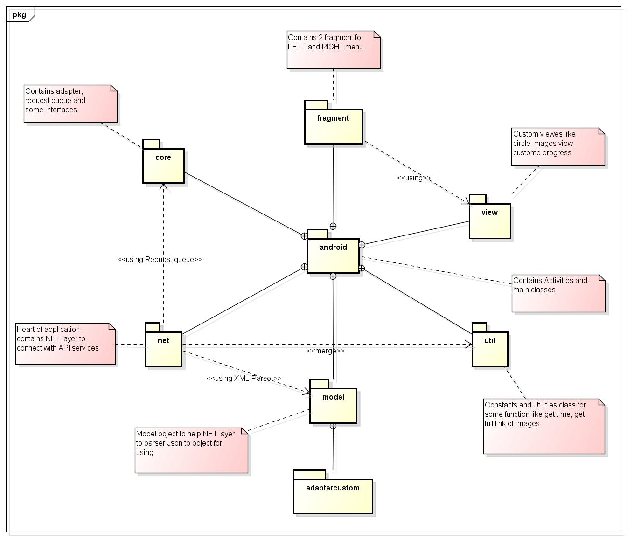

Details:

* **com.oakclub.android**: Contains Activities and main classes
* **com.oakclub.android.fragment**: Contains 2 fragment for LEFT and RIGHT menu
* **com.oakclub.android.view**: Custom viewes like circle images view, custome progress
* **com.oakclub.android.util**: Constants and Utilities class for some function like get time, get full link of images
* **com.oakclub.android.model**: Model object to help NET layer to parser Json to object for using
* **com.oakclub.android.net**: Heart of application, contains NET layer to connect with API services.
* **com.oakclub.android.core**: Contains adapter, request queue and some interfaces

1. Classes

Some classes you must take a look:

* **RequestUI**: works like an asynctask, using to call request to API services, get result and then update UI if need
* **RequestQueue**: Using to manage all RequestUI to a queue with FIFO order. Besides, you could using it with settings priority for each request if you want to put which one to be executed first.
* **OakClubBaseActivity**: Using as a base classes for all activities we use in application. It already setup request queue, image loader lib, init menu,…
* **OakClubApi**: Using to manage all connection to API services.
* **OakClubJsonParser**: Using to parse all Json return data get from services to defined object in Model packages. In this class we using ObjectMapper to parse.
* **OakClubUtil**: Using to solve some static problems like get link, get time,…

1. Functions

* **Sign-up, Sign-in, Send location data**: proceed in MainActivity, using NET layer, send data and save to object, using in Profile Settings activity. Besides, retrived user data to login XMPP server. Beside, you must login to Facebook application to get Accesstoken key.
* **Setup XMPP connection, XMPP listener for live chat**: proceed in MainActivity, using xmpp username and xmpp password to login to XMPP server.
* **Setting profile**: proceed in ProfileSettingsActivity, using data object get from MainActivity to init data.
* **SnapshotSettings**: proceed in SnapshotSettingActivity, create request to load current settings at first, each time user set a new value for any field, send update to API services. If user want to change language, and app-restart is required to apply this change.
* **Chat**:
  + Get Chat history: solve in rightmenu, must call getHistoryMessages API to get
  + Start and chat with another person: XMPP login is required in MainAcitivity, othewise this actoin could not be done. And then, setup and Chat object to send/received message from other user. Also send message to OakClub server to update message history
* **ChangeLanguageSettings**: At first sign-up or when user want to change language, using different String resource file, defined in each folder like:
  + Values-en
  + Values-vi
  + Value-th

o…

to change, and restart application inneed.

1. Libraries

* Jackson: using to parse Json data to object
* UniversalImageLoader: using to load image from URL, support cache
* AsmackAndroid: Using to login XMPP and chat
* ActionBarSherlock: For some special theme, include some lib from higher Android version that support Lower Android Version
* FacebookSDK: Support Facebook login and actions
* ViewPagerLibrary: For some ViewPagers and Indicators screen
* SlidingMenu: For Left and Right menu
* HTTPMime: Support NET layer to connect with API services

1. Notices

* Must logout XMPP before re-login XMPP and setup listener to avoid duplicate listener and some strainge problems with chat function
* Before uploading Application to Google Play Market, must use keystore to generate hashkey for facebook and then add it to Facebook Application page like bellow:

