Adding the create groups from child courses button to the groups function in Moodle 2

In moodle 1.9 Nathan added a button to auto create groups from child courses as the task would be too labourious for staff to do manually. This enable staff to filter their groups in different aspect such as grade and activities.

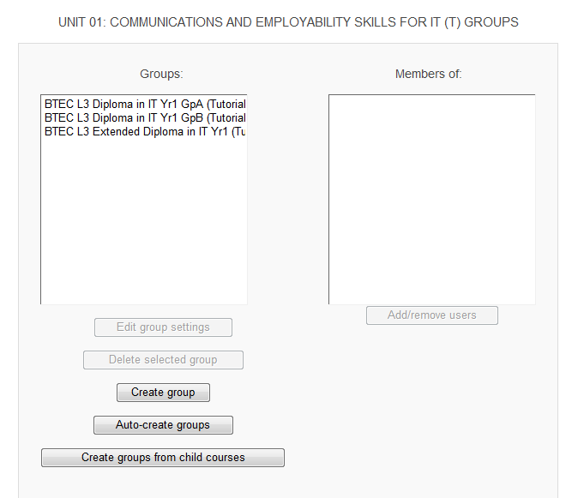

This works on fetching data on students enrolled on courses and their course name under the category and importing them into groups in the groups section in a meta course. The function identifies the child courses from the fact they are the only ones with a course ID number and this identifies the students from MIS

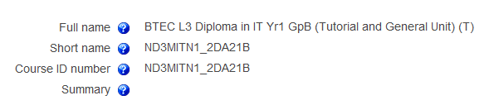

The groups function in a meta course <https://vle.conel.ac.uk/group/index.php?id=27212>

Structure of courses under a category <https://vle.conel.ac.uk/course/category.php?id=731>

Please build and test in moodle 2 test server ready for me to test when I get back on the 12th August. cheers