<<window>>

login interface

<< window>>

admin window

<< window>>

author window

<< window>>

PC chair window

<< window>>

Register window

<< window>>

PC member window

Admin user login

Author user login

PC chair user login

PC member user login

New user register

<< button>>

Last

<< button>>

Next

<< button>>

Download

<< button>>

Remark

click

click

click

click

<< button>>

Save

click

<< button>>

Last

<< button>>

Next

<< button>>

Download

<< button>>

Accept

click

click

click

click

<< button>>

Last

<< button>>

Next

<< button>>

Upload TXT

<< button>>

Upload PDF

click

click

clickk

click

click

<<button>>

Browse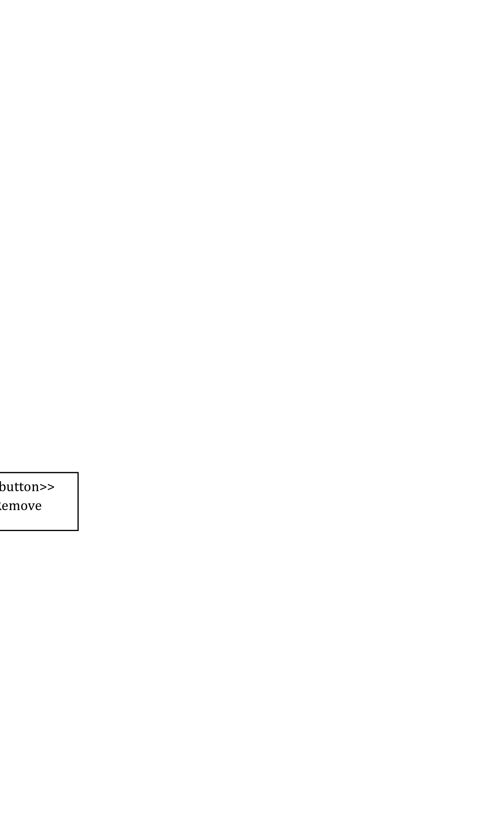

<< button>>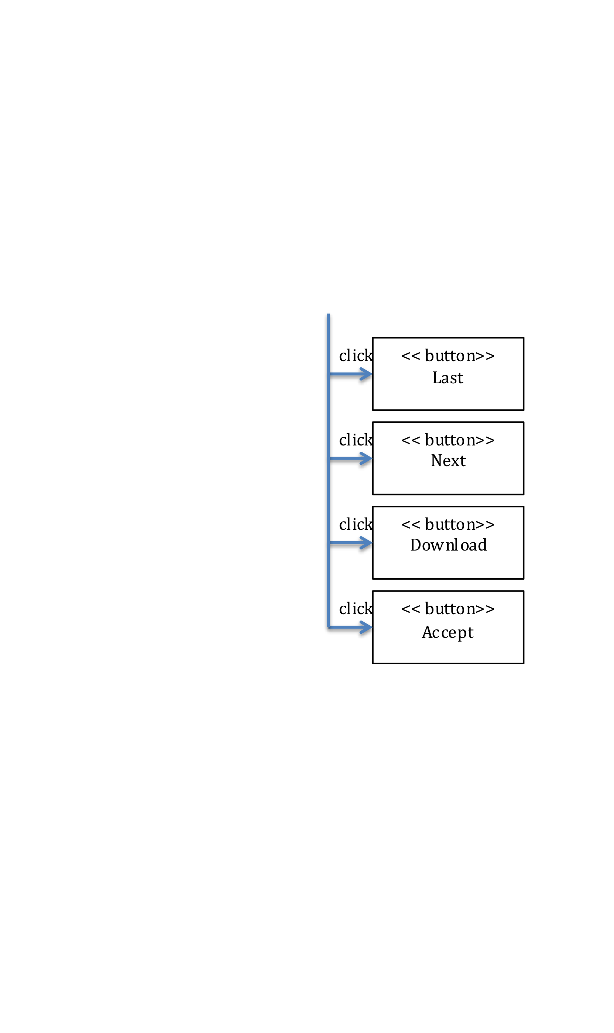

Upload

<< button>>

Add User

<< button>>

Delete User

<< button>>

Add

<< button>>

Remove

click

click

click

click