
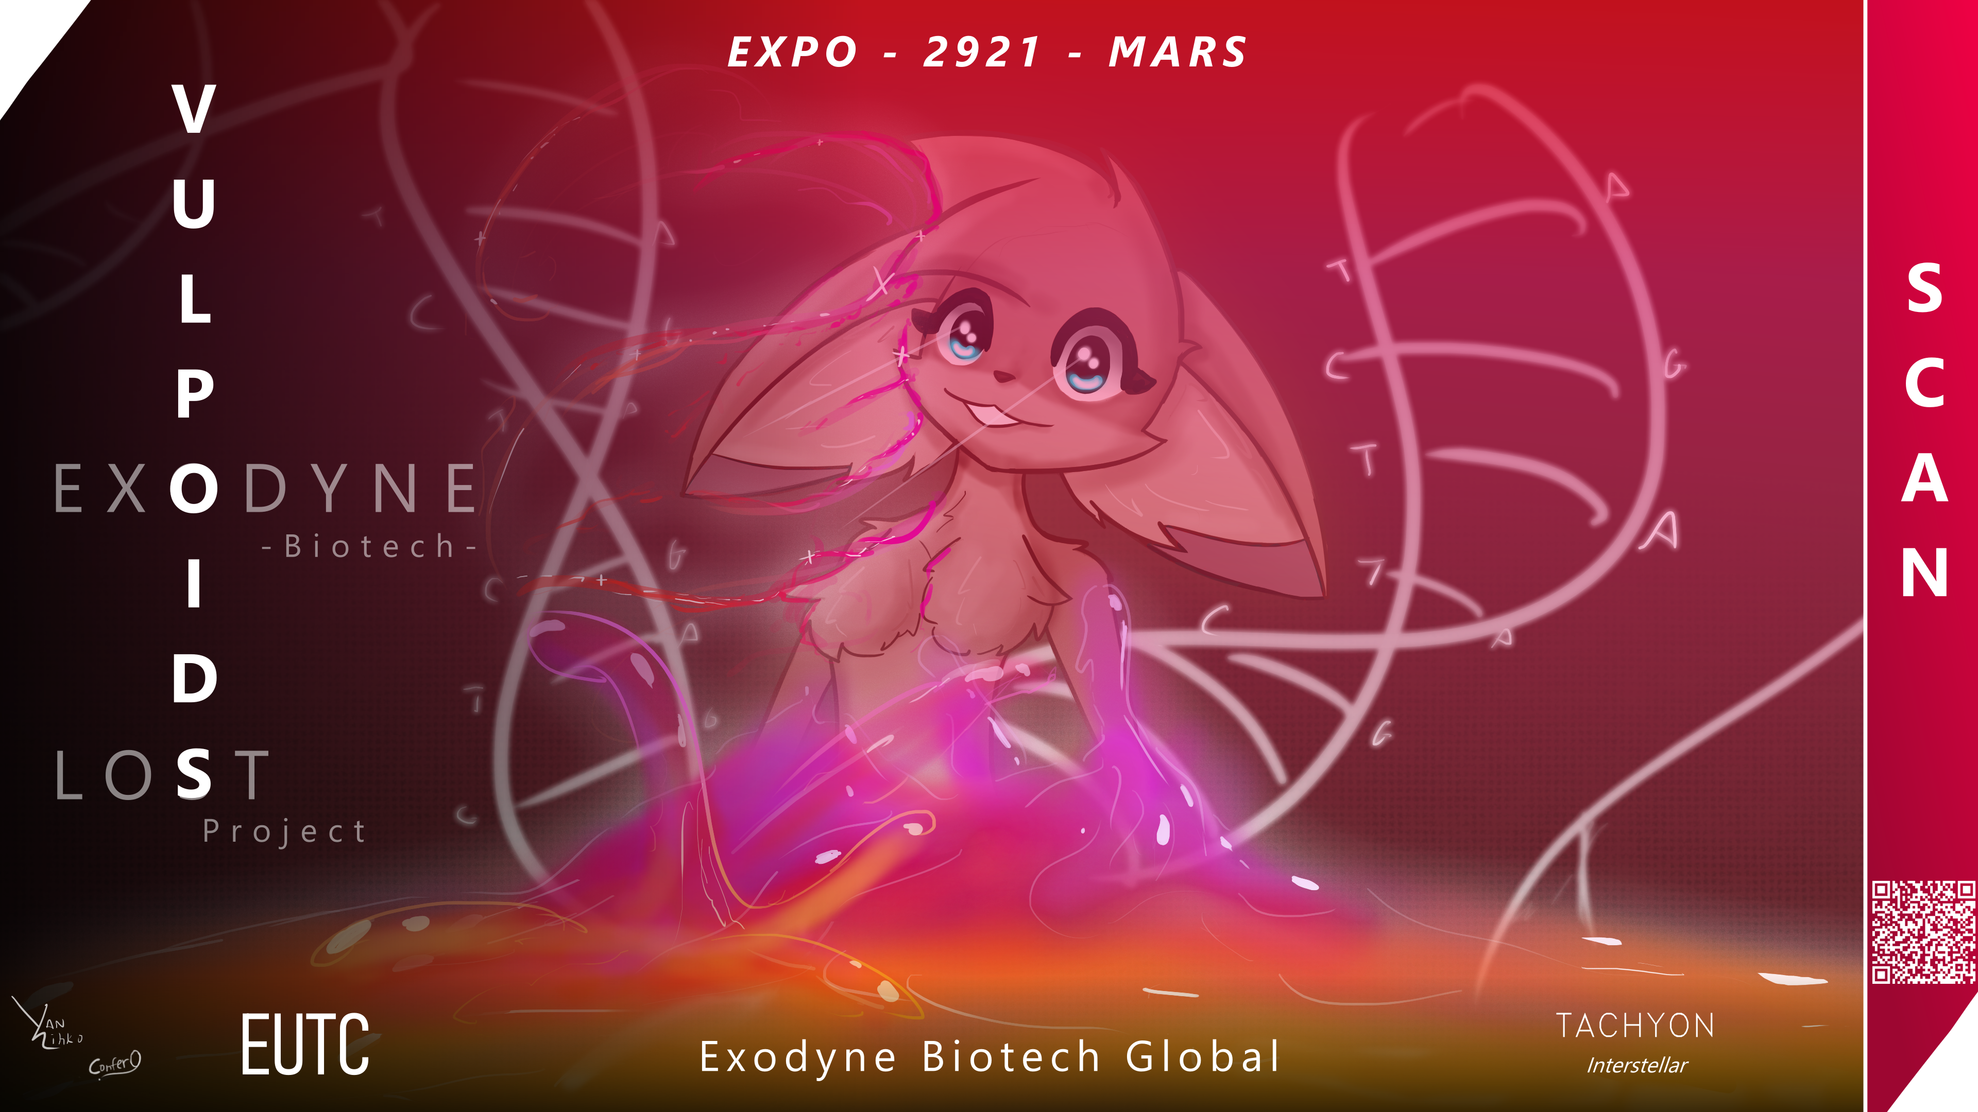

GREETINGS, TRUSTED SHAREHOLDER!

As one of our major shareholders, we at Exodyne Biotech GlobalTM invite you to visit us at EXPO 2921. The VIP ticket we have sent you includes first-class transport Mars from any location within Domain space, and full access to all areas and amenities of the Redheights Campus of Advancements and Technology. You'll receive full access to our stands, and those of our partners from the Eridani-Utopia Terraforming Corporation and TACHYON Interstellar. Not only that, but you're cordially invited to a private meeting with our CEO, researchers and other corporate representatives.

We have provided information below that might be useful for you. If you will have any remaining questions, don't hesitate to reach out to our customer service representatives Yanzihko and Confer0.



1. Main Mechanics 3
2. Spoiler-Free Walkthrough 10
3. Complete Vulpoids Walkthrough (spoilers) 11
4. Complete description of mod features (spoilers) 12
5. List of useful console commands 13


1. Main Mechanics

The following chapter contains broad description of main mechanics of Vulpoids. It will not spoil major story events, but does contain mechanical spoilers. If you find yourself stuck somewhere, feel free to check out chapter 2 below for spoiler-free hints and directions.

When you build your first colony, you'll see a new industry: Organ Farms. Built on Habitable worlds, these facilities produce Harvested Organs for export. Like all industries it can be further improved with AI cores and story points. It's also capable of being improved - or even modified - by Domain relics that you may discover in the fringe.

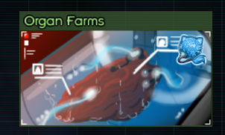

1.1 Foxes Foxes Foxes
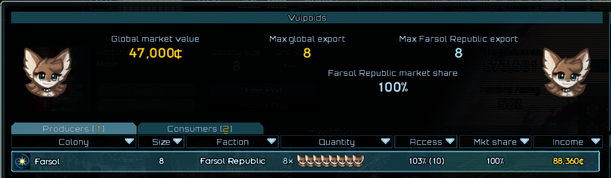
This mod adds a new commodity – Vulpoids, with its own market and demand across the sector... once they are introduced. At first glance it might seem that Vulpoids are identical to any other commodity. But other factions don’t think so:

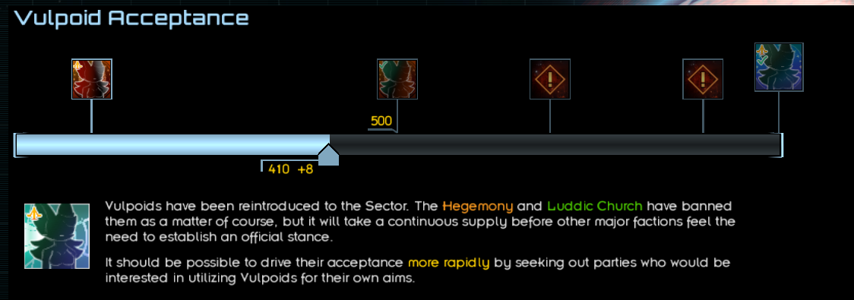
Vulpoid Acceptance is an event that unfolds over time, as various anti-technology factions attempt to interfere with your operations. Be sure to keep tabs on it, in case you and your colonies need to be prepared for a visit from the neighbors.
Progress of this event depends on your monthly Vulpoid production. It can also benefit from various one-time events - ask around the Sector!

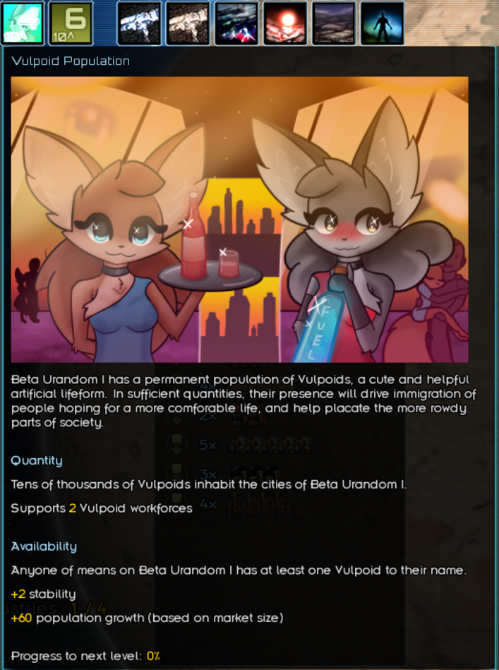
A planet producing Vulpoids will gain a permanent Vulpoid population. This population starts at two less than the current production volume, and slowly increases to match it over the course of a year. Vulpoid population cannot exceed the human population, and even matching it requires Industrial Planning, an alpha core, and industry improvement.
Planet with permanent Vulpoid Population will Automatically receive a Vulpoid Representative you will be able to contact via planetary Comms.

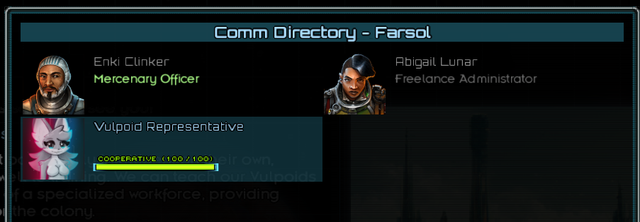
Depending on Vulpoid population size, you will be able to assign a certain amount of Vulpoid Workforces – special planetary modifiers with unique bonuses and conditions.

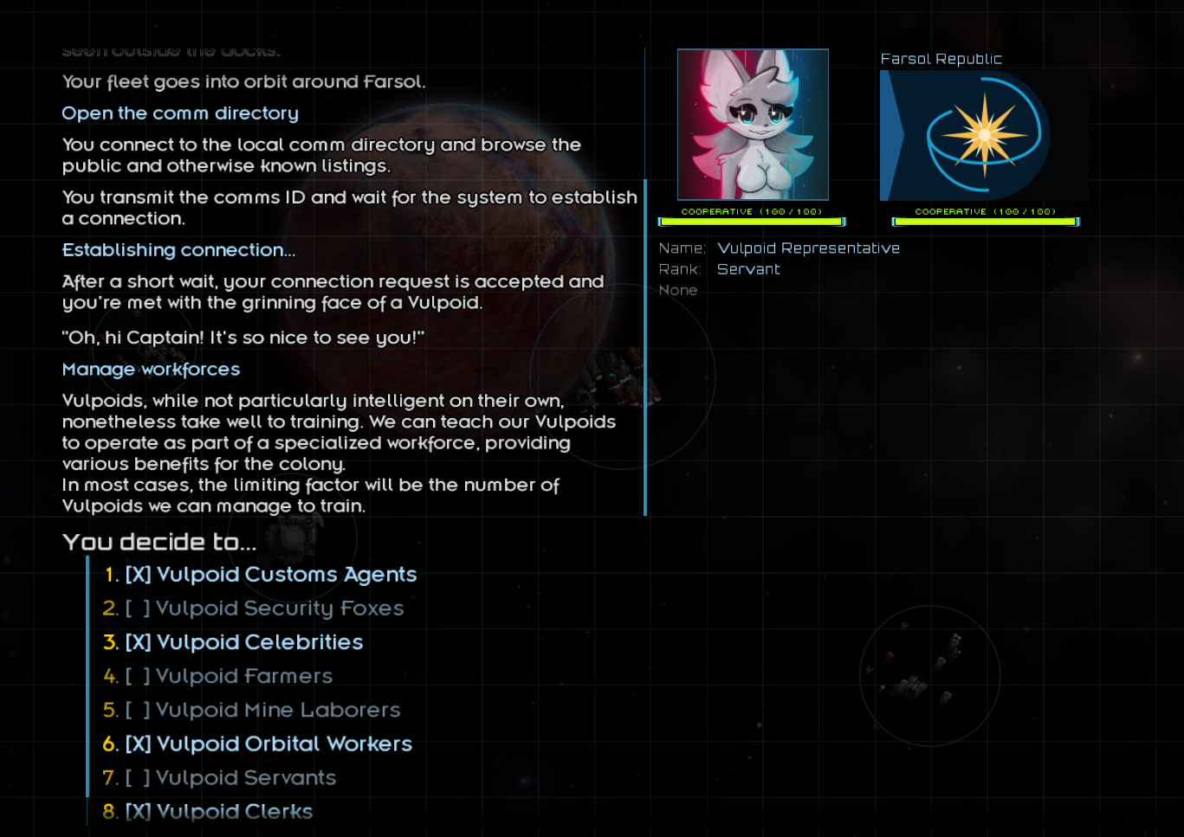

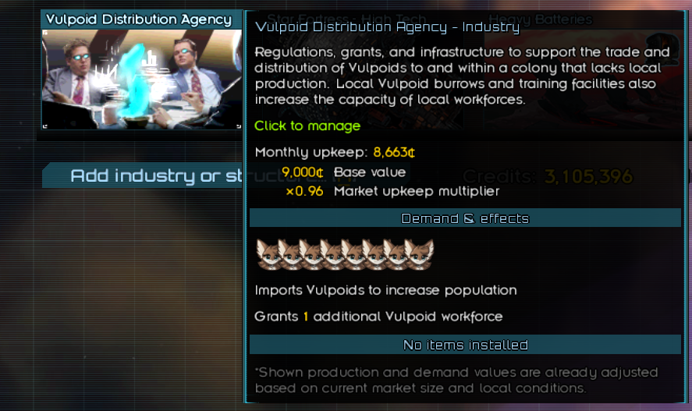
You will get an ability to build Vulpoid Agenices at your colonies, allowing them to import a permanent Vulpoid Population without them having Vulpoid production. Vulpoid agency creates a demand that is dependent on your population. Vulpoid population will never exceed agency demand.

1.2 Fluffy Anomalies
Profecto Vulpoids – A unique variation of Vulpoid that are sometimes produced by your facility. You'll receive a notification when this occurs. You can cherish your Profecto as an assistant, or even friend. Or betray them and turn them in to other factions for credits and reputation.
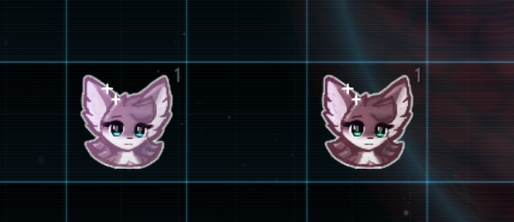
Right clicking at Profecto changes their designation. There are four designations (from right to left)
Cryosleep: (Can be placed in storage, sold on markets, or turned in)
Embarked: (Tied to your fleet, can be assigned to certain administrative tasks)
Officer: (Serving as an officer, requiring payment and counting towards the cap)
Administrator: (Serving as an administrator, requiring payment and counting towards the cap)
Additionally, note the Lock Icon in bottom left corner. This means that the Profecto is currently assigned to some task, such as piloting a ship. Their designation cannot be changed while this is the case.
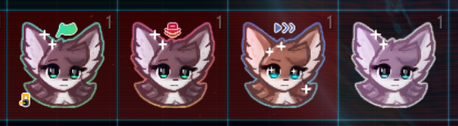
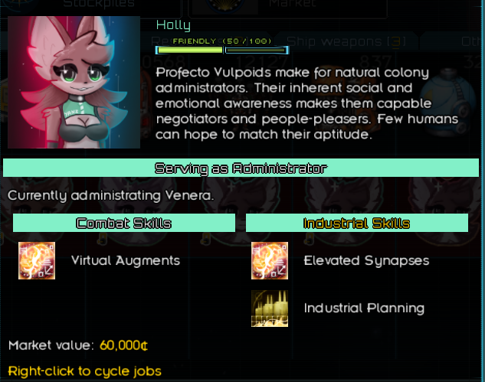
By hovering over their inventory item, you can see information about them, their skills, and their current designation. Each inventory item corresponds to a single, unique person.

They're more than just items though! Using a special ability unlocked through the main quest, you can contact any Profecto aboard your fleet.
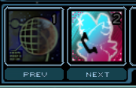
Their names in the list are color coded depending on assignment. Select a Vulpoid and get to chatting! There's plenty to discuss, so be sure to explore your options.
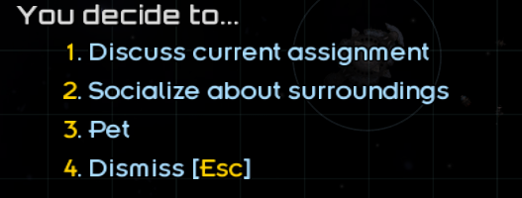
This is also where you can assign administrative tasks to an otherwise-unoccupied Vulpoid. You might obtain some valuable data, or maybe something even more unique.

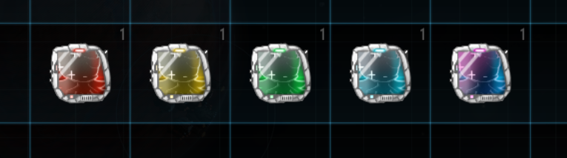

2. Spoiler-Free Walkthrough
-Prove that you are capable of defeating Remnant fleets. Make them angry! After this you might want to visit a bar at Nomios. Look for a strange man in a coat.

-Your curiousity is a key towards unlocking all the secrets. Only you as a player, using your “magical” abilities, will be able to dig to the truth. Explore all the options.

-Being Psycho might lead to negative outcomes. But if you think that our mod is cringe, go ahead.

-Install it. Do it. It is shiny, so it’s probably good. Change the Persean Sector!

-Perhaps giving a certain Fox an Alpha core is not the best idea, but you can always try…

-Turns out, foxes love research projects!

-A few Onslaughts and additional tankers will never hurt.

-Vulpoids are so great, you might find some core Factions giving you new interactions…

-Prepare your Defenses. Really.

-Volturn? Lobsters? Perhaps I should gift one to a Profecto and discuss Volturn while orbiting it...

-The forbidden fruit, forgotten relic and a fluffy miracle... Terran world shall suffice. It is in your powers to create an Eden.

-Profit? Profit.

Utopia is within your grasp, Captain

3. Complete Vulpoids Walkthrough (spoilers)
-Get non-neutral stance with Remnants. It can be negative relations. (Or positive one to account for mod compatibility). The whole point of this is to determine whether you have interacted with remnants or not.

-Visit bar at Nomios. You will enter dialog with a person in a white coat. He will give you a quest with location of remnant fleet with unique ship. Defeat it. It’s not that easy but is beatable with mid-game fleet.

-MAKE save after defeating the fleet. DO NOT board the ship. So you won’t comlain if you screw up.

-After defeating the fleet you will enter boarding dialog chain. Make sure to explore everything. Make sure to have spare 6 story points to uncover all features of the mod. (Or add them with console lol).

-DO NOT choose the extermination option. This will lock access to all mod features.

-Use “call vulpoid” in your fleet abilities board below. If it’s not there, you can add it yourself. Contact one single vulpoid that will be there.

-You got yourself a Vulpoid Bioforge. Build an organ farm at any habitable world. Preferably terran with mild climate modifier. Install Bioforge into organ farm.

-You can upgrade one organ farm into Biotech facility for additional bonuses. But you are limited only to one. Biotech facility supports all bioforges just like organ farms.

-Unique “Vulpoid Acceptance” situation you get is honestly self-explanotary. Build defenses to kill a few invasions, donate some profecto to factions for one-time boost to situation progress and you’ve completed it. Just read its descriptions.

-If you have explored everything in dialog chain above, you will also discover location of mangonut tree. It is generated upon interaction with dialog. If you screw up, you won’t find it. Cache with mangonut tree is not guarded. Install mangonut tree at the same world as Vulpoid Bioforge.

-At this point you have probably got attached to Laisa. Gift her an alpha core. Do it, There’s no drawbacks. After this Laisa will be able to research an unique project for 4 story points. It will take her a year to do so. You must interact with Laisa again to get a new mission.

-Follow to the mark located in the abyss (edge of the sector if you’re in 0.96). This fleet is very hard to beat. XIV armada, all ships with best commanders and 2 in-built hull mods. Has onslaughts. I have warned you, be prepared.

-Restore the unique ship. Make sure to have spare crew, supplies, machinery and fuel to bring this fat thing back to Persean sector.

-Install Nanofilatration core at the same terran world with Vulpoid Bioforge and Mangonut tree. After a while you will get nice “hidden” workforce.

-Lobsters? Voltum? Gift any of your profecto a Vulpoid lobster and discuss with her Volturn while orbiting it. Quest is easy to follow through. But if you have troubles, I will give you a hint that you can click at some of the asteroids in a ring around Volturn. Beat the quest and you get Volturn Lobster Bioforge.

Congratulations, you have completed “Vulpoid – Lost Project”. Thank you for playing!

4. Complete description of mod features (spoilers)
Give player raw numbers please. How pop growth is calculated, what bonuses items give, how vulpoid demand and production is defined. Doesn’t have to be long, one page should be enough. Don’t bother with formating and screenshots, I will do this myself.

5. List of useful console commands
Insert console commands you think are necessary.
Requires Console Commands to be installed:
https://fractalsoftworks.com/forum/index.php?topic=4106.0
addspecial special_vulp – adds a randomly-generated Profecto Vulpoid to your cargo.
addspecial vulpoid_dataX Name – where X is a number from 1 to 5 and Name is any string. Adds a level X Vulpoid Data to your cargo, authored by the provided name.
runcode vulpoids.impl.campaign.intel.events.VulpoidAcceptanceEventIntel.get().setProgress(X); — where X is a number from 1 to 900. Sets progress for the Vulpoid Acceptance event.
Runcode Global.getSector().getPlayerFaction().addKnownIndustry("vulpoidagency"); - Unlock Vulpoid Agency
ForceDismissDialog — Forcefully exits dialog if you get stuck. Let us know if this occurs!
additem -
addspecial -

