1.
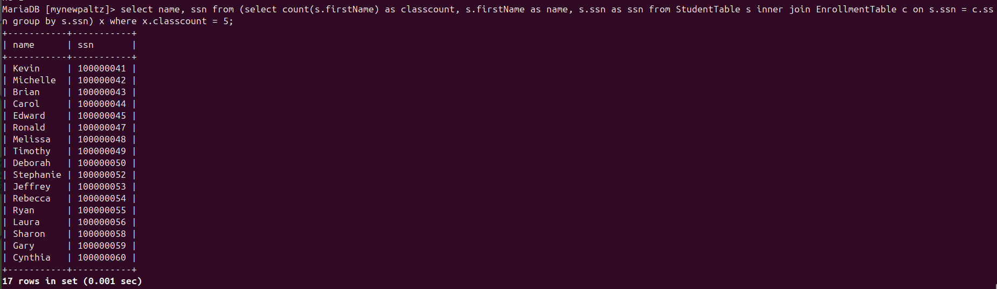
2.
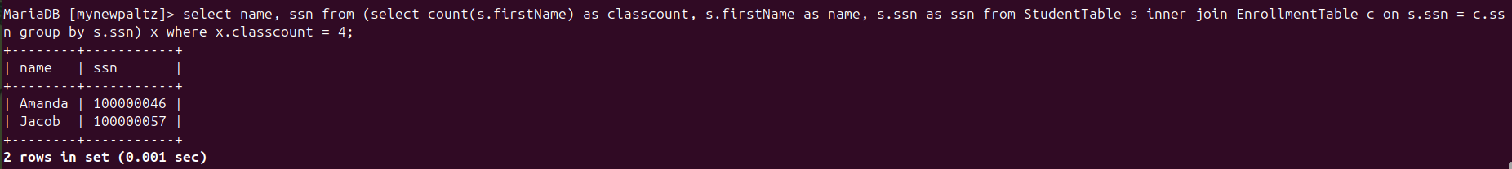
3.
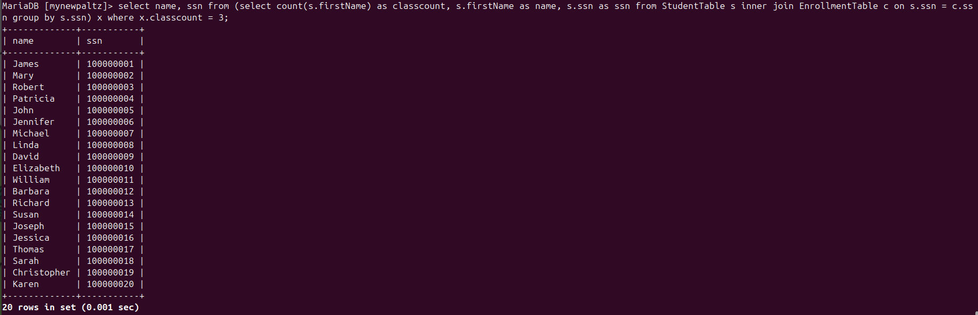
4.


5.
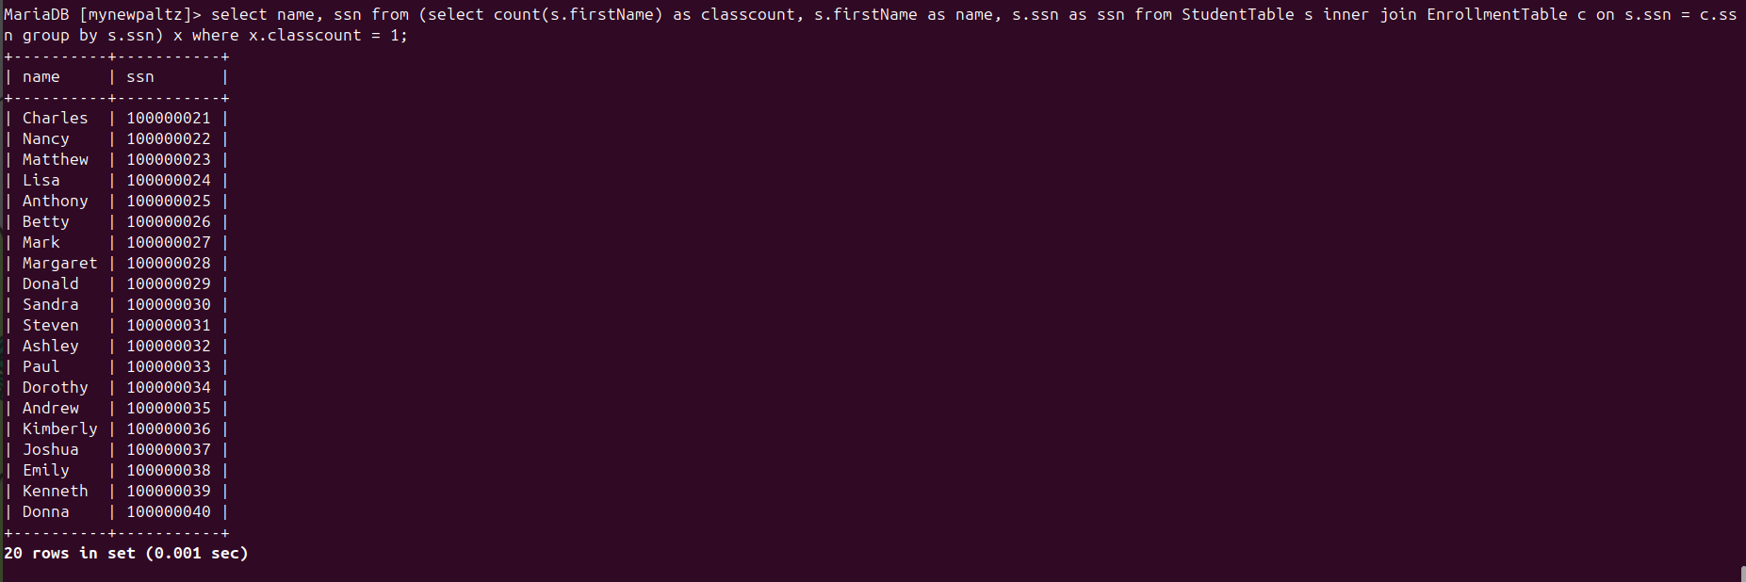
6.
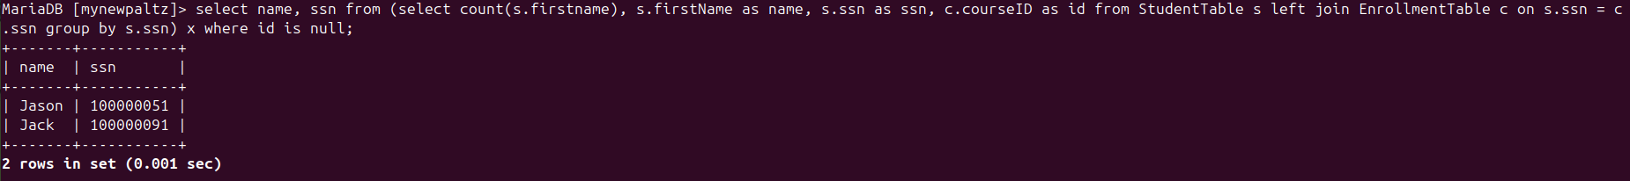
7.
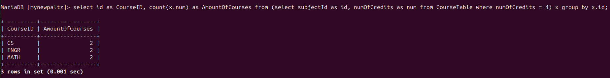
8.
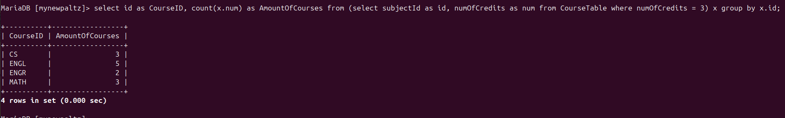
9.
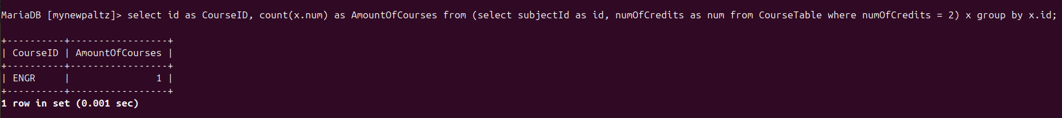
10. No, and no. All courses give a minimum of 2 and a maximum of 4 credits, as can be seen by simply listing all the courses.

11.
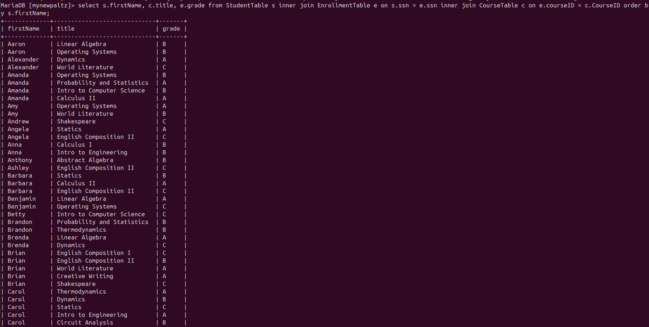
12.
13.
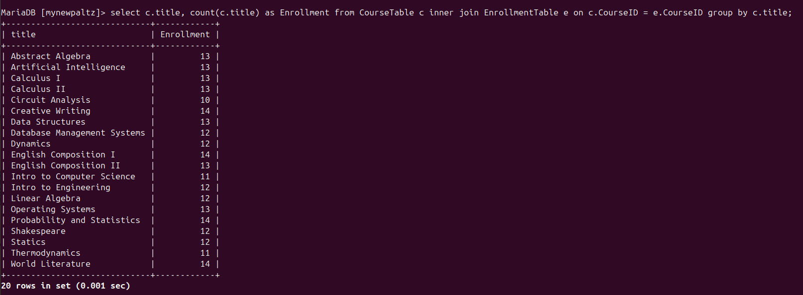

14.
