ADVENTIST UNIVERSITY OF CENTRAL AFRICA
Faculty of Information Technology

AUCA MENTORSHIP PORTAL SYSTEM
Project Proposal Document

Course: INSY 7312 - Java Programming
Instructors: Dr. SEBAGENZI Jason & Jeremie U. Tuyisenge

Submitted by:
Confiance UFITAMAHORO
Student ID: 27185

May 2026

1. Abstract

The AUCA Mentorship Portal System is a distributed Java desktop application designed to digitize and manage the mentorship processes at Adventist University of Central Africa (AUCA). The system addresses the challenge of managing mentorship relationships, scheduling sessions, and tracking mentee progress through a centralized platform.

The application is built using Java RMI for client-server communication, Java Swing for the graphical user interface, Hibernate ORM for database persistence with PostgreSQL, and follows the MVC and DAO design patterns. The system supports full CRUD operations, OTP-based login verification via email simulation and ActiveMQ message broker, data export to PDF, Excel, and CSV, and both business and technical validation rules throughout all modules.

2. Scope

2.1 In Scope
- User registration and management with roles: Admin, Mentor, and Mentee
- Mentor profile management including department, expertise areas, and availability status
- Mentorship program creation, management, and user enrollment
- Mentorship session scheduling, tracking, and status management
- OTP-based login verification using email simulation and Apache ActiveMQ
- Full CRUD operations for all entities exposed through the RMI service layer
- Report generation and export to PDF, Excel, and CSV formats
- Business and technical validation rules across all system modules
- Java Swing GUI with modern custom design
- All database operations restricted to the server application only

2.2 Out of Scope
- Mobile or web-based interfaces
- Real SMS delivery (SMS notification is simulated only)
- Integration with external university student information systems
- Real-time video or chat communication between mentor and mentee

3. Functional Requirements

3.1 User Management
- The system shall allow an administrator to register new users with roles: Admin, Mentor, or Mentee
- The system shall allow users to log in using their email address and password
- The system shall send an OTP to the user email upon login and require verification before access
- The system shall allow administrators to update and deactivate user accounts
- The system shall display all registered users in a searchable JTable

3.2 Mentor Profile Management
- The system shall allow each mentor to create and update a profile (One-to-One relationship with User)
- The mentor profile shall include department, expertise areas, bio, years of experience, and availability
- The system shall allow administrators to view and manage all mentor profiles

3.3 Mentorship Program Management
- The system shall allow administrators to create, edit, and delete mentorship programs
- The system shall support Many-to-Many enrollment between users and programs
- The system shall display enrolled participants for each program in a JTable
- The system shall enforce a maximum enrollment capacity per program

3.4 Session Management
- The system shall allow mentors to schedule sessions with mentees (One-to-Many: Mentor to Sessions)
- The system shall track session status: Scheduled, Completed, or Cancelled
- The system shall allow mentees to view their upcoming and past sessions
- The system shall allow notes and feedback to be recorded for each session

3.5 Notifications
- The system shall send OTP codes to users via email simulation during login
- The system shall use Apache ActiveMQ as a message broker for notification events
- The system shall notify mentees when a new session is scheduled by their mentor

3.6 Reporting and Export
- The system shall generate a report of all active mentorship programs
- The system shall generate a session summary report per mentor
- The system shall export reports to PDF format using the iText library
- The system shall export reports to Excel format using Apache POI
- The system shall export reports to CSV format

4. Non-Functional Requirements

4.1 Performance
- The server shall handle multiple concurrent RMI client connections without blocking
- Database queries shall complete within 2 seconds under normal operating conditions

4.2 Security
- Passwords shall be stored as hashed values using BCrypt
- OTP codes shall expire after 5 minutes and cannot be reused
- All database access shall be performed on the server side only
- Role-based access control shall restrict features based on the logged-in user role

4.3 Usability
- The GUI shall use a consistent color scheme with a clean and modern design
- All forms shall display clear validation messages using JOptionPane dialogs
- The system shall use JTable for all record list views with search functionality
- Navigation shall be clear using a sidebar or tabbed menu structure

4.4 Reliability
- The system shall display meaningful error messages when the server is unreachable
- All Hibernate transactions shall be properly committed or rolled back on failure

4.5 Maintainability
- The system shall follow MVC and DAO design patterns throughout the codebase
- All classes shall follow standard Java naming conventions
- Server and client are separate Maven projects: AUCAMentorshipPortalServer27185 and AUCAMentorshipPortalClient27185

5. Core Entities and Relationships

The system is built around the following five core entities:

Entity | Description | Relationships
User | Represents any system user with role Admin, Mentor, or Mentee | One-to-One with MentorProfile; Many-to-Many with MentorshipProgram
MentorProfile | Stores extended profile information for mentor users | One-to-One with User
MentorshipProgram | Represents a structured mentorship program | Many-to-Many with User
MentorshipSession | An individual session between a mentor and a mentee | Many-to-One with User (mentor); Many-to-One with User (mentee)
Notification | Stores OTP codes and system notification messages | Many-to-One with User

6. Validation Rules

6.1 Business Validation Rules
- A mentor cannot schedule a session with themselves
- A mentee cannot enroll in more than three active programs at the same time
- A session cannot be scheduled for a past date or time
- A program cannot be deleted if it has active enrolled participants
- An OTP code is valid for 5 minutes only and cannot be reused

6.2 Technical Validation Rules
- Email fields must match a valid email format using regular expression validation
- Phone number must be exactly 10 digits and contain only numeric characters
- Password must be at least 8 characters long and include at least one digit
- All required text fields must not be empty or contain only whitespace
- Date fields must be valid calendar dates within an acceptable range

7. Technology Stack

Component | Technology Used
Programming Language | Java 11+
IDE | IntelliJ IDEA
Build Tool | Maven
GUI Framework | Java Swing
Client-Server Communication | Java RMI
ORM Framework | Hibernate 5
Database | PostgreSQL - auca_mentorship_portal_db
Design Patterns | MVC, DAO
Message Broker | Apache ActiveMQ
PDF Export | iText 7
Excel Export | Apache POI
Password Hashing | BCrypt (jbcrypt)
Email Notification | JavaMail API (SMTP simulation)

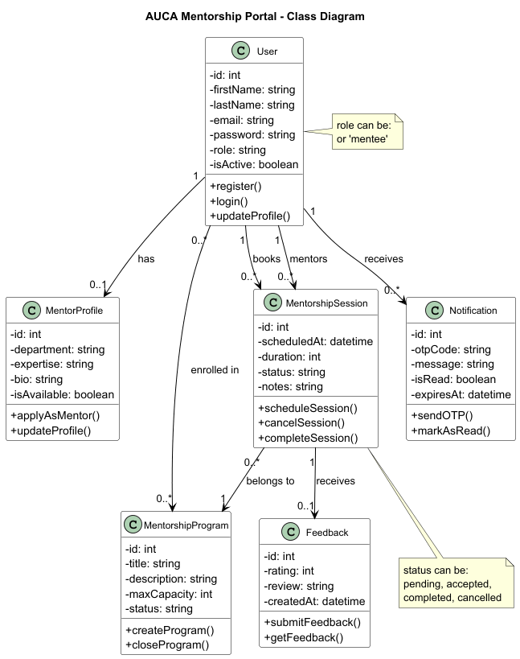
Confiance UFITAMAHORO
Student ID: 27185
May 2026

