❄ ✦ ❄
EUROPEAN
CHRISTMAS MARKETS
GUIDE
2026 – 2027
Your Complete Companion to the Most Magical Holiday Markets in Germany, Austria, France & Beyond, with Itineraries, Festive Foods & Insider Tips
Shelli A. Hibbard

European Christmas Markets Guide 2026–2027
Copyright © 2026 by Shelli A. Hibbard. All rights reserved.
No part of this publication may be reproduced, distributed, or transmitted in any form or by any means, including photocopying, recording, or other electronic or mechanical methods, without the prior written permission of the author, except in the case of brief quotations embodied in reviews and certain other noncommercial uses permitted by copyright law.
Disclaimer: Every effort has been made to ensure the accuracy of the information in this guide at the time of writing. Market dates, opening hours, prices, entry requirements, and travel details change frequently, and some 2026–2027 dates had not been officially announced when this edition was prepared. Readers are advised to confirm all details with official sources before traveling or making non-refundable bookings. The author and publisher accept no responsibility for any loss, injury, or inconvenience sustained by any person using this book.
Image placements in this edition include descriptive prompts for photographs or illustrations.
First Edition, 2026

For everyone who has ever stood in a snowy square,
a warm mug in hand, and felt the magic of the season
and for everyone about to feel it for the first time.
❄

CONTENTS
— ❄ ✦ ❄ —
Table of Contents
Before You Go 1
Why a 2026–2027 Edition? 2
How to Use This Guide 2
Symbols and Boxes You Will See 3
A Word About Choosing Your Markets 3
A Brief History of Christmas Markets 6
The Oldest Markets 7
Martin Luther and the Christ Child 7
Candles, Trees, and Lights 8
From Local Custom to Global Phenomenon 9
The Rhythm of the Season 9
What Makes a "Real" Christmas Market? 10
A Tradition Worth Protecting 11
Planning Your 2026–2027 Trip 13
The 2026 Season at a Glance 13
When Should You Go? 14
Mid to Late November: The Early Bird Window 14
The First Week of Advent (November 27 – December 6): The Sweet Spot 14
Mid-December (December 7–20): Peak Magic, Peak Crowds 15
Christmas Week (December 21–24): Last-Minute Charm 15
After Christmas (December 26 – January 6): The Hidden Season 15
How Long Should You Stay? 15
Getting There 16
Flying In 16
Entry Requirements 16
Getting Around 16
Trains: The Best Way to Travel 16
Driving 17
River Cruises 17
Coach Tours 17
Where to Stay 17
Weather and Daylight 18
What to Pack 18
The Essentials 18
Helpful Extras 18
Budgeting for Your Trip 20
Typical Market Prices 20
Travel Insurance 20
Money Matters 21
Booking Checklist 21
Market Know-How: Mugs, Money, Manners & Safety 23
The Mug Deposit System (Pfand) 23
Paying at the Stalls 24
Market Manners and Etiquette 24
Crowds: How to Beat Them 25
Staying Safe 25
Pickpockets 25
Slips and Falls 26
Staying Warm 26
Food Allergies and Dietary Needs 26
Accessibility 26
Restrooms 26
Photography Tips for the Markets 26
Useful Apps and Resources 27
A Few Words to Know 27
The Festive Food & Drink Guide 29
The Drinks 30
Glühwein (Mulled Wine) 30
Feuerzangenbowle 30
Eierpunsch 30
Jagertee 30
Punsch 30
Glögg 30
Non-Alcoholic Delights 30
Savory Classics 32
Bratwurst and Other Sausages 32
Reibekuchen / Kartoffelpuffer 32
Flammkuchen / Tarte Flambée 32
Raclette 32
Käsespätzle 32
Schupfnudeln 32
Grilled Fish 32
Langos 32
Pierogi, Oscypek, and More 33
Sweet Treats 33
Lebkuchen (Gingerbread) 33
Stollen 34
Gebrannte Mandeln (Candied Almonds) 34
Maroni (Roasted Chestnuts) 34
Baumstriezel / Kürtőskalács / Trdelník 34
Schokofrüchte 34
Crêpes and Waffles 34
Dampfnudeln and Germknödel 34
Poffertjes 34
Kaiserschmarrn 34
Bredele and Christmas Cookies 34
A Regional Tasting Tour 35
Bring the Market Home: Two Recipes 36
Classic Glühwein 36
Kinderpunsch (Children's Punch) 36
Dietary Tips at a Glance 37
Germany: The Heart of Christmas 40
Nuremberg: The Christkindlesmarkt 41
The Opening Ceremony 41
What Makes It Special 41
Beyond the Hauptmarkt 41
Also in Nuremberg 42
Dresden: The Striezelmarkt 43
The Stollen Festival 43
Herrnhut Stars 43
Dresden's Other Markets 43
Cologne: A City of Many Markets 44
Christmas Market at the Cathedral 44
Heinzels Wintermärchen (Old Town) 45
Markt der Engel (Angels' Market) 45
Hafen-Weihnachtsmarkt (Harbour Market) 45
Other Cologne Markets 45
Munich: Bavarian Christmas at Its Best 46
Christkindlmarkt on Marienplatz 46
Kripperlmarkt (Nativity Market) 47
Medieval Market at Wittelsbacherplatz 47
Christmas Village in the Residenz 47
Tollwood Winter Festival 47
Pink Christmas 47
More Munich Markets 47
Rothenburg ob der Tauber: A Storybook Christmas 48
Don't Miss in Rothenburg 48
Berlin: A Capital of Contrasts 50
Top Berlin Markets 50
Stuttgart: The Rooftop Spectacle 51
Esslingen: A Medieval Adventure 52
Frankfurt: Tradition in the Financial Capital 52
Heidelberg: Romance on the Neckar 53
Aachen: Gingerbread and an Emperor's Cathedral 54
Leipzig: Music and Tradition 54
Hamburg: Santa Flies Over the Rathaus 55
Regensburg: A Romantic Market at the Palace 56
Erfurt: Cathedral Steps and Candlelight 57
Lübeck: The Christmas City of the North 57
Hidden Gems and Unusual Markets 57
Ravenna Gorge (Black Forest) 57
Gengenbach: The Giant Advent Calendar 58
Monschau 58
Bernkastel-Kues and the Moselle 59
Quedlinburg: Advent in the Courtyards 59
Hohenzollern Castle 59
Markets in Unexpected Places 59
Suggested Routes in Germany 59
Austria: Advent in the Alps 61
Vienna: The Imperial Christmas 61
Wiener Christkindlmarkt at Rathausplatz 61
Schönbrunn Palace 62
Spittelberg: Vienna's Bohemian Market 63
Am Hof: Vienna's Oldest Tradition 63
Belvedere Palace 63
Karlsplatz: Art Advent 63
Maria-Theresien-Platz 63
More Vienna Markets 63
Beyond the Markets in Vienna 64
Salzburg: The Silent Night City 65
Salzburg Christkindlmarkt 65
More Salzburg Markets 66
The Silent Night Chapel 66
Innsbruck: Christmas in the Mountains 67
Graz: The Ice Nativity 69
Wolfgangsee and the Salzkammergut 70
Hallstatt: The Fairy-Tale Village 70
Linz and Christkindl 70
Krampus: Austria's Dark Side of Christmas 71
Suggested Routes in Austria 71
France: Alsace, the Capital of Christmas 73
Strasbourg: Capitale de Noël 74
The Main Markets 74
The Decorated Streets 74
Beyond the Markets in Strasbourg 75
Colmar: A Fairy Tale Come to Life 76
The Wine Villages of Alsace 78
Kaysersberg 78
Riquewihr 78
Eguisheim 78
Ribeauvillé 78
Obernai 78
Mulhouse: The Christmas Fabric 79
Metz and Nancy: Lorraine's Celebrations 79
Paris: Christmas in the City of Light 79
Other French Christmas Destinations 80
Switzerland: Alpine Elegance 82
Basel: A Market for the Connoisseur 82
Zurich: Crystals, Choirs and Lakeside Lights 83
Montreux Noël: Christmas on the Swiss Riviera 84
Lucerne: Lakeside Charm 85
Bern: The Capital's Arcades 85
Einsiedeln: Pilgrimage and Christmas 85
Czech Republic & Hungary: Gothic Spires and Thermal Baths 87
Prague: The City of a Hundred Spires 87
Old Town Square 87
Wenceslas Square 88
Other Prague Markets 88
What to Eat and Drink in Prague 88
Czech Christmas Traditions 89
Beyond Prague 90
Budapest: The Pearl of the Danube 91
Vörösmarty Square Christmas Fair 91
Advent Feast at the Basilica 91
What to Eat and Drink in Budapest 91
Beyond the Markets in Budapest 92
Belgium & the Netherlands: Canals, Caves and Chocolate 94
Belgium 94
Brussels: Winter Wonders 94
Bruges: The Medieval Jewel 95
Ghent 96
Liège: Belgium's Oldest Village de Noël 96
Durbuy 96
The Netherlands 96
Valkenburg: Christmas Underground 96
Maastricht: Magisch Maastricht 97
Dordrecht: The Big Weekend 97
Deventer Dickens Festival 97
Amsterdam: Lights on the Water 98
Dutch Traditions 98
Scandinavia & the Baltics: Hygge, Lucia and the First Christmas Tree 99
Denmark: Copenhagen 99
Tivoli Gardens 99
Nyhavn 100
More in Copenhagen 100
Sweden: Stockholm and Gothenburg 101
Stockholm: Gamla Stan and Skansen 101
Saint Lucia's Day 101
Gothenburg: Liseberg 102
Norway: Oslo 102
Finland: Helsinki and Lapland 103
Helsinki: Saint Thomas Christmas Market 103
Rovaniemi: Santa's Official Hometown 103
The Baltics: Tallinn and Riga 104
Tallinn, Estonia 104
Riga, Latvia 105
Vilnius, Lithuania 105
Central & Eastern Europe: Hidden Treasures 106
Poland 106
Kraków 106
Kraków's Szopki: A UNESCO Treasure 107
Wrocław 108
Gdańsk 108
Toruń and Gingerbread 109
Slovakia: Bratislava 109
Slovenia: Ljubljana and Lake Bled 109
Ljubljana: Festive December 109
Lake Bled 109
Croatia: Advent in Zagreb 110
Romania: Sibiu and Beyond 111
Italy, Spain, Portugal, the UK & Ireland 112
Italy 112
South Tyrol: The Alpine Christmas Markets 112
Trento 113
Naples: The Street of Nativity Scenes 113
Rome, Milan and Florence 114
Spain 115
Madrid: Plaza Mayor 115
Barcelona: Fira de Santa Llúcia 115
Spanish Traditions 115
Portugal 116
Óbidos Vila Natal 116
Lisbon and Porto 116
The United Kingdom 116
Ireland 116
Hidden Gems: 25 Smaller Markets Worth the Detour 118
Germany 119
1. Goslar: The Christmas Forest 119
2. Wernigerode: The Colorful Town in the Harz 119
3. Traben-Trarbach: A Market in the Wine Cellars 119
4. Bamberg: The Nativity Trail 119
5. Würzburg: Baroque Splendor 119
6. Passau: The City of Three Rivers 120
7. Dortmund: The Giant Tree 120
8. Annaberg-Buchholz: Heart of the Ore Mountains 120
9. Görlitz: A Silesian Christmas 120
10. Meissen: Porcelain Bells 121
11. Bad Wimpfen: Old German Christmas 121
12. Konstanz: Christmas on the Lake 121
Austria 121
13. Rattenberg: The Town of Candlelight 121
14. Steyr: The Christmas City of Austria 122
15. Mariazell: Pilgrim's Advent 122
16. Bad Ischl: The Emperor's Retreat 123
France and Switzerland 123
17. Sélestat: Where the Christmas Tree Was First Written Down 123
18. Turckheim: The Night Watchman's Round 123
19. Bergheim and Hunawihr 123
20. Stein am Rhein and Bremgarten (Switzerland) 123
Beyond 123
21. Luxembourg City: Winterlights 123
22. Aarhus, Denmark: Christmas Through the Ages 123
23. Český Krumlov, Czech Republic 124
24. Levico Terme, Italy 124
25. Brașov, Romania 124
How to Find Your Own Hidden Gems 124
Ready-Made Itineraries 127
Itinerary 1: The Classic German Christmas (7 Nights) 127
Itinerary 2: Imperial Capitals (8 Nights) 128
Itinerary 3: Alsace and the Black Forest (6 Nights) 129
Itinerary 4: Rhine Christmas Classics (5 Nights) 130
Itinerary 5: A Romantic Weekend in Vienna (3 Nights) 130
Itinerary 6: The Budget-Friendly Christmas (7 Nights) 130
Itinerary 7: Christmas with Kids (6 Nights) 131
Itinerary 8: Nordic Lights (6 Nights) 131
Itinerary 9: The Grand Tour (14 Nights) 132
Itinerary Planning Tips 133
Christmas Market River Cruises 134
The Classic Routes 134
The Danube 134
The Rhine 135
The Main and the Rhine 135
Combination Cruises 135
Advantages of a River Cruise 135
Disadvantages to Consider 135
Choosing Your Cruise 136
Pre- and Post-Cruise Stays 136
Onboard Traditions 136
Traveling with Kids, Seniors, Solo & with Limited Mobility 138
Traveling with Children 139
Tips for Families 139
Kid-Friendly Treats 139
Senior Travelers 139
Solo Travelers 140
Travelers with Limited Mobility 140
The Shopper's Guide: Treasures to Bring Home 142
The Best Souvenirs, Country by Country 143
Germany 143
Austria 143
France (Alsace) 143
Czech Republic 143
Poland 144
Switzerland 144
Scandinavia and the Baltics 144
Italy, Spain and Beyond 144
How to Tell Handmade from Mass-Produced 145
Getting Your Treasures Home 145
Packing Fragile Items 145
Shipping 145
Customs Rules 145
Tax-Free Shopping 146
Bring the Magic Home: Festive Recipes from the Markets 147
1. Nuremberg-Style Soft Lebkuchen 148
2. Dresden-Style Christmas Stollen 148
3. Vanillekipferl (Vanilla Crescents) 149
4. Zimtsterne (Cinnamon Stars) 149
5. Gebrannte Mandeln (Candied Almonds) 150
6. Reibekuchen (Potato Pancakes with Apple Sauce) 151
7. Alsatian Tarte Flambée (Flammkuchen) 151
8. Austrian Kaiserschmarrn 152
9. Swedish Glögg 152
10. Homemade Chimney Cake (Trdelník / Kürtőskalács) 152
11. Hungarian Lángos 153
12. Heißer Äppler (Hot Spiced Apple Wine or Juice) 154
Hosting a Christmas Market Evening at Home 154
Beyond the Markets: Advent, New Year's & Epiphany 156
Advent Concerts and Music 157
Christmas Eve and Christmas Day in Europe 157
New Year's Eve: Silvester 158
New Year's Traditions to Try 158
Epiphany and the Three Kings (January 6) 159
Winter Activities to Combine with the Markets 160
The Magic of Staying Late 160
Your Questions Answered 162
Planning Questions 162
Which is the single best Christmas market in Europe? 162
How far in advance should I book? 163
Is it worth going if I can only go for a weekend? 163
Will there be snow? 163
Are the markets open on Sundays? 163
Are the markets open on Christmas Day? 163
Do I need to buy tickets for the markets? 163
At the Markets 163
How much money should I bring each day? 163
Can I use my credit card? 163
What happens if I break a mug? 163
Is the mulled wine strong? 164
Can children visit the markets? 164
Are dogs allowed? 164
Are the markets safe? 164
Travel Questions 164
Should I rent a car or take the train? 164
Is a river cruise better than traveling independently? 164
What should I wear? 164
Do I need to speak German? 164
Can I bring food souvenirs home? 164
The Final Question 165
Will one trip be enough? 165
The 2026–2027 Market Calendar at a Glance 166
Key Dates of the Season 167
Pocket Phrasebook 169
German (Germany, Austria, Switzerland, South Tyrol) 169
French (France, Belgium, Switzerland) 169
Czech (Czech Republic) 169
Hungarian (Hungary) 170
Italian (Italy) 170
Polish (Poland) 170
Dutch (Netherlands, Flanders) 170
Scandinavian Greetings 170
Packing Checklist 172
Documents and Money 172
Clothing 172
Health and Comfort 172
Gear and Gadgets 173
For Your Treasures 173
My Christmas Market Planner & Journal 174
My Trip at a Glance 174
My Route 174
My Market Memories 176
My Daily Budget Tracker 179
My Gift List 179
My Mug Collection 180
Notes and Wishes for Next Year 180
More Notes 181
Useful Resources 183
Official Tourism Websites 183
Travel and Transport 183
Markets by Theme 185
Best for Romance 185
Best for Families 185
Best for Food Lovers 185
Best for Handcrafts 185
Best on a Budget 186
Best Medieval and Historic Settings 186
Best Unusual Settings 186
Best Open After Christmas 186
Best for Easy Access 187
Until Next Christmas 188
About the Author 189

WELCOME

Before You Go
— ❄ ✦ ❄ —
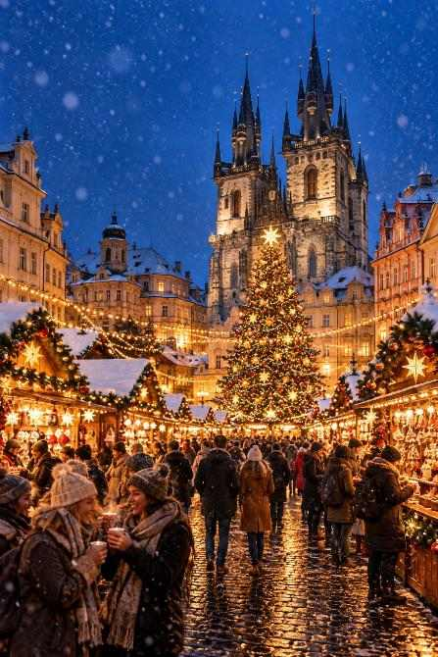

There is a moment that happens at every great Christmas market, and if you have been lucky enough to experience it, you know exactly what I mean.
It usually arrives just after four o'clock in the afternoon, when the short winter day surrenders to the dark. The sky turns from pewter to a deep, velvety blue. Somewhere above you, thousands of tiny lights blink on at once, and a hush ripples through the crowd before the laughter picks up again, a little louder and a little happier than before. The air is thick with cinnamon, clove, roasting almonds, and wood smoke. A brass band starts up from a balcony. A child tugs at a parent's sleeve and points at a carousel. You wrap both hands around a warm ceramic mug of mulled wine, breathe in the spice, and think: this is it. This is what Christmas is supposed to feel like.
That moment is why this book exists.
Europe's Christmas markets are among the most enchanting travel experiences on earth. They are living traditions, some stretching back more than six hundred years, set in medieval squares, beneath cathedral spires, along frozen canals, and even inside ancient caves. They are places where craftspeople still carve nutcrackers by hand, where bakers guard gingerbread recipes like family heirlooms, and where whole cities pause each evening simply to enjoy the light.
Whether you are planning your very first trip, returning for the tenth time, booking a river cruise with your best friend, bringing the grandchildren, or traveling solo in search of a little wonder, this guide was written for you.

Why a 2026–2027 Edition?
Christmas markets are timeless, but the details change every year. Opening days shift with the calendar. Markets move, expand, or add new attractions. Prices creep upward. Some cities introduce reusable-mug systems or cashless payments; others bring back beloved traditions after years away.
The 2026–2027 season has a particular shape worth knowing about. Christmas Day falls on a Friday, which means Christmas Eve is a Thursday and many markets close early that afternoon, while a good number close for the season on Wednesday, December 23. The First Sunday of Advent is November 29, 2026, so most traditional German markets open in the final week of November. And because Epiphany (January 6, 2027) falls on a Wednesday, the long-running markets in Prague, Vienna, Zagreb, and elsewhere offer a wonderful excuse to extend your festive season into the New Year.
Throughout this guide you will find the dates that had been officially announced at the time of writing, clearly marked, along with expected dates based on each market's long-standing pattern where official confirmation was still pending. Market organizers sometimes adjust their plans, so I will remind you more than once: always confirm dates on the official website before booking non-refundable travel.

How to Use This Guide
This book is organized into three parts, so you can dip in wherever you like.
Part One: Planning the Magic covers everything you need before you go: the history and meaning of the markets, when to travel, how to budget, how to get around, what to pack, how the famous mug-deposit system works, how to stay safe and comfortable in crowds, and a mouthwatering guide to the foods and drinks you will meet along the way.
Part Two: The Markets, Country by Country is the heart of the book. We travel from the legendary markets of Germany and Austria through the storybook villages of Alsace, the Alpine towns of Switzerland, the Gothic squares of Prague and Budapest, the canals of Belgium and the Netherlands, the candlelit courtyards of Scandinavia and the Baltics, and on to Poland, Croatia, Italy, Spain, Portugal, Britain, and Ireland, before finishing with twenty-five hidden-gem markets that reward the detour. Each major market includes a Market at a Glance panel with dates, hours, location, and what makes it special.
Part Three: Making It Yours turns inspiration into a real plan, with ready-made itineraries, a practical guide to Christmas market river cruises, advice for families, seniors, solo travelers and those with limited mobility, a shopper's guide to the best handmade treasures, twelve festive recipes to recreate the market flavors at home, a look at the traditions that continue long after the stalls close, and answers to the questions first-timers ask most.
The Appendices give you a fold-down-the-corner calendar of the season, a pocket phrasebook in seven languages, a packing checklist, and journal pages where you can plan your route and record your memories.

Symbols and Boxes You Will See
As you read, keep an eye out for these helpful features:
- Insider Tip: Hard-won advice from experienced market-goers: the quiet hour, the best viewpoint, the stall the locals love.
- Don't Miss: The one experience at each destination you would kick yourself for skipping.
- Budget Note: Ways to enjoy the magic without the sticker shock.
- Good to Know: Practical details about transport, accessibility, safety, or local customs.
- Market at a Glance: A quick-reference panel for each major market.
- Image Placement: Where a photograph or illustration belongs in the finished book.
ℹ GOOD TO KNOW
Prices in this guide are given in local currency with approximate euro equivalents where useful. They reflect typical recent prices and are intended as a planning guide rather than a guarantee. Expect small increases each season.

A Word About Choosing Your Markets
There are, by most estimates, well over ten thousand Christmas markets across Europe each year. Germany alone hosts somewhere between two and three thousand. No one can see them all, and no one should try. The joy of a Christmas market is not in ticking boxes; it is in slowing down.
So as you read, notice which descriptions make your heart beat a little faster. Is it the grand, bustling squares of Vienna and Nuremberg? The half-timbered fairy-tale villages of Alsace? The glowing caves of Valkenburg? The Nordic hygge of Copenhagen's Tivoli Gardens? Trust that feeling. The best Christmas market trip is the one that matches the kind of traveler you are.
✦ INSIDER TIP
If this is your first trip, choose two or three cities within easy train reach of one another and spend at least one full evening in each. Markets are at their most magical after dark, and you will want time to wander without watching the clock.

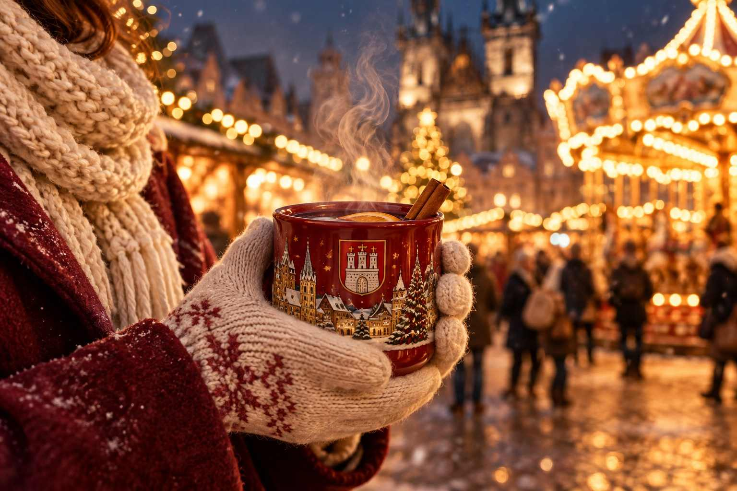

Now, pour yourself something warm, find a comfortable chair, and let's begin our journey through the most magical season in Europe.
Frohe Weihnachten, Joyeux Noël, Veselé Vánoce, and Merry Christmas.
Shelli A. Hibbard

PART ONE
Planning the Magic
— ❄ ✦ ❄ —
Everything you need to know before the first light flickers on: the stories behind the markets, when to go, how to budget, what to pack, and the delicious foods waiting for you.

CHAPTER 1

A Brief History of Christmas Markets
— ❄ ✦ ❄ —
From medieval winter fairs to candlelit squares: how a practical tradition became Europe's most beloved season.
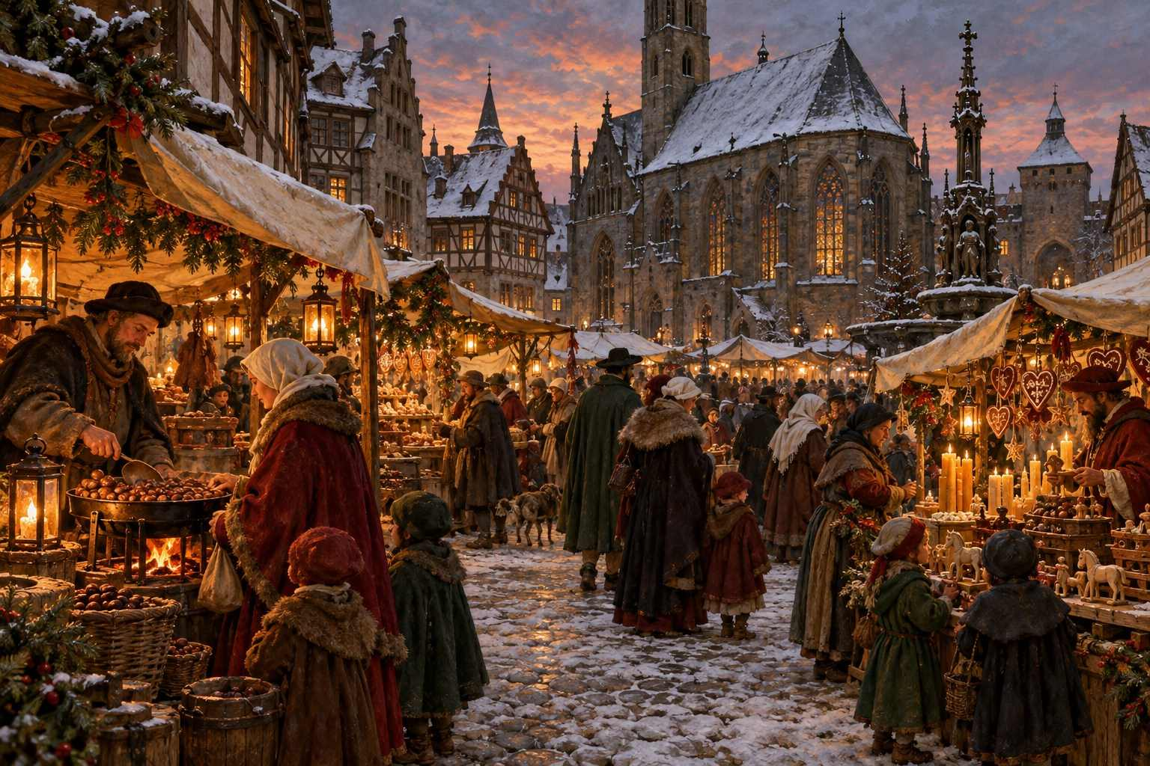

Long before the twinkling lights and souvenir mugs, the Christmas market began with a simple, practical need: people had to get ready for winter.
In the late Middle Ages, towns across the German-speaking lands held short fairs at the start of the cold season. Farmers, butchers, bakers, and craftsmen gathered in the central square so that townspeople could stock up on meat, grain, candles, and warm clothing before the snows made travel difficult. These were called Wintermärkte, winter markets, and they were more about survival than celebration.
Over time, as the calendar of the Church shaped daily life, these gatherings drifted toward Advent, the four weeks of preparation before Christmas. Stalls began offering treats that would only be eaten during the holidays: honey cakes, sugared nuts, and dried fruit breads. Toymakers and woodcarvers set out small gifts. The market slowly transformed from a place to buy supplies into a place to buy joy.

The Oldest Markets
Several cities proudly claim the title of "oldest Christmas market," and the debate is part of the fun.
Vienna is often cited for its Dezembermarkt, for which Duke Albrecht I granted shopkeepers the right to hold a December market as early as 1298. It was not yet a Christmas market in the modern sense, but it set an important precedent.
Bautzen, a small town in Saxony, holds records of its Wenzelsmarkt dating to 1384, making it one of the oldest documented Christmas markets in Germany.
Dresden's Striezelmarkt was first recorded in 1434, when it was a one-day market held on the Monday before Christmas. Its name comes from Striezel, an old word for the fruit loaf we now know as Stollen. Today it is considered by many to be Germany's oldest continuously running Christmas market.
Frankfurt's market appears in records from 1393, and Munich's can be traced to the fourteenth century as well.
Nuremberg's Christkindlesmarkt, perhaps the most famous in the world, has documentation from the early seventeenth century. A wooden box painted with the date 1628, discovered in the city, bears an inscription referring to the market, and many historians believe the tradition is considerably older.
Strasbourg, now in France but for much of its history a German-speaking city, calls itself the Capitale de Noël and traces its Christkindelsmärik to 1570, making it one of the oldest in France.
ℹ GOOD TO KNOW
You will see several markets proudly advertising themselves as "the oldest." Rather than worrying about who is right, enjoy the fact that you are standing in a tradition older than most nations.

Martin Luther and the Christ Child
One of the most fascinating chapters in the story involves the Protestant Reformation.
Before the sixteenth century, children in much of Europe received gifts on December 6, the feast day of Saint Nicholas, the generous fourth-century bishop of Myra. Martin Luther, who wanted to shift attention away from the veneration of saints and toward Christ himself, encouraged families to give gifts on Christmas instead, brought not by Saint Nicholas but by the Christkind, the Christ Child.
The idea spread, and so did the markets that supplied those gifts. The very name Christkindlmarkt, the market of the Christ Child, reflects this shift. Today, the Christkind is often portrayed as a golden-haired angelic figure in a white-and-gold robe and crown, and in cities like Nuremberg a young woman is chosen every two years to play the role, opening the market with a prologue read from the balcony of the Church of Our Lady.
Interestingly, Catholic regions embraced the Christkind too, and it remains the gift-bringer in much of southern Germany, Austria, Switzerland, the Czech Republic (where he is called Ježíšek), Hungary (Jézuska), and parts of Italy. Meanwhile, Saint Nicholas never disappeared; he still visits on the evening of December 5 or the morning of December 6, filling children's boots with oranges, nuts, and chocolate.
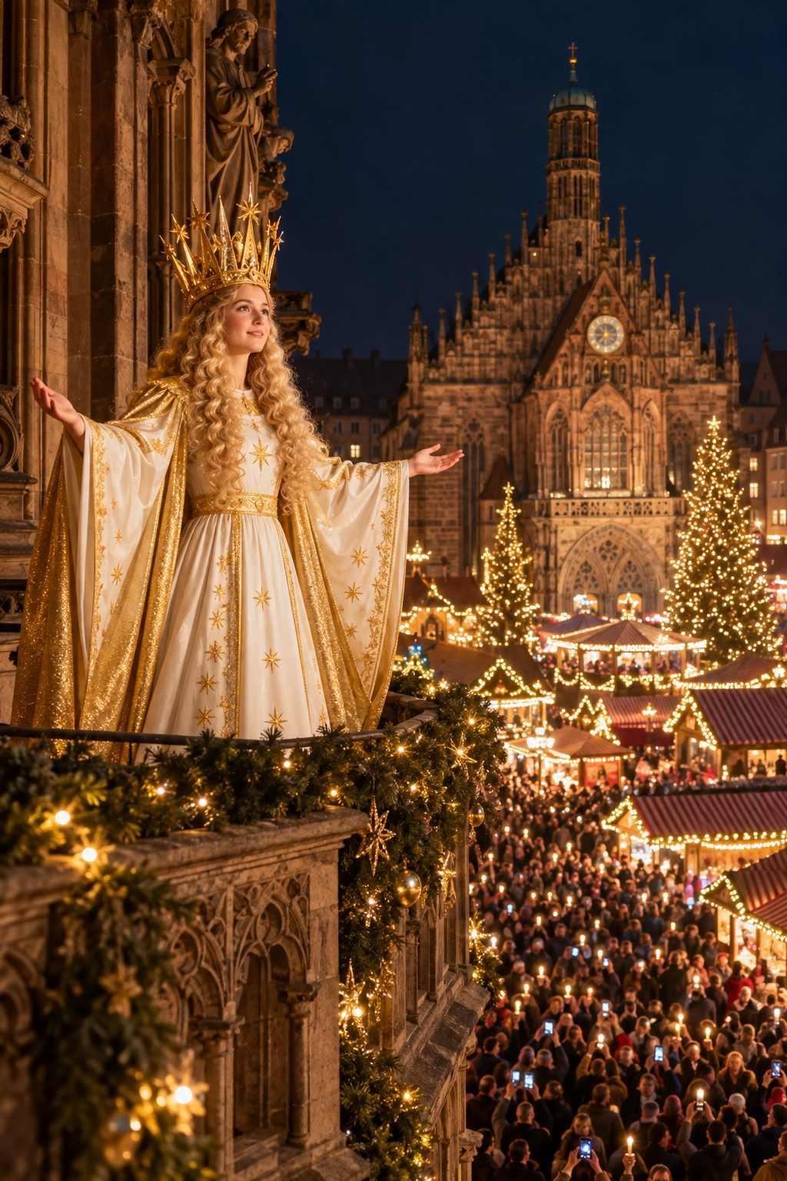

Candles, Trees, and Lights
The Christmas tree as we know it also grew up alongside the markets. Records from the early sixteenth century in Riga (Latvia) and Tallinn (Estonia) describe merchants' guilds decorating a tree in the town square, dancing around it, and then setting it alight. Both cities claim the honor of the "first Christmas tree," and you will see plaques commemorating it when you visit.
By the eighteenth century, decorated trees were common in German homes, lit with small candles and hung with apples, nuts, and paper ornaments. When Queen Victoria and her German-born husband Prince Albert were illustrated beside a tabletop Christmas tree in 1848, the fashion swept Britain and eventually the world.
The markets, naturally, became the place to buy ornaments. In the Thuringian town of Lauscha, glassblowers began producing delicate hand-blown glass baubles in the mid-1800s, reportedly because many families could not afford real fruit to hang on their trees. Those glass ornaments are still made there and remain among the most treasured souvenirs you can buy.
Meanwhile, the woodworkers of the Erzgebirge (the Ore Mountains on the Saxon-Czech border) developed a tradition born of hardship. As the region's silver mines declined, miners turned to woodcarving to support their families. They created nutcrackers, smoking men (Räuchermänner), candle arches (Schwibbögen) and the wonderful candle-powered carousels known as Christmas pyramids. The candle arch, with its half-moon shape, is said to represent the mouth of a mine tunnel, lit by the lamps miners hung at the entrance each Christmas Eve to welcome their comrades home.

From Local Custom to Global Phenomenon
For most of their history, Christmas markets were local affairs. Villagers visited their own market, and perhaps the one in the next town. That began to change in the nineteenth century, when railways made travel easier, and changed dramatically in the late twentieth century as cheap flights, river cruises, and travel media brought the markets to an international audience.
Today, Nuremberg alone welcomes around two million visitors each season. Strasbourg's markets draw a similar crowd. Vienna's Rathausplatz is among the most photographed squares in the world during Advent. River cruise lines run entire itineraries dedicated to the markets, and cities as far afield as Chicago, Tokyo, and Sydney host German-style Christmas markets of their own.
And yet, remarkably, the heart of the tradition has survived. Many market organizers carefully control what can be sold, favoring regional crafts and traditional food over mass-produced souvenirs. Nuremberg, for example, has long required that goods be traditional and that stalls be decorated in a traditional way, and the city even gives an award to the most beautifully decorated booths. Dresden, Rothenburg, and others take similar pride in authenticity.
✦ INSIDER TIP
Look for stalls where you can see the craftsperson at work, whether it is a glassblower, a woodcarver, a candle-dipper, or a gingerbread baker piping icing. These are often the most authentic and the most memorable purchases you will make.

The Rhythm of the Season
To understand Christmas markets, it helps to understand the rhythm of Advent in Central Europe.
Totensonntag and the late-November opening. In many Protestant parts of Germany, the Sunday before Advent is Totensonntag, a day to remember the dead. By tradition, many markets do not open until after this quiet Sunday, which in 2026 falls on November 22. That is why you will see so many German markets opening between November 23 and 27.
Advent Sundays. Each of the four Sundays before Christmas is marked by lighting another candle on the Advent wreath. In 2026 the Advent Sundays fall on November 29, December 6, December 13, and December 20. Many markets hold special concerts, processions, or candle ceremonies on these days, and they tend to be the busiest days of the week.
Saint Barbara's Day (December 4). In parts of Germany, Austria, and the Czech Republic, people cut cherry or forsythia branches on this day and place them in water. If they bloom by Christmas, it is a sign of good luck for the coming year.
Krampus Night (December 5) and Saint Nicholas Day (December 6). In Austria, Bavaria, and the Alpine regions, Saint Nicholas is accompanied by Krampus, a horned, shaggy, fearsome creature who scares naughty children. Krampus runs (Krampusläufe), in which dozens of costumed devils parade through town rattling bells and chains, are thrilling to watch, though perhaps not for very small children.
Saint Lucia's Day (December 13). In Sweden, Norway, and Finland, this festival of light features processions of girls in white gowns with red sashes, led by a Lucia wearing a crown of candles. In 2026 it falls on a Sunday.
Christmas Eve (December 24). In most of Central Europe, Christmas Eve is the main family celebration, with gifts exchanged in the evening. Markets usually close by early afternoon, and the streets fall silent as families gather at home. Many travelers find this a surprisingly moving time to be in a European city: church bells ring, candles glow in windows, and midnight Mass fills the great cathedrals.
The twelve days and Epiphany (January 6). Some markets reopen or continue after Christmas, especially in Austria, the Czech Republic, and Italy, and run until Epiphany, when the Three Kings are said to have arrived in Bethlehem.
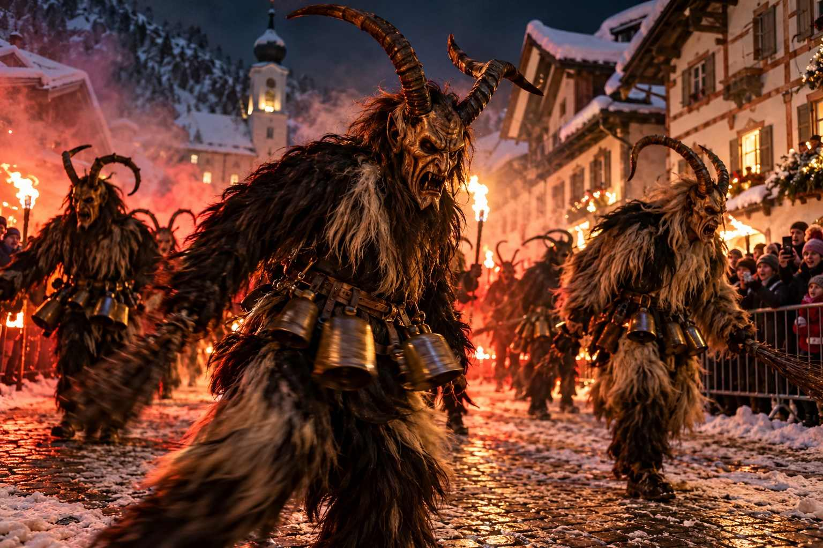

What Makes a "Real" Christmas Market?
You may hear seasoned travelers debate whether a particular market is "authentic." There is no official definition, but most traditional markets share a few qualities:
- A historic setting. A cathedral square, a medieval town hall, a castle courtyard, or an old harbor.
- Wooden stalls. Usually small chalets or booths, often decorated with greenery, lights, and carved figures.
- Seasonal food and drink. Mulled wine, grilled sausages, gingerbread, roasted nuts, and regional specialties.
- Handcrafted goods. Ornaments, candles, toys, textiles, ceramics, and local artisan products.
- Music and ritual. Choirs, brass bands, nativity scenes, an opening ceremony, and a great tree.
- A gathering spirit. Locals meeting after work, families with children, friends sharing a mug in the cold.
Some newer markets are gloriously untraditional: markets on ships, in caves, in train stations, in castles, on frozen lakes, or themed around medieval re-enactment, fairy tales, or LGBTQ+ celebration. These can be tremendous fun and are well worth a visit. The only real test of a Christmas market is whether it makes you feel a little more festive when you leave than when you arrived.

A Tradition Worth Protecting
In recent years, Christmas markets have faced challenges, from the pandemic years when many were canceled, to rising costs, to security concerns that have brought barriers and bag checks to some city centers. Yet each season they return, and each season millions of people choose to gather in the cold, in the dark, simply to be together beneath the lights.
When you visit, you become part of that story. Buy something handmade. Chat with a stallholder. Learn a few words of the local language. Return your mug or keep it as a memento. Tip the musicians. Light a candle in a church. These small acts help keep a six-hundred-year-old tradition alive.
★ DON'T MISS
Arrive at a market in the last hour of daylight and stay as the lights come on. Watching a Christmas market "wake up" at dusk is one of the great simple pleasures of European travel.

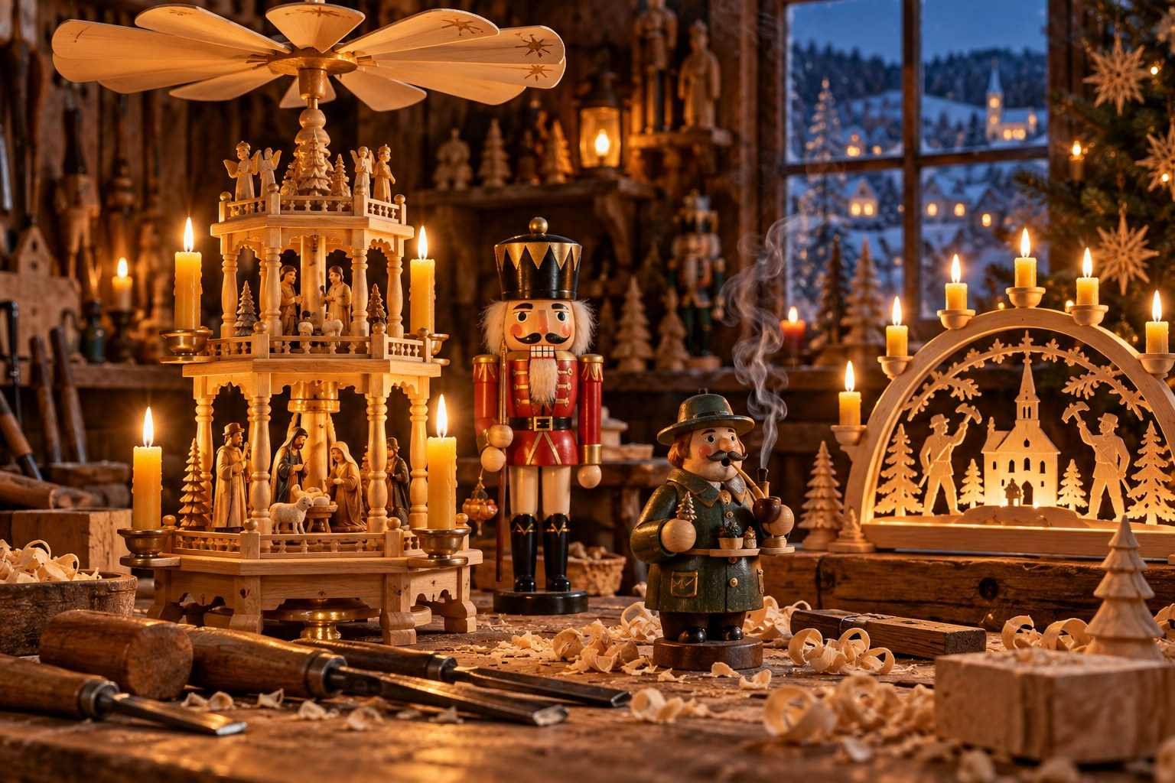

CHAPTER 2

Planning Your 2026–2027 Trip
— ❄ ✦ ❄ —
When to go, where to stay, how to get around, and how to budget for the season of your dreams.
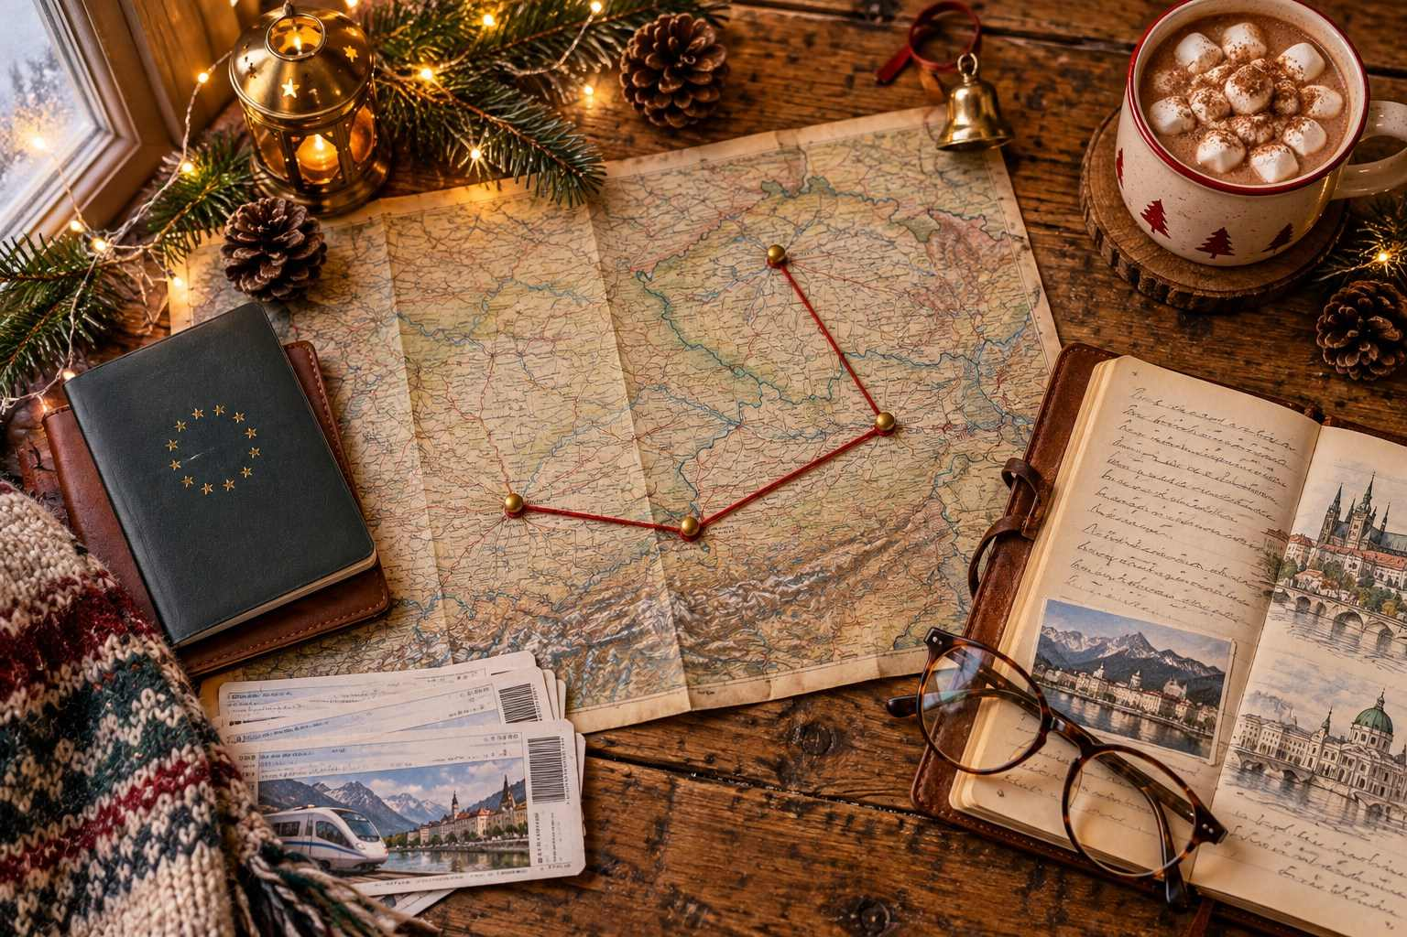

A Christmas market trip is one of the easiest European vacations to plan and one of the easiest to get slightly wrong. The markets run for only a few weeks, the days are short, the weather is unpredictable, and the most popular cities fill up months in advance. A little planning goes a long way, and this chapter will walk you through every decision, step by step.

The 2026 Season at a Glance
Here are the key dates that shape the 2026–2027 Christmas market season:
Date | Day | What It Means for You
November 6, 2026 | Friday | Earliest Vienna markets (Schönbrunn, Stephansplatz) open
November 13, 2026 | Friday | Vienna Rathausplatz, Tivoli Copenhagen, and Cologne Harbour markets open
November 16, 2026 | Monday | Cologne Cathedral market opens
November 19–20, 2026 | Thu–Fri | Salzburg and Munich open
November 22, 2026 | Sunday | Totensonntag; many German markets open in the days after
November 25, 2026 | Wednesday | Dresden Striezelmarkt opens
November 27, 2026 | Friday | Nuremberg Christkindlesmarkt opens
November 28, 2026 | Saturday | Prague and Advent in Zagreb begin
November 29, 2026 | Sunday | First Sunday of Advent
December 5–6, 2026 | Sat–Sun | Krampus night and Saint Nicholas Day
December 13, 2026 | Sunday | Third Advent; Saint Lucia's Day
December 23, 2026 | Wednesday | Last day for many German markets
December 24, 2026 | Thursday | Christmas Eve; most markets close early afternoon
December 25, 2026 | Friday | Christmas Day; nearly all markets closed
December 31, 2026 | Thursday | New Year's Eve celebrations
January 6, 2027 | Wednesday | Epiphany; last day for Prague, Schönbrunn and others

ℹ GOOD TO KNOW
Dates listed as confirmed were published by organizers at the time of writing. Where a market had not yet announced its dates, this guide gives the expected dates based on its long-standing pattern. Always double-check before you book.

When Should You Go?
The honest answer: it depends on what you want most. Each part of the season has its own personality.

Mid to Late November: The Early Bird Window
A handful of markets, mostly in Austria, Cologne, Copenhagen, and some larger cities, open in mid-November. This is a wonderful time to go if you want smaller crowds, lower hotel prices, and plenty of elbow room at the stalls. The downside is that many traditional German markets, including Nuremberg, Dresden, and Rothenburg, will not yet be open, and the Christmas mood is still warming up.
Best for: Vienna, Salzburg, Cologne, Copenhagen, Munich, travelers on a budget.

The First Week of Advent (November 27 – December 6): The Sweet Spot
For many travelers, this is the perfect window. Virtually every market in Europe is open, the decorations are fresh, the crowds have not yet reached their peak, and you can catch special events such as Saint Nicholas Day and the Krampus runs. Hotel prices rise, but not as sharply as they will in mid-December.
Best for: First-timers, multi-country itineraries, anyone who wants to see "everything."

Mid-December (December 7–20): Peak Magic, Peak Crowds
This is the heart of the season. The atmosphere is electric, the choirs are in full voice, and the chance of snow increases. It is also when the markets are busiest, especially on weekends. If you travel in mid-December, plan to visit the biggest markets on weekday afternoons and save the weekends for smaller towns.
Best for: Atmosphere seekers, snow hopefuls, those who love a lively crowd.

Christmas Week (December 21–24): Last-Minute Charm
The final days before Christmas are a special mix of hustle and heart. Locals are doing their last-minute shopping, and there is a genuine sense of anticipation in the air. Be aware that many German markets close on December 22 or 23, and nearly all close by mid-afternoon on December 24.
Best for: Travelers who want to experience Christmas Eve in Europe.

After Christmas (December 26 – January 6): The Hidden Season
Many travelers do not realize that dozens of markets continue after Christmas. Vienna's Schönbrunn and Riesenradplatz markets, Prague's Old Town Square, Zagreb's Advent, Salzburg (until January 1), Tivoli in Copenhagen, the Cologne Harbour market, Bolzano and other Italian markets, and many more remain open into the New Year. Some shift to "winter market" or "New Year's market" themes. It is a fantastic time to combine Christmas lights with a New Year's Eve celebration.
Best for: Flexible travelers, New Year's Eve lovers, those who spend Christmas at home but still want the magic.
✦ INSIDER TIP
If you can travel only once, aim for Sunday, November 29 through Friday, December 4, 2026. Every major market will be open, the first Advent weekend will be behind you, and you will arrive in the quieter weekdays before the Saint Nicholas celebrations.

How Long Should You Stay?
A single evening is enough to sample a small market, but larger cities like Vienna, Cologne, Munich, Berlin, and Prague have many markets spread across the city and deserve two or three days. As a general rule:
- Weekend getaway (2–3 nights): One city plus a day trip. Example: Vienna with a day in Bratislava, or Strasbourg with a day in Colmar.
- One week (6–8 nights): Three or four cities. Example: Munich, Salzburg, Vienna, and Prague.
- Ten days to two weeks: A grand tour across two or three countries, or a river cruise with pre- and post-cruise stays.
Resist the temptation to change hotels every night. Unpacking once and making day trips by train is far more relaxing, especially when daylight is short.

Getting There

Flying In
Most North American travelers fly into one of Europe's major hubs: Frankfurt, Munich, Vienna, Zurich, Amsterdam, Paris, Prague, or Copenhagen. Frankfurt and Munich are especially convenient for the German markets, while Vienna works beautifully for Austria, Prague, Budapest, and Bratislava.
Consider an open-jaw ticket, flying into one city and out of another. For example, fly into Munich and home from Prague, or into Frankfurt and home from Vienna. It often costs little or nothing extra and saves you from backtracking.
€ BUDGET NOTE
Transatlantic fares for early December are often lower than you might expect, because the weeks between Thanksgiving and mid-December are a quieter period for airlines. Book for departure between December 1 and 10 and return before December 18 to avoid holiday peak pricing.

Entry Requirements
Citizens of the United States, Canada, the United Kingdom, Australia, and many other countries can visit the Schengen Area for short stays without a visa. Two changes are worth knowing about:
- The Entry/Exit System (EES), launched in October 2025, registers non-EU travelers electronically at the border, including fingerprints and a facial photo on your first entry. Allow a little extra time at passport control.
- ETIAS, a new online travel authorization for visa-exempt visitors, has been expected to launch in late 2026. If it is in force when you travel, you will need to apply online before departure. Check the official European Union ETIAS website a few weeks before your trip.
Make sure your passport is valid for at least three months beyond your planned departure date from Europe and was issued within the last ten years.

Getting Around

Trains: The Best Way to Travel
Europe's rail network is the Christmas market traveler's best friend. Trains run frequently, city centers are usually a short walk from the station, and watching snowy villages roll past the window is part of the magic.
Germany: Deutsche Bahn's high-speed ICE trains connect all major cities. Book "Sparpreis" and "Super Sparpreis" saver fares early for the best prices. For regional trains, the Deutschlandticket, a monthly subscription pass of roughly €60, covers unlimited local and regional transport nationwide and can be excellent value for a week or more of day trips. Note that it must be canceled before the following month begins, as it renews automatically.
Austria: ÖBB's Railjet trains are comfortable and punctual. Vienna to Salzburg takes about two and a half hours.
Switzerland: Swiss trains are famously efficient. The Swiss Travel Pass covers trains, boats, buses, and city transport, and includes many museums.
France: TGV high-speed trains link Paris to Strasbourg in under two hours. Regional TER trains serve the Alsace villages.
Cross-border: Munich–Salzburg, Vienna–Prague, Vienna–Budapest, Vienna–Bratislava, Prague–Dresden, Frankfurt–Strasbourg, and Cologne–Brussels–Amsterdam are all easy train connections.
A Eurail pass can make sense for longer, flexible itineraries covering several countries, but for most one-week trips, individual advance tickets are cheaper.
✦ INSIDER TIP
Many cities offer a Christmas-market day ticket or tourist card that includes public transport and discounts. Ask at the tourist information office or check the city's official tourism website.

Driving
Renting a car gives you the freedom to reach smaller villages, especially in Alsace, the Black Forest, the Romantic Road, and the Austrian countryside. However, winter driving requires care. In Germany and Austria, winter tires are required in wintry conditions, and rental cars in December will normally be equipped accordingly. City centers can be difficult to drive and park in during market season, so use park-and-ride lots on the edge of town. Many German cities also have low-emission zones requiring a sticker, which rental cars usually have.

River Cruises
For many travelers, especially those who prefer not to handle luggage and logistics, a Christmas market river cruise is the ideal choice. We cover this in detail in Chapter 16.

Coach Tours
Escorted coach tours are another stress-free option, popular with seniors and first-time visitors. They handle hotels, transport, and often include guided market walks. The trade-off is less flexibility and less free time in the evenings, which is when markets shine brightest.

Where to Stay
Book early. For cities such as Strasbourg, Nuremberg, Colmar, Salzburg, and Rothenburg, hotels in the historic center can sell out six to twelve months in advance, particularly for weekends.
Stay central. Being able to walk back to your hotel at night, or pop back to drop off shopping and warm up before evening, is worth a premium.
Consider staying nearby. If Strasbourg is full or expensive, look at Colmar, Kehl (just across the Rhine in Germany), or Offenburg. Instead of Rothenburg, consider nearby towns and a day trip. For Nuremberg, Fürth or Erlangen are a short train ride away.
Look for character. Many historic inns, family-run guesthouses, castle hotels, and converted monasteries decorate beautifully for Advent. Staying in one adds to the magic.
€ BUDGET NOTE
Sunday through Thursday nights are almost always cheaper than Friday and Saturday. Plan your big-city stays for weekdays and spend weekends in smaller towns or in transit.

Weather and Daylight
December in Central Europe is cold, often damp, and dark early. Typical conditions:
City | Avg. December High | Avg. December Low | Sunset (mid-Dec)
Munich | 3°C / 38°F | -3°C / 27°F | about 4:20 pm
Vienna | 3°C / 38°F | -1°C / 30°F | about 4:00 pm
Strasbourg | 5°C / 41°F | 0°C / 32°F | about 4:40 pm
Prague | 2°C / 36°F | -2°C / 28°F | about 4:00 pm
Cologne | 6°C / 43°F | 1°C / 34°F | about 4:30 pm
Copenhagen | 4°C / 39°F | 1°C / 34°F | about 3:40 pm
Stockholm | 1°C / 34°F | -3°C / 27°F | about 2:50 pm

Snow is never guaranteed in the cities, though it becomes more likely at higher elevations, in the Alps, and in Scandinavia. Rain and drizzle are just as common. The good news? Short days mean the markets are lit up by mid-afternoon, so you get more hours of twinkling lights.
✦ INSIDER TIP
Plan museums, churches, and indoor sights for the morning and early afternoon, and save the markets for dusk and evening. You will stay warmer and see the stalls at their most beautiful.

What to Pack
Staying warm and comfortable is the single biggest factor in how much you enjoy the markets. You will be standing outside for hours in cold, damp air, often on cobblestones.

The Essentials
- Warm, waterproof boots with good grip and cushioning. Cobblestones are slippery when wet or icy.
- Thermal base layers (merino wool is ideal): top and bottom.
- A warm, windproof, water-resistant coat that reaches at least mid-thigh.
- Hat, scarf, and gloves. Touchscreen-friendly gloves are helpful for photos and maps.
- Warm socks, preferably wool, and extra pairs.
- A small crossbody bag or anti-theft bag that zips closed and sits in front of you.
- A reusable shopping tote that folds small, for your market purchases.
- A compact umbrella.

Helpful Extras
- Chemical hand and foot warmers
- A small insulated flask for tea during daytime sightseeing
- A portable phone charger; cold drains batteries quickly
- Lip balm and hand cream; winter air is drying
- Bubble wrap or packing cubes for fragile ornaments
- A European plug adapter (Type C/F for most of Europe; Type G for the UK and Ireland)
- Any medications you need, in original packaging
- Copies of important documents stored separately from originals
A complete packing checklist is in Appendix C.
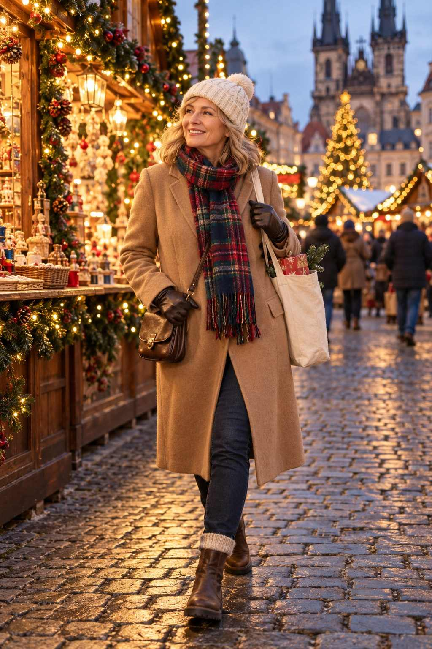

Budgeting for Your Trip
Christmas markets themselves are almost always free to enter (a few exceptions, such as Tivoli Gardens and some castle markets, charge admission). But the costs add up quickly once you start sipping and shopping. Here is a realistic daily budget per person, excluding flights, based on typical recent prices in Germany and Austria:
Expense | Budget Traveler | Mid-Range | Comfort
Accommodation (per person, sharing) | €50–80 | €90–150 | €180+
Market food and drink | €20–30 | €30–45 | €45–70
Other meals | €15–25 | €30–50 | €60–100
Local transport and trains | €10–20 | €20–40 | €40–80
Sightseeing and entry fees | €5–15 | €15–30 | €30–60
Souvenirs and gifts | €10–20 | €30–60 | €80+
Daily total | €110–190 | €215–375 | €435+

Prices in Switzerland, Scandinavia, and the UK are noticeably higher. Prague, Budapest, Kraków, Zagreb, Bratislava, and other Central and Eastern European cities are generally more affordable.

Typical Market Prices
- Mulled wine (Glühwein): €4–6 per cup, plus a €3–5 mug deposit
- Grilled sausage in a roll: €4–6
- Potato pancakes with apple sauce: €5–7
- A bag of roasted almonds: €4–6 (100–150 g)
- Hand-blown glass ornament: €8–30
- Hand-carved wooden figure: €20–150+
- Nutcracker (authentic Erzgebirge): €60–300+
€ BUDGET NOTE
Eat one "main meal" a day at the markets, where portions are hearty, and keep breakfast simple. Many hotels include a generous European breakfast buffet that will carry you well into the afternoon.

Travel Insurance
Winter travel carries a higher risk of weather delays, missed connections, and slips on icy streets. A comprehensive travel insurance policy that includes trip cancellation, trip interruption, medical coverage, and emergency evacuation is strongly recommended, especially for older travelers. Check whether your policy covers pre-existing conditions and winter activities if you plan to ski or skate.

Money Matters
The euro is used in Germany, Austria, France, Belgium, the Netherlands, Italy, Spain, Portugal, Ireland, Slovakia, Slovenia, Croatia, Estonia, Latvia, Lithuania, Finland, and Luxembourg. Other currencies you may need:
- Switzerland: Swiss franc (CHF)
- Czech Republic: Czech koruna (CZK)
- Hungary: Hungarian forint (HUF)
- Poland: Polish złoty (PLN)
- Denmark: Danish krone (DKK)
- Sweden: Swedish krona (SEK)
- United Kingdom: Pound sterling (GBP)
- Romania: Romanian leu (RON)
Card acceptance at Christmas markets has improved dramatically, and some markets (including Budapest's main fair in recent years) are now card-only. However, many smaller stalls, especially in Germany and Austria, still prefer cash. Carry a mix: a contactless card with no foreign transaction fees, plus €50–100 in small notes and coins for the stalls.
ℹ GOOD TO KNOW
When paying by card abroad, always choose to be charged in the local currency, not your home currency. "Dynamic currency conversion" almost always comes with a poor exchange rate.

Booking Checklist
Use this timeline to stay on track:
- 9–12 months before: Choose your destinations and book central hotels in high-demand towns (Strasbourg, Colmar, Nuremberg, Rothenburg, Salzburg). Book river cruises.
- 6 months before: Book flights. Research travel insurance.
- 3 months before: Book long-distance trains when saver fares open. Reserve special experiences (Tivoli tickets, Valkenburg caves, concerts, Advent dinners).
- 1 month before: Check official market websites for confirmed dates and hours. Check ETIAS and entry requirements. Notify your bank of travel.
- 1 week before: Check the forecast, pack, download offline maps and train apps, and order a small amount of local currency if desired.
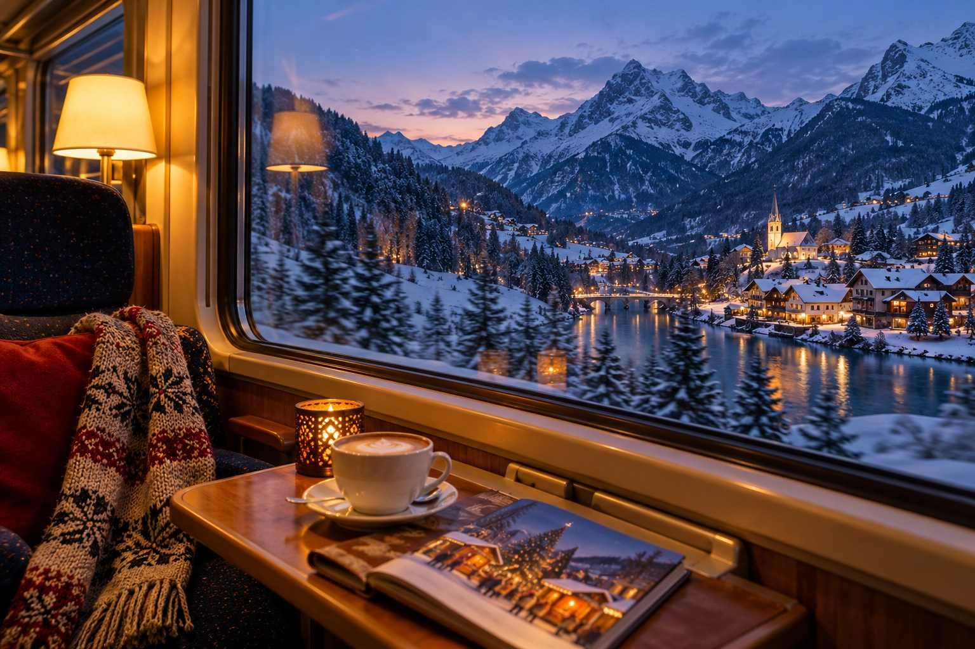

CHAPTER 3

Market Know-How: Mugs, Money, Manners & Safety
— ❄ ✦ ❄ —
The unwritten rules every market-goer should know, so you can relax and enjoy the magic like a local.
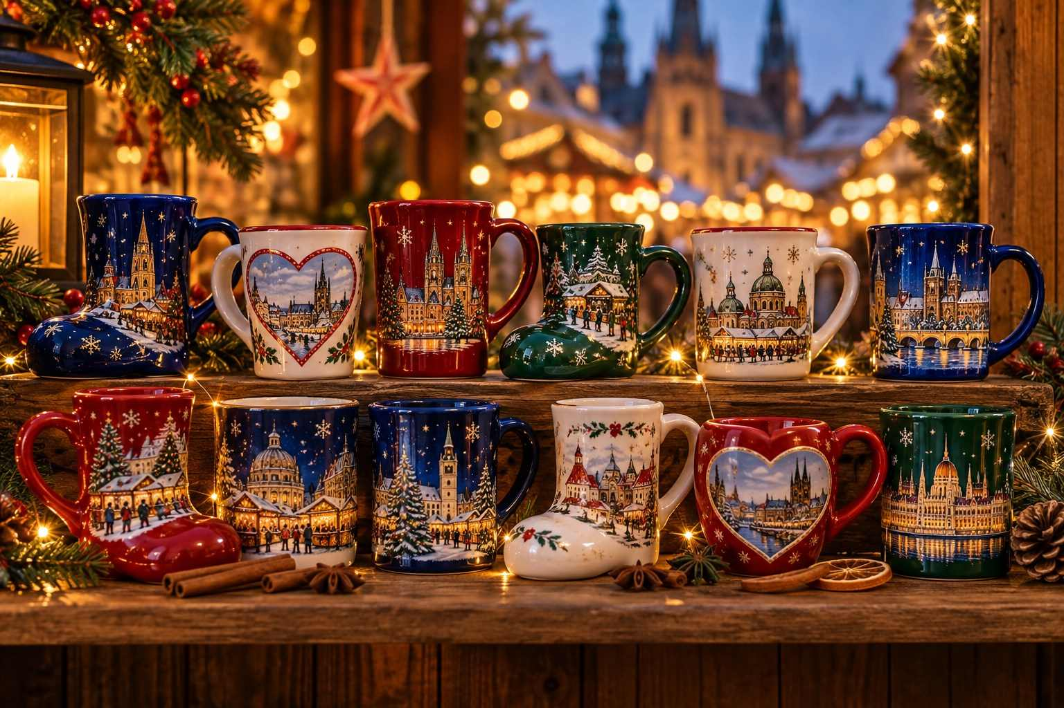

Christmas markets are friendly, informal places, and nobody expects visitors to know all the customs. Still, a little know-how helps you feel at home, saves money, and makes the whole experience more relaxed. This chapter covers the practical side of market life, from the famous mug deposit to staying safe in a crowd.

The Mug Deposit System (Pfand)
At most German, Austrian, and Swiss markets, and increasingly elsewhere, hot drinks are served in ceramic or reusable mugs rather than paper cups. When you buy your drink, you pay a small deposit on the mug, known in German as Pfand.
How it works:
- Order your drink. The price will be shown as the drink price plus the deposit, for example "Glühwein €5 + €4 Pfand."
- Enjoy your drink at the stall's standing tables or while wandering.
- When you are finished, either return the mug to any stall selling that market's drinks (usually any stall with the same mug design) and receive your deposit back, or keep the mug as a souvenir. The deposit becomes its purchase price.
Things to know:
- Deposits typically range from €2 to €5, occasionally more for special designs.
- Each market, and sometimes each section of a large market, has its own mug design, often changing each year. Collectors love them.
- Some stalls give you a token (Pfandmarke) with your mug. You may need to hand it back to reclaim your deposit.
- Mugs from one market cannot usually be returned at another.
- If you want a clean mug to take home, ask for a fresh one when you return your used one. Many vendors will happily swap.
✦ INSIDER TIP
Collecting mugs is a lovely tradition, but they are heavy and fragile. If you plan to collect more than a few, pack bubble wrap or wrap each mug in a pair of socks. Some travelers buy a small, cheap extra bag just for their mug collection.

In some cities, such as Vienna, every market has its own themed mug, and collecting the set is part of the fun. Vienna's Rathausplatz mug has become one of the most sought-after designs, released fresh each year.

Paying at the Stalls
- Have small bills and coins. A €50 note for a €5 drink will not win you friends on a busy evening.
- Tap to pay is increasingly common, especially at larger markets and in Scandinavia, the Netherlands, and the UK. Some markets, such as Budapest's Vörösmarty Square fair in recent seasons, have been card-only.
- ATMs (Geldautomat in German) are available near most markets. Use bank-affiliated ATMs rather than standalone machines, which often carry high fees.
- Tipping at stalls is not expected, though rounding up is appreciated. If a drink is €4.50, you might hand over €5 and say "Stimmt so" ("Keep the change").

Market Manners and Etiquette
Christmas markets are relaxed, but a few courtesies go a long way:
- Greet the vendor. A simple "Guten Tag" (or "Grüß Gott" in Bavaria and Austria), "Bonjour," or "Dobrý den" before you ask for something is appreciated.
- Ask before touching delicate items. Glass ornaments, lace, and hand-painted goods are fragile, and some vendors prefer to hand items to you.
- Ask before photographing a craftsperson or their work. Most are delighted, but some artisans are wary of designs being copied.
- Share the standing tables. High tables around food stalls are communal. It is perfectly normal to join strangers, and you may make new friends.
- Keep the line moving. At popular stalls, know what you want to order when you reach the front.
- Don't bring outside drinks. Enjoy what the market offers.
- Mind the smoking areas. Smoking outdoors is common in parts of Europe. Move upwind if it bothers you.
- Keep an eye on children. Markets can be crowded, and it is easy to get separated. Agree on a meeting point in advance.
ℹ GOOD TO KNOW
Mulled wine is surprisingly strong: the heat and sugar hide the alcohol, and some varieties are fortified with rum or brandy. Pace yourself, eat something, and alternate with non-alcoholic drinks. Every market offers alternatives such as Kinderpunsch (children's punch), hot apple juice, or hot chocolate.

Crowds: How to Beat Them
The most popular markets can become very crowded, especially on Friday and Saturday evenings and on Advent weekends. A few strategies help enormously:
- Visit on weekdays whenever possible, especially Monday through Thursday.
- Go at opening time (typically 10 or 11 am) for shopping. The stalls are fully stocked, the vendors have time to chat, and you can browse in peace.
- Return after dark for atmosphere, but consider arriving around 4 pm and leaving before 7 pm, when local workers and evening visitors arrive.
- Avoid the first opening weekend and the final weekend before Christmas at the most famous markets, if you can.
- Explore beyond the main square. Most big cities have a dozen or more smaller neighborhood markets that are just as charming and far less crowded.
- Skip the cruise-ship rush. In river cities such as Cologne, Nuremberg, Passau, Regensburg, Vienna, and Budapest, markets can fill with tour groups in the late morning and mid-afternoon.
✦ INSIDER TIP
If a famous market feels overwhelming, walk two or three streets away. You will often find a small neighborhood market, a quiet church courtyard, or a cozy café where locals gather. These moments often become the highlight of the trip.

Staying Safe
Christmas markets are generally very safe, family-friendly places. Since 2016, many cities have added visible security measures, including concrete barriers, bag checks at entrances, and increased police presence. These measures are reassuring and rarely intrusive. The most common problems visitors face are minor ones.

Pickpockets
Crowded markets attract pickpockets, just as crowded tourist sites do everywhere. Protect yourself with simple habits:
- Carry a crossbody bag worn in front, with zips closed.
- Keep your phone and wallet in inside or front pockets, never in a back pocket.
- Leave your passport in the hotel safe and carry a photocopy or photo of it.
- Carry only the cash and cards you need for the day.
- Be aware of distractions: someone bumping you, asking for directions, or spilling a drink on you.

Slips and Falls
Wet or icy cobblestones are a genuine hazard, and falls are one of the most common causes of travel insurance claims in winter. Wear shoes with good grip, walk carefully, and hold handrails on steps and bridges. Consider slip-on ice cleats if you are traveling in snowy regions.

Staying Warm
Hypothermia is unlikely at a market, but getting chilled to the bone will ruin your evening. Dress in layers, step into a café or church every hour or so to warm up, and keep your hands, feet, and head covered.

Food Allergies and Dietary Needs
EU law requires food vendors to provide information about the fourteen major allergens, but at small stalls this may be a laminated sheet you need to ask for. Learn the local words for your allergen, or carry a translated allergy card. Nuts, gluten, dairy, and eggs are extremely common in market foods.
Vegetarian and vegan options have expanded dramatically. Look for potato pancakes, mushroom dishes, cheese spätzle, flammekueche with vegetable toppings, grilled vegetable skewers, crêpes, vegan sausages, and roasted chestnuts. Berlin, Munich's Tollwood Winter Festival, and many larger city markets have entire stalls dedicated to vegan food.

Accessibility
Most markets are held in historic squares with uneven cobblestones, and crowds can make navigation challenging for wheelchair users and those with limited mobility. Many cities now publish accessibility information for their markets, and some offer quieter hours or special events. See Chapter 17 for detailed advice.

Restrooms
Public toilets near markets are often temporary units or facilities in nearby buildings, and many charge a small fee (typically €0.50–€1). Keep a few coins handy. Cafés and department stores are good alternatives, though you may be expected to buy something.
✦ INSIDER TIP
In Germany, look for the sign WC or Toiletten. In France, Toilettes. In the Czech Republic, Toalety or WC. Men's rooms are often marked Herren (H) or Hommes, and women's rooms Damen (D) or Femmes.

Photography Tips for the Markets
Christmas markets are among the most photogenic scenes in the world, but low light and crowds can be tricky.
- Shoot at blue hour. The 20–30 minutes after sunset, when the sky is still deep blue and the lights are on, gives the most magical results.
- Find height. A church tower, a café balcony, a bridge, or the top of a Ferris wheel gives you the classic overview shot.
- Get close. Details make wonderful photos: a steaming mug, a row of glass baubles, a carved angel, a gingerbread heart.
- Use night mode on your phone, and hold steady or brace against a wall.
- Mind the crowds. Early morning, just after opening, is best for crowd-free shots of the stalls.
- Be respectful. Ask before photographing people up close, especially children and vendors.
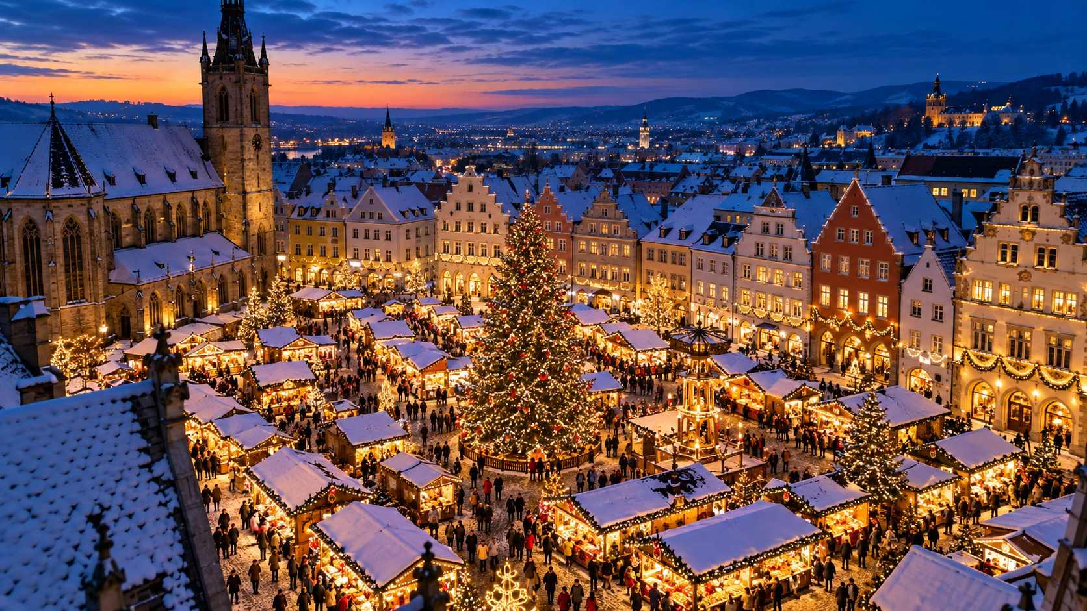

Useful Apps and Resources
- Deutsche Bahn (DB Navigator), ÖBB, SBB, SNCF Connect: Train times and tickets.
- Google Maps or Citymapper: Walking directions and local transit.
- Official city tourism websites: The most reliable source for market dates, hours, and special events.
- Google Translate: Download offline languages; the camera feature is brilliant for menus.
- Weather apps: Check the hourly forecast so you can plan indoor and outdoor time.

A Few Words to Know
A full phrasebook is in Appendix B, but these German words will serve you well across much of Central Europe:
- Glühwein (GLOO-vine): mulled wine
- Pfand (pfahnt): deposit
- Weihnachtsmarkt (VYE-nahkts-markt): Christmas market
- Bitte (BIT-tuh): please / you're welcome
- Danke (DAHN-kuh): thank you
- Prost! (prohst): Cheers!
- Frohe Weihnachten (FRO-uh VYE-nahk-ten): Merry Christmas
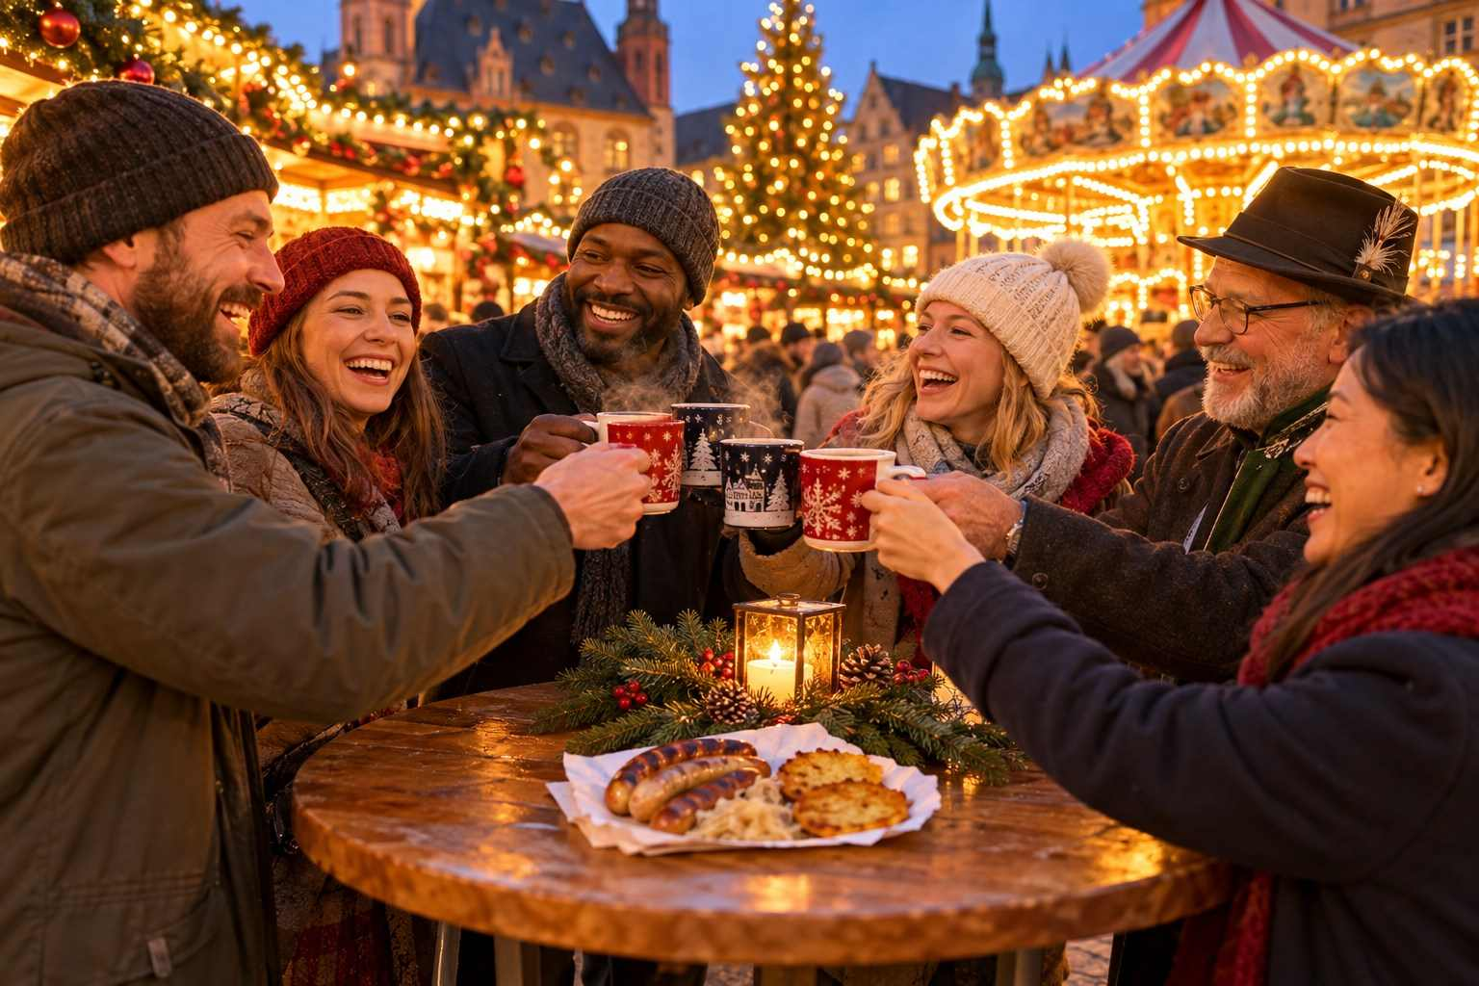

CHAPTER 4

The Festive Food & Drink Guide
— ❄ ✦ ❄ —
Mulled wine, gingerbread, roasted almonds and more: a delicious tour of what to eat and drink at Europe's Christmas markets.
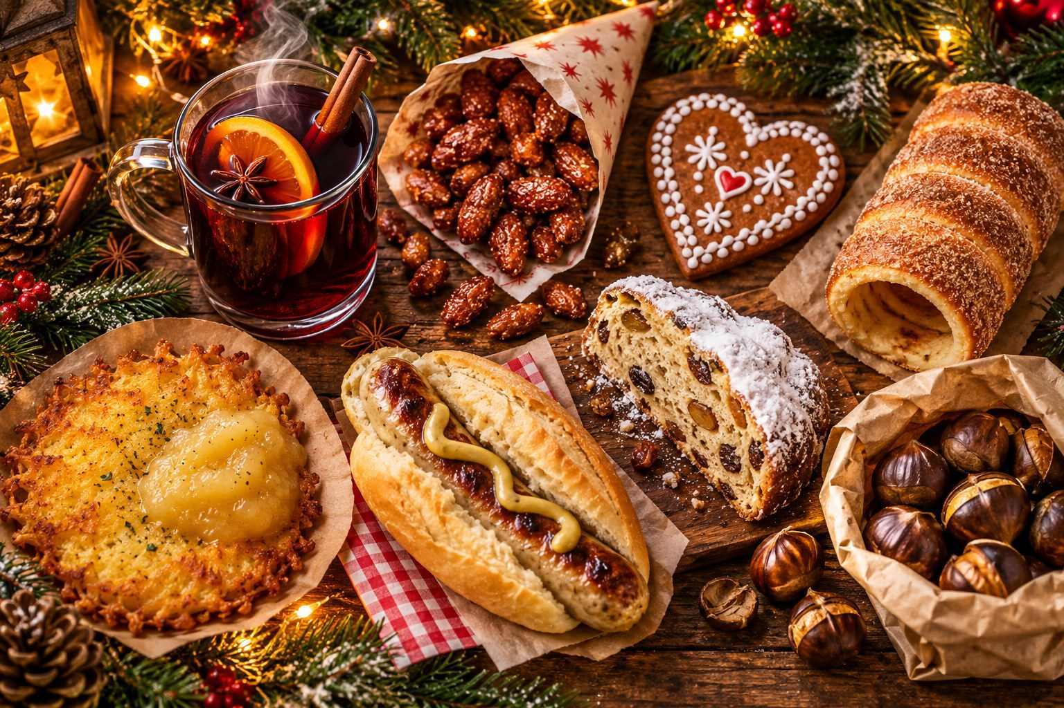

Ask any seasoned market-goer what they remember most, and you may be surprised: it is often not the lights or the crafts, but the food. The smell of roasting almonds that greets you three streets away. The first sip of hot, spiced wine on a freezing evening. The crunch of a sugar-coated chimney cake, still warm from the spit. Christmas markets are, among other things, the world's most delightful outdoor food halls.
This chapter introduces the classics you will find almost everywhere, then takes you on a regional tour of specialties worth seeking out. Come hungry.

The Drinks

Glühwein (Mulled Wine)
The undisputed king of the Christmas market. Glühwein, literally "glow wine," is red wine gently heated with sugar, cinnamon, cloves, star anise, citrus peel, and sometimes cardamom or vanilla. It warms your hands, your body, and your spirits.
You will find endless variations:
- Weißer Glühwein: White mulled wine, lighter and fruitier, popular in southern Germany and Austria.
- Glühwein mit Schuss: With a shot of rum, brandy, or amaretto added. Order this with caution.
- Heidelbeer- or Kirsch-Glühwein: Blueberry or cherry fruit wine, sweet and deeply colored.
- Rosé Glühwein: A pink, often berry-infused version that has become fashionable in recent years.
- Glühgin: A modern twist with gin, apple juice, and spices.
Across Europe, mulled wine goes by many names: vin chaud in France, svařák in the Czech Republic, forralt bor in Hungary, grzaniec in Poland, glögg in Scandinavia, glögi in Finland, vin brulé in Italy, kuhano vino in Croatia, and bisschopswijn in the Netherlands.

Feuerzangenbowle
One of the most spectacular sights at a German market. A large copper cauldron of mulled wine is topped with a Zuckerhut, a cone of sugar, which is soaked in high-proof rum and set alight. As the sugar caramelizes, it drips into the wine below, flickering with blue flames. Nuremberg's market is famous for its giant Feuerzangenbowle, and many other markets offer it too. It is strong, sweet, and utterly theatrical.

Eierpunsch
A creamy, warm egg punch made with white wine, egg yolks, sugar, and vanilla, often topped with whipped cream. Think of it as a warm, boozy custard in a mug. It is particularly popular in eastern Germany, especially Leipzig and Dresden.

Jagertee
Popular in Austria and Bavaria, Jagertee ("hunter's tea") is black tea spiked with Inländer rum and spices. It is a favorite of skiers and is guaranteed to warm you up.

Punsch
Austria's Christmas markets are famous for Punsch, a hot fruit punch that may be made with tea, fruit juices, spices, and rum. Flavors range from orange and berry to Maroni (chestnut) and even chocolate. Many Viennese stalls sell Punsch for charity, and it is a key part of the city's Advent culture.

Glögg
In Sweden, Denmark, and Norway, glögg is served in small cups with a spoonful of raisins and slivered almonds dropped in. It is typically stronger and more spiced than German Glühwein, and pairs perfectly with a gingerbread cookie (pepparkaka).

Non-Alcoholic Delights
- Kinderpunsch: A children's punch of hot fruit juices and spices, delicious for adults too.
- Heißer Apfelsaft: Hot apple juice, sometimes with cinnamon.
- Heiße Schokolade: Hot chocolate, often topped with whipped cream or a shot of liqueur for adults.
- Alkoholfreier Glühwein: Alcohol-free mulled wine, now widely available.
- Hot elderflower or ginger drinks in Nordic and Baltic markets.
✦ INSIDER TIP
Ask for "einen Glühwein, bitte" and hold up a finger. If you want it with a shot of alcohol added, ask for "mit Schuss." If you want it without alcohol, ask for "alkoholfrei" or order a Kinderpunsch.

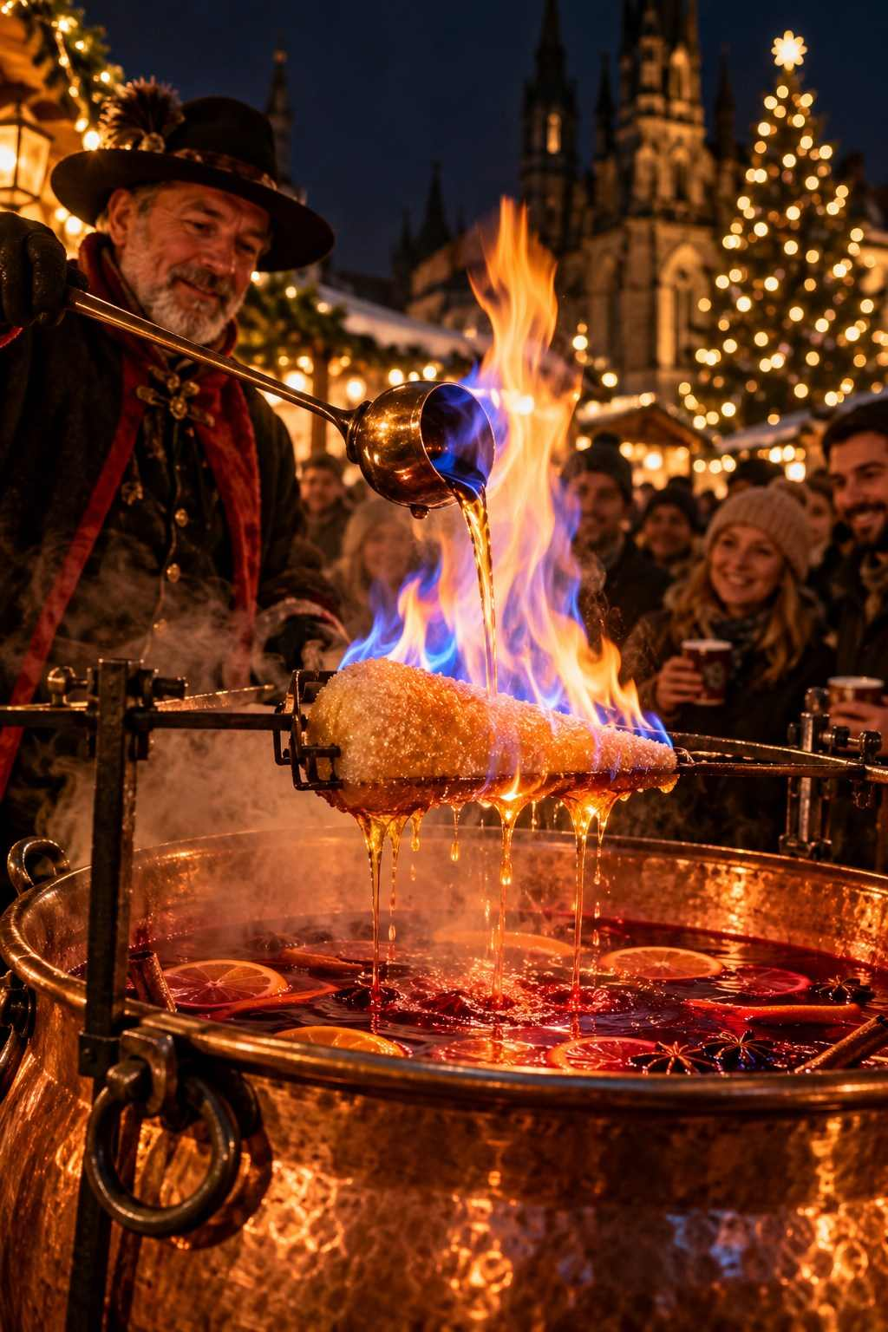

Savory Classics

Bratwurst and Other Sausages
Grilled over open flames and served in a crusty roll (Brötchen) with mustard, the bratwurst is the ultimate market meal. Every region has its own style:
- Nürnberger Rostbratwurst: Small, finger-sized sausages seasoned with marjoram, served "three in a bun" (Drei im Weggla). They have protected geographical status.
- Thüringer Rostbratwurst: Long, thin, and flavorful, grilled over charcoal. Found throughout Germany.
- Currywurst: A sliced sausage doused in curry-spiced ketchup. A Berlin classic.
- Käsekrainer: An Austrian sausage filled with pockets of melting cheese.
- Weißwurst: A delicate white veal sausage from Munich, traditionally eaten before noon with sweet mustard and a pretzel.

Reibekuchen / Kartoffelpuffer
Crispy, golden potato pancakes fried in oil and served with apple sauce (Apfelmus) or sometimes smoked salmon and sour cream. In Cologne and the Rhineland they are called Reibekuchen; elsewhere Kartoffelpuffer or Reiberdatschi. Absolutely irresistible, and a reliable vegetarian choice.

Flammkuchen / Tarte Flambée
A wafer-thin flatbread topped with crème fraîche, onions, and bacon (lardons), baked in a wood-fired oven. It originates in Alsace, where it is called tarte flambée or flammekueche, and it is found at markets throughout Germany and France. Variations include cheese, mushrooms, or sweet versions with apples and cinnamon.

Raclette
Half a wheel of Swiss or French cheese is heated until the surface melts and bubbles, then scraped onto bread or potatoes with pickles and onions. Watching it being scraped is half the fun. Look for it in Switzerland, Alsace, Austria, and increasingly throughout Germany.

Käsespätzle
Soft, hand-made egg noodles layered with melted mountain cheese and topped with crispy fried onions. A Swabian and Alpine favorite, rich and comforting, and ideal for vegetarians.

Schupfnudeln
Finger-shaped potato noodles, pan-fried with sauerkraut and often bacon. Hearty and delicious.

Grilled Fish
At markets near rivers and lakes, you may see whole fish (usually mackerel or trout) grilled on sticks over an open fire (Steckerlfisch), or smoked salmon roasted on wooden planks by an open flame (Flammlachs), a Nordic technique now popular across Germany.

Langos
A Hungarian specialty found throughout Central Europe: a large disc of deep-fried dough, rubbed with garlic and topped with sour cream and grated cheese.

Pierogi, Oscypek, and More
In Poland, look for pierogi (dumplings), and in Kraków especially, oscypek, a smoked sheep's cheese from the Tatra mountains, grilled and served with cranberry sauce.
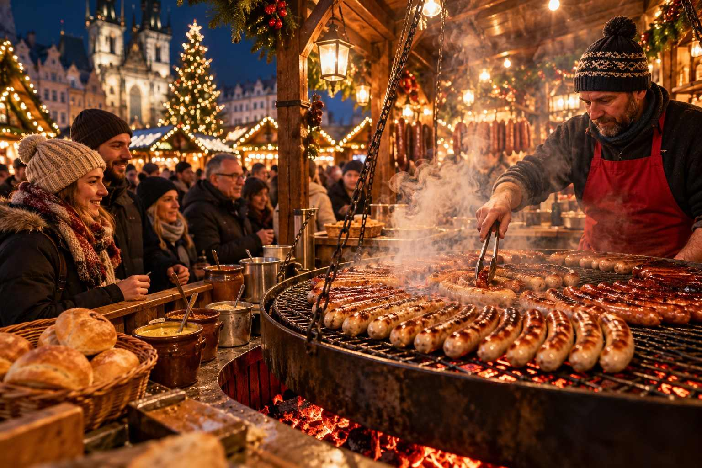

Sweet Treats

Lebkuchen (Gingerbread)
Gingerbread is the sweet soul of the Christmas market. German Lebkuchen is softer and more cake-like than the crisp gingerbread many Americans know, made with honey, spices, nuts, and candied citrus peel.
- Nürnberger Elisenlebkuchen: The finest grade, made with a high proportion of nuts and little or no flour, baked on a thin wafer (Oblate). Nuremberg Lebkuchen has protected geographical status.
- Lebkuchenherzen: Large gingerbread hearts decorated with colorful icing messages like "Ich liebe dich" (I love you) or "Frohe Weihnachten." They are usually decorative rather than for eating, and make charming souvenirs.
- Aachener Printen: A hard, spiced gingerbread from Aachen, sometimes coated in chocolate or studded with nuts.
- Pulsnitzer Pfefferkuchen: Gingerbread from the small Saxon town of Pulsnitz, a gingerbread-making center for centuries.
- Toruński piernik: Poland's famous gingerbread from the city of Toruń.
- Pain d'épices: The French version, a honey-spice loaf popular in Alsace and Burgundy.

Stollen
A dense, buttery, fruit-studded yeast bread dusted thickly with powdered sugar, meant to represent the swaddled Christ Child. Dresdner Christstollen is the original and is protected by law, produced only by licensed bakers in the Dresden area. Each authentic loaf carries a golden seal. Other varieties include marzipan stollen, poppy seed stollen, and quark stollen.

Gebrannte Mandeln (Candied Almonds)
Almonds roasted in a copper kettle with sugar, cinnamon, and vanilla until they are coated in a crunchy caramel shell. The aroma is one of the signature scents of every Christmas market. You will also find candied cashews, hazelnuts, and even chocolate or amaretto-flavored varieties.

Maroni (Roasted Chestnuts)
Chestnuts roasted over coals in a big iron drum and sold in paper cones. Crack them open while they are hot. They are especially beloved in Austria, Italy, and France (marrons chauds).

Baumstriezel / Kürtőskalács / Trdelník
A spiral of sweet dough wrapped around a wooden or metal cylinder, rotated over hot coals or in a special oven, and coated in cinnamon sugar, nuts, or coconut. It originated in Transylvania and Hungary (kürtőskalács, or "chimney cake"), and is known as trdelník in Prague and Baumstriezel in Germany. In Prague, you will often see it filled with ice cream or whipped cream, a modern tourist invention but undeniably delicious.

Schokofrüchte
Fruit skewers (strawberries, grapes, bananas, and pineapple) dipped in milk, dark, or white chocolate, sometimes with sprinkles. Kids adore them.

Crêpes and Waffles
Found in almost every market and particularly good in France and Belgium, where you can enjoy a warm Liège waffle with its crunchy pearl-sugar crust.

Dampfnudeln and Germknödel
Fluffy steamed yeast dumplings. The Austrian Germknödel is filled with plum jam and topped with melted butter and poppy-seed sugar, often with vanilla sauce. It is a meal in itself.

Poffertjes
Tiny, fluffy Dutch pancakes, cooked in a special pan with dozens of small hollows and served with butter and powdered sugar. A must in the Netherlands and Belgium.

Kaiserschmarrn
A fluffy, shredded caramelized pancake served with plum compote or apple sauce. Named for Emperor Franz Joseph, it is an Austrian classic you will find at many Alpine markets.

Bredele and Christmas Cookies
In Alsace, households bake dozens of kinds of small Christmas cookies called bredele: butter cookies, anise cookies, cinnamon stars, and more. You can buy assorted bags at markets throughout the region.
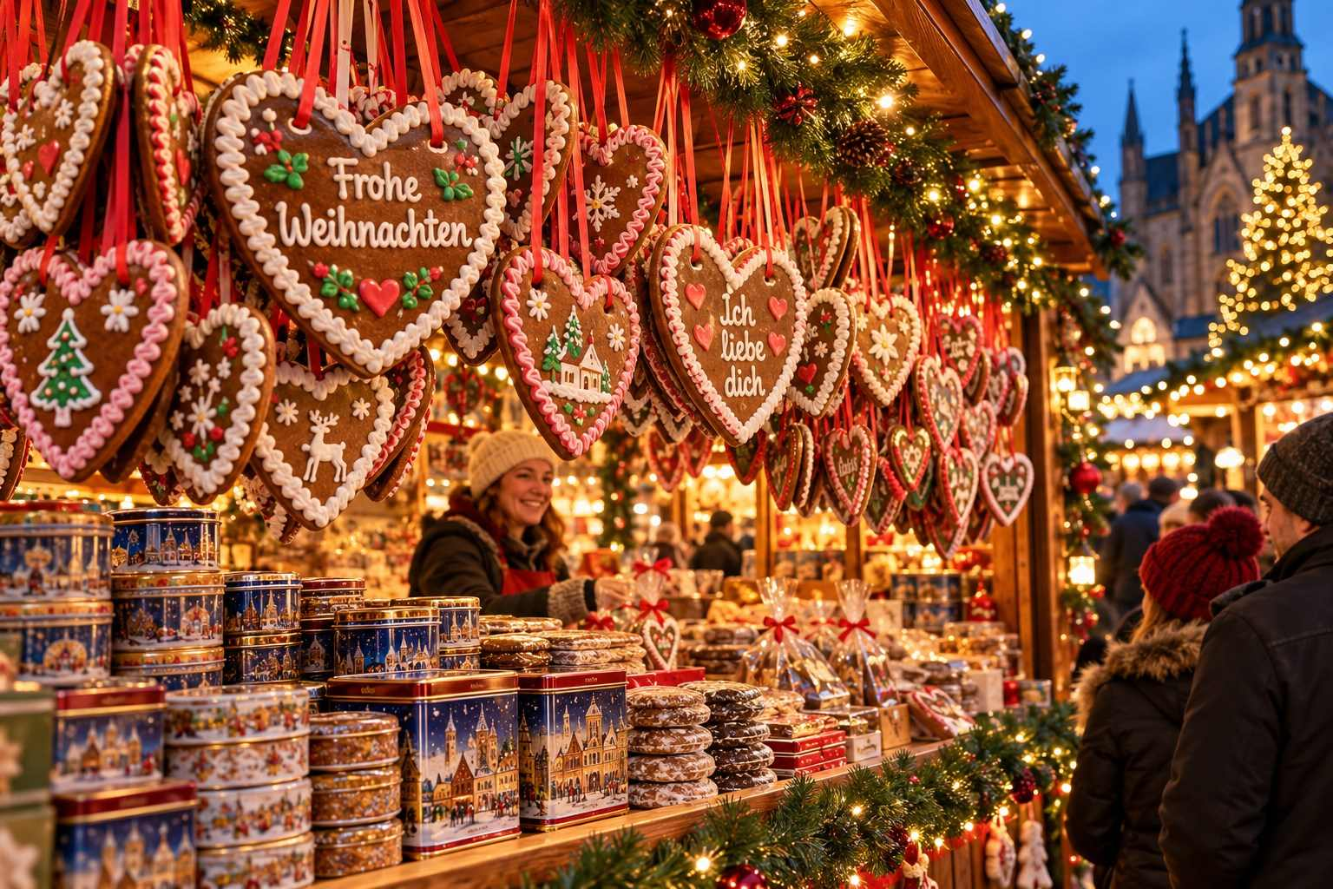

A Regional Tasting Tour
Beyond the classics, every region has its own festive specialties. Keep an eye out for these:
Bavaria (Germany): Nürnberger Rostbratwurst, Lebkuchen, Schneeballen (Rothenburg's "snowball" pastry), roast pork with crackling in a bun, and Bavarian Christmas beer.
Saxony (Germany): Dresdner Stollen, Eierpunsch, Pulsnitz gingerbread, and potato soup.
The Rhineland (Germany): Reibekuchen with apple sauce, Aachener Printen, and Himmel un Ääd ("heaven and earth": mashed potatoes with apples and black pudding).
Swabia and the Black Forest (Germany): Käsespätzle, Maultaschen (Swabian ravioli), Black Forest ham, and Black Forest gateau.
Austria: Punsch, Maroni, Käsekrainer, Germknödel, Kaiserschmarrn, Kiachl (fried dough with cranberry or sauerkraut), and Bratkartoffeln (fried potatoes).
Alsace (France): Vin chaud, tarte flambée, bredele cookies, pain d'épices, kougelhopf, and bretzels.
Switzerland: Raclette, fondue, Basler Läckerli (spiced honey biscuits), and Grittibänz (bread men for Saint Nicholas).
Czech Republic: Svařák, trdelník, klobása (grilled sausages), Prague ham carved from the spit, medovina (warm honey mead), and vánočka (braided Christmas bread).
Hungary: Forralt bor, kürtőskalács, lángos, stuffed cabbage, goulash served in bread bowls, and beigli (poppy seed or walnut rolls).
Poland: Grzaniec, pierogi, oscypek, bigos (hunter's stew), and Toruń gingerbread.
Scandinavia: Glögg, æbleskiver (Danish pancake puffs), pepparkakor, saffron buns (lussekatter), smoked reindeer, and Swedish cardamom buns.
The Baltics: Hot black-currant drinks, Riga Black Balsam (a potent herbal liqueur), grey peas with bacon, and gingerbread.
Belgium and the Netherlands: Waffles, poffertjes, oliebollen (Dutch doughnuts), speculaas spiced biscuits, and Belgian beer and chocolate.
Italy: Vin brulé, panettone, pandoro, torrone (nougat), and in the South Tyrol, Zelten fruit bread and speck.
Spain: Turrón (nougat), churros with thick hot chocolate, and polvorones (crumbly almond shortbread).
United Kingdom: Mince pies, mulled cider, hot roast pork sandwiches, and Christmas pudding.
★ DON'T MISS
In Nuremberg, eat Drei im Weggla (three Rostbratwurst in a roll) and buy Elisenlebkuchen. In Dresden, taste real Christstollen with its golden seal. In Vienna, drink a Punsch at one of the charity stalls. In Prague, try svařák and a cinnamon-sugar trdelník. In Strasbourg, share a tarte flambée with a glass of Alsatian white vin chaud.

Bring the Market Home: Two Recipes

Classic Glühwein
Serves 6
- 1 bottle (750 ml) dry red wine, such as Merlot, Dornfelder, or Zinfandel
- 250 ml (1 cup) orange juice or water
- 2 oranges, one sliced and one zested
- 1 lemon, zested
- 3–4 tablespoons sugar or honey, to taste
- 2 cinnamon sticks
- 6 whole cloves
- 2 star anise
- 3 cardamom pods, lightly crushed (optional)
- A splash of rum or brandy (optional)
- Place the orange juice or water, sugar, citrus zest, and spices in a large pot. Warm gently until the sugar dissolves.
- Add the wine and orange slices. Heat slowly over low heat for 20–30 minutes. Do not let it boil, or the alcohol will evaporate and the flavor will turn bitter.
- Taste, adjust the sweetness, and add rum or brandy if you like.
- Strain out the spices, ladle into mugs, and garnish with an orange slice and cinnamon stick.

Kinderpunsch (Children's Punch)
Serves 6
- 500 ml (2 cups) red grape juice
- 500 ml (2 cups) apple juice
- 250 ml (1 cup) orange juice
- 250 ml (1 cup) brewed fruit tea (hibiscus or berry)
- 2 cinnamon sticks, 4 cloves, 1 star anise
- 1 orange, sliced
- Honey to taste
Combine all ingredients in a pot, warm gently for 15–20 minutes without boiling, strain, and serve in festive mugs.
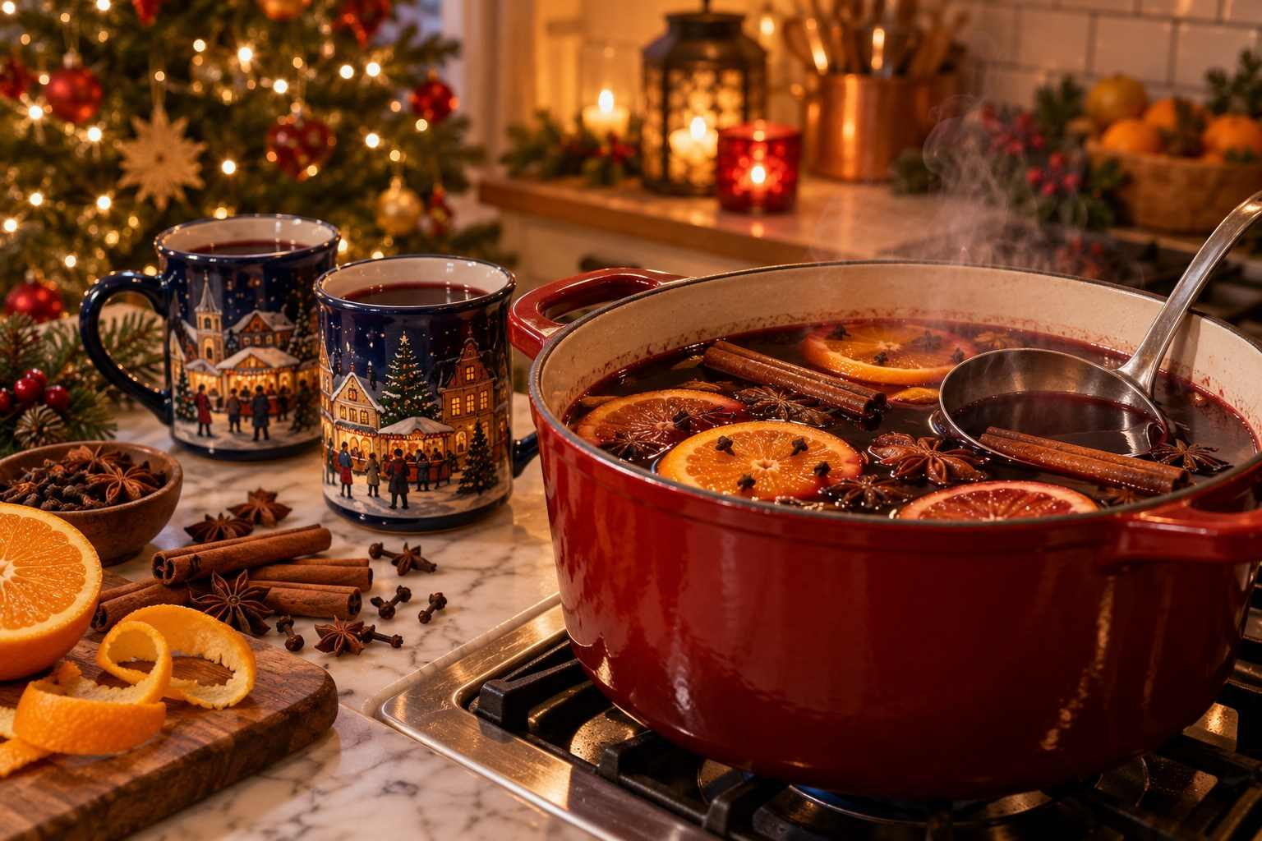

Dietary Tips at a Glance
- Vegetarian: Potato pancakes, raclette, Käsespätzle, flammkuchen (ask for vegetarian topping), mushrooms in garlic cream, langos, crêpes, waffles, roasted chestnuts, and many sweets.
- Vegan: Roasted chestnuts, candied nuts (check for honey), falafel, vegan sausages, grilled vegetables, fruit, and some potato dishes. Berlin and Munich's Tollwood festival are especially vegan-friendly.
- Gluten-free: Grilled sausages without the roll (check ingredients), roasted chestnuts, candied almonds, raclette with potatoes, and some grilled meat. Cross-contamination is common, so those with celiac disease should take care.
- Alcohol-free: Kinderpunsch, hot apple juice, alcohol-free Glühwein, hot chocolate, tea.
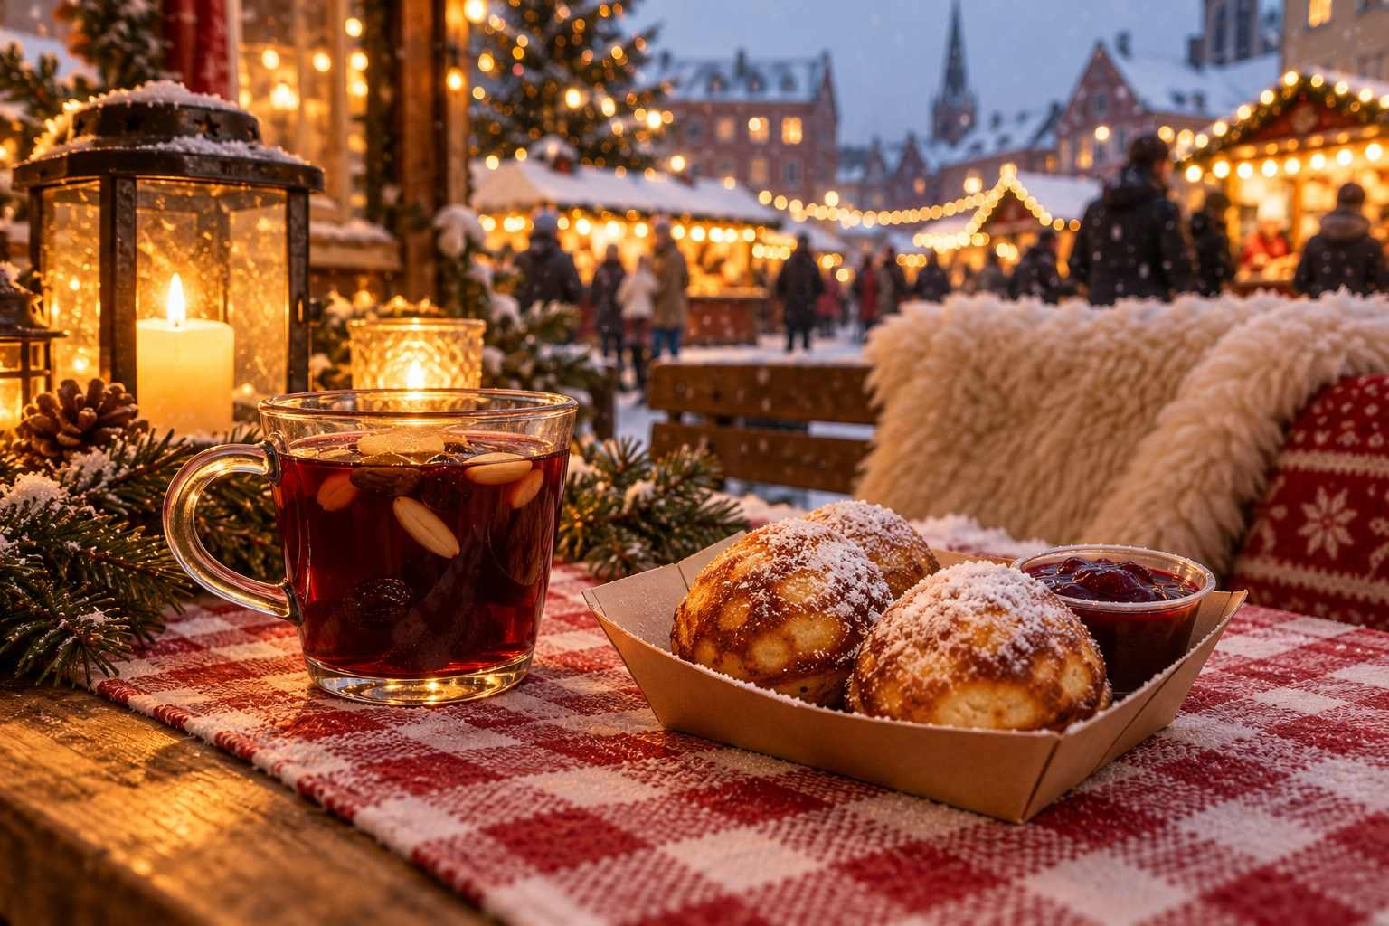

PART TWO
The Markets, Country by Country
— ❄ ✦ ❄ —
From the legendary squares of Nuremberg and Vienna to the canals of Bruges and the candlelit courtyards of Scandinavia: your guide to the finest Christmas markets in Europe.

CHAPTER 5

Germany: The Heart of Christmas
— ❄ ✦ ❄ —
Where it all began. Gingerbread, glass ornaments, grand cathedrals, and more Christmas markets than anywhere else on earth.
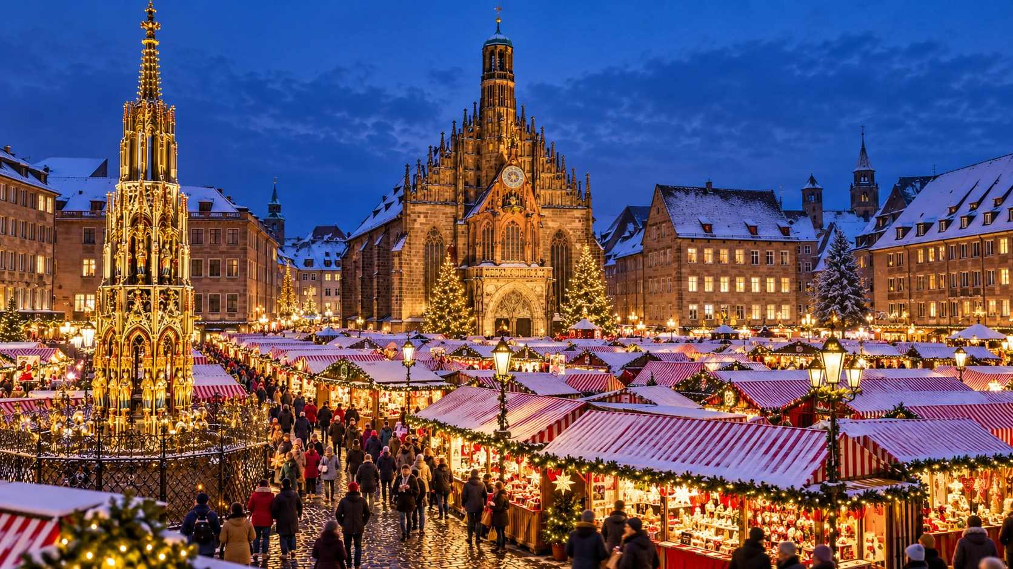

If Christmas markets have a homeland, it is Germany. Nearly every city, town, and village in the country hosts at least one market during Advent, and many host a dozen. Estimates suggest that somewhere between two and three thousand Christmas markets take place across Germany each year, welcoming well over a hundred million visits.
German markets set the template for the rest of the world: wooden stalls, twinkling lights, mulled wine in collectible mugs, grilled sausages, gingerbread, and handcrafted ornaments. Yet each region, and each city, has its own character. The markets of Bavaria feel different from those of Saxony, and the markets of the Rhineland feel different again. Part of the joy of a German Christmas trip is discovering those differences.
In this chapter, we visit the great markets first, then explore some of the most enchanting smaller towns and unusual settings.
ℹ GOOD TO KNOW
2026 at a glance for Germany: Totensonntag is November 22, so most traditional markets open between November 23 and 27. Many close on December 22 or 23. Christmas Eve (Thursday, December 24) sees early-afternoon closings where markets are still open.

Nuremberg: The Christkindlesmarkt
There are bigger markets in Germany, and older ones too, but none is more famous than Nuremberg's Christkindlesmarkt. For many travelers, it is the Christmas market, the one they have dreamed about since childhood, and it rarely disappoints.
The market fills the Hauptmarkt, the great central square of Nuremberg's old town, with around 180 stalls roofed in red-and-white striped canvas, earning it the nickname "the little town of wood and cloth." Behind it rises the lacy Gothic façade of the Frauenkirche (Church of Our Lady), and at its edge stands the Schöner Brunnen, the "Beautiful Fountain," a nineteen-meter Gothic spire of gilded and painted figures. Find the brass ring set into the fountain's railing and turn it for good luck.

The Opening Ceremony
The market opens on the Friday before the first Sunday of Advent with one of the most beloved ceremonies in Europe. At dusk, the Nuremberg Christkind, a young woman chosen every two years to serve as the city's festive ambassador, appears on the balcony of the Frauenkirche in her golden crown and robes and recites the solemn prologue that begins:
"Ihr Herrn und Fraun, die Ihr einst Kinder wart, Ihr Kleinen, die Ihr's heute seid..." (You ladies and gentlemen, who once were children, you little ones who are children today...)
Thousands gather in the square below, and a hush falls as she speaks. It is a genuinely moving moment, even if you do not understand the German.
✦ INSIDER TIP
Crowds for the opening ceremony are enormous. Arrive at least an hour early for a good view, or watch from a side street and enjoy the atmosphere. Many locals prefer to visit the market on a quiet weekday morning in the following weeks.

What Makes It Special
Nuremberg's organizers have long guarded the market's traditional character. Vendors must sell traditional Christmas goods, plastic decorations and mass-produced kitsch are discouraged, and the most beautifully decorated stalls receive an annual award. Look for:
- Nürnberger Lebkuchen: The city's world-famous gingerbread. Buy it from the market stalls or from traditional bakeries nearby.
- Nürnberger Rostbratwurst: Small marjoram-scented sausages, served Drei im Weggla (three in a roll).
- Zwetschgenmännle: Charming little figures made from dried prunes, figs, and nuts, dressed as chimney sweeps, farmers, and angels. They are a Nuremberg specialty and said to bring good luck.
- Rauschgoldengel: Delicate golden foil angels, a Nuremberg tradition inspired by the Christkind.
- Feuerzangenbowle: The flaming rum-and-sugar punch, served in giant cauldrons.

Beyond the Hauptmarkt
Do not miss the Kinderweihnacht (Children's Christmas) at Hans-Sachs-Platz, with an old-fashioned carousel, a steam train, a Ferris wheel, and baking workshops, and the Markt der Partnerstädte (Sister Cities Market) at Rathausplatz, where Nuremberg's twin cities from around the world, including Atlanta, Kraków, Nice, and Kavala, sell their own festive specialties.
On selected evenings, thousands of children carry homemade lanterns in the Lichterzug, a lantern procession up to the Imperial Castle. It is one of the loveliest sights of the season.
MARKET AT A GLANCE
Nuremberg Christkindlesmarkt
Dates | November 27 – December 24, 2026 (as published)
Hours | Daily 10:00–21:00; December 24 until 14:00
Location | Hauptmarkt, Old Town
Getting there | 10-minute walk from Nuremberg Hauptbahnhof
Don't miss | The Christkind's prologue on opening night; Drei im Weggla; prune men
Best for | First-timers, traditionalists, families

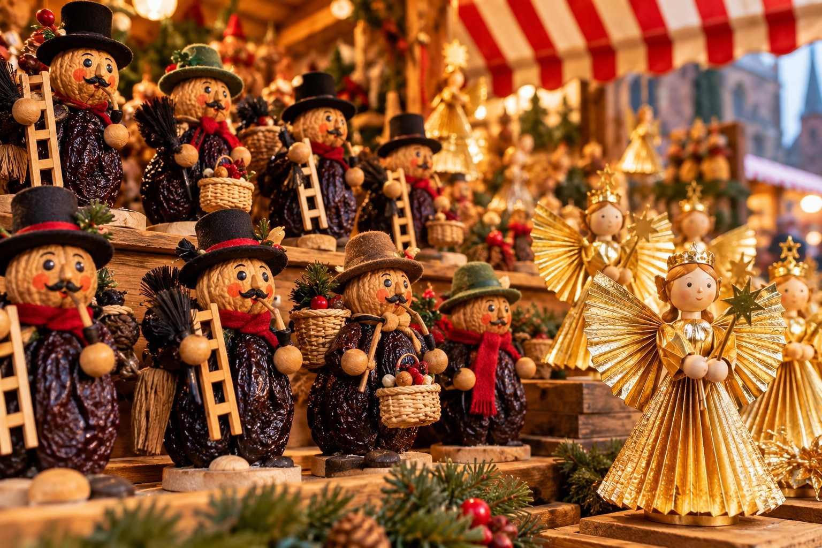

Also in Nuremberg
- Imperial Castle (Kaiserburg): Walk up for panoramic views over the snowy rooftops.
- Albrecht Dürer's House: The home of Germany's greatest Renaissance artist.
- Germanisches Nationalmuseum: A treasure house of German art and culture, including historic Christmas ornaments and toys.
- Nuremberg Toy Museum: Delightful, especially for families.
- Handwerkerhof: A small walled craftsmen's courtyard near the station, with half-timbered workshops selling crafts and Lebkuchen year-round.

Dresden: The Striezelmarkt
If Nuremberg is Germany's most famous Christmas market, Dresden's Striezelmarkt is its oldest documented in continuous operation, first recorded in 1434. Held on the Altmarkt square in the heart of the Saxon capital, it has a warm, traditional atmosphere shaped by the crafts of the nearby Ore Mountains (Erzgebirge).
The market's centerpiece is a giant Erzgebirge Christmas pyramid, around fourteen meters tall, its tiers of carved figures slowly turning. Nearby stands a towering candle arch (Schwibbogen) and a giant smoking man. Around them, some 200 stalls sell hand-carved nutcrackers, incense smokers, candle arches, Plauen lace, blue-painted Lusatian pottery, Herrnhut stars, and, of course, Stollen.

The Stollen Festival
On the Saturday before the second Sunday of Advent (expected December 5, 2026), Dresden holds its famous Stollenfest. A giant Stollen weighing several tonnes is baked by the city's bakers, loaded onto a horse-drawn carriage, and paraded through the old town, accompanied by the Stollen Girl (Stollenmädchen), bakers, and brass bands. On arrival at the Striezelmarkt, it is ceremonially cut with a giant knife and sold by the slice, with proceeds going to charity.

Herrnhut Stars
Look for the many-pointed Herrnhut stars (Herrnhuter Sterne), paper or plastic stars with twenty-five points, first made by the Moravian Church community in Herrnhut, Saxony, in the nineteenth century. They glow from windows and doorways all over eastern Germany during Advent and make a beautiful, lightweight souvenir.

Dresden's Other Markets
Dresden hosts more than a dozen Christmas markets, and many visitors find the smaller ones even more atmospheric:
- Advent at the Neumarkt: In the shadow of the rebuilt Frauenkirche, styled in the fashion of the nineteenth century. Open into early January.
- Medieval Christmas Market in the Stallhof: Inside the courtyard of the Royal Palace, with jugglers, blacksmiths, mead, and torch-lit evenings. A small entrance fee may apply.
- Augustusmarkt: Along the Hauptstraße in the Neustadt, with distinctive white pagoda tents.
- Winter Lights on Prager Straße: A modern market with a fifteen-meter tree.
MARKET AT A GLANCE
Dresden Striezelmarkt
Dates | November 25 – December 24, 2026 (as published)
Hours | Daily 10:00–21:00; December 24 shorter hours
Location | Altmarkt, Old Town
Getting there | 10-minute walk from Dresden Hauptbahnhof; trams to Altmarkt
Special event | Stollenfest, expected Saturday, December 5, 2026
Best for | Erzgebirge crafts, Stollen, history lovers

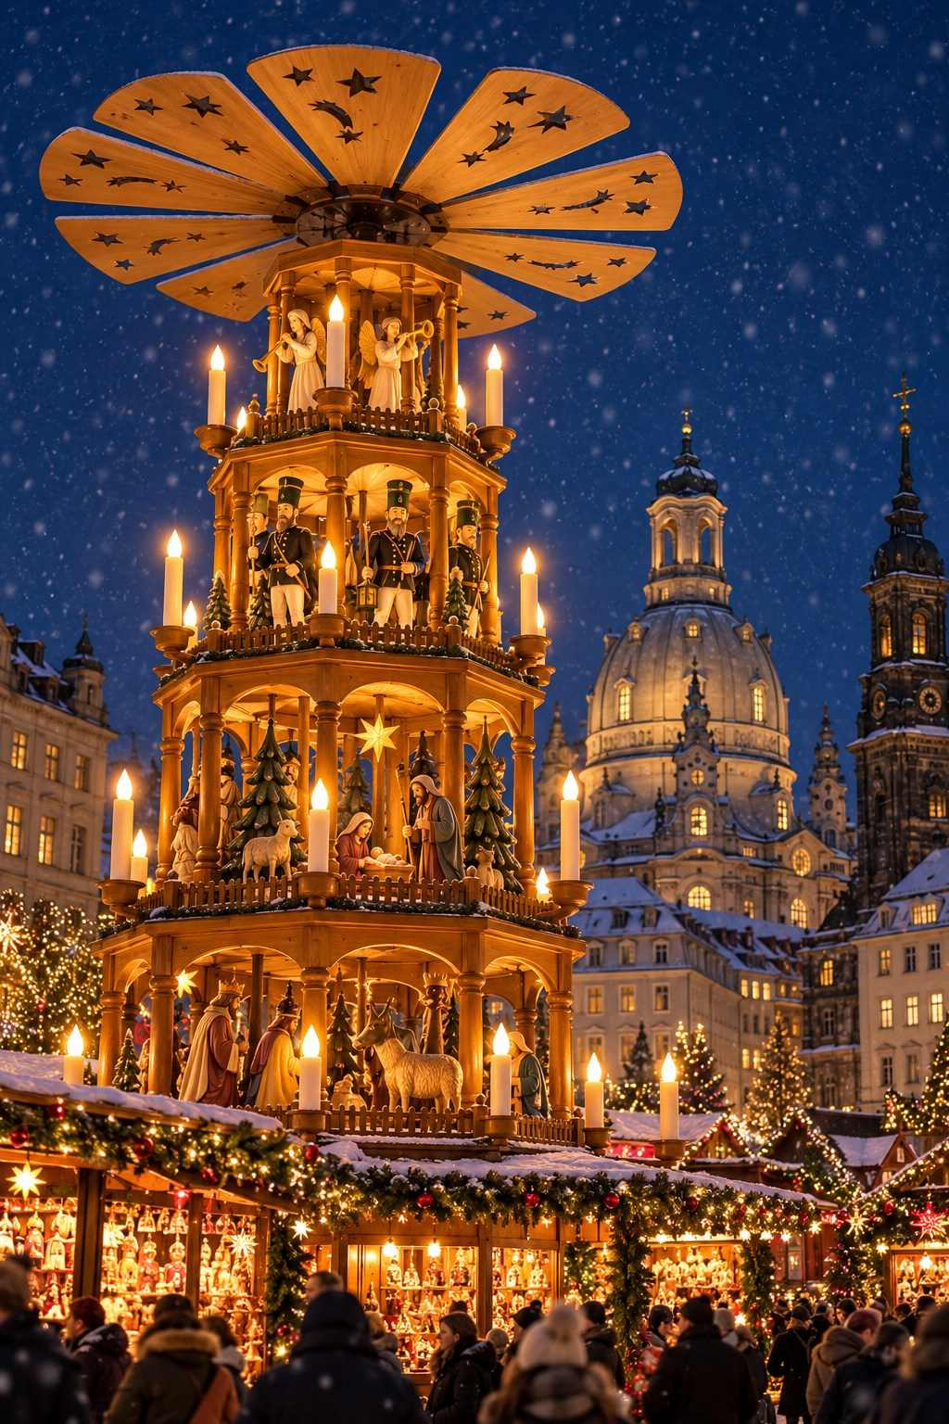

Cologne: A City of Many Markets
Cologne (Köln) does Christmas with gusto. The city hosts seven or more major markets, each with its own theme and personality, and all within walking distance of one another. Add the extraordinary backdrop of Cologne Cathedral, one of the greatest Gothic buildings in the world, and you have one of Germany's most rewarding market destinations.

Christmas Market at the Cathedral
Set on Roncalliplatz, directly beside the cathedral's soaring twin spires, this is Cologne's signature market. Around 150 stalls are gathered beneath a canopy of thousands of twinkling lights strung from a huge central Christmas tree, among the tallest in the Rhineland. The effect, with the illuminated cathedral rising above, is breathtaking. A stage hosts choirs and bands most evenings.

Heinzels Wintermärchen (Old Town)
On Alter Markt and Heumarkt, this market celebrates the legend of the Heinzelmännchen, the helpful house gnomes who, as the story goes, secretly did the work of Cologne's craftsmen at night until a curious tailor's wife scared them away. The stalls are decorated with gnome figures, and the market includes an ice-skating rink and curling lanes on the Heumarkt.

Markt der Engel (Angels' Market)
At Neumarkt, Cologne's oldest Christmas market is a place of starry lights and angels. Costumed angels wander through the market, and the stalls sell a lovely selection of crafts.

Hafen-Weihnachtsmarkt (Harbour Market)
By the Rhine, next to the Chocolate Museum, this maritime-themed market features white tents, sailors, and a festive harbor atmosphere. It is Cologne's longest-running market, open into January.

Other Cologne Markets
- Nikolausdorf (Saint Nicholas Village) at Rudolfplatz, beside the medieval Hahnentor gate.
- Stadtgarten Christmas market, a small, cozy market in a park, loved by locals.
- The Christmas market boat (KD's Weihnachtsschiff) on the Rhine, with stalls on board.
MARKET AT A GLANCE
Cologne Cathedral Christmas Market
Dates | November 16 – December 23, 2026 (as published)
Hours | Sun–Wed 11:00–21:00; Thu–Fri 11:00–22:00; Sat 10:00–22:00
Location | Roncalliplatz, beside the cathedral
Getting there | Directly outside Köln Hauptbahnhof
Also open | Harbour Market November 13, 2026 – January 3, 2027; Angels' Market and Nikolausdorf November 16 – December 23
Best for | Market-hopping, dramatic settings, easy train access

✦ INSIDER TIP
Cologne's main station is right next to the cathedral, making the city an ideal day trip from Düsseldorf, Bonn, Aachen, or even Brussels and Amsterdam. Climb the cathedral's 533 steps to the south tower viewing platform for an unforgettable view, but go before 4 pm, as winter closing times are early.

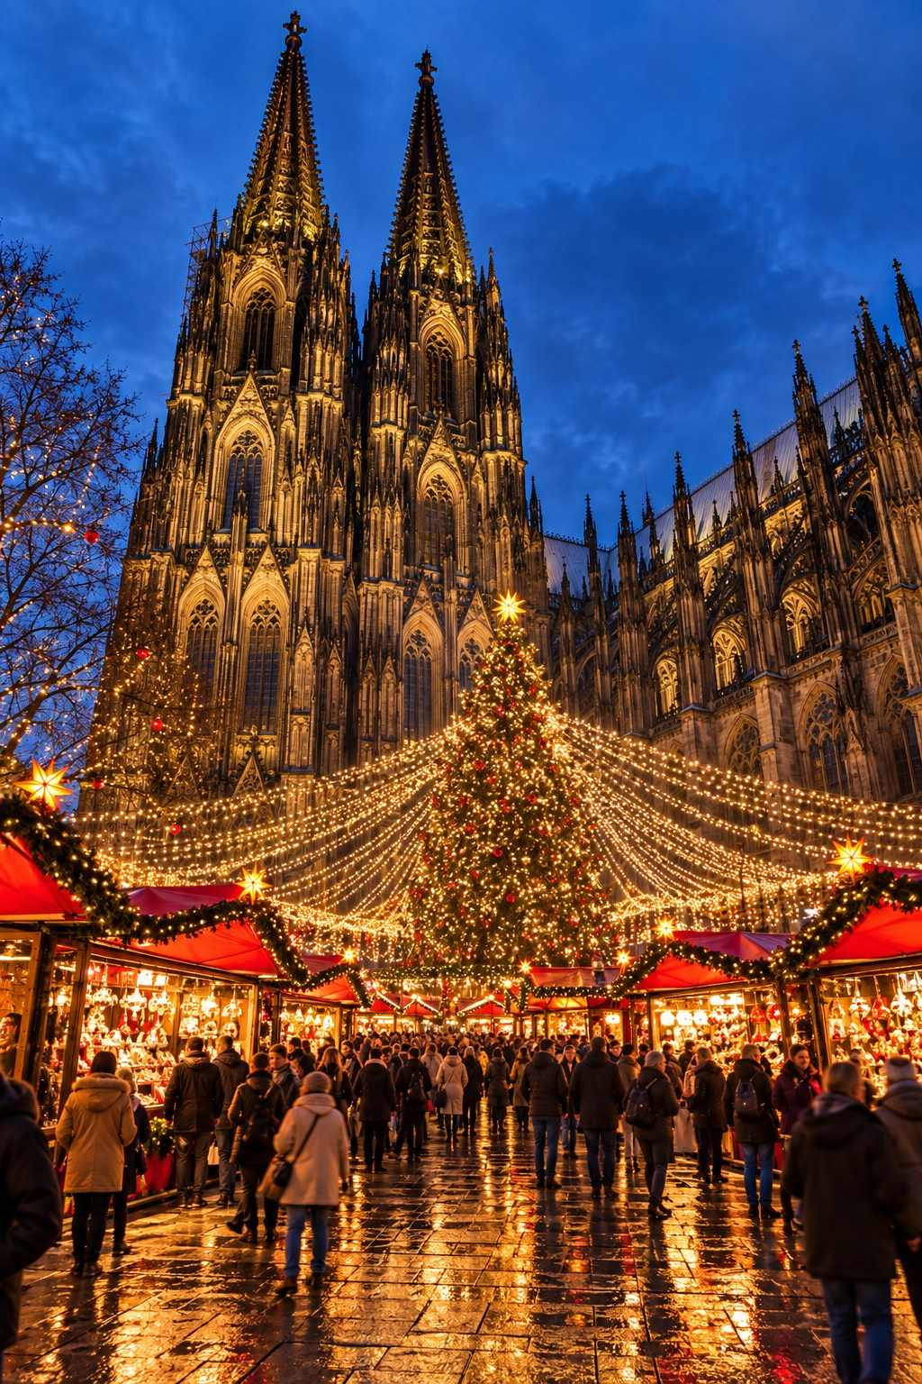

Munich: Bavarian Christmas at Its Best
Munich's Christmas season is warm, joyful, and deeply Bavarian. The city hosts more than twenty markets, from the grand Christkindlmarkt on Marienplatz to medieval, nativity-themed, and alternative markets, making it one of the most varied Christmas destinations in Germany.

Christkindlmarkt on Marienplatz
Munich's main market dates back to the fourteenth century and fills Marienplatz and the surrounding streets with around 140 to 160 stalls. The neo-Gothic New Town Hall (Neues Rathaus) forms a spectacular backdrop, and a giant Christmas tree, often thirty meters tall, stands at its center. Every evening at 5:30 pm, live Advent music is performed from the town hall balcony.

Kripperlmarkt (Nativity Market)
On Rindermarkt, just off Marienplatz, Germany's largest nativity market sells everything you need to build a Bavarian crib scene: carved figures of every size, animals, stables, lanterns, and tiny accessories. It is a fascinating glimpse into a tradition that is deeply cherished in Catholic Bavaria.

Medieval Market at Wittelsbacherplatz
Here the clock turns back five hundred years. Vendors in period costume sell handmade goods, mead, and roasted meats, while jugglers, musicians, and blacksmiths entertain the crowds.

Christmas Village in the Residenz
In the elegant Kaiserhof courtyard of the Munich Residenz, the former royal palace, this market features a fairy-tale village atmosphere with oversized figures, a nativity scene, and cozy food stalls.

Tollwood Winter Festival
Held on the Theresienwiese, the Oktoberfest grounds, Tollwood is a bohemian, eco-friendly winter festival with a "Market of Ideas" selling fair-trade and handcrafted goods, international and largely organic food, and circus and theater performances in big-top tents. It runs through New Year's Eve.

Pink Christmas
Munich's LGBTQ+ Christmas market on Stephansplatz is cheerful, welcoming, and open to all.

More Munich Markets
- Chinese Tower Christmas Market in the English Garden, around the pagoda-style beer garden tower.
- Winter Wonderland at the Munich Airport, with an ice rink and Christmas market between the terminals, perfect if you have a long layover.
MARKET AT A GLANCE
Munich Christkindlmarkt
Dates | November 20 – December 24, 2026 (as listed at time of writing; confirm before travel)
Hours | Mon–Sat 10:00–21:00; Sun 10:00–20:00; December 24 until 14:00
Location | Marienplatz and surrounding streets
Getting there | S-Bahn and U-Bahn to Marienplatz
Also in Munich | Medieval market, Kripperlmarkt, Residenz Christmas Village, Tollwood (Theresienwiese)
Best for | Bavarian tradition, variety, beer lovers

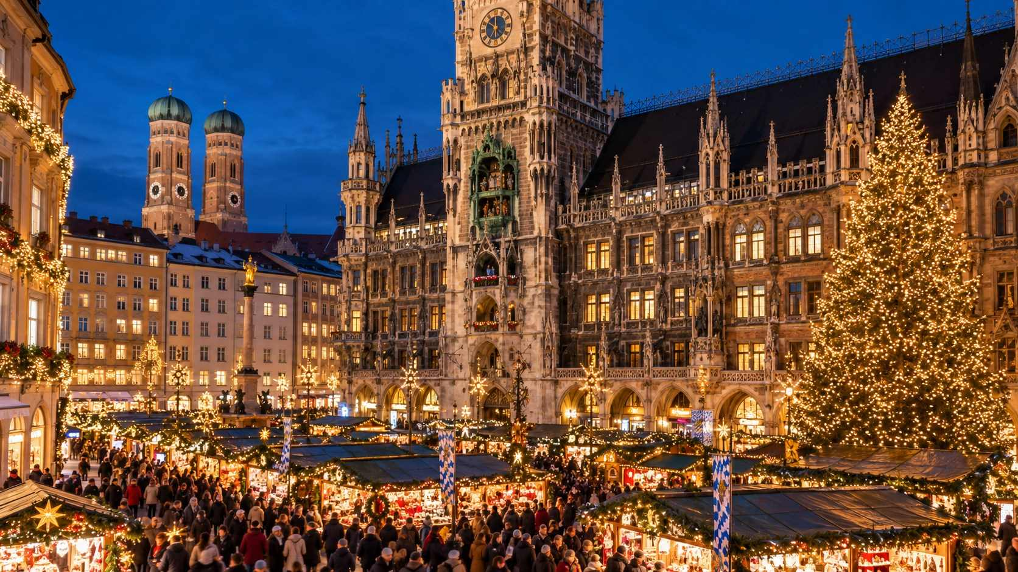

Rothenburg ob der Tauber: A Storybook Christmas
Rothenburg ob der Tauber looks as though it has stepped straight out of a fairy tale. Its perfectly preserved medieval walls, cobbled lanes, and half-timbered houses are lovely at any time of year, but at Christmas, when the rooftops are frosted and the windows glow, it is pure enchantment.
The Reiterlesmarkt fills the Marktplatz and the square around Saint Jacob's Church. Its name comes from the Reiterle, a mythical rider who, in old legend, carried the souls of the dead across the sky in winter. Today, the Reiterle is a friendlier figure who greets visitors at the market's opening.

Don't Miss in Rothenburg
- Schneeballen: "Snowballs" of shortcrust pastry strips formed into balls, fried, and dusted with sugar or dipped in chocolate. They are Rothenburg's signature treat. Buy one or two, as they can be dry, and eat them with coffee.
- Käthe Wohlfahrt Christmas Village: A vast year-round Christmas shop, filled with ornaments, nutcrackers, smoking men, and a giant tree. It is a wonderland, though prices reflect the brand.
- German Christmas Museum: Upstairs from the Christmas Village, a charming collection of historic ornaments, Santa figures, and tree decorations.
- Night Watchman's Tour: Each evening, a costumed night watchman leads an entertaining walking tour (in English and German) through the old town, full of humor and history.
- Walk the walls: The covered wooden walkway along the medieval ramparts offers wonderful views over the snow-dusted rooftops.
MARKET AT A GLANCE
Rothenburg Reiterlesmarkt
Dates | Expected November 27 – December 23, 2026
Hours | Typically 11:00–19:30 (Fri–Sat until 20:30)
Location | Marktplatz and around St. Jakob's Church
Getting there | Regional train from Steinach (connections from Würzburg and Nuremberg), or by car/coach on the Romantic Road
Best for | Fairy-tale atmosphere, photographers, romantic getaways

✦ INSIDER TIP
Rothenburg is extremely popular with day-trippers and tour buses. Stay overnight if you can. After the buses leave, around 5 pm, the town becomes wonderfully peaceful, and the early morning, with frost on the cobblestones, is magical.

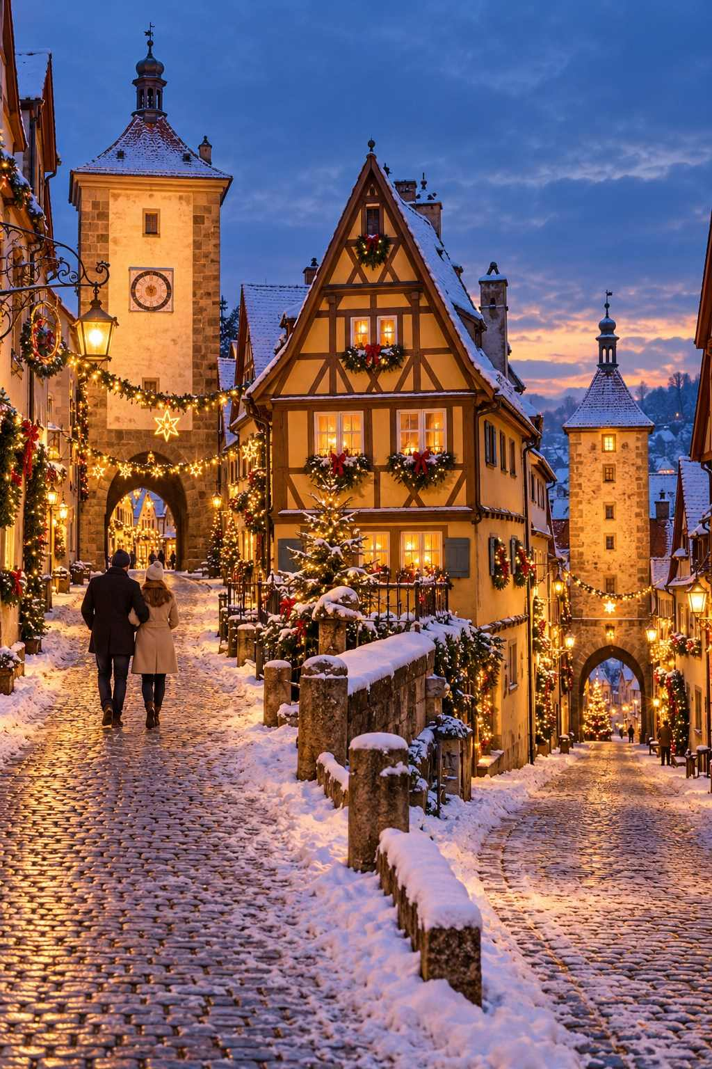

Berlin: A Capital of Contrasts
Berlin has around eighty Christmas markets, reflecting the city's size, diversity, and creativity. You can sip Glühwein beneath a palace, shop for design objects in a former brewery, or join a Scandinavian-themed celebration.

Top Berlin Markets
- WeihnachtsZauber at Gendarmenmarkt: Often called Berlin's most beautiful market, set on one of Europe's finest squares between the twin German and French Cathedrals and the Konzerthaus. White tents, high-quality crafts, and live performances. A small entrance fee typically applies.
- Christmas Market at Charlottenburg Palace: Stalls set against the illuminated baroque palace, with a romantic and elegant atmosphere.
- Spandau Christmas Market: One of Berlin's largest, in the charming old town of Spandau, with a medieval section by the Gothic Nikolaikirche.
- Lucia Christmas Market at the Kulturbrauerei: A Scandinavian-themed market in the courtyards of a converted red-brick brewery, with Nordic food and glögg.
- Alexanderplatz: A big, lively, family-friendly market with an ice rink and a Ferris wheel.
- Breitscheidplatz: Beside the Kaiser Wilhelm Memorial Church in the West. In 2016, this market was the site of a terrorist attack in which thirteen people ultimately lost their lives. A golden crack set into the steps and a memorial honor the victims. The market reopened and continues each year, a quiet symbol of resilience. Pause for a moment of reflection when you visit.
MARKET AT A GLANCE
Berlin Christmas Markets
Dates | Most open between November 23 and November 30, 2026; several run until December 26 or 31 (expected)
Hours | Typically 11:00–21:00 or 22:00
Getting there | Excellent U-Bahn and S-Bahn connections to all major markets
Best for | Variety, city breaks, culture, vegan and international food

€ BUDGET NOTE
Berlin is one of Germany's more affordable big cities for food and accommodation. Buy a public transport day ticket and hop between markets across the city.

Stuttgart: The Rooftop Spectacle
Stuttgart's Christmas market is one of the largest and oldest in Germany, with around 280 stalls spread across the Schillerplatz, Marktplatz, and Schlossplatz. What sets it apart is the extraordinary decoration of the stall roofs. Vendors compete to create elaborate rooftop scenes of angels, snowmen, gingerbread houses, Alpine villages, and moving figures. Walk slowly and look up.
Children love the Children's Christmas Land on Karlsplatz with its miniature railway and carousels, and the Finnish Christmas village, where you can taste Nordic specialties and warm up by a fire.
MARKET AT A GLANCE
Stuttgart Christmas Market
Dates | Expected November 25 – December 23, 2026
Hours | Typically Mon–Sat 10:00–21:00; Sun 11:00–21:00
Location | Marktplatz, Schillerplatz, Schlossplatz
Getting there | 10-minute walk from Stuttgart Hauptbahnhof
Best for | Decorated stall roofs, families, Swabian food

Esslingen: A Medieval Adventure
Just fifteen minutes by train from Stuttgart, the small city of Esslingen am Neckar hosts one of Germany's most spectacular medieval Christmas markets. Merchants, craftsmen, jesters, and musicians in period costume fill the old town. You can watch blacksmiths and glassblowers at work, try archery, drink mead from clay goblets, eat roasted meats and flatbreads, and warm up by open fires. In the evenings, torchlight processions and fire shows bring the medieval streets to life.
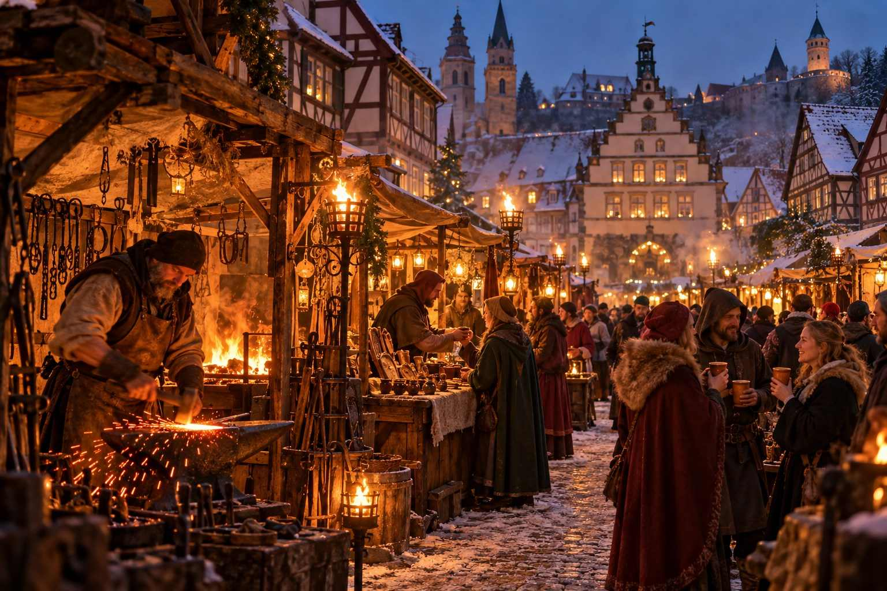

Frankfurt: Tradition in the Financial Capital
Frankfurt's Christmas market is among the oldest in Germany, with records dating to 1393, and one of the largest, with around 200 stalls winding from the Römerberg square down to the river Main. The Römerberg itself, with its row of reconstructed half-timbered houses and the stepped gables of the old city hall, is one of the most picturesque market settings in the country. The market's towering tree, often around thirty meters high, is one of the tallest in Germany.
Try the local specialties: Bethmännchen (marzipan cookies decorated with almond halves), Frankfurter Brenten (almond pastries), and a warm cup of Heißer Äppler, hot spiced apple wine.
MARKET AT A GLANCE
Frankfurt Christmas Market
Dates | Expected November 23 – December 22, 2026
Hours | Typically Mon–Sat 10:00–21:00; Sun 11:00–21:00
Location | Römerberg, Paulsplatz, Mainkai
Getting there | U-Bahn to Dom/Römer
Best for | Convenient first or last stop near Frankfurt Airport, hot apple wine

✦ INSIDER TIP
Frankfurt Airport is one of the most common arrival points for international travelers. If you land in the morning, drop your bags at a hotel near the Römer and spend your first evening at the market. It is the perfect cure for jet lag.

Heidelberg: Romance on the Neckar
The university town of Heidelberg is one of the most romantic places in Germany, with its ruined red sandstone castle perched above the old town and the river Neckar. At Christmas, the market spreads across several squares in the long, pedestrianized Hauptstraße, so you can stroll from one to the next.
The highlight is the Karlsplatz, where an ice-skating rink sits directly below the floodlit castle ruins. Skating beneath the castle, with mulled wine waiting at the rink's edge, is an unforgettable experience.
MARKET AT A GLANCE
Heidelberg Christmas Market
Dates | Expected November 23 – December 22, 2026
Hours | Typically 11:00–21:00
Location | Several squares along the Hauptstraße, including Marktplatz, Universitätsplatz, Kornmarkt, and Karlsplatz
Getting there | Buses from Heidelberg Hauptbahnhof to Bismarckplatz, then walk
Best for | Romance, castle views, ice skating

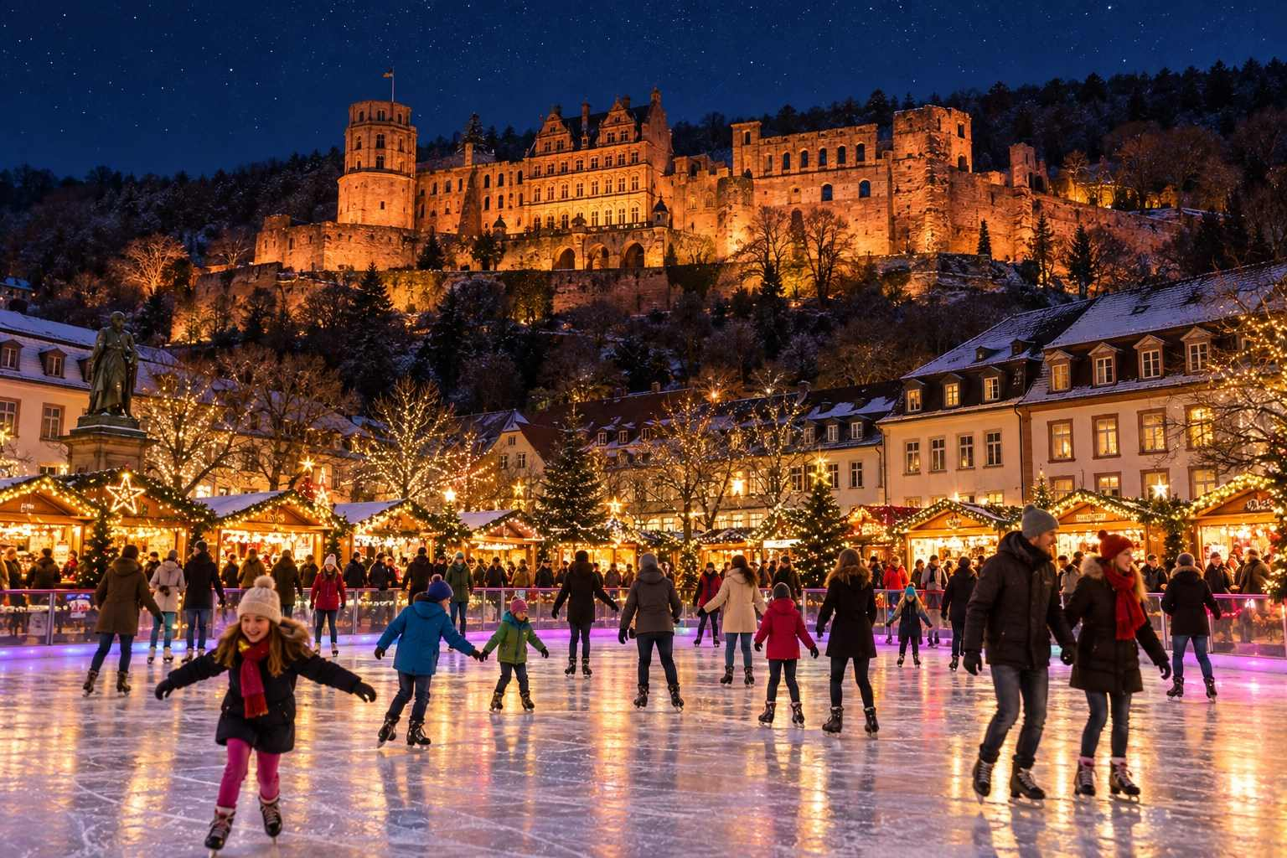

Aachen: Gingerbread and an Emperor's Cathedral
On Germany's western border, close to Belgium and the Netherlands, Aachen was the favored residence of Charlemagne, and its extraordinary cathedral, begun around 800 AD, is a UNESCO World Heritage Site. The Christmas market wraps around the cathedral and the Gothic town hall, creating a setting steeped in history.
Aachen's specialty is Printen, a hard, spiced gingerbread sweetened with beet syrup and flavored with anise, coriander, and clove. You will find it in countless varieties, from plain to chocolate-coated to nut-studded. The historic Printen bakeries in the old town are worth a visit in their own right.
MARKET AT A GLANCE
Aachen Christmas Market
Dates | Expected November 20 – December 23, 2026
Hours | Typically 11:00–21:00
Location | Around the cathedral, Katschhof, and Markt
Getting there | 10-minute walk from Aachen Hauptbahnhof; easy connections from Cologne, Liège, and Maastricht
Best for | History, Printen, combining Germany with Belgium and the Netherlands

Leipzig: Music and Tradition
Leipzig, the city of Bach, hosts one of Germany's largest and oldest markets, with around 250 stalls centered on the Markt beside the Renaissance Old Town Hall. The atmosphere is warm and musical: brass players perform from the balcony of the Old Town Hall, and the Thomanerchor, the famous boys' choir of Saint Thomas Church (where Bach was cantor), gives concerts during Advent.
Look for the Finnish Village on the Augustusplatz, the Medieval Market in the Naschmarkt, and one of the world's largest free-standing Advent calendars. Be sure to try Eierpunsch and Leipziger Lerche, a small shortcrust pastry filled with marzipan and jam.
MARKET AT A GLANCE
Leipzig Christmas Market
Dates | Expected November 24 – December 23, 2026
Hours | Typically 10:00–21:00
Location | Markt, Augustusplatz, Naschmarkt, and nearby streets
Getting there | 10-minute walk from Leipzig Hauptbahnhof, one of Europe's largest stations
Best for | Music lovers, Bach fans, combining with Dresden

Hamburg: Santa Flies Over the Rathaus
Hamburg's Historic Christmas Market on the Rathausmarkt, in front of the grand neo-Renaissance city hall, is known for its high-quality crafts and a delightful spectacle: several times each evening, Santa Claus flies over the market in his sleigh on a high wire, telling a Christmas story as he goes. Children and adults alike gasp with delight.
Hamburg also has a lively market on the Jungfernstieg beside the Binnenalster lake, where white tents glow on the water's edge, and the Winterpride LGBTQ+ market in Sankt Georg.
MARKET AT A GLANCE
Hamburg Historic Christmas Market
Dates | Expected November 23 – December 23, 2026
Hours | Typically 11:00–21:00 (Fri–Sat until 22:00)
Location | Rathausmarkt
Special feature | Santa's flying sleigh several times each evening
Best for | Families, maritime atmosphere, combining with Lübeck

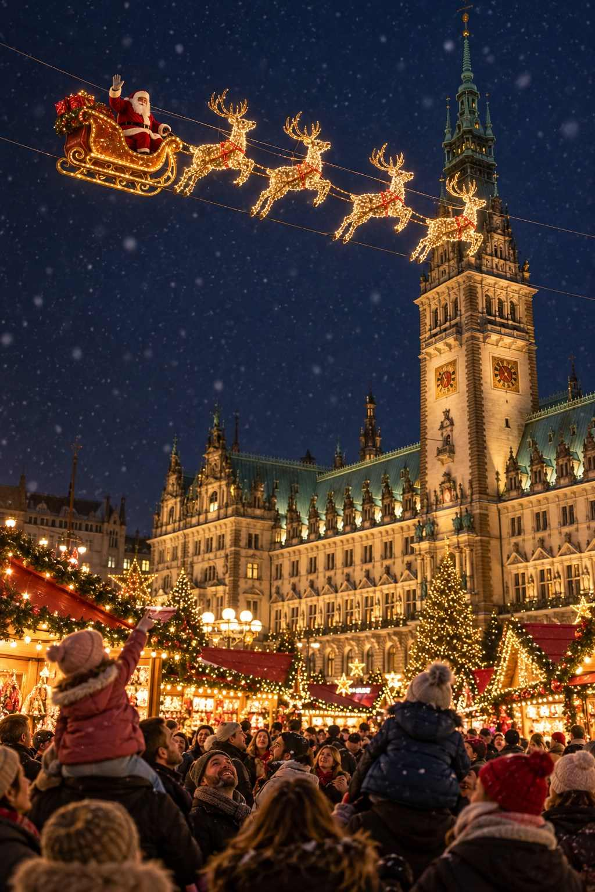

Regensburg: A Romantic Market at the Palace
Regensburg, a beautifully preserved medieval city on the Danube, is a favorite stop for river cruises. Its Romantic Christmas Market is held in the courtyards and park of Saint Emmeram Palace, the home of the princely Thurn und Taxis family. Torches, open fires, artisan workshops, and aristocratic surroundings create a special atmosphere, and an entrance fee helps keep crowds at a comfortable level.
Regensburg also hosts a traditional market on the Neupfarrplatz and a lovely Lucrezia Market on the Haidplatz, focused on arts and crafts.
✦ INSIDER TIP
While in Regensburg, visit the Historic Sausage Kitchen (Historische Wurstkuchl) beside the Stone Bridge, said to be one of the oldest continuously operating restaurants in the world, serving grilled sausages with sauerkraut and sweet mustard since the twelfth century.

Erfurt: Cathedral Steps and Candlelight
Erfurt, the capital of Thuringia, hosts one of Germany's most beautiful markets on the Domplatz, below the dramatic staircase leading to the Gothic cathedral and the Church of Saint Severus. A giant Christmas pyramid, a Ferris wheel, and a nativity scene with life-sized figures complete the scene. Do not miss the medieval Krämerbrücke, a bridge lined with inhabited half-timbered houses and little shops.

Lübeck: The Christmas City of the North
The Hanseatic city of Lübeck, with its red-brick Gothic churches and gabled merchant houses, calls itself the "Christmas City of the North." Highlights include the market in front of the town hall, a maritime market by the Church of Saint Peter, and a crafts market held inside the medieval Heiligen-Geist-Hospital, one of the oldest social institutions in Europe. Taste the city's famous Lübeck marzipan at the historic Niederegger shop.

Hidden Gems and Unusual Markets
Some of Germany's most memorable Christmas experiences happen away from the big cities.

Ravenna Gorge (Black Forest)
Deep in the Black Forest, beneath a soaring nineteenth-century railway viaduct, the Christmas market in the Ravenna Gorge (Weihnachtsmarkt in der Ravennaschlucht) is one of the most magical in Europe. The viaduct is lit in changing colors, stalls nestle among the snow-covered trees, and a historic mill wheel turns by the stream. It runs on weekends in Advent, and advance ticket reservations are required because capacity is limited.
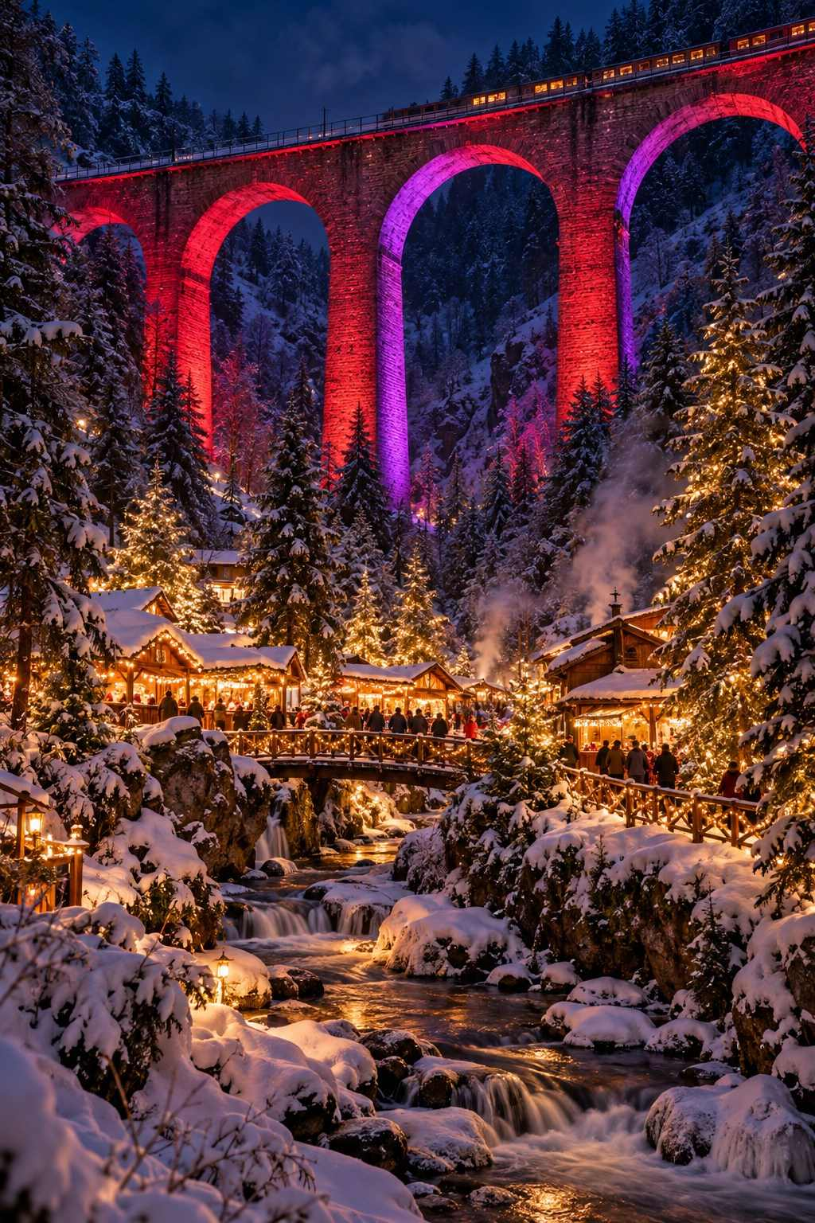

Gengenbach: The Giant Advent Calendar
In the Black Forest town of Gengenbach, the twenty-four windows of the baroque town hall become a giant Advent calendar. Each evening at 6 pm, a new window is opened to reveal an illuminated picture, often by a famous illustrator. The small Christmas market in the square below is charming and relaxed.

Monschau
Nestled in a narrow valley in the Eifel hills near the Belgian border, the half-timbered town of Monschau is a picture-perfect setting for a small, cozy market. Weekend crowds can be heavy, so try a weekday.

Bernkastel-Kues and the Moselle
The wine town of Bernkastel-Kues, on the Moselle River, holds a small, charming market among its half-timbered houses. Many Moselle wineries serve their own mulled wine made from local Riesling.

Quedlinburg: Advent in the Courtyards
In the UNESCO-listed old town of Quedlinburg in the Harz Mountains, more than twenty private courtyards open to the public on Advent weekends. Families and artisans set up small stalls, serve homemade treats, and welcome visitors into their historic homes.

Hohenzollern Castle
On selected Advent weekends, the fairy-tale Hohenzollern Castle, perched on a mountaintop in Swabia, hosts a Royal Christmas Market in its courtyards. Tickets are required and sell quickly.

Markets in Unexpected Places
Look out for markets in unexpected places: on ships in Hamburg and Cologne, in the cellars of old breweries, and even in the historic mines of the Erzgebirge, where miners' parades (Bergparaden) take place during Advent.
★ DON'T MISS
Visit at least one small-town market during your trip. The famous city markets are spectacular, but a village market, where the vendors are neighbors and the choir is the local school, shows you the heart of German Christmas.

Suggested Routes in Germany
The Classic Bavarian Loop (5–7 days): Munich, Nuremberg, Rothenburg, Regensburg, back to Munich.
Saxony's Christmas Heartland (4–5 days): Dresden, Leipzig, Seiffen (the toy village of the Erzgebirge), and Bautzen.
The Rhine and Beyond (5–6 days): Cologne, Aachen, Düsseldorf, Koblenz, Rüdesheim, and Frankfurt.
The Black Forest and Swabia (5–6 days): Stuttgart, Esslingen, Ravenna Gorge, Gengenbach, Freiburg, and across the border to Strasbourg and Colmar.
The Hanseatic North (4–5 days): Hamburg, Lübeck, Bremen, and Lüneburg.
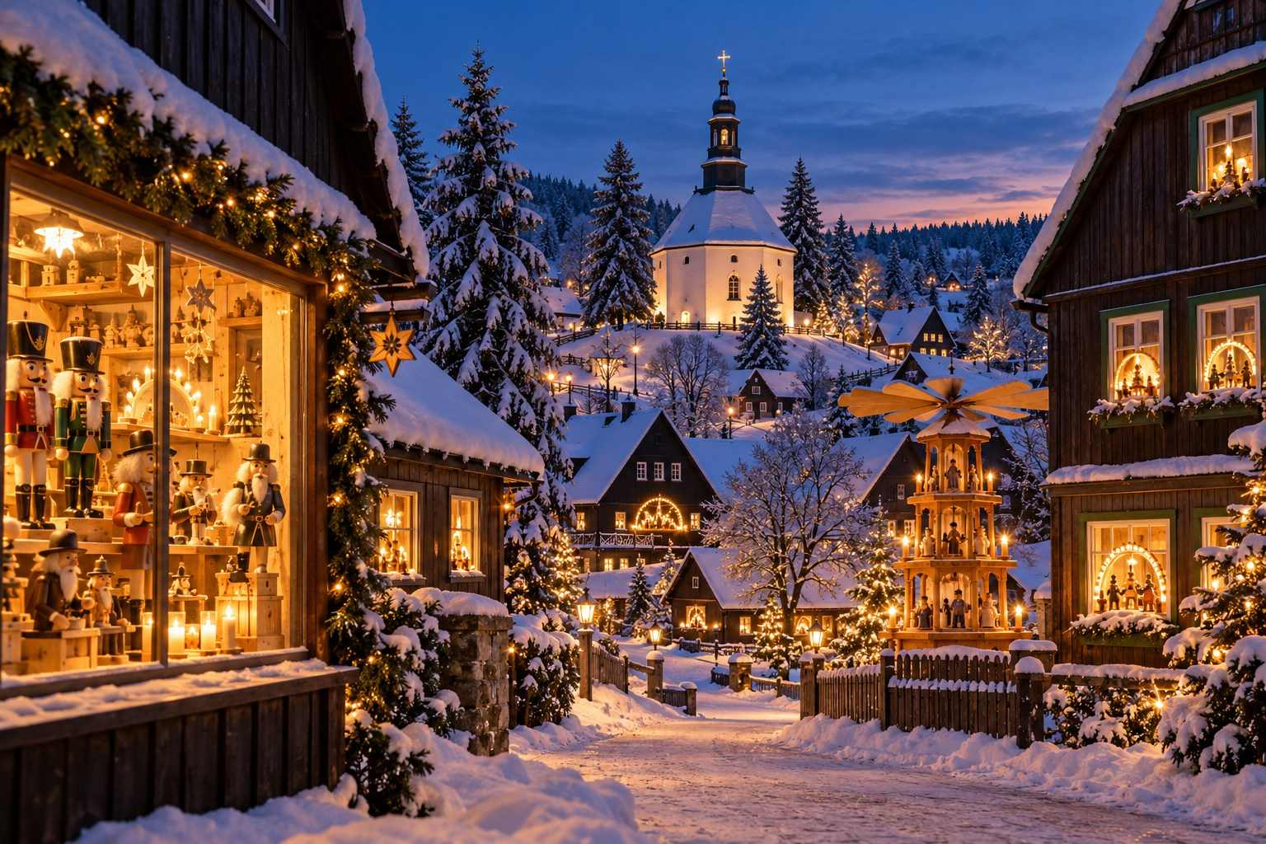

CHAPTER 6

Austria: Advent in the Alps
— ❄ ✦ ❄ —
Imperial Vienna, the Silent Night of Salzburg, and Alpine villages where Krampus still roams.
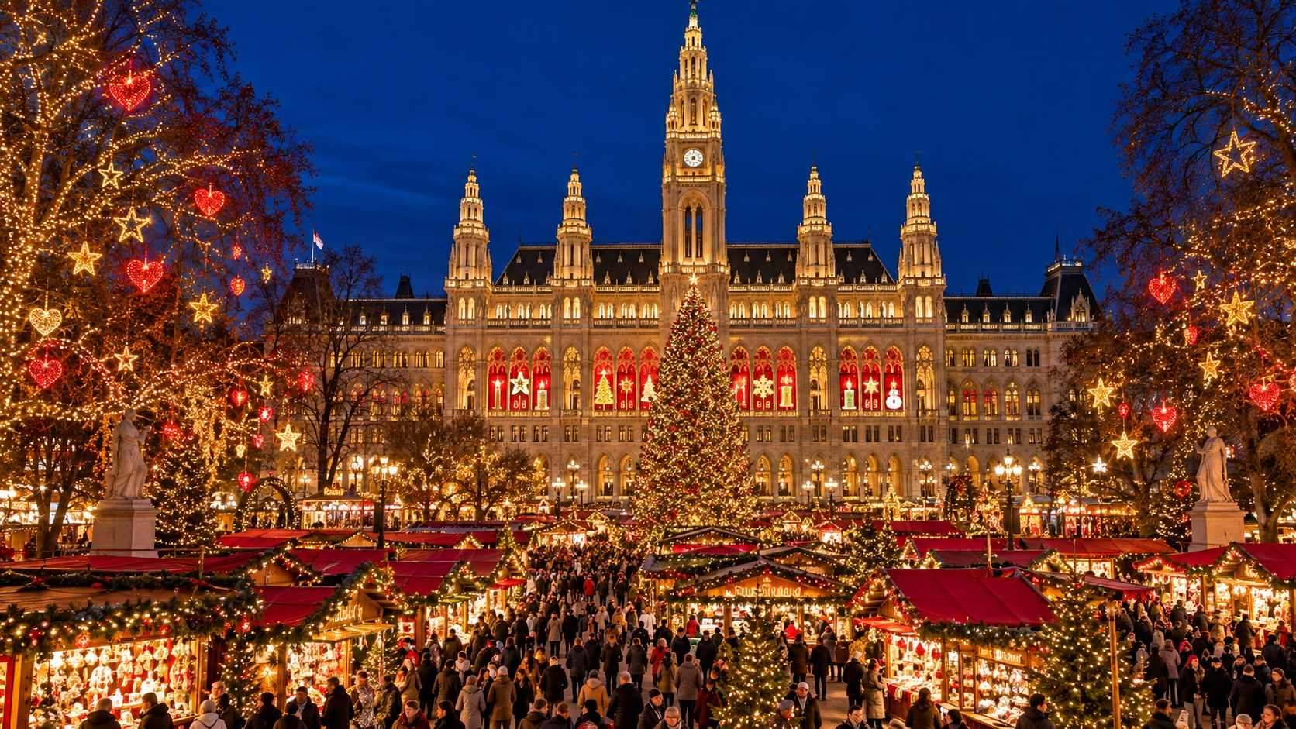

If Germany is the heart of the Christmas market tradition, Austria is its soul. Here, Advent is not only a season of shopping and feasting but a time of music, candlelight, and quiet reflection. The Austrians even have a word for this: Adventstimmung, the special mood of Advent. You will feel it in Vienna's grand imperial squares, in Salzburg's baroque old town, and in tiny Alpine villages where candles glow in every window.
Austria also has a practical advantage for travelers: its markets tend to open earlier and close later than Germany's, with several in Vienna opening in early November and running until New Year's or Epiphany.

Vienna: The Imperial Christmas
Vienna is one of the world's great Christmas cities, with more than twenty markets spread throughout the city, each with its own atmosphere. You could spend a week here and not see them all. From the grand spectacle of Rathausplatz to intimate neighborhood markets in cobbled lanes, Vienna offers something for every kind of traveler.

Wiener Christkindlmarkt at Rathausplatz
Vienna's largest and most famous market fills the square in front of the magnificent neo-Gothic City Hall (Rathaus). Around 100 stalls sell ornaments, crafts, sweets, and food, but the real star is the setting. The trees of the adjoining Rathauspark are hung with glowing hearts, stars, and gifts of light, and the City Hall's windows become a giant Advent calendar. The Wiener Eistraum ice-skating paths wind through the park, and on selected days there are workshops where children can bake cookies and make candles inside the City Hall.
✦ INSIDER TIP
Collect the famous Rathausplatz mug. A new design is released each year, and many visitors come back specifically to add it to their collection. Arrive around opening time, 10 am, on a weekday to enjoy the market before the evening crowds.

MARKET AT A GLANCE
Wiener Christkindlmarkt, Rathausplatz
Dates | November 13 – December 26, 2026 (as published)
Hours | Daily 10:00–22:00; December 24 until 18:30
Location | Rathausplatz, 1st District
Getting there | U2 to Rathaus; trams 1, 2, D, and 71 to Rathausplatz/Burgtheater
Best for | Grand spectacle, ice skating, families

Schönbrunn Palace
Set in the great courtyard of the Habsburgs' summer palace, the Christmas and New Year's market at Schönbrunn is among the most elegant in Europe. The yellow baroque palace provides a regal backdrop, and the stalls focus on quality crafts. Classical concerts, including performances of Viennese waltzes, take place throughout the season. This market runs until Epiphany, making it perfect for a post-Christmas visit.
MARKET AT A GLANCE
Schönbrunn Palace Christmas Market
Dates | November 6, 2026 – January 6, 2027 (as published)
Hours | Daily 10:00–21:00; December 24 until 16:00; from December 25, 10:00–19:00
Location | Schönbrunn Palace forecourt
Getting there | U4 to Schönbrunn
Best for | Imperial elegance, post-Christmas visits, classical music

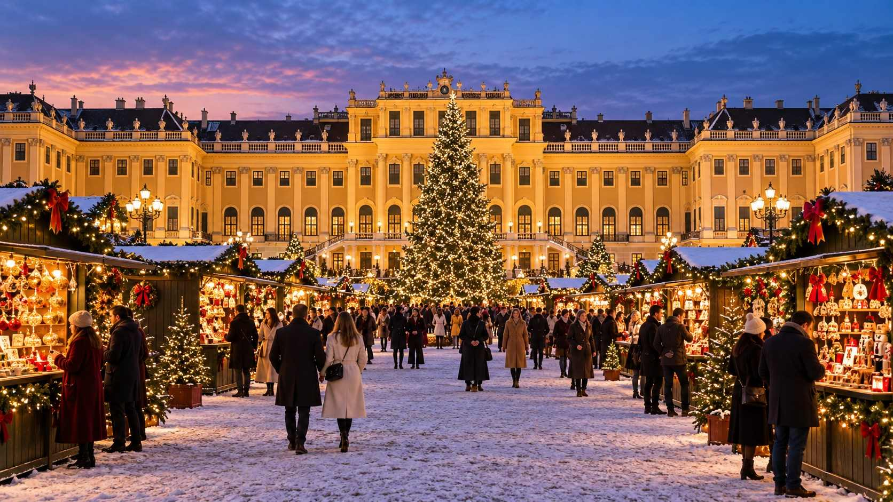

Spittelberg: Vienna's Bohemian Market
In the narrow, cobbled lanes of the Biedermeier-era Spittelberg quarter, this market is a local favorite. The stalls, tucked between pastel-colored houses, focus on original art, handmade jewelry, ceramics, and design objects. It is cozier and more creative than the big markets, and many Viennese consider it the best in the city.

Am Hof: Vienna's Oldest Tradition
On one of Vienna's oldest squares, the Advent market Am Hof specializes in antiques, traditional crafts, and Austrian specialties. Its white-roofed stalls and warm atmosphere make it a lovely place to find a unique gift.

Belvedere Palace
The K&K (Imperial and Royal) Christmas market in front of the Upper Belvedere Palace offers a stunning view of the palace reflected in its pond. Combine it with a visit to the Belvedere museum to see Gustav Klimt's The Kiss.

Karlsplatz: Art Advent
In front of the magnificent baroque Karlskirche, the Art Advent market showcases Austrian artisans and craftspeople. The stalls are chosen for quality, and there is a straw-filled petting area and play zone for children. Organic food and drink are a specialty here.

Maria-Theresien-Platz
Set between Vienna's twin museums, the Museum of Art History and the Museum of Natural History, this market is known as the Christmas Village. Its classic stalls, carousels, and elegant setting make it a favorite for both locals and visitors.

More Vienna Markets
- Freyung Old Viennese Christmas Market: Traditional crafts and live music on a historic square.
- Stephansplatz: Beside Saint Stephen's Cathedral, a small, lively market in the city's beating heart.
- Altes AKH: In the courtyard of the old general hospital, a university campus market popular with students and young locals.
- Wintermarkt at Riesenradplatz: In the Prater amusement park, beneath the giant Ferris wheel, open into January.
- Schwarzenbergplatz: A new addition to Vienna's Christmas scene from 2026.
MARKET AT A GLANCE
Other Vienna Markets (2026, as published)
Spittelberg | From November 13; Mon–Fri 14:00–21:30, weekends 11:00–21:30
Am Hof and Freyung | From November 13
Stephansplatz | November 6 – December 26
Belvedere | November 20 – December 31
Karlsplatz Art Advent | From November 13; daily from noon
Maria-Theresien-Platz | November 20 – December 26
Riesenradplatz Wintermarkt | November 20, 2026 – January 6, 2027

€ BUDGET NOTE
Many Viennese Punsch stalls are run by charities, clubs, and service organizations, and the proceeds support good causes. Look for signs reading "Charity Punsch" and enjoy your drink knowing you have done a good deed.

Beyond the Markets in Vienna
- Advent concerts: Vienna is the city of music, and Advent brings a feast of concerts, from the Vienna Boys' Choir to Mozart and Strauss in palaces and churches. Book ahead.
- Christmas at the Spanish Riding School: The famous Lipizzaner stallions perform special Advent programs.
- Coffeehouses: Warm up with a Melange and a slice of Sachertorte or apple strudel at a classic coffeehouse like Café Central, Café Sperl, or Café Landtmann.
- The Graben and Kärntner Straße: Vienna's main shopping streets are spectacularly lit with giant chandeliers of light hanging over the street.
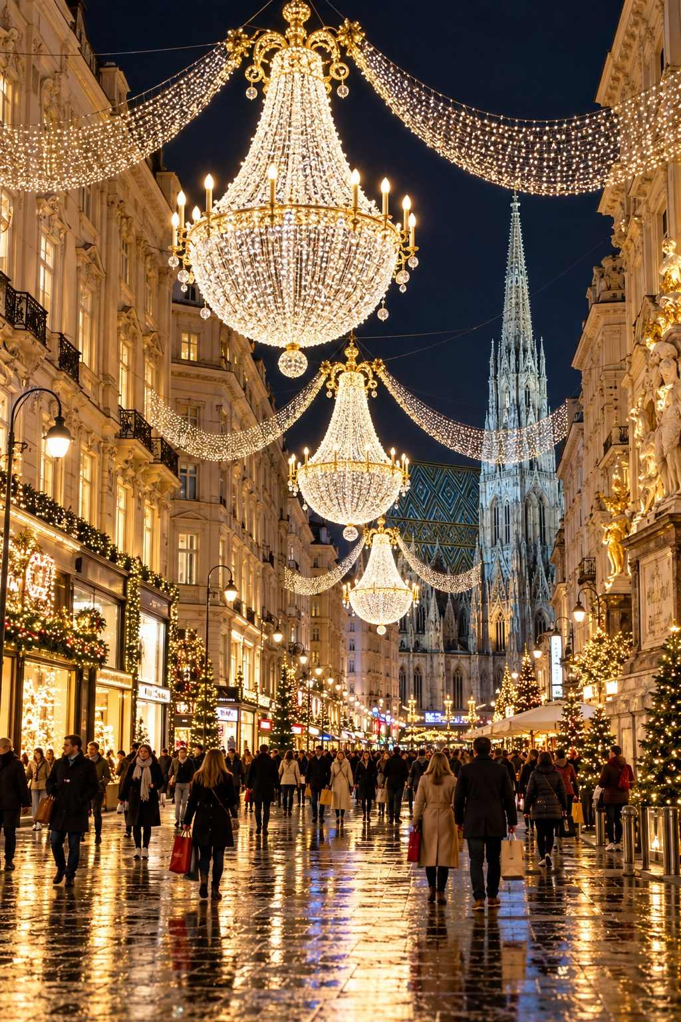

Salzburg: The Silent Night City
Salzburg is where the world's most beloved Christmas carol was born, and the city wears its Christmas heritage with pride. Mozart's hometown, with its baroque churches, fortress-crowned hill, and river Salzach, is breathtaking in winter.

Salzburg Christkindlmarkt
The main market, one of the oldest and most beautiful in the German-speaking world, fills the Domplatz and Residenzplatz before the great baroque cathedral. Around 95 stalls sell traditional crafts: carved nativity figures, wooden toys, glass ornaments, beeswax candles, and Salzburg specialties. High above, the Hohensalzburg Fortress glows on its hilltop.
The market is known for its music: tower-blowers (Turmblasen) play from the cathedral on Thursday and Saturday evenings, and over ninety choirs perform throughout the season. On Advent Sundays, the Salzburg Christkind makes appearances, and there are Krampus runs through the old town.
MARKET AT A GLANCE
Salzburg Christkindlmarkt
Dates | November 19, 2026 – January 1, 2027 (as published)
Hours | Mon–Thu 10:00–20:30; Fri 10:00–21:00; Sat 9:00–21:00; Sun and holidays 9:00–20:30; December 24 9:00–15:00
Location | Domplatz and Residenzplatz
Special events | Krampus runs (expected December 5 and 21); St. Nicholas visit December 6; choirs and tower-blowing throughout
Best for | Music, tradition, romantic city breaks

More Salzburg Markets
- Hellbrunn Palace Advent Market: In the courtyard of this playful early-baroque pleasure palace, just outside the city, with hundreds of decorated Christmas trees in the forest around it, a Krampus and Perchten parade, and an Advent calendar made from the palace's windows.
- Salzburg Fortress Advent Market: Inside the historic courtyards of Hohensalzburg Fortress, reached by funicular.
- Mirabellplatz: A smaller, local-flavored market near the famous Mirabell Palace and Gardens.
- Sternadvent: In the Sternbräu courtyard, a cozy market with regional crafts.

The Silent Night Chapel
On Christmas Eve in 1818, in the small village of Oberndorf, about twenty kilometers north of Salzburg, assistant priest Joseph Mohr and schoolteacher Franz Xaver Gruber first performed a new carol: "Stille Nacht! Heilige Nacht!" (Silent Night! Holy Night!). Legend says the church organ had broken, so Gruber composed the melody for guitar.
The original church has since been replaced by the small Silent Night Chapel (Stille-Nacht-Kapelle), which draws visitors from around the world. A small museum tells the story, and on Christmas Eve, a moving memorial service is held outside the chapel, with the carol sung in many languages. A local Christmas market is held on Advent weekends.
★ DON'T MISS
If you are in Salzburg on Christmas Eve, join the gathering at the Silent Night Chapel in Oberndorf. Hearing "Silent Night" sung by hundreds of voices in the snowy darkness, in the place where it was first performed, is one of the most moving experiences of the Christmas season.

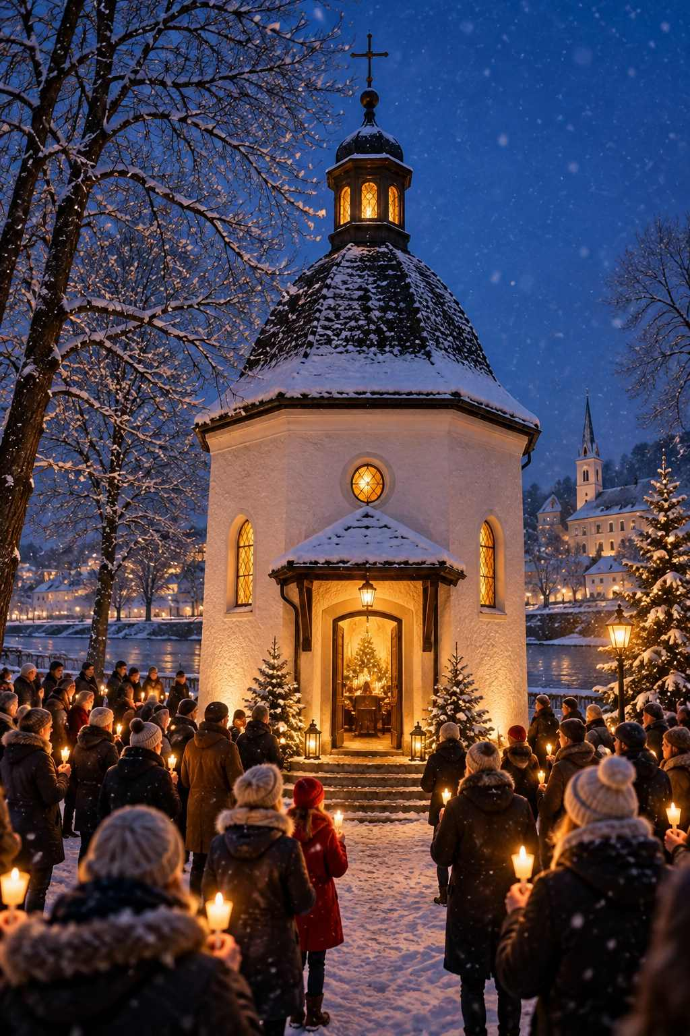

Innsbruck: Christmas in the Mountains
Innsbruck, capital of Tyrol, sits in a dramatic valley surrounded by snow-capped peaks. Its compact old town, crowned by the famous Golden Roof (Goldenes Dachl), a late-Gothic balcony covered with 2,657 fire-gilded copper tiles, is the setting for the city's main Christmas market.
Innsbruck has several markets within walking distance:
- Old Town Market: Beneath the Golden Roof, with a giant crystal tree decorated by Swarovski (based in nearby Wattens) and a fairy-tale lane for children.
- Maria-Theresien-Straße: A modern market on the main shopping street, with stunning mountain views.
- Marktplatz: On the banks of the river Inn, with a giant Christmas tree and family attractions.
- Hungerburg: Take the futuristic Hungerburgbahn funicular, designed by Zaha Hadid, up the mountain to a small market with panoramic views of the illuminated city below.
MARKET AT A GLANCE
Innsbruck Christmas Markets
Dates | Expected mid-November 2026 – January 6, 2027 (Old Town)
Hours | Typically 11:00–21:00
Location | Old Town (Golden Roof), Maria-Theresien-Straße, Marktplatz, Hungerburg
Getting there | Railjet trains from Munich (about 1 hr 45 min), Salzburg (about 2 hr), and Vienna (about 4 hr 15 min)
Best for | Mountain scenery, combining markets with skiing or winter walks

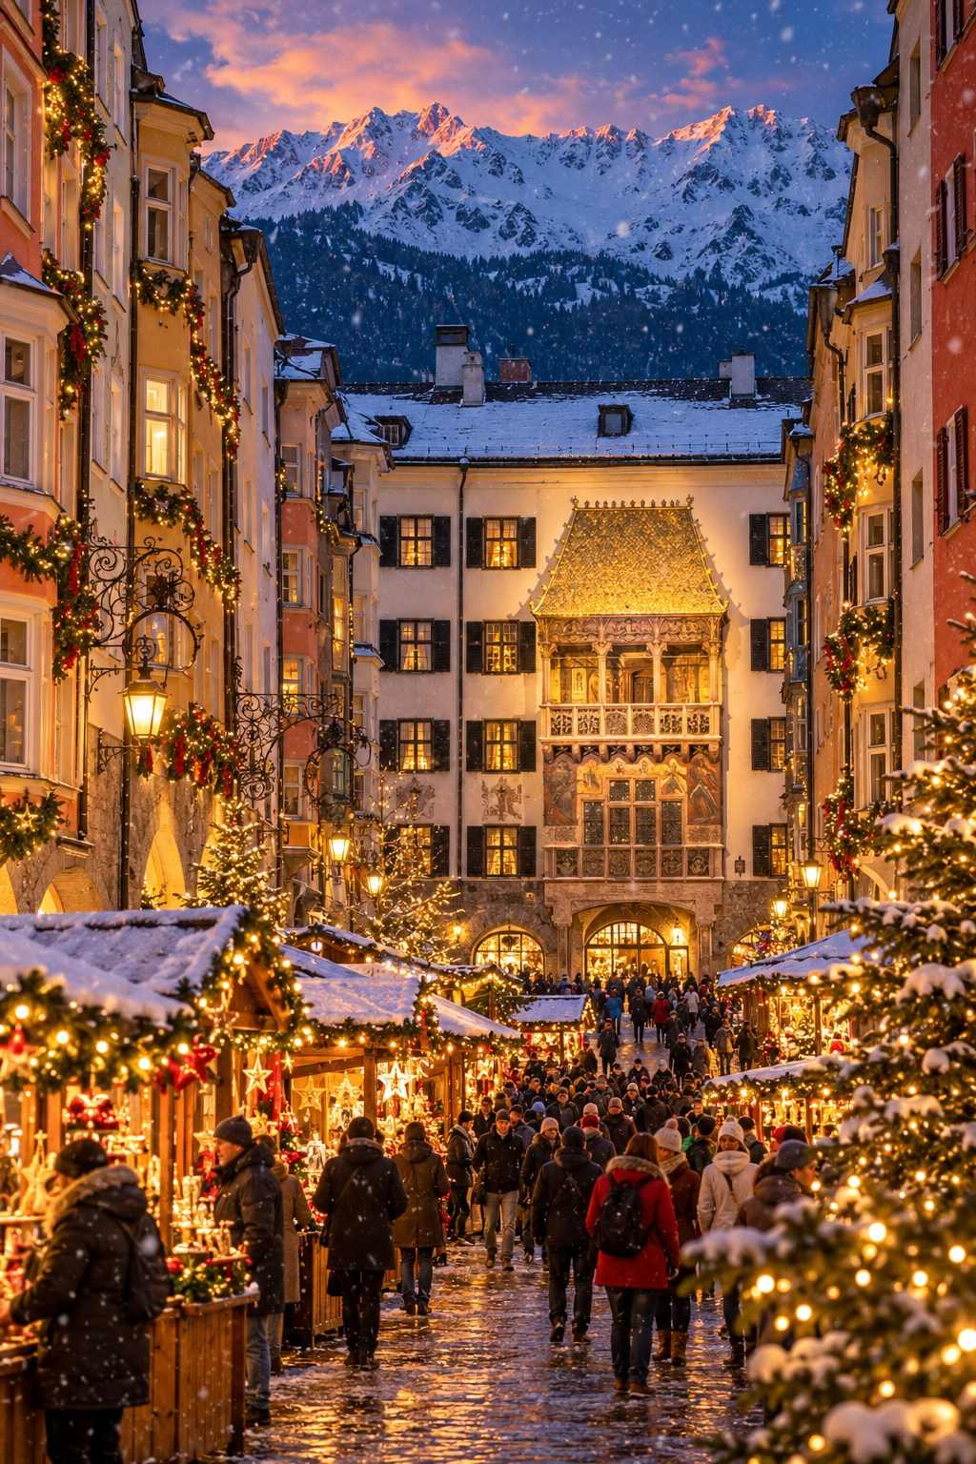

Graz: The Ice Nativity
Austria's second-largest city, Graz, has a beautifully preserved old town (a UNESCO World Heritage Site) and a relaxed, friendly Christmas season. Its most famous attraction is the Ice Nativity (Eiskrippe), a life-sized nativity scene carved from many tonnes of ice, displayed in the arcaded Renaissance courtyard of the Landhaus. Illuminated at night, it is utterly beautiful.
Graz has around a dozen markets. Take the funicular or the elevator up the Schlossberg for a panoramic view and a small market at the top.

Wolfgangsee and the Salzkammergut
The Salzkammergut lake district east of Salzburg is one of Austria's most beautiful regions, and at Christmas, the villages around Lake Wolfgang (Wolfgangsee) host a charming joint celebration known as Wolfgangsee Advent. The three villages of Sankt Gilgen, Strobl, and Sankt Wolfgang each hold a market on Advent weekends (typically Thursday or Friday to Sunday), and boats ferry visitors between them across the lake. A giant floating lantern glows on the water, and the villages are linked by a pilgrim path.
In Sankt Wolfgang, the historic White Horse Inn (Weißes Rössl), made famous by the operetta, provides a romantic backdrop.
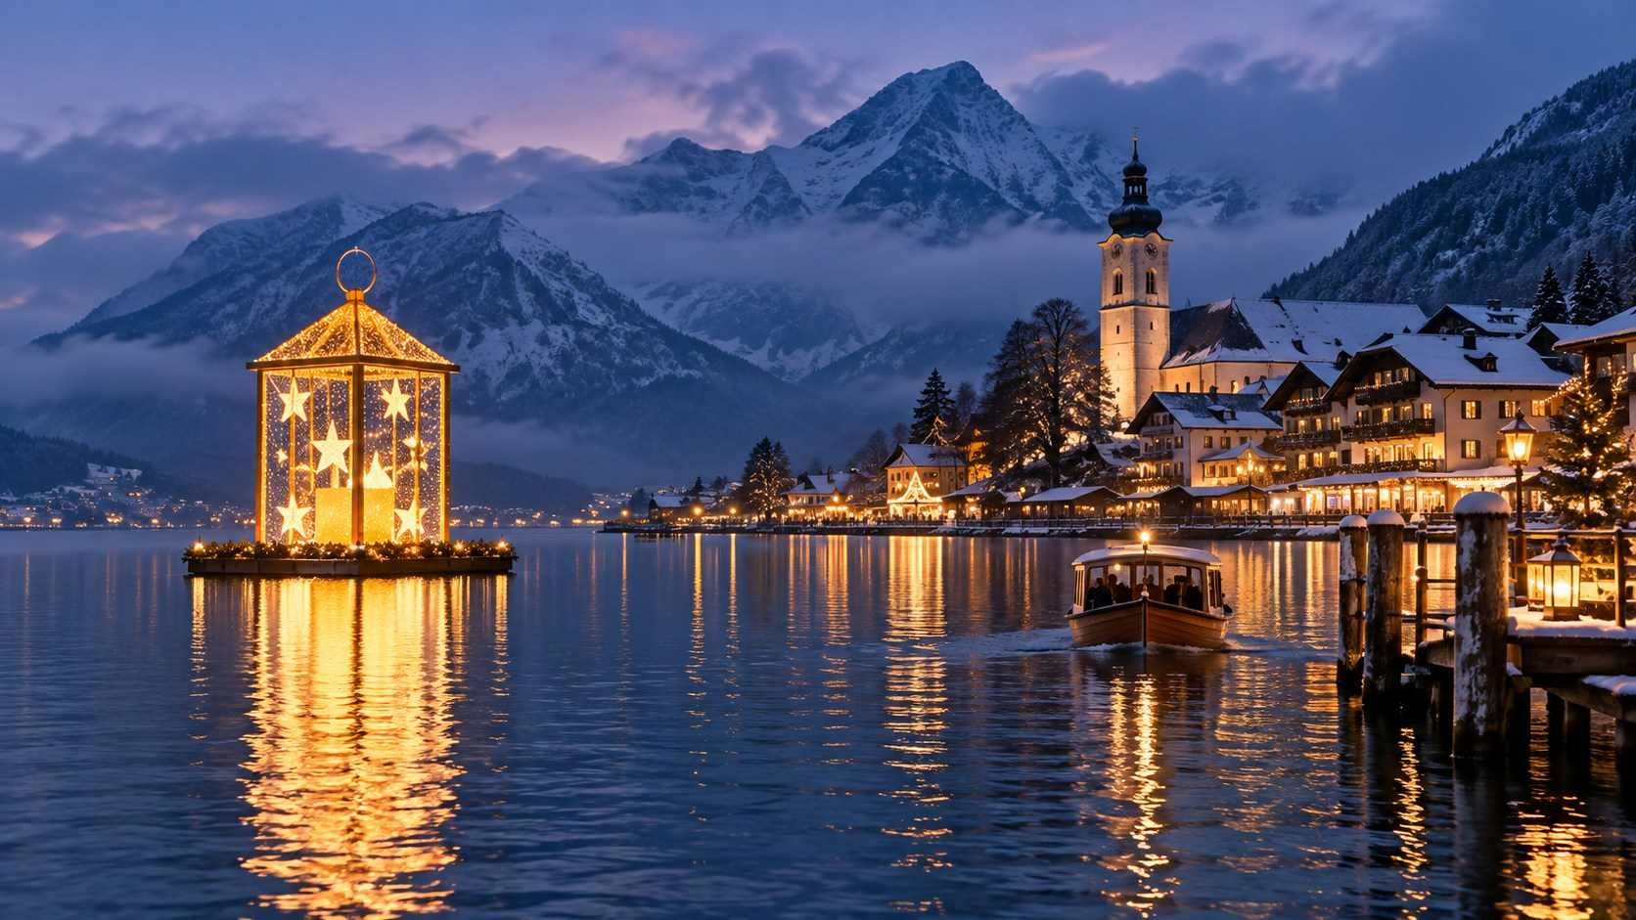

Hallstatt: The Fairy-Tale Village
Hallstatt, the tiny lakeside village that has become one of the most photographed places in the world, is gloriously atmospheric in winter. It holds a small Advent market on a few weekends, and its church bells, pastel houses, and snowy mountain backdrop make it a dream. However, Hallstatt has struggled with overtourism, and the village asks visitors to be respectful: keep your voice low, stay on public paths, do not fly drones, and remember that people live here.
✦ INSIDER TIP
Visit Hallstatt early in the morning or stay overnight to experience it without the crowds. Take the train to Hallstatt station on the opposite shore and cross by ferry, just as travelers have done for generations.

Linz and Christkindl
Linz, on the Danube, is a lively cultural city with several markets, including one on the Hauptplatz and another in the Volksgarten. A short trip away, near the town of Steyr, the pilgrimage village of Christkindl operates a special Christmas post office during Advent. Letters and cards sent from here receive a unique Christkindl postmark, and people from all over the world send their Christmas mail here to be stamped.

Krampus: Austria's Dark Side of Christmas
No Austrian Christmas would be complete without Krampus. On the evening of December 5, Saint Nicholas visits children to reward the good ones with treats, accompanied by Krampus, a terrifying horned, fur-covered demon who threatens the naughty. In the weeks around this date, towns across Austria host Krampus runs (Krampusläufe) and Perchten runs, where dozens or even hundreds of masked figures parade through the streets.
The masks are often hand-carved from wood and are works of art in their own right, and the costumes, made from goat or sheep fur, can weigh many kilograms. The runs are thrilling, noisy, and a little scary. Stand behind barriers, keep small children close, and be prepared for a playful swat with a birch switch!
Some of the best Krampus runs take place in Salzburg, at Hellbrunn Palace, in Innsbruck, in Bad Gastein, and in the villages of Tyrol and Carinthia.
ℹ GOOD TO KNOW
Krampus runs are intense and not suitable for very young or easily frightened children. Check local tourism websites for dates, as many runs take place on the weekends around December 5.

Suggested Routes in Austria
Imperial Austria (5–7 days): Vienna (3 nights), Salzburg (2 nights), with a day trip to Hallstatt or Wolfgangsee.
The Alpine Christmas (5–7 days): Innsbruck, Salzburg, and the Salzkammergut, perhaps with a few days of skiing.
The Danube Christmas (4–5 days): Vienna, Melk Abbey, Dürnstein, and Linz, or by river cruise from Passau to Budapest.
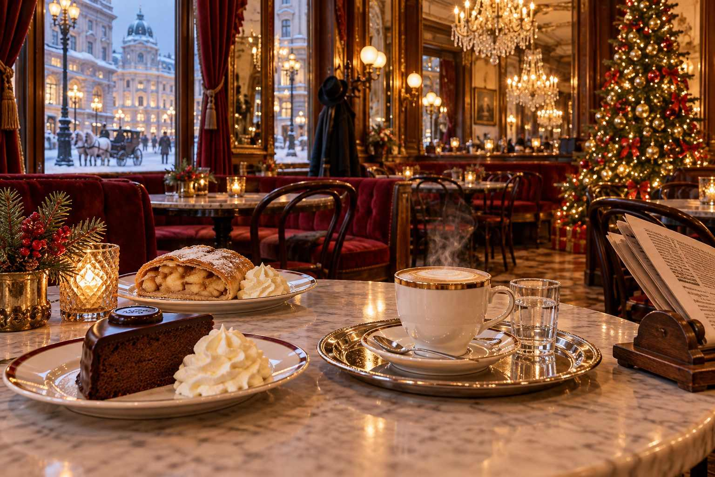

CHAPTER 7

France: Alsace, the Capital of Christmas
— ❄ ✦ ❄ —
Half-timbered villages, canals of light, and a city that has celebrated Christmas since 1570.
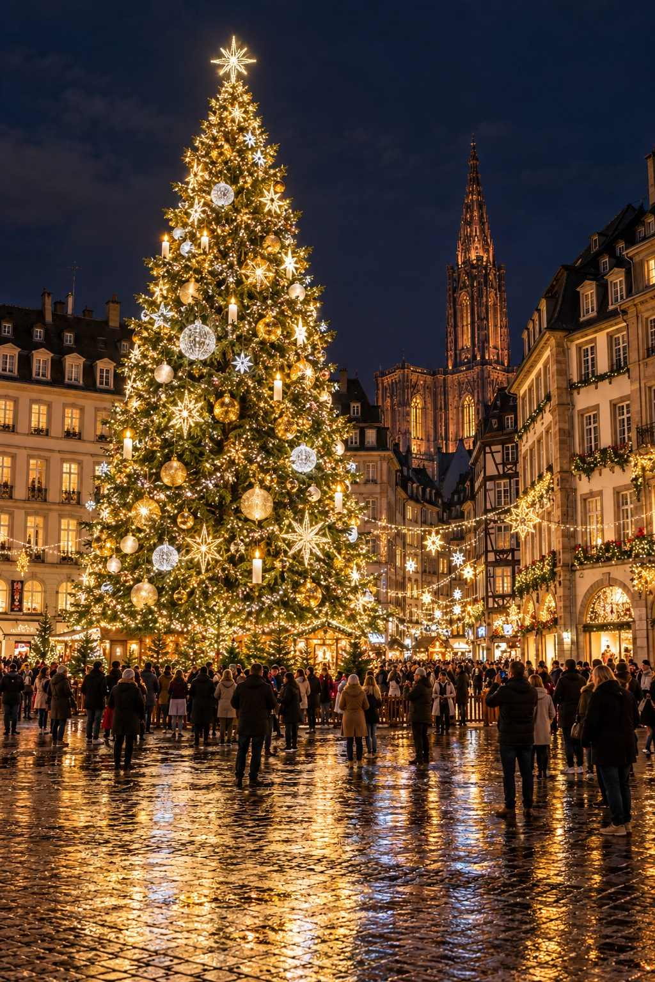

France has many lovely Christmas markets, but one region stands head and shoulders above the rest: Alsace. Tucked between the Vosges mountains and the river Rhine, on the border with Germany, Alsace has passed between French and German rule several times over the centuries. The result is a unique culture that blends the best of both: French elegance and gastronomy, German Christmas traditions, and a local dialect, Alsatian, all its own.
At Christmas, Alsace transforms into a storybook land. Its half-timbered villages, many of them among the most beautiful in France, glow with lights and overflow with decorations. The food is extraordinary, the wine is excellent, and the markets are among the finest in Europe.

Strasbourg: Capitale de Noël
Strasbourg proudly calls itself the Capital of Christmas, and it is not an idle boast. Its Christkindelsmärik (the Alsatian name for the market of the Christ Child) dates to 1570, making it one of the oldest in Europe, and today the whole city center becomes a Christmas wonderland. Some three hundred chalets are spread across more than a dozen locations, and the entire Grande Île, the island at the heart of the old town and a UNESCO World Heritage Site, is decorated with lights, garlands, and ornaments.

The Main Markets
- Place Broglie: The historic site of the Christkindelsmärik, the oldest and largest of the city's markets, with rows of chalets selling crafts, ornaments, and treats.
- Place de la Cathédrale: In the shadow of the magnificent pink sandstone Gothic cathedral, one of the most spectacular market settings anywhere.
- Place Kléber: Home to the Great Christmas Tree (Grand Sapin), typically around thirty meters tall and decorated with thousands of lights and ornaments. The tree has been a symbol of Strasbourg's Christmas for decades.
- Place Benjamin Zix and Petite France: In the picturesque Petite France quarter, with its canals, half-timbered tanners' houses, and covered bridges, a small market full of charm.
- Place du Marché aux Poissons: Beside the river Ill, a market of regional products.
- Guest country village: Each year, Strasbourg invites a guest country to showcase its Christmas traditions, crafts, and food.
- Village of Sharing (Village du Partage): At Place Grimmeissen, a market of charitable organizations and humanitarian associations.
- Alsatian farmers' market: Regional producers selling foie gras, cheese, wine, and bredele.

The Decorated Streets
What makes Strasbourg truly special is that the whole city center is dressed for Christmas. Shopkeepers compete to create the most extravagant façades, with giant teddy bears, oversized ornaments, and cascading garlands hanging above their doorways. The Carré d'Or (Golden Square) around the cathedral is especially dazzling: streets such as Rue Mercière, Rue des Orfèvres, and Rue du Maroquin are transformed into tunnels of light.
✦ INSIDER TIP
Strasbourg is one of the most crowded Christmas destinations in Europe, especially on weekends. Visit on a weekday, go early in the day for shopping, and stay overnight to enjoy the illuminated streets after the day-trippers leave. Security checkpoints control access to the Grande Île during the market season, so allow extra time and avoid bringing large bags.

MARKET AT A GLANCE
Strasbourg Christkindelsmärik
Dates | Expected late November (around November 25–27) – December 24, 2026; official dates not yet announced at the time of writing
Hours | Typically 11:00–21:00 (opening day from afternoon); December 24 until about 18:00; closed December 25
Location | Grande Île: Place Broglie, Place de la Cathédrale, Place Kléber, and many more
Getting there | TGV from Paris (about 1 hr 50 min); trains from Frankfurt, Stuttgart, Basel; 15-minute walk or tram from the station
Official site | noel.strasbourg.eu
Best for | The ultimate Christmas city experience, food lovers

Beyond the Markets in Strasbourg
- Strasbourg Cathedral: Visit the astronomical clock, whose mechanical figures parade daily at 12:30 pm, and climb the 332 steps to the platform for a view over the city and, on clear days, the Black Forest.
- Batorama boat tour: See the city from the river Ill.
- Winstubs: Eat in a traditional Alsatian wine tavern. Try choucroute garnie (sauerkraut with sausages and pork), baeckeoffe (a slow-baked meat and potato casserole), or tarte flambée.
- Kougelhopf: Taste the famous Alsatian ring-shaped brioche with raisins and almonds.
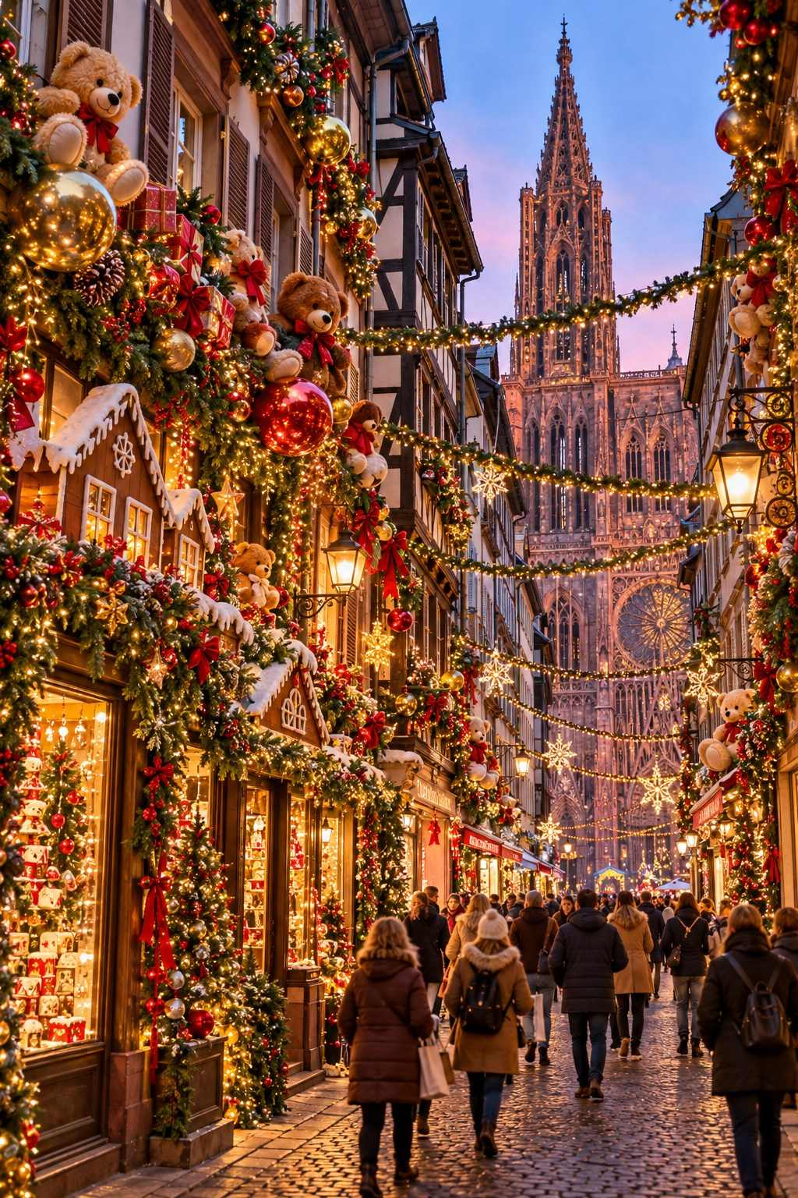

Colmar: A Fairy Tale Come to Life
If Strasbourg is the capital of Christmas, Colmar is its most beautiful jewel. This small city, around thirty minutes south of Strasbourg by train, is the very picture of a fairy tale: colorful half-timbered houses, flower-trimmed canals, cobbled lanes, and tiny squares. It is often said to have inspired the setting of a famous animated film about a beauty and a beast, and at Christmas it is simply magical.
Colmar hosts six Christmas markets, each with its own theme, all within a short walk of one another:
- Place des Dominicains: Beneath the Gothic Dominican church, with stalls glowing in the light of the stained-glass windows.
- Place de l'Ancienne Douane: Around the Koïfhus, the old customs house, one of Colmar's most photogenic buildings, with an indoor section showcasing regional crafts.
- Place Jeanne d'Arc: Focused on traditional crafts and local products.
- Place des Six Montagnes Noires: A small, charming market by the river Lauch.
- Petite Venise children's market: In the "Little Venice" quarter, where the canals are lined with pastel houses, a market designed for children, with a giant letterbox for letters to Santa.
- Koïfhus market: Inside the historic customs house, with around thirty artisans.
At night, the old town is beautifully lit, with a special lighting scheme highlighting the architecture. A boat ride through Petite Venise, if available, is unforgettable.
MARKET AT A GLANCE
Colmar Christmas Markets
Dates | Expected late November – December 29, 2026 (official dates not yet announced at the time of writing)
Hours | Typically 10:00–19:00 (Fri–Sat until 20:00); December 24 until 17:00; closed December 25
Location | Six markets across the old town
Getting there | Trains from Strasbourg (about 30 min), Basel, and Mulhouse; old town is a 15-minute walk from the station
Best for | Fairy-tale scenery, photographers, romantic getaways

€ BUDGET NOTE
Hotels in Colmar sell out months in advance. If Colmar is full, consider staying in Strasbourg or Mulhouse and visiting by train, or stay in a wine village guesthouse and visit Colmar by car or bus.

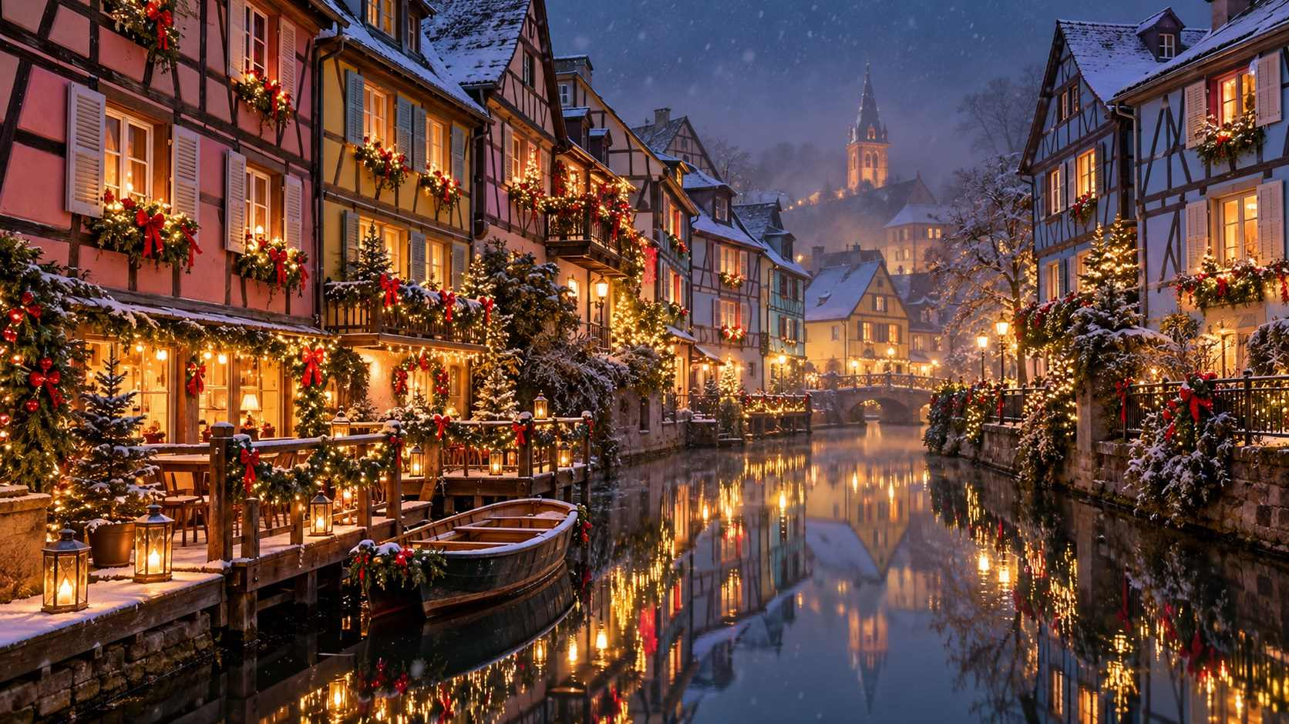

The Wine Villages of Alsace
Along the Alsace Wine Route (Route des Vins d'Alsace), a string of enchanting villages nestles among the vineyards at the foot of the Vosges. Many hold small, atmospheric Christmas markets, often only on weekends. Visiting them is one of the great joys of a Christmas trip to Alsace.

Kaysersberg
Kaysersberg, the birthplace of Nobel Peace Prize winner Albert Schweitzer, is one of the most beautiful villages in France. Its half-timbered houses line the river Weiss, crossed by a fortified bridge, and a ruined castle watches over the town. The Christmas market is small, traditional, and famous for its quality crafts. It is typically held on weekends (Friday to Sunday) during Advent.

Riquewihr
Encircled by medieval walls and surrounded by vineyards, Riquewihr looks like something from a picture book. Its Christmas market fills the main street with stalls selling crafts, wine, and local treats. Many shops, including a famous year-round Christmas store, are open daily.

Eguisheim
Built in concentric circles around its castle, Eguisheim is often voted one of France's favorite villages. At Christmas, its narrow, curving lanes are decorated with lights and greenery, and a small market is held in the center. Look out for the village's decorated wells and fountains.

Ribeauvillé
Ribeauvillé hosts a medieval Christmas market on Advent weekends, with minstrels, jugglers, fire-eaters, and costumed merchants, and a delightful procession. Its three ruined castles on the hillside above are floodlit at night.

Obernai
Obernai, one of the largest wine towns, has a lively Christmas market around its Renaissance town hall and bell tower, open daily through much of Advent.
MARKET AT A GLANCE
Alsace Wine Villages
Kaysersberg | Typically Advent weekends (Fri–Sun)
Riquewihr and Eguisheim | Typically daily from late November to around December 23
Ribeauvillé | Medieval market, typically Advent weekends
Obernai | Typically daily from late November
Getting there | By car along the Wine Route, by local bus from Colmar, or on organized day tours
Best for | Village charm, wine lovers, a slower pace

✦ INSIDER TIP
Many visitors combine Colmar with a day touring the wine villages. Local buses connect Colmar with Kaysersberg, Riquewihr, and Ribeauvillé, but schedules are limited. For flexibility, consider a small-group tour or rent a car for a day.

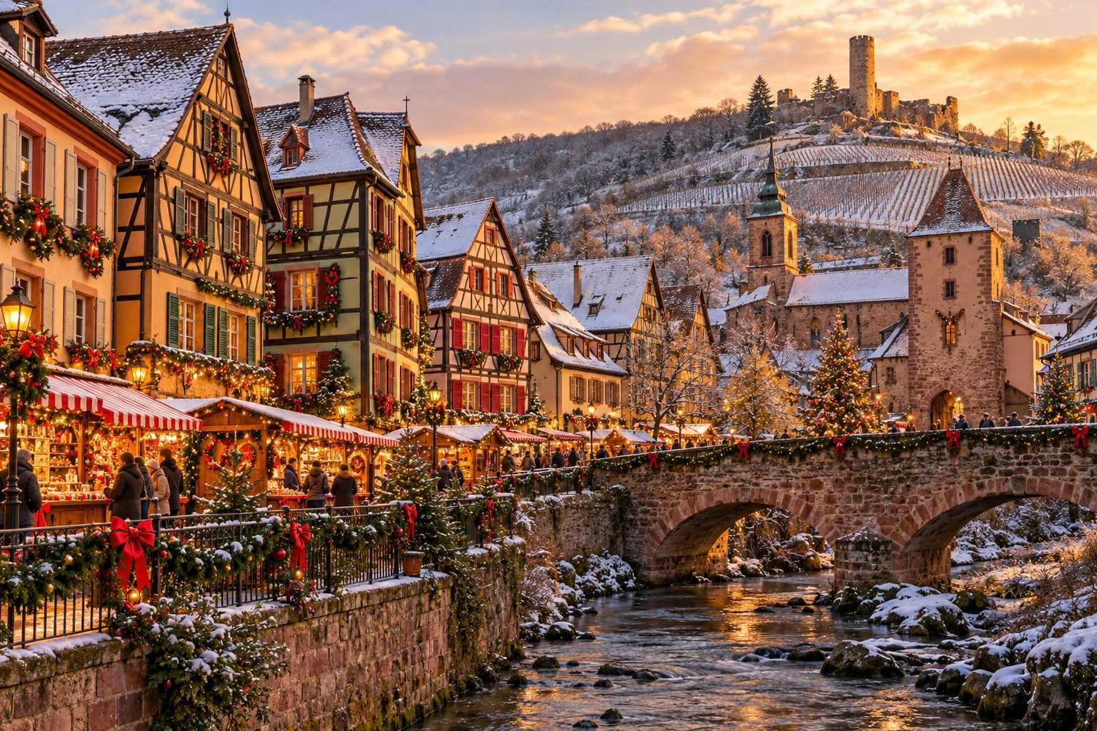

Mulhouse: The Christmas Fabric
The industrial city of Mulhouse, famous for its textile heritage, has a unique Christmas tradition. Each year, a special Christmas fabric (Étoffe de Noël) is designed and printed, and it is used to decorate the market stalls, the streets, and the magnificent Temple Saint-Étienne, the tallest Protestant church in France. You can buy the fabric by the meter, as well as tea towels, table linens, and other items. The market on the Place de la Réunion is authentic and less crowded than Strasbourg and Colmar.

Metz and Nancy: Lorraine's Celebrations
Neighboring Lorraine has its own rich traditions.
Metz hosts one of the largest Christmas celebrations in France, with markets spread across several squares, an ice rink on the Place de la République, a Ferris wheel, and illuminated streets. Its magnificent Gothic cathedral, Saint-Étienne, has some of the largest expanses of stained glass in the world.
Nancy celebrates Saint Nicholas, the patron saint of Lorraine, with a major festival on the weekend closest to December 6. The highlight is a grand parade of illuminated floats, followed by fireworks over the beautiful Place Stanislas, one of Europe's most elegant squares.

Paris: Christmas in the City of Light
Paris is not known primarily for its Christmas markets, but it is a spectacular place to spend Advent. The Champs-Élysées is illuminated from end to end, the great department stores dress their windows with animated displays, and the churches and concert halls are filled with music.
- Galeries Lafayette Haussmann: The giant Christmas tree beneath the glass Art Nouveau dome is one of the most famous sights of Christmas in Paris. The window displays are a delight for all ages.
- Printemps Haussmann: Another spectacular set of Christmas windows.
- Jardin des Tuileries: A large Christmas market and funfair with rides, a Ferris wheel, and many food stalls.
- La Défense: The largest Christmas market in the Paris region, with hundreds of stalls in the business district.
- Notre-Dame: Following its reopening in December 2024 after the 2019 fire, the cathedral is a moving place to visit during Advent. Check for services and concert times.
✦ INSIDER TIP
Paris is only about one hour and fifty minutes from Strasbourg by high-speed TGV train, making it easy to combine the city with Alsace.

Other French Christmas Destinations
- Lille: A Christmas market on the Place Rihour and a Ferris wheel in the Grand Place, with Flemish-style architecture and easy Eurostar connections to London and Brussels.
- Amiens: One of the largest markets in northern France, with more than a hundred chalets, and Europe's largest Gothic cathedral illuminated with color.
- Montbéliard: The Lumières de Noël (Lights of Christmas) market is one of the most admired in eastern France, known for its authentic crafts.
- Provence: The south of France has its own traditions, including the charming santons, small clay nativity figures, sold at special santon fairs in Marseille and Aix-en-Provence.
- Lyon: The Fête des Lumières (Festival of Lights), held over four nights around December 8, transforms the city with spectacular light installations. It is one of the largest light festivals in the world.
★ DON'T MISS
If you can time your trip for around December 8, the Fête des Lumières in Lyon is an extraordinary spectacle. Hotels book up far in advance, so plan early.

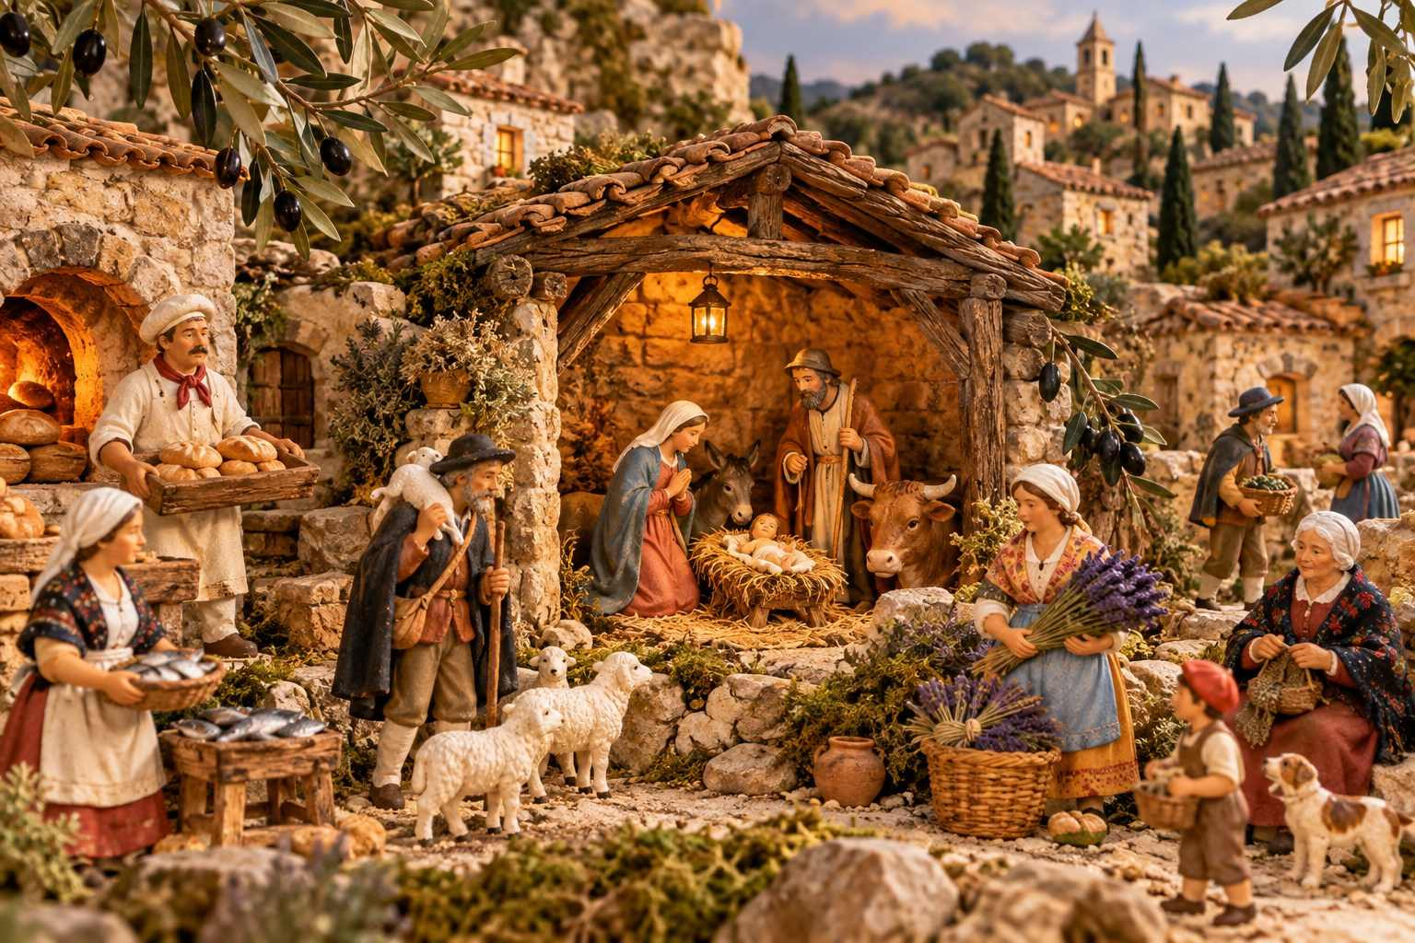

CHAPTER 8

Switzerland: Alpine Elegance
— ❄ ✦ ❄ —
Lakeside chalets, crystal trees, singing choirs, and Santa's house on a mountaintop.
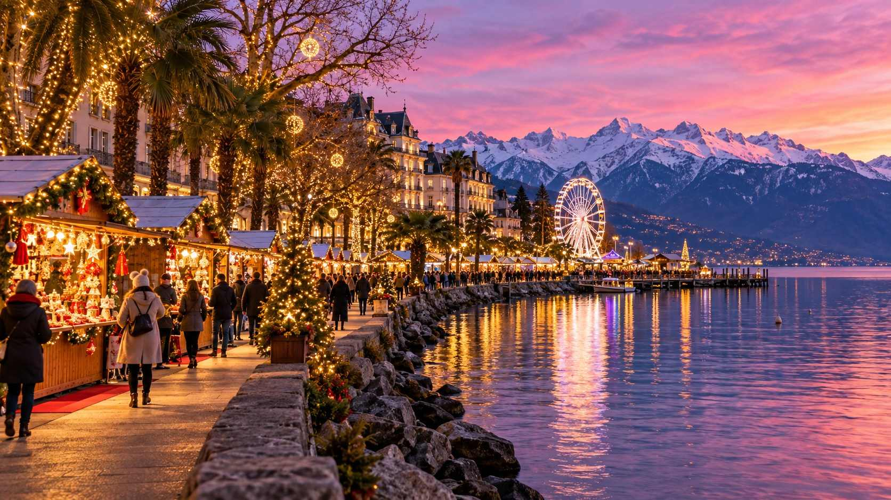

Switzerland brings a special kind of polish to Christmas. Its markets are spotless, well organized, and beautifully designed, set against backdrops of lakes, mountains, and medieval old towns. Swiss cities are also compact and connected by one of the best rail networks in the world, so it is easy to see several markets in a few days.
Be prepared for Swiss prices, which are among the highest in Europe. A cup of mulled wine typically costs CHF 6–9, plus a mug deposit, and a raclette or sausage is often CHF 10–16. The quality, however, is excellent.

Basel: A Market for the Connoisseur
Basel, on the Rhine where Switzerland meets France and Germany, hosts what many consider Switzerland's largest and most beautiful Christmas market. It is spread across two squares in the old town:
- Barfüsserplatz: The lively heart of the market, with food, drink, and crafts.
- Münsterplatz: Before the red sandstone Basel Minster, a quieter, more elegant market with a fairy-tale forest for children and a giant tree.
The streets of the old town are decorated with elegant lights, and the shops are dressed for the season. Basel is also home to one of Europe's most famous Christmas shops, where handmade glass ornaments and antique-style decorations draw collectors from around the world.
Taste Basler Läckerli, spiced honey biscuits with candied peel and almonds, a Basel specialty for centuries.
MARKET AT A GLANCE
Basel Christmas Market
Dates | Expected late November – December 23, 2026
Hours | Typically 11:00–20:30
Location | Barfüsserplatz and Münsterplatz
Getting there | Basel SBB station, 10 minutes by tram; easy connections from Strasbourg, Colmar, Freiburg, and Zurich
Best for | Quality crafts, combining with Alsace and the Black Forest

Zurich: Crystals, Choirs and Lakeside Lights
Switzerland's largest city offers a sophisticated and varied Christmas season.
- Christkindlimarkt in the Main Station: One of Europe's largest indoor Christmas markets fills the vast hall of Zurich Hauptbahnhof, beneath a towering tree glittering with ornaments. Perfect on a rainy day.
- Wienachtsdorf at Sechseläutenplatz: A modern "Christmas village" by the lake and the Opera House, with Scandinavian-style chalets, an ice rink, and excellent food.
- Singing Christmas Tree: On the Werdmühleplatz, choirs of children and adults stand on a tiered, tree-shaped stage and sing carols several times a day. It is a lovely, uplifting experience.
- Niederdorf Market: In the narrow lanes of the old town, a cozy, traditional market.
- Lucy Light Show on Bahnhofstrasse: Zurich's famous shopping street is illuminated by a dazzling canopy of lights.
MARKET AT A GLANCE
Zurich Christmas Markets
Dates | Expected late November – December 24, 2026 (varies by market)
Hours | Typically 11:00–21:00 or 22:00
Getting there | Zurich Airport is 10 minutes by train from the Hauptbahnhof
Best for | City sophistication, choral music, indoor shopping

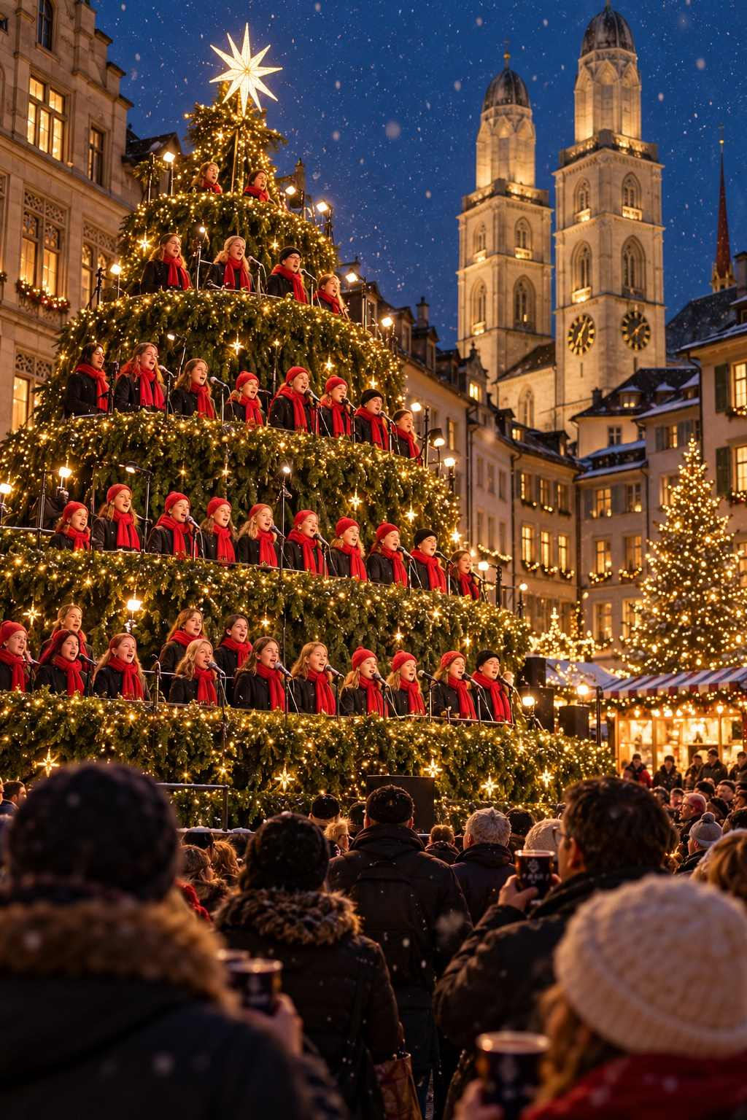

Montreux Noël: Christmas on the Swiss Riviera
On the shores of Lake Geneva, framed by the Alps, Montreux Noël is one of the most scenic Christmas markets in Europe. Around 150 chalets line the lakeside promenade, where palm trees remind you of the town's unusually mild climate.
What makes Montreux special is its imaginative extras:
- Santa's flying sleigh: Santa soars over the market on a high wire several times each evening.
- Santa's house on the Rochers-de-Naye: Take the cog railway from Montreux up to 2,000 meters to visit Santa's house at the summit, with spectacular views over Lake Geneva and the Alps. Children can hand over their wish lists in person.
- Medieval market at Chillon Castle: The famous medieval castle, which seems to float on the lake, hosts a medieval Christmas market on selected weekends, with costumed characters and period crafts.
MARKET AT A GLANCE
Montreux Noël
Dates | Expected late November – December 24, 2026
Hours | Typically 11:00–21:00 (Fri–Sat until 22:00)
Location | Lakeside promenade (Quai de la Rouvenaz)
Getting there | Trains from Geneva (about 1 hr) and Lausanne (about 20 min); scenic GoldenPass trains from Lucerne via Interlaken
Best for | Lake and mountain views, families, romance

★ DON'T MISS
Ride the cog railway to Santa's house on the Rochers-de-Naye. Even without children, the views of Lake Geneva from the summit on a clear winter day are unforgettable. Book tickets in advance for the Christmas season.

Lucerne: Lakeside Charm
Lucerne, with its covered wooden Chapel Bridge, painted buildings, and lakeside setting, is one of Switzerland's most picturesque cities. Its Christmas markets on the Franziskanerplatz and Weinmarkt squares are small and charming, and the old town glows with lights. Combine your visit with a cruise on Lake Lucerne or a trip to the snowy summit of Mount Pilatus or Rigi.

Bern: The Capital's Arcades
In Bern, the Swiss capital, the medieval old town is a UNESCO World Heritage Site with six kilometers of covered arcades, perfect for shopping in any weather. Christmas markets are held on the Münsterplatz, beneath the Gothic cathedral, and on the Waisenhausplatz. Do not miss the Zytglogge clock tower with its mechanical figures.

Einsiedeln: Pilgrimage and Christmas
The great baroque Benedictine abbey of Einsiedeln, a pilgrimage site for over a thousand years, hosts one of Switzerland's largest Christmas markets in the vast square before its façade, and a special nativity exhibition. The abbey's candlelit services during Advent are deeply atmospheric.
€ BUDGET NOTE
To save money in Switzerland, buy picnic supplies at supermarkets like Coop and Migros, and consider a Swiss Travel Pass or Half Fare Card if you will be traveling by train several times. Eat your main meal at lunchtime, when many restaurants offer good-value set menus.

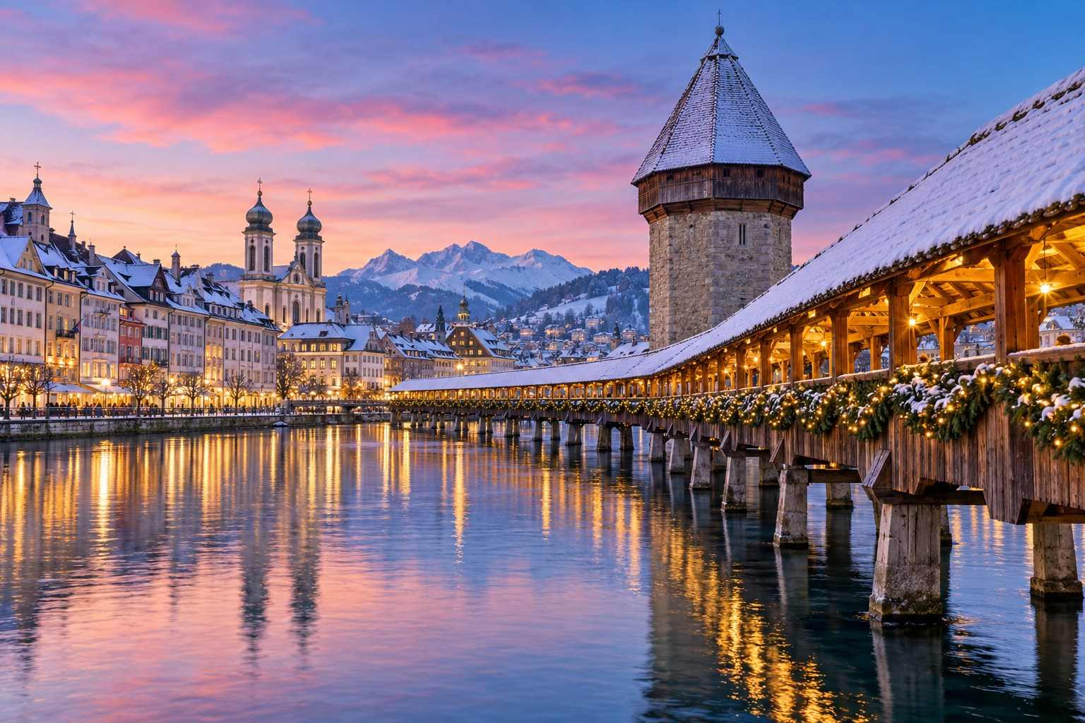

CHAPTER 9

Czech Republic & Hungary: Gothic Spires and Thermal Baths
— ❄ ✦ ❄ —
Prague's fairy-tale skyline, Budapest's dazzling light shows, and the warm hospitality of Central Europe.
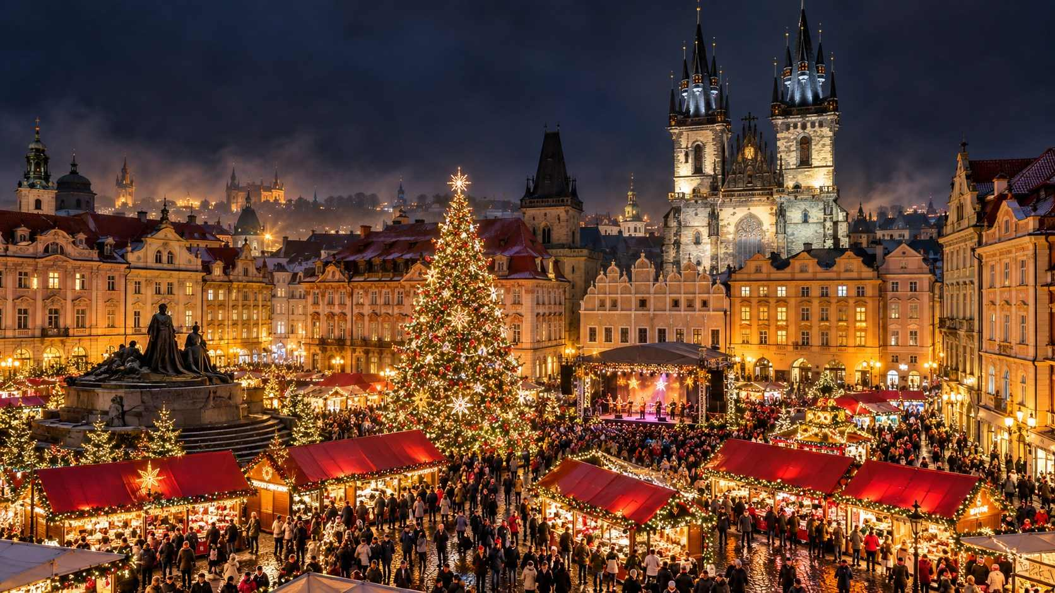

For many travelers, the markets of Prague and Budapest offer the perfect combination: breathtaking architecture, lively atmosphere, delicious food, and prices noticeably lower than in Germany, Austria, or Switzerland. Both cities are easy to reach by train from Vienna, and both keep their markets open well into the New Year.

Prague: The City of a Hundred Spires
Few cities are as beautiful at Christmas as Prague. With its Gothic towers, baroque churches, cobbled lanes, and the castle glowing on the hill above the river Vltava, the Czech capital looks like a snow globe come to life.

Old Town Square
Prague's main Christmas market fills the Old Town Square (Staroměstské náměstí), one of the most beautiful squares in Europe. Around its edges stand the Gothic Church of Our Lady before Týn, the Old Town Hall with its famous Astronomical Clock, and a jumble of pastel baroque and Renaissance houses. In the center rises a great Christmas tree, lit by tens of thousands of lights, often accompanied by a stage for concerts and a small nativity scene with live animals.
The tree lighting on the opening evening is a major event. During the season, the tree's lights are switched on in a short light show several times each evening, typically on the half-hour.
✦ INSIDER TIP
For the best view of the market, climb the Old Town Hall tower (there is an elevator) at dusk. From the top, you will look down on the glowing market, the tree, and the spires of the Týn Church, with the castle on the horizon. Go just before sunset to see the lights come on.

Wenceslas Square
A short walk away, the long boulevard of Wenceslas Square (Václavské náměstí) hosts the city's second main market, with more food stalls and a slightly more local feel.

Other Prague Markets
- Peace Square (Náměstí Míru): In front of the neo-Gothic Church of Saint Ludmila in the Vinohrady district. A local favorite, with fewer tourists and good prices.
- Republic Square (Náměstí Republiky): Beside the Art Nouveau Municipal House.
- Prague Castle: A small market on Saint George's Square, inside the castle complex, beside the Gothic Saint Vitus Cathedral.
- Kampa Island: A small market on the picturesque island beneath Charles Bridge.
MARKET AT A GLANCE
Prague Christmas Markets
Dates | November 28, 2026 – January 6, 2027 (Old Town Square and Wenceslas Square, as published)
Hours | Daily 10:00–22:00
Location | Old Town Square, Wenceslas Square, and several neighborhood squares
Getting there | Direct trains from Vienna (about 4 hr), Dresden (about 2 hr 15 min), Berlin (about 4 hr 15 min), Munich, and Budapest
Currency | Czech koruna (CZK); cards widely accepted
Best for | Fairy-tale architecture, long season, good value

What to Eat and Drink in Prague
- Svařák: Czech mulled wine.
- Medovina: Warm honey mead.
- Trdelník: The sweet spit-roasted pastry. Though a relatively recent import to Prague's streets, it has become a symbol of the city's markets.
- Pražská šunka: Prague ham, roasted on a spit over an open fire and sold by weight. Check the price per 100 grams before ordering, as a portion can add up quickly.
- Klobása: Grilled Czech sausage with mustard and bread.
- Bramboráky: Crispy potato pancakes flavored with garlic and marjoram.
- Czech beer: Some of the best in the world. Try a Pilsner Urquell or a dark lager.
ℹ GOOD TO KNOW
At some tourist-oriented stalls, especially those selling ham by weight, prices can be much higher than expected. Always ask for the price before ordering, and check your change.

Czech Christmas Traditions
- Saint Nicholas Eve (December 5): Groups of three, Saint Nicholas (Mikuláš) with a white beard and bishop's robes, an angel, and a devil (čert), wander the streets, especially around Old Town Square, visiting children. Good children receive sweets; naughty ones might get a lump of coal or a potato.
- Carp sellers: In the days before Christmas, vendors sell live carp from large tubs in the streets. Carp is the traditional Czech Christmas Eve dinner, and many families keep the fish in the bathtub until the big day.
- Christmas Eve: The main celebration. Families eat fish soup and fried carp with potato salad, and gifts are brought not by Santa but by Ježíšek, the baby Jesus.
- Christmas cookies (cukroví): Czech families bake a dozen or more varieties of small, beautifully decorated cookies.
- Superstitions: Floating walnut-shell candles, cutting an apple crosswise to see your fortune, and a single young woman throwing a shoe over her shoulder to see if she will marry in the coming year.
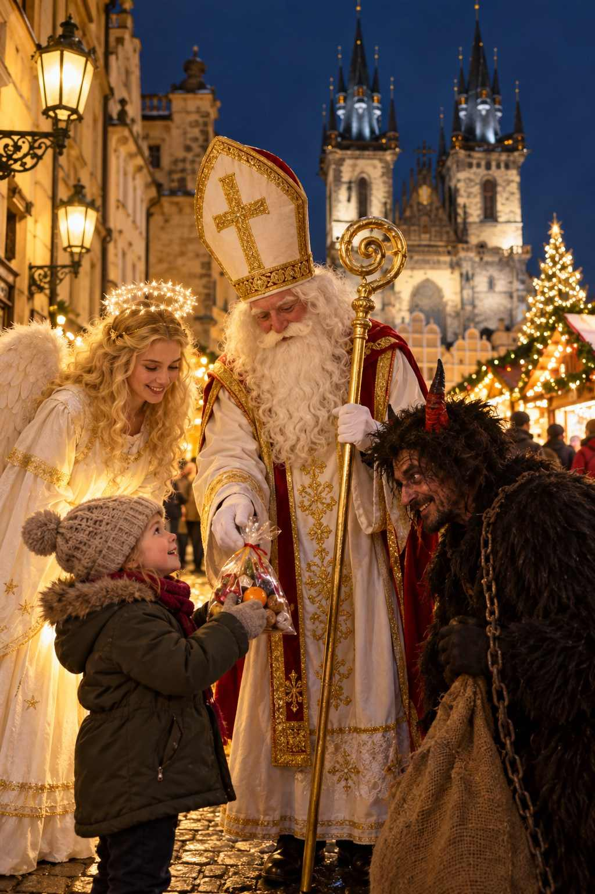

Beyond Prague
- Český Krumlov: This UNESCO-listed town in South Bohemia, with a dramatic castle perched above a loop of the river Vltava, hosts a lovely Christmas market in its main square. It is about three hours from Prague by bus, or can be combined with a trip to Salzburg or Linz. Stay overnight to see it lit up and empty of day-trippers.
- Brno: The Czech Republic's second city has several well-regarded, great-value markets, especially on Freedom Square (Náměstí Svobody) and Cabbage Market (Zelný trh).
- Kutná Hora: An easy day trip from Prague, with the spectacular Gothic Saint Barbara's Cathedral and the famous bone chapel of Sedlec, plus a small Advent market.

Budapest: The Pearl of the Danube
Budapest, straddling the Danube, is one of Europe's most romantic and spectacular capitals. At Christmas, its grand boulevards and bridges are strung with lights, and its markets offer hearty Hungarian food, excellent crafts, and a warm welcome.

Vörösmarty Square Christmas Fair
Budapest's oldest and best-known Christmas market is on Vörösmarty tér, at the start of the elegant Váci utca shopping street. It is known for its high-quality handcrafts, as each stall is selected by a jury. Look for embroidered linens, leather goods, felt, ceramics, hand-painted Easter eggs, woodcarvings, and wonderful Hungarian folk art. The façade of the famous Gerbeaud café and patisserie, one of the grandest coffeehouses in Europe, is often transformed into a giant Advent calendar.

Advent Feast at the Basilica
In the square before Saint Stephen's Basilica, this market has won international awards and is known for its festive atmosphere and spectacular 3D light show, projected onto the façade of the Basilica several times each evening. A small ice rink circles the Christmas tree in the middle of the square.
MARKET AT A GLANCE
Budapest Christmas Markets
Dates | Expected mid-November 2026 – January 1, 2027 (not confirmed at the time of writing; a new organizer may change the format)
Hours | Typically Sun–Thu 11:00–21:00; Fri–Sat 11:00–22:00; shorter hours December 24–26; late opening on New Year's Eve
Location | Vörösmarty Square and St. Stephen's Basilica
Payment | In recent seasons, the Vörösmarty fair has been card-only
Currency | Hungarian forint (HUF)
Best for | Crafts, hearty food, light shows, combining with thermal baths

What to Eat and Drink in Budapest
- Forralt bor: Hungarian mulled wine.
- Kürtőskalács: The original chimney cake, from Transylvania.
- Lángos: Deep-fried dough with garlic, sour cream, and cheese.
- Töltött káposzta: Stuffed cabbage rolls, the classic Hungarian Christmas dish.
- Goulash: Served in a hollowed-out bread bowl.
- Beigli: A rolled pastry filled with poppy seed or walnuts.
- Kolbász: Paprika-spiced Hungarian sausage.
- Pálinka: Potent fruit brandy, often made from apricots, plums, or pears. Sip carefully!
€ BUDGET NOTE
Budapest's central Christmas markets have become more expensive in recent years, and some visitors find prices at Vörösmarty and the Basilica high for Hungary. For better value, visit smaller neighborhood markets or eat a sit-down meal at a local restaurant.

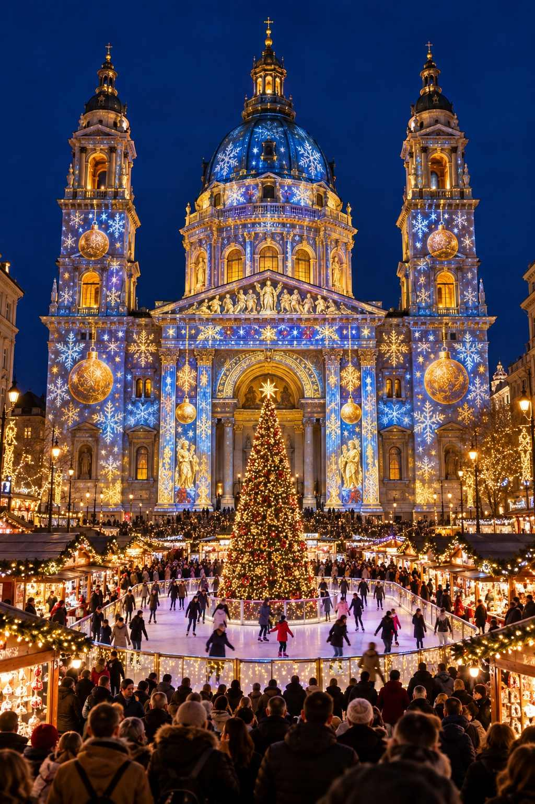

Beyond the Markets in Budapest
- Thermal baths: Soaking in the steaming outdoor pools of the Széchenyi Baths on a cold winter evening, with snow on the ground, is one of Budapest's great experiences. The Gellért Baths, famous for their Art Nouveau interior, have been closed for renovation, so check before visiting; the Rudas Baths and Lukács Baths are other excellent choices.
- The Christmas Tram: A historic tram decorated with thousands of lights runs along the Danube during Advent, a delightful sight whether you ride it or not.
- Danube River cruise: An evening cruise past the illuminated Parliament, Chain Bridge, and Buda Castle is magical.
- Buda Castle and Fisherman's Bastion: Stunning views over the city, especially at dusk.
- The Great Market Hall: A beautiful nineteenth-century covered market for paprika, salami, and souvenirs.
★ DON'T MISS
Take an evening soak at the Széchenyi Baths. Relaxing in warm thermal water as steam rises into the frosty air, surrounded by neo-baroque yellow buildings, is a wonderful way to rest your feet after a day of market-hopping.

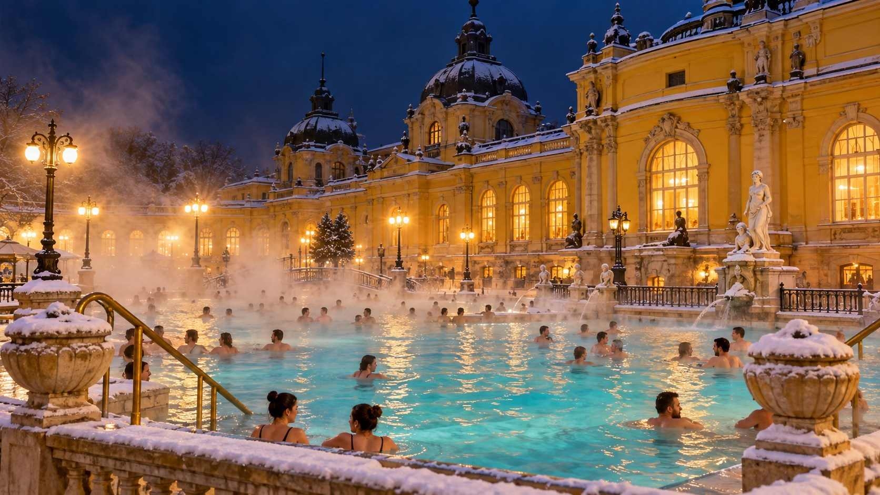

CHAPTER 10

Belgium & the Netherlands: Canals, Caves and Chocolate
— ❄ ✦ ❄ —
Medieval guildhalls, markets deep underground, a Dickens village come to life, and the sweetest treats in Europe.
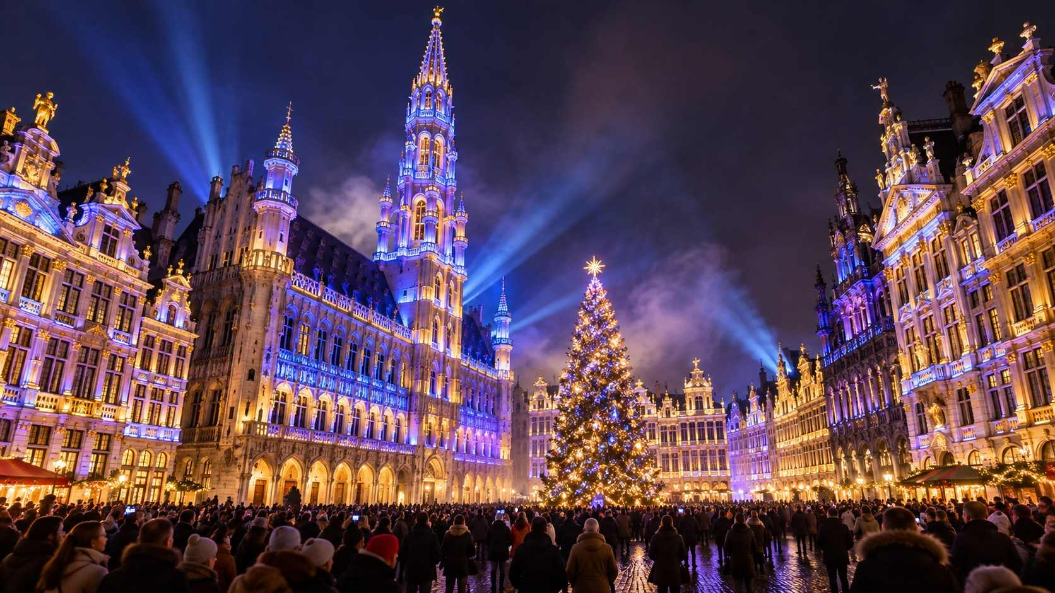

Belgium and the Netherlands are small countries with big Christmas personalities. In just a few days, you can see some of the most beautiful squares in Europe, shop at a market held deep inside ancient caves, and eat your fill of waffles, chocolate, and warm doughnuts. Distances are short, and trains are frequent, making it easy to combine the region with Cologne, Aachen, Paris, or London.

Belgium

Brussels: Winter Wonders
The Belgian capital's festive season is called Winter Wonders (Plaisirs d'Hiver in French, Winterpret in Dutch), and it spreads across the city center. More than two hundred chalets line the streets from the Bourse (the old stock exchange) to the Place Sainte-Catherine and the Marché aux Poissons (Fish Market), where a Ferris wheel offers views over the rooftops.
The undoubted highlight is the Grand-Place, one of the most beautiful squares in the world, where a huge Christmas tree and a life-size nativity scene are joined each evening by a spectacular sound-and-light show projected onto the gilded guildhalls and the Gothic Town Hall.
MARKET AT A GLANCE
Brussels Winter Wonders
Dates | Expected late November 2026 – early January 2027
Hours | Typically 12:00–22:00
Location | Grand-Place, Bourse, Place Sainte-Catherine, Marché aux Poissons
Getting there | Eurostar from London (about 2 hr); Eurostar from Paris (about 1 hr 25 min), Cologne, and Amsterdam
Best for | Grand architecture, chocolate, combining with Bruges and Ghent

✦ INSIDER TIP
Buy your chocolate from the city's great chocolatiers around the Grand-Place and the elegant Galeries Royales Saint-Hubert, one of Europe's oldest covered shopping arcades. Tasting Belgian pralines while listening to carols echo through the glass-roofed gallery is a treat in itself.

Bruges: The Medieval Jewel
Bruges, with its canals, cobbled lanes, and Gothic brick architecture, is one of the best-preserved medieval cities in Europe and a dream at Christmas. Its markets fill the Markt, the main square beneath the tall Belfry tower, and the smaller Simon Stevinplein. The whole city center glows with lights, and in recent years the Bruges Winter Glow has lit up the Minnewater park (the "Lake of Love") with a trail of light installations.
Take a horse-drawn carriage ride, climb the Belfry's 366 steps for a view over the red roofs, and warm up with a Belgian beer in a cozy tavern.
MARKET AT A GLANCE
Bruges Christmas Market
Dates | Expected late November 2026 – early January 2027
Hours | Typically 11:00–22:00
Location | Markt and Simon Stevinplein
Getting there | Trains from Brussels (about 1 hr) and Ghent (about 25 min)
Best for | Romance, canal scenery, Belgian beer

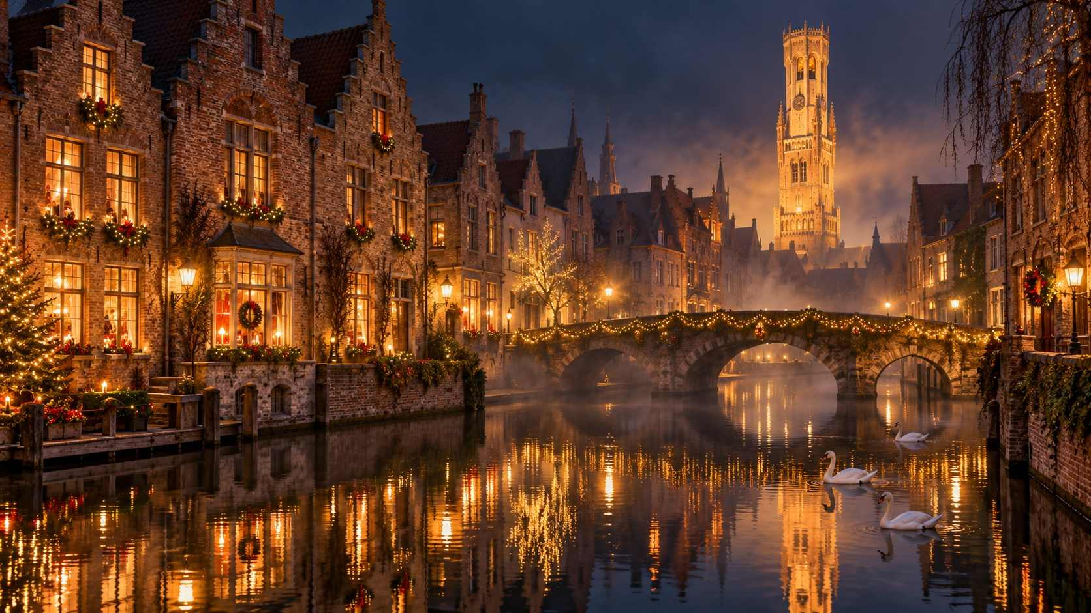

Ghent
Ghent is Bruges's livelier, less touristy neighbor, a university city with a stunning medieval center. Its Christmas market fills the streets around Saint Bavo's Cathedral (home of the famous Ghent Altarpiece by the van Eyck brothers) and the Korenmarkt, with around a hundred and fifty chalets. The medieval Graslei and Korenlei quays along the river are beautiful when lit up at night.

Liège: Belgium's Oldest Village de Noël
In French-speaking Wallonia, Liège hosts Belgium's oldest and one of its largest Christmas markets, the Village de Noël, with around two hundred chalets across the Place Saint-Lambert and Place du Marché. Taste the real Liège waffle, with its caramelized pearl sugar, and warming péket, the local juniper spirit, served in flavors from apple to speculoos.

Durbuy
Durbuy in the Ardennes, which calls itself "the smallest town in the world," holds a charming Christmas market in its medieval lanes, with a festive trail and illuminated topiary garden.

The Netherlands

Valkenburg: Christmas Underground
In the hilly southern province of Limburg, the small town of Valkenburg hosts one of the most unusual Christmas markets in Europe: markets held deep inside ancient marlstone caves. The Gemeentegrot (Municipal Cave), once used by the Romans and later as a wartime shelter, and the Fluweelengrot (Velvet Cave), with its passages beneath a ruined castle, are filled with stalls, lights, and carved sculptures. The caves remain at a constant, comfortable temperature, so you can shop in comfort whatever the weather outside.
On selected evenings, Valkenburg hosts an illuminated Christmas parade through the town, and the whole village is decorated as a "Christmas Town."
MARKET AT A GLANCE
Valkenburg Cave Christmas Markets
Dates | Expected mid-November – December 23, 2026
Hours | Typically 10:00–18:00 or later on weekends
Tickets | Required for the caves; book online in advance, especially for weekends
Getting there | Trains from Maastricht (about 10 min); close to Aachen and Liège
Best for | Unique setting, rainy days, families

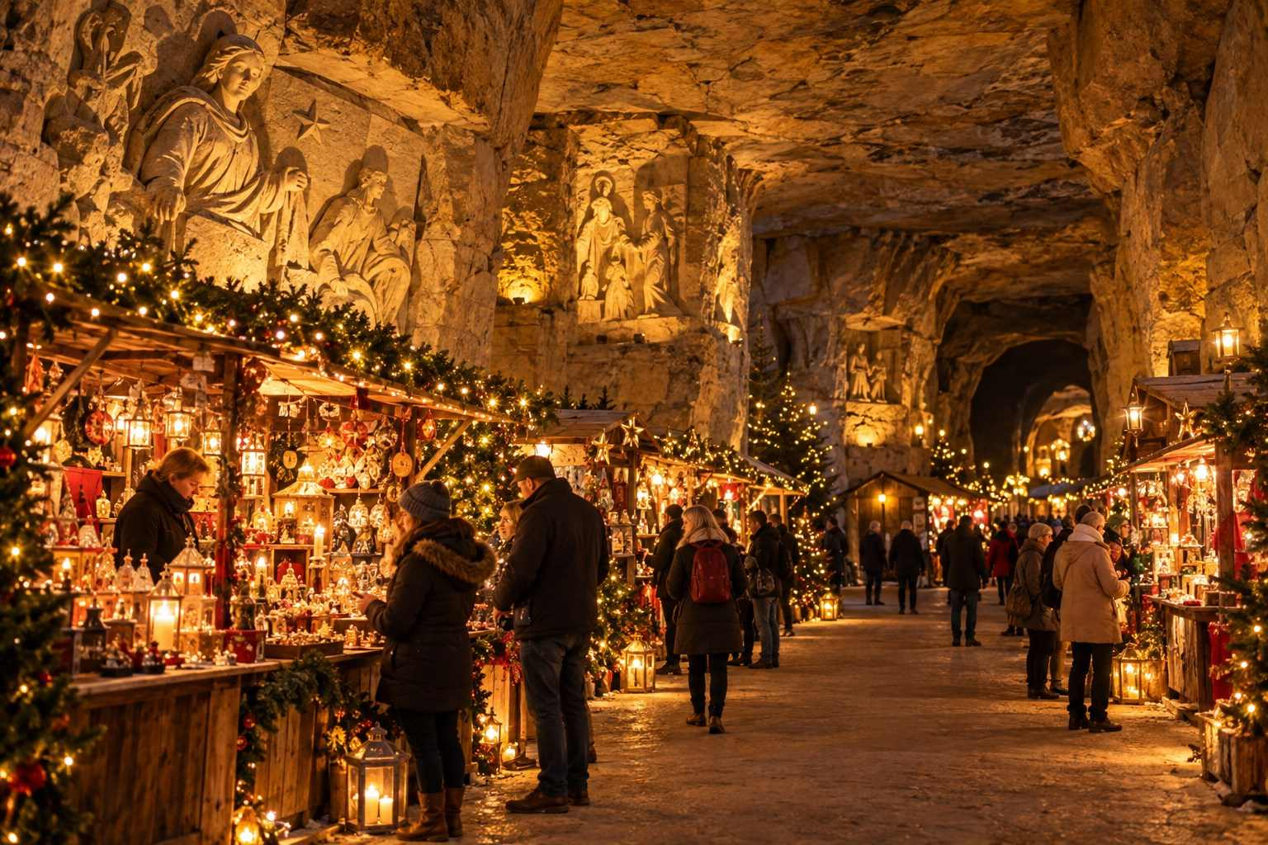

Maastricht: Magisch Maastricht
The elegant city of Maastricht, a short hop from Valkenburg and Aachen, hosts Magisch Maastricht (Magical Maastricht) on the grand Vrijthof square, with a Ferris wheel, an ice rink, and cozy chalets beneath the Basilica of Saint Servatius. Don't miss Dominicanen, a bookshop set inside a thirteenth-century Gothic church, often called one of the most beautiful bookshops in the world.

Dordrecht: The Big Weekend
The historic port city of Dordrecht holds what is often described as the largest Christmas market in the Netherlands, but only for a single long weekend in mid-December. Hundreds of stalls fill the old harbor streets, and the atmosphere is festive and friendly.

Deventer Dickens Festival
On one weekend in mid-December, the old town of Deventer transforms into the world of Charles Dickens. Hundreds of costumed characters, from Scrooge and Tiny Tim to Oliver Twist, chimney sweeps, carolers, and Victorian gentry, fill the lanes around the medieval Bergkerk. It is free, and hugely popular, so arrive early and be patient with the queues.
★ DON'T MISS
If you are in the Netherlands in mid-December, the Deventer Dickens Festival is unlike anything else in Europe. Check the festival's official website for the exact dates, which are typically announced well in advance.

Amsterdam: Lights on the Water
Amsterdam is not a traditional Christmas market city, though you will find festive markets at the Museumplein and other spots in the city. Its real highlight is the Amsterdam Light Festival, held from late November into January, when artworks of light are installed along the canals. The best way to see them is on an evening canal cruise.

Dutch Traditions
In the Netherlands, the main gift-giving day for children is not Christmas but Sinterklaas, on the evening of December 5 (Pakjesavond, "present evening"). Sinterklaas arrives from Spain by steamboat in mid-November and travels on a white horse. Try pepernoten and kruidnoten (small spiced cookies), speculaas (spiced biscuits), chocolate letters, and oliebollen, deep-fried doughnut balls dusted with powdered sugar, sold from stalls throughout the winter, especially around New Year's Eve.
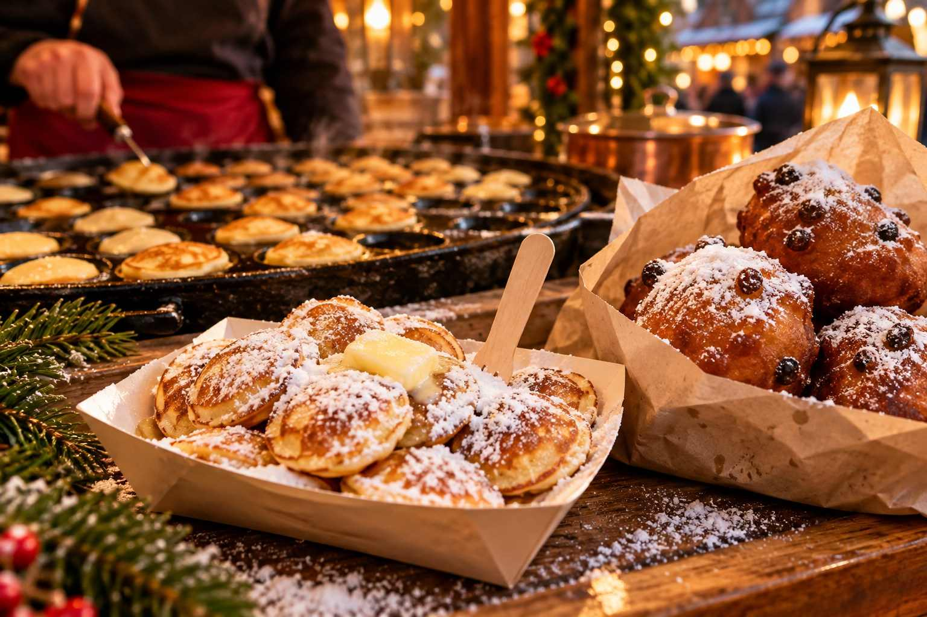

CHAPTER 11

Scandinavia & the Baltics: Hygge, Lucia and the First Christmas Tree
— ❄ ✦ ❄ —
Candlelit courtyards, glögg by the fire, Santa's official hometown, and medieval squares on the Baltic Sea.
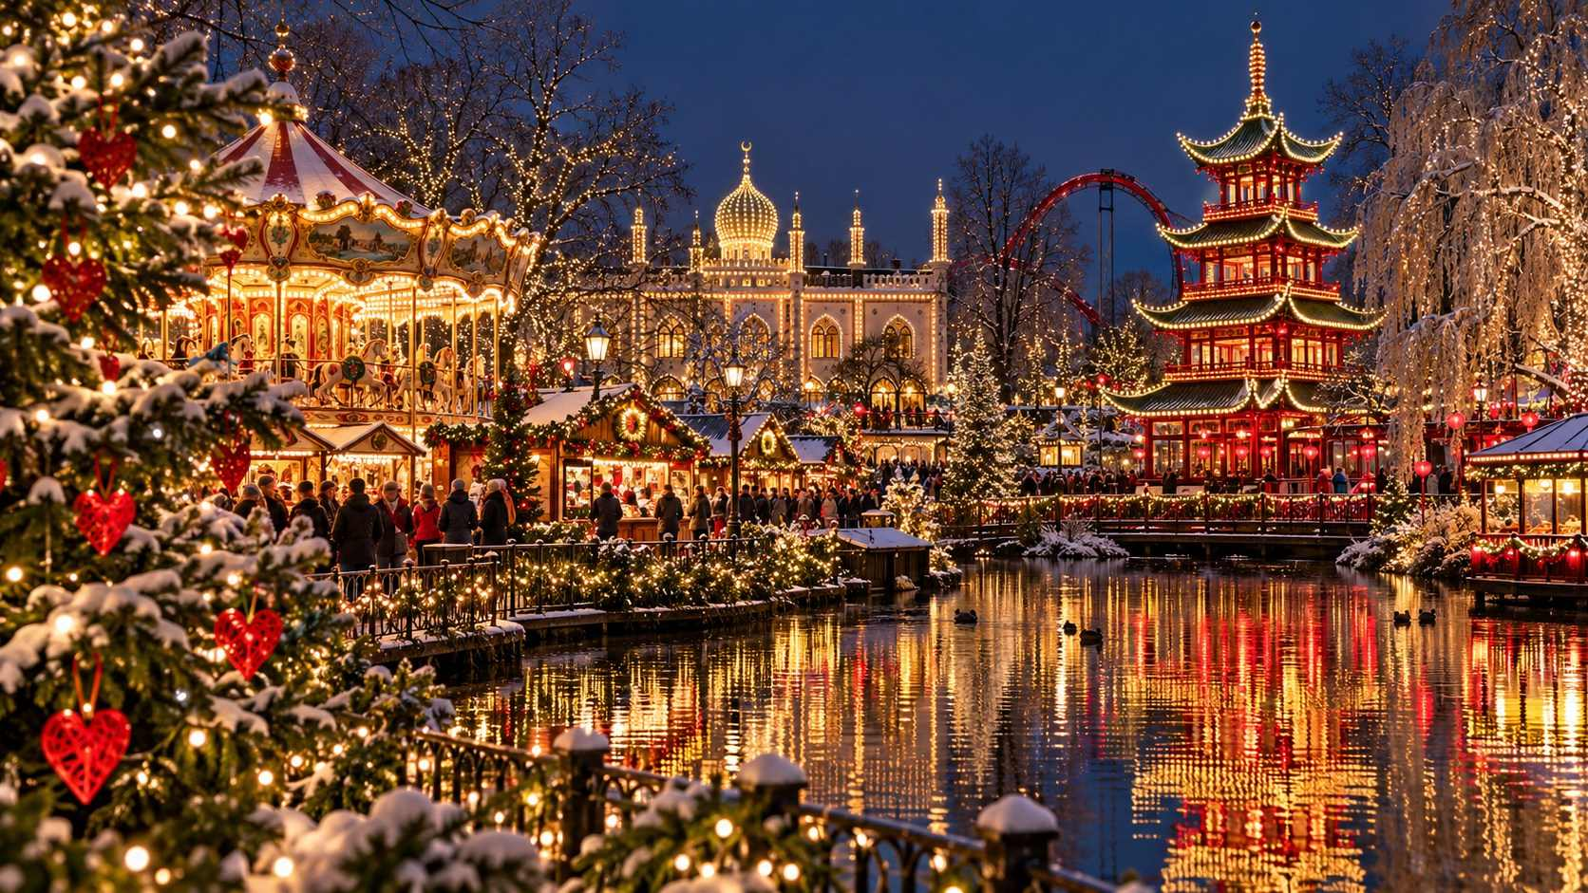

The Nordic countries bring their own gentle magic to Christmas. Here, where winter days are at their shortest and darkest, the season is all about light, warmth, and togetherness. The Danes call it hygge, the cozy feeling of candles, blankets, good food, and good company. The Swedes celebrate Saint Lucia with processions of light. And across the Baltic Sea, the medieval cities of Tallinn and Riga each claim to be the home of the very first Christmas tree.
Prices in Scandinavia are high, and daylight is short (as little as six hours in Stockholm and even less further north), but the atmosphere is uniquely warm and welcoming.

Denmark: Copenhagen

Tivoli Gardens
The historic Tivoli Gardens, one of the oldest amusement parks in the world (opened in 1843), is transformed each winter into a Christmas wonderland. Hundreds of thousands of lights twinkle in the trees, the lake glows, and wooden stalls sell Danish crafts, glögg, and æbleskiver, round pancake puffs served with jam and powdered sugar. Many of the rides stay open, and the Nordic-style decorations are enchanting. The park has an entrance fee, with ride tickets extra.
MARKET AT A GLANCE
Tivoli Christmas
Dates | November 13, 2026 – January 3, 2027 (as published)
Hours | Typically 11:00–22:00; later on weekends
Admission | Entrance ticket required (rides extra); buy online in advance
Location | Opposite Copenhagen Central Station
Best for | Families, romance, Nordic Christmas magic

Nyhavn
The famous seventeenth-century harbor of Nyhavn, with its brightly painted townhouses and wooden sailing ships, hosts a small Christmas market along the quay. Once darkness falls, around 3:30 pm in December, it becomes one of the most photogenic spots in Europe.
MARKET AT A GLANCE
Nyhavn Christmas Market
Dates | November 14 – December 20, 2026 (as published)
Hours | Typically Mon–Wed 11:00–19:00; Thu 11:00–20:00; Fri–Sat 11:00–21:00; Sun 12:00–19:00
Admission | Free
Best for | Photographs, harbor atmosphere

✦ INSIDER TIP
Cross to the quieter side of the canal after dark to photograph Nyhavn's colorful houses reflected in the water. Then warm up with glögg and æbleskiver in one of the cozy candlelit cafés.

More in Copenhagen
- Højbro Plads and Kongens Nytorv: Smaller city-center markets.
- Royal Copenhagen and Illums Bolighus: Beautiful Danish design shops for Christmas plates, ornaments, and gifts.
- Hotel windows and Strøget: Copenhagen's main pedestrian shopping street is beautifully lit.
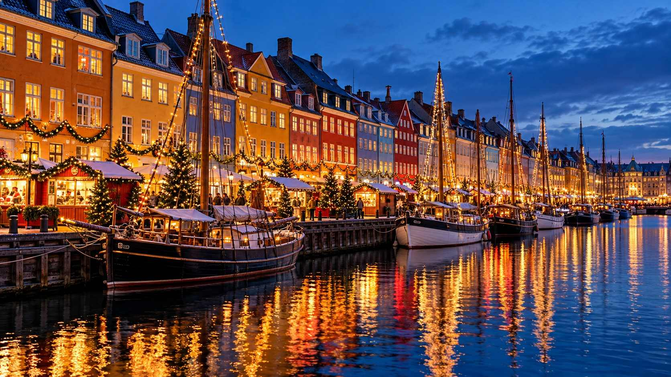

Sweden: Stockholm and Gothenburg

Stockholm: Gamla Stan and Skansen
Stockholm's most famous Christmas market is on Stortorget, the small, cobbled main square of the old town (Gamla Stan), surrounded by colorful merchant houses. The red stalls sell Swedish handicrafts, smoked sausages, reindeer meat, cheese, saffron buns, and glögg. It is small, cozy, and utterly charming.
On the island of Djurgården, the open-air museum Skansen has held a Christmas market since 1903. Held on Advent weekends, it is set among historic farmhouses and cottages, with folk dancing around the tree, traditional crafts, and demonstrations of old Swedish Christmas customs. It is a wonderful place to experience a traditional Swedish Christmas.

Saint Lucia's Day
On December 13 (a Sunday in 2026), Sweden celebrates Lucia. Before dawn and throughout the day, processions of girls and boys in white gowns, with a Lucia at the head wearing a crown of candles, sing traditional songs in churches, schools, offices, and concert halls. Concerts in Stockholm's great churches, such as the Storkyrkan in Gamla Stan, and at Uppsala Cathedral a short train ride away, are especially beautiful. Taste lussekatter, S-shaped saffron buns with raisins.
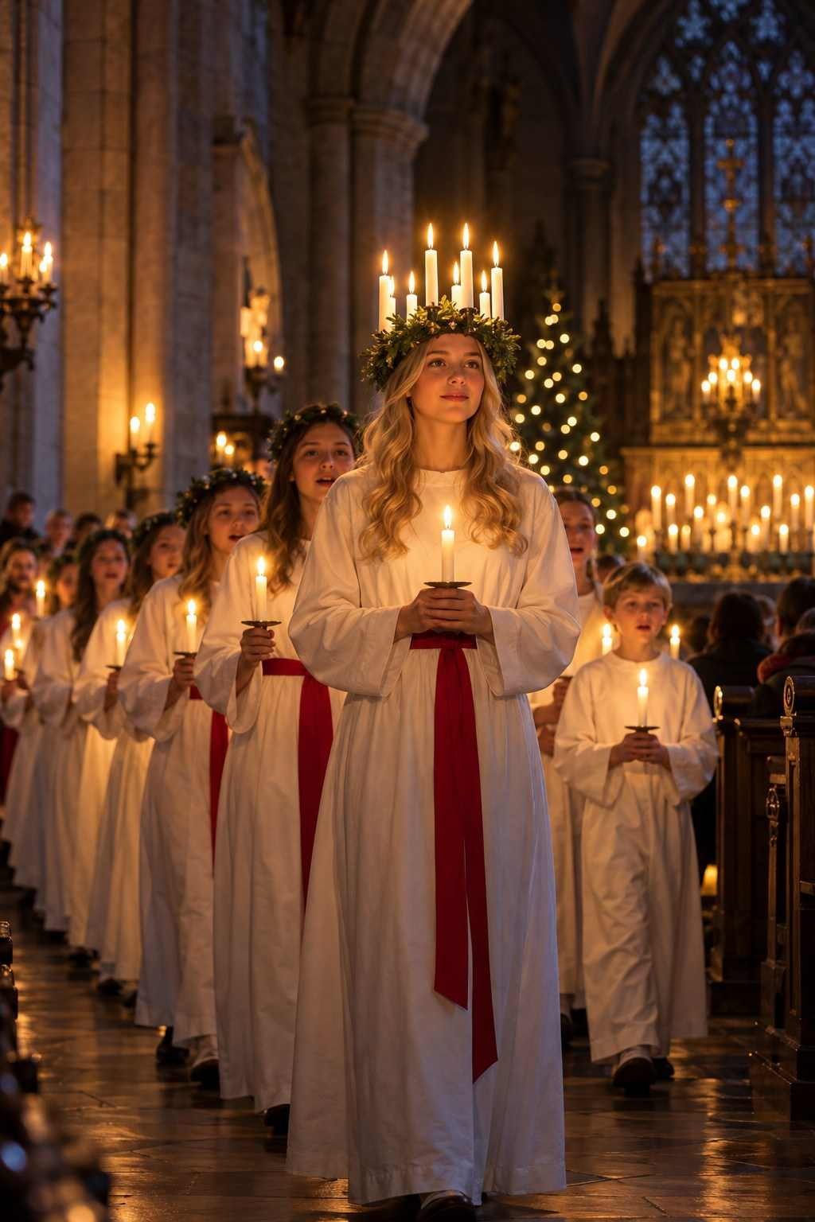

Gothenburg: Liseberg
Sweden's second city is home to Liseberg, Scandinavia's largest amusement park, which hosts one of the largest Christmas markets in the Nordic countries. Millions of lights, an ice-skating rink, reindeer, and traditional food make it a favorite for families.

Norway: Oslo
Oslo's Christmas Winter Wonderland at Spikersuppa, on the main boulevard Karl Johans gate, features an ice rink, a Ferris wheel, and stalls with Norwegian crafts. The Norsk Folkemuseum hosts a traditional Christmas fair on Advent weekends in its historic farm buildings.

Finland: Helsinki and Lapland

Helsinki: Saint Thomas Christmas Market
On the grand Senate Square, beneath the white neoclassical Helsinki Cathedral, the Saint Thomas Christmas Market (Tuomaan markkinat) has been held for decades. It features around a hundred stalls selling Finnish crafts, woolens, candles, and delicacies, and a carousel for children. It typically runs from early December to just before Christmas.

Rovaniemi: Santa's Official Hometown
For the ultimate Christmas adventure, travel north to Rovaniemi, the capital of Finnish Lapland, right on the Arctic Circle. The Santa Claus Village is open year-round, but December is its peak season. You can meet Santa in his office, send cards from the Santa Claus Main Post Office with a special Arctic Circle postmark, cross the Arctic Circle line, ride reindeer and husky sleighs, and, with luck, see the Northern Lights.
ℹ GOOD TO KNOW
Rovaniemi in December is very cold (often –10°C to –25°C, or 14°F to –13°F) and has only a few hours of twilight each day. Dress in serious winter gear, and book accommodations, activities, and flights well in advance, as December is extremely busy.

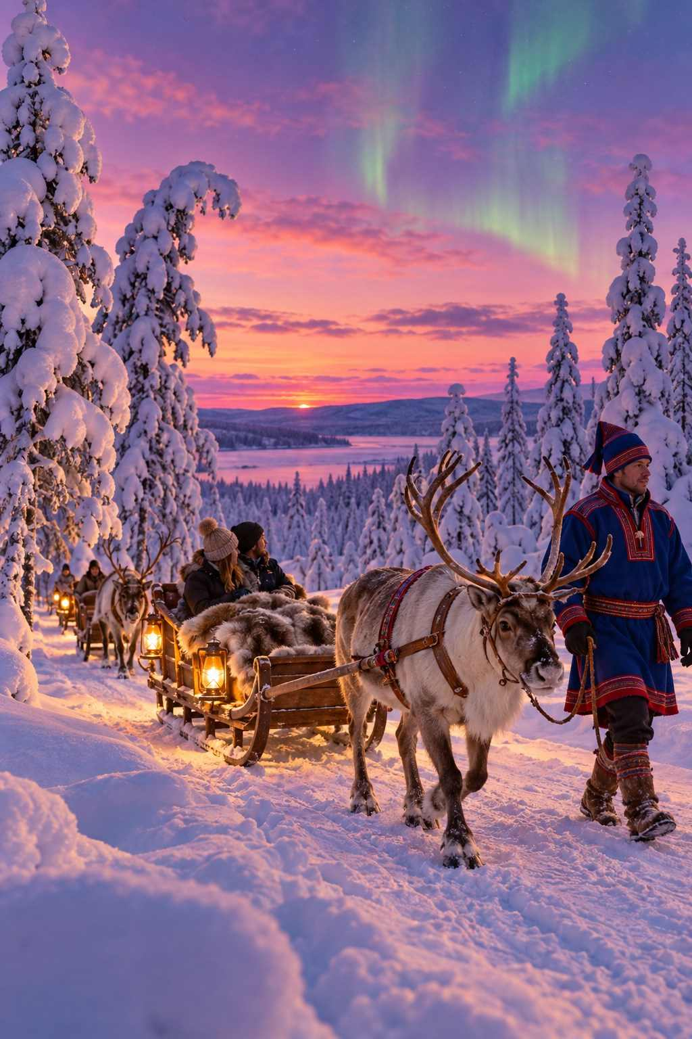

The Baltics: Tallinn and Riga
The three Baltic capitals, Tallinn, Riga, and Vilnius, have become some of Europe's favorite Christmas destinations, thanks to their beautiful medieval old towns, reasonable prices, and snowy winters.

Tallinn, Estonia
Tallinn's Christmas market fills the Town Hall Square (Raekoja plats) in the heart of its perfectly preserved medieval old town, a UNESCO World Heritage Site. The Gothic Town Hall, with its slender spire, forms the backdrop, and a giant tree stands in the center. Tallinn claims that the first public Christmas tree was erected here in 1441 by the Brotherhood of Blackheads, a guild of unmarried merchants, who danced around it and then set it on fire.
The market is friendly and reasonably priced, with Estonian crafts (woolen socks, mittens, wooden toys, and juniper-wood items), black bread, sauerkraut with sausages, gingerbread, and hot drinks, including warm black-currant juice. Santa often has a small hut where children can visit him.
MARKET AT A GLANCE
Tallinn Christmas Market
Dates | Expected late November 2026 – early January 2027
Hours | Typically 10:00–19:00 or 20:00
Location | Town Hall Square, Old Town
Getting there | Flights to Tallinn; ferries from Helsinki (about 2 hours)
Best for | Medieval charm, snow, good value, combining with Helsinki

Riga, Latvia
Riga also claims the world's first decorated Christmas tree, in 1510, and a plaque on the Town Hall Square marks the spot. Riga's main Christmas market is on the Dome Square (Doma laukums), beside the Riga Cathedral, with Latvian handicrafts, knitted mittens with traditional patterns, amber jewelry, honey, and hearty food like grey peas with bacon. Warm up with a shot of Riga Black Balsam, a dark, potent herbal liqueur, often mixed with hot black-currant juice.
Riga's Art Nouveau district is one of the finest in Europe and makes a wonderful daytime excursion.

Vilnius, Lithuania
Vilnius is famous for its spectacular, often avant-garde Christmas tree on Cathedral Square, which has been ranked among the most beautiful in Europe, and for a Christmas market around it.
€ BUDGET NOTE
The Baltic capitals are some of the best-value Christmas destinations in northern Europe. Budget airlines connect them with many European cities, and it is easy to travel between Tallinn, Riga, and Vilnius by bus.

CHAPTER 12

Central & Eastern Europe: Hidden Treasures
— ❄ ✦ ❄ —
Kraków's glittering nativity scenes, Zagreb's award-winning Advent, and some of the best-value markets in Europe.
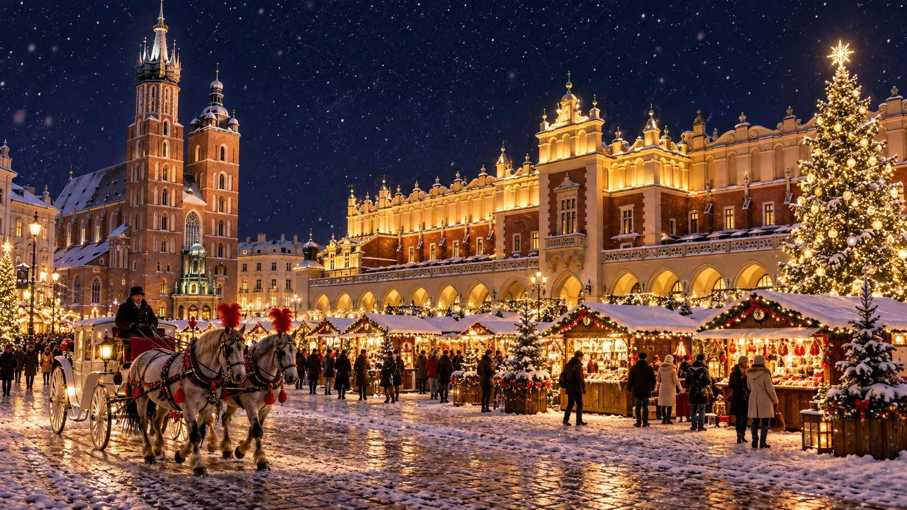

Beyond the famous markets of Germany and Austria lies a world of Christmas treasures that many travelers have yet to discover. The cities of Poland, Slovakia, Slovenia, Croatia, and Romania offer beautiful settings, rich traditions, warm hospitality, and prices that can be half those of Western Europe. If you have visited the classic markets before, or simply want to explore something different, this chapter is for you.

Poland

Kraków
Kraków's Christmas market fills the Main Market Square (Rynek Główny), the largest medieval town square in Europe. It is surrounded by the Renaissance Cloth Hall, the tall Town Hall Tower, and the magnificent Gothic Saint Mary's Basilica, from whose tallest tower a trumpeter plays the Hejnał every hour, stopping abruptly mid-melody in memory of a medieval trumpeter said to have been struck by an arrow.
The market offers Polish crafts (hand-painted glass ornaments, amber, wooden toys, lace, and ceramics), and delicious food: pierogi, grilled oscypek cheese with cranberry sauce, kiełbasa sausages, bigos hunter's stew, and grzaniec, Polish mulled wine.

Kraków's Szopki: A UNESCO Treasure
Kraków's most extraordinary Christmas tradition is the szopka, a glittering, multi-tiered nativity scene built to resemble the city's architecture, with towers and domes inspired by Saint Mary's Basilica and Wawel Cathedral, all made from colored foil, paper, and wood. The tradition is recognized by UNESCO as Intangible Cultural Heritage.
On the first Thursday of December (expected December 3, 2026), szopka makers bring their creations to the Main Square and display them around the Adam Mickiewicz monument for a competition. The best szopki are then exhibited at the Kraków Museum (in the Krzysztofory Palace) through the winter.
★ DON'T MISS
If you are in Kraków on the first Thursday of December, go to the Main Square in the morning to see the szopki arrive. Then visit the exhibition to admire the winners up close.

MARKET AT A GLANCE
Kraków Christmas Market
Dates | Expected late November 2026 – late December 2026 or early January 2027
Hours | Typically 10:00–21:00 or 22:00
Location | Main Market Square (Rynek Główny)
Currency | Polish złoty (PLN)
Best for | Beautiful setting, szopki, good value

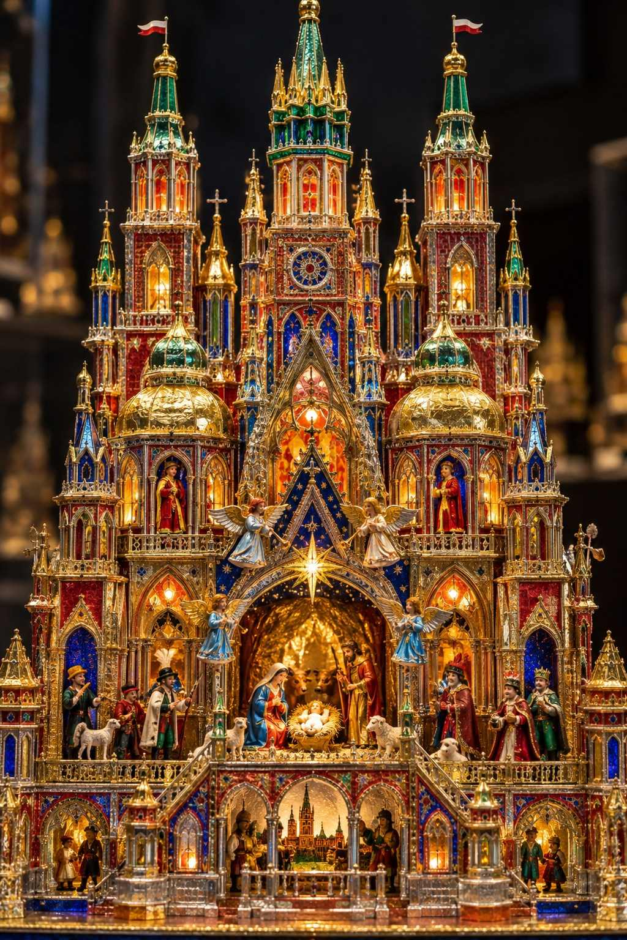

Wrocław
Wrocław's Christmas market, often considered one of Poland's finest, fills the grand Market Square around the Gothic town hall. It is large and lively, with a giant tree, a Ferris wheel, and a fairy-tale section for children. Wrocław is also famous for its hundreds of tiny bronze dwarf statues (krasnale) hidden throughout the city; hunting for them is a delightful activity for all ages, and some dress up for the season.

Gdańsk
On the Baltic coast, Gdańsk hosts a festive market on the Targ Węglowy (Coal Market) square, near the colorful merchant houses of the Long Market. The city is known for its amber, making it an excellent place to buy jewelry.

Toruń and Gingerbread
The medieval city of Toruń, birthplace of Copernicus, is famous for its gingerbread (piernik), made here since the Middle Ages. Visit the Living Museum of Gingerbread to decorate your own.

Slovakia: Bratislava
Just an hour from Vienna by train or boat, the Slovak capital Bratislava has a charming old town with a compact, friendly Christmas market on the Main Square (Hlavné námestie) and neighboring Františkánske Square. Taste lokše (thin potato pancakes filled with duck fat, poppy seeds, or jam), cigánska pečienka (a grilled pork sandwich), roasted chestnuts, medovina (mead), and Slovak mulled wine. Prices are low, the mood is local, and Bratislava Castle glows on the hill above.
✦ INSIDER TIP
Bratislava makes a perfect day trip from Vienna. Trains run frequently, taking about an hour. Spend the afternoon exploring the old town and castle, and the evening at the market before returning.

Slovenia: Ljubljana and Lake Bled

Ljubljana: Festive December
Slovenia's small, green capital celebrates Festive December (Praznični december) with beautiful and imaginative light installations throughout its old town, and Christmas stalls along the banks of the Ljubljanica River, beneath the castle. Walk across the Triple Bridge, visit the Art Nouveau buildings of Prešeren Square, and take the funicular up to Ljubljana Castle for views over the lights. The atmosphere is relaxed, cultured, and delightfully uncrowded.

Lake Bled
Just forty-five minutes from Ljubljana, Lake Bled, with its island church and cliff-top castle, is magical in winter. A small Advent market is held on the lakeshore on weekends, and the island church is sometimes illuminated for the season. Try the famous Bled cream cake (kremšnita).
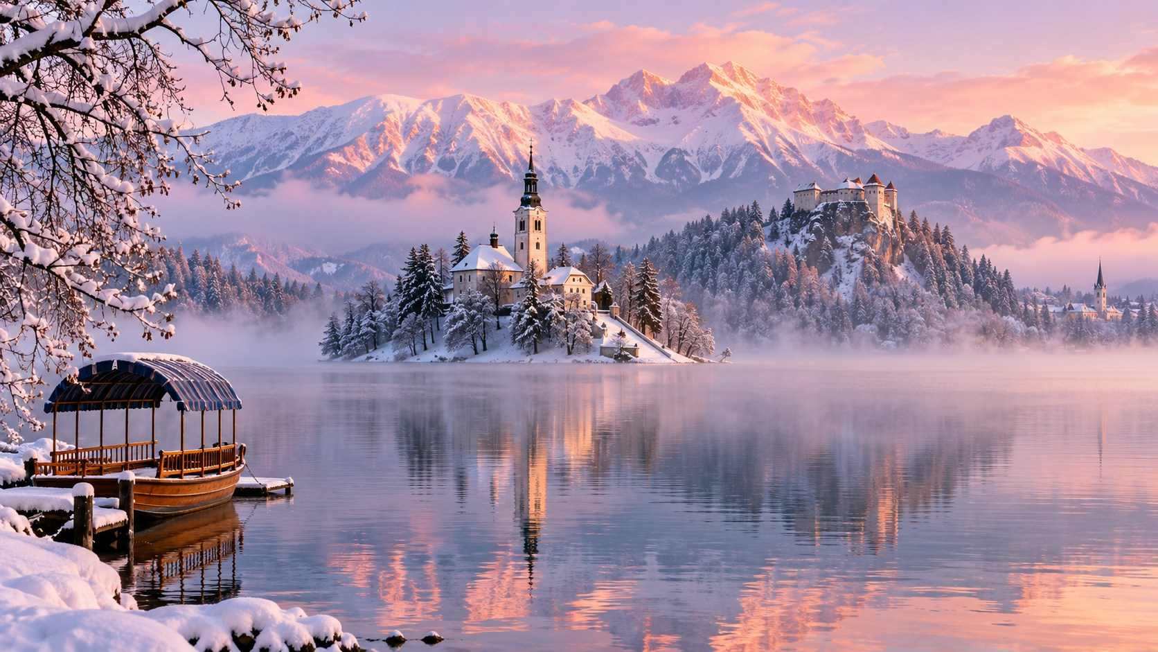

Croatia: Advent in Zagreb
Advent in Zagreb has become one of Europe's most celebrated Christmas events, and the Croatian capital was voted "Best Christmas Market in Europe" in a popular online poll three years running (2016–2018). What makes it special is that the whole city center becomes one big festive celebration, with dozens of locations, each with its own character.
- Ban Jelačić Square: The main square, with a great tree, the Advent wreath, and a lively atmosphere.
- King Tomislav Square: An ice park and skating rink in front of the grand yellow railway station.
- Zrinjevac Park: A romantic park with illuminated trees, a music pavilion, and food stalls.
- The Upper Town: The historic hilltop quarter, with festive lights, the Strossmayer promenade overlooking the city, and outdoor concerts.
The food is excellent: try fritule (small doughnuts), štrukli (cheese pastries), grilled sausages, and kuhano vino (mulled wine).
MARKET AT A GLANCE
Advent in Zagreb
Dates | November 28, 2026 – January 7, 2027 (as published)
Hours | Typically 10:00–20:00 or later at some locations
Location | Throughout the Lower and Upper Town
Currency | Euro
Best for | Festive city-wide atmosphere, food, good value

Romania: Sibiu and Beyond
The Transylvanian city of Sibiu, with its colorful medieval houses with "eyes" (small eyelid-shaped roof windows), hosts one of Eastern Europe's most beautiful Christmas markets in its Great Square (Piața Mare). Modeled on the markets of Austria and Germany, it has a Ferris wheel, an ice rink, and stalls selling Romanian crafts, sweet chimney cakes, and mulled wine. Nearby Brașov, with its Black Church and mountain backdrop, has a lovely market too, and the capital Bucharest hosts a large market in Constitution Square.
€ BUDGET NOTE
The markets of Poland, Slovakia, Croatia, and Romania offer some of the best value in Europe. A mug of mulled wine often costs half of what you would pay in Munich or Zurich, and hotel prices are much lower too.

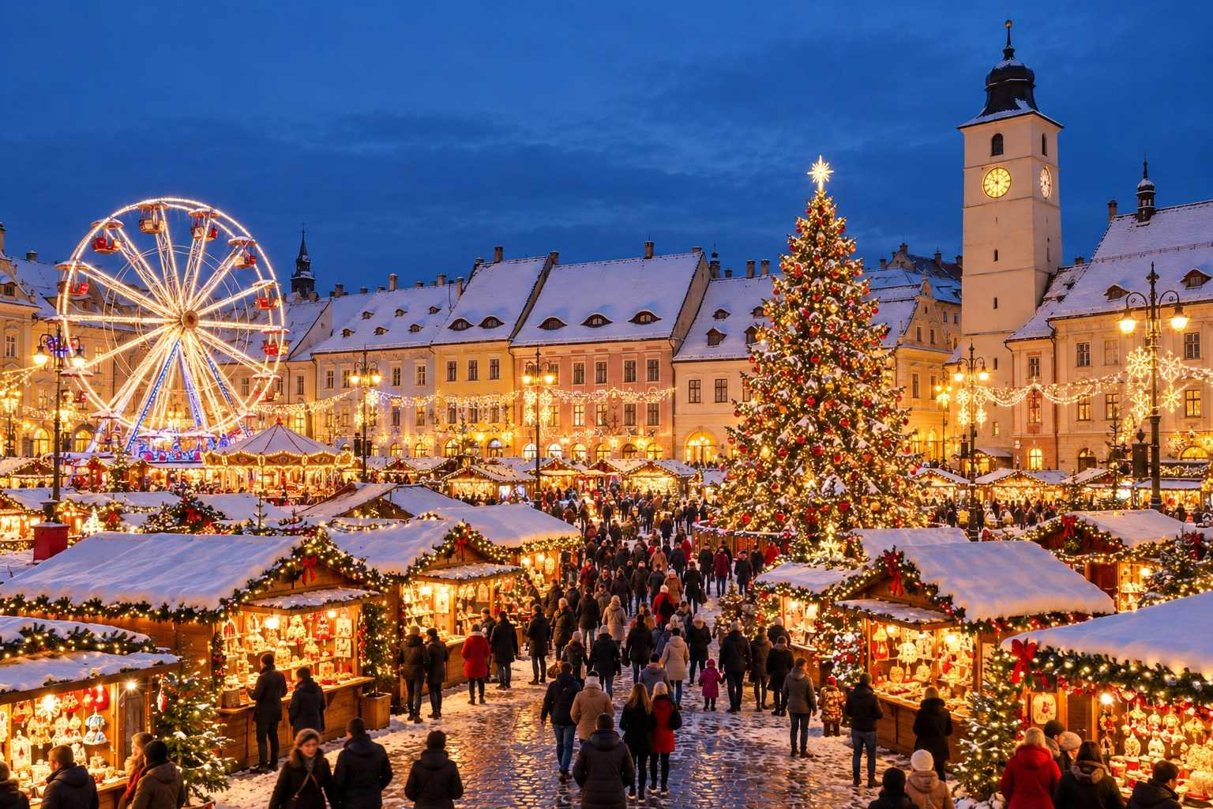

CHAPTER 13

Italy, Spain, Portugal, the UK & Ireland
— ❄ ✦ ❄ —
Alpine markets in the Dolomites, nativity streets in Naples, the Three Kings in Spain, and a very British Christmas.
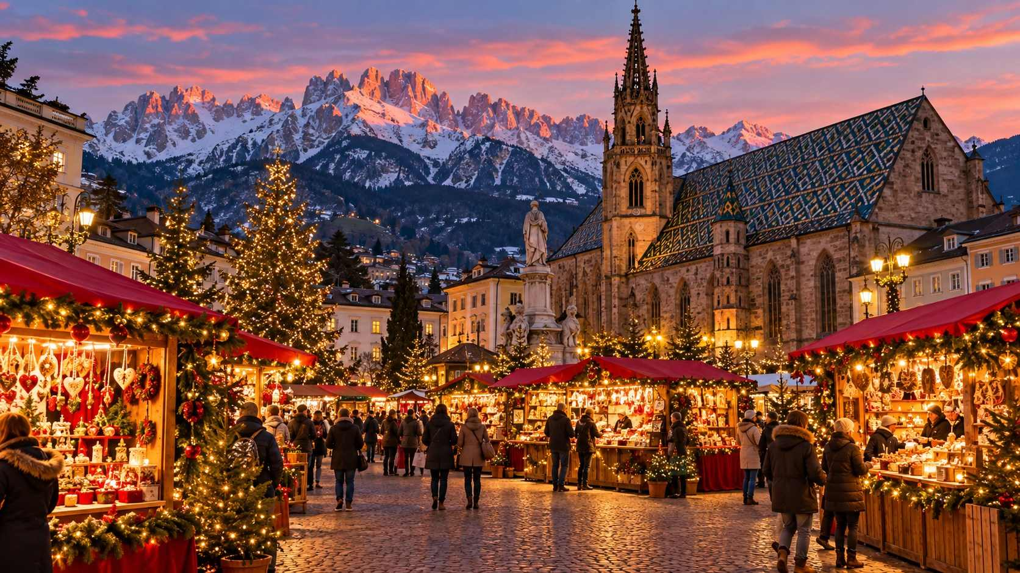

As you travel south and west from the German-speaking heartland, the Christmas market tradition changes shape. In northern Italy's Alpine regions, it looks and feels much like Austria. Further south, the focus shifts to nativity scenes, family gatherings, and the arrival of the Three Kings in January. In Spain and Portugal, you will find festive fairs with a Mediterranean twist. And in Britain and Ireland, the German-style market has been joyfully adopted and blended with local traditions.

Italy

South Tyrol: The Alpine Christmas Markets
The province of South Tyrol (Alto Adige in Italian, Südtirol in German) was part of Austria until 1919, and it remains largely German-speaking. Its Christmas markets, set against the dramatic peaks of the Dolomites, combine Austrian tradition with Italian flair and food. Five towns form the "Original South Tyrol Christmas Markets."
- Bolzano (Bozen): Italy's largest Christmas market fills Waltherplatz with around eighty stalls selling regional crafts, woodcarvings, and specialties. It has a lively Italian atmosphere, a small train that tours the old town, and is open until Epiphany.
- Merano (Meran): In the elegant spa town, the market stretches along the river Passer promenade. Combine it with a visit to the Merano Thermal Baths.
- Bressanone (Brixen): A small, atmospheric market on the cathedral square of this ancient bishop's town, with an evening light show projected onto the Hofburg palace.
- Vipiteno (Sterzing): A charming mountain-town market beneath the medieval Zwölferturm tower.
- Brunico (Bruneck): A cozy market in a town surrounded by skiing country.
Try Zelten (a dense fruit-and-nut bread), speck (smoked ham), Schlutzkrapfen (spinach-and-cheese ravioli), Kaiserschmarrn, and vin brulé.
MARKET AT A GLANCE
South Tyrol Christmas Markets
Dates | Expected late November 2026 – early January 2027 (Bolzano and Merano typically until January 6)
Hours | Typically 10:00–19:00 or 20:00
Getting there | Trains from Munich and Innsbruck via the Brenner Pass, and from Verona
Best for | Alpine scenery, Italian-Austrian food, combining with skiing

Trento
In the neighboring province of Trentino, Trento hosts a lovely market in the Piazza Fiera, beside the medieval city walls. Nearby, the lakeside town of Levico Terme holds a market in the park of the Habsburg villa, and Rovereto has an atmospheric market in its old town.

Naples: The Street of Nativity Scenes
In Naples, Christmas is all about the presepe, the nativity scene. On the narrow Via San Gregorio Armeno, in the heart of the historic center, artisan workshops create handcrafted nativity figures, a tradition going back centuries. The street is crammed with stalls displaying shepherds, angels, market vendors, pizza makers, and entire miniature Neapolitan villages, alongside humorous figures of footballers, politicians, and celebrities. It is crowded, noisy, and wonderful, especially in December.
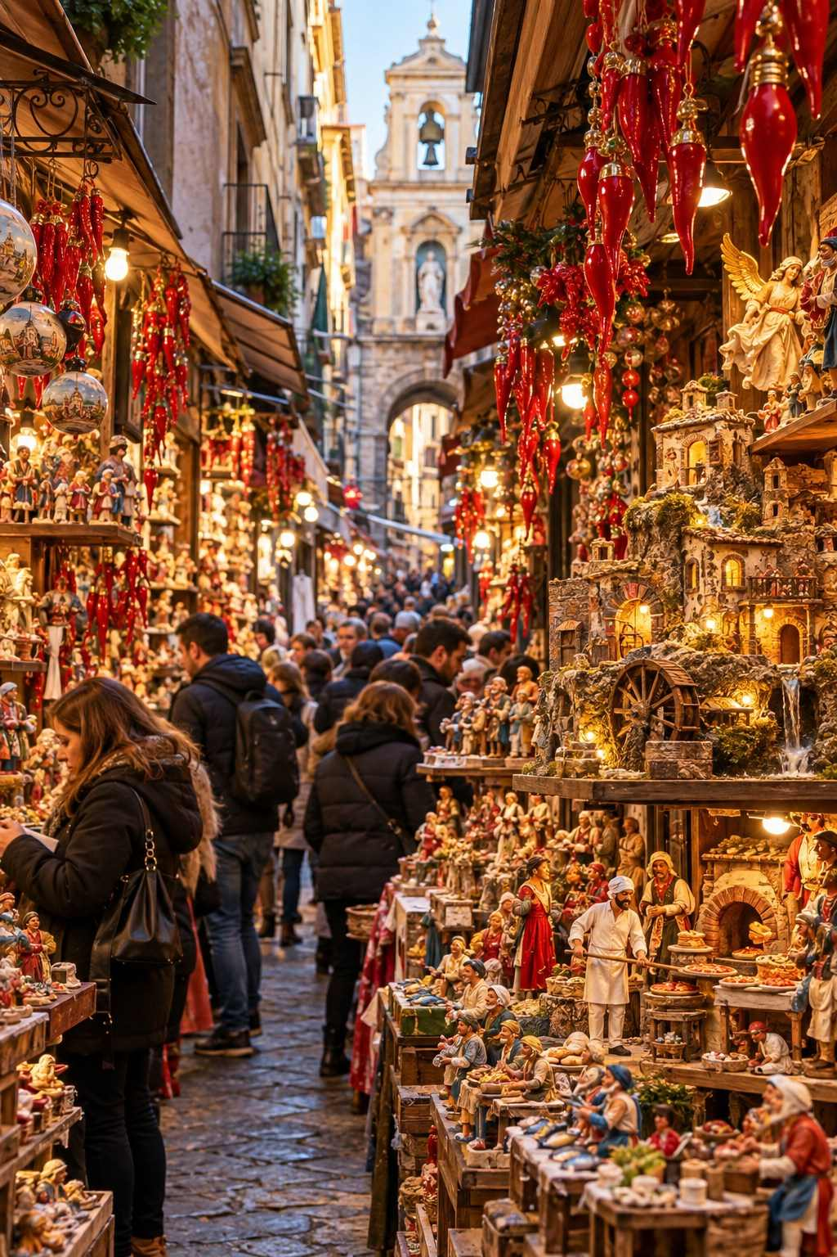

Rome, Milan and Florence
- Rome: The Piazza Navona hosts a festive market with nativity figures, sweets, and a carousel, traditionally running until Epiphany, when the good witch La Befana delivers gifts to Italian children. Visit Saint Peter's Square to see the great tree and life-size nativity scene.
- Milan: The ancient Oh Bej! Oh Bej! fair, held around the feast of Milan's patron saint, Saint Ambrose (December 7), is a lively traditional market near the Castello Sforzesco. Taste panettone, Milan's famous Christmas bread.
- Florence: A German-style Christmas market is held in the Piazza Santa Croce, before the great Franciscan basilica.

Spain

Madrid: Plaza Mayor
Madrid's historic Plaza Mayor hosts a Christmas market that dates back to the nineteenth century. More than a hundred stalls sell nativity figures (belenes), Christmas decorations, and, amusingly, wigs, fake noses, and jokes for the Día de los Santos Inocentes (December 28), the Spanish equivalent of April Fool's Day. Try churros con chocolate at the famous Chocolatería San Ginés nearby.

Barcelona: Fira de Santa Llúcia
Barcelona's Fira de Santa Llúcia, held in front of the Gothic cathedral since 1786, is one of the oldest Christmas fairs in Spain. Its hundreds of stalls sell moss, pine branches, nativity figures, and two very Catalan curiosities:
- The caganer: A small figure of a peasant squatting to relieve himself, traditionally hidden in the nativity scene as a symbol of fertility and good luck. Today, you can buy caganers of celebrities, footballers, and politicians.
- The caga tió: A smiling log with a red hat and a blanket, which children "feed" during Advent. On Christmas Eve or Day, they beat it with sticks while singing a song, and it "poops out" sweets and small gifts.

Spanish Traditions
- El Gordo: Spain's giant Christmas lottery is drawn on December 22, sung aloud by schoolchildren on live television.
- Nochebuena: Christmas Eve dinner is the main family meal.
- The Three Kings: On the evening of January 5, cities across Spain hold spectacular Cabalgatas de Reyes, parades of the Three Kings on floats, throwing sweets to the crowds. Children receive their main gifts on the morning of January 6. Eat a slice of roscón de reyes, a ring-shaped cake with a hidden figurine.
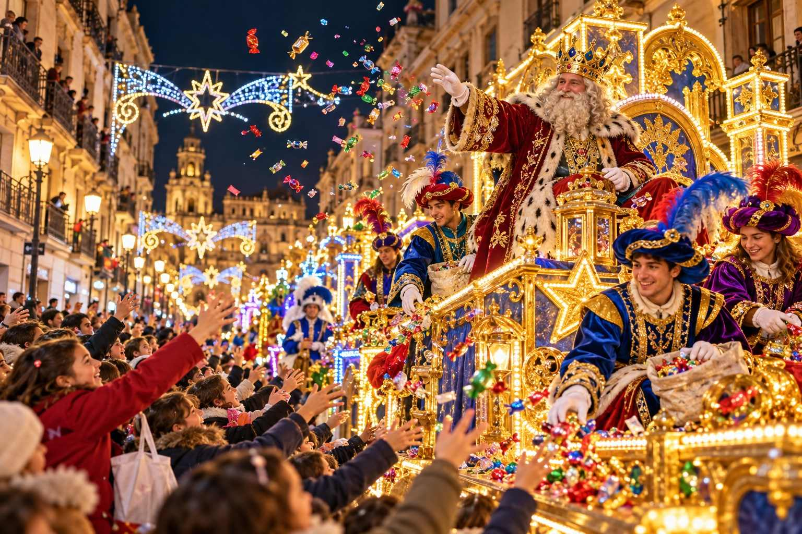

Portugal

Óbidos Vila Natal
The medieval walled town of Óbidos, an hour north of Lisbon, becomes Óbidos Vila Natal (Christmas Village) each year, with festive attractions, an ice rink, a Christmas market, and family entertainment inside its castle walls. Admission is typically charged for the main area. Try ginjinha, a sour-cherry liqueur served in a small chocolate cup.

Lisbon and Porto
Lisbon's Christmas lights sparkle along the elegant Baixa streets and the Praça do Comércio, where a giant tree is usually installed, and Wonderland Lisboa in the Parque Eduardo VII offers a market, an ice rink, and a Ferris wheel. In Porto, the Avenida dos Aliados is beautifully lit. Taste bolo rei, the Portuguese king cake, and pastéis de nata, custard tarts.

The United Kingdom
British cities have embraced Christmas markets with enthusiasm, many inspired directly by German traditions.
- Edinburgh: The Scottish capital's Christmas celebrations, set in the East Princes Street Gardens below the castle, include a market, a Ferris wheel, and rides. Stay on for Hogmanay, one of the world's great New Year's Eve celebrations, with a torchlight procession, a street party, and fireworks over the castle.
- Bath: The Georgian streets around Bath Abbey fill with around two hundred chalets, many selling local crafts. The elegant setting is superb.
- Manchester: One of the UK's largest markets, spread across several city-center locations.
- Birmingham: The Frankfurt Christmas Market, run in partnership with Frankfurt, is often described as the largest authentic German market outside Germany and Austria.
- Winchester: A charming market beside the medieval cathedral, with an ice rink in the Cathedral Close.
- York: The Saint Nicholas Fair fills the medieval streets, and the Shambles, a narrow lane of overhanging timber-framed buildings, is especially magical.
- London: Hyde Park Winter Wonderland is a vast festive funfair with markets, rides, shows, and an ice rink; tickets are required. The Southbank Centre Winter Market along the Thames is a lovely, smaller alternative. Visit the lights on Regent Street, Oxford Street, and Carnaby Street, and the windows of the great department stores.
✦ INSIDER TIP
The UK is not part of the Schengen Area. Travelers visiting the UK from many countries, including the United States and Canada, now need an Electronic Travel Authorisation (ETA), which you apply for online before travel. Check the official UK government website.

Ireland
- Galway: The Continental Christmas Market in Eyre Square is a festive highlight in this lively west-coast city, with a Ferris wheel and plenty of good cheer.
- Belfast (Northern Ireland, UK): The market on the grounds of City Hall has been a festive favorite for years.
- Dublin: The Irish capital is best for its Christmas lights on Grafton Street and Henry Street, its cozy pubs with traditional music, and Christmas concerts in Saint Patrick's and Christ Church cathedrals.
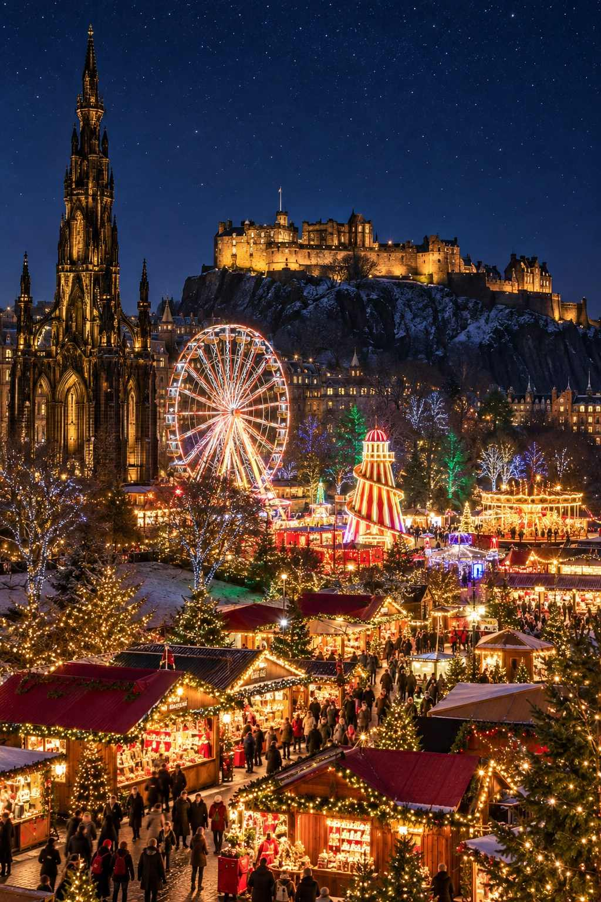

CHAPTER 14

Hidden Gems: 25 Smaller Markets Worth the Detour
— ❄ ✦ ❄ —
Candlelit towns, Christmas forests, wine-cellar markets, and village squares where the locals still outnumber the visitors.
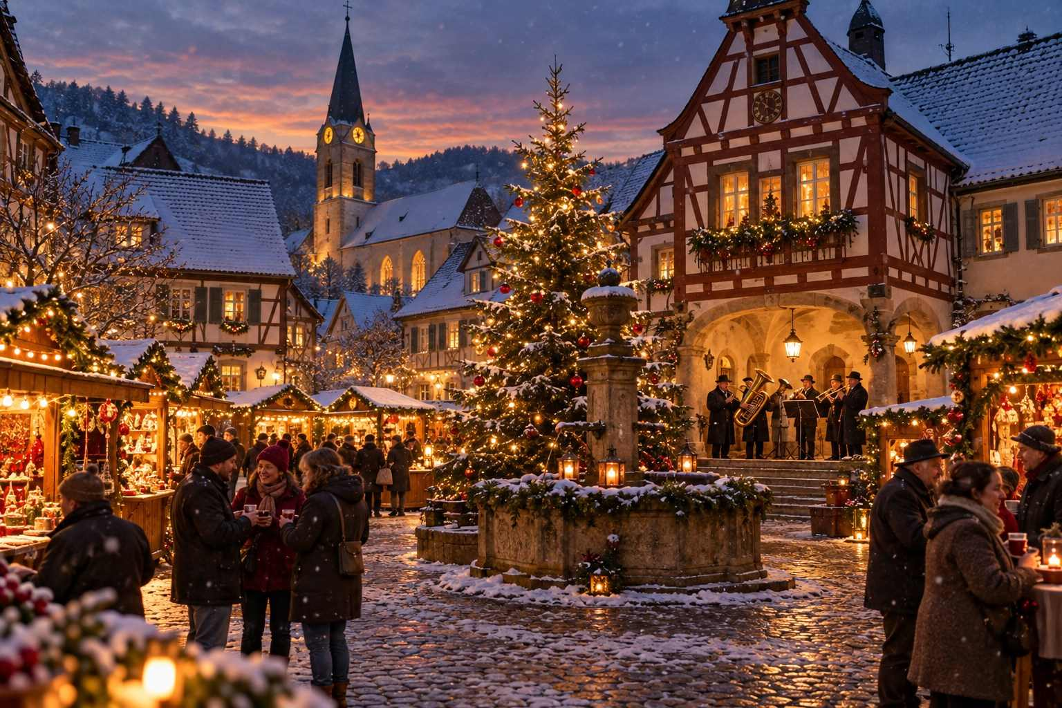

The famous markets of Nuremberg, Vienna, and Strasbourg are famous for good reason, but some of the most memorable Christmas experiences in Europe happen in places you may never have heard of. In a small town, the market is not a tourist attraction; it is the community's living room. The vendors are neighbors, the choir is the local school, and the mulled wine is often made by the fire brigade or the sports club to raise money for a good cause.
This chapter introduces twenty-five smaller markets and festive towns that reward the detour. Many are easy day trips from the big cities, and several can be combined with the itineraries in the next part of this book.
ℹ GOOD TO KNOW
Smaller markets often have shorter seasons and may open only on weekends or for a few days. Dates for 2026 were not published for most of them at the time of writing, so always check the town's official website before you go.

Germany

1. Goslar: The Christmas Forest
In the UNESCO-listed silver-mining town of Goslar, in the Harz Mountains, the market square is transformed into a Weihnachtswald, a Christmas forest. Dozens of real fir trees, each strung with lights, are planted between the stalls, so you wander among glowing evergreens with the half-timbered guild houses all around. The effect after dark is enchanting, and the atmosphere is intimate even on busy evenings.
Getting there: Regional trains from Hanover or Brunswick. Combine with Wernigerode.

2. Wernigerode: The Colorful Town in the Harz
Known as "the colorful town in the Harz," Wernigerode is a feast of painted half-timbered houses overlooked by a fairy-tale castle on the hill. Its Christmas market fills the square before the town hall, one of the most photographed half-timbered buildings in Germany. Take the historic narrow-gauge steam train of the Harz railway toward the Brocken, the highest peak in northern Germany, for a snowy winter adventure.

3. Traben-Trarbach: A Market in the Wine Cellars
On the Moselle River, the wine town of Traben-Trarbach holds one of Germany's most unusual Christmas markets: the Mosel-Wein-Nachts-Markt, set partly underground in the town's historic vaulted wine cellars. Stalls glow beneath stone arches, local winemakers pour their Rieslings, and it stays cozy whatever the weather outside. It is typically held on weekends during Advent.
✦ INSIDER TIP
Combine Traben-Trarbach with Bernkastel-Kues and Cochem for a Moselle Christmas day trip. The riverside scenery of vineyards, castles, and half-timbered villages is lovely even in winter.

4. Bamberg: The Nativity Trail
Bamberg, a UNESCO-listed city built on seven hills, is famous for its smoked beer (Rauchbier) and its cathedral. At Christmas, it hosts the Bamberger Krippenweg, a nativity trail linking dozens of churches, museums, and public spaces, each displaying a crib scene, from tiny carved figures to life-size tableaux. Pick up a map at the tourist office and follow the trail through the old town, stopping at the small Christmas market on Maxplatz along the way.

5. Würzburg: Baroque Splendor
Würzburg's Christmas market spreads across the Marktplatz beside the Gothic Marienkapelle, with its red-and-white façade. The city's highlight is the magnificent Würzburg Residence, a UNESCO-listed baroque palace with a staircase ceiling fresco by Giovanni Battista Tiepolo, among the largest frescoes in the world. Taste the local Franconian wine, served in its distinctive flat, round bottle, the Bocksbeutel.

6. Passau: The City of Three Rivers
At the meeting of the Danube, Inn, and Ilz rivers, Passau is a favorite stop for Danube river cruises. Its market is held on the Domplatz, before the baroque Saint Stephen's Cathedral, home to one of the largest church organs in the world. Try to attend a midday organ concert; the sound is overwhelming.

7. Dortmund: The Giant Tree
The industrial city of Dortmund is not often on travelers' lists, but its Christmas market boasts what it proudly calls one of the world's largest Christmas trees, a towering structure around forty-five meters tall, built from well over a thousand individual spruce trees and decorated with thousands of lights. It is a spectacular sight, and the market around it is large and lively.

8. Annaberg-Buchholz: Heart of the Ore Mountains
For a deep dive into the Erzgebirge Christmas tradition, visit Annaberg-Buchholz, a former silver-mining town in the heart of the Ore Mountains. Its market features a giant pyramid, and the town hosts one of the region's great miners' parades (Bergparaden) in Advent, in which hundreds of miners and smelters march in traditional ceremonial uniforms, accompanied by brass bands. Combine it with Seiffen, the toy village, and the Schwarzenberg and Marienberg markets.
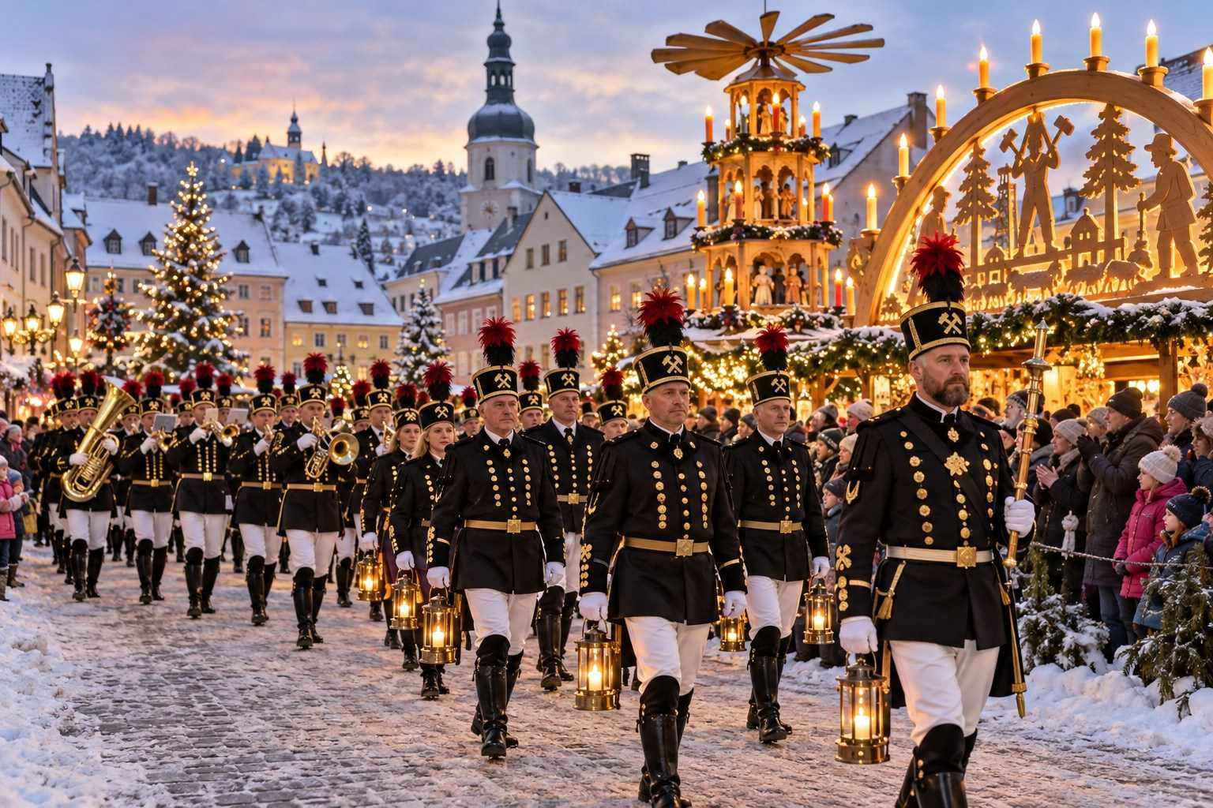

9. Görlitz: A Silesian Christmas
On Germany's eastern border with Poland, Görlitz is one of the best-preserved historic cities in Germany, with more than four thousand listed buildings and a history as a filming location for many movies. Its Silesian Christkindelmarkt reflects the traditions of the historic region of Silesia, with Silesian specialties such as Mohnkließla (a poppy seed dessert) and Liegnitzer Bombe (a gingerbread cake). Walk across the bridge into Zgorzelec, Poland, for a two-country stroll.

10. Meissen: Porcelain Bells
The birthplace of European porcelain, Meissen sits above the river Elbe, crowned by its Gothic cathedral and the Albrechtsburg castle. Its Christmas market fills the historic Marktplatz, where the Frauenkirche carillon, made of Meissen porcelain bells, chimes over the stalls. Visit the Meissen porcelain manufactory to see artisans at work.

11. Bad Wimpfen: Old German Christmas
The medieval hilltop town of Bad Wimpfen, above the river Neckar, hosts the Altdeutscher Weihnachtsmarkt, an "Old German" Christmas market that is among the most atmospheric in Baden-Württemberg. The market winds through the narrow lanes of the old imperial palace town, with torches, craftspeople, and views over the valley. It is typically held on the first three Advent weekends.

12. Konstanz: Christmas on the Lake
On the shores of Lake Constance (the Bodensee), where Germany, Switzerland, and Austria meet, Konstanz hosts a large and lively market along the harbor, including a Christmas market on a ship moored at the quay. From here you can take ferries to Meersburg and Lindau, whose harbor market, with the lion statue at the harbor entrance and Alpine views across the lake, is one of the most scenic in Germany.

Austria

13. Rattenberg: The Town of Candlelight
Rattenberg, one of the smallest towns in Austria, is famous for its glassmakers. During its Advent in Rattenberg (Rattenberger Advent), held on selected weekends, the town switches off its electric streetlights, and the medieval lanes are lit only by candles, lanterns, and torches. The effect is magical: glass workshops glow, choirs sing in the lanes, and the whole town seems to step back in time.
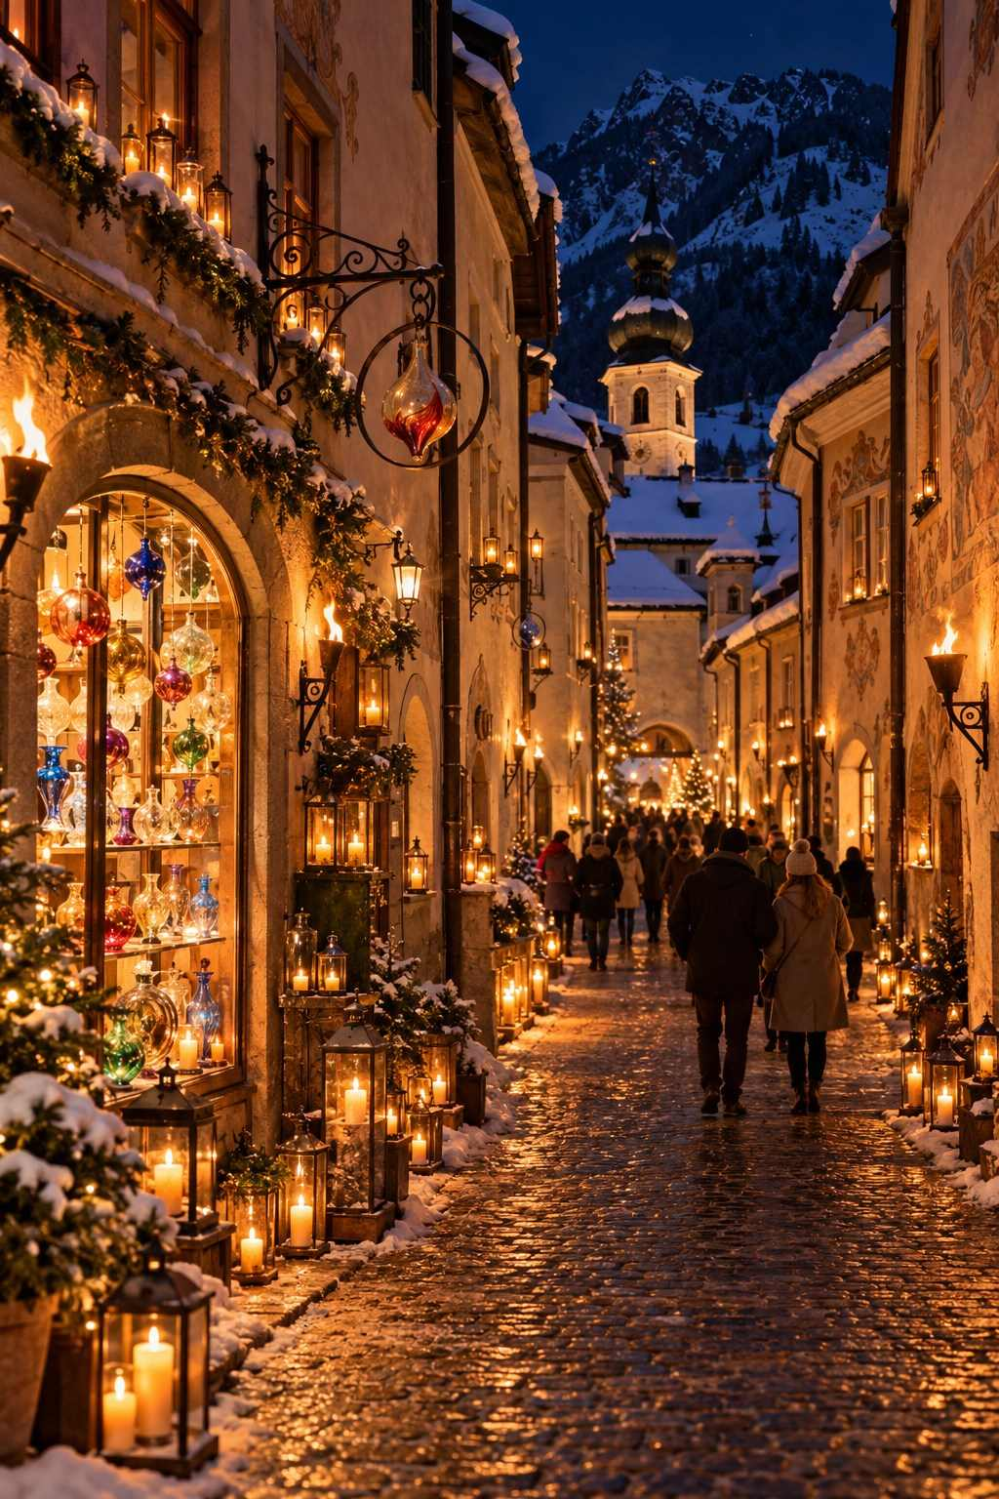

14. Steyr: The Christmas City of Austria
The medieval city of Steyr, where the rivers Enns and Steyr meet, has one of Austria's most beautiful town squares, and it calls itself Austria's "Christmas city." Visit the market on the town square, the historic Steyr Nativity Theater (Steyrer Kripperl), one of the last surviving rod-puppet nativity theaters in the German-speaking world, and the nearby pilgrimage village of Christkindl, with its special Christmas post office.

15. Mariazell: Pilgrim's Advent
In the mountains of Styria, the great pilgrimage church of Mariazell hosts a large Advent market and the world's largest Advent wreath, laid out on the square before the basilica. The atmosphere combines devotion and festivity, and the local gingerbread and honey liqueur are famous throughout Austria.

16. Bad Ischl: The Emperor's Retreat
Emperor Franz Joseph spent his summers in the spa town of Bad Ischl, in the Salzkammergut. At Christmas, its elegant streets host a market, and the town is a pleasant base for exploring Hallstatt and Wolfgangsee. Stop at the historic Zauner patisserie for a slice of cake in imperial style.

France and Switzerland

17. Sélestat: Where the Christmas Tree Was First Written Down
Between Strasbourg and Colmar, the small town of Sélestat holds a remarkable place in Christmas history. Its Humanist Library preserves the town's accounts from 1521, which record a payment to guard the forest trees cut for Christmas, one of the earliest written mentions of the Christmas tree. Each year, the Church of Saint George hosts an exhibition of Christmas trees decorated in the style of different eras, and the town's market is friendly and uncrowded.

18. Turckheim: The Night Watchman's Round
The small, walled wine village of Turckheim, near Colmar, is one of the last towns in France where a night watchman still makes his rounds. In a long cape and a tricorn hat, carrying a lantern and a halberd, he walks through the town each evening, singing his traditional songs at every corner. The village's Christmas market and illuminated streets make a lovely evening excursion from Colmar.

19. Bergheim and Hunawihr
These two tiny Alsatian wine villages, both among the most beautiful in France, host small Christmas markets on selected weekends. Bergheim, with its medieval fortifications, and Hunawihr, with its fortified church above the vineyards, offer village Christmas at its most authentic.

20. Stein am Rhein and Bremgarten (Switzerland)
Stein am Rhein, with its astonishing painted façades on the main square, is one of the most picturesque towns in Switzerland and hosts a charming small Christmas market. Near Zurich, Bremgarten in the canton of Aargau holds a very large one-weekend market in its medieval old town, attracting visitors from across the region.

Beyond

21. Luxembourg City: Winterlights
The Grand Duchy's capital hosts Winterlights, with Christmas markets on the Place d'Armes and Place de la Constitution, where a Ferris wheel overlooks the dramatic Pétrusse Valley. Luxembourg's free public transport makes getting around easy.

22. Aarhus, Denmark: Christmas Through the Ages
In Denmark's second city, the open-air museum Den Gamle By (The Old Town) recreates Christmases from different centuries in its historic houses: a merchant's home of the 1860s, a 1920s apartment, a 1970s home, and more. Streets are decorated, shops sell traditional goods, and costumed interpreters bring the past to life. It is a delightful experience for all ages.

23. Český Krumlov, Czech Republic
Mentioned in Chapter 9, this UNESCO-listed Bohemian town deserves its place among the gems. The winding river, the castle's painted tower, and the snow-dusted red roofs make it one of the most beautiful places in Central Europe at Christmas.

24. Levico Terme, Italy
In Trentino, the Christmas market of Levico Terme is set in the park of the Habsburg-era Villa Paradiso, among centuries-old trees, with wooden stalls, a nativity scene, and a welcoming Alpine-Italian atmosphere.

25. Brașov, Romania
Beneath the forested slopes of Mount Tâmpa, Brașov's Council Square hosts a charming market with the town's Gothic Black Church as a backdrop. Transylvanian traditions, hearty food, and low prices make it a rewarding choice for adventurous travelers.
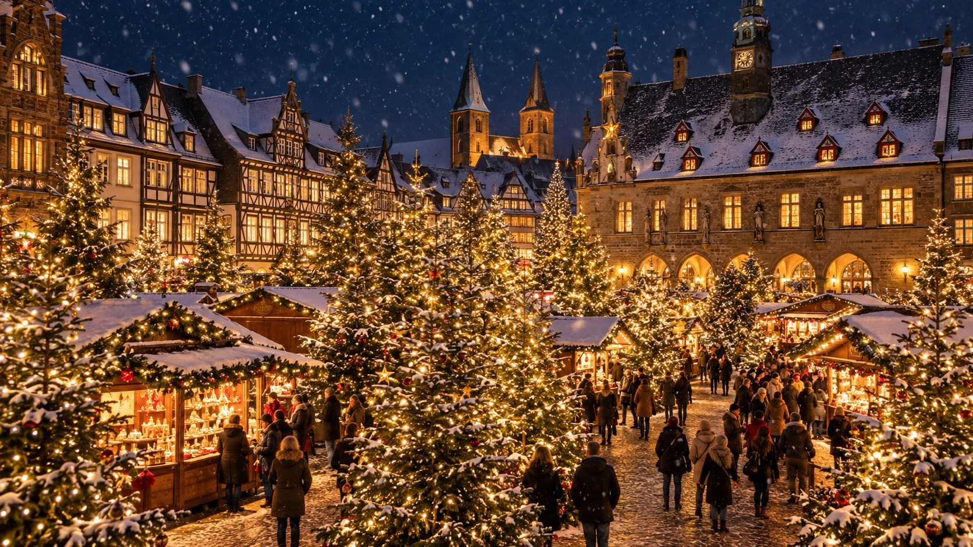

How to Find Your Own Hidden Gems
- Ask locals. Hotel staff, taxi drivers, and café owners often know the small markets that never make the guidebooks.
- Look for weekend-only markets. Many villages hold their markets for just one or two weekends in Advent. Regional tourism websites list them.
- Follow the church bells. Parish and monastery markets are often small, charming, and full of homemade goods.
- Check castle and palace calendars. Many castles, abbeys, and stately homes host special Advent markets in their courtyards.
- Use regional trains. A regional rail ticket or pass makes it easy to hop off in small towns along the way.
★ DON'T MISS
Plan at least one "surprise" evening on your trip: pick a small town on your route that you know nothing about, and simply go. Some of the happiest Christmas market memories come from places travelers stumbled upon by chance.

PART THREE
Making It Yours
— ❄ ✦ ❄ —
Ready-made itineraries, river cruises, advice for every kind of traveler, the best treasures to bring home, and the traditions that continue long after the stalls close.

CHAPTER 15

Ready-Made Itineraries
— ❄ ✦ ❄ —
Nine tried-and-tested routes, from a romantic weekend to a grand two-week tour, with day-by-day plans.
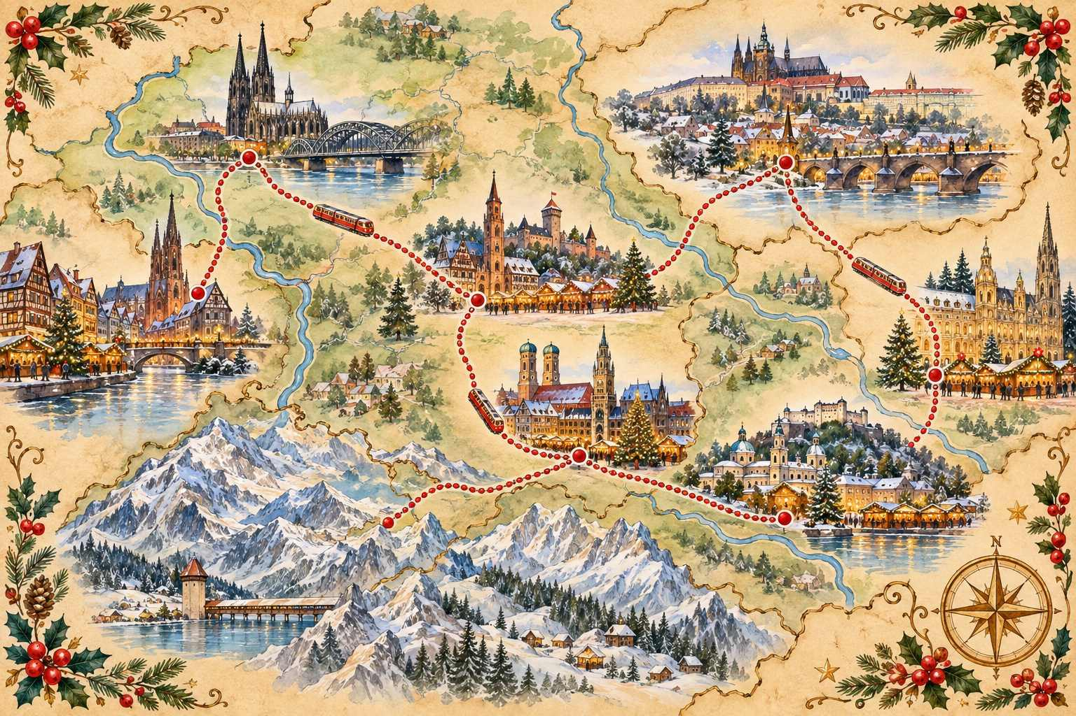

The following itineraries are designed to be practical and relaxed, with realistic travel times and plenty of evening market time. Each assumes travel by train unless noted. Feel free to mix and match, shorten, or extend them to suit your style.
ℹ GOOD TO KNOW
All itineraries assume the markets are open. Check the dates of each market against your travel days, especially for markets that close on December 22 or 23, and for weekend-only markets in smaller villages.

Itinerary 1: The Classic German Christmas (7 Nights)
Route: Munich – Nuremberg – Rothenburg – Munich (or fly home from Frankfurt)
Best for: First-timers who want the quintessential German Christmas experience
Best dates: Between November 30 and December 18, 2026
Day 1: Arrive in Munich. Check in to a hotel near Marienplatz. Recover from your flight with a stroll through the Christkindlmarkt and the Kripperlmarkt. Dinner at a traditional Bavarian beer hall.
Day 2: Munich. Morning at the Residenz palace or the Deutsches Museum. Afternoon at the Residenz Christmas Village and the Medieval Market at Wittelsbacherplatz. Hear Advent music from the town hall balcony at 5:30 pm. Evening at the Tollwood Winter Festival.
Day 3: Munich to Nuremberg (about 1 hr by ICE). Check in near the old town. Afternoon at the Imperial Castle. As dusk falls, enter the Christkindlesmarkt. Eat Drei im Weggla and drink Glühwein from the famous boot-shaped or classic mug.
Day 4: Nuremberg. Morning at the Germanisches Nationalmuseum or the Toy Museum. Afternoon at the Kinderweihnacht and the Sister Cities Market. Buy Lebkuchen to take home. Evening Feuerzangenbowle.
Day 5: Nuremberg to Rothenburg (about 1 hr 15 min by regional train, via Ansbach and Steinach). Check in within the walls. Walk the ramparts, visit the German Christmas Museum, and browse the Reiterlesmarkt. Join the Night Watchman's tour at 8 pm.
Day 6: Rothenburg. Early-morning photographs at the Plönlein before the crowds. Relaxed shopping and Schneeballen. Evening at the market.
Day 7: Return to Munich (about 3 hr). Final evening in Munich, perhaps at the Chinese Tower market in the English Garden.
Day 8: Depart from Munich.
✦ INSIDER TIP
Alternatively, end in Frankfurt (about 2 hr 30 min from Rothenburg by train) and spend your last evening at the Römerberg market before an easy departure from Frankfurt Airport.

Itinerary 2: Imperial Capitals (8 Nights)
Route: Munich – Salzburg – Vienna – Prague
Best for: Culture lovers, music lovers, grand architecture
Best dates: Between November 28 and December 22, 2026 (Prague opens November 28)
Days 1–2: Munich. As in Itinerary 1.
Day 3: Munich to Salzburg (about 1 hr 30 min). Afternoon walk through the old town and Getreidegasse, visit Mozart's birthplace, and spend the evening at the Christkindlmarkt on Domplatz.
Day 4: Salzburg. Morning funicular to the Hohensalzburg Fortress and its Advent market. Afternoon at Hellbrunn Palace Advent market. On Advent weekends, see a Krampus run or Advent Singing concert.
Day 5: Salzburg to Vienna (about 2 hr 30 min). Afternoon at Schönbrunn Palace Christmas market. Evening at the Rathausplatz Christkindlmarkt.
Day 6: Vienna. Morning at the Hofburg and the Spanish Riding School. Afternoon coffee and cake at a classic coffeehouse. Evening at Spittelberg and Maria-Theresien-Platz. Advent concert if you can.
Day 7: Vienna. Morning at the Belvedere to see Klimt's The Kiss and its Christmas market. Afternoon at Karlsplatz Art Advent. Evening at Am Hof and Freyung.
Day 8: Vienna to Prague (about 4 hr). Evening on Old Town Square, watching the tree's light show.
Day 9: Prague. Morning at Prague Castle and Saint George's Square market. Walk down across Charles Bridge. Afternoon at the Old Town Hall tower. Evening at Wenceslas Square and Peace Square.
Day 10: Depart from Prague.
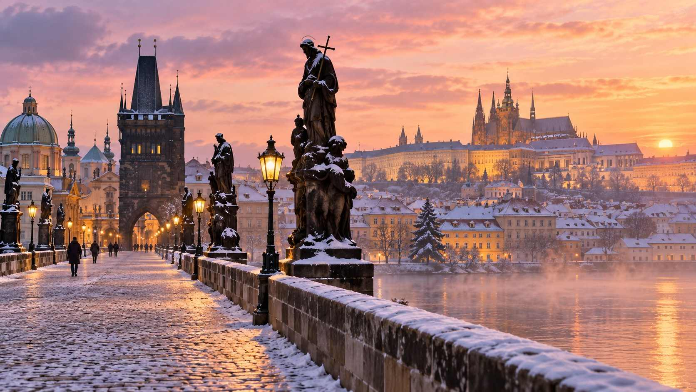

Itinerary 3: Alsace and the Black Forest (6 Nights)
Route: Strasbourg – Colmar (with wine villages) – Freiburg – Ravenna Gorge
Best for: Food and wine lovers, fairy-tale villages
Best dates: Between November 27 and December 20, 2026 (to include weekend village markets)
Day 1: Arrive in Strasbourg (TGV from Paris, or train from Frankfurt or Basel). Evening in the Grande Île: Place Kléber and the Great Tree, Place de la Cathédrale, and the Carré d'Or.
Day 2: Strasbourg. Morning at the cathedral and astronomical clock (12:30 pm). Afternoon in Petite France. Evening at Place Broglie and dinner in a winstub.
Day 3: Strasbourg to Colmar (about 30 min). Explore all six markets and Petite Venise. Dinner of choucroute or baeckeoffe.
Day 4: Wine villages. By car, tour, or local bus: Eguisheim in the morning, Kaysersberg for lunch (if a weekend market is on), and Riquewihr in the afternoon. Wine tasting at a family winery.
Day 5: Colmar to Freiburg (about 1 hr 15 min via Basel or by car, about 1 hr). Freiburg's Christmas market spreads around the Rathausplatz and its medieval squares. Admire the Gothic cathedral.
Day 6: Ravenna Gorge (weekends only; reservations required). Take the Höllentalbahn railway into the Black Forest. Visit the gorge market in the afternoon and stay until dark. Return to Freiburg.
Day 7: Depart from Basel, Zurich, or Frankfurt.

Itinerary 4: Rhine Christmas Classics (5 Nights)
Route: Cologne – Aachen – Düsseldorf – Koblenz – Frankfurt
Best for: Market hoppers, easy trains, combining with Belgium or the Netherlands
Days 1–2: Cologne. Explore the Cathedral market, Heinzels Wintermärchen, the Angels' Market, and the Harbour Market. Climb the cathedral tower. Visit the Chocolate Museum.
Day 3: Day trip to Aachen (about 35 min). See Charlemagne's cathedral and treasury, eat Printen, and enjoy the market. Optional side trip to Valkenburg's caves (about 30 min further by bus or car).
Day 4: Day trip to Düsseldorf (about 25 min). Explore the Altstadt's themed markets, the Königsallee, and a traditional brewery for an Altbier.
Day 5: Cologne to Koblenz and on to Frankfurt. Take the scenic Rhine Valley railway (on the left bank for the best views of castles). Stop in Koblenz for the market at the confluence of the Rhine and Moselle. Continue to Frankfurt for an evening at the Römerberg.
Day 6: Depart from Frankfurt.

Itinerary 5: A Romantic Weekend in Vienna (3 Nights)
Best for: Couples, anniversaries, city breaks
Day 1: Arrive, check in to a classic hotel in the first district. Evening stroll along the Graben beneath the chandelier lights to Stephansplatz. Dinner and a glass of Grüner Veltliner.
Day 2: Morning coffee and cake at a grand café. Afternoon at Schönbrunn. Evening ice skating at Rathausplatz, followed by Punsch.
Day 3: Morning at the Belvedere. Afternoon at Spittelberg's artisan stalls. Evening at a concert in a palace or church, then a late supper.
Day 4: Depart, or take a morning trip to Bratislava before your flight from Vienna Airport, which is between the two cities.

Itinerary 6: The Budget-Friendly Christmas (7 Nights)
Route: Budapest – Bratislava – Vienna (day trip) – Kraków (or Prague)
Best for: Value seekers, travelers who have seen the classic markets
Days 1–3: Budapest. Vörösmarty Square, the Basilica light show, Széchenyi Baths, the Great Market Hall, and an evening Danube cruise.
Days 4–5: Bratislava (about 2 hr 30 min from Budapest). The Main Square market, the castle, and a day trip to Vienna (about 1 hr) for an evening at the Rathausplatz.
Days 6–7: Kraków (flight, or long train via Vienna or overnight connections). The Main Market Square, Wawel Castle, the Wieliczka Salt Mine (with its underground chapel carved from salt), and the szopki exhibition.
Day 8: Depart from Kraków.
€ BUDGET NOTE
For this itinerary, a mug of mulled wine will often cost €3–5 rather than €5–7, and good central hotels are frequently half the price of those in Munich or Salzburg.

Itinerary 7: Christmas with Kids (6 Nights)
Route: Frankfurt – Rüdesheim – Hamburg (or Montreux in Switzerland)
Best for: Families with children aged 4–12
Days 1–2: Frankfurt. The Römerberg market and its carousels, the Senckenberg Natural History Museum (with dinosaurs), and a river boat ride.
Day 3: Rüdesheim (about 1 hr). The Christmas Market of Nations in the narrow lanes of this Rhine wine town, with a life-size nativity scene, and Siegfried's Mechanical Music Cabinet museum.
Days 4–6: Hamburg (about 3 hr 30 min from Frankfurt). Watch Santa fly over the Rathausmarkt, visit Miniatur Wunderland (the world's largest model railway exhibition, a guaranteed hit), explore the harbor, and ride the ferries.
Day 7: Depart from Hamburg.
Swiss alternative: Zurich (2 nights) for the Singing Christmas Tree and the station market, then Montreux (3 nights) for Santa's house on the Rochers-de-Naye, the flying sleigh, and the medieval market at Chillon Castle.

Itinerary 8: Nordic Lights (6 Nights)
Route: Copenhagen – Stockholm – Helsinki (or Tallinn)
Best for: Hygge lovers, Lucia celebrations, design lovers
Best dates: Around December 10–16, 2026, to include Saint Lucia's Day (December 13)
Days 1–2: Copenhagen. Tivoli Gardens, Nyhavn, Danish design shops, and smørrebrød for lunch.
Days 3–4: Stockholm (about 5 hr by train, or a short flight). Gamla Stan's Stortorget market, Skansen on the weekend, the Vasa Museum, and a Lucia concert on December 13.
Days 5–6: Helsinki (overnight ferry from Stockholm, or a short flight). The Saint Thomas market on Senate Square, the Rock Church, and a Finnish sauna. Optional: a day trip by ferry to Tallinn's medieval market.
Day 7: Depart from Helsinki, or continue north to Rovaniemi for a Lapland adventure.
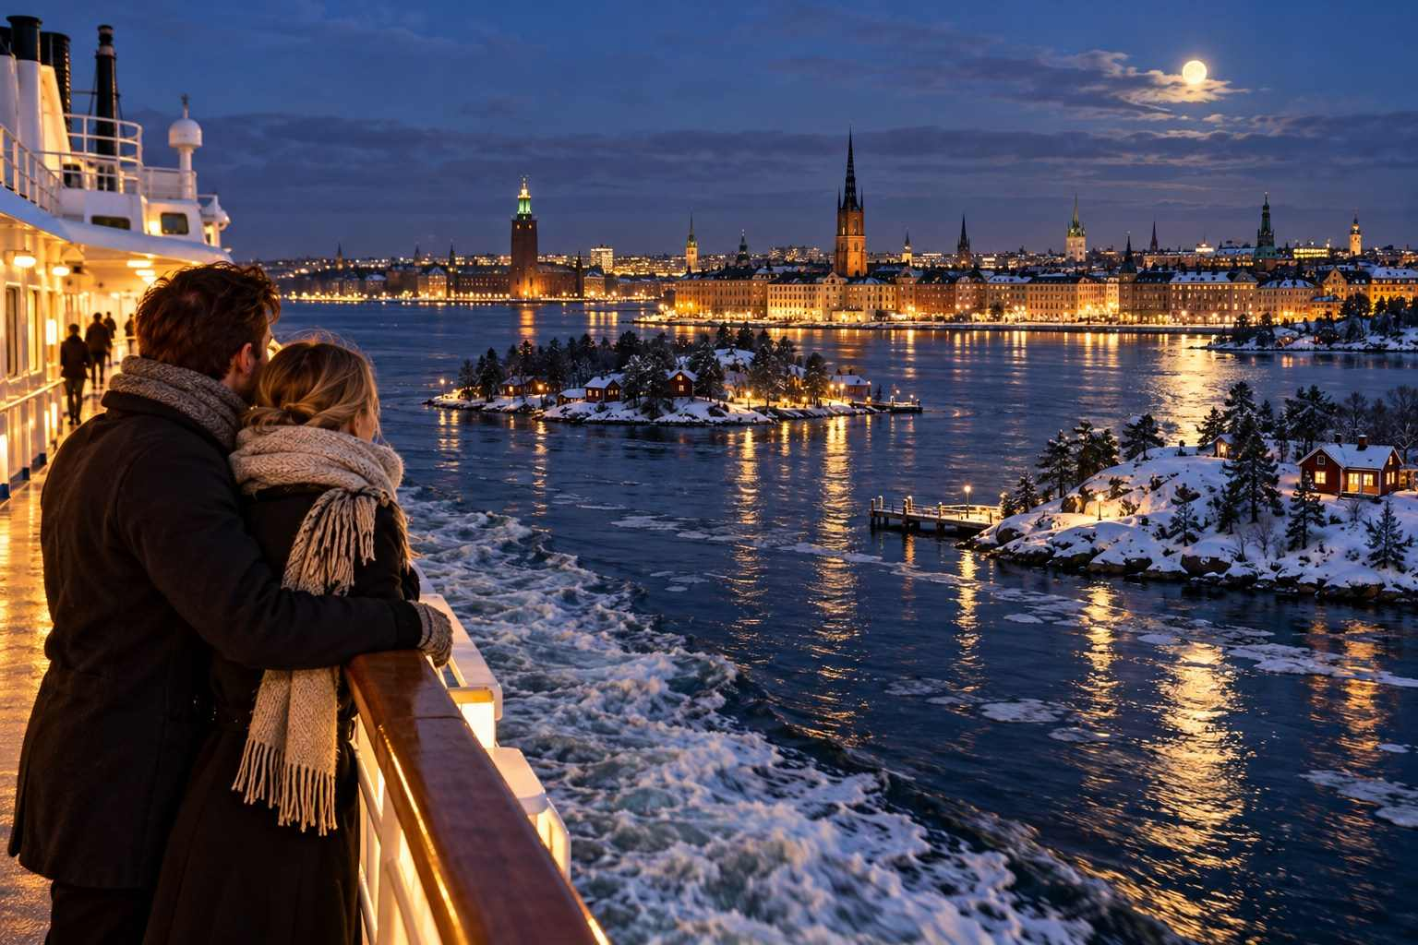

Itinerary 9: The Grand Tour (14 Nights)
Route: Frankfurt – Strasbourg – Colmar – Munich – Salzburg – Vienna – Prague – Dresden – Berlin
Best for: Travelers with time who want to see the very best
Best dates: November 28 – December 12, 2026
- Nights 1–2: Frankfurt (Römerberg) with a day trip to Heidelberg
- Nights 3–4: Strasbourg, with a day trip to Colmar and the wine villages
- Nights 5–6: Munich (via Stuttgart, with an afternoon stop at the Stuttgart market)
- Night 7: Salzburg
- Nights 8–10: Vienna, with a day trip to Bratislava
- Nights 11–12: Prague
- Night 13: Dresden (Striezelmarkt and Stollenfest on December 5 if dates align)
- Night 14: Berlin
- Day 15: Depart from Berlin
✦ INSIDER TIP
On a long trip, schedule a "slow day" every four or five days: no trains, no plans, just a late breakfast, a museum, a nap, and an evening at the market. You will enjoy the second week as much as the first.

Itinerary Planning Tips
- Book the anchors first: Hotels in the most popular towns (Strasbourg, Colmar, Rothenburg, Salzburg, Nuremberg) and any timed-entry experiences (Ravenna Gorge, Tivoli, Valkenburg caves).
- Keep train journeys under four hours where possible, and travel in the morning so you arrive in time for the evening market.
- Pack light. You will be carrying your luggage on and off trains, often over cobblestones. A medium-sized wheeled suitcase and a daypack are ideal.
- Consider luggage storage. Most major stations have lockers, so you can stop for a few hours at a market along the way.
- Check the Sunday rule. In Germany and Austria, most shops are closed on Sundays, though the Christmas markets are open.
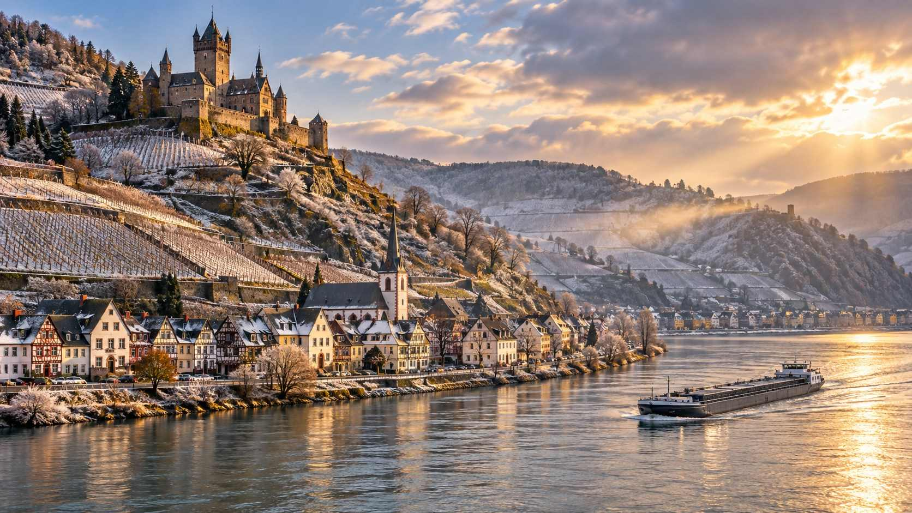

CHAPTER 16

Christmas Market River Cruises
— ❄ ✦ ❄ —
Unpack once, wake up in a new town each morning, and float from market to market along Europe's great rivers.
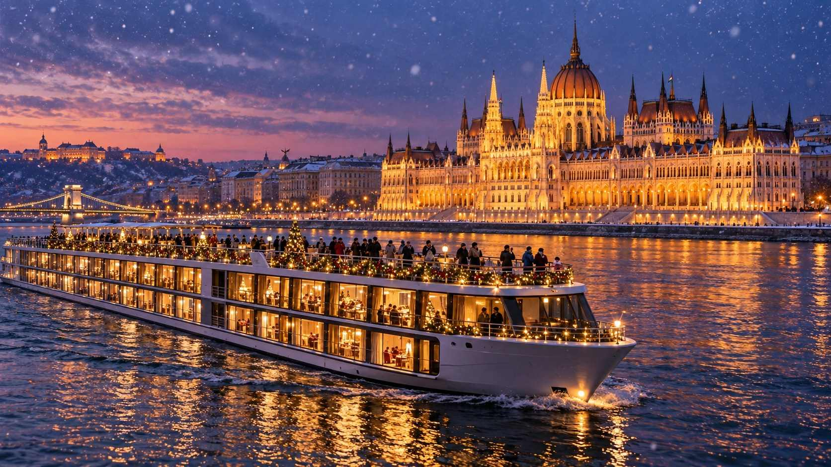

For many travelers, especially those who prefer not to manage trains, hotels, and luggage, a river cruise is the ideal way to experience the Christmas markets. You unpack once, your "floating hotel" carries you from city to city while you sleep or dine, and you step off the ship each morning, often right in the heart of a historic town.
Christmas market cruises have become one of the most popular products in river cruising, and nearly every major river cruise line offers them, typically between late November and December 23.

The Classic Routes

The Danube
The Danube is the most popular Christmas market river, and for good reason: it connects some of Europe's most beautiful cities.
Typical itinerary (7–8 nights): Nuremberg or Passau – Regensburg – Passau – Linz (for Salzburg or Český Krumlov excursions) – Melk or Dürnstein – Vienna – Bratislava – Budapest.
Highlights: Nuremberg's Christkindlesmarkt, Regensburg's palace market, Passau's cathedral with its giant organ, Salzburg on a day excursion, Vienna's imperial markets, and an unforgettable arrival in Budapest, sailing past the illuminated Parliament.

The Rhine
Typical itinerary (7–8 nights): Amsterdam – Cologne – Koblenz – Rüdesheim – Mannheim or Heidelberg – Speyer – Strasbourg – Breisach (for Colmar or the Black Forest) – Basel.
Highlights: Cologne's many markets, the castle-lined Middle Rhine Gorge, Rüdesheim's Christmas Market of Nations, Heidelberg, Strasbourg, and Colmar.

The Main and the Rhine
Typical itinerary (7 nights): Frankfurt – Würzburg – Bamberg – Nuremberg (or reverse), sometimes extended along the Main-Danube Canal.
Highlights: The baroque Würzburg Residence, Bamberg's UNESCO-listed old town with its famous smoked beer, Rothenburg on a day excursion, and Nuremberg.

Combination Cruises
Longer cruises of ten to fifteen nights combine the Rhine, Main, and Danube, sailing from Amsterdam to Budapest through the heart of Europe.

Advantages of a River Cruise
- Unpack once. No packing, no luggage handling, no train connections.
- Central docking. Ships usually moor within walking distance of the old town or provide a short shuttle.
- Included meals and excursions. Most cruises include meals, guided city tours, and often drinks with meals.
- Onboard festivities. Many ships host gingerbread-decorating classes, glass-ornament workshops, Glühwein tastings, carol concerts, and festive dinners.
- Social atmosphere. River ships are small (typically 100–190 passengers), and it is easy to make friends.
- Accessibility. Many ships have elevators, and it is easier for those with limited mobility than traveling independently.

Disadvantages to Consider
- Limited evening time. Some itineraries sail in the late afternoon or evening, when the markets are at their best. Check the schedule for evening stops in key cities.
- Group touring. Excursions are often in large groups, and markets can feel crowded when several ships dock at the same time.
- Water levels. In dry or very wet periods, low or high water can force itinerary changes, with passengers transferred by coach or ships swapped mid-cruise. This is not common in December but can happen.
- Cost. River cruises are not cheap, typically ranging from around US$2,500 to US$6,000+ per person for a week, depending on the line, the cabin, and the season, before airfare.
✦ INSIDER TIP
When comparing cruises, look closely at the docking times in each city. The best Christmas market cruises schedule evening stays or overnight stops in the key market cities, such as Nuremberg, Vienna, Cologne, and Strasbourg, so you can enjoy the lights after dark.

Choosing Your Cruise
Ask these questions before you book:
- Which cities have evening or overnight stops?
- How far is the dock from the market?
- What excursions are included, and what costs extra?
- Are drinks included, and which ones?
- What happens if water levels disrupt the itinerary?
- How many passengers does the ship carry?
- Are there special Christmas activities on board?
- Is there a single supplement for solo travelers, and are there solo cabins?
- What is the cancellation and deposit policy?
€ BUDGET NOTE
Book early for the best cabin selection and early-booking discounts, or look for last-minute deals in the autumn if you are flexible. Consider booking a cabin on the lowest deck: it has smaller windows, but you will spend most of your time ashore or in the lounge anyway.

Pre- and Post-Cruise Stays
Add a few nights at the start or end of your cruise to explore more deeply. Popular options include Prague before a Danube cruise from Nuremberg or Passau, Budapest after a Danube cruise, Amsterdam before a Rhine cruise, and Lucerne or Zurich after a cruise ending in Basel.

Onboard Traditions
Many river cruise ships celebrate the season with festive touches: decorated Christmas trees in the lounge, Advent calendars in the cabins, a Saint Nicholas visit on December 6, Glühwein receptions on deck, and gala dinners featuring roast goose, Stollen, and Lebkuchen. Some ships offer lectures on local Christmas customs, cooking demonstrations, and carol singing with local choirs who come on board.
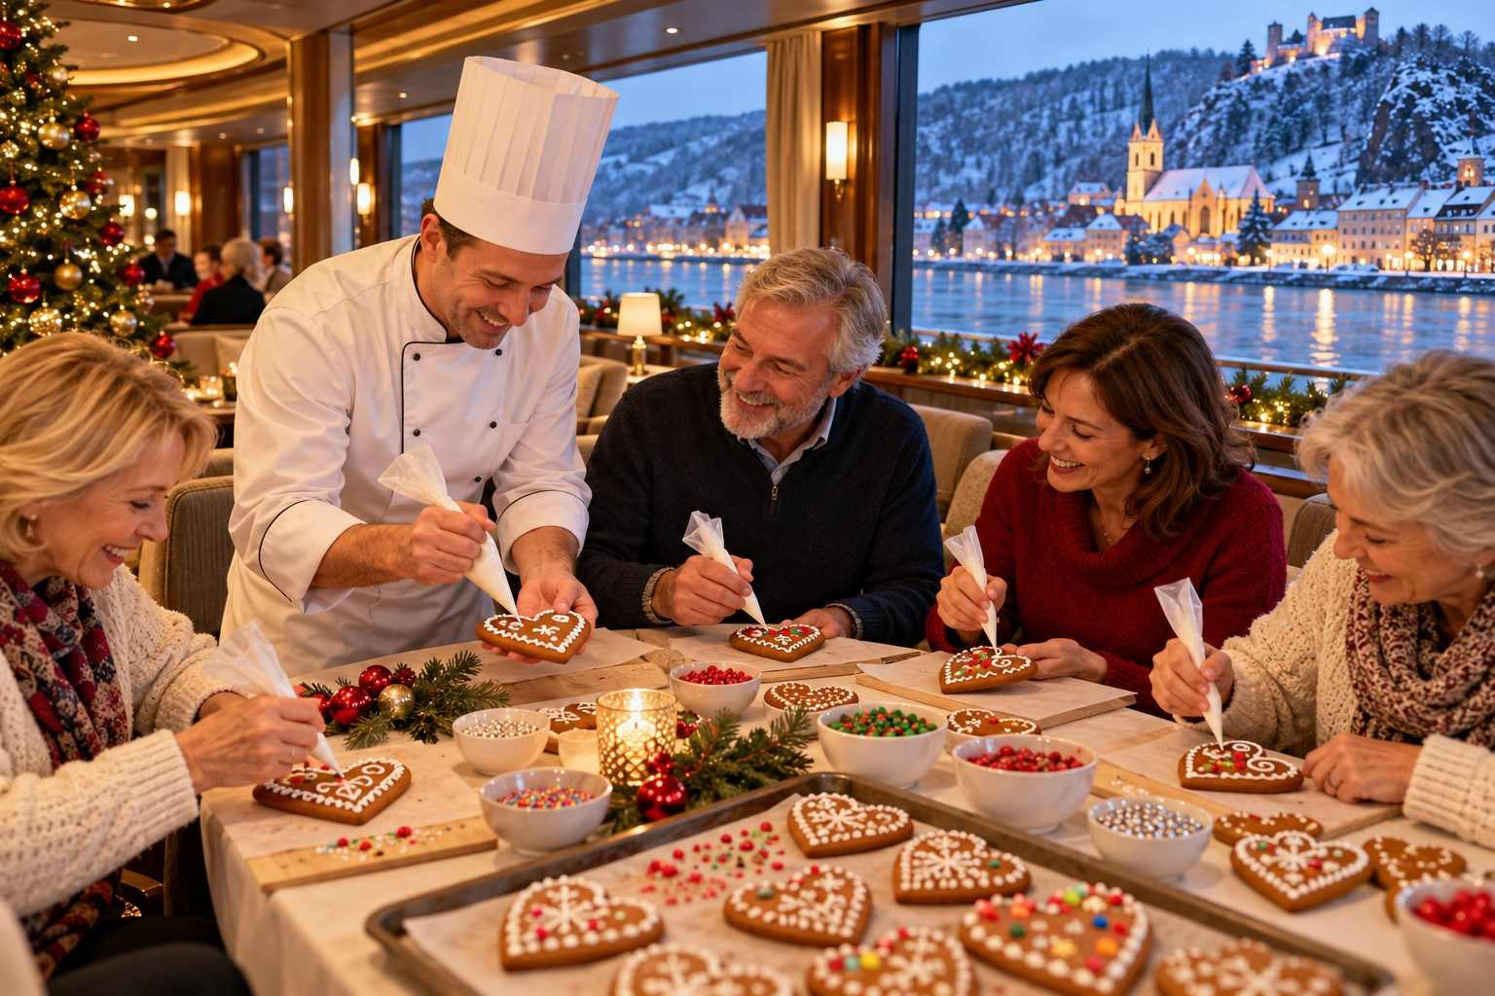

CHAPTER 17

Traveling with Kids, Seniors, Solo & with Limited Mobility
— ❄ ✦ ❄ —
Practical advice so every traveler can enjoy the magic, whatever their age, pace, or needs.
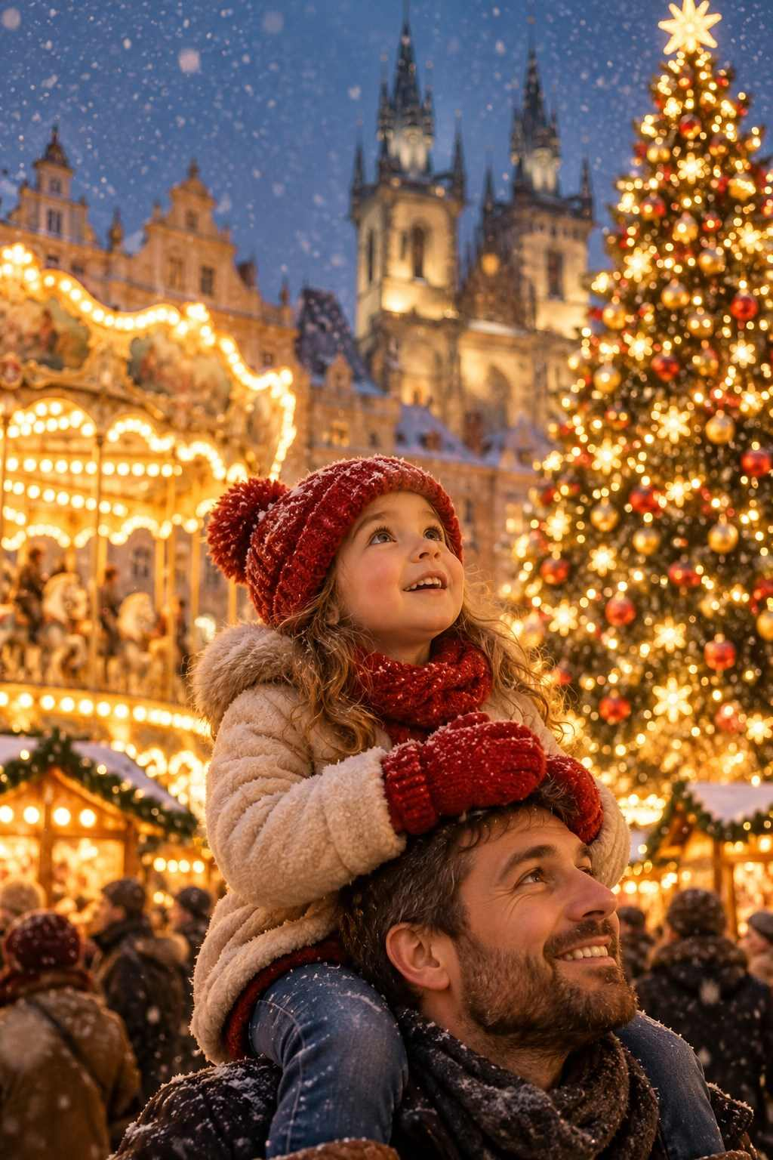

Christmas markets are for everyone. Grandparents and grandchildren, honeymooners and solo adventurers, wheelchair users and marathon walkers can all find joy beneath the lights. This chapter offers practical advice for different kinds of travelers.

Traveling with Children
Christmas markets are a child's dream: carousels, Ferris wheels, gingerbread, puppet shows, Santa (or the Christkind), and endless lights. With a little planning, a market trip can create memories your children will treasure forever.

Tips for Families
- Choose family-friendly markets. Nuremberg's Kinderweihnacht, Stuttgart's Children's Christmas Land, Vienna's Rathausplatz (with ice skating and baking workshops), Hamburg's flying Santa, Montreux, Tivoli, Liseberg, and Rovaniemi are especially good for children.
- Visit in the afternoon. Markets are less crowded before 5 pm, and children can still enjoy the lights as the sun sets early.
- Set a meeting point. Agree on a clear meeting spot, such as the Christmas tree or a particular carousel, in case you are separated. Write your phone number on a card in your child's pocket, or use a wristband.
- Dress in bright colors. A red hat or bright jacket makes children easy to spot in a crowd.
- Bring a stroller or carrier. For young children, a compact stroller is useful, though markets can be crowded; a carrier may be easier.
- Plan warm-up breaks. Children get cold faster than adults. Pop into cafés, museums, or churches regularly.
- Budget for treats and rides. Carousel rides typically cost €2–4 each, and treats add up quickly. Give older children a small daily budget to spend as they choose.
- Mix in other attractions. Toy museums, model railways, zoos, science museums, and swimming pools help keep everyone happy.

Kid-Friendly Treats
Kinderpunsch, hot chocolate, chocolate-covered fruit, crêpes, waffles, candied almonds, gingerbread, and potato pancakes are all child favorites.
✦ INSIDER TIP
Many markets have a place where children can write and post letters to Santa or the Christkind. In Germany, the Christkind post office in the village of Engelskirchen and others answer children's letters if they are mailed early enough. It is a lovely tradition to begin before your trip.

Senior Travelers
Many Christmas market travelers are retirees, and for good reason: the season is gentle, the pace can be relaxed, and the trips are full of culture, music, and history.
- Choose central hotels within walking distance of the markets, so you can return to rest between outings.
- Pace yourself. One or two markets a day is plenty. Build in rest time, especially in the afternoons.
- Consider a river cruise or escorted tour to avoid luggage handling and navigating train stations.
- Book first-class train tickets for more space, comfort, and quieter carriages. The price difference is often modest when booked early.
- Wear shoes with excellent grip and consider walking poles or ice cleats in snowy regions. Falls on icy cobblestones are a real risk.
- Carry medications in your hand luggage, along with a list of prescriptions and doctor's contact details.
- Get comprehensive travel insurance, including medical evacuation and coverage for pre-existing conditions.
- Ask about discounts. Many museums, attractions, and transport systems offer senior discounts, though some apply only to EU residents.

Solo Travelers
Christmas markets are wonderful for solo travelers. They are sociable, safe, and full of opportunities to meet people, whether at a shared standing table or on a walking tour.
- Join a walking tour or food tour to meet other travelers and learn from local guides.
- Stay in a friendly guesthouse or small hotel where you can chat with the staff and other guests.
- Choose a river cruise with solo cabins or a reduced single supplement.
- Share a table. Standing tables at the markets are communal. Saying "Ist hier noch frei?" ("Is this spot free?") is an easy way to start a conversation.
- Stay safe. Keep your phone charged, share your itinerary with someone at home, and use licensed taxis or ride-sharing apps late at night.
★ DON'T MISS
For solo travelers, a Christmas concert in a great cathedral is a deeply rewarding experience, a moment of beauty and peace that feels perfect on your own.

Travelers with Limited Mobility
While historic city centers and cobblestones present challenges, many markets are increasingly accessible, and with planning, travelers with limited mobility can enjoy the season fully.
- Research accessibility. Many city tourism websites publish accessibility information, including step-free routes, accessible toilets, and quiet times.
- Choose flatter cities. Munich, Cologne, Vienna, Strasbourg, Copenhagen, and Berlin are relatively flat. Hilly cities such as Prague (the castle district), Salzburg, and Heidelberg can be more challenging, though funiculars and elevators help.
- Visit at quiet times. Weekday mornings and early afternoons are much less crowded.
- Use accessible transport. Most modern trains, trams, and buses in Germany, Austria, and Switzerland are step-free, and railway companies offer free assistance at stations if booked in advance (for example, Deutsche Bahn's Mobility Service Center).
- Consider a river cruise with an elevator on board and ships docked centrally, though check whether gangways and docking arrangements are suitable.
- Rent equipment locally. Wheelchairs and mobility scooters can be rented in many cities; arrange this in advance.
- Ask about quiet or inclusive hours. Some markets now offer special quieter times for visitors with disabilities or sensory sensitivities.
ℹ GOOD TO KNOW
If you use a wheelchair, the most accessible markets are generally those held in large, paved squares or modern plazas, such as Vienna's Rathausplatz, Munich's Marienplatz, and the Cologne Cathedral market. Cobbled medieval streets, such as those in Rothenburg and the Alsace villages, can be difficult.

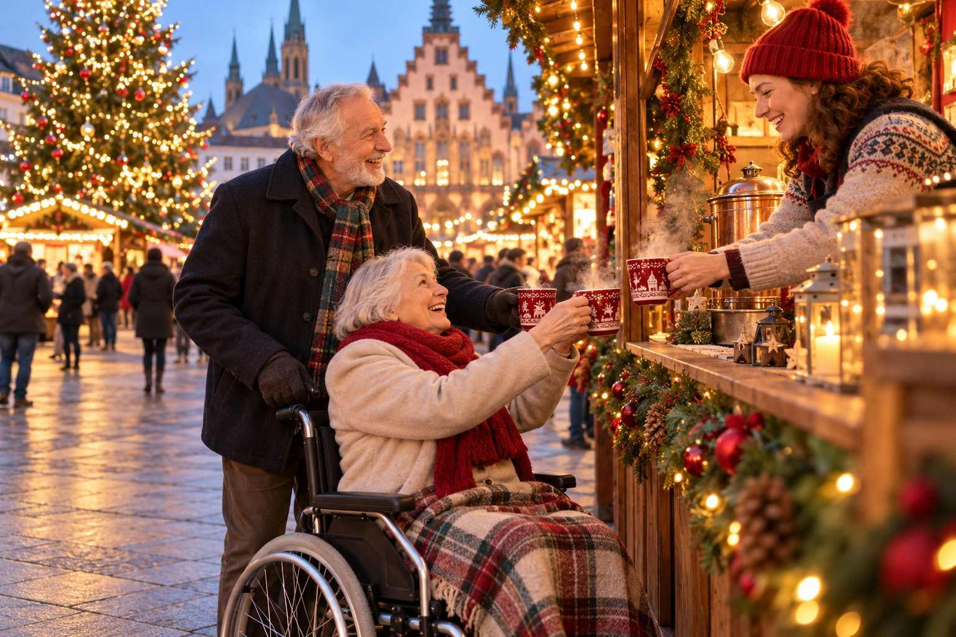

CHAPTER 18

The Shopper's Guide: Treasures to Bring Home
— ❄ ✦ ❄ —
How to find authentic handcrafted gifts, spot the fakes, and get your treasures home in one piece.
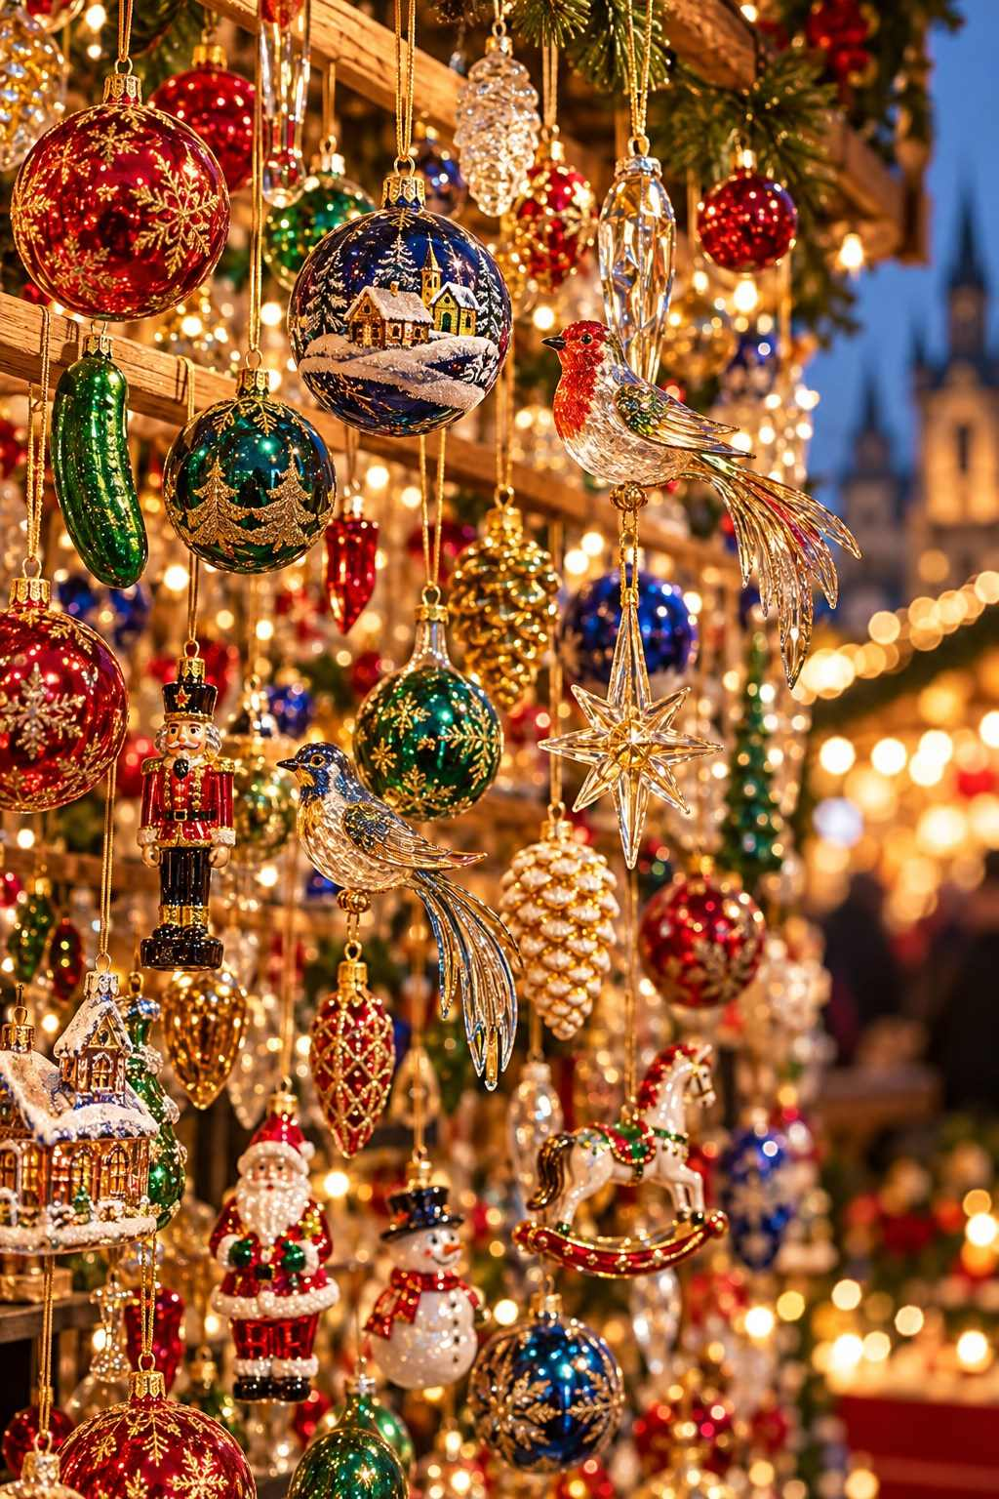

One of the great joys of a Christmas market trip is bringing home something special: an ornament you will hang on your tree for decades, a hand-carved figure that becomes a family heirloom, or a tin of gingerbread that brings back the scent of the markets. This chapter will help you shop wisely.

The Best Souvenirs, Country by Country

Germany
- Erzgebirge wood crafts: Nutcrackers, smoking men, Christmas pyramids, candle arches, angels and miners, and wooden toys from the Ore Mountains. Look for the "Echt Erzgebirge" label, which indicates authentic regional origin.
- Lauscha glass ornaments: Mouth-blown and hand-painted glass ornaments from the Thuringian town where the glass Christmas bauble was born.
- Herrnhut stars: Illuminated paper or plastic stars with twenty-five points.
- Käthe Wohlfahrt and specialty shops: Year-round Christmas stores in Rothenburg, Nuremberg, and other towns.
- Lebkuchen and Stollen: Nuremberg Lebkuchen in decorative tins and Dresden Christstollen with its golden seal travel well.
- Plauen lace: Fine machine-embroidered lace from Saxony.
- Beeswax candles: Hand-dipped and molded candles in traditional shapes.
- Collectible market mugs.

Austria
- Hand-carved nativity figures from Tyrol and Salzburg.
- Loden wool and traditional textiles.
- Mozartkugeln: Chocolate-and-marzipan balls from Salzburg.
- Augarten porcelain and Riedel glass.
- Straw ornaments and handmade Advent wreaths.

France (Alsace)
- Kougelhopf molds: Glazed earthenware molds from the pottery villages of Soufflenheim.
- Alsatian linens in traditional blue-and-red Kelsch fabric.
- Pain d'épices and bredele cookies.
- Alsatian wine and crémant.
- Meisenthal glass baubles: Beautiful contemporary glass ornaments from the northern Vosges, where the glass ball tradition is also celebrated.

Czech Republic
- Bohemian glass and crystal.
- Blown glass bead ornaments from the Jizera Mountains (inscribed on the UNESCO list of Intangible Cultural Heritage).
- Wooden toys and marionettes.
- Garnet jewelry.

Poland
- Hand-painted glass ornaments from Polish studios.
- Amber jewelry from the Baltic coast.
- Bolesławiec pottery, with its distinctive blue-and-white patterns.

Switzerland
- Swiss chocolate and Läckerli.
- Wood-carved figures from the Brienz region.
- Swiss army knives and watches.

Scandinavia and the Baltics
- Danish design ornaments and Royal Copenhagen Christmas plates.
- Swedish Dala horses, hand-painted wooden horses.
- Straw goats (julbock) and straw ornaments.
- Wool mittens and socks with traditional Baltic patterns.
- Amber from Latvia and Lithuania.

Italy, Spain and Beyond
- Neapolitan nativity figures from Via San Gregorio Armeno.
- Catalan caganers from Barcelona.
- Panettone and torrone.
- Provençal santons from southern France.
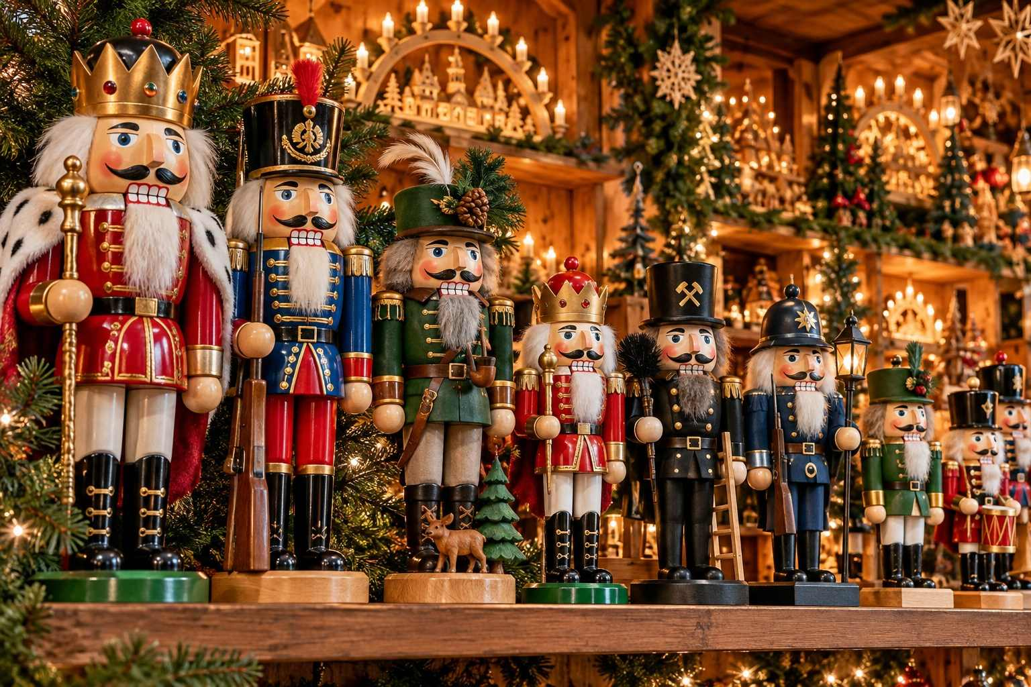

How to Tell Handmade from Mass-Produced
Not everything sold at a Christmas market is handmade or local. Here is how to spot the real thing:
- Look for the maker. At the best stalls, the craftsperson is present and may be working on pieces as you watch.
- Check for labels and certificates. Many authentic products carry origin labels, such as "Echt Erzgebirge," or come with a certificate of authenticity.
- Examine the details. Hand-painted items show subtle variations, and hand-carved pieces show tool marks and wood grain.
- Be wary of identical items. If a stall has dozens of exactly identical pieces at low prices, they are likely factory-made.
- Ask questions. Genuine artisans are usually delighted to tell you about their work and techniques.
- Consider the price. A genuine hand-carved Erzgebirge nutcracker costs far more than a mass-produced one. Quality comes at a price, but it lasts a lifetime.
✦ INSIDER TIP
Buy one high-quality, authentic piece rather than several cheap souvenirs. Many families collect one special ornament or figure from each trip, creating a tree full of memories over the years.

Getting Your Treasures Home

Packing Fragile Items
- Pack bubble wrap or buy it locally from a stationery or post shop.
- Wrap glass ornaments in tissue paper, then bubble wrap, and pack them in a small hard container.
- Use clothing as padding, especially socks and sweaters.
- Carry the most fragile items in your hand luggage.
- Ask the vendor to pack delicate items for travel; many are experts.

Shipping
Many specialty shops and larger vendors can ship purchases home for you. This is often a good option for large or heavy items such as pyramids, large nutcrackers, or pottery. Ask about insurance and delivery times, which can be several weeks.

Customs Rules
- United States: Returning residents typically have a duty-free exemption of US$800 per person for items acquired abroad. Most baked goods, chocolate, candies, and hard cheeses are generally allowed, but meat products (including sausages and salami) are generally prohibited. Always declare all food items.
- Canada: Personal exemptions depend on how long you have been away. Declare all food items.
- United Kingdom: Rules on bringing meat and dairy products from the EU have been tightened; most such products are not allowed in personal luggage. Check the latest government guidance.
- Australia and New Zealand: Very strict biosecurity rules apply. Wooden items, straw decorations, seeds, and food must be declared and may be inspected.
ℹ GOOD TO KNOW
Customs rules change periodically. Check your home country's official customs website before you travel for the latest allowances and restrictions.

Tax-Free Shopping
Visitors from outside the EU can often claim back the value-added tax (VAT) on larger purchases from participating shops, typically 19–20 percent in Germany and Austria, minus a service fee. Ask for a tax-free form when you buy, have it stamped by customs before you check your bags at the airport (you may need to show the items), and claim your refund. The minimum purchase amount varies by country (in Germany it is currently a little over €50 per receipt; Austria and France set higher minimums), so ask the shop before you buy. Christmas market stalls generally do not offer tax-free forms, but specialty shops often do.
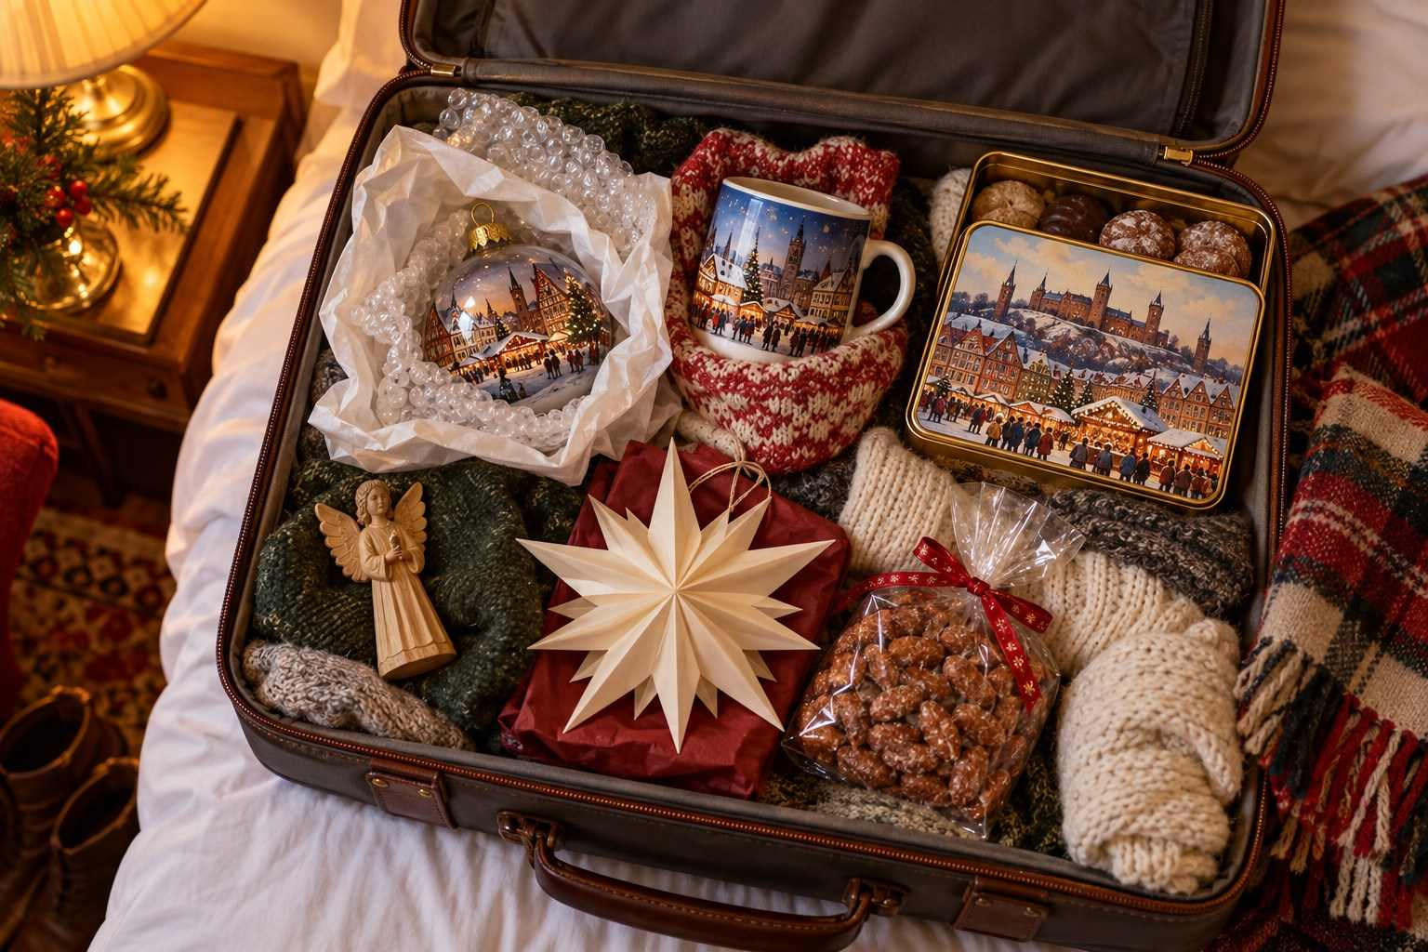

CHAPTER 19

Bring the Magic Home: Festive Recipes from the Markets
— ❄ ✦ ❄ —
Twelve beloved recipes, so the scent of cinnamon, butter, and spice can fill your kitchen long after your trip.
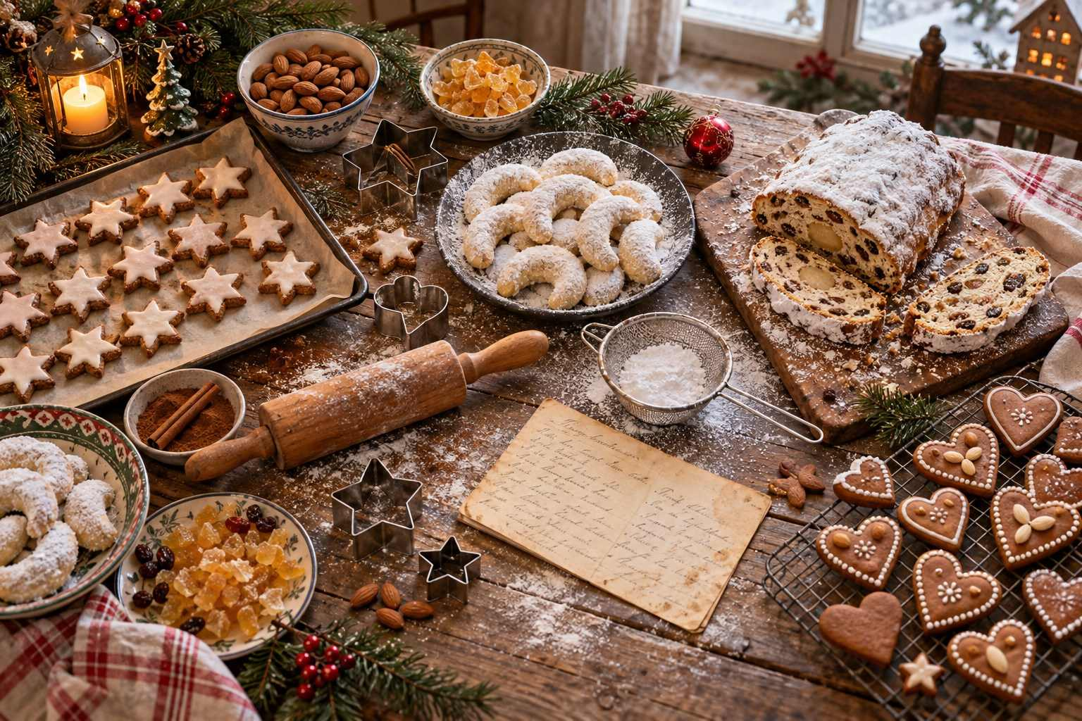

One of the loveliest ways to extend your Christmas market journey is to recreate its flavors at home. The recipes in this chapter are adapted for home kitchens, with ingredients you can find in most supermarkets. They are wonderful for Advent baking with family, for holiday parties, or simply for a quiet evening when you want to remember a snowy square far away.
ℹ GOOD TO KNOW
Measurements are given in both metric and US units. For baking, a kitchen scale gives the most reliable results. Oven temperatures are for conventional ovens; reduce by about 20°C (25°F) for fan or convection ovens.

1. Nuremberg-Style Soft Lebkuchen
Makes about 20
These soft, nutty gingerbread rounds are inspired by the famous Elisenlebkuchen of Nuremberg.
- 3 large eggs
- 200 g (1 cup) brown sugar
- 1 teaspoon vanilla extract
- 200 g (2 cups) ground almonds
- 100 g (1 cup) ground hazelnuts
- 75 g (½ cup) finely chopped candied orange and lemon peel
- 2 tablespoons all-purpose flour
- 2 teaspoons gingerbread spice (or 1 tsp cinnamon, ½ tsp ginger, ¼ tsp each cloves, nutmeg, and cardamom)
- Zest of 1 lemon
- ½ teaspoon baking powder
- 20 round baking wafers (Oblaten), 7 cm (2¾ in), or parchment paper
- For the glaze: 150 g dark chocolate, or 100 g (¾ cup) powdered sugar mixed with 2 tablespoons lemon juice
- Beat the eggs, sugar, and vanilla until thick and pale, about 5 minutes.
- Fold in the nuts, candied peel, flour, spice, lemon zest, and baking powder.
- Spread a heaped tablespoon of the mixture onto each wafer, doming it slightly and leaving a small border. Let rest uncovered for 1 hour.
- Bake at 160°C (325°F) for 18–22 minutes, until just set and lightly golden. They should remain soft.
- When cool, dip or brush with melted chocolate or sugar glaze, and decorate with blanched almond halves.
- Store in an airtight tin with a slice of apple for a few days to keep them soft.

2. Dresden-Style Christmas Stollen
Makes 1 large loaf
- 125 ml (½ cup) warm milk
- 1 packet (7 g / 2¼ tsp) dried yeast
- 60 g (¼ cup) sugar
- 375 g (3 cups) all-purpose flour
- ½ teaspoon salt
- ½ teaspoon each cinnamon and cardamom, pinch of nutmeg
- 1 egg
- 150 g (⅔ cup) soft butter, plus 50 g (3½ tbsp) melted for brushing
- 150 g (1 cup) raisins, soaked overnight in 3 tablespoons rum or orange juice
- 75 g (½ cup) candied citrus peel
- 75 g (¾ cup) chopped almonds
- 150 g (5 oz) marzipan (optional)
- Plenty of powdered sugar
- Dissolve the yeast and a pinch of sugar in the warm milk and let stand for 10 minutes until foamy.
- Combine the flour, remaining sugar, salt, and spices. Add the yeast mixture, egg, and soft butter, and knead for 8–10 minutes into a smooth dough. Cover and let rise for 1½ hours.
- Knead in the drained raisins, peel, and almonds.
- Roll the dough into an oval about 2 cm (¾ in) thick. If using marzipan, roll it into a log and place it along the center. Fold one long side over, not quite to the other edge, to create the classic Stollen shape.
- Let rise for 45 minutes, then bake at 175°C (350°F) for 45–55 minutes.
- While still hot, brush generously with melted butter and dust thickly with powdered sugar. Repeat once cooled.
- Wrap tightly and let rest for at least a week before slicing. Stollen improves with age.
✦ INSIDER TIP
In Germany, Stollen is traditionally baked at the start of Advent and enjoyed over several weeks. Its thick white coat of sugar represents the swaddling clothes of the infant Jesus.

3. Vanillekipferl (Vanilla Crescents)
Makes about 40
A favorite Christmas cookie in Austria and Bavaria, these crescents melt in your mouth.
- 250 g (2 cups) all-purpose flour
- 100 g (1 cup) ground almonds or hazelnuts
- 80 g (⅓ cup) sugar
- 200 g (¾ cup plus 2 tbsp) cold butter, cubed
- 2 egg yolks
- Seeds of 1 vanilla bean or 1 teaspoon vanilla extract
- For coating: 100 g (¾ cup) powdered sugar mixed with 1 packet vanilla sugar
- Rub the butter into the flour, nuts, and sugar, then add the yolks and vanilla and quickly knead into a dough. Chill for 1 hour.
- Roll small pieces into logs about 5 cm (2 in) long, taper the ends, and curve into crescents.
- Bake at 175°C (350°F) for 10–12 minutes, until just golden at the edges.
- While still warm, gently roll the crescents in the vanilla sugar.

4. Zimtsterne (Cinnamon Stars)
Makes about 30
These chewy, gluten-free almond stars with their snowy meringue topping are a German Christmas classic.
- 2 egg whites
- 200 g (1⅔ cups) powdered sugar
- 250 g (2½ cups) ground almonds, plus extra for rolling
- 1½ teaspoons cinnamon
- 1 teaspoon lemon juice
- Beat the egg whites to stiff peaks, then gradually beat in the powdered sugar and lemon juice. Set aside about 4 tablespoons of this meringue for the topping.
- Fold the almonds and cinnamon into the remaining meringue to form a sticky dough. Chill for 30 minutes.
- Roll out between sheets of parchment dusted with ground almonds to about 7 mm (¼ in) thick, and cut out stars.
- Spread a thin layer of the reserved meringue over each star.
- Bake at 140°C (285°F) for 10–12 minutes. The meringue should stay white and the cookies soft inside.
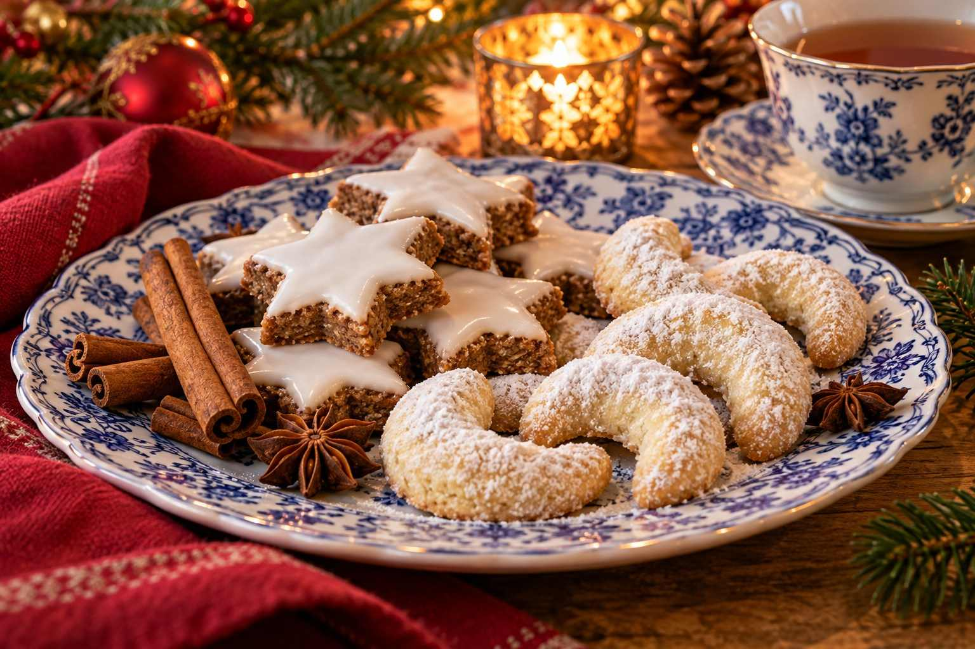

5. Gebrannte Mandeln (Candied Almonds)
Makes about 250 g (2 cups)
The irresistible scent of every Christmas market, made in your own kitchen in 15 minutes.
- 200 g (1⅓ cups) whole almonds, skin on
- 125 g (⅔ cup) sugar
- 100 ml (7 tbsp) water
- 1 teaspoon cinnamon
- 1 teaspoon vanilla sugar or ½ teaspoon vanilla extract
- In a wide, heavy pan, bring the water, sugar, cinnamon, and vanilla to a boil.
- Add the almonds and stir constantly over medium-high heat.
- The syrup will thicken and then crystallize into a dry, sandy coating. Keep stirring.
- Lower the heat and continue stirring until the sugar begins to melt again and coats the almonds in a shiny, caramelized glaze.
- Tip onto parchment paper at once, separate the almonds with two forks, and let cool.
ℹ GOOD TO KNOW
Hot sugar causes serious burns. Keep children at a safe distance while cooking, and let the almonds cool completely before tasting.

6. Reibekuchen (Potato Pancakes with Apple Sauce)
Serves 4
- 1 kg (2 lb) floury potatoes, peeled
- 1 onion
- 2 eggs
- 2–3 tablespoons flour or oats
- 1 teaspoon salt, pepper, pinch of nutmeg
- Vegetable oil for frying
- Apple sauce to serve
- Grate the potatoes and onion finely, then squeeze out as much liquid as possible in a clean kitchen towel.
- Mix with the eggs, flour, and seasonings.
- Heat 5 mm (¼ in) of oil in a skillet. Drop in heaped tablespoons of the mixture, flatten into thin rounds, and fry for 3–4 minutes per side until deep golden and crisp.
- Drain on paper towels and serve hot with apple sauce, as in Cologne, or with smoked salmon and sour cream.

7. Alsatian Tarte Flambée (Flammkuchen)
Makes 2 thin flatbreads
- 250 g (2 cups) all-purpose flour
- 125 ml (½ cup) water
- 2 tablespoons oil
- ½ teaspoon salt
- 200 g (¾ cup) crème fraîche or sour cream
- 1 large onion, very thinly sliced
- 150 g (5 oz) bacon lardons (or mushrooms for a vegetarian version)
- Pepper and a pinch of nutmeg
- Knead the flour, water, oil, and salt into a smooth dough. Rest for 30 minutes.
- Heat your oven as hot as it will go, ideally 250°C (480°F) or higher, with a baking tray or pizza stone inside.
- Roll the dough out as thinly as possible into two rectangles.
- Spread with crème fraîche, season with pepper and nutmeg, and scatter with onion and bacon.
- Bake for 8–10 minutes until the edges are crisp and blistered. Cut into strips and share at once, as they do in Alsace.

8. Austrian Kaiserschmarrn
Serves 2–3
- 4 eggs, separated
- 250 ml (1 cup) milk
- 150 g (1¼ cups) flour
- 2 tablespoons sugar, plus extra for caramelizing
- Pinch of salt
- 40 g (3 tbsp) raisins, soaked in rum or water
- 30 g (2 tbsp) butter
- Powdered sugar and plum compote or apple sauce to serve
- Whisk the yolks, milk, flour, and a pinch of salt into a smooth batter. Beat the whites with the sugar to stiff peaks and gently fold in.
- Melt the butter in a large skillet, pour in the batter, and scatter with raisins. Cook over medium heat until golden underneath.
- Cut into quarters, flip, and cook briefly. Then tear into bite-sized pieces with two forks.
- Sprinkle with a spoonful of sugar and toss until lightly caramelized.
- Dust with powdered sugar and serve with plum compote.

9. Swedish Glögg
Serves 8
- 1 bottle (750 ml) red wine
- 250 ml (1 cup) port or brandy (optional)
- 100 g (½ cup) sugar
- 1 orange peel, in strips
- 2 cinnamon sticks, 10 cloves, 8 cardamom pods (crushed), 1 small piece fresh ginger
- To serve: raisins and blanched slivered almonds
- Warm all ingredients except the raisins and almonds very gently for 30 minutes without boiling. For the best flavor, let steep overnight and reheat.
- Strain and serve in small cups, with a few raisins and almonds in each.

10. Homemade Chimney Cake (Trdelník / Kürtőskalács)
Makes 6
You do not need a charcoal spit to enjoy this market favorite. Wrap the dough around foil-covered rolling pins, thick wooden dowels, or even clean, foil-wrapped cans.
- 500 g (4 cups) all-purpose flour
- 1 packet (7 g) dried yeast
- 50 g (¼ cup) sugar
- 250 ml (1 cup) warm milk
- 2 eggs
- 60 g (¼ cup) melted butter, plus more for brushing
- Pinch of salt
- For the coating: 150 g (¾ cup) sugar mixed with 2 teaspoons cinnamon and 50 g (½ cup) chopped walnuts
- Knead the dough ingredients into a soft, smooth dough and let rise for 1 hour.
- Roll into a thin sheet, cut into long strips about 2 cm (¾ in) wide, and wind them around your greased, foil-covered cylinders, slightly overlapping.
- Brush with butter and roll in the cinnamon-sugar-walnut mixture.
- Bake at 200°C (400°F) for 15–20 minutes, turning once, until golden and caramelized.
- Slide off the cylinders and eat warm.
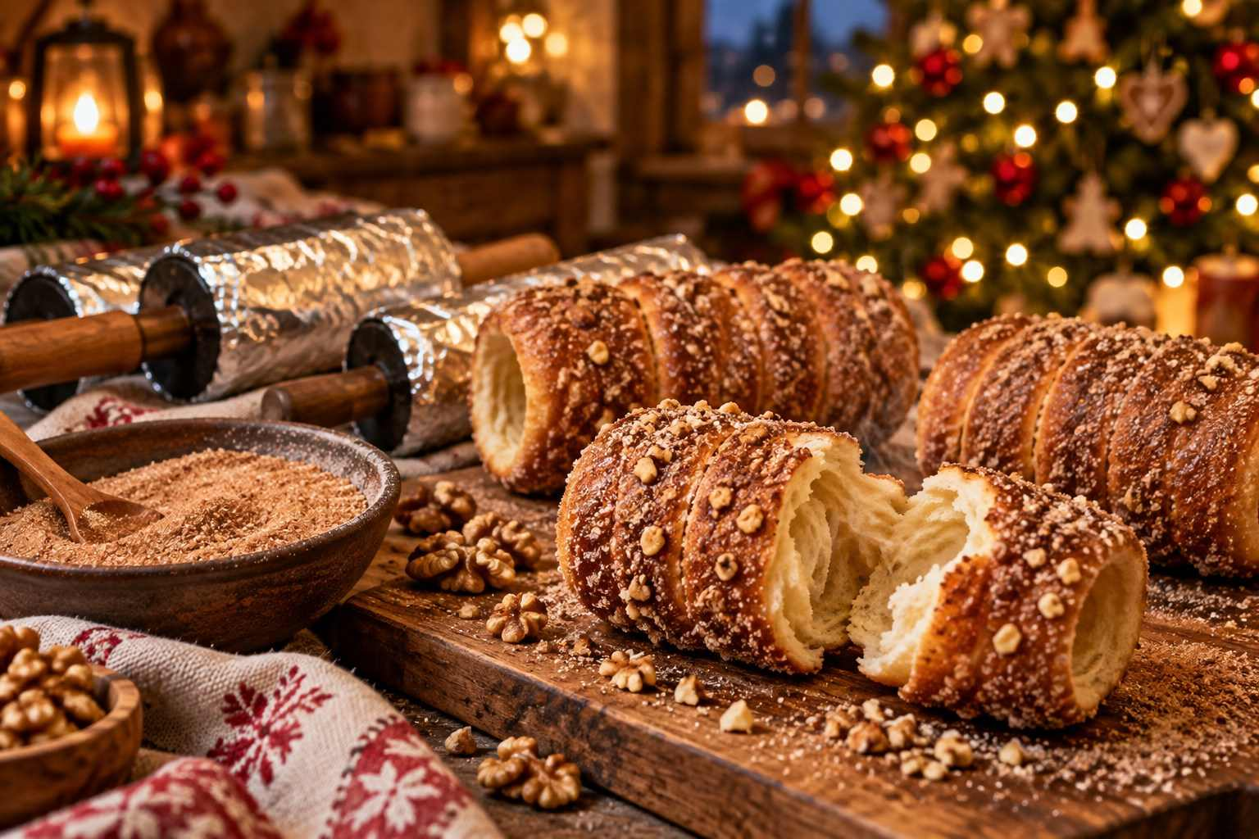

11. Hungarian Lángos
Makes 6
- 500 g (4 cups) flour
- 1 packet (7 g) dried yeast
- 1 teaspoon sugar
- 1 teaspoon salt
- 1 medium potato, boiled and mashed (optional, for softness)
- 300 ml (1¼ cups) warm water
- Oil for frying
- Toppings: garlic oil (crushed garlic in oil), sour cream, and grated cheese
- Combine the ingredients into a soft, sticky dough. Cover and let rise for 1 hour.
- With oiled hands, stretch pieces of dough into thin discs about 15 cm (6 in) wide, slightly thicker at the edges.
- Fry in hot oil for 1–2 minutes per side until golden and puffed.
- Brush with garlic oil, spread with sour cream, and top with grated cheese.

12. Heißer Äppler (Hot Spiced Apple Wine or Juice)
Serves 4
A Frankfurt favorite. For a family-friendly version, use cloudy apple juice.
- 1 liter (4 cups) hard apple cider or apple juice
- 2–3 tablespoons honey or sugar
- 1 cinnamon stick, 4 cloves, 1 star anise
- 1 lemon, sliced
- Warm everything gently for 15–20 minutes without boiling.
- Strain and serve in mugs with a slice of lemon, ideally in your favorite Christmas market mug.

Hosting a Christmas Market Evening at Home
Why not bring friends and family together for your own Christmas market evening?
- Set up "stalls": A mulled wine station, a potato pancake griddle, a cookie table, and a craft corner for making paper Herrnhut stars or straw ornaments.
- Use your collected mugs and invite guests to guess which market each came from.
- Play the music: A playlist of German, Austrian, and Czech carols, brass-band music, and Viennese waltzes.
- Light it up: Fairy lights, candles, and a candle arch in the window.
- Share your stories: Pass around your travel journal and photos, and start planning next year's trip together.
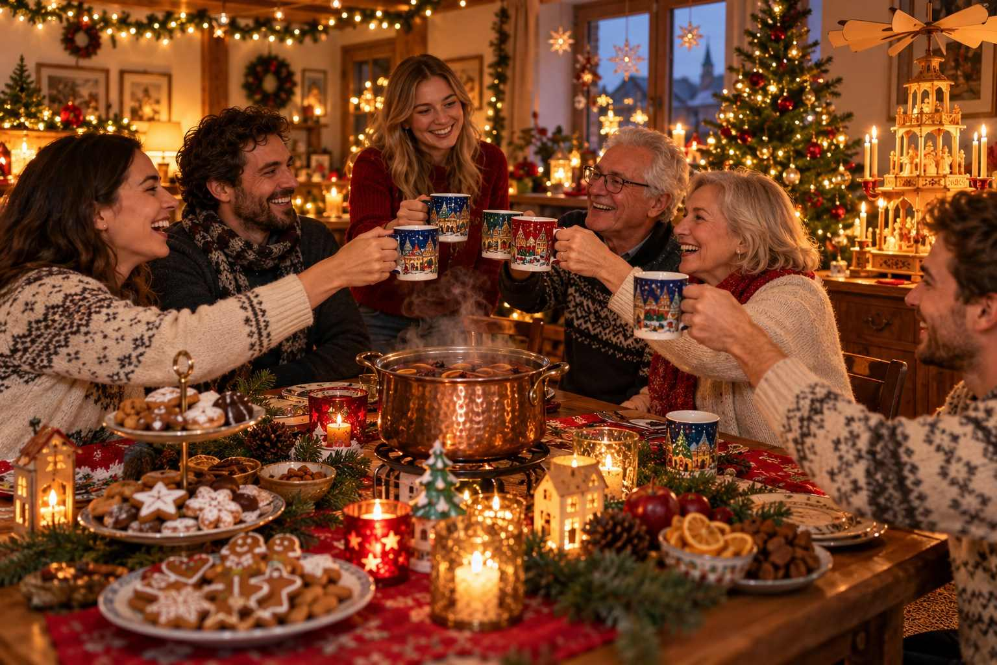

CHAPTER 20

Beyond the Markets: Advent, New Year's & Epiphany
— ❄ ✦ ❄ —
Candlelit concerts, midnight Mass, New Year's fireworks, and the Three Kings: the traditions that make the season complete.
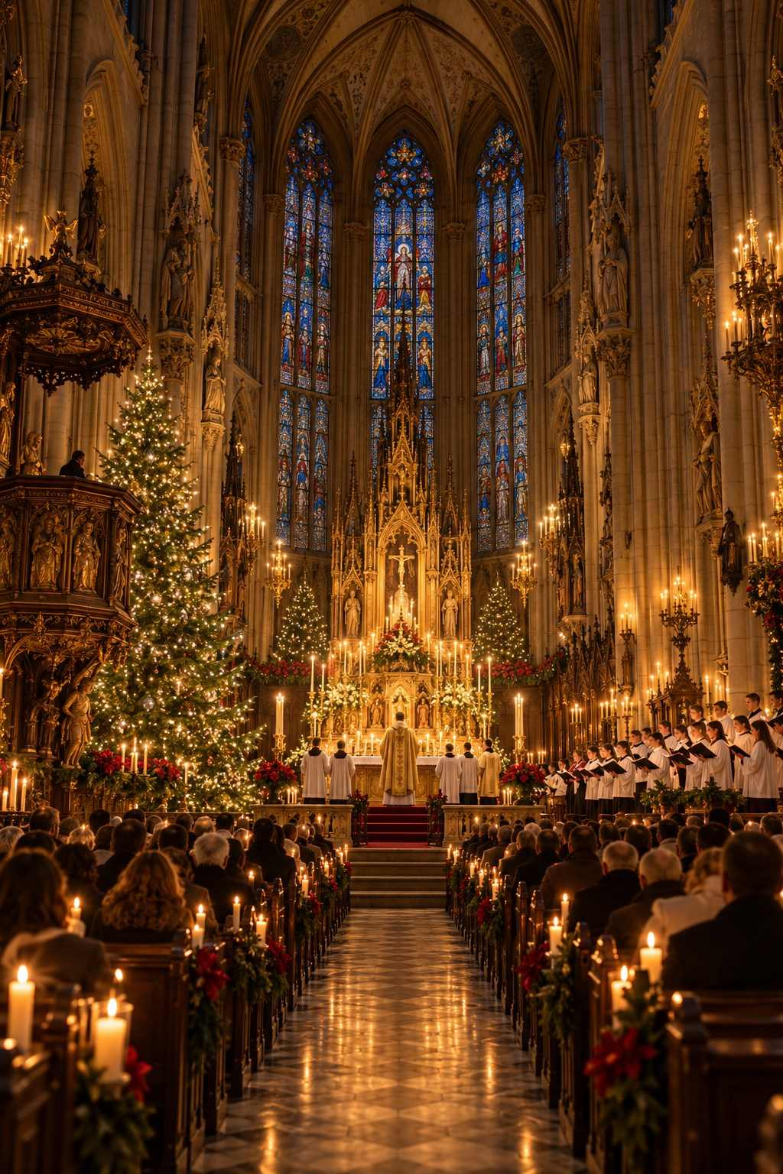

The Christmas markets may be the most visible part of the season in Europe, but they are only one thread in a rich tapestry of traditions. To truly experience Christmas in Europe, look beyond the stalls to the music, the churches, the family customs, and the celebrations that continue into the New Year.

Advent Concerts and Music
Advent is a season of music in Europe. Churches, cathedrals, palaces, and concert halls host an extraordinary variety of performances, many of them free or modestly priced.
- Vienna: The Vienna Boys' Choir sings Mass on Sundays at the Hofburg Chapel, and Advent concerts are held throughout the city. The Musikverein and the State Opera offer festive programs.
- Salzburg: The Salzburger Adventsingen, a beloved Advent musical performance in the Great Festival Hall, has been held for decades and sells out quickly.
- Leipzig: Bach's Christmas Oratorio at Saint Thomas Church, where Bach himself was cantor, is a pilgrimage for music lovers.
- Dresden: The Dresdner Kreuzchor, one of the oldest boys' choirs in the world, performs Advent vespers in the Kreuzkirche.
- Prague: Concerts of classical and baroque music are held almost every evening in the city's churches, including Saint Nicholas Church in the Lesser Town and the Church of Saint Francis near Charles Bridge.
- Scandinavia: Lucia concerts on and around December 13.
- United Kingdom: Carol services and the famous Nine Lessons and Carols tradition, broadcast from King's College, Cambridge, on Christmas Eve.
✦ INSIDER TIP
Check the websites of local cathedrals and churches for free Advent concerts, organ recitals, and candlelight services. These are often some of the most memorable and least expensive experiences of a Christmas trip.

Christmas Eve and Christmas Day in Europe
If you are traveling over Christmas itself, be prepared for a very different experience from North America.
- Christmas Eve (December 24) is the main celebration in most of Central Europe. Shops and markets close by early afternoon, and by evening, the streets are quiet as families gather for dinner and gift-giving. Restaurants may be closed or offer special set menus requiring reservations.
- Midnight Mass and other Christmas Eve services are held in churches and cathedrals. Visitors are welcome, but arrive early for major cathedrals, and dress respectfully.
- Christmas Day (December 25) and Saint Stephen's Day (December 26) are public holidays in Germany, Austria, and many other countries. Most shops, markets, and many attractions are closed. Plan ahead: book restaurants in advance, and buy supplies before December 24.
ℹ GOOD TO KNOW
In 2026, Christmas Eve falls on a Thursday and Christmas Day on a Friday, followed by the weekend. That means a long, quiet stretch from the afternoon of December 24 through December 27 in many cities. Many hotels offer special Christmas dinners, a wonderful option for travelers.

New Year's Eve: Silvester
New Year's Eve, known as Silvester in German-speaking countries (after Pope Saint Sylvester, whose feast day is December 31), is celebrated with enthusiasm across Europe.
- Vienna: The Silvesterpfad (New Year's Eve Trail) winds through the old town with stages, food stalls, and music. At midnight, the great Pummerin bell of Saint Stephen's Cathedral rings in the New Year, followed by the Blue Danube waltz, and everyone dances in the streets. On New Year's Day, the Vienna Philharmonic New Year's Concert is broadcast around the world.
- Berlin: A giant party at the Brandenburg Gate with music and fireworks.
- Prague: Fireworks over the Vltava River, often best viewed from the riverbanks or bridges.
- Budapest: Celebrations in the streets and fireworks over the Danube.
- Edinburgh: Hogmanay, with a torchlight procession, a street party, and fireworks over the castle.
- Copenhagen: Jump off a chair at midnight to "leap" into the New Year, as the Danes do.

New Year's Traditions to Try
- Bleigießen (Germany/Austria): Melting small pieces of tin in a spoon over a candle, dropping them into cold water, and interpreting the shapes to predict the year ahead. Many households now use wax instead.
- Lucky charms: Small figures of chimney sweeps, pigs, four-leaf clovers, horseshoes, and ladybugs are given as good-luck gifts. Look for marzipan pigs in German and Austrian bakeries.
- Dinner for One: A short black-and-white British comedy sketch shown on German television every New Year's Eve, a beloved cult tradition.
- Twelve grapes (Spain): Eating one grape for each stroke of midnight brings good luck for each month of the year.
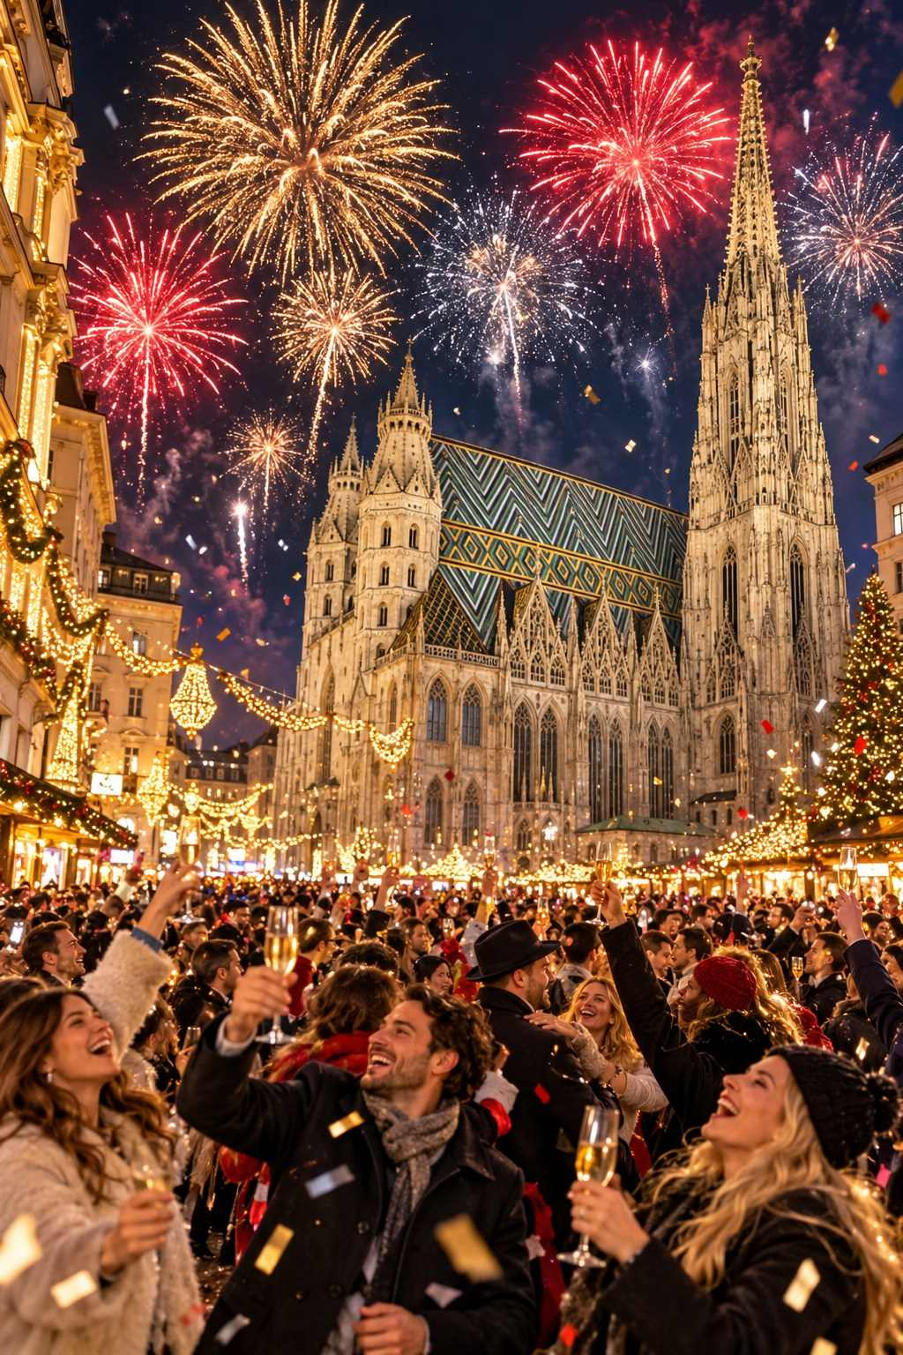

Epiphany and the Three Kings (January 6)
The Christmas season traditionally ends with Epiphany on January 6, commemorating the arrival of the Three Kings (the Magi) in Bethlehem. In 2027, Epiphany falls on a Wednesday.
- Germany and Austria: Between New Year's Day and Epiphany, children dressed as the Three Kings (the Sternsinger, or star singers) go from house to house, singing carols and collecting money for children's charities. They mark the doorframe with chalk: *20 C + M + B + 27*, standing for the year and Christus mansionem benedicat* ("May Christ bless this house"), also understood as the initials of the Kings Caspar, Melchior, and Balthasar.
- Italy: La Befana, a kindly old witch on a broomstick, brings sweets to good children and coal to naughty ones on the night of January 5.
- Spain: The spectacular Cabalgatas de Reyes parades on January 5, and children open their main presents on the morning of January 6.
- France: Families share a galette des rois, a puff-pastry cake filled with almond cream, containing a small hidden figurine (fève). Whoever finds it becomes king or queen for the day and wears a paper crown.
- Cologne: The relics of the Three Kings are kept in a magnificent golden shrine in Cologne Cathedral, making the city a place of pilgrimage for centuries.
★ DON'T MISS
Visit the golden Shrine of the Three Kings behind the high altar in Cologne Cathedral. Created in the late twelfth and early thirteenth centuries, it is the largest reliquary in the Western world and a masterpiece of medieval goldsmithing.

Winter Activities to Combine with the Markets
- Skiing and snowboarding in the Alps: Innsbruck, Salzburg, South Tyrol, and Switzerland are all close to excellent ski areas.
- Ice skating in city squares: Vienna, Prague, Budapest, Zagreb, Heidelberg, and many more.
- Thermal spas: Budapest's baths, Baden-Baden in Germany, the Merano Thermal Baths in Italy, and Austrian spa towns.
- Winter hiking and sledging in the mountains.
- Horse-drawn sleigh rides in Alpine villages.
- Northern Lights in Lapland and northern Norway.

The Magic of Staying Late
Many travelers go home before Christmas, but staying into the new year has real rewards. The crowds thin after December 26, hotel prices often drop (except around New Year's Eve), and markets that remain open take on a relaxed, local atmosphere. The decorations remain up until Epiphany, and the post-Christmas sales begin in many cities. If your schedule allows, consider spending Christmas at home and traveling between December 27 and January 6.
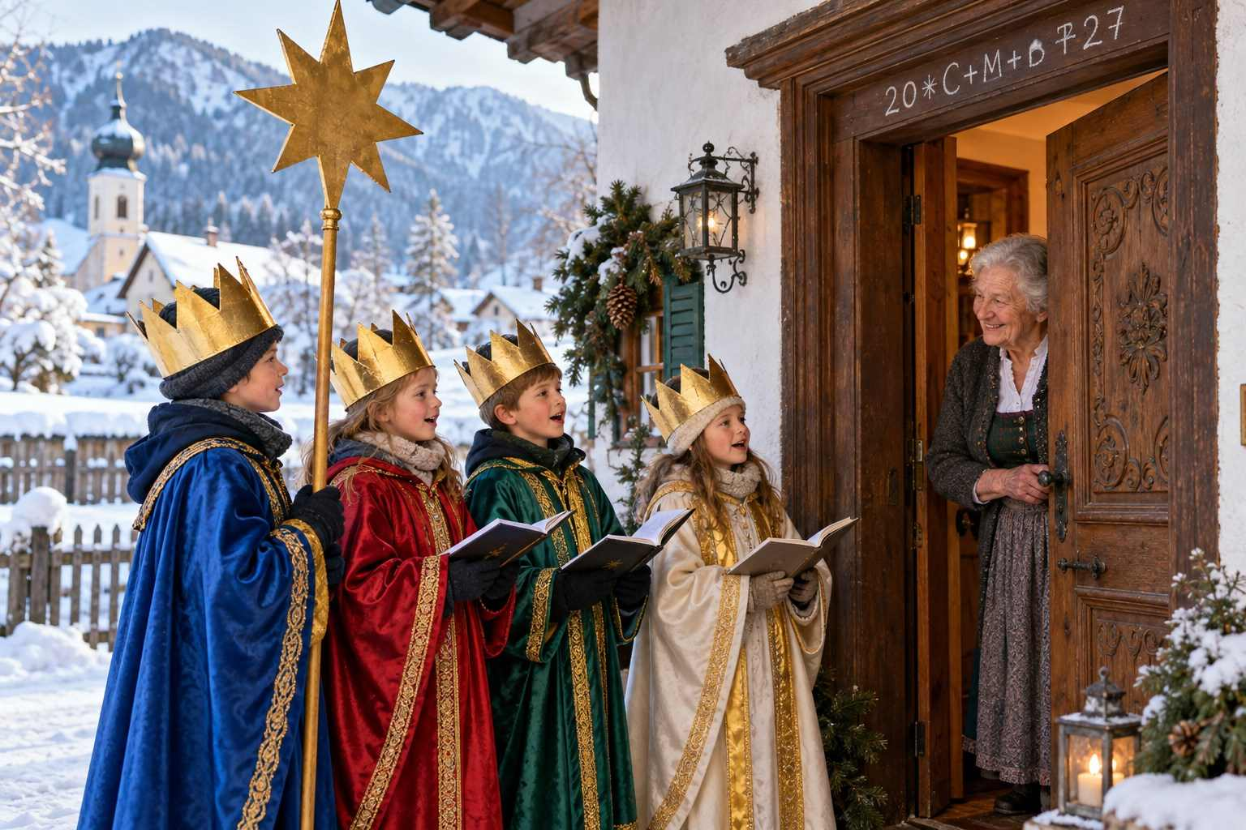

CHAPTER 21

Your Questions Answered
— ❄ ✦ ❄ —
Straight answers to the questions first-time market-goers ask most often.
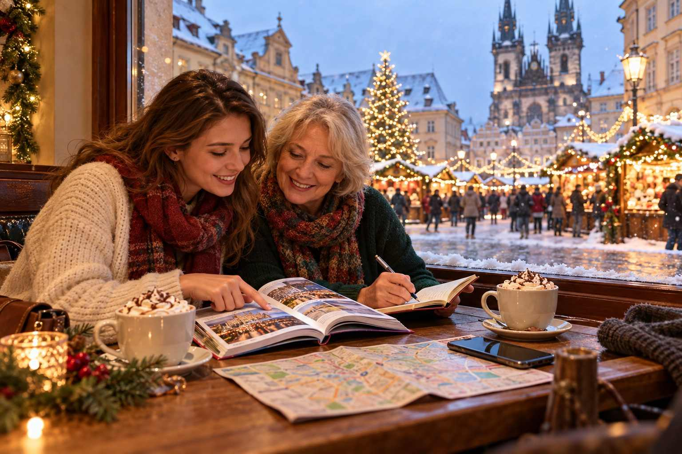

Over the years, the same questions come up again and again from travelers planning their first Christmas market trip. Here are the answers, gathered in one place.

Planning Questions

Which is the single best Christmas market in Europe?
There is no single answer, and anyone who tells you otherwise is guessing! For a first visit, many travelers find that Nuremberg, Strasbourg, Vienna, Dresden, Cologne, Colmar, and Prague live up to their reputations. For charm, the smaller towns of Rothenburg, Esslingen, and the Alsace wine villages are hard to beat. The best market for you depends on whether you love grand spectacle, fairy-tale villages, fine crafts, lively crowds, or quiet candlelight.

How far in advance should I book?
For popular towns such as Strasbourg, Colmar, Rothenburg, Salzburg, and Nuremberg, book hotels six to twelve months in advance, especially for weekends. For big cities, three to six months is usually enough. River cruises often sell out a year ahead.

Is it worth going if I can only go for a weekend?
Absolutely. A weekend in Vienna, Munich, Prague, Strasbourg, or Cologne can be wonderful, because each city has many markets within walking distance. Choose one city and perhaps a single day trip, and do not try to do too much.

Will there be snow?
Snow is never guaranteed in the cities, especially in western Germany, France, and the Netherlands, where December is more often gray and damp. Your chances improve in Bavaria, Austria, Switzerland, the Czech Republic, and Scandinavia, and at higher elevations. Mountain towns like Innsbruck, and anywhere in Lapland, are your best bets.

Are the markets open on Sundays?
Yes. Almost all Christmas markets are open on Sundays, and Sunday afternoons are often very busy. However, in Germany and Austria, most regular shops are closed on Sundays, so plan your non-market shopping for other days.

Are the markets open on Christmas Day?
Very few. Most German markets close on December 22 or 23, or at midday on December 24. A number of markets in Austria, the Czech Republic, Hungary, Croatia, Italy, Scandinavia, and elsewhere reopen on December 26 or continue into January, but almost all are closed on December 25.

Do I need to buy tickets for the markets?
Nearly all Christmas markets are free to enter. Exceptions include Tivoli Gardens in Copenhagen, the Valkenburg caves, the Ravenna Gorge, some castle and palace markets (such as Hohenzollern and Regensburg's Thurn und Taxis market), Óbidos Vila Natal, Hyde Park Winter Wonderland at busy times, and a few special themed markets.

At the Markets

How much money should I bring each day?
A comfortable budget for food and drink at the markets is roughly €30–45 per person per day in Germany and Austria, plus whatever you plan to spend on gifts. Carry €50–100 in small notes and coins, plus a contactless card.

Can I use my credit card?
Increasingly, yes, especially at larger markets and in Scandinavia, the Netherlands, and the UK. But many smaller stalls in Germany and Austria still prefer cash. Carry both.

What happens if I break a mug?
Accidents happen, and vendors are used to them. You simply lose your deposit. Some vendors will kindly waive it if you are honest about the mishap.

Is the mulled wine strong?
Standard Glühwein is similar in strength to ordinary wine, around 7–10 percent alcohol, but the heat and sugar make it easy to drink quickly. Versions "mit Schuss" (with a shot of spirits added) are much stronger. Pace yourself and eat something.

Can children visit the markets?
Of course! Christmas markets are very family-friendly, with carousels, children's areas, puppet shows, and plenty of treats. Children are welcome at all hours, though the late evening can get crowded.

Are dogs allowed?
Dogs on leashes are generally allowed in outdoor markets in Germany, Austria, and Switzerland, but crowds, dropped food, and hot drinks can be stressful for them. Some markets and many indoor venues do not allow dogs.

Are the markets safe?
Yes. Christmas markets are generally very safe, family-friendly places, with visible security in larger cities. The most common problem is pickpocketing in crowds, which you can avoid with sensible precautions (see Chapter 3).

Travel Questions

Should I rent a car or take the train?
For most travelers, the train is easier, more relaxing, and delivers you right to the city center. A car is useful for exploring rural areas such as the Alsace wine villages, the Black Forest, or the Romantic Road, but parking in cities during market season can be difficult and expensive.

Is a river cruise better than traveling independently?
It depends on your style. A cruise is easier, more social, and ideal if you dislike logistics or have limited mobility. Independent travel is more flexible and gives you more evening time at the markets, when they are at their best. See Chapter 16 for a full comparison.

What should I wear?
Dress for standing still outdoors in cold, damp air for several hours: thermal base layers, a warm waterproof coat, waterproof boots with good grip, and a hat, scarf, and gloves. Layers are key, because you will move between cold streets and warm cafés and churches.

Do I need to speak German?
No. English is widely spoken in tourist areas, especially by younger people. But a few words of the local language, such as "bitte," "danke," and "Frohe Weihnachten," are always appreciated and will bring smiles.

Can I bring food souvenirs home?
Most baked goods, chocolates, and sweets are fine for most countries, but meat products such as sausages and salami are generally prohibited in the United States and many other countries. Always declare food at customs. See Chapter 18 for details.

The Final Question

Will one trip be enough?
Probably not! Many travelers find that their first Christmas market trip becomes the start of a new tradition. Each year, there is another country to discover, another town to explore, and another mug to add to the collection. Consider yourself warned.
✦ INSIDER TIP
Before you leave each market town, write down three things you want to remember: a taste, a sound, and a moment. Years from now, those notes will bring the whole trip rushing back.

APPENDIX A

The 2026–2027 Market Calendar at a Glance
— ❄ ✦ ❄ —
A quick-reference guide to the season's major markets. "Published" means dates were announced by organizers at the time of writing; "Expected" means dates are based on each market's usual pattern. Always confirm before travel.
Market | Country | 2026–2027 Dates | Status
Schönbrunn Palace, Vienna | Austria | Nov 6 – Jan 6 | Published
Stephansplatz, Vienna | Austria | Nov 6 – Dec 26 | Published
Rathausplatz, Vienna | Austria | Nov 13 – Dec 26 | Published
Spittelberg, Am Hof, Freyung, Karlsplatz, Vienna | Austria | From Nov 13 | Published
Belvedere, Vienna | Austria | Nov 20 – Dec 31 | Published
Riesenradplatz, Vienna | Austria | Nov 20 – Jan 6 | Published
Salzburg Christkindlmarkt | Austria | Nov 19 – Jan 1 | Published
Innsbruck Old Town | Austria | Mid-Nov – Jan 6 | Expected
Cologne Harbour Market | Germany | Nov 13 – Jan 3 | Published
Cologne Cathedral Market | Germany | Nov 16 – Dec 23 | Published
Munich Christkindlmarkt | Germany | Nov 20 – Dec 24 | Listed
Aachen | Germany | Nov 20 – Dec 23 | Expected
Frankfurt Römerberg | Germany | Nov 23 – Dec 22 | Expected
Heidelberg | Germany | Nov 23 – Dec 22 | Expected
Hamburg Rathausmarkt | Germany | Nov 23 – Dec 23 | Expected
Leipzig | Germany | Nov 24 – Dec 23 | Expected
Dresden Striezelmarkt | Germany | Nov 25 – Dec 24 | Published
Stuttgart | Germany | Nov 25 – Dec 23 | Expected
Nuremberg Christkindlesmarkt | Germany | Nov 27 – Dec 24 | Published
Rothenburg Reiterlesmarkt | Germany | Nov 27 – Dec 23 | Expected
Berlin (most markets) | Germany | Late Nov – Dec 26/31 | Expected
Strasbourg | France | Late Nov – Dec 24 | Expected
Colmar | France | Late Nov – Dec 29 | Expected
Basel | Switzerland | Late Nov – Dec 23 | Expected
Montreux Noël | Switzerland | Late Nov – Dec 24 | Expected
Zurich | Switzerland | Late Nov – Dec 24 | Expected
Prague Old Town Square | Czech Republic | Nov 28 – Jan 6 | Published
Budapest Vörösmarty & Basilica | Hungary | Mid-Nov – Jan 1 | Expected
Brussels Winter Wonders | Belgium | Late Nov – early Jan | Expected
Bruges | Belgium | Late Nov – early Jan | Expected
Valkenburg Caves | Netherlands | Mid-Nov – Dec 23 | Expected
Tivoli Gardens, Copenhagen | Denmark | Nov 13 – Jan 3 | Published
Nyhavn, Copenhagen | Denmark | Nov 14 – Dec 20 | Published
Stockholm Stortorget | Sweden | Late Nov – Dec 23 | Expected
Tallinn Town Hall Square | Estonia | Late Nov – early Jan | Expected
Kraków Main Square | Poland | Late Nov – late Dec/early Jan | Expected
Advent in Zagreb | Croatia | Nov 28 – Jan 7 | Published
Bolzano | Italy | Late Nov – Jan 6 | Expected
Edinburgh | United Kingdom | Mid-Nov – early Jan | Expected

Key Dates of the Season
Date | Occasion
Sunday, November 22, 2026 | Totensonntag (many German markets open after this day)
Sunday, November 29, 2026 | First Sunday of Advent
Thursday, December 3, 2026 | Kraków szopki competition (first Thursday of December)
Friday, December 4, 2026 | Saint Barbara's Day
Saturday, December 5, 2026 | Krampus Night; Dresden Stollenfest (expected); Sinterklaas evening
Sunday, December 6, 2026 | Saint Nicholas Day; Second Sunday of Advent
Tuesday, December 8, 2026 | Feast of the Immaculate Conception (holiday in Austria, Italy, Spain); Lyon Festival of Lights around this date
Sunday, December 13, 2026 | Saint Lucia's Day; Third Sunday of Advent
Sunday, December 20, 2026 | Fourth Sunday of Advent
Thursday, December 24, 2026 | Christmas Eve
Friday, December 25, 2026 | Christmas Day
Saturday, December 26, 2026 | Saint Stephen's Day / Boxing Day
Thursday, December 31, 2026 | New Year's Eve (Silvester, Hogmanay)
Friday, January 1, 2027 | New Year's Day
Tuesday, January 5, 2027 | Three Kings parades in Spain; La Befana eve in Italy
Wednesday, January 6, 2027 | Epiphany

APPENDIX B

Pocket Phrasebook
— ❄ ✦ ❄ —
A few friendly words go a long way. Here are the phrases you will use most at the markets.

German (Germany, Austria, Switzerland, South Tyrol)
- Hello: Guten Tag (GOO-ten tahk); in Bavaria and Austria: Grüß Gott (grooss got)
- Good evening: Guten Abend (GOO-ten AH-bent)
- Please / You're welcome: Bitte (BIT-tuh)
- Thank you: Danke (DAHN-kuh)
- Merry Christmas: Frohe Weihnachten (FRO-uh VYE-nahk-ten)
- Happy New Year: Frohes neues Jahr (FRO-es NOY-es yar)
- One mulled wine, please: Einen Glühwein, bitte (EYE-nen GLOO-vine, BIT-tuh)
- How much does it cost? Was kostet das? (vahs KOS-tet dahs)
- The deposit, please: Das Pfand, bitte (dahs pfahnt, BIT-tuh)
- Is this spot free? Ist hier noch frei? (ist heer nokh fry)
- Cheers! Prost! (prohst)
- Where is the toilet? Wo ist die Toilette? (vo ist dee toy-LET-tuh)

French (France, Belgium, Switzerland)
- Hello: Bonjour (bohn-ZHOOR)
- Good evening: Bonsoir (bohn-SWAHR)
- Please: S'il vous plaît (seel voo PLAY)
- Thank you: Merci (mair-SEE)
- Merry Christmas: Joyeux Noël (zhwah-YUH no-EL)
- Happy New Year: Bonne année (bun ah-NAY)
- One mulled wine, please: Un vin chaud, s'il vous plaît (uhn van SHOW, seel voo PLAY)
- How much is it? C'est combien? (say kohm-bee-EN)
- Cheers! Santé! (sahn-TAY)

Czech (Czech Republic)
- Hello: Dobrý den (DOH-bree den)
- Please / You're welcome: Prosím (PRO-seem)
- Thank you: Děkuji (DYEH-koo-yee)
- Merry Christmas: Veselé Vánoce (VEH-seh-leh VAH-no-tseh)
- Happy New Year: Šťastný nový rok (SHTYAST-nee NO-vee rok)
- One mulled wine, please: Jeden svařák, prosím (YEH-den SVAR-zhahk, PRO-seem)
- Cheers! Na zdraví! (nah ZDRAH-vee)

Hungarian (Hungary)
- Hello: Jó napot (yoh NAH-pot)
- Please: Kérem (KAY-rem)
- Thank you: Köszönöm (KUR-sur-num)
- Merry Christmas: Boldog karácsonyt (BOL-dog KAH-rah-chony-t)
- Happy New Year: Boldog új évet (BOL-dog ooy AY-vet)
- Cheers! Egészségedre! (EG-ace-shay-ged-reh)

Italian (Italy)
- Hello: Buongiorno (bwon-JOR-no)
- Please: Per favore (pair fah-VO-reh)
- Thank you: Grazie (GRAHT-see-eh)
- Merry Christmas: Buon Natale (bwon nah-TAH-leh)
- Happy New Year: Felice anno nuovo (feh-LEE-cheh AHN-no NWO-vo)
- Cheers! Salute! / Cin cin! (sah-LOO-teh / chin chin)

Polish (Poland)
- Hello: Dzień dobry (jen DOB-ri)
- Please: Proszę (PRO-sheh)
- Thank you: Dziękuję (jen-KOO-yeh)
- Merry Christmas: Wesołych Świąt (veh-SWO-ih SHVYONT)
- Cheers! Na zdrowie! (nah ZDRO-vyeh)

Dutch (Netherlands, Flanders)
- Hello: Hallo / Goedendag (HAH-lo / KHOO-den-dakh)
- Please: Alstublieft (AHL-stoo-bleeft)
- Thank you: Dank u wel (dahnk oo vel)
- Merry Christmas: Vrolijk kerstfeest (VRO-luk KERST-fayst)
- Cheers! Proost! (prohst)

Scandinavian Greetings
- Danish: Glædelig jul (GLEH-deh-lee yool)
- Swedish: God jul (goo yool)
- Norwegian: God jul (goo yool)
- Finnish: Hyvää joulua (HUE-va-ah YO-loo-ah)

APPENDIX C

Packing Checklist
— ❄ ✦ ❄ —
Tick off each item as you pack. Staying warm and comfortable is the secret to enjoying the markets.

Documents and Money
☐ Passport (valid at least three months beyond departure)
☐ ETIAS / UK ETA authorization, if required
☐ Flight, train, hotel, and cruise confirmations
☐ Travel insurance documents
☐ Credit and debit cards (no foreign transaction fees)
☐ Small amount of local currency in small notes and coins
☐ Photocopies or photos of important documents
☐ Driver's license and International Driving Permit (if renting a car)

Clothing
☐ Warm, waterproof coat
☐ Thermal base layers (tops and bottoms)
☐ Sweaters and fleece layers
☐ Warm trousers or jeans
☐ Waterproof boots with good grip
☐ Comfortable shoes for indoor sightseeing
☐ Wool socks (several pairs)
☐ Hat, scarf, and gloves (touchscreen-friendly)
☐ Smart outfit for concerts or festive dinners
☐ Sleepwear and underwear
☐ Swimsuit (for thermal baths and spas)

Health and Comfort
☐ Prescription medications in original packaging
☐ Pain relievers and cold remedies
☐ Hand and foot warmers
☐ Lip balm and rich hand cream
☐ Tissues and hand sanitizer
☐ Reusable water bottle or small flask
☐ Ice cleats (for snowy regions)

Gear and Gadgets
☐ Phone and charger
☐ Portable power bank
☐ European plug adapter (Type C/F; Type G for UK and Ireland)
☐ Camera and spare batteries
☐ Crossbody or anti-theft bag
☐ Foldable shopping tote
☐ Compact umbrella
☐ Offline maps and translation app downloaded

For Your Treasures
☐ Bubble wrap and tissue paper
☐ Small hard-sided container for ornaments
☐ Extra foldable bag for souvenirs
☐ Zip-top bags for food items

APPENDIX D

My Christmas Market Planner & Journal
— ❄ ✦ ❄ —
Use these pages to plan your route before you go and to capture your favorite memories while you travel.

My Trip at a Glance
Travel dates:
Departure city:
Arrival city:
Countries I will visit:
Travel companions:
Budget per day:
Must-see market:
Must-taste treat:
Must-buy souvenir:

My Route
Night | City | Hotel | Markets to Visit
1
2
3
4
5
6
7
8
9
10

My Market Memories
❖ MARKET 1
Market and city:
Date and weather:
What I saw:

What I tasted:
What I bought:
My favorite moment:

❖ MARKET 2
Market and city:
Date and weather:
What I saw:

What I tasted:
What I bought:
My favorite moment:

❖ MARKET 3
Market and city:
Date and weather:
What I saw:

What I tasted:
What I bought:
My favorite moment:

❖ MARKET 4
Market and city:
Date and weather:
What I saw:

What I tasted:
What I bought:
My favorite moment:

❖ MARKET 5
Market and city:
Date and weather:
What I saw:

What I tasted:
What I bought:
My favorite moment:

❖ MARKET 6
Market and city:
Date and weather:
What I saw:

What I tasted:
What I bought:
My favorite moment:

❖ MARKET 7
Market and city:
Date and weather:
What I saw:

What I tasted:
What I bought:
My favorite moment:

❖ MARKET 8
Market and city:
Date and weather:
What I saw:

What I tasted:
What I bought:
My favorite moment:

❖ MARKET 9
Market and city:
Date and weather:
What I saw:

What I tasted:
What I bought:
My favorite moment:

❖ MARKET 10
Market and city:
Date and weather:
What I saw:

What I tasted:
What I bought:
My favorite moment:

My Daily Budget Tracker
Day | Food & Drink | Gifts | Transport | Other | Total
1
2
3
4
5
6
7
8
9
10

My Gift List
For | Gift Idea | Where to Buy | Bought?

My Mug Collection
Market | Year | Design | Kept or Returned?

Notes and Wishes for Next Year

More Notes

APPENDIX E

Useful Resources
— ❄ ✦ ❄ —
Official websites are the most reliable source for dates, hours, and events. Bookmark the ones you need.

Official Tourism Websites
- Germany: germany.travel
- Nuremberg Christkindlesmarkt: christkindlesmarkt.de
- Dresden: dresden.de and marketing.dresden.de
- Cologne: cologne-tourism.com
- Munich: muenchen.travel
- Austria: austria.info
- Vienna: wien.info
- Salzburg: salzburg.info and christkindlmarkt.co.at
- Strasbourg: noel.strasbourg.eu
- Alsace: visit.alsace
- Switzerland: myswitzerland.com
- Prague: prague.eu
- Budapest: budapestinfo.hu
- Belgium: visitflanders.com and visitwallonia.com
- Netherlands: holland.com
- Denmark: visitcopenhagen.com and tivoli.dk
- Sweden: visitstockholm.com
- Poland: poland.travel
- Croatia: infozagreb.hr
- Italy (South Tyrol): suedtirol.info

Travel and Transport
- Deutsche Bahn (Germany): bahn.com
- ÖBB (Austria): oebb.at
- SBB (Switzerland): sbb.ch
- SNCF (France): sncf-connect.com
- České dráhy (Czech Republic): cd.cz
- Eurail: eurail.com
- European Union travel information and ETIAS: travel-europe.europa.eu
- UK Electronic Travel Authorisation: gov.uk

APPENDIX F

Markets by Theme
— ❄ ✦ ❄ —
Not sure where to start? Find the markets that match the kind of trip you are dreaming of.

Best for Romance
- Colmar, France: Canals, half-timbered houses, and lights reflected in the water of Petite Venise.
- Heidelberg, Germany: Ice skating beneath the floodlit castle ruins.
- Salzburg, Austria: Mozart, choirs, and the Silent Night Chapel.
- Bruges, Belgium: Horse-drawn carriages and candlelit canals.
- Lake Wolfgang, Austria: Boats between village markets and a floating lantern on the lake.
- Montreux, Switzerland: Lakeside chalets with the Alps across the water.

Best for Families
- Nuremberg, Germany: The Kinderweihnacht children's market and the lantern procession.
- Hamburg, Germany: Santa's flying sleigh and Miniatur Wunderland nearby.
- Stuttgart, Germany: Children's Christmas Land with a miniature railway.
- Vienna, Austria: Ice skating paths and cookie-baking workshops at Rathausplatz.
- Copenhagen, Denmark: Tivoli Gardens, with its rides and Nordic magic.
- Rovaniemi, Finland: Santa Claus Village on the Arctic Circle.

Best for Food Lovers
- Strasbourg and Alsace, France: Tarte flambée, bredele, choucroute, and Alsatian wine.
- Dresden, Germany: Real Christstollen and Eierpunsch.
- Nuremberg, Germany: Rostbratwurst and Elisenlebkuchen.
- Munich, Germany: Bavarian roast pork, Tollwood's organic world food, and Christmas beer.
- Budapest, Hungary: Lángos, chimney cake, stuffed cabbage, and goulash.
- Bolzano, Italy: Speck, Schlutzkrapfen, and Alpine-Italian treats.

Best for Handcrafts
- Dresden and the Erzgebirge, Germany: Nutcrackers, pyramids, candle arches, and smoking men.
- Salzburg, Austria: Carved nativity figures and traditional Alpine crafts.
- Vienna's Spittelberg and Karlsplatz, Austria: Original art and quality Austrian artisan work.
- Budapest's Vörösmarty Square, Hungary: Jury-selected folk art and handcrafts.
- Basel, Switzerland: Hand-blown ornaments and elegant decorations.
- Kraków, Poland: Glittering szopki, amber, and hand-painted glass.

Best on a Budget
- Kraków and Wrocław, Poland
- Bratislava, Slovakia
- Zagreb, Croatia
- Brno and Prague's neighborhood markets, Czech Republic
- Sibiu and Brașov, Romania
- Tallinn and Riga, the Baltics

Best Medieval and Historic Settings
- Esslingen, Germany: A full medieval market with blacksmiths and torchlight.
- Rothenburg ob der Tauber, Germany: A walled medieval town straight from a storybook.
- Munich's Wittelsbacherplatz, Germany: Medieval market in the heart of the city.
- Dresden's Stallhof, Germany: A medieval market in the Royal Palace courtyard.
- Ribeauvillé, France: Minstrels, jugglers, and fire-eaters on Advent weekends.
- Tallinn, Estonia: A market in one of Europe's best-preserved medieval old towns.

Best Unusual Settings
- Valkenburg, Netherlands: Markets deep inside ancient caves.
- Ravenna Gorge, Germany: A forest market beneath a glowing railway viaduct.
- Traben-Trarbach, Germany: A market in historic wine cellars.
- Goslar, Germany: A Christmas forest of lit fir trees in the market square.
- Rattenberg, Austria: A whole town lit only by candles and torches.
- Zurich, Switzerland: A market inside the main railway station.

Best Open After Christmas
- Vienna, Austria: Schönbrunn and Riesenradplatz until January 6.
- Prague, Czech Republic: Old Town Square until January 6.
- Zagreb, Croatia: Advent until January 7.
- Salzburg, Austria: Christkindlmarkt until January 1.
- Copenhagen, Denmark: Tivoli until January 3.
- Cologne, Germany: The Harbour Market until January 3.
- Bolzano, Italy: Until Epiphany.

Best for Easy Access
- Cologne, Germany: The cathedral market is right outside the main station.
- Frankfurt, Germany: Minutes from one of Europe's biggest airports.
- Zurich, Switzerland: Ten minutes by train from the airport.
- Munich, Germany: Good step-free public transport and flat, paved squares.
- Vienna, Austria: Large paved squares and excellent public transport.
✦ INSIDER TIP
Mix and match themes. A week that combines one grand city, one fairy-tale town, and one unusual setting makes for a trip full of variety and surprises.

A FINAL NOTE

Until Next Christmas
— ❄ ✦ ❄ —
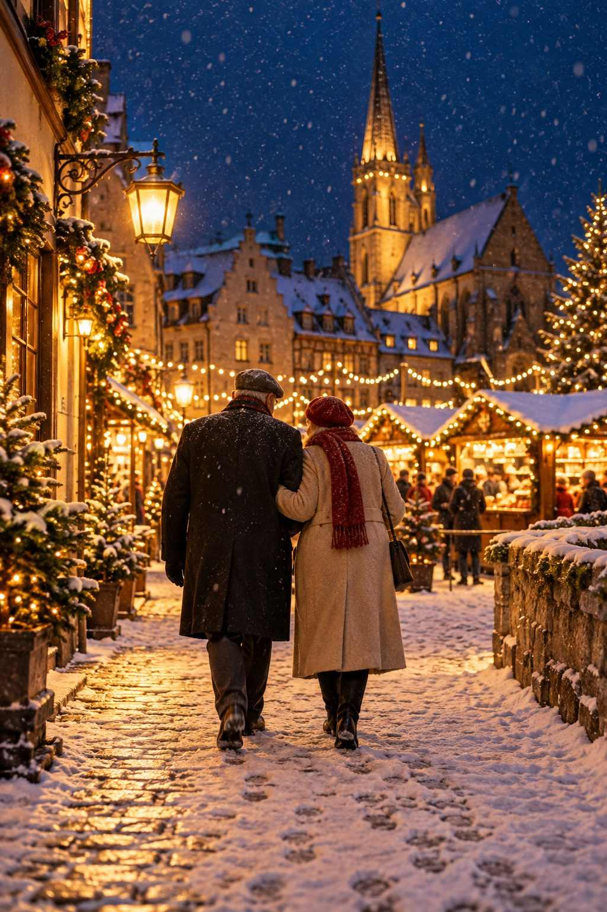

Ask anyone who has traveled to the Christmas markets what they remember most, and it is rarely the grand sights that come to mind first. It is the small moments. A stallholder who takes the time to explain how her grandfather carved the angels she still sells. A choir of schoolchildren singing in a snowy square. A stranger who shares his table and his potato pancakes. The quiet of a village church on Christmas Eve, candles flickering, the whole world holding its breath.
These markets have endured for more than six hundred years because they give us something we all need: a reason to gather, to slow down, and to find light in the darkest weeks of the year. I hope this guide helps you find those moments for yourself.
Travel slowly. Stay until the lights come on. Talk to the people behind the stalls. Try the food you cannot pronounce. Buy the ornament that makes you smile. And when you are standing in some ancient square, a warm mug in your hands and the scent of cinnamon in the air, take a moment to remember that you are part of a very old and very beautiful story.
Wherever your travels take you this season, I wish you a Christmas full of wonder.
Frohe Weihnachten, and safe travels.
Shelli A. Hibbard

About the Author
Shelli A. Hibbard is a travel writer with a lifelong love of Europe's winter traditions. Her guides are written for curious, practical travelers who want to experience the magic of a place and to plan their trips with confidence. When she is not wandering through candlelit squares with a mug of mulled wine, she is planning her next journey.
If you enjoyed this guide, please consider leaving a review. Your feedback helps other travelers discover the magic of Europe's Christmas markets, and helps shape future editions.

