#### 运行Welcome类：

运行脚本文件：run1.bat

set JAVA_HOME=D:\java11

set PROJECT_HOME=D:\JavaHomework\ch1_homework

set path=%path%;%JAVA_HOME%\bin

set classpath=%classpath%;%PROJECT_HOME%\chapter1\class

java -classpath %classpath% homework.ch1.Welcome

pause

运行结果：

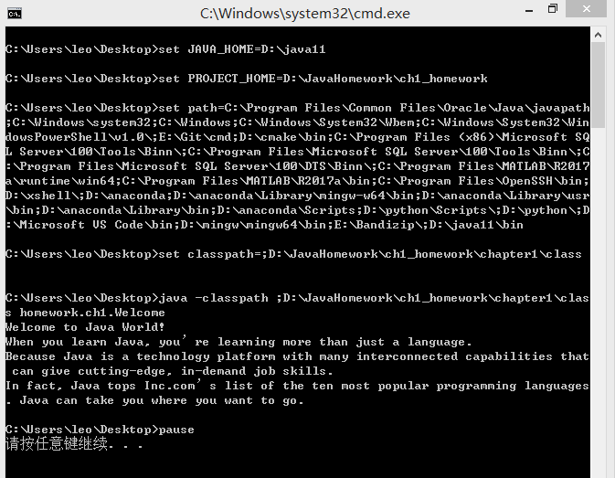

#### 运行run.jar中的Welcome类：

运行脚本文件：run2.bat

set JAVA_HOME=D:\java11

set PROJECT_HOME=D:\JavaHomework\ch1_homework

set path=%path%;%JAVA_HOME%\bin

set classpath=%classpath%;%PROJECT_HOME%\chapter1\jar\run.jar

java -classpath %classpath% homework.ch1.Welcome

pause

运行结果：

