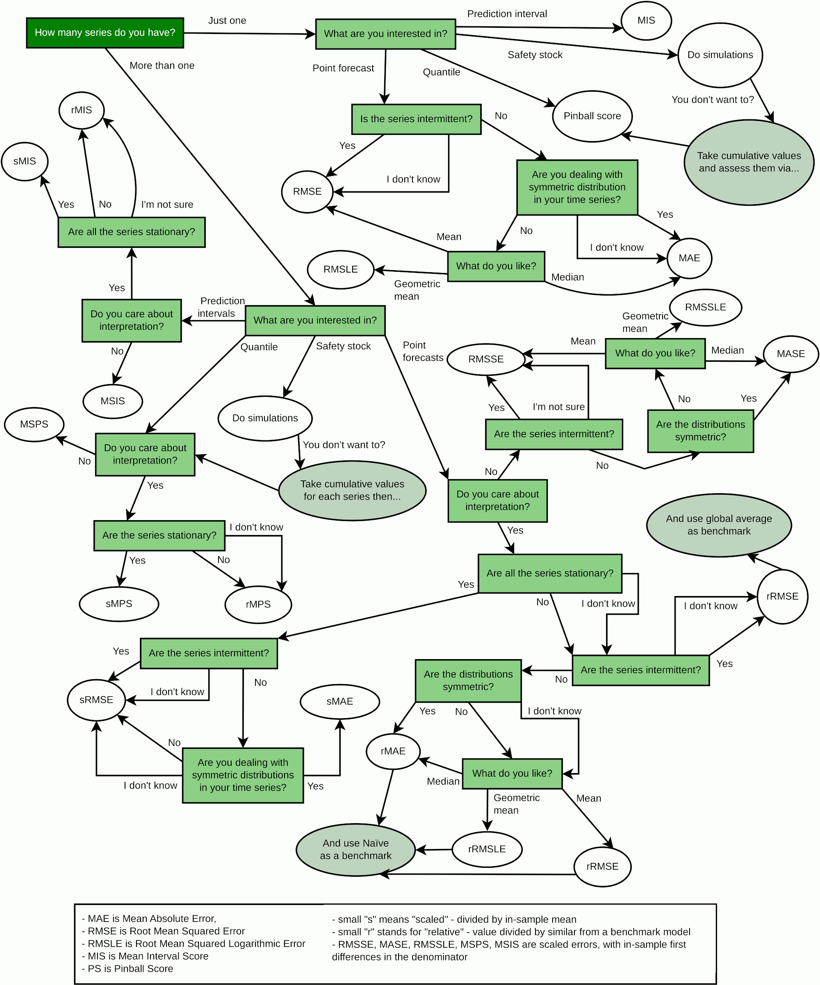
Developed by Ivan Svetunkov, CMAF, Lancaster University. https://forecasting.svetunkov.ru/
See more about error measures at https://openforecast.org/adam/forecastsEvaluation.html

