Merchant Realms
Economy Diversity Audit
━━━━━━━━━━━━━━━━━━━━━━━━
Year 1 — 360 Days of Economic Simulation
Generated: March 27, 2026
19 Towns • 4 Kingdoms • 73 Resources

1. Executive Summary
This audit examines 360 days (1 in-game year) of economic activity across the world of Merchant Realms, tracking market prices, kingdom treasuries, trade opportunities, and demographic changes across 13 data points (initial + 12 monthly snapshots).
Key Findings
• Price Trends: Average prices increased by 43.5% over the year (49.8 → 71.5 gold average).
• Money Supply: Total money supply grew by 764.3% (248,512 → 2,148,003 gold).
• Population: World population grew by 50.9% (4456 → 6725).
• Wars: 6 war event(s) recorded across all kingdoms during the year.
• Best Trade Opportunity: Fish: Buy at Coral Haven (0.8g) → Sell at Marshton (11g) for 1308% profit.
• Most Volatile Goods: Wood (345%), Wheat (256%), Planks (229%), Tools (201%), Stone (195%)
• Most Stable Goods: Waterskin (41%), Camping Kit (41%), Tent (41%), Bedroll (41%), Cider (41%)

2. Price Analysis
Comprehensive analysis of market prices across all towns and resources, showing price ranges, volatility, and geographic price differences.
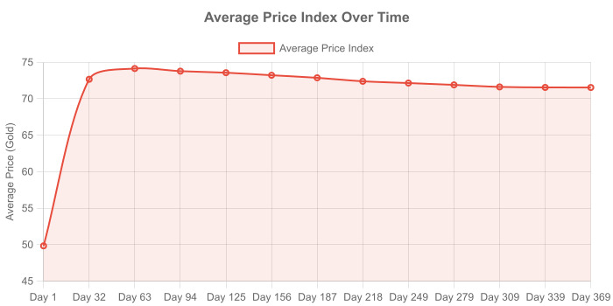
Raw Goods
Resource | Base | Min | Max | Avg | Range | Vol% | Cheapest | Most Expensive
Wheat | 2 | 0.4 | 3.6 | 1.3 | 3.2 | 256% | Windhill (0.5) | New Crossing (2.6)
Iron Ore | 12 | 2.1 | 26.2 | 13.5 | 24.1 | 179% | Marshton (2.6) | Tidewatch (22.2)
Wood | 5 | 1.3 | 15 | 4 | 13.8 | 345% | Elmcrest (1.5) | Watch Haven (11.8)
Stone | 6 | 1.3 | 18.1 | 8.6 | 16.8 | 195% | Ivybridge (2.6) | Watch Haven (14.4)
Wool | 4 | 0.9 | 6.4 | 4.2 | 5.5 | 133% | Windhill (1.1) | Silverstream (6.1)
Hide | 5 | 1.3 | 8 | 6.3 | 6.8 | 107% | Hawksrest (1.6) | Portmoor (7.7)
Grapes | 4 | 2.3 | 6.5 | 5.7 | 4.1 | 73% | Goldleaf (3) | Ivybridge (6.1)
Gold Ore | 20 | 14.7 | 32.2 | 29 | 17.5 | 60% | New Crossing (21.2) | Ivybridge (30.4)
Salt | 7 | 1.2 | 11.3 | 7.5 | 10 | 134% | Coral Haven (1.9) | Coldspring (10.4)
Hemp | 3 | 0.8 | 4.8 | 4 | 4.1 | 101% | Silverstream (1) | Ivybridge (4.6)
Clay | 4 | 4 | 6.5 | 5.9 | 2.5 | 41% | Camp Bluff (5.4) | Portmoor (6.2)
Honey | 8 | 7.2 | 12.9 | 11.8 | 5.7 | 48% | Camp Bluff (10.9) | Portmoor (12.3)
Herbs | 3 | 2.6 | 4.8 | 4.4 | 2.2 | 50% | Post Hill (3.6) | Portmoor (4.6)
Processed Goods
Resource | Base | Min | Max | Avg | Range | Vol% | Cheapest | Most Expensive
Flour | 8 | 2 | 12.6 | 7.2 | 10.6 | 146% | Ivybridge (2.5) | Tidewatch (12.1)
Iron Bars | 22 | 5 | 35.4 | 27.4 | 30.5 | 111% | Vinehill (9.9) | The Shattered Reef (33)
Planks | 10 | 2.5 | 30.1 | 12 | 27.6 | 229% | Ivybridge (3.1) | East Crossing (28.5)
Cloth | 8 | 2 | 12.7 | 7.3 | 10.7 | 146% | Marshton (2.5) | Oldcliff (11.9)
Leather | 10 | 2.6 | 16.1 | 13.2 | 13.5 | 103% | Ivybridge (5.5) | Highwall (15.2)
Bricks | 12 | 3 | 36.1 | 19.1 | 33.1 | 173% | Ivybridge (12.5) | Post Hill (34.3)
Rope | 10 | 4.2 | 16.1 | 13.4 | 11.9 | 89% | Uppermill (8.5) | Portmoor (15.4)
Gut String | 12 | 11.7 | 19.3 | 17.7 | 7.7 | 43% | Uppermill (16.2) | Portmoor (18.5)
Food Goods
Resource | Base | Min | Max | Avg | Range | Vol% | Cheapest | Most Expensive
Bread | 5 | 1.3 | 8 | 4.1 | 6.8 | 165% | Elmcrest (1.6) | Coral Haven (6.9)
Meat | 10 | 2.3 | 17.5 | 12 | 15.3 | 127% | Ivybridge (5) | Coldspring (15.9)
Eggs | 2 | 0.5 | 3.2 | 2 | 2.7 | 139% | Orchard End (0.7) | Goldleaf (3)
Poultry | 10 | 10 | 16.1 | 14.8 | 6.1 | 41% | Camp Bluff (13.6) | Portmoor (15.4)
Fish | 5 | 0.8 | 11.3 | 5.7 | 10.5 | 185% | Tidewatch (0.9) | Hawksrest (10.6)
Preserved Food | 30 | 23.2 | 48.3 | 43.1 | 25.2 | 58% | Ravensbrook (31.7) | Portmoor (46.2)
Vegetables | 3 | 2.5 | 4.8 | 4.4 | 2.3 | 53% | Post Hill (3.5) | Portmoor (4.6)
Finished Goods
Resource | Base | Min | Max | Avg | Range | Vol% | Cheapest | Most Expensive
Clothes | 18 | 4.7 | 29 | 23.8 | 24.3 | 102% | Hawksrest (6.5) | Highwall (27.3)
Tools | 30 | 7.6 | 83.4 | 37.7 | 75.8 | 201% | Ivybridge (9.4) | North Point (47.1)
Furniture | 30 | 29.9 | 48.3 | 44.2 | 18.4 | 42% | Portmoor (39.5) | Ivybridge (45.6)
Saddles | 35 | 9.1 | 56.3 | 49.8 | 47.2 | 95% | Hawksrest (13.3) | Portmoor (53.8)
Luxury Goods
Resource | Base | Min | Max | Avg | Range | Vol% | Cheapest | Most Expensive
Wine | 25 | 6.4 | 40.1 | 26.7 | 33.7 | 126% | Vinehill (8.3) | Post Hill (35.7)
Jewelry | 50 | 18.8 | 78 | 56.2 | 59.2 | 105% | Silverstream (42) | West Haven (72.3)
Pearls | 40 | 24.3 | 64.4 | 48.1 | 40.1 | 83% | Goldleaf (28) | Hawksrest (60.7)
Drum | 20 | 5.1 | 32.2 | 26.7 | 27.1 | 102% | Hawksrest (7.1) | Portmoor (30.7)
Flute | 12 | 12 | 19.3 | 17.8 | 7.3 | 41% | Camp Bluff (16.3) | Portmoor (18.5)
Lute | 25 | 22.6 | 40.3 | 36 | 17.7 | 49% | Ivybridge (23.6) | Portmoor (38.5)
Harp | 60 | 60 | 96.7 | 89 | 36.7 | 41% | Camp Bluff (81.6) | Portmoor (92.4)
Hurdy-Gurdy | 90 | 90 | 145 | 133.5 | 55 | 41% | Camp Bluff (122.4) | Portmoor (138.7)
Silk | 35 | 21.7 | 56.3 | 46 | 34.6 | 75% | Windhill (32) | Hawksrest (53.1)
Perfume | 45 | 45 | 72.5 | 66.6 | 27.5 | 41% | Camp Bluff (61.2) | Portmoor (69.3)
Fine Clothes | 60 | 27 | 96.7 | 85.8 | 69.7 | 81% | Silverstream (54.2) | Portmoor (92.3)
Tapestry | 80 | 31.4 | 128.9 | 104.3 | 97.6 | 94% | Vinehill (51.3) | Hawksrest (121.3)
Gold Goblet | 70 | 50 | 112.8 | 103 | 62.8 | 61% | Portmoor (94.9) | Ivybridge (106.4)
Pearl Jewelry | 55 | 55 | 88.6 | 81.6 | 33.6 | 41% | Camp Bluff (74.8) | Portmoor (84.7)
Military Goods
Resource | Base | Min | Max | Avg | Range | Vol% | Cheapest | Most Expensive
Swords | 55 | 13.9 | 88.5 | 66.5 | 74.7 | 112% | Silverstream (24.4) | Hawksrest (83.4)
Armor | 90 | 78.8 | 144.9 | 121 | 66.1 | 55% | Silverstream (91) | Portmoor (138.5)
Horses | 60 | 15.1 | 96 | 67.6 | 80.8 | 120% | Hawksrest (23.8) | Oldcliff (89.1)
Bows | 25 | 6.5 | 40.2 | 32.2 | 33.8 | 105% | Silverstream (9.1) | Portmoor (38.5)
Arrows | 5 | 1.3 | 8 | 5.5 | 6.8 | 123% | Silverstream (1.7) | Elmcrest (7.4)
Good Swords | 165 | 165 | 265.9 | 244.7 | 100.9 | 41% | Camp Bluff (224.4) | Portmoor (254.2)
Excellent Swords | 495 | 495 | 797.6 | 734.2 | 302.6 | 41% | Camp Bluff (673.1) | Portmoor (762.6)
Good Armor | 270 | 270 | 435.1 | 400.5 | 165.1 | 41% | Camp Bluff (367.1) | Portmoor (416)
Excellent Armor | 810 | 810 | 1,305.2 | 1,201.4 | 495.2 | 41% | Camp Bluff (1,101.4) | Portmoor (1,247.9)
Good Bows | 75 | 75 | 120.9 | 111.2 | 45.9 | 41% | Camp Bluff (102) | Portmoor (115.6)
Excellent Bows | 225 | 225 | 362.6 | 333.7 | 137.6 | 41% | Camp Bluff (306) | Portmoor (346.7)
Good Arrows | 15 | 15 | 24.2 | 22.3 | 9.2 | 41% | Camp Bluff (20.4) | Portmoor (23.1)
Demolition Tools | 55 | 55 | 88.6 | 81.6 | 33.6 | 41% | Camp Bluff (74.8) | Portmoor (84.7)
Livestock Goods
Resource | Base | Min | Max | Avg | Range | Vol% | Cheapest | Most Expensive
Cow | 40 | 40 | 64.4 | 55.6 | 24.4 | 44% | Elmcrest (44.1) | Portmoor (61.5)
Pig | 25 | 25 | 40.2 | 35.9 | 15.3 | 42% | Hawksrest (27.5) | Portmoor (38.5)
Chicken | 15 | 12.7 | 24.1 | 18.8 | 11.5 | 61% | Coldspring (14.1) | Portmoor (23.1)
Contraband Goods
Resource | Base | Min | Max | Avg | Range | Vol% | Cheapest | Most Expensive
Poison | 50 | 34.9 | 80.6 | 72 | 45.7 | 64% | Kingsbury (57.8) | Portmoor (77)
Blasting Powder | 40 | 40 | 64.5 | 59.3 | 24.5 | 41% | Camp Bluff (54.4) | Portmoor (61.6)
Beverage Goods
Resource | Base | Min | Max | Avg | Range | Vol% | Cheapest | Most Expensive
Water | 1 | 0.3 | 1.6 | 1 | 1.4 | 136% | Elmcrest (0.4) | Coral Haven (1.5)
Ale | 4 | 1.6 | 6.4 | 5.7 | 4.9 | 86% | Post Hill (3.5) | Portmoor (6.2)
Mead | 8 | 8 | 12.9 | 11.9 | 4.9 | 41% | Camp Bluff (10.9) | Portmoor (12.3)
Cider | 5 | 5 | 8.1 | 7.4 | 3.1 | 41% | Camp Bluff (6.8) | Portmoor (7.7)
Herbal Tea | 6 | 1.5 | 9.7 | 7.6 | 8.1 | 107% | Ravensbrook (3.9) | Portmoor (9.2)
Supplies Goods
Resource | Base | Min | Max | Avg | Range | Vol% | Cheapest | Most Expensive
Bedroll | 8 | 8 | 12.9 | 11.9 | 4.9 | 41% | Camp Bluff (10.9) | Portmoor (12.3)
Tent | 25 | 25 | 40.3 | 37.1 | 15.3 | 41% | Camp Bluff (34) | Portmoor (38.5)
Camping Kit | 45 | 45 | 72.5 | 66.7 | 27.5 | 41% | Camp Bluff (61.2) | Portmoor (69.3)
Waterskin | 5 | 5 | 8.1 | 7.4 | 3.1 | 41% | Camp Bluff (6.8) | Portmoor (7.7)
Biggest Price Spreads (Arbitrage Potential)
These goods show the largest price variation between towns:
1. Excellent Armor: 810 — 1,305.2 (range: 495.2) ██████████████████████████████
2. Excellent Swords: 495 — 797.6 (range: 302.6) ██████████████████████████████
3. Good Armor: 270 — 435.1 (range: 165.1) ██████████████████████████████
4. Excellent Bows: 225 — 362.6 (range: 137.6) ██████████████████████████████
5. Good Swords: 165 — 265.9 (range: 100.9) ██████████████████████████████
6. Tapestry: 31.4 — 128.9 (range: 97.6) ██████████████████████████████
7. Horses: 15.1 — 96 (range: 80.8) ███████████████████████████
8. Tools: 7.6 — 83.4 (range: 75.8) █████████████████████████
9. Swords: 13.9 — 88.5 (range: 74.7) █████████████████████████
10. Fine Clothes: 27 — 96.7 (range: 69.7) ███████████████████████

3. Land & Housing
Land prices across towns, showing how tier, prosperity, and time affect real estate.
Land Prices (Day 1 vs Day 360)
Town | Tier | Day 1 | Day 360 | Change | % Change
Marshton | capital | 1,440g | 2,948g | +1,508g | +104.7%
Ravensbrook | city | 1,380g | 2,716g | +1,336g | +96.8%
Uppermill | town | 960g | 2,648g | +1,688g | +175.8%
Kingsbury | village | 760g | 2,485g | +1,725g | +227.0%
Vinehill | capital | 2,520g | 2,767g | +247g | +9.8%
Goldleaf | city | 960g | 1,378g | +418g | +43.5%
Highwall | town | 530g | 1,381g | +851g | +160.6%
Greendale | village | 710g | 700g | -10g | -1.4%
Ivybridge | capital | 2,120g | 1,379g | -741g | -35.0%
Orchard End | city | 500g | 1,383g | +883g | +176.6%
Elmcrest | town | 1,480g | 1,387g | -93g | -6.3%
Windhill | village | 590g | 695g | +105g | +17.8%
Silverstream | capital | 1,920g | 2,445g | +525g | +27.3%
Hawksrest | city | 2,120g | 2,742g | +622g | +29.3%
Copperhill | town | 600g | 1,349g | +749g | +124.8%
Coldspring | village | 540g | 2,358g | +1,818g | +336.7%
The Shattered Reef | village | 175g | 666g | +491g | +280.6%
Coral Haven | village | 200g | 663g | +463g | +231.5%
Tidewatch | village | 250g | 338g | +88g | +35.2%
Average Land Cost by Tier
capital: Avg 2,392g | Min 1,379g | Max 3,449g
city: Avg 1,899g | Min 500g | Max 3,458g
town: Avg 1,096g | Min 530g | Max 2,837g
village: Avg 891g | Min 145g | Max 2,605g
outpost: Avg 268g | Min 250g | Max 510g

4. Kingdom Economics
Treasury trends, tax policies, and military spending for each kingdom.
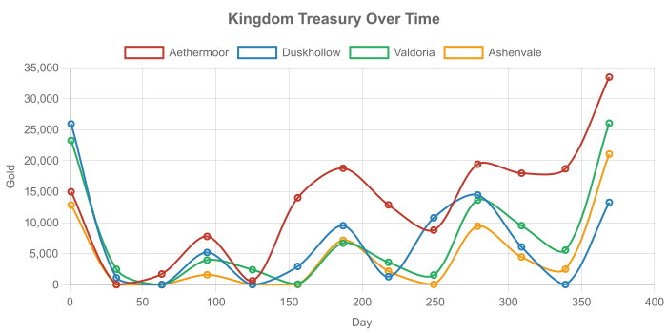
Kingdom of Aethermoor
Day | Treasury | Tax Rate | Prosperity | Happiness | Military | At War
1 | 14,997g | 7.1% | 50 | 50 | 0 | —
32 | 4g | 9.1% | 61.71677778806114 | 63.425907216049794 | 195 | —
63 | 1,718g | 9.1% | 65.65455868420302 | 59.49164015249284 | 199 | —
94 | 7,783g | 9.1% | 57.5239070743293 | 56.99122546654923 | 240 | —
125 | 631g | 9.1% | 54.31233575878167 | 59.10646024537389 | 211 | —
156 | 14,026g | 9.1% | 55.918361045256326 | 56.252154441633635 | 209 | —
187 | 18,788g | 9.1% | 51.775541273764965 | 61.1918777867104 | 196 | —
218 | 12,877g | 9.1% | 51.034077710552566 | 61.08567503330628 | 198 | —
249 | 8,802g | 9.1% | 48.16398724698279 | 59.40839960417031 | 221 | —
279 | 19,431g | 10.1% | 48.45474847334953 | 59.85298661460966 | 225 | —
309 | 17,992g | 10.1% | 47.88308133264004 | 56.00012276529041 | 186 | —
339 | 18,692g | 10.1% | 43.2444959914906 | 44.12815768699887 | 173 | —
369 | 33,497g | 11.1% | 46.27973423782709 | 48.35315127606967 | 192 | —
Treasury: 14,997g → 33,497g (+123.4%)
Kingdom of Duskhollow
Day | Treasury | Tax Rate | Prosperity | Happiness | Military | At War
1 | 25,943g | 9.4% | 50 | 50 | 0 | Valdoria
32 | 1,097g | 9.4% | 58.55664952145077 | 40.54357356797482 | 199 | Valdoria
63 | 0g | 11.3% | 57.620067079910555 | 37.76727449145521 | 189 | Valdoria
94 | 5,193g | 14.3% | 58.507459070570704 | 50.04294218765291 | 168 | —
125 | 0g | 14.3% | 56.779680018961066 | 62.49086638918338 | 164 | —
156 | 2,939g | 14.3% | 50.82285238686855 | 72.1439288855747 | 171 | —
187 | 9,511g | 10.3% | 52.43147382330879 | 73.06280930878825 | 178 | —
218 | 1,287g | 10.3% | 50.98325709534395 | 71.15096101315848 | 179 | —
249 | 10,786g | 10.3% | 48.65562891434023 | 71.06508575593985 | 167 | —
279 | 14,474g | 10.3% | 47.153278585915174 | 79.04049352824877 | 171 | —
309 | 6,088g | 10.3% | 40.436521654797026 | 77.3634314648044 | 175 | —
339 | 26g | 12.4% | 42.2154402645525 | 61.91839996475976 | 171 | —
369 | 13,280g | 12.4% | 40.691486394914904 | 63.49139723639573 | 169 | —
Treasury: 25,943g → 13,280g (-48.8%)
Wars: 3 war period(s) observed — wars increase military spending and disrupt trade routes.
Kingdom of Valdoria
Day | Treasury | Tax Rate | Prosperity | Happiness | Military | At War
1 | 23,262g | 8.6% | 50 | 50 | 0 | Duskhollow
32 | 2,474g | 11.0% | 64.05001480659624 | 45.79451962037915 | 259 | Duskhollow
63 | 0g | 12.1% | 67.97802728049632 | 33.57294805460197 | 222 | Duskhollow
94 | 3,958g | 10.0% | 60.184445924662896 | 45.39301398085654 | 154 | —
125 | 2,403g | 12.5% | 58.12595187876137 | 74.79057637616502 | 139 | —
156 | 83g | 12.5% | 64.13729479046766 | 68.27068933113767 | 137 | —
187 | 6,697g | 10.0% | 58.94919602277769 | 68.02973271974875 | 125 | —
218 | 3,605g | 10.0% | 53.76687496693772 | 72.49315416542913 | 113 | —
249 | 1,554g | 11.6% | 51.8400161597708 | 72.30711328411498 | 116 | —
279 | 13,649g | 10.0% | 52.9790090203216 | 75.06746302521415 | 117 | —
309 | 9,520g | 10.0% | 52.89973820921944 | 77.51373668906065 | 116 | —
339 | 5,564g | 10.0% | 51.3225570270517 | 77.98261565424518 | 121 | —
369 | 26,050g | 10.0% | 51.90015340134337 | 85.32366855561183 | 134 | —
Treasury: 23,262g → 26,050g (+12.0%)
Wars: 3 war period(s) observed — wars increase military spending and disrupt trade routes.
Kingdom of Ashenvale
Day | Treasury | Tax Rate | Prosperity | Happiness | Military | At War
1 | 12,850g | 18.8% | 50 | 50 | 0 | —
32 | 0g | 18.8% | 49.451439199158756 | 46.77065102380329 | 297 | —
63 | 0g | 18.8% | 59.004172756693706 | 39.49664260008849 | 325 | —
94 | 1,591g | 8.0% | 60.22688065354854 | 55.68481915586601 | 366 | —
125 | 10g | 8.0% | 60.62836514583561 | 68.69439819297922 | 388 | —
156 | 22g | 10.4% | 57.9237353493126 | 65.89697273790962 | 441 | —
187 | 7,146g | 10.0% | 59.69406051061083 | 66.82659436246637 | 502 | —
218 | 2,183g | 10.0% | 60.45901774984603 | 72.02479082177658 | 574 | —
249 | 35g | 12.6% | 63.14960882356845 | 60.443757940792324 | 638 | —
279 | 9,431g | 10.0% | 59.6278598518409 | 58.697946140181465 | 574 | —
309 | 4,461g | 10.0% | 60.74933849364953 | 52.10048242109887 | 648 | —
339 | 2,493g | 10.0% | 52.3878240889416 | 43.617824826535895 | 676 | —
369 | 21,073g | 8.0% | 55.809725612324975 | 53.01472167675332 | 711 | —
Treasury: 12,850g → 21,073g (+64.0%)

5. Trade Opportunity Analysis
Best arbitrage opportunities based on end-of-year price data. Buy low, sell high.
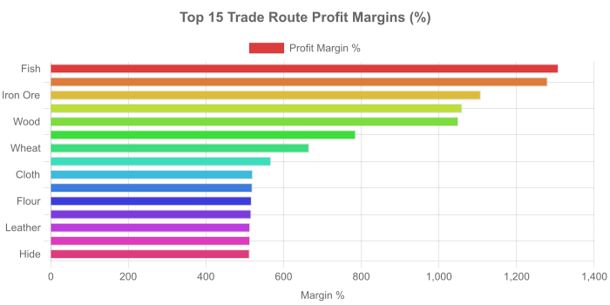
Top 25 Trade Routes
# | Resource | Cat. | Buy Town | Buy $ | Sell Town | Sell $ | Margin | %
1 | Fish | food | Coral Haven | 0.8g | Marshton | 11g | 10.2g | 1308%
2 | Stone | raw | Hawksrest | 1.3g | Watch Pass | 17.3g | 16g | 1280%
3 | Iron Ore | raw | Marshton | 2.2g | Tidewatch | 26g | 23.8g | 1108%
4 | Planks | processed | Marshton | 2.5g | Post Hill | 29.1g | 26.6g | 1060%
5 | Wood | raw | Marshton | 1.3g | Watch Pass | 14.4g | 13.1g | 1050%
6 | Salt | raw | Tidewatch | 1.2g | Marshton | 11g | 9.8g | 786%
7 | Wheat | raw | Kingsbury | 0.4g | Post Hill | 2.9g | 2.5g | 666%
8 | Wool | raw | Windhill | 0.9g | Highwall | 6.2g | 5.3g | 568%
9 | Cloth | processed | Marshton | 2g | Copperhill | 12.4g | 10.4g | 521%
10 | Water | beverage | Ivybridge | 0.3g | Tidewatch | 1.6g | 1.3g | 520%
11 | Flour | processed | Marshton | 2g | Tidewatch | 12.4g | 10.4g | 518%
12 | Swords | military | Marshton | 13.9g | Hawksrest | 85.5g | 71.6g | 517%
13 | Leather | processed | Ivybridge | 2.6g | Marshton | 15.7g | 13.2g | 514%
14 | Drum | luxury | Hawksrest | 5.1g | Marshton | 31.4g | 26.3g | 514%
15 | Hide | raw | Hawksrest | 1.3g | Marshton | 7.9g | 6.6g | 513%
16 | Arrows | military | Marshton | 1.3g | Elmcrest | 7.8g | 6.5g | 511%
17 | Bread | food | Ivybridge | 1.3g | Tidewatch | 7.7g | 6.5g | 509%
18 | Tools | finished | Ivybridge | 7.7g | Hawksrest | 46.6g | 39g | 507%
19 | Bows | military | Silverstream | 6.5g | Marshton | 39.2g | 32.7g | 507%
20 | Clothes | finished | Hawksrest | 4.7g | Marshton | 28.3g | 23.6g | 504%
21 | Saddles | finished | Hawksrest | 9.1g | Marshton | 55g | 45.9g | 504%
22 | Herbal Tea | beverage | Ravensbrook | 1.5g | Copperhill | 9.3g | 7.7g | 502%
23 | Horses | military | Elmcrest | 15.1g | Oldcliff | 89.8g | 74.7g | 493%
24 | Hemp | raw | Silverstream | 0.8g | Marshton | 4.7g | 3.9g | 490%
25 | Jewelry | luxury | Silverstream | 18.8g | Ivybridge | 77.7g | 59g | 314%
Best Route Per Category
food: Fish — Coral Haven (0.8g) → Marshton (11g) = 1308%
raw: Stone — Hawksrest (1.3g) → Watch Pass (17.3g) = 1280%
processed: Planks — Marshton (2.5g) → Post Hill (29.1g) = 1060%
beverage: Water — Ivybridge (0.3g) → Tidewatch (1.6g) = 520%
military: Swords — Marshton (13.9g) → Hawksrest (85.5g) = 517%
luxury: Drum — Hawksrest (5.1g) → Marshton (31.4g) = 514%
finished: Tools — Ivybridge (7.7g) → Hawksrest (46.6g) = 507%
contraband: Poison — Ravensbrook (35.6g) → Marshton (78.4g) = 120%
livestock: Chicken — Copperhill (12.7g) → Marshton (23.5g) = 85%
supplies: Bedroll — Lower Hollow (10.8g) → Marshton (12.6g) = 16%

6. Town Comparison
Population, buildings, prosperity, and economic activity by town.
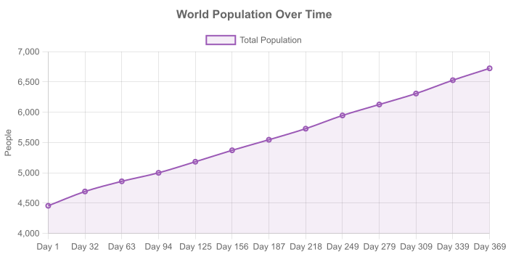
Town Overview (End of Year)
Town | Tier | Kingdom | Pop | Pop Δ | Prosperity | Buildings | Land Cost | Port
Marshton | capital | Aethermoor | 734 | +139 | 73.7069579066526 | 40 | 2,948g | —
Ravensbrook | city | Aethermoor | 476 | +199 | 67.92010957482051 | 32 | 2,716g | —
Uppermill | town | Aethermoor | 409 | +230 | 66.2197065696291 | 23 | 2,648g | ⚓
Kingsbury | village | Aethermoor | 417 | +351 | 62.130563943099915 | 10 | 2,485g | —
Vinehill | capital | Duskhollow | 377 | -195 | 69.18259456918261 | 41 | 2,767g | —
Goldleaf | city | Duskhollow | 210 | -80 | 68.92952159251911 | 29 | 1,378g | ⚓
Highwall | town | Duskhollow | 196 | +73 | 69.08512923079857 | 18 | 1,381g | ⚓
Greendale | village | Duskhollow | 125 | +58 | 70.062696246591 | 15 | 700g | ⚓
Ivybridge | capital | Valdoria | 313 | -246 | 68.9826283481531 | 45 | 1,379g | —
Orchard End | city | Valdoria | 271 | +26 | 69.19502159356277 | 31 | 1,383g | —
Elmcrest | town | Valdoria | 200 | +41 | 69.38265556737663 | 18 | 1,387g | —
Windhill | village | Valdoria | 142 | +82 | 69.53318822101897 | 15 | 695g | —
Silverstream | capital | Ashenvale | 835 | +305 | 61.144862602653966 | 42 | 2,445g | ⚓
Hawksrest | city | Ashenvale | 759 | +395 | 68.57102599428933 | 35 | 2,742g | —
Copperhill | town | Ashenvale | 276 | +117 | 67.4907857799288 | 15 | 1,349g | ⚓
Coldspring | village | Ashenvale | 426 | +347 | 58.954924817886734 | 10 | 2,358g | —
The Shattered Reef | village | Ashenvale | 99 | +68 | 66.66802330355699 | 11 | 666g | ⚓
Coral Haven | village | Ashenvale | 158 | +101 | 66.39775732146173 | 10 | 663g | ⚓
Tidewatch | village | Duskhollow | 49 | +5 | 67.61899530248361 | 9 | 338g | ⚓
Old Bluff | outpost | Duskhollow | 8 | +8 | 2.530187700974915 | 1 | 250g | —
Portmoor | village | Valdoria | 82 | +62 | 61.63231551617181 | 11 | 616g | —
New Crossing | outpost | Ashenvale | 10 | +10 | 26.341635371748072 | 2 | 263g | —
Camp Bluff | outpost | Duskhollow | 7 | +7 | 0.3015961303380937 | 1 | 250g | —
Lower Hollow | outpost | Aethermoor | 9 | +9 | 0.5024142914720027 | 1 | 250g | —
North Haven | outpost | Valdoria | 10 | +10 | 25.060638298261477 | 1 | 250g | —
North Point | outpost | Valdoria | 5 | +5 | 19.504001137654726 | 2 | 250g | —
North Bluff | outpost | Aethermoor | 11 | +11 | 24.778990806455376 | 1 | 250g | —
Watch Haven | outpost | Duskhollow | 13 | +13 | 14.299883642677738 | 1 | 250g | —
Oldcliff | village | Ashenvale | 47 | +16 | 51.17085187836664 | 4 | 255g | —
West Hollow | outpost | Duskhollow | 3 | +2 | 20.69715526780754 | 1 | 250g | —
East Crossing | outpost | Duskhollow | 6 | +6 | 24.507104265775894 | 1 | 250g | —
Watch Pass | outpost | Aethermoor | 3 | +2 | 28.899396572660144 | 1 | 288g | —
Post Hill | outpost | Ashenvale | 5 | +5 | 35.74766344103248 | 1 | 357g | —
West Haven | village | Valdoria | 34 | +3 | 32.11077852854746 | 4 | 160g | —
Building Distribution (Top 5 Towns)
Silverstream:
well (3), flour mill (2), lumber camp (2), jeweler (2), market stall (2), brewery (2), wheat farm (1), bakery (1), blacksmith (1), armorer (1), fletcher (1), arrow maker (1), barracks (1), watchtower (1), iron mine (1), smelter (1), fishery (1), dock (1), sawmill (1), weaver (1), tanner (1), brick kiln (1), smokehouse (1), winery (1), silk weaver (1), fine tailor (1), tapestry loom (1), pasture (1), warehouse (1), cistern (1), tavern (1), restaurant (1), general store (1), hemp farm (1), gold mine (1)
Hawksrest:
wheat farm (3), flour mill (3), cattle ranch (2), pasture (2), weaver (2), market stall (2), well (2), saddler (2), drum maker (2), bakery (1), sheep farm (1), lumber camp (1), tanner (1), toolsmith (1), rope maker (1), horse ranch (1), tailor (1), general store (1), pig farm (1), instrument workshop (1), herbalist hut (1), carpenter (1), perfumery (1), quarry (1)
Marshton:
well (3), iron mine (2), weaver (2), jeweler (2), market stall (2), wheat farm (1), flour mill (1), bakery (1), blacksmith (1), armorer (1), fletcher (1), arrow maker (1), barracks (1), watchtower (1), smelter (1), sheep farm (1), lumber camp (1), sawmill (1), tanner (1), brick kiln (1), toolsmith (1), winery (1), fine tailor (1), instrument workshop (1), warehouse (1), cistern (1), brewery (1), tavern (1), general store (1), armory shop (1), bathhouse (1), horse breeder (1), clothing shop (1), quarry (1)
Ravensbrook:
wheat farm (3), market stall (3), well (2), flour mill (1), bakery (1), sheep farm (1), cattle ranch (1), lumber camp (1), smelter (1), weaver (1), tanner (1), toolsmith (1), smokehouse (1), blacksmith (1), iron mine (1), winery (1), tailor (1), warehouse (1), brewery (1), pig farm (1), herbalist hut (1), drum maker (1), saddler (1), tapestry loom (1), silk weaver (1), horse ranch (1), vineyard (1)
Coldspring:
wheat farm (2), winery (2), bakery (1), chicken farm (1), sheep farm (1), market stall (1), well (1), flour mill (1)

7. Macro-Economic Trends
Overall economic health: money supply, inflation, market dynamics, and supply-demand.
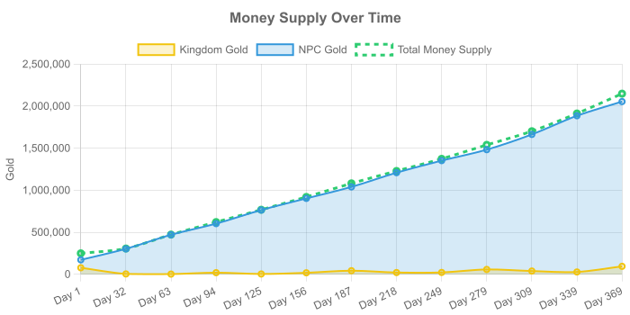
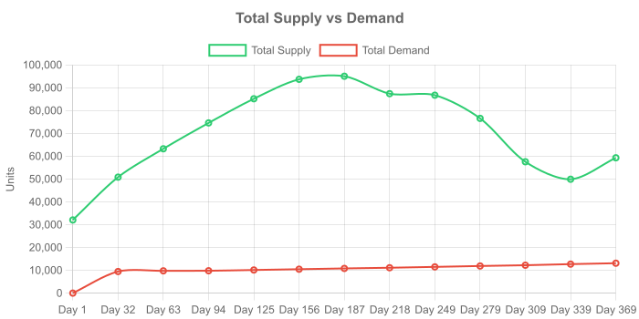
Economic Indicators Over Time
Day | Kingdom $ | NPC $ | Money Supply | Avg Price | Supply | Demand | Pop | Wars
1 | 77,052 | 171,460 | 248,512 | 49.8 | 32,054 | 0 | 4456 | 2
32 | 3,575 | 302,176 | 305,751 | 72.7 | 50,821 | 9,463 | 4692 | 2
63 | 1,718 | 469,904 | 471,622 | 74.1 | 63,244 | 9,755 | 4860 | 2
94 | 18,525 | 601,873 | 620,398 | 73.8 | 74,574 | 9,798 | 5000 | —
125 | 3,044 | 764,045 | 767,089 | 73.6 | 85,160 | 10,131 | 5183 | —
156 | 17,070 | 902,184 | 919,254 | 73.2 | 93,678 | 10,480 | 5372 | —
187 | 42,142 | 1,038,827 | 1,080,969 | 72.9 | 95,034 | 10,818 | 5546 | —
218 | 19,952 | 1,208,184 | 1,228,136 | 72.4 | 87,392 | 11,117 | 5729 | —
249 | 21,177 | 1,351,492 | 1,372,669 | 72.2 | 86,727 | 11,493 | 5947 | —
279 | 56,985 | 1,481,796 | 1,538,781 | 71.9 | 76,561 | 11,885 | 6128 | —
309 | 38,061 | 1,663,096 | 1,701,157 | 71.6 | 57,561 | 12,220 | 6309 | —
339 | 26,775 | 1,885,298 | 1,912,073 | 71.6 | 49,897 | 12,706 | 6529 | —
369 | 93,900 | 2,054,103 | 2,148,003 | 71.5 | 59,295 | 13,103 | 6725 | —
Inflation / Deflation Analysis
Over 12 measurement periods: 2 inflationary, 8 deflationary, 2 stable periods.
Supply-Demand Imbalances (End of Year)
Town | Resource | Supply | Demand | Ratio | Type
Silverstream | Arrows | 1,592 | 1 | ∞ | surplus
Marshton | Iron Ore | 316 | 0 | ∞ | surplus
Marshton | Grapes | 9 | 0 | ∞ | surplus
Marshton | Flour | 192 | 0 | ∞ | surplus
Marshton | Iron Bars | 36 | 0 | ∞ | surplus
Marshton | Cloth | 1,013 | 0 | ∞ | surplus
Marshton | Swords | 255 | 0 | ∞ | surplus
Marshton | Horses | 12 | 0 | ∞ | surplus
Marshton | Pearls | 56 | 0 | ∞ | surplus
Marshton | Arrows | 934 | 0 | ∞ | surplus
Marshton | Water | 53 | 0 | ∞ | surplus
Marshton | Herbal Tea | 54 | 0 | ∞ | surplus
Ravensbrook | Iron Ore | 56 | 0 | ∞ | surplus
Ravensbrook | Grapes | 3 | 0 | ∞ | surplus
Ravensbrook | Flour | 153 | 0 | ∞ | surplus
... and 1262 more imbalances detected.
Market Volatility by Category
Category | Avg Vol | Min Vol | Max Vol | Goods
raw | 132.5% | 41.0% | 345.0% | 13
processed | 130.0% | 43.0% | 229.0% | 8
finished | 110.0% | 42.0% | 201.0% | 4
food | 109.7% | 41.0% | 185.0% | 7
beverage | 82.2% | 41.0% | 136.0% | 5
luxury | 70.1% | 41.0% | 126.0% | 14
military | 64.8% | 41.0% | 123.0% | 13
contraband | 52.5% | 41.0% | 64.0% | 2
livestock | 49.0% | 42.0% | 61.0% | 3
supplies | 41.0% | 41.0% | 41.0% | 4

