Task 1

Dataset

(<https://www.kaggle.com/aungpyaeap/supermarket-sales>)

Hi, we’ve chosen dataset which contains invoice information of a supermarket. It contains more than 900 rows. Unfortunately, the database doesn’t have image column itself. So, we decided to create one!



(FK_INVOICE is a foreign key from main table “Supermarket”)

Task 2

Import Data…

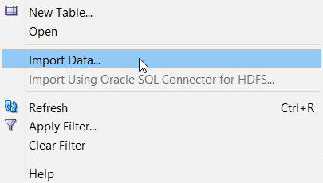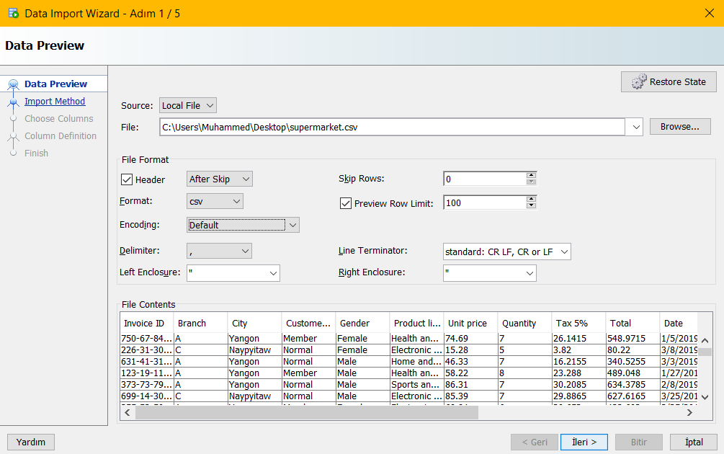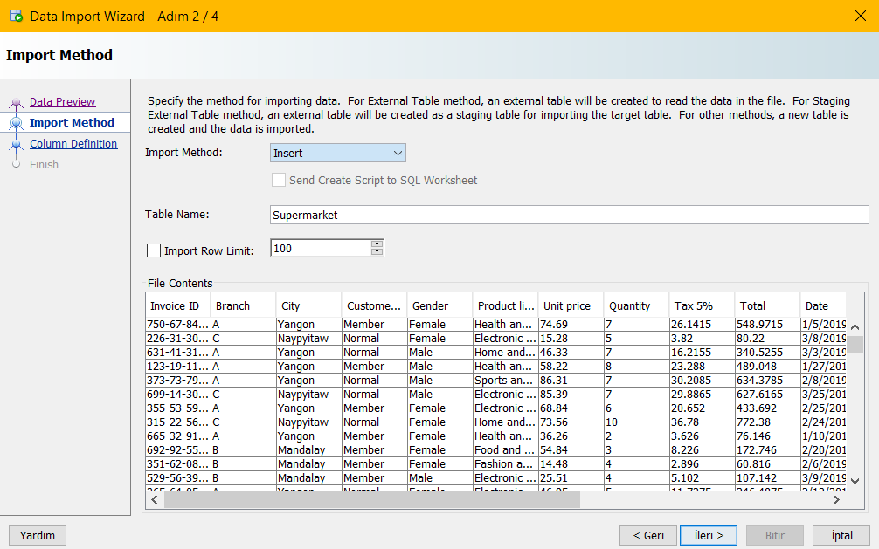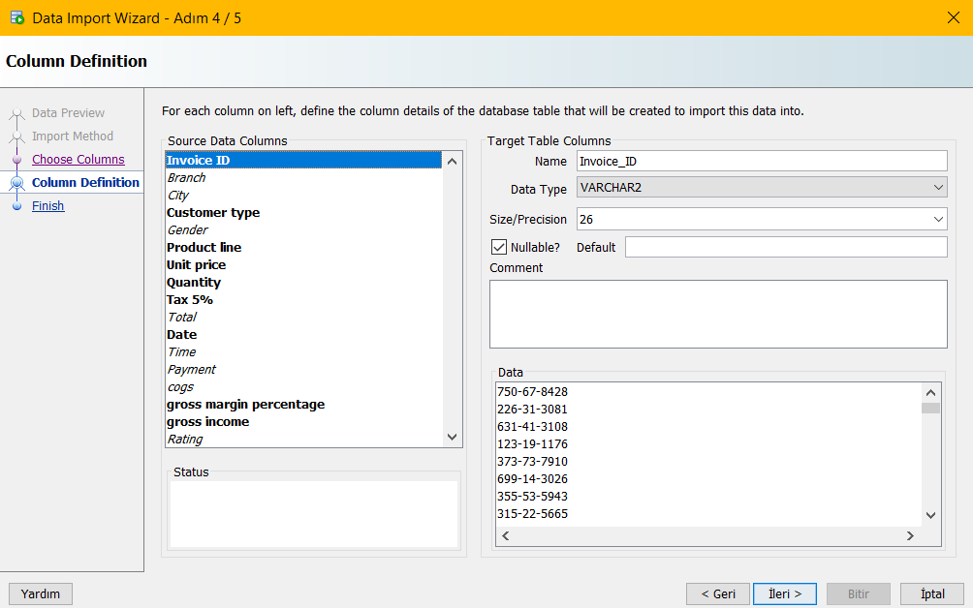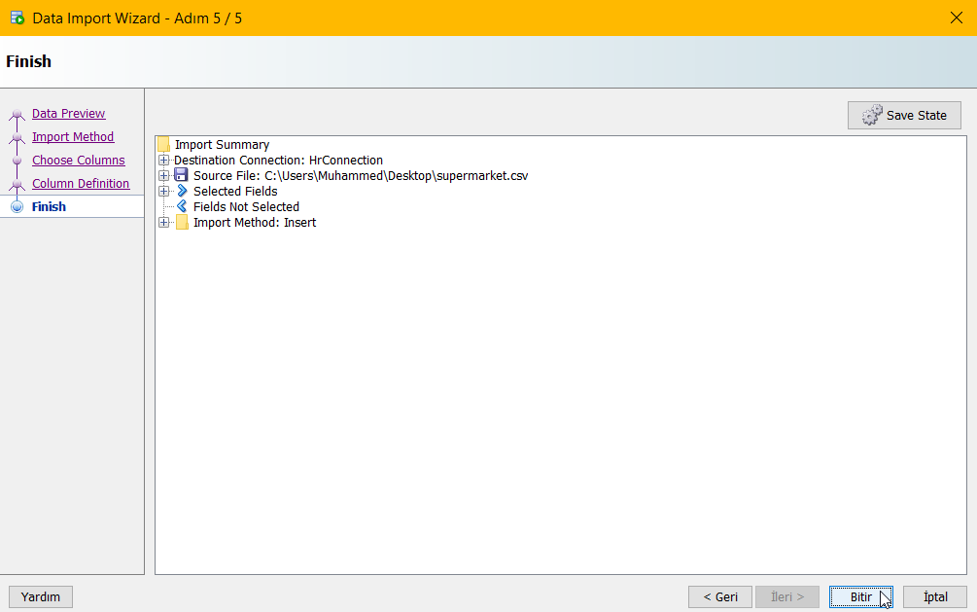

Image Table

The column holding Images has BLOB data type.

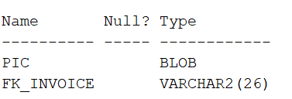

Derived Columns

ALTER TABLE supermarket

ADD (

price_with_tax AS (cogs+tax_5_percent)

); -- Column that is sum of total price and tax.

ALTER TABLE supermarket

ADD (

intallment_12mo AS (((cogs+tax_5_percent)/12) * 1.10)

); -- Installment price for 12 month with 10% interest

Tables

We have 2 tables in our database. “Supermarket” is the main one and “Pictures” table that hold image. And they’re connected by the foreign key constraint. (FK_INVOICE)

Task 3

[Unfortunately, we could not make connection between the frontend and backend part.](https://www.youtube.com/watch?v=Y_oD111dK7c&ab_channel=AuroraVibes)

Task 4

Functions & Procedures

create or replace FUNCTION get_5_percent

(p_invoice IN supermarket.invoice_id%TYPE)

RETURN NUMBER IS

v_number NUMBER;

BEGIN

SELECT (unit_price * quantity) * 5/10

INTO v_number

FROM supermarket

WHERE invoice_id = p_invoice;

RETURN v_number;

END get_5_percent; --Calculates the 5% tax for the price

create or replace FUNCTION get_total

(payment_type IN supermarket.payment%TYPE)

RETURN NUMBER IS

v_total supermarket.cogs%TYPE;

BEGIN

SELECT sum(cogs)

INTO v_total

FROM supermarket

WHERE payment = payment_type;

RETURN v_total;

END get_total; -- Calculates total number of money earned with given payment type (Cash, Ewallet & etc.)

CREATE OR REPLACE PROCEDURE create_invoice (

invoice IN VARCHAR(26),

branch IN VARCHAR(26),

city IN VARCHAR(26),

customer_type IN VARCHAR(26),

gender IN VARCHAR(26),

prod_line IN VARCHAR(26),

unt_price IN NUMBER(38),

quantity IN NUMBER(38),

tax_5 IN VARCHAR(26),

total NUMBER(38),

datee IN DATE,

time IN VARCHAR(26),

payment IN VARCHAR(26),

cogs IN NUMBER(38),

gross_margin IN NUMBER(38),

gross_inco IN VARCHAR(26),

rating IN NUMBER(38)

) AS

BEGIN

INSERT INTO SUPERMARKET(Invoice_id, Branch, city, customer_type, gender, product_line, unit_price,

quantity, tax_5_percent, total, datee, time, payment, cogs, gross_margin_percentage, gross_income, rating)

VALUES (invoice, branch, city, customer_type, gender, prod_line, unt_price, quantity, tax_5, total,

datee, time, payment, cogs, gross_margin, gross_inco, rating);

END;-- This procedure is defined to add new invoice to the table

create or replace PROCEDURE print_bill(

invoiceID supermarket.invoice_id%TYPE

)

IS

r_sp supermarket%ROWTYPE;

BEGIN

SELECT *

INTO r_sp

FROM supermarket

WHERE invoice_id = invoiceID;

dbms_output.put_line(r_sp.branch || ' ' || r_sp.city || ' ' || r_sp.customer_type || ' ' || r_sp.gender

|| ' ' || r_sp.product_line || ' ' || r_sp.unit_price || ' ' || r_sp.quantity || ' ' || r_sp.tax_5_percent

|| ' ' || r_sp.total || ' ' || r_sp.datee || ' ' || r_sp.time || ' ' || r_sp.payment || ' ' || r_sp.cogs

|| ' ' || r_sp.gross_margin_percentage || ' ' || r_sp.gross_income || ' ' || r_sp.rating);

END; --With this procedure, you can print any invoice information you want.

Collections

DECLARE

TYPE t_invoice_date IS TABLE OF supermarket.datee%TYPE

INDEX BY VARCHAR(11);

v_invoice_date_tab t_invoice_date;

BEGIN

FOR sm_rec IN

(SELECT invoice_id, datee FROM supermarket)

LOOP

v_invoice_date_tab(sm_rec.invoice_id) := sm_rec.datee;

END LOOP;

DECLARE

TYPE t_invoice_date IS TABLE OF supermarket.datee%TYPE

INDEX BY VARCHAR(11);

v_invoice_date_tab t_invoice_date;

v_invoice_date_count NUMBER(4);

BEGIN

FOR sm_rec IN

(SELECT invoice_id, datee FROM supermarket)

LOOP

v_invoice_date_tab(sm_rec.invoice_id) := sm_rec.datee;

END LOOP;

DBMS_OUTPUT.PUT_LINE(v_invoice_date_tab.COUNT);

END;

END;

Cursors

DECLARE

CURSOR curs IS

select invoice_id from supermarket

where city = 'Yangon' AND customer_type = 'Member';

invoiceID supermarket.invoice_id%TYPE;

BEGIN

OPEN curs;

LOOP

FETCH curs INTO invoiceID;

EXIT WHEN curs%NOTFOUND;

DBMS_OUTPUT.PUT_LINE(invoiceID);

END LOOP;

CLOSE curs;

END;

Output:

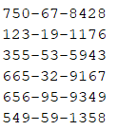

DECLARE

CURSOR curs IS

select product_line, unit_price from supermarket

where unit_price > (select avg(unit_price) from supermarket);

productLine supermarket.product_lıne%TYPE;

unitPrice supermarket.unit_price%TYPE;

BEGIN

OPEN curs;

LOOP

FETCH curs INTO productLine, unitPrice;

EXIT WHEN curs%NOTFOUND;

DBMS_OUTPUT.PUT_LINE(productLine || ' - ' || unitPrice);

END LOOP;

CLOSE curs;

END;

Output:

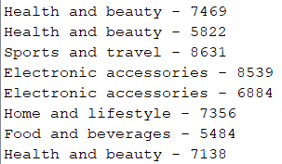

DECLARE

CURSOR curs IS

select customer_type, gender, rating from supermarket;

BEGIN

FOR v_dep_records IN curs LOOP

DBMS_OUTPUT.PUT_LINE(v_dep_records.customer_type || ' - ' || v_dep_records.gender || ' - ' || v_dep_records.rating);

END LOOP;

END;

Output:

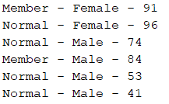

DECLARE

CURSOR curs IS

select customer_type, gender, product_line from supermarket

where city = 'Yangon';

v_record curs%ROWTYPE;

BEGIN

OPEN curs;

LOOP

FETCH curs INTO v_record;

EXIT WHEN curs%NOTFOUND;

DBMS_OUTPUT.PUT_LINE(v_record.customer_type || ' - ' || v_record.gender || ' - ' || v_record.product_line);

END LOOP;

DBMS_OUTPUT.PUT_LINE(SQL%ROWCOUNT);

CLOSE curs;

END;

Output:

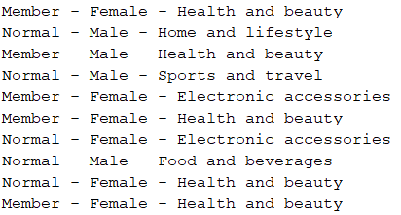

Packages

create or replace PACKAGE BODY sm_package AS

PROCEDURE print_bill(invoiceID supermarket.invoice_id%TYPE) IS

r_sp supermarket%ROWTYPE;

BEGIN

SELECT * INTO r_sp FROM supermarket

WHERE invoice_id = invoiceID;

dbms_output.put_line(r_sp.branch || ' ' || r_sp.city || ' ' || r_sp.customer_type || ' ' || r_sp.gender

|| ' ' || r_sp.product_line || ' ' || r_sp.unit_price || ' ' || r_sp.quantity || ' ' || r_sp.tax_5_percent

|| ' ' || r_sp.total || ' ' || r_sp.datee || ' ' || r_sp.time || ' ' || r_sp.payment || ' ' || r_sp.cogs

|| ' ' || r_sp.gross_margin_percentage || ' ' || r_sp.gross_income || ' ' || r_sp.rating);

END;

END sm_package;

create or replace PACKAGE BODY sm_functions AS

FUNCTION get_5_percent

(p_invoice IN supermarket.invoice_id%TYPE)

RETURN NUMBER IS

v_number NUMBER;

BEGIN

SELECT (unit_price * quantity) * 5/10

INTO v_number

FROM supermarket

WHERE invoice_id = p_invoice;

RETURN v_number;

END get_5_percent;

FUNCTION get_total

(payment_type IN supermarket.payment%TYPE)

RETURN NUMBER IS

v_total supermarket.cogs%TYPE;

BEGIN

SELECT sum(cogs)

INTO v_total

FROM supermarket

WHERE payment = payment_type;

RETURN v_total;

END get_total;

END sm_package; –-This one contains the 5% percent calculator and get_total function which can calculate total number of money earned from specific payment type.

Triggers

CREATE TABLE Invoice_Log(

ID NUMBER,

OPERATION_DATE DATE,

ACTION VARCHAR(15),

AUTHOR VARCHAR(15)); --Loggings table

create or replace TRIGGER Invoice_delete

AFTER DELETE ON "SUPERMARKET" FOR EACH ROW

BEGIN

INSERT INTO Invoice_LOG(ID, NEW_INV_ID, OLD_INV_ID, AUTHOR, OPERATION_DATE, ACTION)

VALUES(inv_seq.NEXTVAL, :NEW.INVOICE_ID ,:OLD.INVOICE_ID ,USER, SYSDATE, 'DELETE');

END; --Saves deleted invoice information

CREATE OR REPLACE TRIGGER drop_user

BEFORE drop on SCHEMA

BEGIN

IF ora_dict_obj_name ='SUPERMARKET'

THEN

RAISE_APPLICATION_ERROR( -20001, 'This table can not be deleted!' );

END IF;

END; --This trigger prevents drop of main table

create or replace TRIGGER Invoice_update

AFTER UPDATE ON "SUPERMARKET" FOR EACH ROW

BEGIN

INSERT INTO Invoice_LOG(ID, NEW_INV_ID, OLD_INV_ID, AUTHOR, OPERATION_DATE, ACTION)

VALUES(inv_seq.NEXTVAL, :NEW.INVOICE_ID ,:OLD.INVOICE_ID ,USER, SYSDATE, 'UPDATE');

END; -- Saves information of updated invoice.

Dynamic SQL

DECLARE

my_query VARCHAR(100);

intCl NUMBER(4);

BEGIN

my_query := 'Select count(invoice_id) from supermarket';

EXECUTE IMMEDIATE my_query INTO intCl;

DBMS_OUTPUT.PUT_LINE('Number of bills: ' || intCl);

END; -- Outputs number of bills

DECLARE

plsql_block VARCHAR(300) := 'BEGIN create_invoice(:a, :b, :c, :d, :e, :f, :g, :h, :i, :j, :k, :l, :m, :n, :o, :p, :q); END;';

new_invoice IN VARCHAR(26) := '120-06-4234';

new_branch IN VARCHAR(26) := 'A';

new_city IN VARCHAR(26) := 'Yangon';

new_customer_type IN VARCHAR(26) := 'Member';

new_gender IN VARCHAR(26) := 'Male';

new_prod_line IN VARCHAR(26) := 'Electronic accessories';

new_unt_price IN NUMBER(38) := 3061;

new_quantity IN NUMBER(38) := 6;

new_tax_5 IN VARCHAR(26) := '9.183';

new_total NUMBER(38) := 192843;

new_datee IN DATE := '12/03/2019';

new_time IN VARCHAR(26) := '20:36';

new_payment IN VARCHAR(26) := 'Cash';

new_cogs IN NUMBER(38) := 18366;

new_gross_margin IN NUMBER(38) := 4761904762;

new_gross_inco IN VARCHAR(26) := 9.183;

new_rating IN NUMBER(38) := 89;

BEGIN

EXECUTE IMMEDIATE plsql_block

USING IN new_invoice, new_branch, new_city, new_customer_type, new_gender, new_prod_line, new_unt_price,

new_quantity, new_tax_5, new_total, new_datee, new_time, new_payment, new_cogs, new_gross_margin, new_gross_inco,

new_rating;

END;