Cost-effectiveness of Dengvaxia in Puerto Rico

Guido España1, Andrew Leidner2, Stephen Waterman3, and Alex Perkins4  
1University of Notre Dame,  
2 Centers for Disease Control and Prevention,  
3Centers for Disease Control and Prevention, Puerto Rico branch,  
4University of Notre Dame

# Abstract

Vaccination could reduce the burden of dengue disease, which causes 50 million cases every year. Dengue is endemic in Puerto Rico and the vaccine CYD-TDV is under consideration as a control measure. This vaccine showed efficacy only in people with previous exposure to dengue virus. Hence, the WHO recommended a pre-vaccination screening and subsequent vaccination strategy. To estimate the cost-effectiveness and benefits of this intervention in Puerto Rico, we simulated 10 years of the intervention in 9-year-olds using an agent-based model. We found that 5.5% of hospitalizations could be averted and 20 hospitalizations could be averted for each additional hospitalization in children without previous exposure to the virus. At a base cost of 382 USD, we found an incremental cost-effectiveness ratio of 79,000 USD per QALY gained. Our estimates can inform decision making on the introduction of the CYD-TDV vaccine.

# Introduction

The use of vaccination as a public health intervention has contributed to the control of many contagious diseases [1]. For instance, in the United States, 103.1 million clinical episodes of childhood diseases have been prevented from vaccination since 1924 [1]. However, the public health impact of vaccines depends strongly on their effectiveness and economic benefits for countries considering implementation of routine vaccination. For new vaccines, such as the first licensed dengue vaccine [2–5], estimating the health and cost benefits from vaccination is relevant to support public health decisions.

Around 50 million people are affected by dengue disease every year across the world [6]. Without an effective control measure, dengue continues to spread around the world [7]. This viral disease is considered the most important mosquito-borne disease in the world with half the world’s population living in areas at risk [7,8]. Recent large outbreaks highlight the global health importance of dengue. For instance, in 2019, Latin America had a historical record number of dengue cases, with 2.7 million cases reported to the health systems, from which 1,200 resulted in deaths [9]. In the absence of an effective vaccine against dengue, vector control is the only alternative to control the spread of the virus. Although some trials are being conducted to determine the efficacy of novel vector control using Wolbachia-infected mosquitoes [10], there is little evidence of the efficacy to reduce dengue incidence with vector control [11]. Two dengue vaccine candidates are in efficacy trials [12,13], and one (CYD-TDV) has been licensed. However, efficacy studies of the CYD-TDV vaccine showed that only a subgroup of the population would benefit from the vaccine [5].

Recent analyses of CYD-TDV vaccine trials showed an increased risk of severe dengue upon subsequent natural infection among vaccinees without previous exposure to dengue virus (DENV) [5]. The World Health Organization (WHO) recommends pre-vaccination screening to ensure that only those with previous exposure to DENV are vaccinated[14]. However, rapid diagnostic tests with high sensitivity and specificity are not currently available. Hence, it is important to estimate the potential benefits or risks of a pre-vaccination screening strategy with CYD-TDV.

The benefits and cost-effectiveness of pre-vaccination screening for economic scenarios resembling the Philippines and Brazil have been investigated in a recent study [15]. This analysis showed that there could be epidemiological benefits from this intervention with pre-vaccination screening and subsequent vaccination with CYD-TDV in areas with moderate to high-transmission intensity. Other studies have reached similar conclusions on the benefits from vaccination based on serostatus testing, arguing that several rounds of screening could improve the cost benefits of the intervention [16,17]. Our goal for the current study was to evaluate the impact of a pre-vaccination screening and subsequent vaccination strategy with CYD-TDV in Puerto Rico using the previously validated agent-based model that was used to study these issues int he Philippines and Brazil. Our main objective was to estimate the impact of CYD-TDV in Puerto Rico by evaluating the epidemiological benefits and cost-effectiveness of a hypothetical vaccination program over a 10-year time-frame.

# Description of methods specific for Puerto Rico

## Agent-Based Model

To evaluate the impact of a pre-vaccination screening intervention in Puerto Rico, we used an agent-based model of dengue transmission, which has been described elsewhere [15]. This stochastic model represents DENV transmission at various scales by simulating daily interactions of humans with mosquitoes in time and space. Although our model has been calibrated to Iquitos’ demographic and geographic data [18], it can be used to represent DENV transmission in a generic setting [19]. In fact, our model’s projections about the impact of CYD-TDV in the absence of serological screening agreed with those from seven other models [19]. We modeled 10 years of routine pre-vaccination screening and subsequent vaccination in 9-year-olds. Every year, children of 9 years of age are screened for previous exposure to DENV and administered the vaccine to those who tested positive. To simulate the specific case of Puerto Rico, we modified the transmission parameters of the model to approximate the transmission dynamics of DENV in Puerto Rico.

## Model parameterization for Puerto Rico ()

We adjusted the transmission intensity of DENV in our model to achieve a scenario representative of the current situation of Puerto Rico. We measured transmission intensity as the proportion of 9-year-olds exposed to at least one serotype of DENV () after 40 years of constant importation of cases. Although we focused on 9-year-olds to measure transmission intensity, our model explicitly incorporates transmission dynamics in humans of all ages. We estimated the for Puerto Rico based on two serological studies. Coudeville et al. [20] estimated 50% seroprevalence in 9-year-olds in areas where the CYD-TDV phase-3 trials were conducted. According to Argüello, 49.8% (95% CI = 43.6-56.0%) of participants between 10-18 years of age had a positive IgG anti-DENV antibodies [21]. It’s important to note that seroprevalence differs from . refers to the true proportion of 9-year-olds with previous exposure to DENV, whereas seroprevalence () is the observed proportion of individuals with previous exposure to DENV, which depends on the underlying , as well as the sensitivity, and the specificity of serological screening. We assumed a baseline of . Given the uncertainty on these estimates, we explored a lower value of , and an upper value of to assess the sensitivity of our estimates to changes in the intensity of transmission in Puerto Rico.

In our model, the effect of a vaccination on an individual is similar to a silent infection, which is consistent with assumptions in other models [16,17,19,22]. This assumptions is consistent with empirical evidence that seronegative individuals vaccinated with CYD-TDV have a higher risk of hospitalization after a natural infection [5]. To match the most recent trial results [5], we calibrated model parameters characterizing vaccine profile to vaccine trial data using a particle filtering approach, which is explained in more detail elsewhere ([15], Appendix S2). The results from the calibration step are shown in table 1 with the upper and lower bounds of the 95% confidence interval. The top four parameters in table 1 are related to the vaccine mode of action, while the rest of the parameters correspond to the rates of symptomatic cases (dengue fever) and hospitalizations (severe dengue) for primary, secondary, and post-secondary infections. Other model parameters related to DENV transmission have been previously estimated for this model [15,18]. Specific details of the model are available elsewhere [15,18], and the source code is available in a Github repository [23].

Table 1. Vaccine profile parameters calibrated to CYD-TDV data on vaccine efficacy [5].

|  |  |  |  |
| --- | --- | --- | --- |
| Description | Fit | Lower 95% CI | Upper 95% CI |
| Average duration (days) of protection for seronegative vaccinees | 426.69 | 41.02 | 733.75 |
| Average duration (days) of protection for seropositive vaccinees | 258.66 | 136.71 | 464.09 |
| Probability of vaccine protection for seronegative vaccinees conditional to exposure | 0.32 | 0.05 | 1.00 |
| Probability of vaccine protection for seropositive vaccinees conditional to exposure | 0.52 | 0.15 | 0.97 |
| Probability of symptoms conditional on primary infection | 0.41 | 0.26 | 0.54 |
| Probability of symptoms conditional on secondary infection | 0.34 | 0.27 | 0.52 |
| Probability of symptoms conditional on post-secondary infection | 0.09 | 0.04 | 0.13 |
| Probability of hospitalization conditional on symptoms from primary infection | 0.07 | 0.04 | 0.11 |
| Probability of hospitalization conditional on symptoms from secondary infection | 0.38 | 0.27 | 0.42 |
| Probability of hospitalization conditional on symptoms from post-secondary infection | 0.10 | 0.06 | 0.11 |

## Epidemiological benefits

We used our model to project the epidemiological benefits of a vaccination program coupled with pre-vaccination screening in Puerto Rico. We define the epidemiological benefits as population benefits and individual benefits from the program. Population benefits were defined as the proportion of symptomatic and hospitalized cases averted for the total population. Individual benefits were defined as the relative risk of an individual child who undergoes screening and possibly vaccination compared to a child not covered in the program. Given that misclassification would result in naïve individuals receiving the vaccine, we also estimated the proportion of adverse events in this group of naïve individuals vaccinated. The magnitude of the risk of individuals misclassified as seropositive was estimated in two ways: as the number of hospitalizations in naïve vaccinated children per 1,000 children vaccinated, and as the number of hospitalizations averted by the intervention per each additional hospitalization in the naïve group.

In our simulations, we assumed that coverage of the intervention (i.e., serological screening and vaccination in the event of a positive result) was 80%, but evaluated an alternative scenario of lower coverage (50%) in the sensitivity analysis. We assumed that 100% of children with a positive screening result were vaccinated. The baseline values of sensitivity (0.8) and specificity (0.95) were based on a recent review of rapid diagnostic tests for determination of serostatus [24]. However, the actual properties of serological screening could differ from this baseline. Assuming that increasing sensitivity would result in poorer specificity, and vice-versa, we assumed three additional scenarios ( of baseline values): higher sensitivity (0.95), but sacrificing specificity (0.76), higher specificity (0.99) but sacrificing sensitivity (0.64), and higher sensitivity (0.95) without sacrificing specificity (0.95). We also simulated pre-vaccination screening over a wider range of values of sensitivity and specificity (0-1) to find the minimum values required to achieve positive proportion of dengue cases averted.

Given the stochastic nature of our model, we simulated 3,000 paired replicates over the parameter ranges, and reported the smoothed the output of these simulations using a generalized additive model (GAM) in R. The uncertainty on the vaccine parameters was taking into account by simulating the model over the upper and lower bound of the estimates of the vaccine profile parameters.

## Cost-effectiveness analysis

We evaluated the incremental cost-effectiveness ratio (ICER) of the intervention over a time horizon of 10 years. We used a public health perspective, as it has been used in previous economic analyses of the potential impact of routine vaccination with CYD-TDV. We calculated the ICER as shown in equation 1, using in the denominator three measures of the intervention effect ( and ): QALYs gained, symptomatic cases averted, and hospitalizations averted.

To evaluate the ICER of pre-vaccination screening and subsequent vaccination with CYD-TDV in Puerto Rico, we assumed a baseline scenario of costs. The baseline cost per fully vaccinated child was set to 382 USD (32 USD - 682 USD) based on current prices of vaccines in the US (Tables S1-S4). The individual cost of screening was set to 10 USD based on a seroprevalence study in school children in Vietnam [25], but we varied this price from 1 USD to 30 USD.

Estimates of the costs paid by the government associated with treatment of dengue cases for ambulatory cases and hospitalizations were based on estimates from 2002 to 2009 (projected to 2010) in Puerto Rico [26]. Using the consumer price index for medical care for Puerto Rico [27], we adjusted these costs from 2010 values to 2019 USD. In summary, the cost of an ambulatory case was set to 315 USD (252 - 378) and the cost of a hospitalization was set to 2,132 USD (1,705 - 2,558). Future costs were discounted by 3% annually.

We estimated the quality-adjusted life-years (QALYs) gained with the intervention based on quality of life lost due to dengue fever or severe dengue, using disability weights and the duration of disability from previous studies of dengue [19,28–30]. We used disability weights (D) from the estimated values of DALYs per dengue case obtained by Zeng et al. [31] in a systematic analysis of nonfatal dengue episodes. These values are listed in table 2. A disability weight of zero represents perfect health, and a value of one represents death. Assuming a discounting rate (r) of 3%, we estimated the QALYs, such that

where *i* is each individual in the model, N is the total number of people represented in the model, and T is the number of years of the intervention (10). In the case of deaths caused by severe dengue, we adjusted for life expectancy (L) at a discounting rate (r) of 3%, such that the discounted QALY was .

Table 2. Disability weight for dengue cases.

|  |  |  |  |
| --- | --- | --- | --- |
| Parameter | Value | 95% CI | Reference |
| Disability weight (dengue fever) | 0.0307 | 0.0170 - 0.0917 | [31] |
| Disability weight (hospitalizations) | 0.0351 | 0.0241 - 0.0960 | [31] |
| Disability weight (death) | 1 | - | - |

# Results

## Epidemiological benefits from vaccination

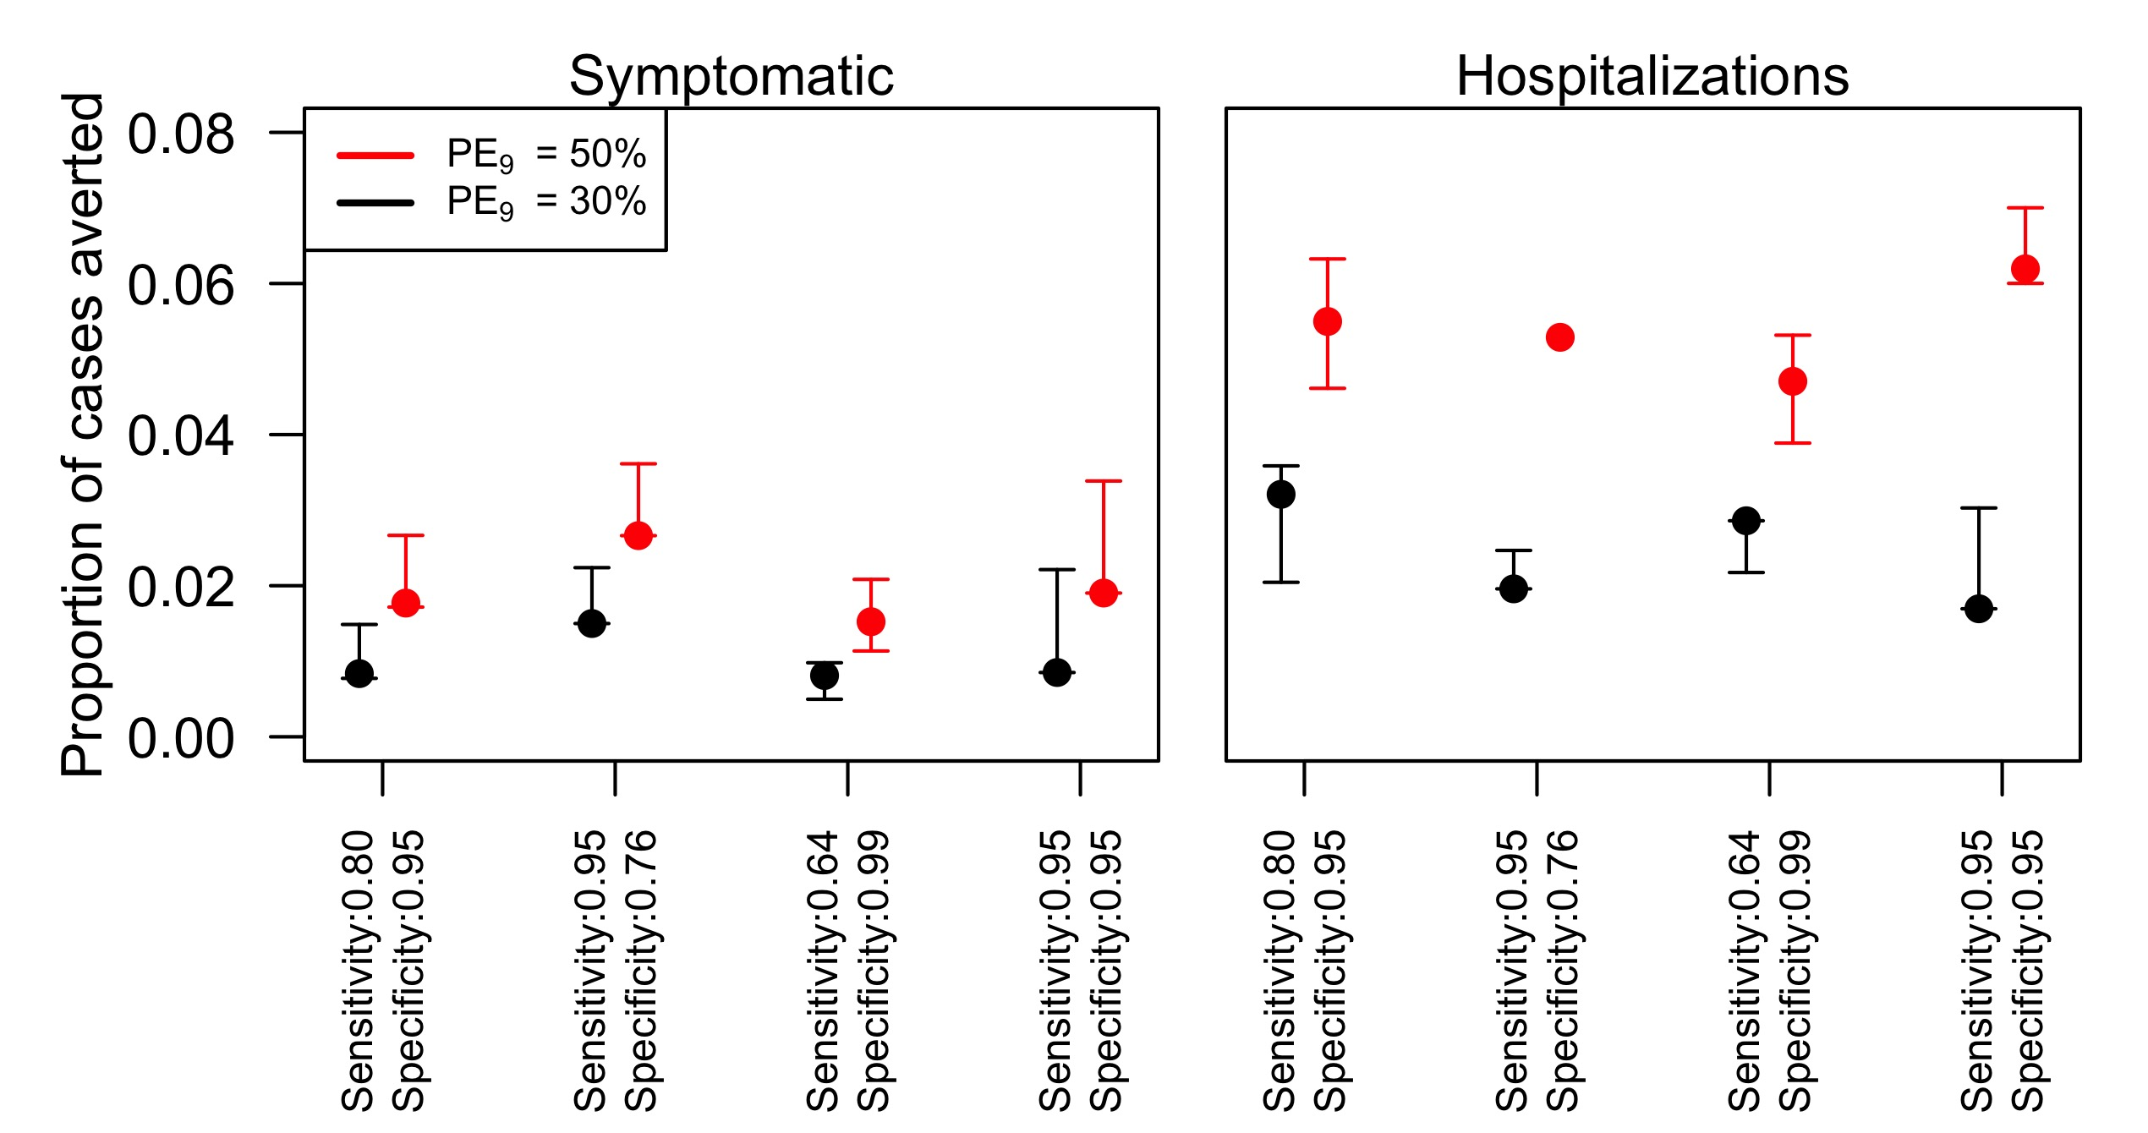

Figure 1. Proportion of total cases averted in Puerto Rico with the pre-vaccination screening strategy in 9-year-olds for different values of sensitivity and specificity. Left panel refers to symptomatic cases and right panel to hospitalizations. The x-axis shows different assumptions on the specificity and sensitivity of screening. The simulations were performed for 80% intervention coverage of routine pre-vaccination screening in 9 year-olds over 10 years.

### Population benefits

From a population level, our simulations showed that the intervention resulted in positive proportion of symptomatic cases averted in the baseline scenarios of the sensitivity or specificity (Fig. 1, left panel). The minimum values of specificity and sensitivity to achieve benefits in Fig. 2 show that symptomatic cases were averted for any set of values of specificity and sensitivity. This reduction in symptomatic cases over a wide range of parameter values is explained by the model parameters being fitted to phase-3 clinical trial data, which showed that all vaccinated individuals acquired some protection against symptomatic dengue fever, independently of their serostatus [5]. Hence, increasing the number of vaccinated individuals would increase benefits in terms of symptomatic cases, even without previous serological screening.

In addition, our results show that for the four scenarios of sensitivity and specificity, hospitalizations were also averted. Around 5.5% (4.6% - 6.3%) of hospitalizations were averted in a scenario of , and around 3% (2% - 3.6%) in a lower-transmission scenario of (Fig. 1, right panel). Reducing specificity to increase sensitivity resulted in a lower proportion of the hospitalizations averted. Similarly, lower sensitivity (0.64) and higher specificity (0.99) lowered the proportion of hospitalizations averted to 4.7% (3.8% - 5.3%) in the scenario, and to 2.8% (2.1% - 2.8%) in the scenario. Finally, increasing both, sensitivity and specificity, increased benefits of vaccination up to 6.2% (6% - 7%) in the baseline transmission scenario (). Our simulations over the whole range of sensitivity and specificity values suggest that even with perfect sensitivity, the minimum value of specificity is 0.6 to obtain any positive cases averted (Fig. 2, right panel). In the baseline scenario of specificity (0.95), we found that sensitivity could be of any value above 0.2 to obtain positive cases averted. These values represent the absolute minimum values to avoid an increase in the hospitalizations due to dengue.

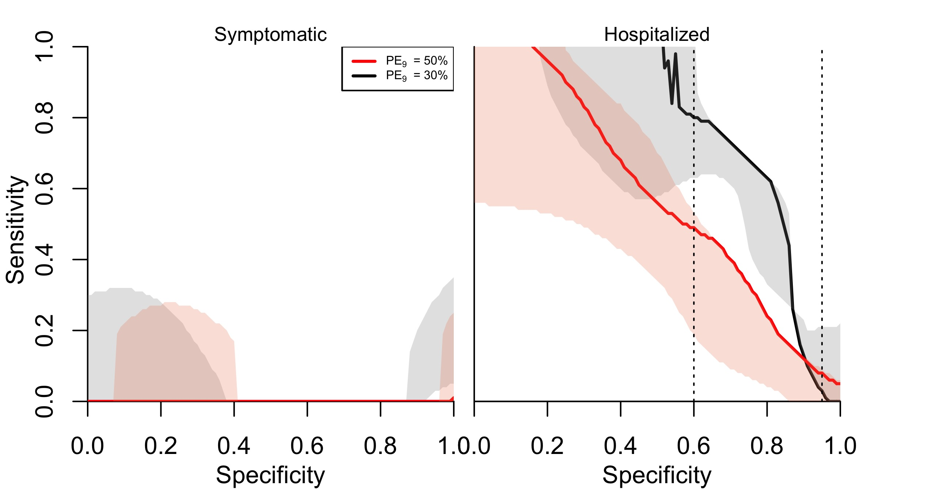

Figure 2. Minimum sensitivity required for each specificity value to have positive averted cases from pre-vaccination screening strategy. Left panel refers to symptomatic cases and right panel to hospitalizations. The shaded areas in each line represent the lower and upper bounds of the vaccine parameters. The simulations were performed for 80% intervention coverage of routine pre-vaccination screening in 9 year-olds over 10 years.

### Individual benefits

From the level of an individual screened for previous DENV infection and, in case of a positive screening result vaccinated, the relative risk of a symptomatic case was slightly reduced (Fig. 3, left panel). In the baseline scenario of sensitivity and specificity, the risk was around 0.85 (0.82 - 1.0) for and around 0.9 (0.87 - 1.0) for . For symptomatic cases, the risk was lowest when sensitivity was increased and specificity was reduced, given that more people got the vaccine in this scenario. In terms of hospitalizations, the relative risk was also reduced to around 0.63 (0.3 - 1.0) for and around 0.73 (0.73 - 1.0) for (Fig. 3, right panel). In contrast to symptomatic cases, reducing specificity to increase sensitivity increased the relative risk of hospitalizations, above 1.0 for the low-transmission scenario. Compared to the baseline, sacrificing sensitivity or specificity increased the risk of hospitalization. Increasing sensitivity without sacrificing specificity reduced the hospitalization risk in both transmission scenarios.

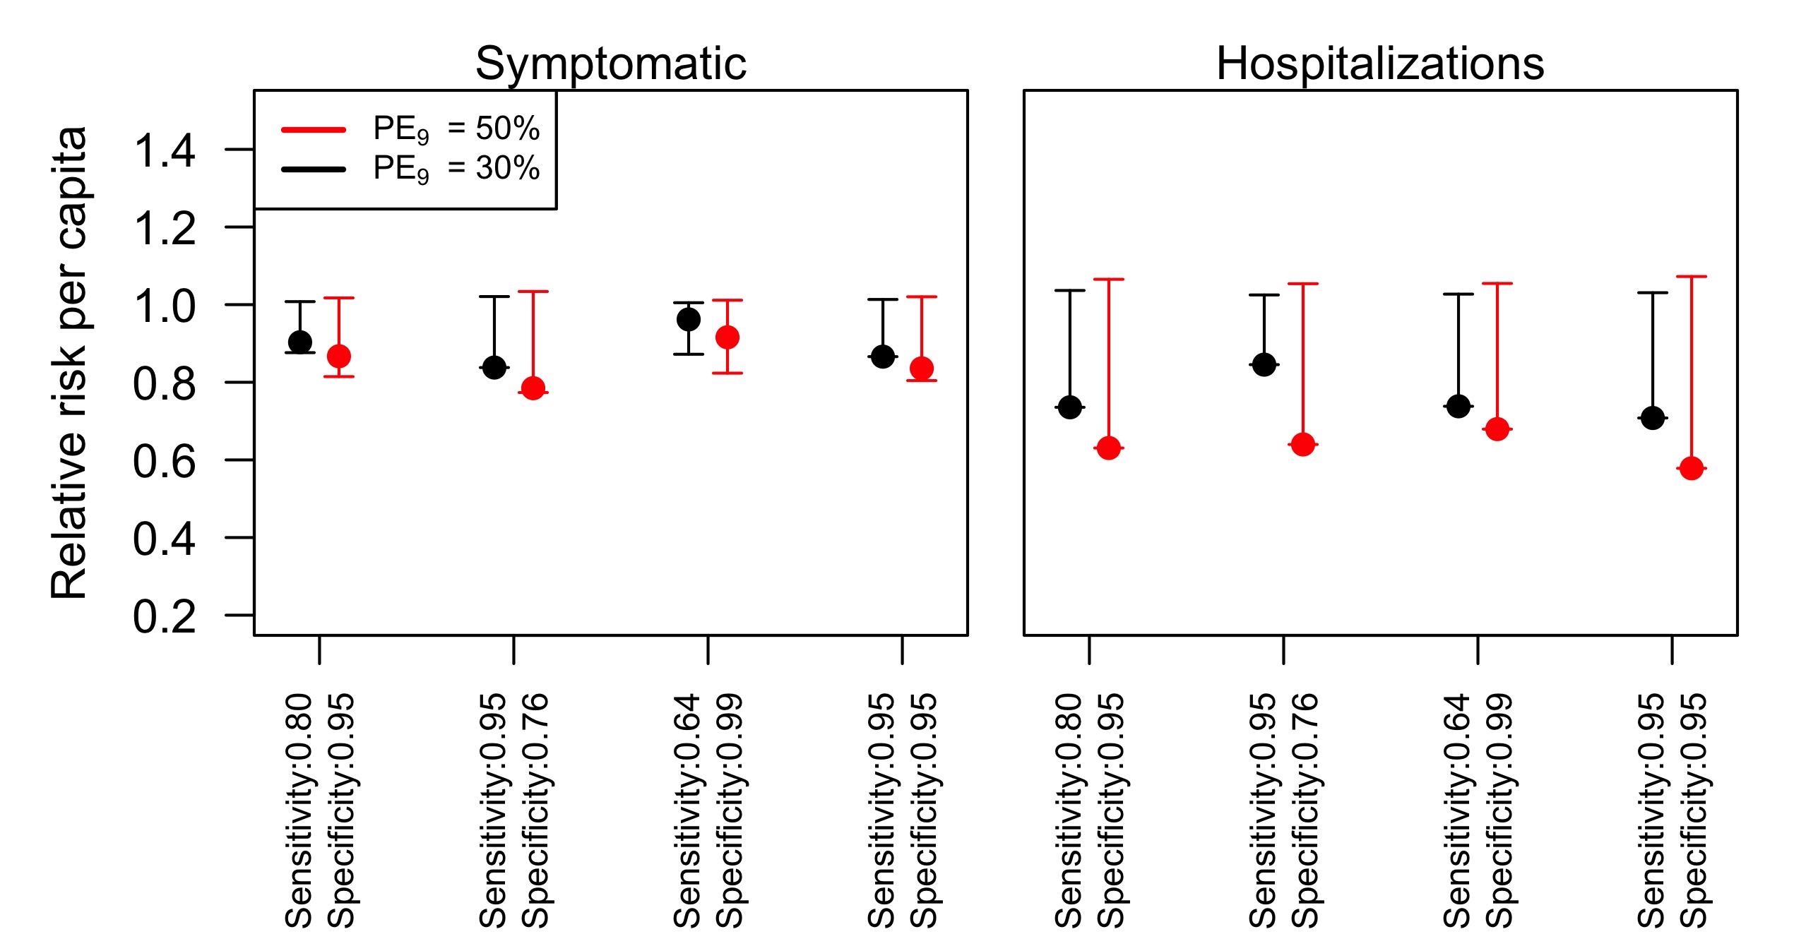

Figure 3. Relative risk of dengue for individuals in the intervention group. Left panel refers to the risk of symptomatic cases, and the right panel to the risk of hospitalizations. Red lines show an assumed intensity of transmission of , and black lines represent . The simulations were performed for 80% intervention coverage of routine pre-vaccination screening in 9 year-olds over 10 years.

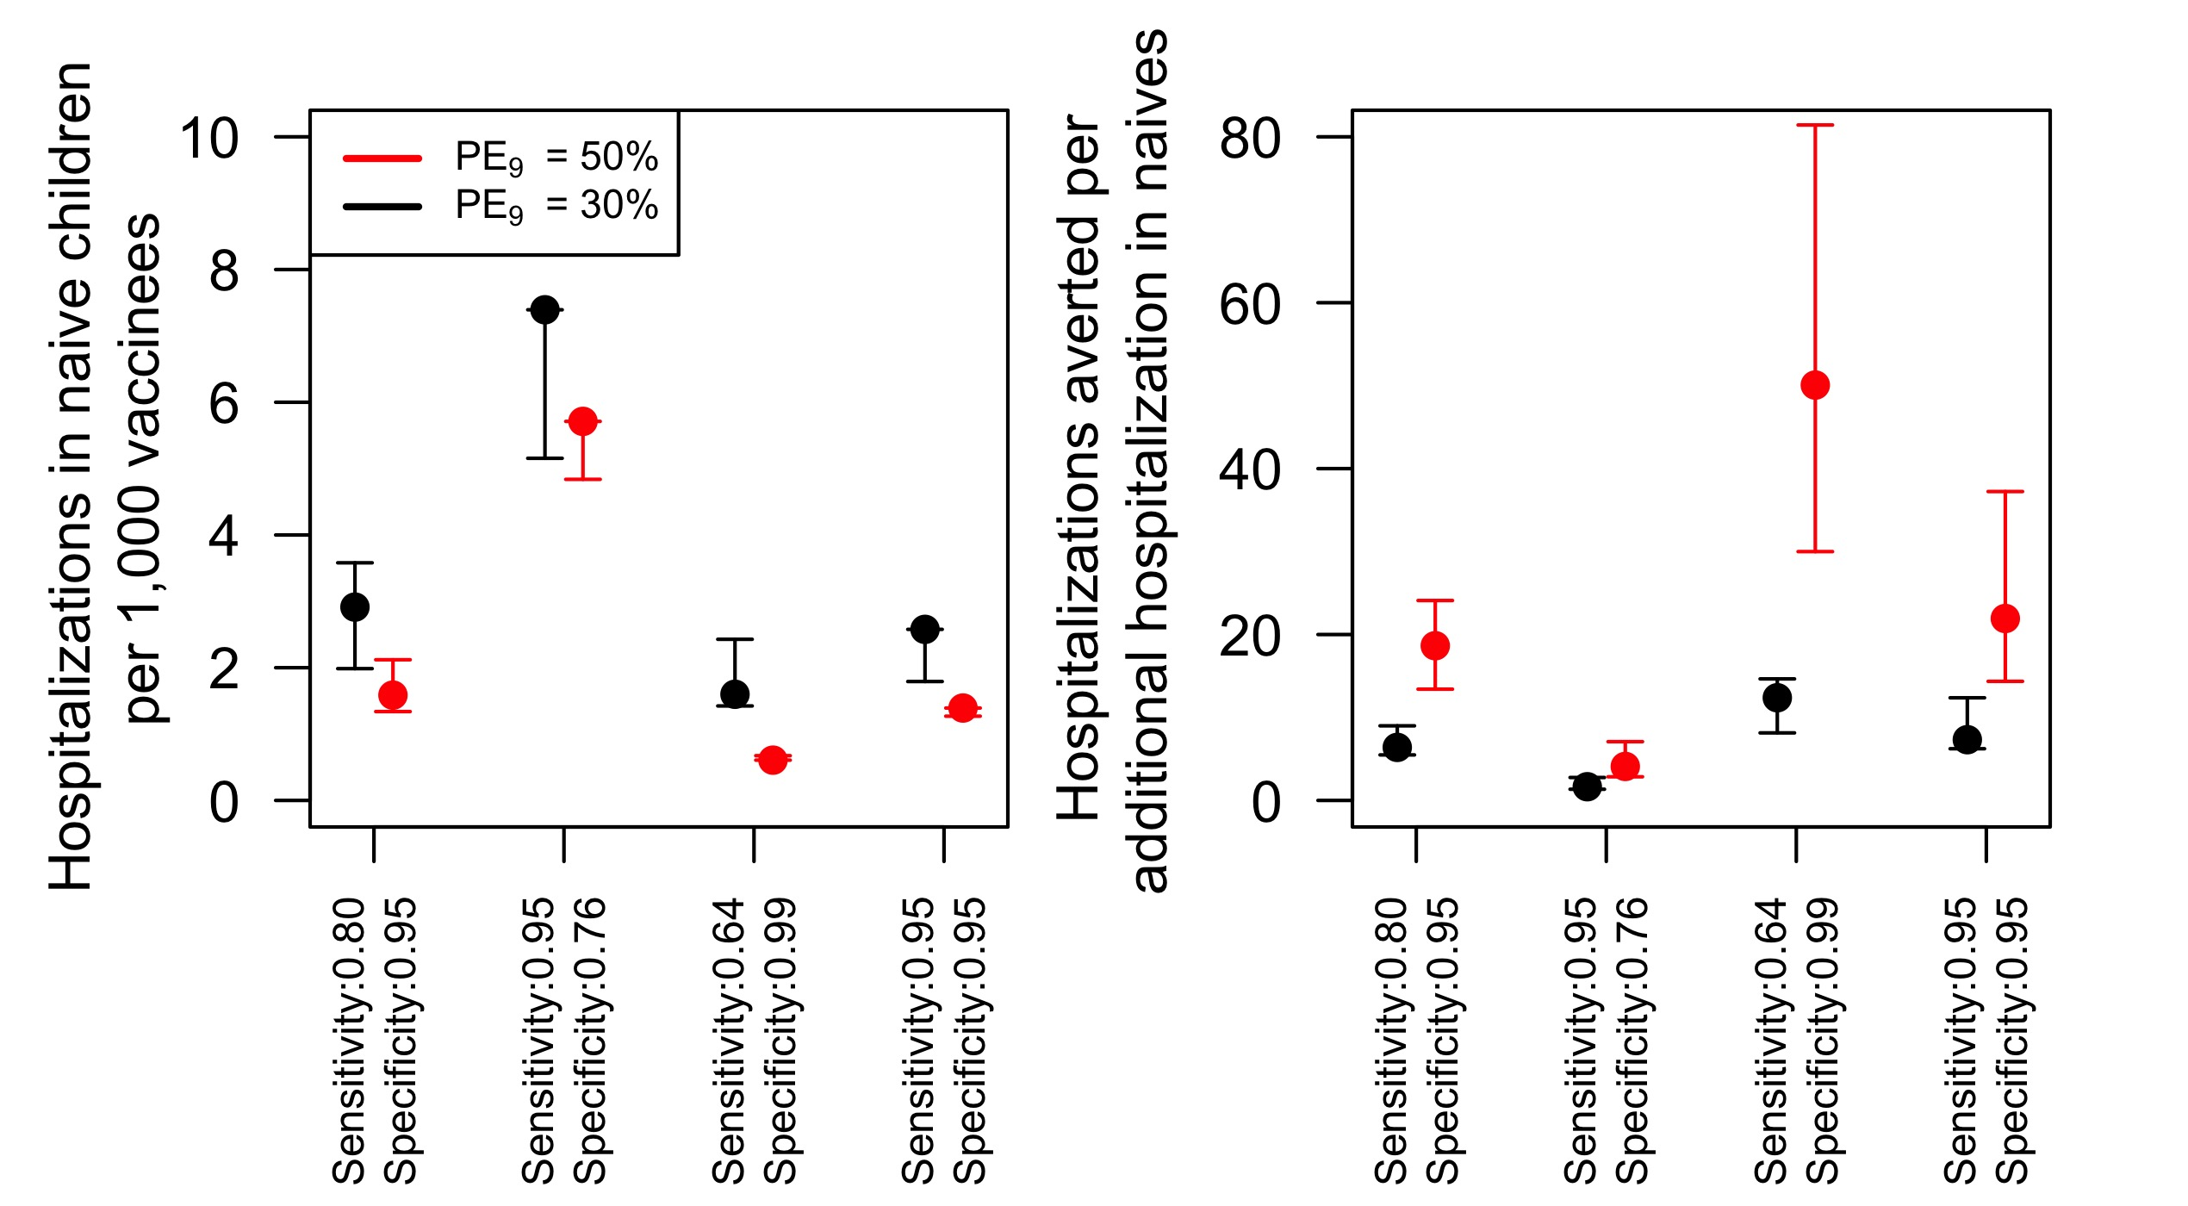

Figure 4. Number of additional hospitalization cases due to vaccination of DENV-naïve children at different levels of sensitivity and specificity. Left panel shows the number of hospitalizations per every 1,000 children vaccinated. The right panel shows the number of hospitalizations averted for every additional hospitalization case in the DENV-naïve group. The simulations were performed for 80% intervention coverage of routine pre-vaccination screening in 9 year-olds over 10 years.

### Magnitude of naïve children at increased risk of hospitalization due to vaccination

As shown in Fig. 4 (left panel), the number of hospitalizations due to misclassification of naïve children was around 1.6 (1.3 - 2.1) per 1,000 vaccinees (). This number increased to almost 3 (1.9 - 3.6) cases per 1,000 vaccinees in a lower transmission scenario. Reducing specificity to increase sensitivity resulted in more than double the baseline hospitalizations in the naïve group. In contrast, reducing sensitivity to increase specificity to 0.99 reduced the number of hospitalizations to about half the baseline number. Furthermore, we found that about 18 (13 - 24) () cases were averted for every additional hospitalization (Fig. 4, right panel), while in a lower transmission setting this number was around 6.5 (5.5 - 9.0). Reducing specificity and increasing sensitivity reduced the number of averted cases per additional hospitalization to about 4 (3 - 7) () and 1.6 (1.3 - 2.8) (). Increasing specificity and reducing sensitivity more than doubled the number of cases averted per additional hospitalization to around 50 (30 - 80) in a moderate transmission scenario (), but it only increased to 12 (8 - 15) in the low transmission scenario (). Increasing sensitivity without sacrificing specificity did not affect substantially the number of cases averted per additional hospitalization.

Our results suggest that the baseline scenario has benefits in all the metrics used in our analyses. Sacrificing specificity to increase sensitivity would increase the number of hospitalizations averted only in some restricted scenarios, and it will result in an increased risk of hospitalizaion for children without previous exposure to DENV at the time of vaccination. In contrast, increasing specificity while sacrificing sensitivity would reduce the population benefits in terms of hospitalizations averted, but it could increase the ratio of hospitalizations averted for every additional hospitalization in vaccinated children who had not been exposed to DENV at the time of vaccination.

## Cost-effectiveness of the pre-vaccination screening intervention

In the baseline scenario of costs, the incremental cost-effectiveness ratio (ICER) of the intervention was around 79,000 USD per QALY gained (48,000 - 122,000) with moderate transmission intensity of (Fig. 5). The ICER was 160,000 USD at a lower transmission intensity scenario (). At the minimum vaccine price of 32 USD, we found an ICER of 350 USD and 15,000 USD for the moderate and low transmission scenarios, respectively. Our estimates show that for each dollar increment in the vaccine cost, the ICER increases 225 USD () and 415 USD (). In terms on the ICER per averted symptomatic case, we estimated that the intervention costs around 10,000 USD to avert a symptomatic case at moderate transmission (Fig. 5, middle column), and around 17,000 USD at a lower transmission setting. Finally, the cost to avert a hospitalized case was around 14,000 USD for a moderate transmission scenario and around 26,000 USD at a lower transmission scenario (Fig. 5), right column).

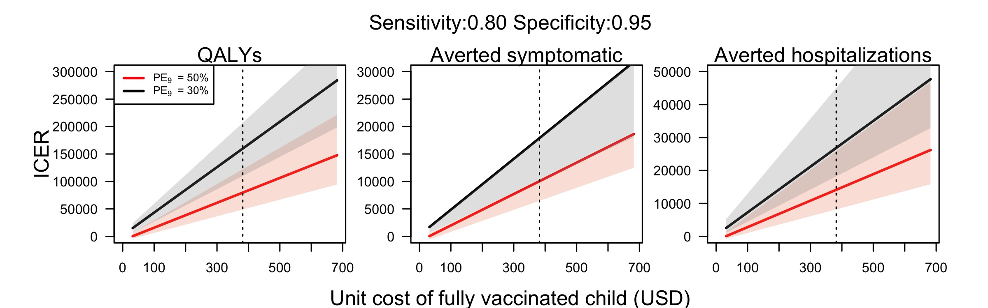

Figure 5. ICER of pre-vaccination screening strategy in Puerto Rico at different costs of vaccination (total cost for three doses per person), assuming a unit cost of serological screening of 10 USD. Dotted line represents the baseline assumption of vaccine cost (382 USD).

## Sensitivity analysis

### Higher transmission setting

We explored the scenario where Puerto Rico has a higher transmission intensity of . In this scenario, we found that around five hospitalizations in naïve children occurred for every 1,000 people vaccinated, compared to six hospitalizations with 6. Compared to the baseline scenario, we found a slight increase in the number of hospitalizations averted for each additional hospitalization in the naïve vaccinated group. However, in the scenario of higher specificity (0.99) with lower sensitivity (0.64), we found that this proportion of hospitalizations averted almost tripled, resulting 141 (84 - 813) hospitalizations averted for each additional hospitalization in the naïve vaccinees group.

We found that the intervention was slightly more cost-effective in a higher transmission setting of . The ICER of the intervention was around 59,000 USD per QALY averted, which represented a reduction of 12,000 USD from the baseline scenario of . In terms of symptomatic cases and hospitalizations, the ICER was also lower. We estimated an ICER of 8,000 USD per symptomatic case averted, and 11,000 USD per hospitalization averted.

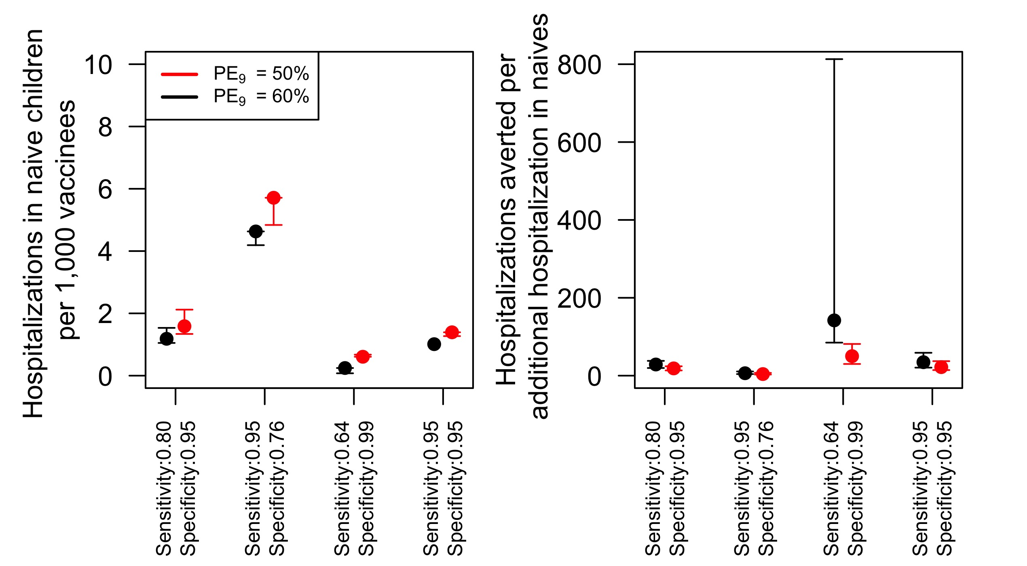

Figure 6. Number of additional hospitalization cases due to vaccination of DENV-naïve children at different levels of sensitivity and specificity. Left panel shows the number of hospitalizations per every 1,000 children vaccinated. The right panel shows the number of hospitalizations averted for every additional hospitalization case in the DENV-naïve group. The simulations were performed for 80% intervention coverage of routine pre-vaccination screening in 9 year-olds over 10 years.

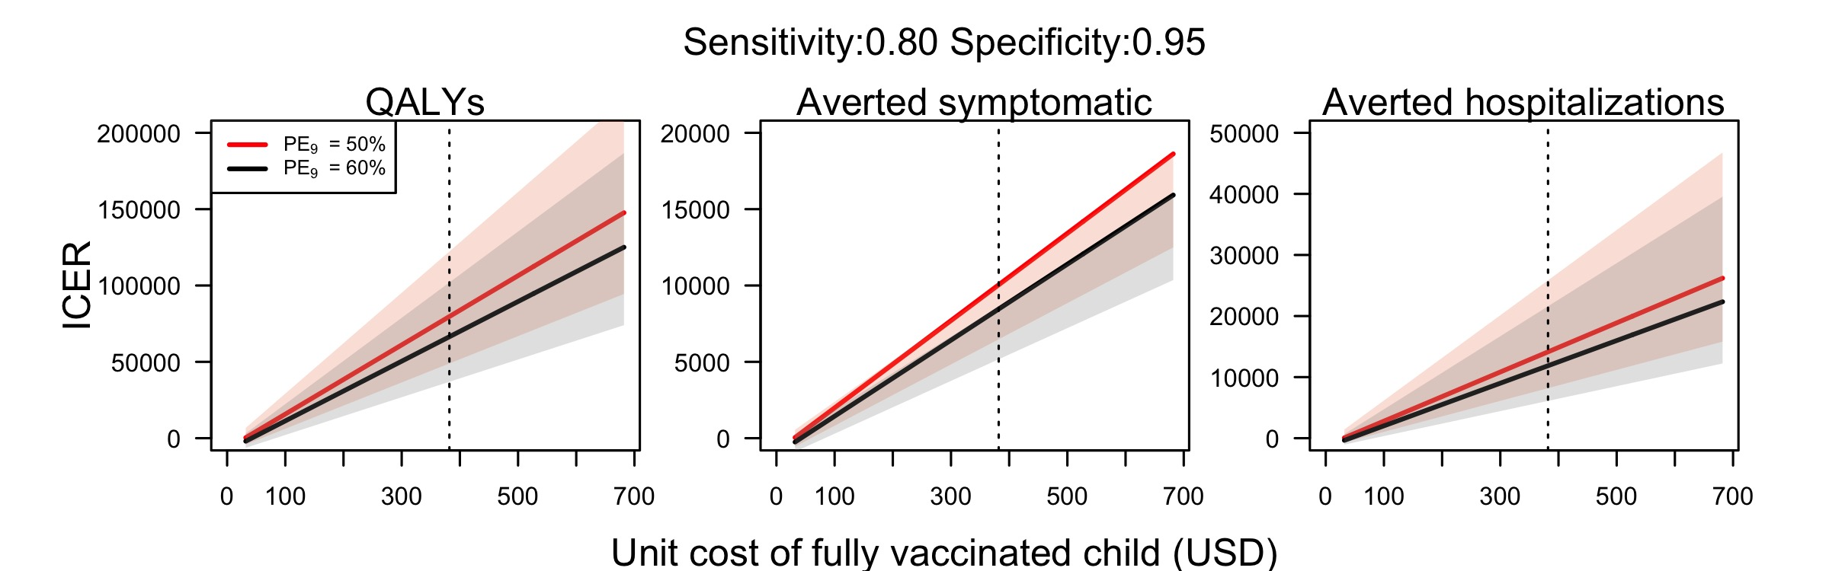

Figure 7. ICER of pre-vaccination screening strategy in Puerto Rico with a higher transmission setting () at different costs of vaccination (total cost for three doses per person), assuming a unit cost of serological screening of 10 USD. Red lines represent a transmission intensity scenario of , and black lines represent a transmission scenario of .

### Sensitivity of cost-effectiveness to uncertainty in sensitivity and specificity values

The cost-effectiveness of the intervention was negatively affected in a scenario of lower specificity (0.76) with higher sensitivity (0.95). For the moderate transmission scenario, the ICER increased to 109,000 USD, and 290,000 USD for the low transmission scenario (Fig. 8). This increment was higher at a low-transmission scenario, given that a reduction on specificity in such a low-transmission level implied a lower number of hospitalizations averted and a higher proportion of hospitalizations caused by misclassification. In contrast, increasing the specificity while reducing sensitivity, slightly reduced the ICER. Changes in the sensitivity and specificity of serological screening did not affect substantially the cost to avert a symptomatic case. With an assumption of lower specificity, more hospitalized cases occurred in the lower transmission scenario, increasing the cost to avert a hospitalization to around 60,000 USD. This cost also increased in a moderate transmission setting to around 21,000 USD. Finally, increasing specificity at a lower sensitivity reduced the cost per hospitalization averted to around 23,000 USD for low transmission.

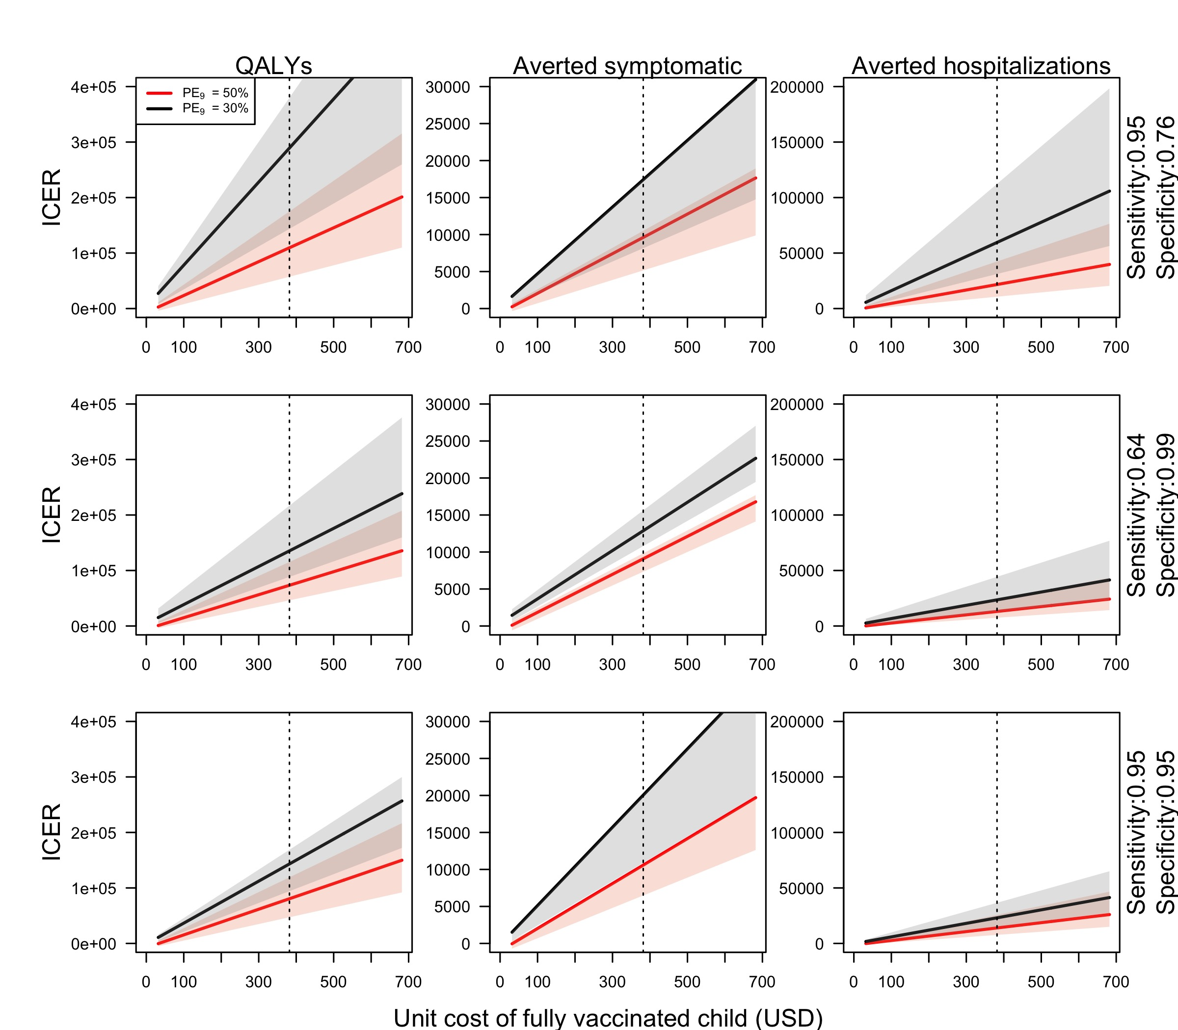

Figure 8. ICER of pre-vaccination screening strategy in Puerto Rico at different cost of vaccination (3 doses per person), assuming a unit cost of serological screening of 10 USD. Dotted vertical line represents the baseline cost of vaccination (382 USD).

### Lower coverage

Achieving 80% coverage in 9-year-olds might be unfeasible. We explored a scenario with a lower coverage of 50% to estimate the effects on cost-effectiveness at a lower vaccination coverage. We found that a lower coverage of vaccination increases slightly the incremental cost of gaining a QALY (Fig. 9, left panel). This increment is more apparent in a lower transmission scenario. Lower coverage also increased slightly the cost to avert a symptomatic case. Whereas, a scenario of lower coverage did not appear to change the cost-effectiveness to avert a hospitalization case (Fig. 9). Although we assume that the vaccine does not provide permanent protection against infection, the slight difference in the cost-effectiveness at lower coverage could be explained by the temporal cross-protection acquired from vaccination, resulting in indirect protection from vaccination in the short term. This indirect protection is reduced a lower coverage, resulting in an increased cost of the intervention.

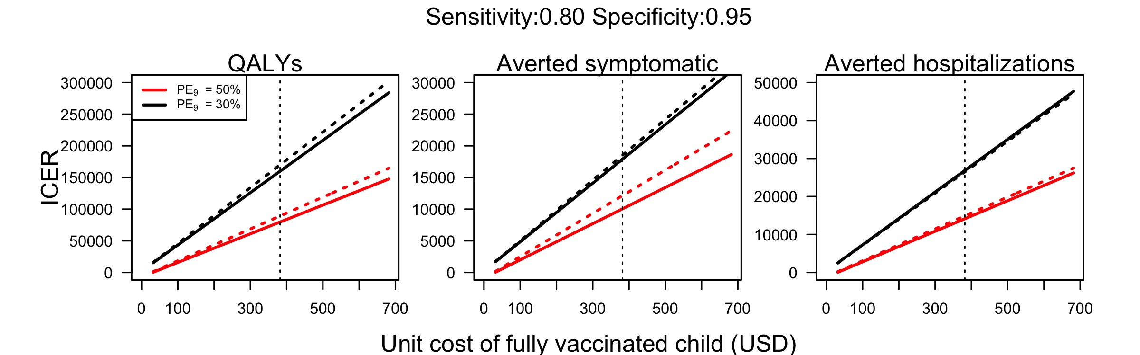

Figure 9. ICER of pre-vaccination screening strategy in Puerto Rico at lower coverage (50%) and at different cost of vaccination (3 doses per person), assuming a unit cost of serological screening of 10 USD.

### Uncertainty about costs and disability weights

To reflect our uncertainty on the assumptions of treatment costs and disability weights, we varied within a 20% range the costs per hospitalized and symptomatic case, and used uncertainty on disability weights from Zeng et al. [zeng2019_AJTMH] (Table 3). Reducing the costs of hospitalization 20% below the baseline assumption resulted in an increased to 81,687 USD per QALY gained in the ICER, while an increment of 20% reduced the ICER to 77,660 USD. Estimates of the ICER showed little sensitivity to 20% variation of the cost of clinical attention of symptomatic cases (79,238 USD - 80,108 USD). The uncertainty on the disability weights of symptomatic cases resulted in a difference of around 30,000 USD in the ICER, while the uncertainty of hospitalizations resulted in around 23,000 USD difference in the ICER. Similar magnitudes were found for the sensitivity of the ICER estimates at lower transmission intensity. Given the large uncertainty associated with the cost of serological screening, we assumed a wide range of values with a lower bound of the unit cost of serological screening of 1 USD, and upper bound of 30 USD. The ICER on these upper and lower bounds showed that increasing the cost to 30 USD increased the ICER to 90,000 USD, whereas the ICER would be reduced to 74,800 USD with an assumption of 1 USD.

Table 3. Sensitivity to changes in costs and disability weights for ICER based on QALYs gained.

|  |  |  |  |  |  |
| --- | --- | --- | --- | --- | --- |
| Parameter |  | Min | ICER(Min) | Max | ICER(Max) |
| costs symptomatic | 50% | 252 | 80,108 | 379 | 79,238 |
| costs hospitalization | 50% | 1,706 | 81,687 | 2,559 | 77,660 |
| unit cost of serological screening | 50% | 1 | 74,873 | 30 | 90,338 |
| disability weight symptomatic | 50% | 0.0170 | 87,725 | 0.0917 | 56,528 |
| disability weight hospitalization | 50% | 0.0241 | 84,085 | 0.0960 | 61,745 |
| costs symptomatic | 30% | 252 | 160,399 | 379 | 159,478 |
| costs hospitalization | 30% | 1,706 | 162,103 | 2,559 | 157,774 |
| unit cost of serological screening | 30% | 1 | 146,397 | 30 | 190,019 |
| disability weight symptomatic | 30% | 0.0170 | 177,693 | 0.0917 | 109,487 |
| disability weight hospitalization | 30% | 0.0241 | 168,931 | 0.0960 | 122,246 |

# Limitations

In this study, we simulated routine pre-vaccination screening programs with CYD-TDV and dengue virus transmission using a highly detailed agent-based model. Although our model has been carefully parameterized and previously validated with seven other models [19], our approach has some limitations.

First, we did not explicitly simulate geographical or demographic characteristics of Puerto Rico. For instance, However, the age structure of the simulated population and other demographic characteristics are based on data from Iquitos, Peru. Instead, we parameterized our model to represent generic settings of transmission intensity around the world. This approach has been used before to make projections on the public health impact of this dengue vaccine [19]. We modeled Puerto Rico by adjusting the intensity of transmission. We focused on two seroprevalence assumptions to account for the uncertainty on the intensity of transmission, given that we only found two studies on the seroprevalence in Puerto Rico. Another limitation of our model is that we are simulating homogeneous importation of DENV serotypes. Although this assumption is unrealistic, given that dengue outbreaks are characterized by the dominance of one of the serotypes, it would be unfeasible to make projections of the serotype-specific DENV importations for the next ten years. In our analysis of costs, we assumed that the cost of vaccinating one child includes transportation, storage, distribution, and other factors. These additional factors should be considered to determine the actual cost per capita of a fully vaccinated child. Finally, we only focused on a public health perspective because this is the main approach studied in previous recommendations of the implementation of this vaccine.

# Discussion

Using an agent-based model of dengue virus transmission, we simulated the impact of a pre-vaccination screening strategy for 10 years of routine vaccination in 9-year-olds at a level of transmission resembling data from Puerto Rico. Our model has been previously calibrated to represent longitudinal data of dengue virus transmission in Iquitos, Peru. Even though many of the model parameters were calibrated for Iquitos, our model was calibrated in such a way that it represents generic patterns of dengue virus transmission. This model has also been used in previous assessments of vaccination impact with CYD-TDV [15,19]. In our previous assessments, our model agreed qualitatively with projections from seven other models of dengue virus transmission. Assuming a moderate and low transmission intensity (PE = [0.5, 0.3]) in Puerto Rico, we found that this intervention could be beneficial at the population and individual level, as long as serological screening has at least moderate values of sensitivity and high specificity. Accounting for uncertainty in our vaccine parameters, we found that a minimum specificity of 0.6 that was required to ensure that the intervention would not result in an increment of hospitalized cases. Additional scenarios of transmission intensity can be explored in our webapp (<http://denguevaccine.crc.nd.edu>).

A sensitivity analysis showed that higher specificity would be more important than high sensitivity to achieve higher cost-effectiveness, mostly at lower transmission scenarios. Assuming that is the case, it would be important to ensure highly specific screening tests for pre-vaccination screening interventions to minimize the number of seronegative individuals misclassified as seropositive and to improve cost-effectiveness by reducing the cost per QALY gained. With respect to additional hospitalizations caused by vaccinating children who had not been exposed to DENV at the time of vaccination, our results suggest that for every 1,000 vaccinated children, around 2 extra cases would be caused (4 in a lower transmission setting). This number more than doubled when we reduced the specificity of screening to improve sensitivity.

Many of our parameters were obtained from previous studies in Puerto Rico or were assumed from previous cost-effectiveness analyses of the intervention. For instance, we focused on a scenario of 80% coverage among nine-year-olds on a routine basis. However, this coverage might not be achieved in practice. For example, if the vaccine were elective and available only on the private market and not with a provider subsidy, vaccination coverage would likely be much lower. Our results suggest that the cost-effectiveness would be affected by a lower coverage by slightly increasing the ICER in low transmission scenarios. This increase could be attributed to the short-term protection that vaccinees acquired against all DENV serotypes, providing a level of indirect protection to those unvaccinated. Other uncertainty sources for the cost-effectiveness analysis affected our estimates of cost-effectiveness. The additional cost per QALY gained was mostly affected by variation in costs of hospitalization. Refinement on these costs would improve estimates of the cost-effectiveness of pre-vaccination screening interventions. Alas, there are few sources of estimates of these type of costs in the literature.

Generally, our results appear to be consistent with other studies that evaluated dengue vaccination in Puerto Rico, but differed in some assumptions. At a vaccine cost of 20 USD per dose (60 USD for three doses), Coudeville et al. found that, using the GDP per capita as a threshold for the willingness to pay for a DALY averted, this intervention could be cost-savings [16]. At a similar cost of the vaccine, we found a lower cost per QALY averted of 7,000 USD. Similar results were found by Zeng et al., although they omitted the cost of screening[32]. Our study differs in the assumption of the costs of clinical care. Whereas we focused on the cost paid by the government (1,615 USD) [26], the two studies mentioned above used the overall direct cost of hospitalization (4,135 USD). At the base case of vaccine cost of 382 USD, dengue vaccination at a cost of 79,000 USD per QALY gained is within the range of current vaccines for adolescents in the United States[33–35]. We were unable to find cost-effectiveness analysis of vector control for dengue in Puerto Rico. However, a study from 2011 on the cost-effectiveness of dengue vector control strategies in Rio de Janeiro, Brazil, suggests an ICER between 615 USD and 1,267 USD per DALY averted [36]. Similar costs per QALY gained could be achieved at a cost of the vaccine below 40 USD.

To summarize, the model estimates a cost-effectiveness for pre-vaccination screening and subsequent vaccination as appropriate on the range of 56,000 to 190,000 USD per QALY, with a range dependent on assumptions about background prevalence, vaccine cost, and other factors. Model results comport fairly well with other epidemiological models and with other estimates of economic value.

# Acknowledgements

This analysis is based on previous analyses available published in PLOS Neglected Tropical Diseases [15], prepared in collaboration with other authors: Yutong Yao, Kathryn B. Anderson, Meagan C. Fitzpatrick, David L. Smith, Amy C. Morrison, Annelies Wilder-Smith, and Thomas W. Scott.

# References

1. van Panhuis WG, Grefenstette J, Jung SY, Chok NS, Cross A, Eng H, et al. Contagious Diseases in the United States from 1888 to the Present. New England Journal of Medicine. 2013;369: 2152–2158. doi:[10.1056/NEJMms1215400](https://doi.org/10.1056/NEJMms1215400)

2. Capeding MR, Tran NH, Hadinegoro SRS, Ismail HIHM, Chotpitayasunondh T, Chua MN, et al. Clinical efficacy and safety of a novel tetravalent dengue vaccine in healthy children in Asia: A phase 3, randomised, observer-masked, placebo-controlled trial. The Lancet. 2014;384: 1358–1365.

3. Villar L, Dayan GH, Arredondo-García JL, Rivera DM, Cunha R, Deseda C, et al. Efficacy of a tetravalent dengue vaccine in children in Latin America. New England Journal of Medicine. 2015;372: 113–123.

4. Sabchareon A, Wallace D, Sirivichayakul C, Limkittikul K, Chanthavanich P, Suvannadabba S, et al. Protective efficacy of the recombinant, live-attenuated, CYD tetravalent dengue vaccine in Thai schoolchildren: A randomised, controlled phase 2b trial. The Lancet. 2012;380: 1559–1567.

5. Sridhar S, Luedtke A, Langevin E, Zhu M, Bonaparte M, Machabert T, et al. Effect of Dengue Serostatus on Dengue Vaccine Safety and Efficacy. New England Journal of Medicine. 2018;379: 327–340. doi:[10.1056/NEJMoa1800820](https://doi.org/10.1056/NEJMoa1800820)

6. Cattarino L, Rodriguez-Barraquer I, Imai N, Cummings DAT, Ferguson NM. Mapping global variation in dengue transmission intensity. Science Translational Medicine. 2020;12. doi:[10.1126/scitranslmed.aax4144](https://doi.org/10.1126/scitranslmed.aax4144)

7. Bhatt S, Gething PW, Brady OJ, Messina JP, Farlow AW, Moyes CL, et al. The global distribution and burden of dengue. Nature. 2013;496: 504. doi:[http://dx.doi.org/10.1038/nature12060](https://doi.org/http://dx.doi.org/10.1038/nature12060)

8. Shepard DS, Undurraga EA, Halasa YA, Stanaway JD. The global economic burden of dengue: A systematic analysis. The Lancet Infectious Diseases. 2016;16: 935–941. doi:[https://doi.org/10.1016/S1473-3099(16)00146-8](https://doi.org/https://doi.org/10.1016/S1473-3099(16)00146-8)

9. American Health Organization}. Dengue in the Americas reaches highest number of cases recorded. 2019.

10. Anders KL, Indriani C, Ahmad RA, Tantowijoyo W, Arguni E, Andari B, et al. The AWED trial (Applying Wolbachia to Eliminate Dengue) to assess the efficacy of Wolbachia-infected mosquito deployments to reduce dengue incidence in Yogyakarta, Indonesia: Study protocol for a cluster randomised controlled trial. Trials. 2018;19: 302. doi:[10.1186/s13063-018-2670-z](https://doi.org/10.1186/s13063-018-2670-z)

11. Bowman LR, Donegan S, McCall PJ. Is dengue vector control deficient in effectiveness or evidence?: Systematic review and meta-analysis. PLOS Neglected Tropical Diseases. 2016;10: 1–24. doi:[10.1371/journal.pntd.0004551](https://doi.org/10.1371/journal.pntd.0004551)

12. Biswal S, Reynales H, Saez-Llorens X, Lopez P, Borja-Tabora C, Kosalaraksa P, et al. Efficacy of a tetravalent dengue vaccine in healthy children and adolescents. New England Journal of Medicine. 0: null. doi:[10.1056/NEJMoa1903869](https://doi.org/10.1056/NEJMoa1903869)

13. ClinicalTrials.gov. Phase III Trial to Evaluate Efficacy and Safety of a Tetravalent Dengue Vaccine. https://clinicaltrials.gov/ct2/show/NCT02406729?cond=dengue+vaccine{&}phase=2{&}draw=2{&}rank=11;

14. World Health Organization. Revised SAGE recommendation on use of dengue vaccine. 2018.

15. España G, Yao Y, Anderson KB, Fitzpatrick MC, Smith DL, Morrison AC, et al. Model-based assessment of public health impact and cost-effectiveness of dengue vaccination following screening for prior exposure. PLOS Neglected Tropical Diseases. 2019;13: 1–21. doi:[10.1371/journal.pntd.0007482](https://doi.org/10.1371/journal.pntd.0007482)

16. Coudeville L, Baurin N, Shepard DS. The potential impact of dengue vaccination with, and without, pre-vaccination screening. Vaccine. 2019. doi:[https://doi.org/10.1016/j.vaccine.2019.12.012](https://doi.org/https://doi.org/10.1016/j.vaccine.2019.12.012)

17. Pearson CAB, Abbas KM, Clifford S, Flasche S, Hladish TJ. Serostatus testing and dengue vaccine cost&#x2013;Benefit thresholds. Journal of The Royal Society Interface. 2019;16: 20190234. doi:[10.1098/rsif.2019.0234](https://doi.org/10.1098/rsif.2019.0234)

18. Perkins TA, Reiner RC, España G, ten Bosch QA, Verma A, Liebman KA, et al. An agent-based model of dengue virus transmission shows how uncertainty about breakthrough infections influences vaccination impact projections. PLOS Computational Biology. 2019;15: 1–32. doi:[10.1371/journal.pcbi.1006710](https://doi.org/10.1371/journal.pcbi.1006710)

19. Flasche S, Jit M, Rodŕiguez-Barraquer I, Coudeville L, Recker M, Koelle K, et al. The Long-Term Safety, Public Health Impact, and Cost-Effectiveness of Routine Vaccination with a Recombinant, Live-Attenuated Dengue Vaccine (Dengvaxia): A Model Comparison Study. von Seidlein L, editor. PLOS Medicine. 2016;13: 1–19. doi:[10.1371/journal.pmed.1002181](https://doi.org/10.1371/journal.pmed.1002181)

20. Coudeville L, Baurin N, Vergu E. Estimation of parameters related to vaccine efficacy and dengue transmission from two large phase III studies. Vaccine. 2016;34: 6417–6425. doi:[10.1016/j.vaccine.2015.11.023](https://doi.org/10.1016/j.vaccine.2015.11.023)

21. Argüello DF, Tomashek KM, Quiñones L, Beltran M, Acosta L, Santiago LM, et al. Incidence of dengue virus infection in school-aged children in Puerto Rico: A prospective seroepidemiologic study. The American journal of tropical medicine and hygiene. 2015;92: 486–491.

22. Ferguson NM, Rodŕiguez-Barraquer I, Dorigatti I, Mier-y-Teran-Romero L, Laydon DJ, Cummings DAT. Benefits and risks of the Sanofi-Pasteur dengue vaccine: Modeling optimal deployment. Science. 2016;353: 1033–1036.

23. Guido España. Cost-effectiveness of dengvaxia in Puerto Rico. https://github.com/confunguido/evaluation-dengue-vaccine-puerto-rico; Github; 2020.

24. Luo R, Fongwen N, Kelly-Cirino C, Harris E, Wilder-Smith A, Peeling R. Rapid diagnostic tests for determining dengue serostatus: A systematic review and key informant interviews. Clinical Microbiology and Infection. 2019. doi:[10.1016/j.cmi.2019.01.002](https://doi.org/10.1016/j.cmi.2019.01.002)

25. Turner HC, Wills BA, Rahman M, Quoc Cuong H, Thwaites GE, Boni MF, et al. Projected costs associated with school-based screening to inform deployment of Dengvaxia: Vietnam as a case study. Transactions of The Royal Society of Tropical Medicine and Hygiene. 2018; try057. doi:[10.1093/trstmh/try057](https://doi.org/10.1093/trstmh/try057)

26. Halasa YA, Shepard DS, Zeng W. Economic cost of dengue in Puerto Rico. The American journal of tropical medicine and hygiene. 2012;86: 745–752.

27. indicadores.pr. Índice de precios al consumidor (histórico). Índice de precios al consumidor (histórico). https://indicadores.pr/dataset/ndice-de-precios-al-consumidor-historico;

28. Shim E. Cost-effectiveness of dengue vaccination in Yucatán, Mexico using a dynamic dengue transmission model. PLOS ONE. 2017;12: 1–17. doi:[10.1371/journal.pone.0175020](https://doi.org/10.1371/journal.pone.0175020)

29. Shim E. Cost-Effectiveness of Dengue Vaccination Programs in Brazil. The American journal of tropical medicine and hygiene. 2017;96: 1227–1234.

30. World Health Organization. The global burden of disease: 2004 update. 2008.

31. Zeng W, Halasa-Rappel YA, Durand L, Coudeville L, Shepard DS. Impact of a nonfatal dengue episode on disability-adjusted life years: A systematic analysis. The American Journal of Tropical Medicine and Hygiene. 2018;99: 1458–1465. doi:[https://doi.org/10.4269/ajtmh.18-0309](https://doi.org/https://doi.org/10.4269/ajtmh.18-0309)

32. Zeng W, Halasa-Rappel YA, Baurin N, Coudeville L, Shepard DS. Cost-effectiveness of dengue vaccination in ten endemic countries. Vaccine. 2018;36: 413–420.

33. Jit M, Brisson M, Portnoy A, Hutubessy R. Cost-effectiveness of female human papillomavirus vaccination in 179 countries: A PRIME modelling study. The Lancet Global health. 2014;2: e406–e414.

34. Shepard CW, Ortega-Sanchez IR, Scott RD, Rosenstein NE. Cost-effectiveness of conjugate meningococcal vaccination strategies in the united states. Pediatrics. 2005;115: 1220–1232. doi:[10.1542/peds.2004-2514](https://doi.org/10.1542/peds.2004-2514)

35. Ortega-Sanchez IR, Lee GM, Jacobs RJ, Prosser LA, Molinari NA, Zhang X, et al. Projected cost-effectiveness of new vaccines for adolescents in the united states. Pediatrics. 2008;121. doi:[https://doi.org/10.1542/peds.2007-1115H](https://doi.org/https://doi.org/10.1542/peds.2007-1115H)

36. Luz PM, Vanni T, Medlock J, Paltiel AD, Galvani AP. Dengue vector control strategies in an urban setting: An economic modelling assessment. The Lancet. 2011;377: 1673–1680. doi:[https://doi.org/10.1016/S0140-6736(11)60246-8](https://doi.org/https://doi.org/10.1016/S0140-6736(11)60246-8)