Cost-effectiveness of Dengvaxia in Puerto Rico

Guido España

Alex Perkins

# Introduction

Recent analyses of CYD-TDV vaccine trials showed an increased risk of severe dengue upon subsequent natural infection among vaccinees without previous exposure to dengue virus (DENV) [1]. The World Health Organization (WHO) recommends pre-vaccination screening to ensure that only those with previous exposure to DENV are vaccinated [2]. However, rapid diagnostic tests with high sensitivity and specificity are not currently available. We have previously discussed the benefits and cost-effectiveness of pre-vaccination screening for economic scenarios resembling the Philippines and Brazil [3]. Here, we discuss the implications of this strategy for Puerto Rico in terms of epidemiological benefits and cost-effectiveness.

# Description of methods specific for Puerto Rico

## Agent-Based Model

As described in the manuscript on which this analysis is based [3], our agent-based model was previously used to make projections of vaccination impact with CYD-TDV in the absence of serological screening [4]. Although our model has been parameterized based on data from Iquitos, Peru, we performed generic simulations that could represent scenarios of transmission from low to high intensity. These simulations showed agreement to the other seven models in the consortium that formed the results described previously [4]. To estimate the impact of the pre-vaccination screening strategy with CYD-TDV for Puerto Rico, we modified our assumptions about costs, and focused our analyses on transmission scenarios with prior DENV exposure among nine-year-olds (PE) as close as possible to empirical estimates from Puerto Rico as possible. We assumed that coverage of the intervention (i.e., serological screening and vaccination in the event of a positive result) was 80% and simulated the sensitivity and specificity of serological screening ranging 0 - 1.

In our model, the vaccine profile was assumed as that of a silent infection, similar to other work [4,5]. Hence, seronegative individuals vaccinated with CYD-TDV have a higher risk of hospitalization after a natural infection. To match the most recent trial results [1], we calibrated model parameters characterizing vaccine profile to vaccine trial data using a particle filtering approach, which is explained in more detail elsewhere ([3], Appendix S2). An overview of these parameter estimates is provided in Table 1.

Table 1. Vaccine profile parameters calibrated to CYD-TDV trial data [1]. We modeled the vaccine mode of action as a silent infection with a temporary protection against DENV infections (first four parameters of the table). In addition, we calibrated 6 more parameter values corresponding to the rates of symptoms and hospitalization for primary, secondary, and post-secondary infections.

|  |  |
| --- | --- |
| Parameter | Estimate |
| Per-exposure protection from vaccination for seronegative vaccinees | 0.321 |
| Per-exposure protection from vaccination for seropositive vaccinees | 0.516 |
| Average duration of protection for seronegative vaccinees | 426 days |
| Average duration of protection for seropositive vaccinees | 258 days |
| Probability of symptoms conditional on infection (primary) | 0.405 |
| Probability of symptoms conditional on infection (secondary) | 0.339 |
| Probability of symptoms conditional on infection (post-secondary) | 0.09 |
| Probability of hospitalization conditional on symptoms (primary) | 0.074 |
| Probability of hospitalization conditional on symptoms (secondary) | 0.376 |
| Probability of hospitalization conditional on symptoms (post-secondary) | 0.101 |

## Cost-effectiveness analysis

We updated our assumptions about the cost associated with treatment of dengue for ambulatory cases and hospitalizations, based on estimates from Puerto Rico from 2002 to 2010 [6]. Using the consumer price index for Puerto Rico, we projected these costs from those years to 2019 USD. Similarly, we took the GDP per capita for Puerto Rico in 2016 [7] and projected its value to 2019 (Table 2).

Table 2. Assumed costs associated with dengue cases and hospitalizations.

|  |  |  |
| --- | --- | --- |
|  | Cost (USD) | Cost Projected (2019 USD) |
| Ambulatory | 239 (2010) | 311 |
| Hospitalization | 1615 (2010) | 2107 |
| GDP per capita | 30,833 (2016) | 31,365 |

We estimated the quality-adjusted life-years (QALYs) gained with pre-vaccination screening using disability weights and the duration of disability from previous studies of dengue [8,9]. In Table 3, the disability weights (D) for dengue fever, hospitalizations, and dengue related deaths are shown. A disability weight of zero represents perfect health, and a value of one represents death. We accounted for discounting and adjusted for life expectancy (L) in the event of dengue related deaths with a discounting rate (r) of 3%, such that the discounted QALY was .

Table 3. Disability weight for dengue cases.

|  |  |  |
| --- | --- | --- |
| Event | Disability weight | Time of disability |
| Dengue fever | 0.0158 | 4 days |
| Hospitalization | 0.545 | 14 days |
| Deaths | 1 | Life expectancy - age of death |

We then calculated the incremental cost-effectiveness ratio (ICER) as

As others have, we deemed the intervention cost-effective if the ICER was below 3 GDP per capita, and very cost-effective if the ICER fell below 1 GDP per capita.

To evaluate the ICER of the pre-vaccination screening scenarios in Puerto Rico, we assumed a baseline scenario of the costs of the intervention. The cost per fully vaccinated child was set to 70 USD based on pricing information from the Philippines ([3], Appendix S4), and the cost to screen an individual for previous exposure to DENV was set to 10 USD based on a study from Vietnam [10]. In our simulations, we chose a baseline assumption of 0.8 and 0.95 for sensitivity and specificity, respectively, based on a recent review of rapid diagnostic tests for determination of serostatus [11]. However, given that these estimates come from studies that included only suspected or known DENV infection and that there is a a trade-off between sensitivity and specificity[11], we evaluated the sensitivity on the cost-effectiveness estimates on a wider range of values to represent three additional scenarios: high specificity (1.0) and low sensitivity (0.5), low specificity (0.5) and high sensitivity (1.0), and high specificity (1.0) and high sensitivity (1.0).

## Estimates of the intensity of transmission in Puerto Rico ()

Estimates of seroprevalence in Puerto Rico indicate that seroprevalence in 9-year-olds is at most 50%. Coudeville et al. estimated 50% seroprevalence in 9-year-olds [12] in clinical trial sites there. According to Argüello, 49.8% (95% CI = 43.6-56.0%) of participants between 10-18 years of age had a positive IgG anti-DENV antibodies [13]. Hence, we conclude that seroprevalence among 9-year-olds in Puerto Rico is likely to be around 40-50%. We assumed a of 0.5, although it’s important to note that seroprevalence differs from the , because the seroprevalence depends on the specificity and sensitivity of the screening method used, whereas the refers to the true proportion of 9-year-olds with previous exposure to DENV.

# Results

## Epidemiological benefits from vaccination

Using an agent-based model, we found that the benefits of pre-vaccination screening depend on the sensitivity, specificity, and transmission intensity. For the specific case of Puerto Rico, we assumed a moderate intensity of transmission with a proportion of previous exposure to DENV in nine-year olds around 50% () [12,13]. In this scenario, our results suggest a more or less linear relationship between the proportion of hospitalizations, and the sensitivity and specificity of screening (Fig. 1). Hence, positive outcomes could be obtained with either high sensitivity or high specificity of screening. However, the largest benefits were found in scenarios of high sensitivity and high specificity. From the perspective of an individual screened for previous DENV infection and vaccinated in the event of a positive result, relative risk was lower for those who were screened when either specificity or sensitivity was high (Fig. 2). These results depend on our baseline assumption about the transmission intensity in Puerto Rico. If the transmission intensity of Puerto Rico were to resemble a lower transmission setting (), tests with high specificity would be required to achieve public health benefits. In contrast, if Puerto Rico has a higher transmission intensity than our assumptions () than our assumptions, then public health benefits would be achieved with wider ranges of specificity and sensitivity, and these benefits would depend mostly on the sensitivity of serological screening (See Figs. 1 & 2 in [3]).

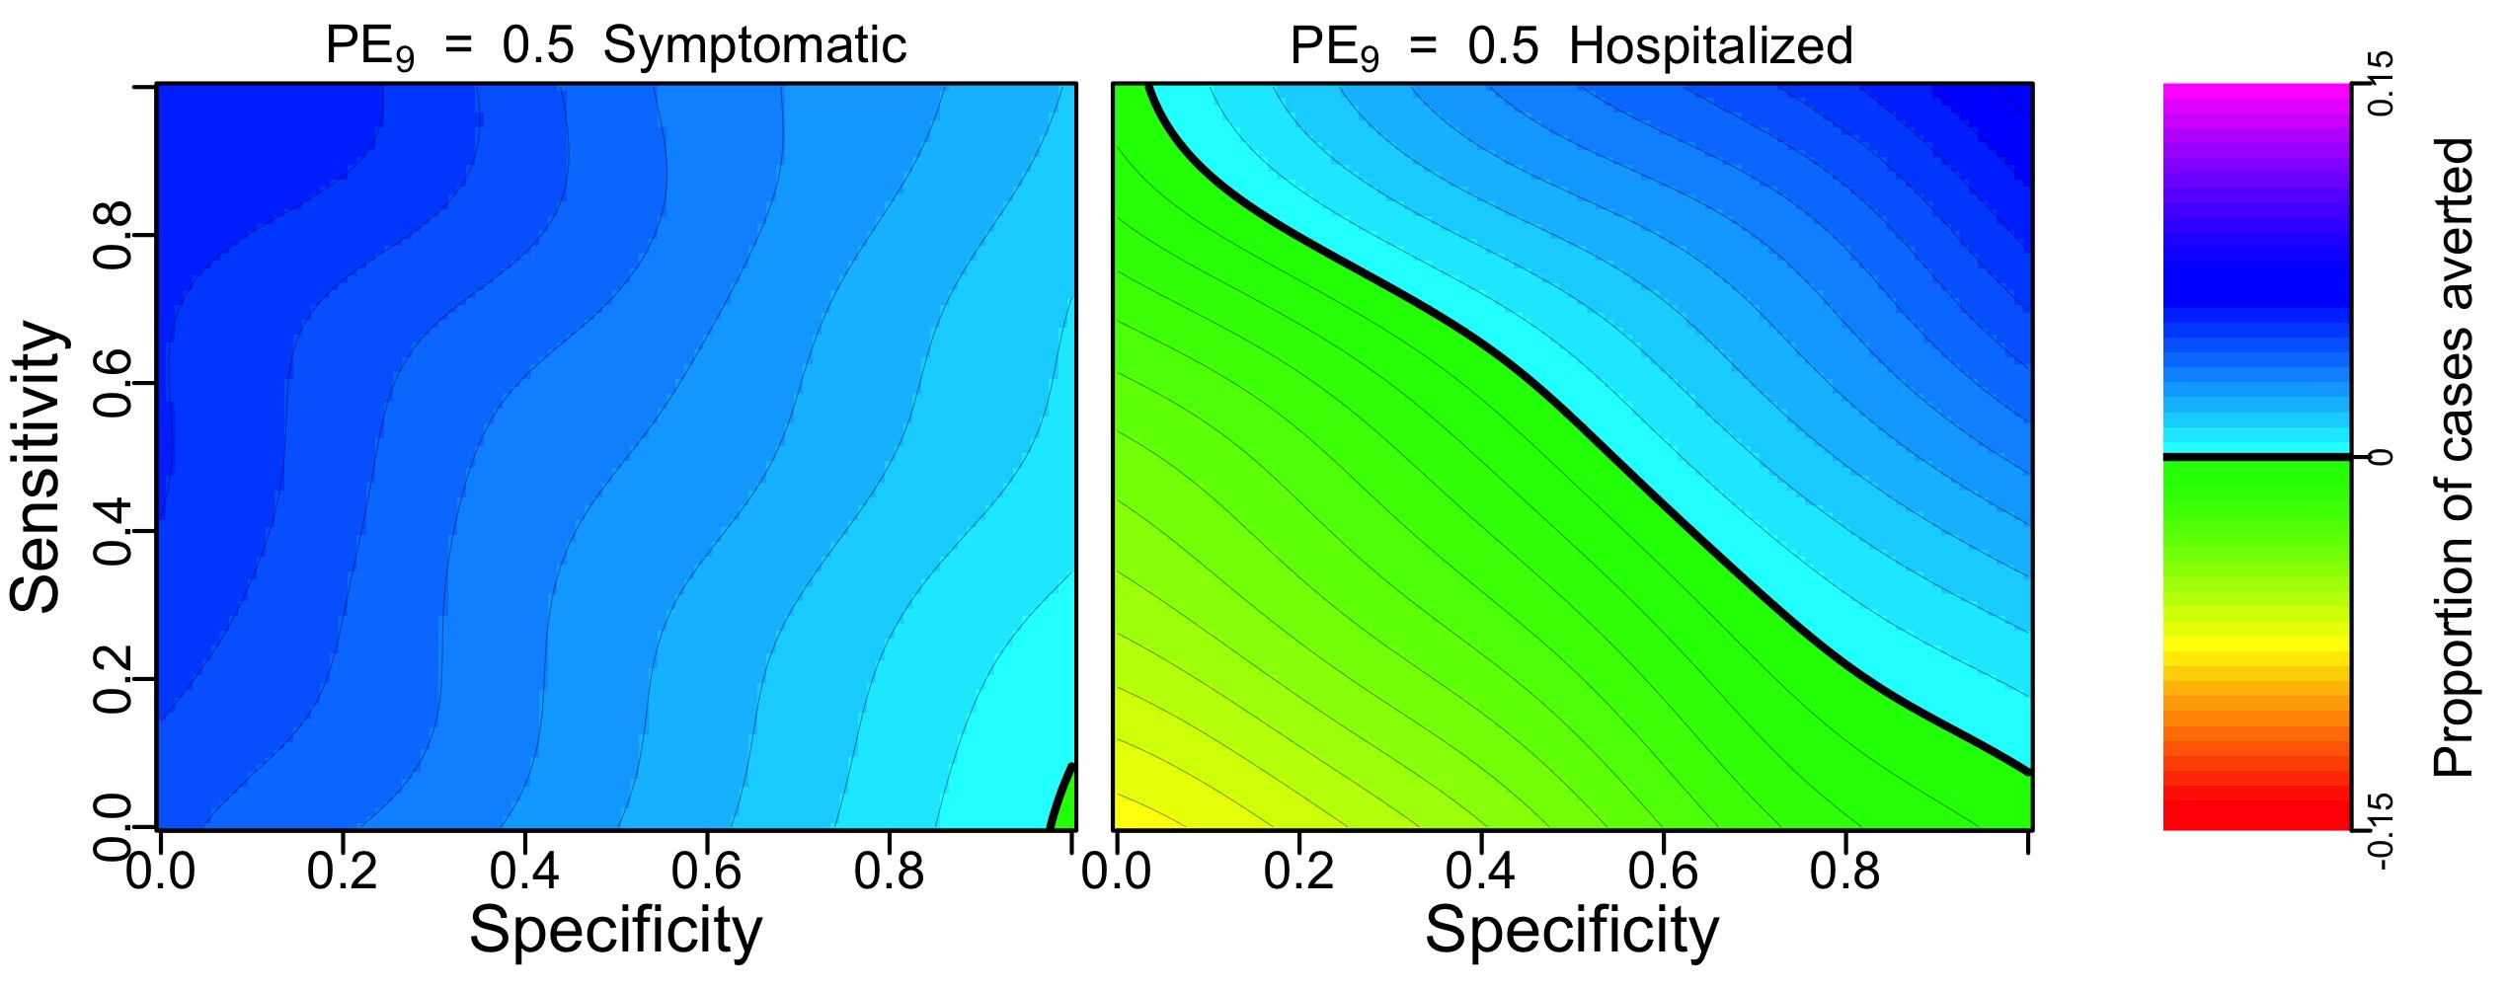

Figure 1. Proportion of symptomatic cases (left) and hospitalizations (right) averted under a pre-vaccination screening strategy with coverage of 80% over 10 years in a population with 50% of 9-year-olds with previous exposure to DENV.

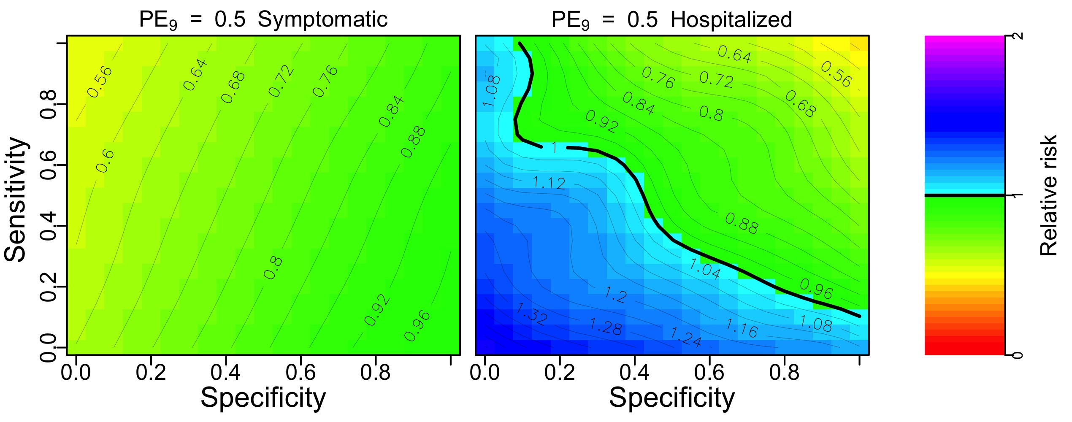

Figure 2. Relative risk of symptomatic (left) or hospitalized (right) diseases among individuals screened and possibly vaccinated under a pre-vaccination screening strategy with coverage of 80% over 10 years in a population with with 50% of 9-year-olds with previous exposure to DENV.

## Cost-effectiveness of pre-vaccination screening strategies

Our cost-effectiveness analysis suggests that the intervention would be cost-effective in Puerto Rico at the assumed price of the vaccine (70 USD) and serological screening (10 USD) (Fig. 3). Below 200 USD per fully vaccinated person, pre-vaccination screening at 10 USD would be cost-effective from a public payer perspective (ICER < 3 GDP per capita). Very cost-effective scenarios could be achieved with a vaccine price below 95 USD per vaccinated individual. At 18 USD per vaccinated individual, the costs of the intervention are equal to the costs without intervention (ICER = 0). Nonetheless, it is important to bear in mind that these cost-effectiveness thresholds depend on our assumptions about specificity and sensitivity of screening. An ideal scenario of high specificity (1.0) and high sensitivity (1.0) resulted in a cost per QALY of 12,843 USD. Sacrificing sensitivity (0.5) to achieve high specificity (1.0) resulted in 22,576 USD per QALY gained, while sacrificing specificity (0.5) to achieve high sensitivity (1.0) resulted in the highest cost per QALY gained (59,379 USD) (Table 4, Fig. 3).

Table 4. Cases averted and total intervention costs estimated for baseline scenario. Negative numbers indicate costs savings obtained with the intervention

|  |  |  |  |  |
| --- | --- | --- | --- | --- |
| Outcome | Baseline | High specificity and low sensitivity | Low specificity and high sensitivity | High specificity and high sensitivity |
| Symptomatic cases | -296 | -186 | -704 | -321 |
| Hospitalizations | -223 | -140 | -155 | -299 |
| Deaths | -1 | 0 | 0 | -1 |
| QALY | 24 | 15 | 16 | 33 |
| TotalCosts (USD) | 441,107 | 334,717 | 971,312 | 422,339 |
| MedicalCosts (USD) | -462,226 | -290,231 | -449,023 | -600,302 |
| VaccineCosts (USD) | 676,080 | 397,694 | 1,193,082 | 795,388 |
| ScreeningCosts (USD) | 227,254 | 227,254 | 227,254 | 227,254 |
| CostQALY (USD) | 18,491 | 22,576 | 59,379 | 12,843 |

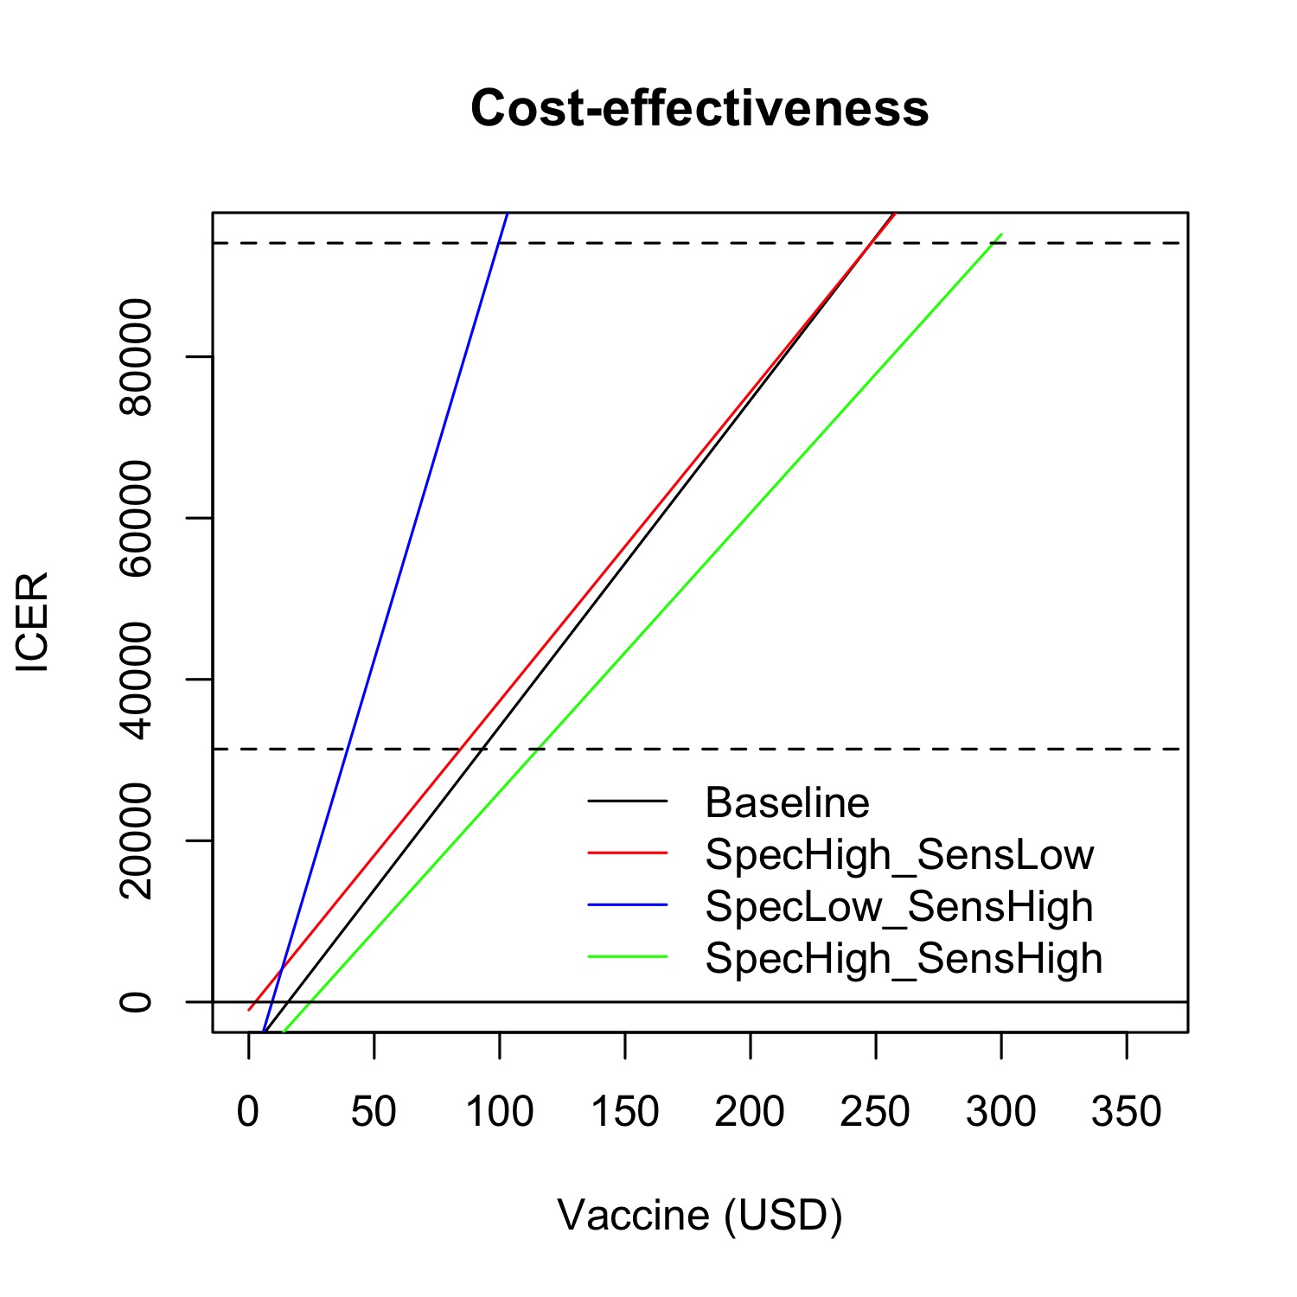

Figure 3. ICER of pre-vaccination screening strategy in Puerto Rico at different cost of vaccination (3 doses per person). Bottom black dashed-line marks one GDP per capita (31,365 USD), top black dashed-line marks 3xGDP per capita (94,095 USD).

## Sensitivity analysis

To characterize the sensitivity of our results to our choices about parameter values, we varied the baseline value of five parameters of the cost-effectiveness analysis: sensitivity, specificity, , vaccine cost for a fully vaccinated individual, and unit cost of serological screening. The ranges of the parameter values are summarized in Table 5. Compared to the sensitivity of screening, the specificity showed a larger impact on the cost-effectiveness of the intervention (Figure 4). The lowest assumption about specificity (0.5) resulted in an ICER above four times the GDP per capita of Puerto Rico. In contrast, the same value for the sensitivity of screening yielded an ICER slightly above one GDP per capita. We also found that a lower transmission intensity (50% below baseline) would affect the cost-effectiveness of the intervention more than a higher transmission intensity (50% above baseline). Finally, a higher cost of screening (50 USD) would still result in ICER values below three GDP per capita, and the vaccine cost could be up to 250 USD for ICER values below three GDP per capita.

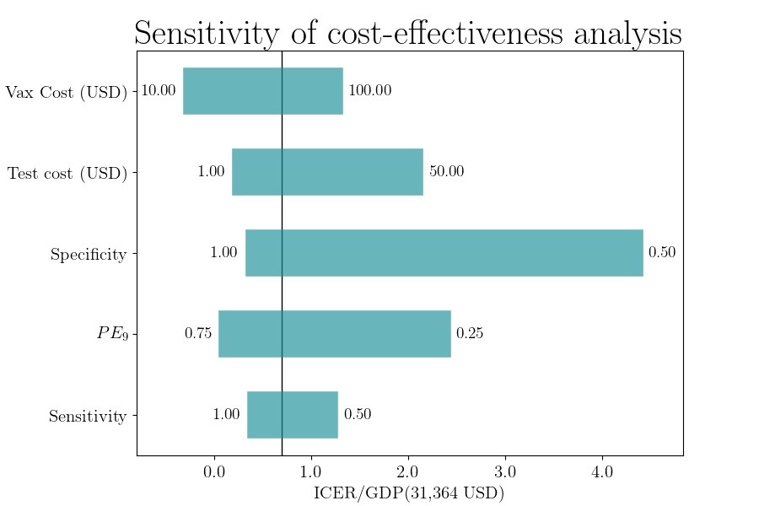

Figure 4. ICER of pre-vaccination screening strategy in Puerto Rico at different parameter values for the cost of the vaccine, the cost of serological screening, the sensitivity and specificity of serological screening, and the proportion of 9-year-olds with previous exposure to DENV.

Table 5. ICER estimates at different parameter values.

|  |  |  |  |  |  |  |
| --- | --- | --- | --- | --- | --- | --- |
| Parameter | Min | Max | ICER (min) | ICER (max) | ICER (default) | GDP |
| Sensitivity | 0.50 | 1.00 | 32,622 | 18,452 | 22,013 | 31,365 |
|  | 0.25 | 0.75 | 69,042 | 9,161 | 22,013 | 31,365 |
| Specificity | 0.50 | 1.00 | 131,214 | 17,683 | 22,013 | 31,365 |
| Test cost (USD) | 1.00 | 50.00 | 13,439 | 60,118 | 22,013 | 31,365 |
| Vax cost (USD) | 10.00 | 100.00 | -2,280 | 34,159 | 22,013 | 31,365 |

# Discussion

Using an agent-based model of dengue virus transmission, we simulated the impact of a pre-vaccination screening strategy for 10 years of routine vaccination at a level of transmission resembling that observed empirically in Puerto Rico. Our model has been previously calibrated to represent longitudinal data of dengue virus transmission in Iquitos, Peru. Even though many of the model parameters were calibrated for Iquitos, our model was calibrated in such as way that it represents generic patterns of dengue virus transmission. This model has also been used in previous assessments of vaccination impact with CYD-TDV with a somewhat simpler assumption about vaccine profile [4]. In our previous assessments, our model agreed qualitatively with projections from seven other models of dengue virus transmission. Assuming a moderate transmission intensity (PE = 0.5) in Puerto Rico, we found that this intervention could be beneficial from the public health and individual health perspective, assuming moderate sensitivity and high specificity.

Our cost-effectiveness analysis showed that this intervention could also be cost-effective under these same conditions. A sensitivity analysis showed that higher specificity would be more important than high sensitivity to achieve greater cost-effectiveness. This could be a result of our main assumption of moderate transmission intensity in Puerto Rico. Assuming that is the case, it would be important to ensure highly specific screening tests for pre-vaccination screening interventions to minimize the number of seronegative individuals and to improve cost-effectiveness by reducing the cost per QALY gained.

We focused our analysis on a scenario of 80% coverage among nine-year-olds on a routine basis. However, this coverage might not be achieved in practice. For example, if the vaccine were elective and available only on the private market and not with a provider subsidy, vaccination coverage would likely be much lower. This would reduce the number of dengue cases averted as a consequence of enhanced herd immunity which would reduce the cost-effectiveness of pre-vaccination screening with CYD-TDV to some degree.

Compared to our previous simulation analysis for the Philippines and Brazil [3], the main difference in this analysis is that costs of treatment of mild and severe dengue cases were based on estimates extrapolated from studies from 2010 in Puerto Rico. More recent estimates of these costs would refine the estimates of cost-effectiveness of pre-vaccination screening with CYD-TDV in Puerto Rico.

# Acknowledgements

This analysis is based on previous analyses available in a BioRxiv pre-print [3], prepared in collaboration with other authors: Yutong Yao, Kathryn B. Anderson, Meagan C. Fitzpatrick, David L. Smith, Amy C. Morrison, Annelies Wilder-Smith, and Thomas W. Scott.

# References

1. Sridhar S, Luedtke A, Langevin E, Zhu M, Bonaparte M, Machabert T, et al. Effect of Dengue Serostatus on Dengue Vaccine Safety and Efficacy. New England Journal of Medicine. 2018;379: 327–340. doi:[10.1056/NEJMoa1800820](https://doi.org/10.1056/NEJMoa1800820)

2. World Health Organization. Revised SAGE recommendation on use of dengue vaccine. 2018;

3. España G, Yao Y, Anderson KB, Fitzpatrick MC, Smith DL, Morrison AC, et al. Model-based assessment of public health impact and cost-effectiveness of dengue vaccination following screening for prior exposure. bioRxiv. Cold Spring Harbor Laboratory; 2019; doi:[10.1101/367060](https://doi.org/10.1101/367060)

4. Flasche S, Jit M, Rodŕiguez-Barraquer I, Coudeville L, Recker M, Koelle K, et al. The Long-Term Safety, Public Health Impact, and Cost-Effectiveness of Routine Vaccination with a Recombinant, Live-Attenuated Dengue Vaccine (Dengvaxia): A Model Comparison Study. von Seidlein L, editor. PLOS Medicine. Public Library of Science; 2016;13: 1–19. doi:[10.1371/journal.pmed.1002181](https://doi.org/10.1371/journal.pmed.1002181)

5. Ferguson NM, Rodŕiguez-Barraquer I, Dorigatti I, Mier-y-Teran-Romero L, Laydon DJ, Cummings DAT. Benefits and risks of the Sanofi-Pasteur dengue vaccine: Modeling optimal deployment. Science. 2016;353: 1033–1036.

6. Halasa YA, Shepard DS, Zeng W. Economic cost of dengue in Puerto Rico. The American journal of tropical medicine and hygiene. ASTMH; 2012;86: 745–752.

7. World Bank. GDP per capita. 2016;

8. Shim E. Cost-effectiveness of dengue vaccination in Yucatán, Mexico using a dynamic dengue transmission model. PLOS ONE. Public Library of Science; 2017;12: 1–17. doi:[10.1371/journal.pone.0175020](https://doi.org/10.1371/journal.pone.0175020)

9. Shim E. Cost-Effectiveness of Dengue Vaccination Programs in Brazil. The American journal of tropical medicine and hygiene. ASTMH; 2017;96: 1227–1234.

10. Turner HC, Wills BA, Rahman M, Quoc Cuong H, Thwaites GE, Boni MF, et al. Projected costs associated with school-based screening to inform deployment of Dengvaxia: Vietnam as a case study. Transactions of The Royal Society of Tropical Medicine and Hygiene. 2018; try057. doi:[10.1093/trstmh/try057](https://doi.org/10.1093/trstmh/try057)

11. Luo R, Fongwen N, Kelly-Cirino C, Harris E, Wilder-Smith A, Peeling R. Rapid diagnostic tests for determining dengue serostatus: A systematic review and key informant interviews. Clinical Microbiology and Infection. Elsevier; 2019; doi:[10.1016/j.cmi.2019.01.002](https://doi.org/10.1016/j.cmi.2019.01.002)

12. Coudeville L, Baurin N, Vergu E. Estimation of parameters related to vaccine efficacy and dengue transmission from two large phase III studies. Vaccine. 2016;34: 6417–6425. doi:[10.1016/j.vaccine.2015.11.023](https://doi.org/10.1016/j.vaccine.2015.11.023)

13. Argüello DF, Tomashek KM, Quiñones L, Beltran M, Acosta L, Santiago LM, et al. Incidence of dengue virus infection in school-aged children in Puerto Rico: A prospective seroepidemiologic study. The American journal of tropical medicine and hygiene. ASTMH; 2015;92: 486–491.