Cost-effectiveness of Dengvaxia in Puerto Rico

Guido España, Alex Perkins

# Introduction

Individuals who are seronegative at vaccination with CYD-TDV have an increased risk of severe dengue in their first dengue virus (DENV) infection [1]. The World Health Organization (WHO) recommends a pre-vaccination screening to ensure that only those with previous exposure to DENV are vaccinated [2]. However, rapid diagnostic tests with high sensitivity and specificity are not currently available. We have previously discussed the benefits and cost-effectiveness of pre-screening vaccination for economic scenarios of the Philippines and Brazil [3]. Here, we discuss the implications of this strategy for Puerto Rico in terms of epidemiological benefits and cost-effectiveness.

# Methods

Based on estimates from 2002 to 2010 [4], we updated our assumptions of treatment of dengue for ambulatory cases and hospitalizations. Using the consumer price index for Puerto Rico, we projected these costs to 2019 USD. Similarly, we took the GDP per-capita for Puerto Rico in 2016 [5] and projected it’s value to 2019.

Costs for dengue burden in Puerto Rico

|  |  |  |
| --- | --- | --- |
|  | Cost (USD) | Cost Projected (2019 USD) |
| Ambulatory | 239 (2010) | 311 |
| Hospitalization | 1615 (2010) | 2107 |
| GDP per-Capita | 30,833 (2016) | 30,833 |

We then calculated the Incremental Cost-Effectiveness Ratio (ICER) as in equation [eq-ICER]. [Rev1Com2] As others have [6–8], we deemed the intervention cost-effective if the ICER was below 3 GDP per-Capita, and very cost-effective if the ICER fell below 1 GDP per-Capita. We assumed a baseline scenario of costs.

[Rev1Com3-1]Estimates of seroprevalence in Puerto Rico indicate that prevalence in 9-year-olds is around 50%. Coudeville et al. estimated 50% of prevalence in 9-year-olds [9] in the clinical trial sites. According to Argüello, 49.8% of participants between 10-18 years of age had a positive IgG anti-DENV antibodies [10]. Hence, we assume that the seroprevalence in 9-year-olds is around 50% but estimate the sensitivity of our analysis from 25% to 75%[Rev1Com3-2].

# Results

## Epidemiological benefits from vaccination

The benefits are outlined in Fig. [fig-epi-benefits]. At there are several scenarios where the vaccine is beneficial from the public health perspective.

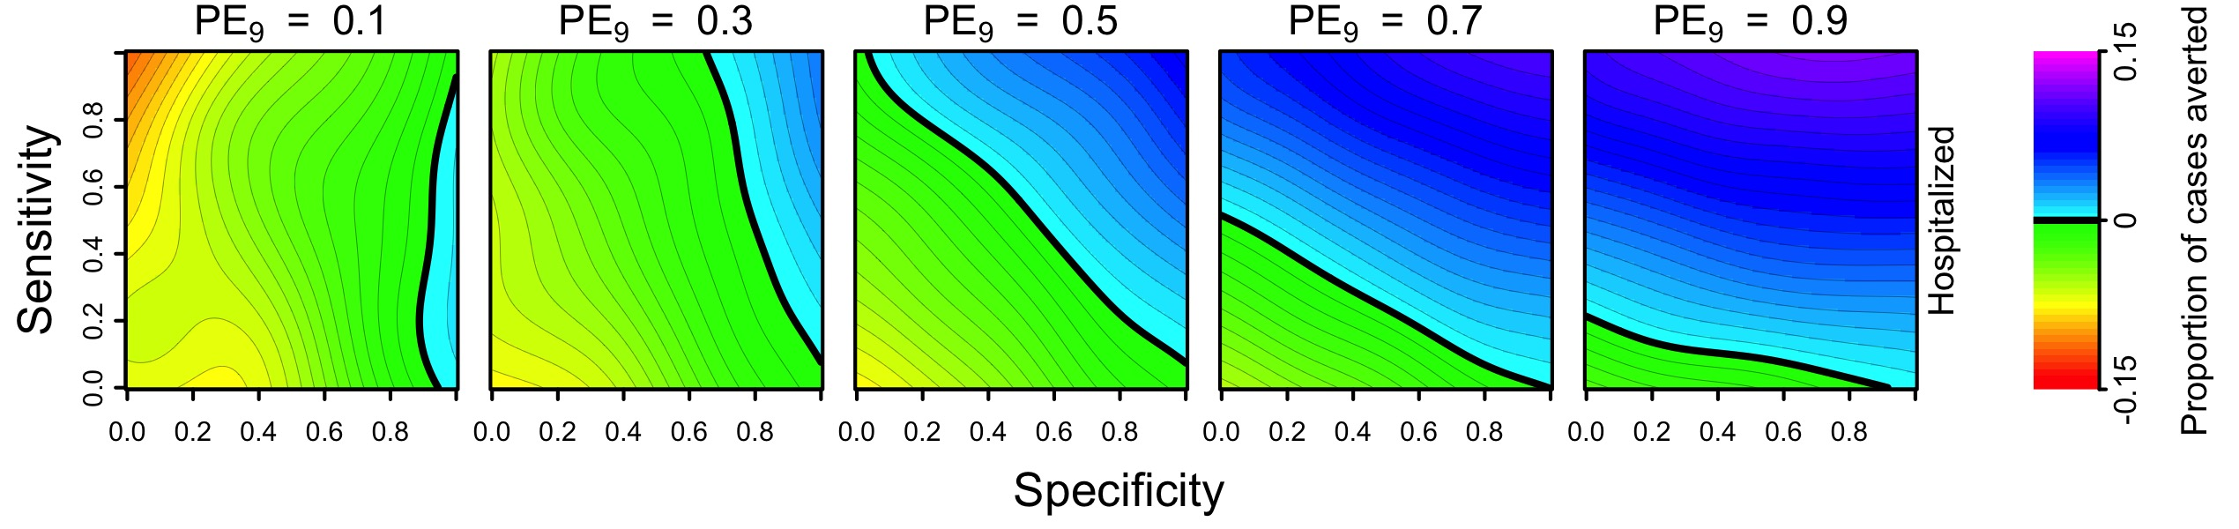

Proportion of cases averted with pre-vaccination screening strategy with CYD-TDV over 10 years

## Cost-effectiveness of pre-vaccination screening strategies

Out cost-effectiveness analysis suggests that the intervention would be cost-effective in Puerto Rico at the assumed price of the vaccine (70 USD) (Fig. [fig-ICER]). Below 200 USD per fully vaccinated person, pre-vaccination screening would be cost-effective from a public payer perspective (ICER < 3 GDP per Capita). Very cost-effective scenarios could be achieved with a vaccine price below 95 USD per vaccinated individual. Also, at 18 USD per vaccinated individual, the costs of the intervention are equal to the costs without intervention (ICER = 0). Nonetheless, these cost-effectiveness thresholds depend on our assumptions of specificity and sensitivity of screening.

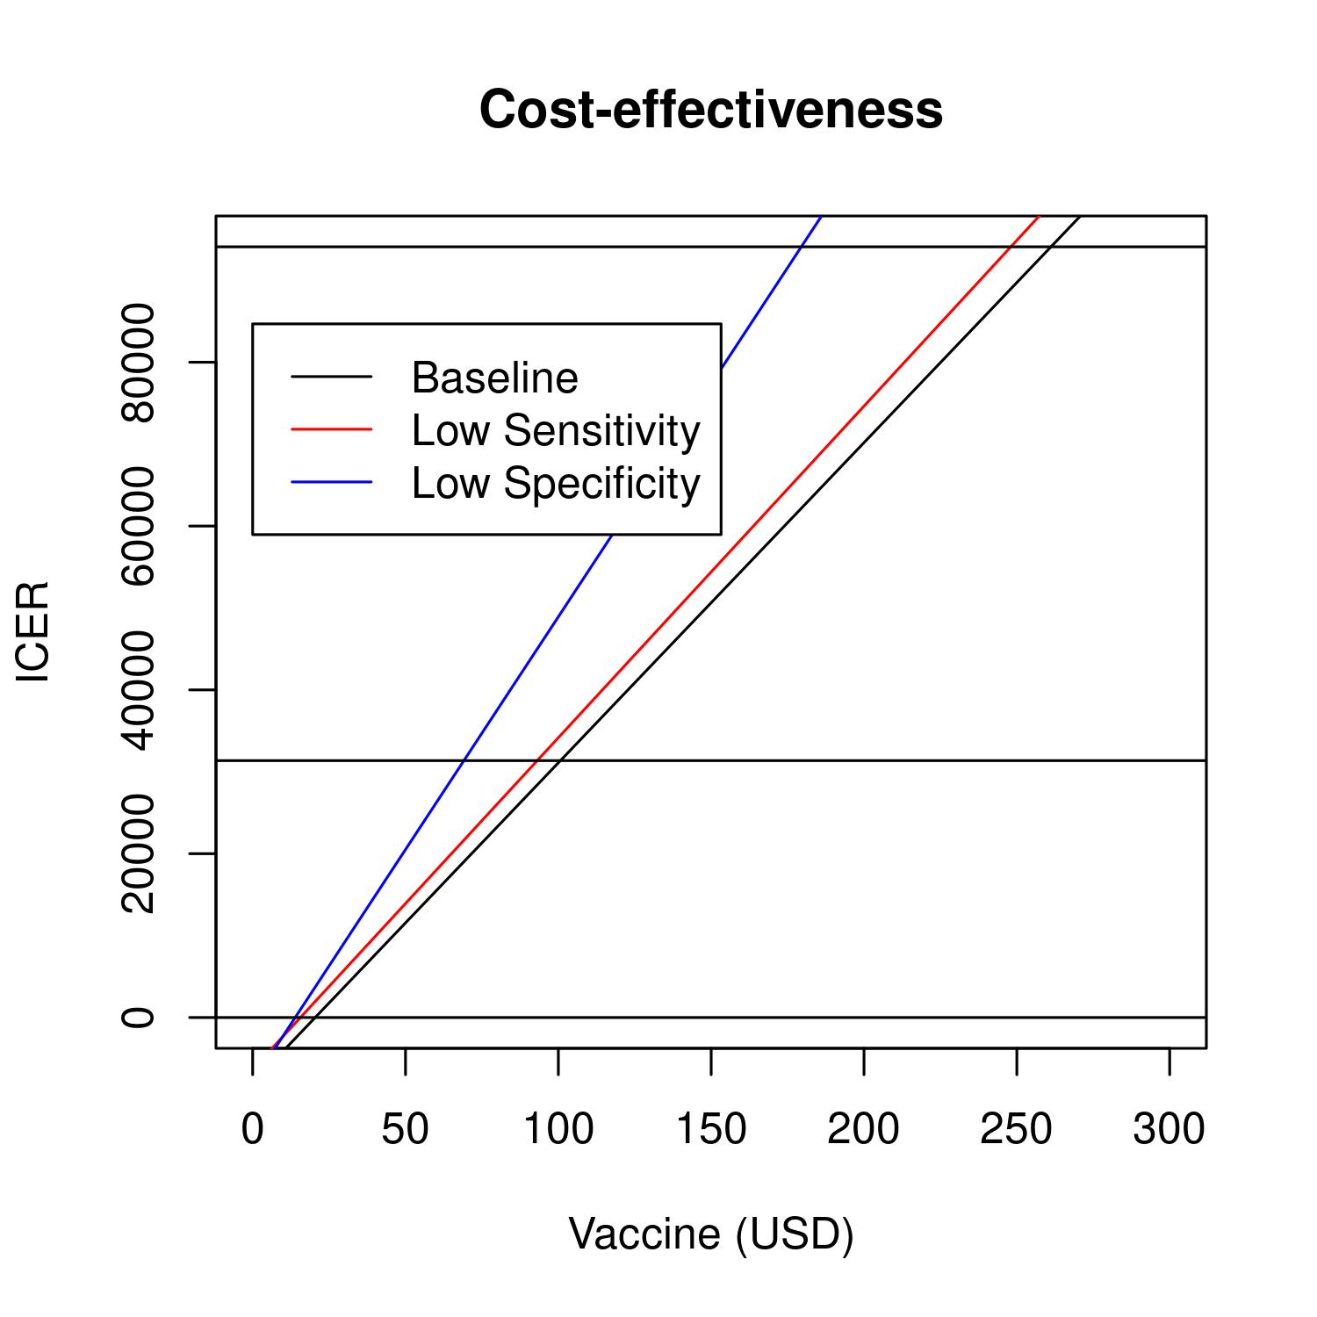

ICER of pre-vaccination screening strategy in Puerto Rico at different cost of vaccination (3 doses per person).

## Tornado diagram and sensitivity analysis

We varied the baseline value of five parameters of the cost-effectiveness analysis: sensitivity, specificity, PE9, vaccine cost for a fully vaccinated individual, and screening unit cost. The ranges of the parameter values are summarized in table [table-tornado]. This sensitivity analysis shows that the specificity of the test greatly affects the cost-effectiveness of the intervention.

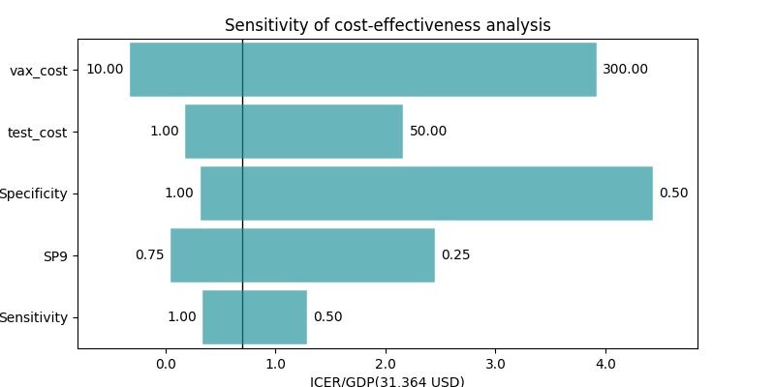

ICER of pre-vaccination screening strategy in Puerto Rico at different cost of vaccination (3 doses per person).

Sensitivity analysis of cost-effectiveness

|  |  |  |  |  |  |  |
| --- | --- | --- | --- | --- | --- | --- |
| parameter | min | max | ICER_min | ICER_max | ICER_default | GDP |
| Sensitivity | 0.50 | 1.00 | 32622.40 | 18452.13 | 22012.70 | 31364.60 |
| SP9 | 0.25 | 0.75 | 69042.20 | 9161.02 | 22012.70 | 31364.60 |
| Specificity | 0.50 | 1.00 | 131214.40 | 17682.60 | 22012.70 | 31364.60 |
| test_cost | 1.00 | 50.00 | 13438.97 | 60118.17 | 22012.70 | 31364.60 |
| vax_cost | 10.00 | 300.00 | -2279.54 | 115132.94 | 22012.70 | 31364.60 |

# Discussion

Assuming a moderate transmission intensity in Puerto Rico, we found that this intervention could be beneficial from the public health and individual perspective, conditioned to moderate values of sensitivity and high values of specificity. Compared to our previous simulation analysis for the Philippines and Brazil [3], the main differences of this analysis are the costs of treatment of dengue fever and severe dengue cases, which are based on studies from 2010. More updated estimates of this type of costs would refine the estimates of cost-effectiveness of p re-vaccination screening with CYD-TDV in Puerto Rico.

1. Sridhar S, Luedtke A, Langevin E, Zhu M, Bonaparte M, Machabert T, et al. Effect of Dengue Serostatus on Dengue Vaccine Safety and Efficacy. New England Journal of Medicine. 2018;379: 327–340. doi:[10.1056/NEJMoa1800820](https://doi.org/10.1056/NEJMoa1800820)

2. World Health Organization. Revised SAGE recommendation on use of dengue vaccine. 2018;

3. España G, Yao Y, Anderson KB, Fitzpatrick MC, Smith DL, Morrison AC, et al. Model-based assessment of public health impact and cost-effectiveness of dengue vaccination following screening for prior exposure. bioRxiv. Cold Spring Harbor Laboratory; 2019; doi:[10.1101/367060](https://doi.org/10.1101/367060)

4. Halasa YA, Shepard DS, Zeng W. Economic cost of dengue in Puerto Rico. The American journal of tropical medicine and hygiene. ASTMH; 2012;86: 745–752.

5. World Bank. GDP per capita. 2016;

6. Shim E. Cost-effectiveness of dengue vaccination in Yucatán, Mexico using a dynamic dengue transmission model. PLOS ONE. Public Library of Science; 2017;12: 1–17. doi:[10.1371/journal.pone.0175020](https://doi.org/10.1371/journal.pone.0175020)

7. Shim E. Cost-Effectiveness of Dengue Vaccination Programs in Brazil. The American journal of tropical medicine and hygiene. ASTMH; 2017;96: 1227–1234.

8. Flasche S, Jit M, Rodŕiguez-Barraquer I, Coudeville L, Recker M, Koelle K, et al. The Long-Term Safety, Public Health Impact, and Cost-Effectiveness of Routine Vaccination with a Recombinant, Live-Attenuated Dengue Vaccine (Dengvaxia): A Model Comparison Study. von Seidlein L, editor. PLOS Medicine. Public Library of Science; 2016;13: 1–19. doi:[10.1371/journal.pmed.1002181](https://doi.org/10.1371/journal.pmed.1002181)

9. Coudeville L, Baurin N, Vergu E. Estimation of parameters related to vaccine efficacy and dengue transmission from two large phase III studies. Vaccine. 2016;34: 6417–6425. doi:[10.1016/j.vaccine.2015.11.023](https://doi.org/10.1016/j.vaccine.2015.11.023)

10. Argüello DF, Tomashek KM, Quiñones L, Beltran M, Acosta L, Santiago LM, et al. Incidence of dengue virus infection in school-aged children in Puerto Rico: A prospective seroepidemiologic study. The American journal of tropical medicine and hygiene. ASTMH; 2015;92: 486–491.