Student’s Full Name: Nguyen Cong Minh

Student ID: 2131200085

**Design Pattern**

**I. DON’T REPEAT YOURSELF (DRY)**

**Exercise 1: Applying “Reflection” to Reduce Redundancy in Logging**

**1. What are Reflection and Expression Trees?**

Reflection allows inspecting and manipulating types at runtime, while Expression Trees represent code structure as data.

**2. Analyze the redundancy in the above code.**

Redundancy exists in repeated Log method structures with different parameter types.

**3. Rewrite the code using Reflection or Expression Trees to eliminate redundancy in**

**logging.**

**Exercise 2: Applying Dependency Injection to Remove Redundancy in the Repository**

**1. Identify DRY violations in the above code.**

Duplicated database connection and query logic violates DRY.

**2. Rewrite the code using Generic Repository Pattern combined with Dependency**

**Injection to reduce redundancy.**

**Exercise 3: Using Generic Constraints to Eliminate Redundancy in API Request Handling**

**1. Identify redundancy in the above code.**

Repeated validation and response logic exists.

**2. Rewrite the code using a Generic Base Controller and Generic Constraints to**

**reduce duplication in API request handling.**

**Exercise 4: Combining Strategy Pattern with Factory Pattern to Avoid Redundancy in Payment Processing**

**1. What are Strategy Pattern and Factory Pattern?**

Strategy Pattern defines interchangeable algorithms, and Factory Pattern encapsulates object creation.

**2. Identify DRY violations in the above code.**

Duplicated payment processing logic violates DRY.

**3. Rewrite the code using Strategy Pattern combined with Factory Pattern to**

**eliminate redundancy and allow easy expansion for new payment methods.**

**Exercise 5: Eliminating Redundancy in Cache Handling with Decorator Pattern**

**You have a service handling data queries with caching as follows:**

**1. Identify redundancy in cache handling.**

Duplicated caching logic in ProductService and UserService.

**2. Rewrite the code using the Decorator Pattern to avoid duplication in caching for**

**both ProductService and UserService.**

**II. PACKAGES**

Exercise 6: Based on the principles of Packages in Architecture, design a solution in .NET

consisting of multiple projects, where each project serves as a package responsible for a

specific functionality. Determine the minimum number of projects required to build a

complete library management system, and explain the role of each project within the

overall architecture. Ensure that the system is scalable, maintainable, and can be easily

upgraded in the future.

#### **Project Structure:**

* **Library.Domain**: Contains the core business entities, domain models, and business rules.

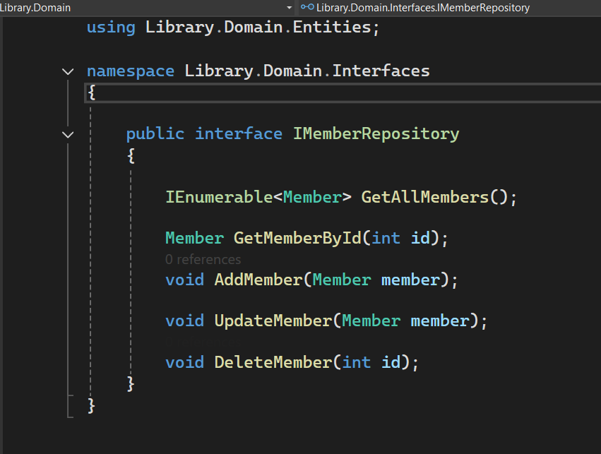

* **Library.DataAccess**: Handles data access operations, such as database interactions.

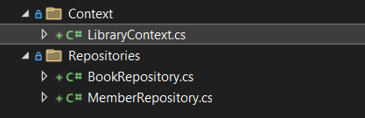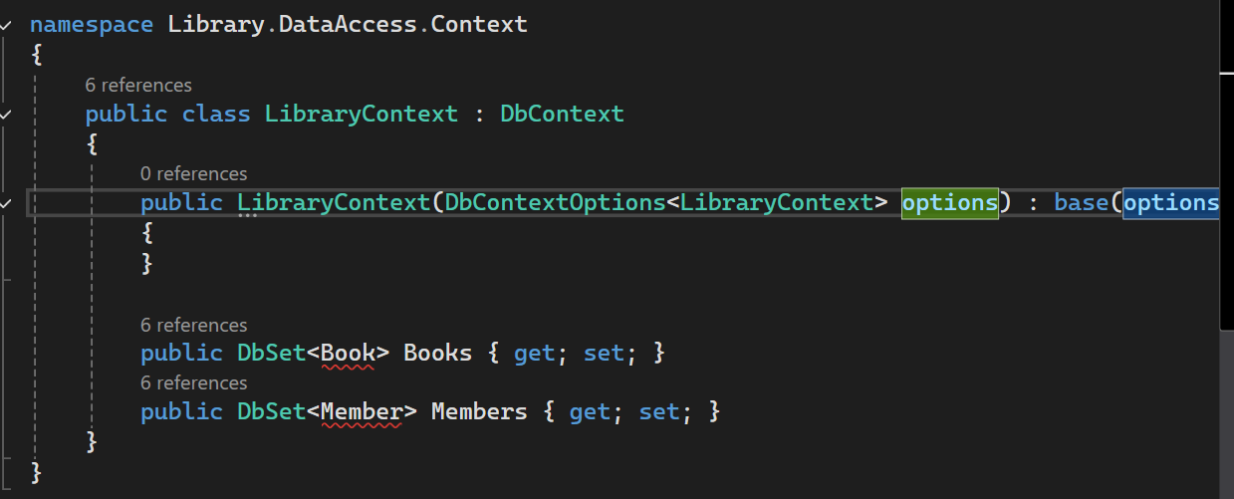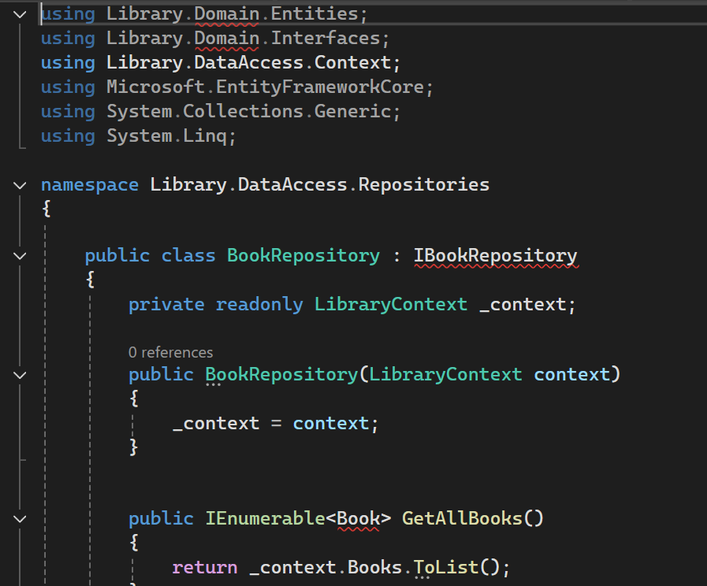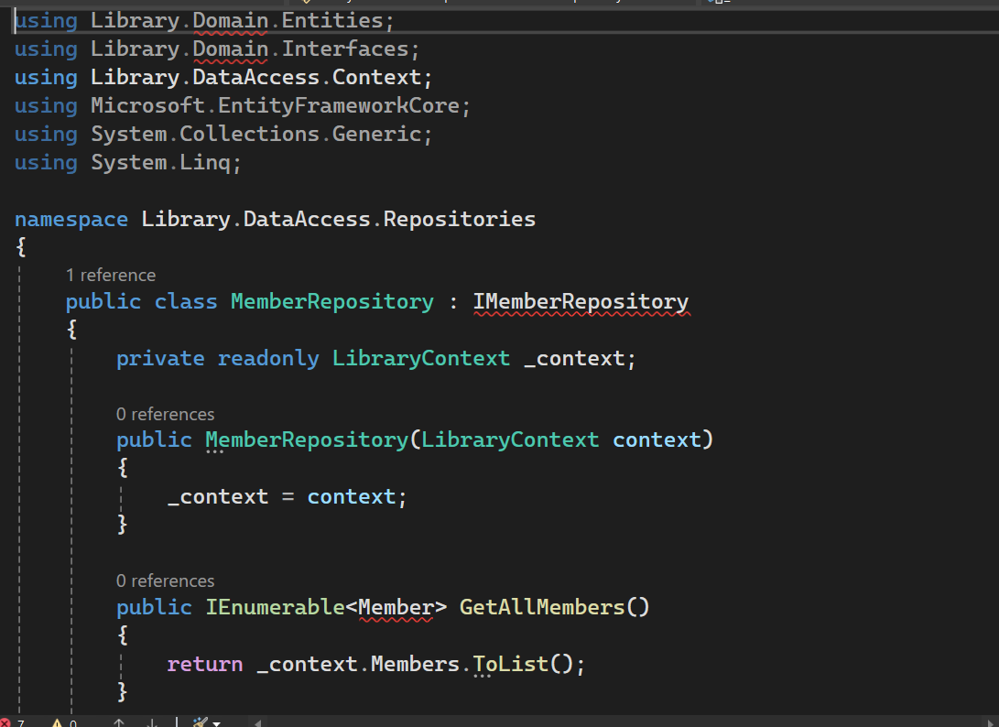

* **Library.Services**: Implements the application - level services that orchestrate the business logic.

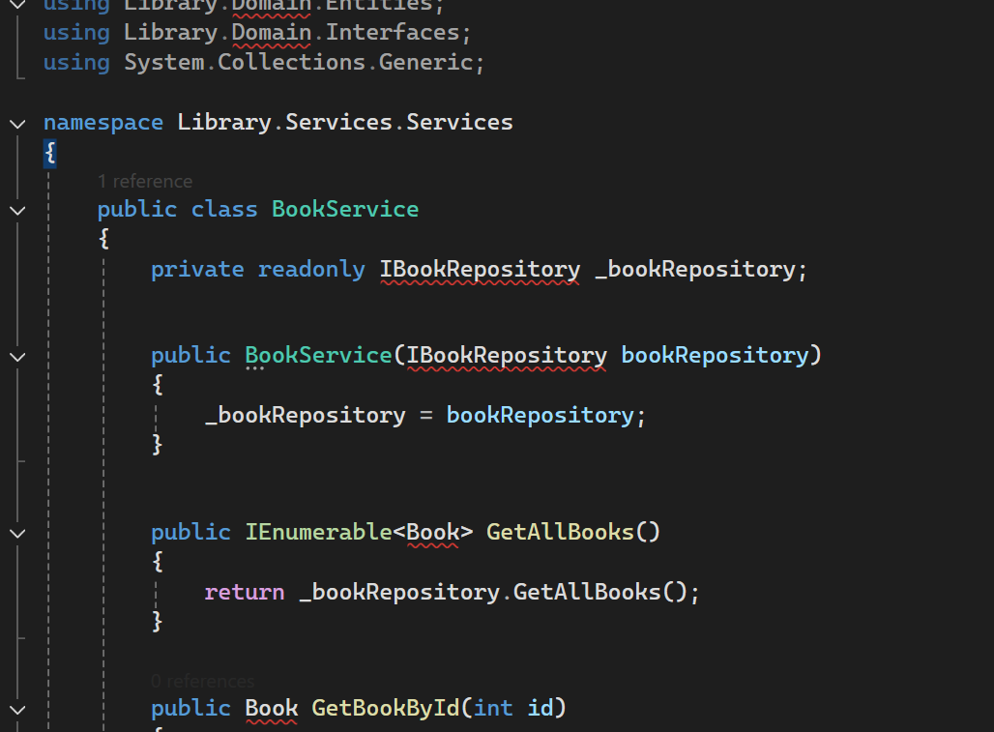

* **Library.Api**: Exposes the system's functionality through a RESTful API.

