**FPT ACADEMY INTERNATIONAL**

**FPT – ATECH COMPUTER EDUCATION**

**LIBERTY ELECTRONICS**

|  |  |
| --- | --- |
| **Supervisor:  Semester:  Batch No:  Group No:** | *Nguyen Ha Vy 01 T1.2207.E1 03* |

|  |  |  |
| --- | --- | --- |
| ***No.*** | ***Full name*** | ***Roll No.*** |
| *1* | *Bui Duc Dong* | *Student1396943* |
| *2* | *Vo Dang Quang* | *Student1396964* |
| *3* | *Nguyen Thai Phong* | *Student1398831* |
| *4* | *Dao Cong Tri* | *Student1396957* |

***Month:*** *10* ***Year:*** *2020*

**This is to certify that:**

**Mr.** Bui Duc Dong

**Mr.** Vo Dang Quang

**Mr.** Nguyen Thai Phong

**Mr.** Dao Cong Tri

**Have successfully Designed & Developed**

**LIBERTY ELECTRONICS**

**Submitted by:**

**Ms. Nguyen Ha Vy**

**Date Of Issue:**

**Authorized Signature:**

**CONTENT**

Content

Acknowledge

Synopsis

Review1 (1)

Review2 (2)

Review3 (7)

Testting Document (17)

Final Checklist (18)

Tasksheet (19)

**ACKNOWLEDGE**

We understand that the eProject is a step-by-step learning environment that closely simulates the classroom and Lab based learning environment into actual implementation. It is a project implementation at your fingertips!! An electronic, live juncture on the machine that allows you to

* Practice step by step i.e. laddered approach.
* Build a larger more robust application.
* Usage of certain utilities in applications designed by user.
* Single program to unified code leading to a complete application.
* Learn implementation of concepts in a phased manner.
* Enhance skills and add value.
* Work on real life projects.
* Give a real life scenario and help to create applications more complicated and useful.
* Mentoring through email support.

We would like to send a great thank you to our professor and other students for the adorable support during the time of the project.  
Besides several mistakes we had made in the project, we hope to have more opportunities to widen our knowledge in the web developing world.  
We also thank you so much for your information and the “demo” project from India APTECH to help us get more real experience in this project. Since we have gained more experience from this project, we will not stop learning anything as much as we can to be more successful in the future.  
Yours Sincerely, Team Group 03.

**SYNOSPSIS**

The Objective of this program is to give a sample project to work on real life projects. These applications help you build a larger more robust application.

The objective is not to teach you JavaScript/Dreamweaver but to provide you with a real life scenario and help you create basic applications using the tools.

You can revise the chapters before you start with the project.

This project is meant for students who have completed the module of ***HTML5***. These programs should be done in the Lab sessions with assistance of the faculty if required.

It is very essential that a student has a clear understanding of the subject. Students should go through the project and solve the assignments as per requirements given.

Kindly get back @ [eprojects@aptech.ac.in](mailto:eprojects@aptech.ac.in) in case of any doubts regarding the application or its objectives.

**PROBLEM DEFINITION**

**LIBERTY ELECTRONICS** is a shop selling various electronic products. The company advertises by distributing the pamphlets, advertising on television and so on. Due to rapid development in internet field, the company decides to launch a website where people will get all the information about the various products available with them easily.

The website is to be developed for the Windows Platform using HTML5, JavaScript and Geolocation. The site should work well in all leading browsers including Chrome, IE, Firefox etc.

**Requirement Specification:**

The Web site is to be created based on the following requirements.

1. The Home Page should be created making use of sections with a suitable logo
2. The site should display a menu which will contain the options for brief introduction about the various products available, location of the shop and any other information if required.
3. The information should be categorized according to the brand names of the products like if a User wants to see only Samsung products then he click on a Link/button/menu etc and he will see only That Brand products.
4. When a user selects any particular brand, a list of products for that brand will be displayed
5. A brief summary of features of individual products should be displayed on the Web Page along with the product but detailed Features should be stored in Individual Word documents which can be downloaded or viewed by the User who wishes to see the same.
6. The user should also be able to compare the various products of different as well as similar brands.
7. There should be a “Contact Us” page which will have the Address of the Company which is as follows and the mail address which when clicked will invoke the local mail client from where they can send an email. Address of the Company should be displayed using GeoLocation API (eg. GoogleMaps).

**CUSTOM REQUIREMENTS SPECIFICATIONS**

**User:  
Input:**- Information on search.  
- Data of registered members.  
- Feedback to the webmaster.

-Add to cart  
**Process:**- Find the searching.  
- Check the data of registered members.  
- Check the feedback of users.  
**Output:**- Result of searching.

- Confirm the data of registered members.  
- Confirm the feedback of the users.

- Product card.

**Hardware/ Software Requirements**

**Hardware**

* A minimum computer system that will help you access all the tools in the courses is a Pentium 166 or better
* 64 Megabytes of RAM or better

**Software**

* Notepad/HTML editor
* Dreamweaver
* IE 5.0/ Netscape 6.0

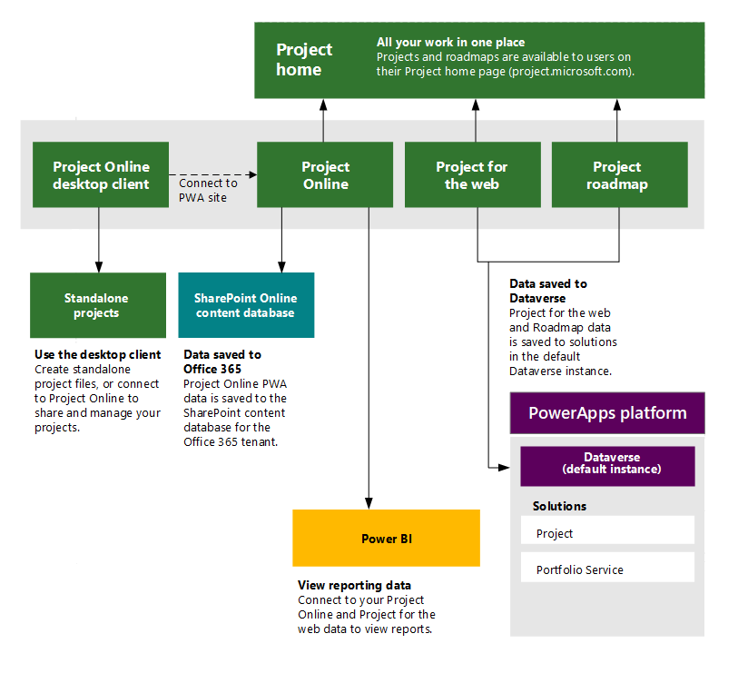**Architecture and design of the project**

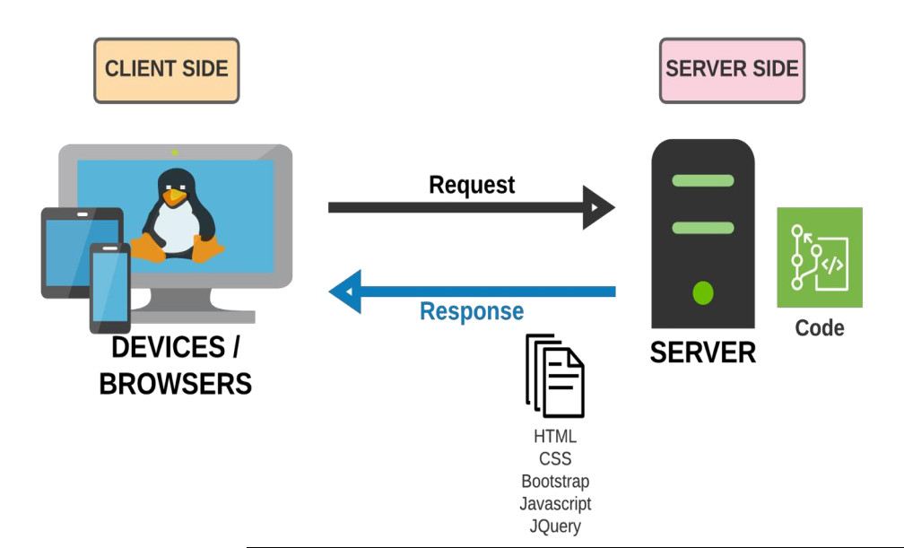

|  |  |  |  |
| --- | --- | --- | --- |
| ***No.*** | ***Full name*** | **Work** | **%** |
| *1* | *Bui Duc Dong* | iPhone web | 30% |
| *2* | *Vo Dang Quang* | iMac web | 30% |
| *3* | *Nguyen Thai Phong* | iPad web | 30% |
| *4* | *Dao Cong Tri* | Main web | 30% |

**TASKSHEET**