expr:



gcd:



lvalue2:



many arguments:



multiarray:

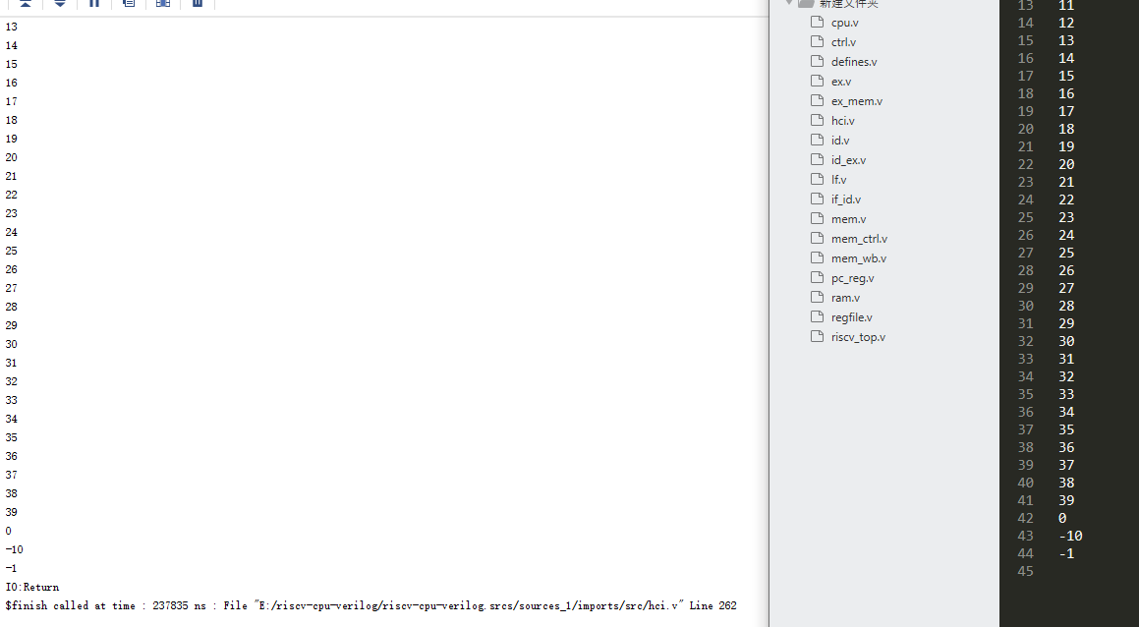

magic:

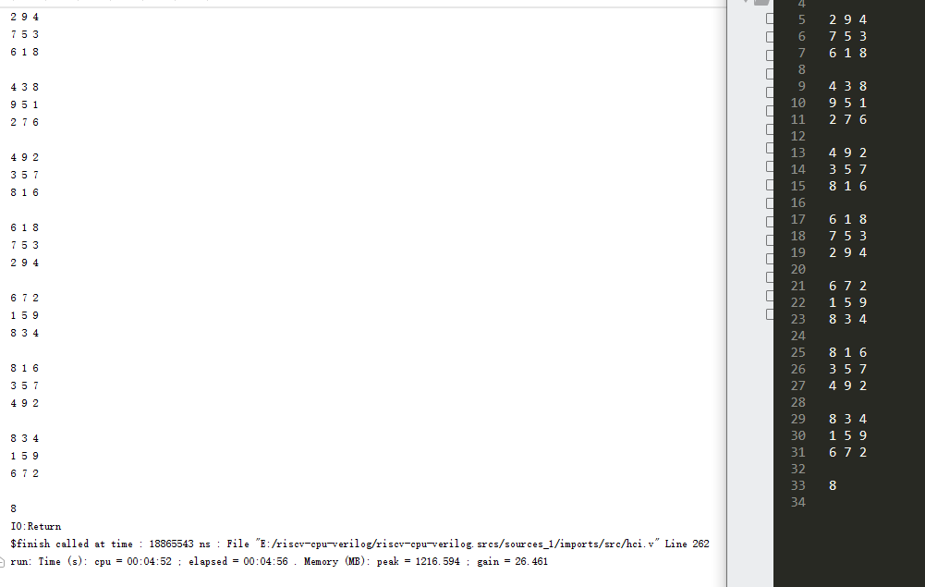

basicopt1:



pi:

