CS 202: Advanced Operating Systems
University of California, Riverside

Lab #2: Modifying xv6 Scheduler

In this assignment, you will implement the lottery scheduler and the stride scheduler. The goal is to implement only basic operations of these schedulers (i.e., no ticket transfers, no compensation tickets, etc). Assume a single CPU core for xv6 (“CPUS := 1” in Makefile).

Background: xv6 scheduler
To get started, look at the file “kernel/proc.c”. In there you will find scheduler(), a simple round-robin CPU scheduler implemented. Xv6 runs a periodic timer interrupt, and whenever the timer interrupt arrives (at every clock tick), the scheduler function is called to decide which process to run next. The default scheduler simply selects the next ready (runnable) process from the process list, achieving a round-robin scheduling policy with a time slice length equal to one tick. To implement other scheduling policies, you should change the logic there and add appropriate information in the process control block as needed.

Part 1: System Calls
Add two system calls:
int sched_statistics(void);
- This system call prints, for each process, 1) PID, 2) name in a parenthesis, 3) the ticket value, and 4) the number of times it has been scheduled to run (i.e., a rough estimation of the number of ticks used by each process).
- Below shows an example output format:
1(init): tickets: xxx, ticks: 21
2(sh): tickets: xxx, ticks: 15
- This syscall should report the correct number of ticks used by the process, regardless of what scheduler is being used (lottery, stride, and the original xv6 scheduler)
int sched_tickets(int);
- This system call sets the caller process’s ticket value to the given parameter. The maximum number of tickets for each process cannot exceed 10000.
Both system calls always return 0.

Part 2: Scheduler Implementation
Implement two scheduling policies: lottery and stride scheduling. The lottery scheduler needs a random number generator, which is not included in the xv6 code base. So use the following code for your implementation. Note: the output of rand() is in an unsigned short range.
1  2  3  4  5  6  7  8  9 | // pseudo random generator (https://stackoverflow.com/a/7603688)  unsigned short lfsr = 0xACE1u;  unsigned short bit;  unsigned short rand()  {  bit = ((lfsr >> 0) ^ (lfsr >> 2) ^ (lfsr >> 3) ^ (lfsr >> 5)) & 1;  return lfsr = (lfsr >> 1) | (bit << 15);  }
In case of the stride scheduler, use 10000 for the large constant K (stride₁ in the stride scheduling paper) to compute a stride value. Our goal is to implement the “Basic” stride scheduling algorithm that was covered in class (Sec 2.1 of the paper). No need to implement the “Dynamic” and “Hierarchical” stride scheduling algorithms.
Assign a default ticket value of 10000 to each process so that it can be scheduled even if its ticket was not explicitly assigned by sched_tickets(). It is ok to use a different default ticket value if you like.

How to compile:
Use preprocessor directives to switch between the lottery, stride and original round-robin schedulers. For example:
......xv6 code......
#if defined(LOTTERY)
your code for lottery scheduler
#elif defined(STRIDE)
Your code for strider scheduler
#else
Original xv6 round-robin scheduler
#endif
......xv6 code......
You need to modify the Makefile to let you can toggle it on/off in command line:
After lines 72-73 “CFLAGS = -fno-pie ...... endif”, insert 2 new lines:
LAB2 = RR
CFLAGS += -D$(LAB2)
So your code should be compiled for the lottery scheduler by “make clean; make LAB2=LOTTERY” and for the stride scheduler by “make clean; make LAB2=STRIDE”. To test with the original round-robin scheduler, “make clean; make” (no need to specify LAB2 in this case).

How to test:
To test your scheduler implementation, add the following user-level program as user/lab2.c.
1  2  3  4  5  6  7  8  9  10  11  12  13  14  15  16  17  18  19  20  21  22  23  24  25  26  27  28  29  30  31  32  33  34  35 | #include "kernel/types.h"  #include "kernel/stat.h"  #include "user/user.h"  #define MAX_PROC 10  int main(int argc, char *argv[])  {  int sleep_ticks, n_proc, ret, proc_pid[MAX_PROC];  if (argc < 4) {  printf("Usage: %s [SLEEP] [N_PROC] [TICKET1] [TICKET2]...\n", argv[0]);  exit(-1);  }  sleep_ticks = atoi(argv[1]);  n_proc = atoi(argv[2]);  if (n_proc > MAX_PROC) {  printf("Cannot test with more than %d processes\n", MAX_PROC);  exit(-1);  }  for (int i = 0; i < n_proc; i++) {  int n_tickets = atoi(argv[3+i]);  ret = fork();  if (ret == 0) { // child process  sched_tickets(n_tickets);  while(1);  }  else { // parent  proc_pid[i] = ret;  continue;  }  }  sleep(sleep_ticks);  sched_statistics();  for (int i = 0; i < n_proc; i++) kill(proc_pid[i]);  exit(0);  }

This user program creates N child processes, assigns a different number of tickets to each process, waits for a specific amount of time, and then prints scheduling results of the child processes.
For example, if you want to test 3 processes with 30, 20, and 10 tickets respectively during 100 ticks, type:
$ lab2 100 3 30 20 10
(the first argument is the test time in ticks, the second argument is the number of processes to create, and the rest arguments are the number of ticks for each process).
This will print like below under the stride scheduler:
1(init): tickets: xxx, ticks: 21
2(sh): tickets: xxx, ticks: 15
7(lab2): tickets: xxx, ticks: 101
8(lab2): tickets: 30, ticks: 50
9(lab2): tickets: 20, ticks: 33
10(lab2): tickets: 10, ticks: 17
Since three processes were tested, the last three lines are what you have to focus on. Use the number of ticks to calculate the allocated ratio per process: (number of ticks per program) / (total number of ticks by all 3 processes). Ideally, the ratio of the first process is 1/2, the ratio of the second process is 1/3, and the ratio of third process is 1/6.
Compare the outputs from the lottery and the stride schedulers and check if they perform as expected.
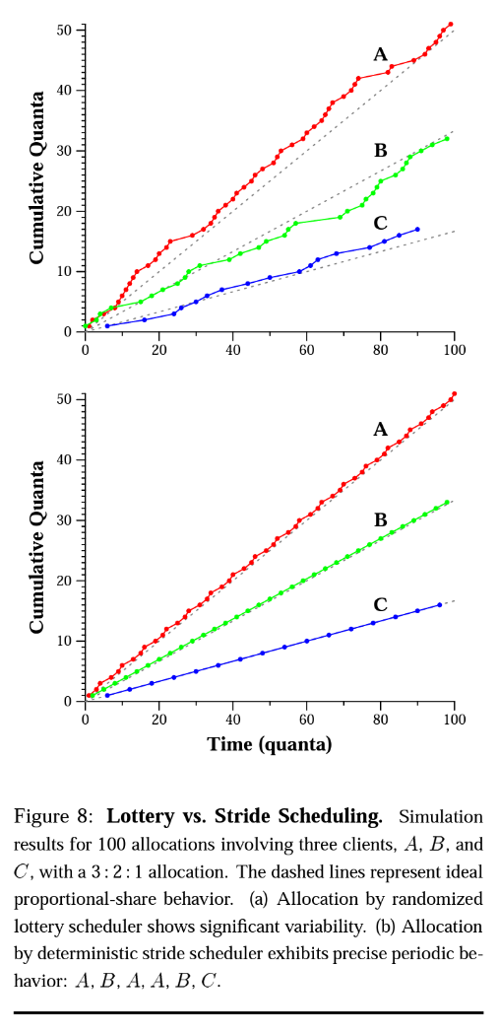

Part 3: Experiments
See Section 5 of the stride scheduling paper (http://publications.csail.mit.edu/lcs/pubs/pdf/MIT-LCS-TM-528.pdf) on the evaluation of the two schedulers. Your goal is to reproduce the plots like Figure 8 using your xv6 implementation (not in simulation).
Run two experiments: (1) four processes with 8, 4, 2, 1 tickets for each, and (2) four processes with all 1 ticket (1:1:1:1 allocation). For the x-axis of each plot, use a step of 20 time ticks (i.e., run test program for 20, 40, 60, 80, 100 test time ticks). For each given test time, measure cumulative ticks allocated to each process and run the test at least 5 times to get the average of them. Then draw plots for lottery and strider scheduling. Give a short discussion on how far they differ from the ideal allocation. Clarify how many times you ran the test to get the average.

What to submit:
You need to submit the following:
- The entire XV6 source code with your modifications (‘make clean’ to reduce the size before submission)
- A report (in PDF) with detailed explanation what changes you have made (Part 1 & 2), the experiment figures and discussion (Part 3). Also, give a brief summary of the contributions of each member.
- A demo video showing that all the functionalities you implemented can work as expected, as if you were demonstrating your work in-person.
You don’t need to demonstrate Part 1 and Part 3. Only show Part 2 with “lab2 100 3 30 20 10” and “lab2 100 2 19 1” under both lottery and stride schedulers.

Grades breakdown:
- System calls (with an explanation in the report): 10 pts
- Working lottery scheduler (with an explanation in the report): 35 pts
- Working strider scheduler (with an explanation in the report): 35 pts
- Experiment figures and discussion: 20 pts

Total: 100 pts

