VIETNAM NATIONAL UNIVERSITY - HO CHI MINH CITY
INTERNATIONAL UNIVERSITY SCHOOL OF PHYSICS

Differential Equation Report

Topic: Rocket model
MEMBER LIST:

Phạm Công Anh | SESEIU24002
Nguyễn Đức Anh | SESEIU25003
Trần Trung Kiên | SESEIU24014
Trần Trung Kỳ | SESEIU24015
Lê Võ Anh Thư | SESEIU24024

Instructor: Nguyen Quang

TABLE OF CONTENTS
1 Research Objectives and Physical Modeling 1
2 Analytical Solutions for the Frictionless Case 2
3 Numerical Methods and Order of Convergence 3
4 Baseline Simulation Results and Peak Acceleration Analysis 4
5 Burn Rate Sensitivity and Flight Optimization 5
6 Verification Framework, Dataset Synthesis, and Limitations 6
Appendix A. Analytical Derivations 7
Appendix B. Numerical Algorithms and Convergence 8
Appendix C. Verification, Toolkit and Reproduction 9
Appendix D. Compliance, Declaration and References 13

LIST OF FIGURES
Figure 1. Local no-drag errors for burnout velocity, burnout altitude and apogee over four step sizes. 3
Figure 2. Baseline altitude, velocity, coordinate acceleration and mass. Burnout is at t=2 s. 4
Figure 3. Apogee versus burn rate for fixed propellant mass, with and without quadratic drag. 5
Figure 4. DE kit integration and wmlab verification workflow used by the project. 11

1 Research Objectives and Physical Modeling

1.1 Project Context and Research Questions
This project investigates the vertical ascent of a variable-mass model rocket: how high it flies under quadratic drag, and whether fixed propellant should be burned rapidly or slowly. Analytical solutions, three explicit integrators and independent verification are used to answer these questions.

1.2 Parameters and Governing Equations
Physical quantity | Symbol | Baseline | SI unit
Initial / dry mass | m₀ / m_f | 1.0 / 0.6 | kg
Propellant / burn rate | Δm / q | 0.4 / 0.2 | kg / kg s⁻¹
Effective exhaust velocity | vₑ | 500 | m s⁻¹
Drag coefficient | c | 0 or 0.002 | kg m⁻¹
Gravity | g | 9.81 | m s⁻²
Thrust / burn duration | T / t_b | 100 / 2 | N / s

With upward positive, y=(h,v,m), h(0)=v(0)=0 and m(0)=m₀. The burn ends at t_b=(m₀−m_f)/q. The phase equations are:
$$h'=v, v'=\frac{T-cv|v|}{m}-g$$
$$0≤t<t_{b}: T=qv_{e}, m'=-q; t≥t_{b}: T=0, m'=0, m=m_{f}$$
Integration stops at the first post-burnout v=0 crossing (apogee). Initial lift-off requires qvₑ>m₀g; the baseline thrust-to-weight ratio is 10.194.

1.3 Assumptions and Dimensional Check
The model assumes vertical point-mass motion, constant g, vₑ and c, a constant powered burn rate and instantaneous shutdown. It neglects changing atmospheric density, wind, rotation, motor transients and recovery. The mass is continuous at burnout, but acceleration is discontinuous.
Both qvₑ and cv|v| have units of force (N); division by m gives m/s². The signed drag term always opposes velocity. Numerical verification checks this mathematical model; it is not experimental validation of a physical rocket.

2 Analytical Solutions for the Frictionless Case

2.1 Powered Flight
For c=0, conservation of momentum gives m dv/dt=qvₑ−mg and m=m₀−qt. Dividing by m and integrating from launch yields:
$$v(t)=v_{e}ln[\frac{m_{0}}{m_{0}-qt}]-gt$$
A second integration, with the substitution m=m₀−qt, gives:
$$h(t)=\frac{v_{e}}{q}\{qt-(m_{0}-qt)ln[\frac{m_{0}}{m_{0}-qt}]\}-\frac{gt^{2}}{2}$$
At burnout, let L=ln(m₀/m_f). The exact event values are:
$$v_{b}=v_{e}L-gt_{b}$$
$$h_{b}=\frac{v_{e}}{q}[(m_{0}-m_{f})-m_{f}L]-\frac{g{t_{b}}^{2}}{2}$$

2.2 Coasting to Apogee
With τ=t−t_b, the mass is constant and acceleration is −g:
$$v=v_{b}-gτ, h=h_{b}+v_{b}τ-\frac{gτ^{2}}{2}, m=m_{f}$$
$$t_{apogee}=t_{b}+\frac{v_{b}}{g}, H=h_{b}+\frac{{v_{b}}^{2}}{2g}$$
For the baseline, v_b=235.792812 m/s, h_b=214.141564 m, H=3047.895394 m and t_apogee=26.035965 s. These closed-form histories provide reference values at every exported time, not only at the two events.

2.3 Exact Relations for Coasting with Drag
For c>0 and upward coasting, v′=−g−cv²/m_f. Separating variables gives:
$$H-h_{b}=\frac{m_{f}}{2c}ln[1+\frac{c{v_{b}}^{2}}{m_{f}g}]$$
$$t_{coast}=\sqrt{\frac{m_{f}}{cg}} arctan[v_{b}\sqrt{\frac{c}{m_{f}g}}]$$
Both expressions approach the drag-free limits as c→0. They provide additional checks; the independent DOP853 reference still integrates both flight phases. Detailed integration steps and the no-drag burn-rate argument are retained in Appendix A.

3 Numerical Methods and Order of Convergence

3.1 Time Integration and Event Handling
The project implements Forward Euler, Heun and classical RK4 directly. Euler uses one slope, Heun averages initial and predicted slopes, and RK4 combines four slopes. Their global orders on smooth intervals are 1, 2 and 4; formulas are given in Appendix B.
The final powered step is shortened to land exactly at burnout, and every stage uses the powered RHS. The next step uses the coasting RHS. After velocity changes sign, bisection evaluates fractional steps from the same left state until the bracket is ≤10⁻¹² s, with a 100-iteration limit. This refines the numerical event but does not remove accumulated integration error.

3.2 Measured Convergence and Step Selection
$$E(Δt)=|Q_{num}-Q_{ref}|, p=\log_{2}[\frac{E(Δt)}{E(Δt/2)}]$$
The local study uses Δt={0.1,0.05,0.025,0.0125} s against the no-drag solution. A log–log fit gives the burnout-velocity orders below. wmlab measures the full state at the smooth fixed horizon t=1.5 s with Δt={0.1,0.05,0.025} s; the two studies therefore test different quantities.
Method | Theoretical order | Local fitted order | wmlab order
Euler | 1 | 0.996296 | 0.988516
Heun | 2 | 1.999932 | 1.999868
RK4 | 4 | 4.001140 | 3.999388

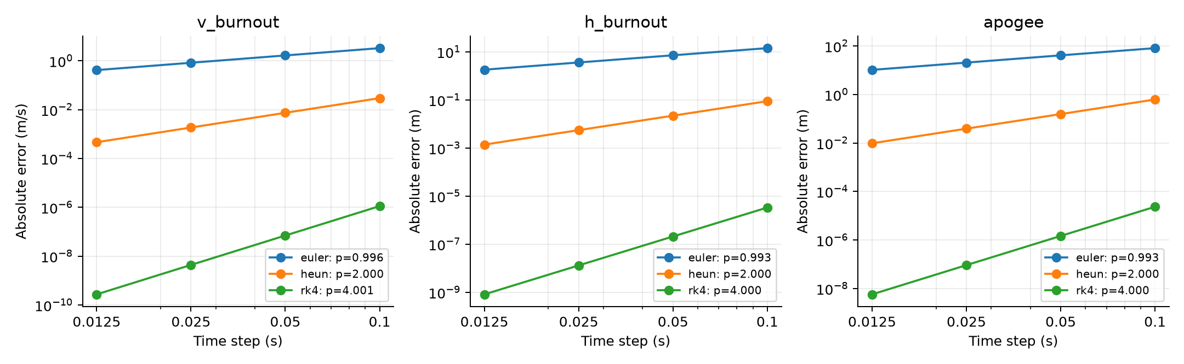
Figure 1. Local no-drag errors for burnout velocity, burnout altitude and apogee over four step sizes.
RK4 with maximum Δt=0.02 s is used for baseline results: the independent trajectory errors are below 1.6×10⁻⁷ m and 6.7×10⁻⁸ m/s. Step selection is driven by accuracy; a failed coarse-step check alone is not proof of instability. Appendix B gives a local stability diagnostic.
Source: outputs/convergence.csv; convergence/wmlab/*_report.json.

4 Baseline Simulation Results and Peak Acceleration Analysis

4.1 Drag versus Drag-Free Ascent
The cases use identical baseline parameters and RK4 with maximum Δt=0.02 s; only c changes. Burnout occurs at 2 s in both cases.
Metric | No drag | With drag | Unit
Burnout velocity | 235.793 | 172.272 | m/s
Burnout altitude | 214.142 | 183.593 | m
Apogee altitude | 3047.895 | 544.420 | m
Time to apogee | 26.036 | 8.999 | s
Maximum upward a/g | 15.989 | 9.841 | 1
Maximum |a|/g | 15.989 | 11.084 | 1

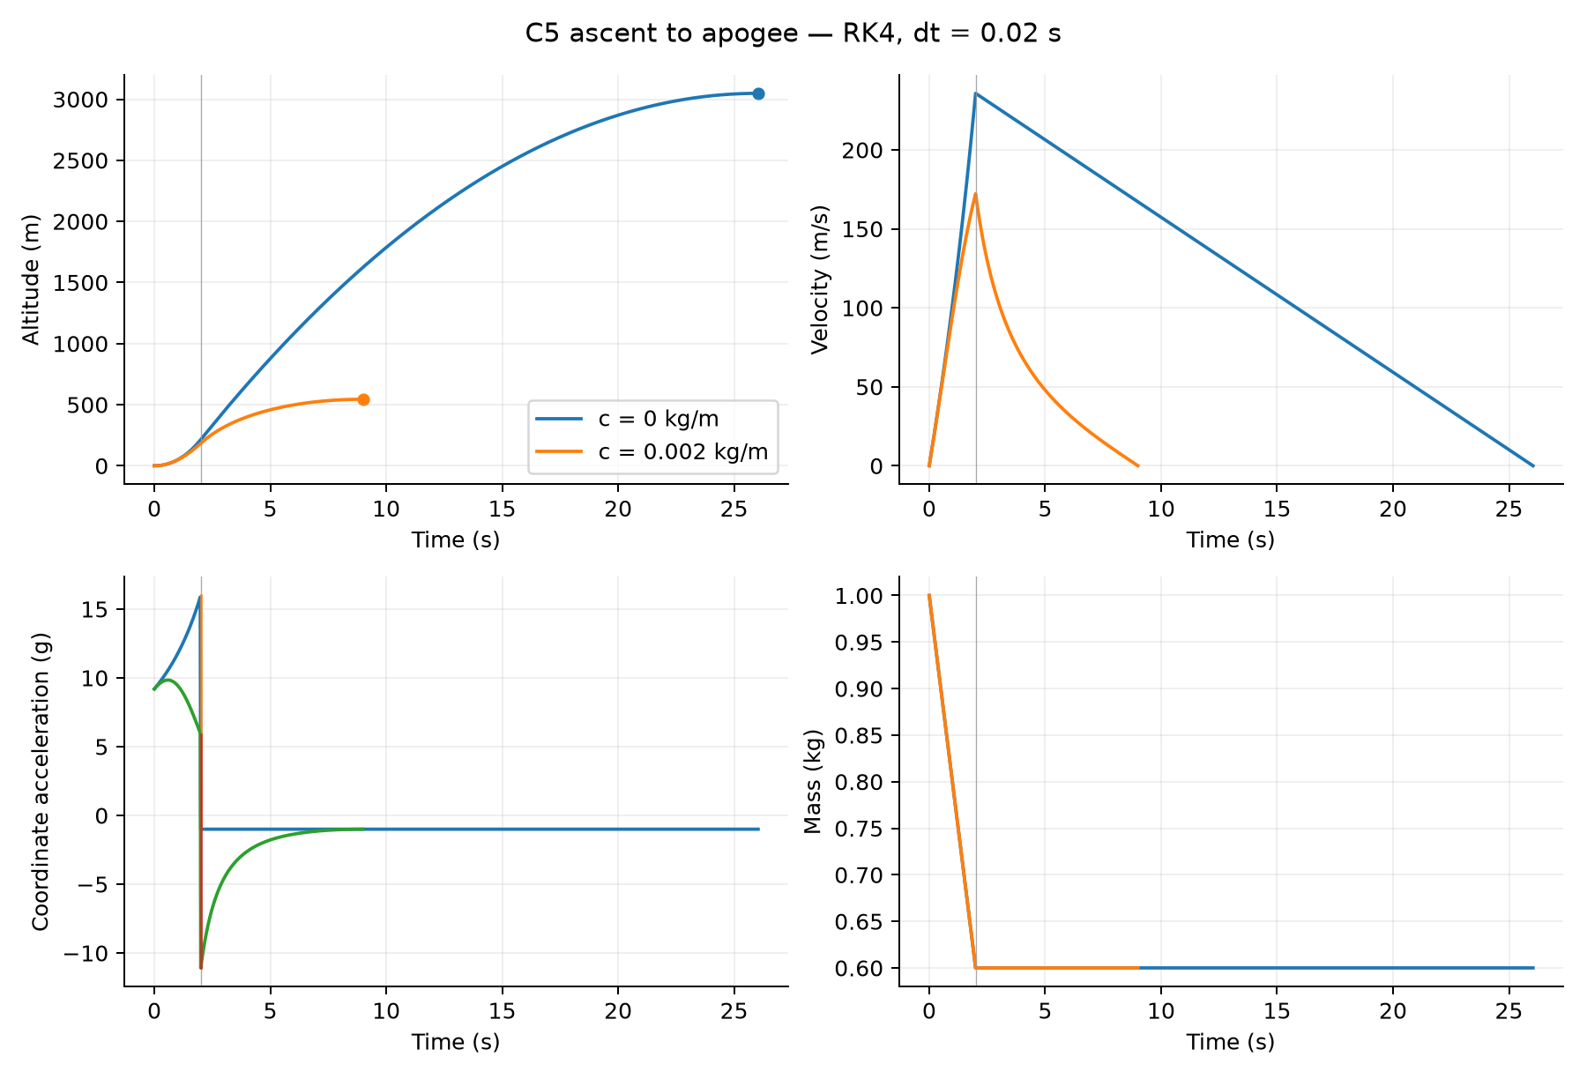
Figure 2. Baseline altitude, velocity, coordinate acceleration and mass. Burnout is at t=2 s.

4.2 Acceleration Interpretation
Drag lowers apogee by 82.14%. Its upward acceleration peaks near 0.58 s (9.841g), falling to 5.905g at t_b⁻ and jumping to −11.084g at t_b⁺. Thus the largest |a| occurs after shutdown. Proper acceleration is a+g; peak |a+g|/g is 16.989 without drag and 10.841 with drag. These point-mass diagnostics do not establish structural stress.
Source: outputs/baseline.csv; outputs/figures/trajectories.png.

5 Burn Rate Sensitivity and Flight Optimization

5.1 Parameter Sweep and Bounded Refinement
For fixed propellant mass 0.4 kg, the study starts at q_min=1.05m₀g/vₑ=0.020601 kg/s, a 5% lift-off thrust margin. Each sweep uses 65 logarithmic samples; upper bounds 0.5, 1 and 2 kg/s check domain sensitivity. Detected peaks are refined by bounded scalar minimization and compared with the endpoints.
$$c=0.002 kg/m: q*≈0.04509253 kg/s, tᵦ≈8.871 s, H≈642.411947 m$$
This candidate gains 97.99 m (18.00%) over q=0.2 kg/s. Halving the integration step changes H by about 1.85×10⁻⁸ m; its DOP853 discrepancy is about 1.97×10⁻⁸ m. It is a numerical optimum within the investigated domain, not a universal global-optimality proof.
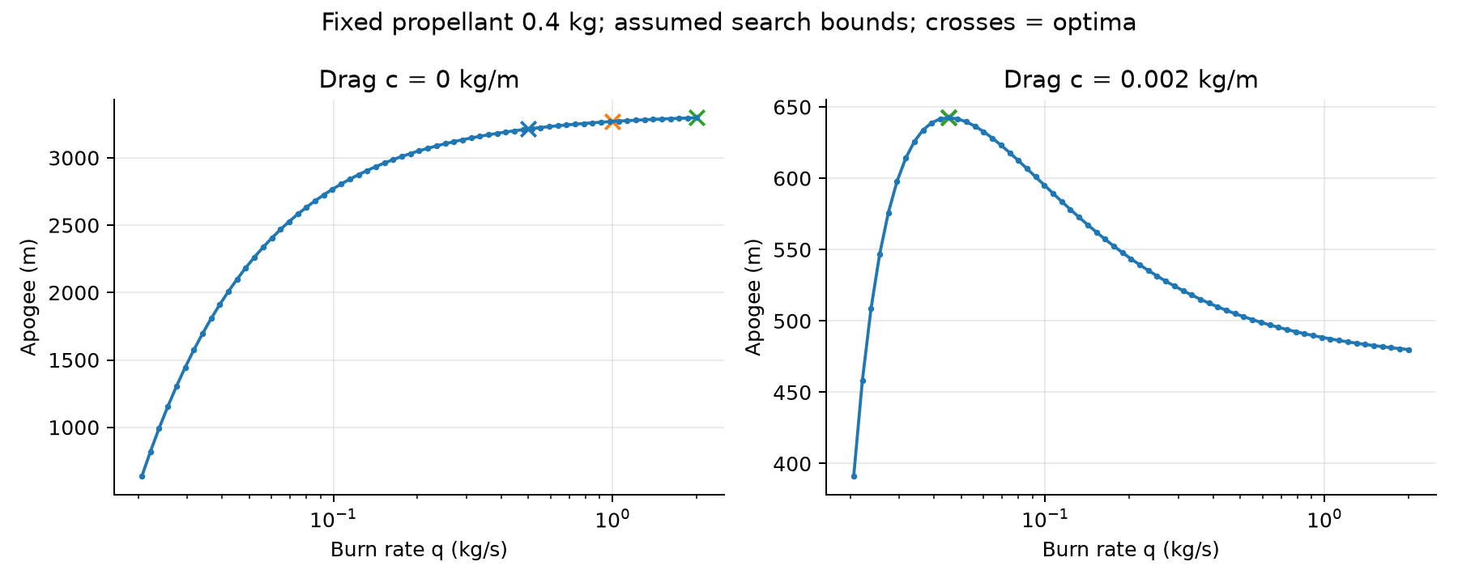
Figure 3. Apogee versus burn rate for fixed propellant mass, with and without quadratic drag.

5.2 Gravity–Drag Trade-Off
Low burn rates prolong powered flight and increase gravity losses. Higher rates shorten the burn but raise velocity, increasing drag force cv² and dissipation cv³. The drag-inclusive maximum balances these effects. The constant c model does not represent atmospheric-density variation with altitude.

5.3 No-Drag Limit

Because m₀L>m₀−m_f, H increases monotonically with q toward vₑ²L²/(2g). The unconstrained no-drag model therefore has no finite maximizing burn rate. Motor or structural constraints would be needed for a realizable optimum.
Source: outputs/burn_rate_sweep.csv; outputs/burn_rate_optima.csv.

6 Verification Framework, Dataset Synthesis, and Limitations

6.1 DE Kit, wmlab and Independent Checks
The DE Starter Kit supplies the module, scenario and system-card templates. wmlab 0.1.1 loads scenario YAML and calls c5_rocket.py, which adapts the project simulator to the toolkit’s t,Y interface. Euler, Heun and RK4 remain the project’s own implementations. wmlab writes trajectory files and JSON check reports; its dataset command writes c5_rocket.npz.
Toolkit scenario | Method / Δt | Actual | Expected
c5_baseline_drag | RK4 / 0.02 s | PASS | PASS
c5_analytic_no_drag | RK4 / 0.02 s | PASS | PASS
c5_euler_coarse_fail | Euler / 0.5 s | FAIL | FAIL

The coarse Euler reference error is 0.313115, above 10⁻⁶ despite acceptable physical bounds: an accuracy failure, not proof of instability. The runner reads JSON verdicts because wmlab can exit with code 0 even when checks fail. Archived evidence records 172 passing pytest tests and three passing convergence reports.
Every exported h,v,m sample is compared at matching times with the analytical solution (c=0) or an independent, burnout-split DOP853 integration (c>0; rtol=atol=2×10⁻¹²). Dynamics checks test h′=v, acceleration and phase-specific mass slopes with one-sided burnout treatment. The clean trajectories pass; copied-trajectory mutations are detected. Detailed tolerances, errors and mutation results are in Appendix C.

6.2 Dataset and System Card
wmlab generates 200 common-time ascent segments with seed 20261027 and stride=1. c5_rocket.npz stores Y with shape (200,201,3), ordered h,v,m, on 0–4 s at Δt=0.02 s. Phase-correct fractional steps are used instead of PCHIP. All 200 segments pass independent validation; maximum h/v/m errors are 2.69×10⁻⁷ m, 1.76×10⁻⁷ m/s and 1.40×10⁻¹⁴ kg. system_card.yaml records the authors, model, sampling assumptions and validity limits.

6.3 Scope and Conclusion
The results answer both project questions: baseline drag reduces apogee from 3047.90 to 544.42 m, while a slower burn near 0.04509 kg/s raises the drag-case apogee to 642.41 m. Verification supports the tested numerical model and exported data, not real-flight accuracy or absence of all possible faults. The model omits wind, rotation, variable density, transonic effects and motor transients. Reproduction details are in Appendix C and README.md.

Appendix A. Analytical Derivations

A.1 Momentum Balance and Powered Velocity
For a rocket ejecting propellant at relative speed vₑ, the effective thrust is qvₑ. With m′=−q and c=0, momentum balance gives m v′=qvₑ−mg. Since m(t)=m₀−qt, integration yields:
$$v(t)=\int_{0}^{t}{[\frac{qv_{e}}{m_{0}-qs}-g] ds}=v_{e}ln[\frac{m_{0}}{m_{0}-qt}]-gt$$

A.2 Powered Altitude and Burnout
Write m=m₀−qt. Substitution u=m₀−qs converts the logarithmic integral into:
$$\int_{0}^{t}{ln[\frac{m_{0}}{m_{0}-qs}] ds}=\frac{1}{q}\int_{m}^{m_{0}}{ln(\frac{m_{0}}{u}) du}$$
$$∫ln(\frac{m_{0}}{u}) du=u ln(\frac{m_{0}}{u})+u$$
Therefore h(t)=(vₑ/q)[m₀−m−m ln(m₀/m)]−gt²/2. Setting m=m_f gives the burnout height in Section 2.1. The coast has constant acceleration −g, so v_b−gτ=0 gives τ=v_b/g and H=h_b+v_b²/(2g).

A.3 Drag-Coast Integrals and Limiting Cases
For upward coasting, v′=−(g+cv²/m_f) and dh/dv=v/v′. Integrating from v_b to zero gives:
$$H-h_{b}=\int_{0}^{v_{b}}{\frac{v}{g+\frac{cv^{2}}{m_{f}}} dv}=\frac{m_{f}}{2c}ln[1+\frac{c{v_{b}}^{2}}{m_{f}g}]$$
$$t_{coast}=\int_{0}^{v_{b}}{\frac{1}{g+\frac{cv^{2}}{m_{f}}} dv}=\sqrt{\frac{m_{f}}{cg}} arctan[v_{b}\sqrt{\frac{c}{m_{f}g}}]$$
As c→0, ln(1+x)~x and arctan(x)~x recover v_b²/(2g) and v_b/g. These relations verify the coast using the supplied burnout state; they are separate from the full DOP853 reference.

A.4 Monotonic No-Drag Burn-Rate Dependence
Substituting t_b=(m₀−m_f)/q into h_b+v_b²/(2g), the terms proportional to t_b² cancel:
$$H(q)=\frac{{v_{e}}^{2}L^{2}}{2g}-\frac{v_{e}}{q}[m_{0}L-(m_{0}-m_{f})], L=ln(\frac{m_{0}}{m_{f}})$$
For r=m₀/m_f>1, ln r>1−1/r; hence m₀L−(m₀−m_f)>0 and dH/dq>0. The limiting height is finite, but is approached only as q→∞ in this unconstrained model. This argument explains the upper-bound optima in the no-drag numerical sweeps.

Appendix B. Numerical Algorithms and Convergence

B.1 Explicit Updates
For y′=f(t,y) and step Δt, the project uses the following updates on each smooth flight phase:
$$Euler: yₙ₊₁=yₙ+Δt f(tₙ,yₙ)$$
$$Heun: y*=yₙ+Δt f(tₙ,yₙ)$$
$$yₙ₊₁=yₙ+(Δt/2)[f(tₙ,yₙ)+f(tₙ+Δt,y*)]$$
$$RK4: k₁=f(tₙ,yₙ), k₂=f(tₙ+Δt/2,yₙ+Δt k₁/2)$$
$$k₃=f(tₙ+Δt/2,yₙ+Δt k₂/2), k₄=f(tₙ+Δt,yₙ+Δt k₃)$$
$$yₙ₊₁=yₙ+(Δt/6)(k₁+2k₂+2k₃+k₄)$$
For event refinement, a fractional step is recomputed from the same left state; linear interpolation is not substituted for the selected integrator. Burnout splitting prevents a Runge–Kutta stage from mixing two different force laws.

B.2 Local Burnout-Velocity Errors
Δt (s) | Euler (m/s) | Heun (m/s) | RK4 (m/s)
0.1 | 3.303708e+00 | 2.962515e-02 | 1.118532e-06
0.05 | 1.659260e+00 | 7.407128e-03 | 6.994608e-08
0.025 | 8.314815e-01 | 1.851834e-03 | 4.372765e-09
0.0125 | 4.162037e-01 | 4.629619e-04 | 2.723368e-10

Fitted orders are 0.996296, 1.999932 and 4.001140. The fit across all levels differs from a single pairwise estimate. The toolkit uses three step sizes and the state at 1.5 s, giving orders 0.988516, 1.999868 and 3.999388. Every configured toolkit order check passes.

B.3 Local Linear Stability Diagnostic
Holding phase and mass fixed, a velocity perturbation has λ=∂v′/∂v=−2c|v|/m. On the negative real axis, |R(λΔt)|≤1 gives |λ|Δt≤2 for Euler and Heun and approximately 2.785 for RK4. The baseline drag case reaches |λ|≈1.14848 s⁻¹ at burnout, corresponding to local limits about 1.74 s and 2.43 s. The 0.02 s baseline step is well below these values.
This is a frozen-coefficient diagnostic, not a global stability proof for the coupled, variable-mass, switched system. In particular, Euler at 0.5 s can pass this local diagnostic while failing the required accuracy check. Convergence and independent-reference tests remain necessary.
Source: outputs/convergence.csv; convergence/wmlab/*_report.json; baseline v_b and m_f.

Appendix C. Verification, Toolkit and Reproduction

C.1 Trajectory Checks and Tolerances
All exported h,v,m samples are compared at identical times. For each sample, PASS requires |x−x_ref|≤atol+rtol|x_ref|. The independent DOP853 reference uses a separate RHS, algebraic mass and a split at burnout. No altered trajectory replaces the candidate during verification.
Quantity | Absolute allowance | Relative allowance
h | 0.01 m | 10⁻⁶
v | 0.01 m/s | 10⁻⁶
m | 10⁻¹⁰ kg | 0
stored a versus ODE | 10⁻⁸ m/s² | 10⁻¹⁰

The h/v allowances match the event-check resolution; mass is algebraically prescribed. The acceleration channel is an algebraic output and needs no differentiation allowance. Each error is tested against its own allowance; maximum absolute and relative errors are descriptive statistics.
c (kg/m) | State | Max. abs. error¹ | Max. rel. error | Result
0.0 | h | 3.761e-08 | 1.188e-09 | PASS
0.0 | v | 1.791e-09 | 9.995e-01 | PASS
0.0 | m | 1.110e-16 | 1.476e-16 | PASS
0.002 | h | 1.588e-07 | 8.984e-09 | PASS
0.002 | v | 6.682e-08 | 9.993e-01 | PASS
0.002 | m | 1.110e-16 | 1.476e-16 | PASS

¹ Units are m, m/s and kg for h, v and m. Relative error excludes zero references; a large ratio near zero does not override an acceptable absolute error.

C.2 Dynamics Consistency and Mutations
On each phase-local interval, the verifier compares the state secant with the trapezoidal mean RHS. The allowance is the same stencil’s bias on the independent reference plus propagated endpoint state allowances and roundoff. For h, the budget includes (εh,i+εh,i+1)/Δt+(εv,i+εv,i+1)/2; acceleration sensitivity supplies the analogous v term. Mass slopes are −q during burn and zero during coast. Burnout uses the appropriate one-sided acceleration in each adjacent interval; stored a at burnout uses the right limit.
c | t (s) | Field | Change¹ | Primary check | Detected
0.0 | 1 | v | +25 | trajectory_v | YES
0.0 | 1 | h | +1 | trajectory_h | YES
0.0 | 1 | m | +0.02 | trajectory_m | YES
0.0 | 1 | a | +25 | dynamics_acceleration | YES
0.0 | 3 | v | +25 | trajectory_v | YES
0.0 | 3 | h | +1 | trajectory_h | YES
0.0 | 3 | m | +0.02 | trajectory_m | YES
0.0 | 3 | a | +25 | dynamics_acceleration | YES
0.002 | 1 | v | +25 | trajectory_v | YES
0.002 | 1 | h | +1 | trajectory_h | YES
0.002 | 1 | m | +0.02 | trajectory_m | YES
0.002 | 1 | a | +25 | dynamics_acceleration | YES
0.002 | 3 | v | +25 | trajectory_v | YES
0.002 | 3 | h | +1 | trajectory_h | YES
0.002 | 3 | m | +0.02 | trajectory_m | YES
0.002 | 3 | a | +25 | dynamics_acceleration | YES

¹ Changes are in m, m/s, kg and m/s² for h, v, m and a, respectively. All 16 local mutations are detected; each modifies a copied interior sample while retaining the original arrays and event values. The toolkit additionally detects 12/12 h/v/m faults. Its three-column output has no separate acceleration channel, so local Trajectory tests cover that channel. These results do not guarantee detection below tolerance or between unexported times.
Source: outputs/trajectory_verification.json; outputs/wmlab/mutations.json.

C.3 Toolkit Interface and Dataset Provenance
The DE kit is the course integration package; wmlab 0.1.1 is its execution and checking tool. c5_rocket.py exports NAME, STATE, simulate, analytic, quantities, reference_quantities, bounds and sample. EXTRA_CHECKS adds trajectory_reference, dynamics_consistency and event_consistency. Checks consume the returned candidate arrays. The English edition localizes toolkit text and retains separate original/localized hash manifests.
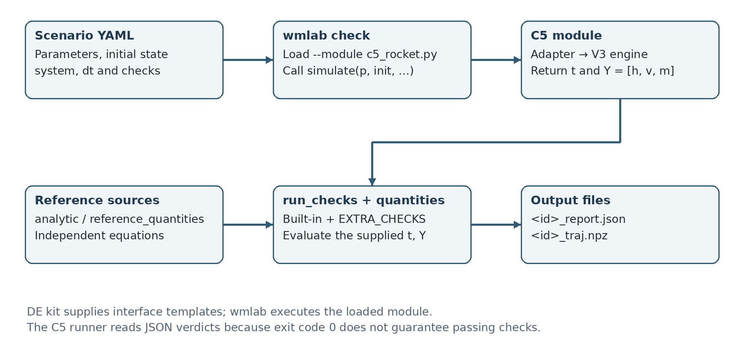
Figure 4. DE kit integration and wmlab verification workflow used by the project.
The 200 toolkit samples use seed 20261027, stride=1 and a shared physical-time grid 0–4 s, with 201 points. Y stores [h,v,m]. The following independently drawn ranges define a numerical test population, not measured rocket statistics:
Draw | Range
m₀ | 0.8–1.2 kg
Propellant fraction | 0.25–0.45
vₑ | 400–550 m/s
Initial thrust-to-weight ratio | 1.2–15
c | 0–0.003 kg/m

The model derives m_f=m₀(1−fraction) and q=TWR·m₀g/vₑ, ensuring positive dry mass and an initial lift-off margin. Broad thrust and drag ranges exercise solver behavior; they do not establish hardware feasibility. All 200 segments pass independent validation. They are not all complete flights to apogee. outputs/local_dataset_200.npz is a separate full-ascent dataset with seed 20261024.
Source: system_card.yaml; c5_rocket.npz; outputs/wmlab/dataset_validation.json.

C.4 Reproduction and Evidence Files
Run these commands from the project root containing main.py. The local requirements install the bundled toolkit. Manual simulations create separate outputs/quick_runs/ folders; the verification and report commands regenerate standard evidence.
python3 -m venv .venv
source .venv/bin/activate
python -m pip install -r requirements.txt
python main.py compare --method rk4 --dt 0.02 --c 0.002
python main.py verify
python main.py report

Direct toolkit examples:
python -m wmlab --lang en check \
scenarios/wmlab/c5_baseline_drag.yaml \
--module c5_rocket.py -o outputs/wmlab
python -m wmlab --lang en dataset --system c5_rocket \
--module c5_rocket.py --n 200 --seed 20261027 \
--stride 1 -o c5_rocket.npz

A completed process is not itself a passing verdict. scripts/wmlab_verify.py inspects individual JSON checks, verifies the expected coarse-Euler failure and validates the dataset. Source YAML and system_card.yaml already contain group metadata; a rerun refreshes report metadata from those source files.
Evidence | Project-relative file or directory
Regression tests | outputs/pytest.txt
Whole-trajectory checks and local mutations | outputs/trajectory_verification.json
Toolkit scenario JSON reports | outputs/wmlab/*_report.json
Toolkit perturbations | outputs/wmlab/mutations.json
Dataset validation | outputs/wmlab/dataset_validation.json
Three convergence reports | convergence/wmlab/*_report.json
Baseline / convergence / sweep data | outputs/baseline.csv; outputs/convergence.csv; outputs/burn_rate_sweep.csv
Refined optimum | outputs/burn_rate_optima.csv
Toolkit dataset and model record | c5_rocket.npz; system_card.yaml

The reported verdicts and datasets are traceable to these archived project files. To reproduce them, run the commands above and inspect each check result.

Appendix D. Compliance, Declaration and References

D.1 Evidence Mapping
Criterion | Weight | Evidence
Model and analysis | 20 | Sections 1–2; Appendix A
Numerical methods and convergence | 20 | Section 3; Appendix B; convergence/wmlab/
Verification | 20 | Section 6.1; Appendix C.1–C.2; outputs/wmlab/
Real-world answers | 15 | Sections 4–5: apogee, acceleration and burn-rate trade-off
Dataset and system card | 15 | Section 6.2; Appendix C.3; c5_rocket.npz; system_card.yaml
Reporting and reproduction | 10 | Six-page main body; Appendix C.4; README.md

The main body occupies pages 1–6, with supporting material in the appendices. The cover and contents are front matter. The evidence mapping follows the catalogue’s technical criteria.

D.2 AI Assistance Declaration
Declaration: ChatGPT Codex assisted in analytical drafting, Python simulation scripting, test harness setup, and documentation formatting.
All mathematical proofs, numerical calculations, and technical interpretations were independently verified and validated by the student team. AI assistance is disclosed in this report; consent_physeval remains false.

D.3 References
1. Quang Nguyen. Differential Equations – Simulation Projects, Version 1.0, October 2026. Department of Physics, International University, VNU-HCM. C5 model rocket; submission requirements and grading rubric.
2. DE Project Starter Kit, supplied course distribution. Module and scenario templates, system-card template and bundled wmlab 0.1.1 documentation.
3. SE_Rocket.rar, SE_Rocket/c5_rocket_final. Project implementation: main.py, c5_rocket.py, rocket/, verification/, experiments/studies.py and scripts/wmlab_verify.py. Model record and dataset: system_card.yaml and c5_rocket.npz.
4. Project numerical evidence: outputs/baseline.csv, outputs/convergence.csv, outputs/burn_rate_sweep.csv, outputs/burn_rate_optima.csv, outputs/trajectory_verification.json, outputs/wmlab/ and convergence/wmlab/.
5. Independent-reference implementation: verification/independent.py, using SciPy DOP853 through solve_ivp. Powered and coasting phases are integrated separately with rtol=atol=2×10⁻¹².

