1. Build the source code of the website and open the homepage with a browser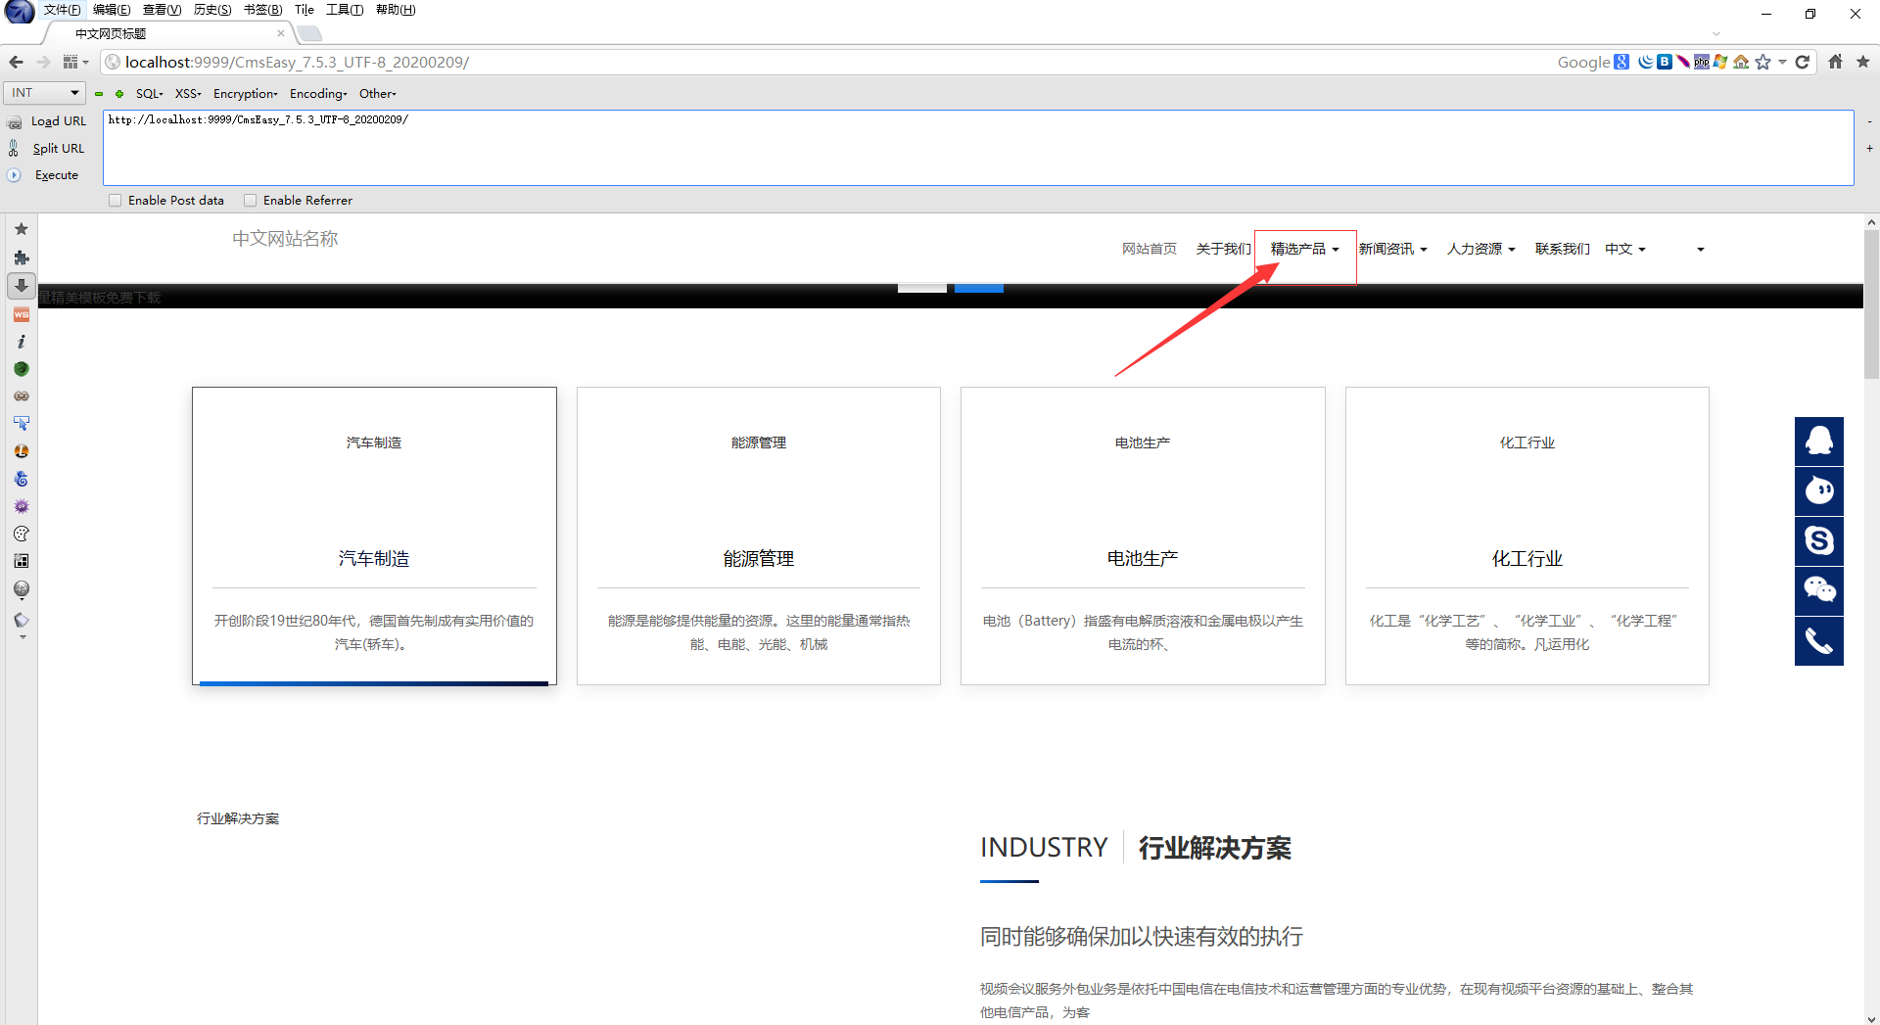

2.Click the selected products, and then click any product to open the purchase page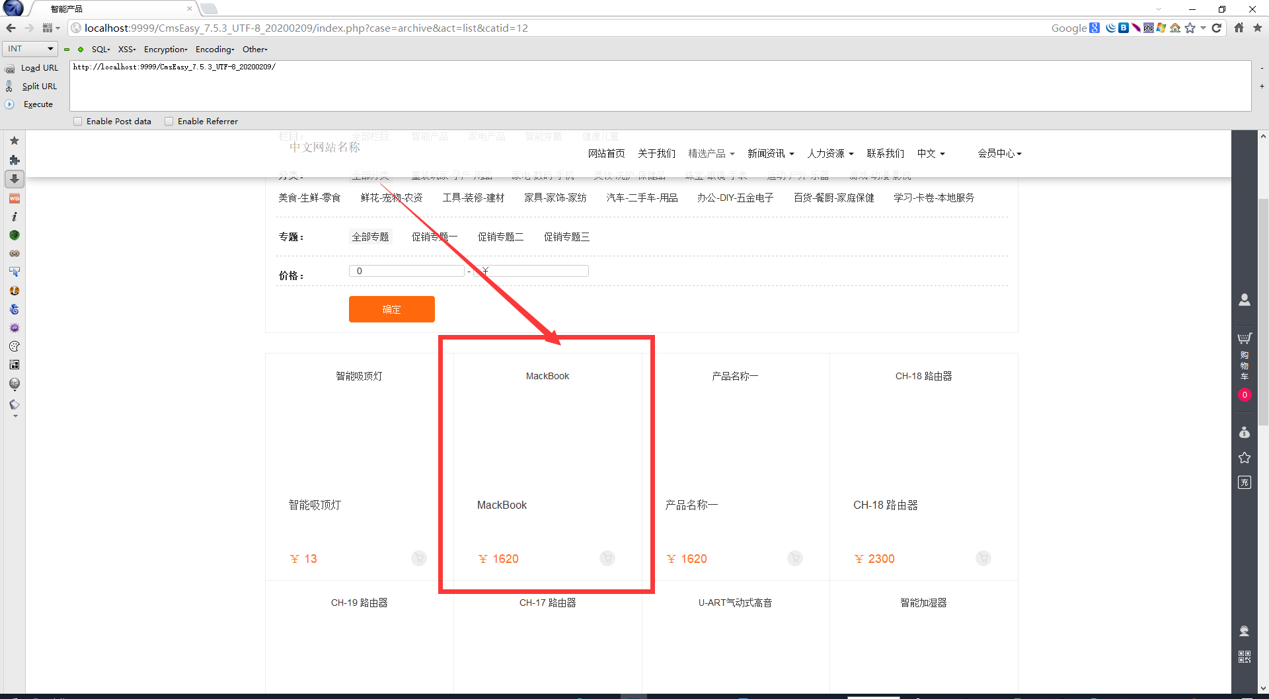

3.Open the user center, log in and find that my current amount is 8100910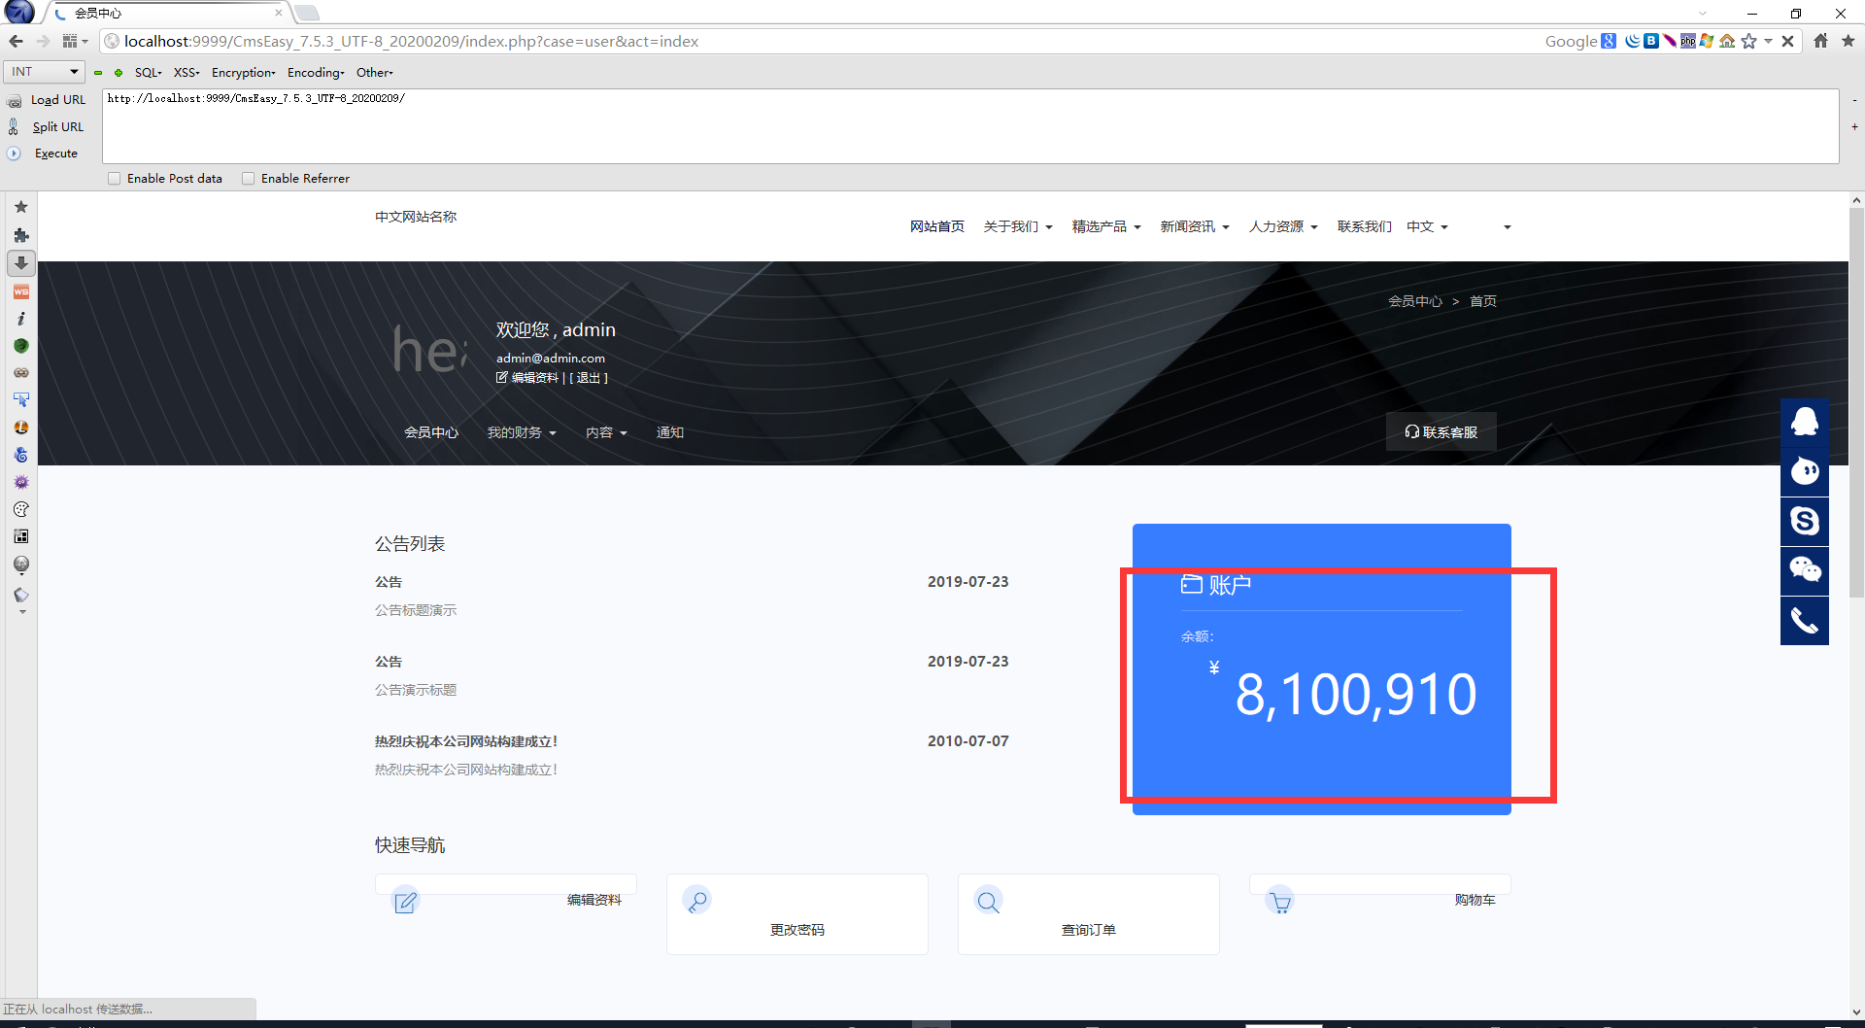

4.Then enter the purchase page and input - 1 in quantity (after input, click the mouse to purchase directly, if you click other places, the protection mechanism will be triggered)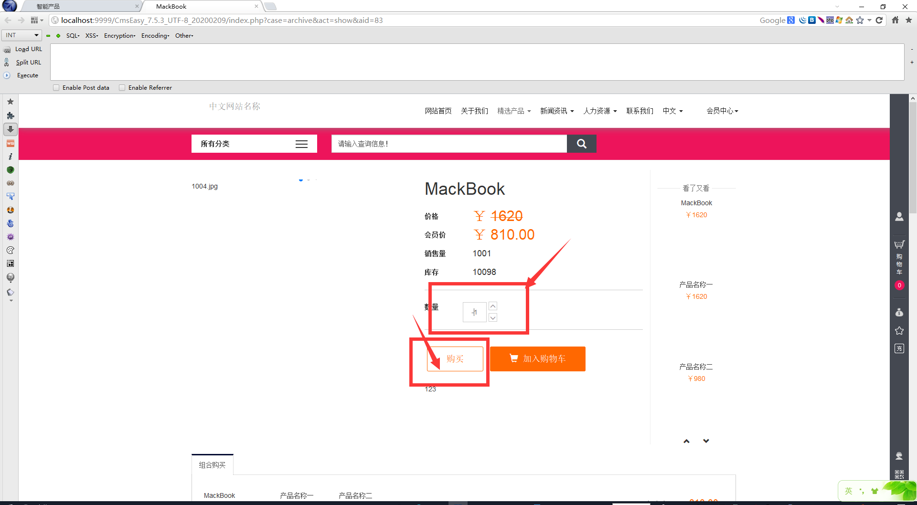

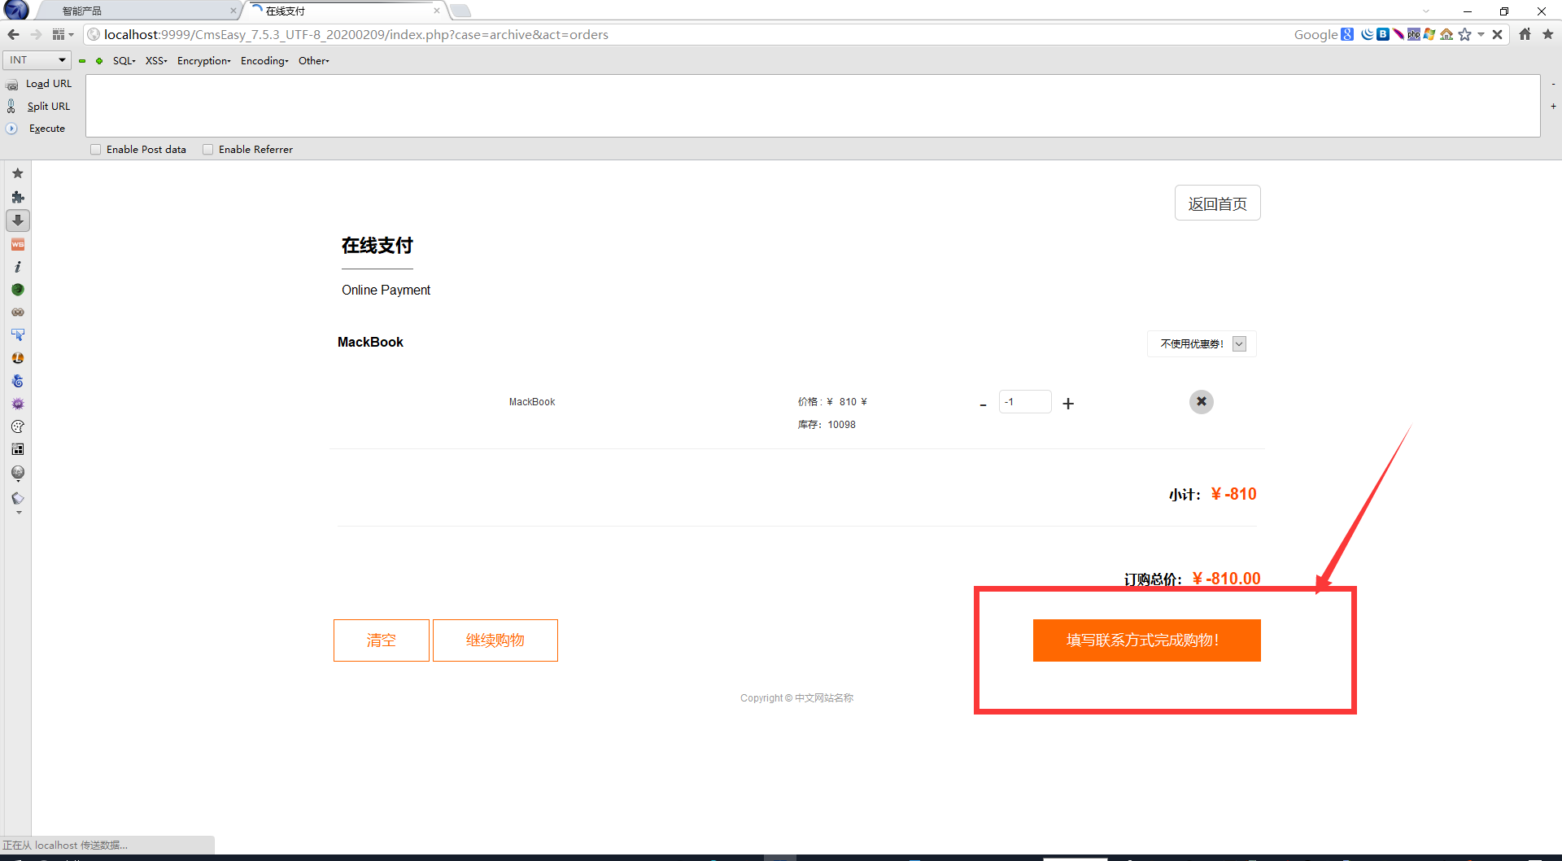

5. Then click fill in the exercise method to complete the shopping, then fill in the exercise method, and click online payment

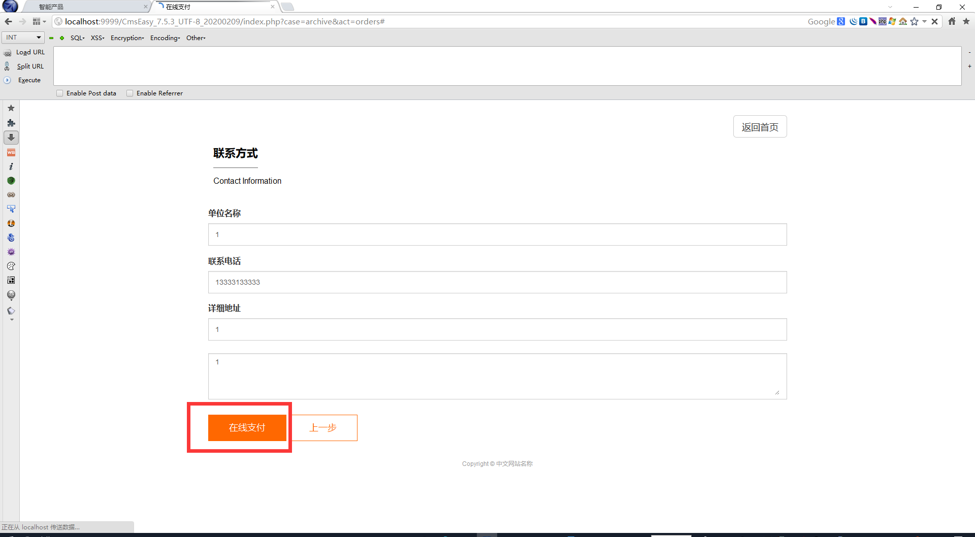

6. Click to buy

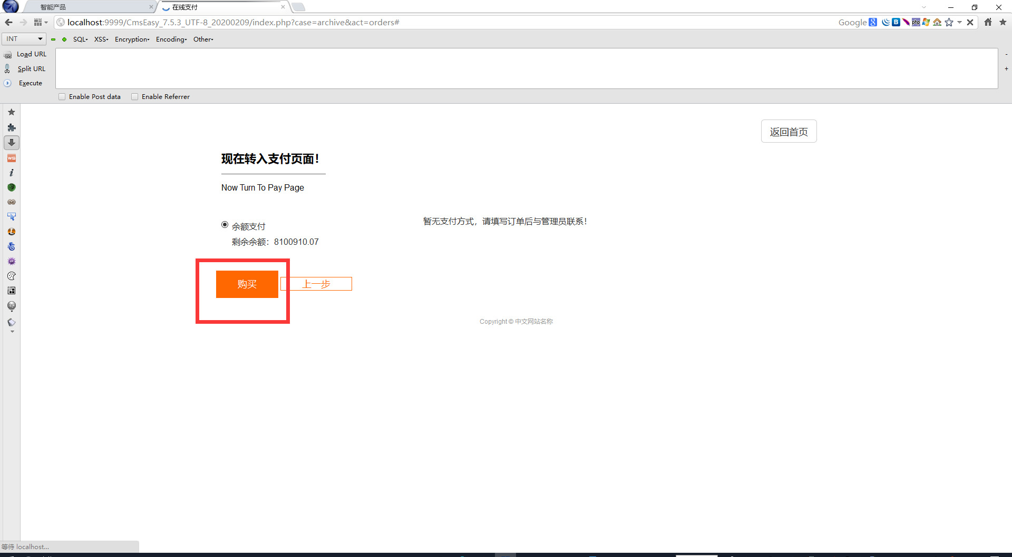

7.Then go back to the user center and check the balance. You can find that the balance has increased