MACHINE LEARNING FOR CREDIT CLASSIFICATION: CASE STUDY IN A VIETNAMESE COMMERCIAL BANK
Lê Thị Thanh An^{a,b} Lê Kim Thư^{c}, Đàm Công Danh^{c,}*
ªUniversity of Economics and Law, Ho Chi Minh City, Vietnam
^{b}Vietnam National University, Ho Chi Minh City, Vietnam
^{c}Hanoi University of Science and Technology (HUST), Hanoi, Vietnam
* Corresponding author.
Email address: danh.dc251317m@sis.hust.edu.vn, Tel.: +84 966 565 830
Submitted to the 3rd Global Conference on Sustainability in Economics, Business and Law (UEL SEBL International Conference 2026), “Green Economy and Sustainable Governance: New Growth Drivers for the Private Sector,” Ho Chi Minh City, October 6, 2026.
Abstract
Robust, transparent credit-risk classification is a governance precondition for responsible private-sector lending in Vietnam. Using 27,001 loan contracts from a Vietnamese commercial bank, this paper builds a machine-learning pipeline for five-group debt classification. After data preparation with Information Value screening, an explicit leakage diagnostic and feature engineering, six classifiers — Logistic Regression, Decision Tree, Random Forest, XGBoost, LightGBM and CatBoost — are each evaluated under two imbalance treatments, inverse-frequency class weighting and no weighting, giving a symmetric twelve-configuration comparison on a common hold-out set and under repeated cross-validation. The central finding is that the imbalance treatment, not the choice of algorithm, is what the evidence identifies: class weighting lowers Macro-F1 for five of the six classifiers, and the four leading configurations are all unweighted tree ensembles (Decision Tree–none, XGBoost–none, Random Forest–none, LightGBM–none), spanning Macro-F1 0.6183 to 0.6271. A corrected resampled paired t-test with Holm adjustment cannot separate them, so this paper deliberately names no single winning algorithm, while the advantage of dropping class weighting survives the same correction for every tree-based model. Class weighting is not merely worse, however: it trades precision on the non-performing debt groups for recall, a distinction a single Macro-F1 figure conceals and that a bank must therefore decide deliberately rather than inherit from a default. We contribute a regulatory-compliant, explainable pipeline that evaluates under extreme class imbalance using Macro-F1 and a corrected resampled paired t-test with Holm adjustment on a real-world bank dataset; and we advance model governance by showing empirically that SHAP explanations are more stable than Gain-based importance across both algorithms and imbalance treatments, and by implementing validation protocols that close identified data-leakage paths. All governance claims are conditional on the out-of-time validation this single-snapshot dataset cannot supply.
Keywords: credit risk classification; class imbalance; explainable AI; model governance; Vietnam

Introduction
A growing private sector needs reliable access to bank credit at a fair, risk-appropriate cost, and reliable access depends on banks being able to classify credit risk soundly. Every commercial bank allocates credit through an internal risk-classification process, and the quality of that process determines how much credit reaches productive private borrowers, how consistently problem loans are identified, and how resilient the banking system remains through the credit cycle. Weak or opaque credit risk assessment can restrict the flow of credit to bankable private borrowers because risk cannot be priced with confidence, or it can allow risk to accumulate unrecognized until it surfaces as non-performing loans (NPLs) that force banks to retrench lending precisely when the private sector needs it most.
In Vietnam, the classification of loans into risk-ordered debt groups is not a purely internal modelling choice; it is a regulatory obligation. Under the asset-classification framework currently in force — Circular No. 31/2024/TT-NHNN, as amended by Circular No. 37/2025/TT-NHNN and consolidated in Document No. 27/VBHN-NHNN dated 21 November 2025 — commercial banks, non-bank credit institutions, and foreign bank branches must classify each loan into one of five debt groups of increasing risk, with groups 3–5 constituting non-performing debt. This classification underpins provisioning, portfolio monitoring, and, ultimately, the volume and cost of credit a bank is willing and able to extend to private borrowers. A bank that can classify the current risk of its portfolio more accurately and more consistently — with less dependence on any single officer's judgment—is a bank that can govern its credit portfolio more soundly and support private-sector growth more confidently.
Machine learning offers a way to strengthen this classification process, but it also raises a governance concern that is directly relevant to a “sustainable governance” agenda: models that are accurate but opaque, or that unintentionally learn the labeling rule itself rather than genuine predictive signal, are unsuitable for a regulated, accountable credit process. Good governance of an AI-based credit model therefore requires three things simultaneously: predictive performance that is fairly measured under severe class imbalance; a feature set that is efficient and auditable rather than needlessly large; and an explanation of why the model classifies a given loan as it does.
This paper addresses these three requirements using a real dataset of 27,001 loan contracts from a Vietnamese commercial bank (Data_credit_rating_VN.xlsx), covering the debt-group target NHOMNOMOI (groups 1–5) and 21 raw variables describing the loan, the borrower, and the branch. Building on a broader ongoing thesis-level research programme on AI applications in credit rating, this paper isolates and reports the full pipeline and results obtained on this single dataset, reframed around the following three questions, chosen for their direct relevance to credit governance and private-sector financing:
RQ1. How do standard machine-learning classifiers compare on a multi-class, severely imbalanced debt-group classification task, and how far does the ranking depend on the imbalance treatment applied, under imbalance-aware evaluation metrics?
RQ2. Does adding more features always improve out-of-sample performance, or can a smaller, cheaper-to-maintain feature set retain (near-)full performance?
RQ3. Which business-defined groups of information (loan tenure, product/purpose, balance/utilization, branch, demographics, pricing) drive predictive performance, and is this conclusion stable across two different importance measures (Gain and SHAP)?
The remainder of the paper is organized as follows. Section 2 reviews the credit-scoring literature and the Vietnamese legal context. Section 3 describes the data, the preprocessing and leakage-control pipeline, the engineered features, and the modeling and evaluation design. Section 4 reports the empirical results and discusses their implications for sustainable credit governance and private-sector financing. Section 5 concludes and states the limitations of the study.

Literature Review

2.1 From statistical scoring to machine learning
Credit scoring has a long statistical tradition. Altman (1968) introduced the multivariate discriminant Z-score on a matched sample of 66 U.S. manufacturing firms, reporting about 95% correct classification one year before bankruptcy — a result obtained on a small, artificially balanced sample and therefore not directly transferable as an accuracy benchmark to a modern, imbalanced retail-banking dataset. Ohlson (1980) moved the field toward probabilistic prediction with a logit model estimated on a much larger and more realistic sample (105 bankrupt vs. 2,058 non-bankrupt firms). In consumer credit, Hand and Henley (1997) and Thomas (2000) systematized the statistical foundations of credit and behavioural scoring; logistic regression became — and remains — the industry baseline because of its transparent, additive log-odds structure (Hosmer, Lemeshow, & Sturdivant, 2013).
The 2000s and 2010s extended the toolkit substantially. Random Forest (Breiman, 2001) reduces variance relative to a single decision tree (Quinlan, 1986) by averaging over bootstrap-sampled, decorrelated trees. Gradient Boosting (Friedman, 2001) fits an additive sequence of weak learners to residual error. XGBoost (Chen & Guestrin, 2016), LightGBM (Ke et al., 2017) and CatBoost (Prokhorenkova, Gusev, Vorobev, Dorogush, & Gulin, 2018) are, respectively, a regularised and scalable boosting framework, a histogram/leaf-wise boosting framework optimised for large, high-dimensional tabular data, and a boosting framework with native handling of categorical features. Large-scale benchmarking studies caution against assuming any one family is uniformly best: Baesens et al. (2003) found that non-linear classifiers did not dominate logistic regression consistently across eight European and U.S. credit datasets, while Lessmann, Baesens, Seow, and Thomas (2015), updating that benchmark on 41 classifiers and 8 datasets, found that many classifiers outperform logistic regression and that heterogeneous ensembles perform well on average, but that rankings vary by dataset and metric. Brown and Mues (2012) show, across five real credit datasets under class ratios pushed from 70/30 to an extreme 99/1, that the best-performing algorithm changes with the degree of imbalance, with Random Forest performing best at the most extreme imbalance level they test.

2.2 Class imbalance, evaluation and explainability
Credit datasets are structurally imbalanced: good loans vastly outnumber bad ones. Under such imbalance, Accuracy is a misleading headline metric because a trivial “always predict good” classifier can score deceptively well; Macro-F1, which averages F1 across classes without weighting by class frequency, is a more informative primary metric because it penalizes poor detection of rare, high-risk classes (Brown & Mues, 2012). The Synthetic Minority Over-sampling Technique (SMOTE) (Chawla, Bowyer, Hall, & Kegelmeyer, 2002) is a widely used resampling method to counteract imbalance, but it must be fitted only within the training partition to avoid leaking synthetic-neighbour information into the evaluation set. Beyond raw predictive performance, credit-risk models used in a regulated setting must also be explainable. SHAP (SHapley Additive exPlanations), grounded in cooperative game theory, attributes each prediction additively to its input features at both the individual and the aggregate level (Lundberg & Lee, 2017), and is increasingly treated as a governance tool rather than a purely technical add-on, precisely because it lets a bank show, feature by feature, why a given loan was scored as it was.
A complementary, older but still standard tool for feature screening in credit scoring is the Weight of Evidence / Information Value (WOE/IV) framework (Siddiqi, 2006), which quantifies how well a single variable separates “good” from “bad” outcomes before any model is fitted, using conventional thresholds (IV < 0.02 “useless,” 0.02–0.1 “weak,” 0.1–0.3 “medium,” 0.3–0.5 “strong,” 0.5–1.0 “very strong,” and > 1.0 flagged as “suspiciously high,” a common heuristic trigger to check for data leakage). This last threshold matters for governance: an unusually high IV is not proof of leakage, but it is a signal that a variable's availability at scoring time must be verified before the variable is used — a discipline this paper applies explicitly in Section 3.

2.3 Legal and institutional context in Vietnam, and its alignment with this dataset's timing
The target variable used in this paper is not an arbitrary research construct: it is the debt group assigned to each loan under Vietnam's binding regulatory framework for asset classification, which has been revised several times. Decision No. 493/2005/QĐ-NHNN (as amended by Decision No. 18/2007/QĐ-NHNN) first codified the five-group debt-classification structure retained in every subsequent version. Circular No. 02/2013/TT-NHNN (as amended by Circular No. 09/2014/TT-NHNN) replaced Decision 493; Circular No. 11/2021/TT-NHNN, effective 1 October 2021, then replaced Circular 02/2013; and Circular No. 31/2024/TT-NHNN, effective 1 July 2024 and further amended by Circular No. 37/2025/TT-NHNN (consolidated in Document No. 27/VBHN-NHNN, 21 November 2025), is the framework currently in force. Across all versions, assets are classified into five debt groups of increasing risk, with groups 3, 4 and 5 constituting non-performing debt. In parallel, the National Credit Information Center of Vietnam (CIC), operating under Circular No. 15/2023/TT-NHNN, aggregates cross-institution credit-history information used in classification and monitoring.
The dataset does not record its classification date, so the operative circular cannot be established from the file alone. A snapshot before 1 October 2021 may fall under Circular No. 02/2013/TT-NHNN; a later snapshot may fall under Circular No. 11/2021/TT-NHNN. The narrower claim is that NHOMNOMOI appears to operationalize Vietnam's long-standing five-group regulatory structure, while the exact legal instrument and bank-internal assignment rules remain unverified. Circular No. 31/2024/TT-NHNN is cited only for the framework currently in force.

2.4 Prior machine-learning credit-scoring work in Vietnam
Several recent studies have applied machine learning to credit risk at Vietnamese commercial banks. Dang and Nguyen (2020) built an early credit-scoring pipeline for a Vietnamese bank; Tran and Nguyen Vuong (2025) developed a credit-scoring model for individual Vietnamese bank customers, comparing Logistic Regression, k-nearest neighbors, Decision Tree, Random Forest, LightGBM and SVM; Nguyen and Ngo (2025) compared four boosting algorithms (AdaBoost, XGBoost, LightGBM, CatBoost) for personal default prediction on a pooled dataset of 7,542 customers from Vietnamese commercial banks and financial institutions (2014–2022); and, closest in subject to the present paper, Nguyen, Trinh, Phuong, and Ly (2024) built an early-warning system for debt-group migration at one Vietnamese commercial bank, comparing Logistic Regression, SVM, Decision Tree and Random Forest and reporting up to 81.84% Accuracy for a Random Forest model predicting overdue-debt migration.

2.5 The research gaps

The above studies indicate that machine learning is an active, competitive area of Vietnamese banking research and that ensemble/boosting methods are strong candidates in this setting, but there are three gaps that motivate the present paper's design. First, model comparisons are typically reported using Accuracy as the headline metric — including the 81.84% figure above — without a class-imbalance-robust primary metric such as Macro-F1; Section 4.1 of this paper shows directly, on this same category of data, how misleading Accuracy can be under severe imbalance (CatBoost's Accuracy and Macro-F1 diverge sharply). Second, none of these studies checks whether its feature-importance conclusions are stable across more than one algorithm or more than one importance measure; Section 4.3 shows that Gain-based importance computed from two different tree-boosting libraries on the same Vietnamese dataset can disagree sharply with each other, and disagree again when the imbalance treatment changes, a methodological caution directly relevant to any single-model importance analysis in this literature. Third, none reports an explicit leakage diagnostic for a dominant predictor, an ablation study, or a check of sensitivity to an arbitrary modelling convention such as a reference date — verification steps this paper treats as a governance requirement (Section 4.6) rather than an optional robustness check. The present paper's contribution is accordingly not one more machine-learning model for a Vietnamese bank, but a demonstration of a verification-first methodology — cross-model importance triangulation, a leakage ablation, a reference-date sensitivity check, and imbalance-metric discipline with a properly specified statistical test — that this literature has not yet applied together, and that this paper argues should be a governance baseline before a model of this kind informs credit decisions affecting private-sector borrowers.

Methodology

3.1 Dataset
The dataset (Data_credit_rating_VN, shortened to Dataset A) contains 27,001 loan contracts from a Vietnamese commercial bank and 21 raw variables, with no missing values in the target variable NHOMNOMOI (debt group, 1–5), which is defined per the classification framework described in Section 2.3. Table 1 reports the class distribution together with the stratified 80/20 train/test split (random_state = 42) used throughout.
Table 1. Debt-group distribution in Dataset A
Group | Total | Share (%) | Train | Test
1 (standard) | 20,965 | 77.65 | 16,771 | 4,194
2 (special mention) | 1,287 | 4.77 | 1,030 | 257
3 (sub-standard) | 604 | 2.24 | 483 | 121
4 (doubtful) | 784 | 2.90 | 627 | 157
5 (loss) | 3,361 | 12.45 | 2,689 | 672
Total | 27,001 | 100.00 | 21,600 | 5,401
The imbalance ratio between the largest and smallest groups is approximately 35:1 (Group 1 vs. Group 3), which motivates the imbalance-aware modelling and evaluation choices described below. The shape of the distribution also deserves comment, because it is not the shape of a normally performing active loan book. In such a book the groups decline monotonically with severity, since loans migrate downward one step at a time and most are resolved or written off before reaching the final group. Here the opposite holds: Group 5 alone (12.45%) is larger than Groups 2, 3 and 4 combined (9.91%). The most plausible reading is that the file contains a legacy stock of loss-classified loans that have accumulated over several years and remain on the balance sheet pending recovery, write-off or off-balance-sheet transfer, rather than a normal flow of newly deteriorating credits. The maturity evidence in Table 2b supports this: the median Group-5 loan is roughly six years past its original contractual maturity date, and 92.1% of Group-5 loans are past maturity, against 44.2% in Group 2. This matters for how the modelling results below should be read. Group 5 is not a hard early-warning target but a largely settled, easily separable end state, so strong per-class performance on Group 5 (Section 4.1) should not be read as evidence that the model anticipates deterioration; the operationally demanding groups are the transitional ones, 2 to 4.
The raw file does not contain an explicit “as-of” or classification-date field, so this paper treats the 27,001 records as a single cross-sectional snapshot rather than a panel spanning multiple classification dates. Two pieces of indirect evidence support, without conclusively proving, this reading. First, a three-valued field named ID_TIME initially raised the possibility that the data spans multiple reporting periods; direct inspection shows it instead encodes loan tenor category (short/medium/long-term), not a time period, so it provides no evidence of multi-date pooling. Second, OPEN_DATE is heavily concentrated in 2016–2019, falls to five records in 2020, and contains none after 8 November 2020 — a pattern consistent with a single extraction of the active loan book taken shortly after that date, though it does not rule out staggered classification dates within the book. Because this cannot be verified independently from the data, the fixed reference date d0 = 31 December 2021 used below (Section 3.4) should be read as a modelling convention consistent with the wider pipeline rather than a value read from a recorded snapshot-date field; this is stated explicitly as an assumption and revisited in Section 5.
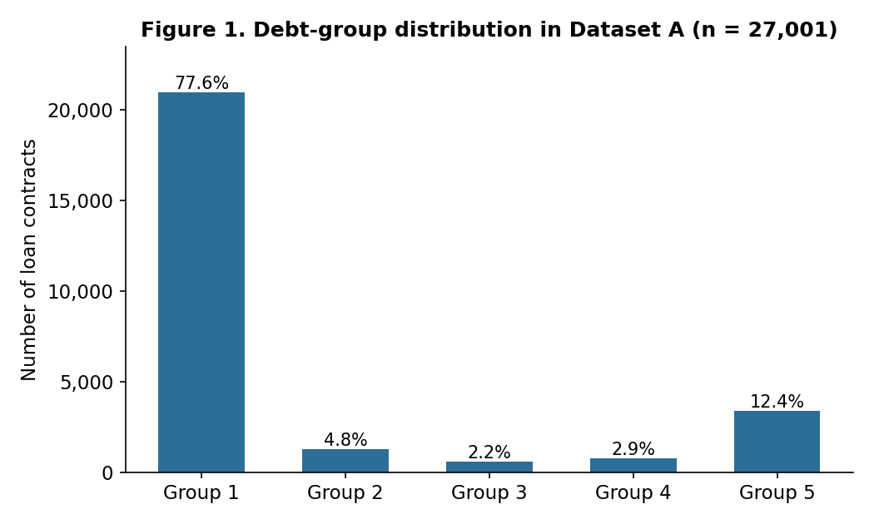
Figure 1. Debt-group distribution in Dataset A (n = 27,001). Group 1 (standard debt) alone accounts for 77.6% of loan contracts, while the three non-performing groups (3–5) together account for only 17.6%.

3.2 Data cleaning
Before computing descriptive statistics, the two date fields OPEN_DATE and NGAYDENHAN (maturity date) were checked for format consistency. A substantial share of records stored dates as Excel serial-date integers rather than dd/mm/yyyy text strings — 36.85% of OPEN_DATE (9,949 records) and 36.63% of NGAYDENHAN (9,890 records). Because the original date parser only recognized text-formatted dates, applying it without this check would have silently converted more than a third of records to missing values. Serial-date values were therefore converted using the Excel epoch (30 December 1899); after cleaning, both fields had zero missing or unparsed records.
Some raw numeric variables (BASE_BAL and CURR_BAL in particular) show strong right skew typical of monetary variables in banking data — for instance, the standard deviation of BASE_BAL (6.40 × 10⁹) is more than ten times its mean (4.28 × 10⁸) — and elevated Interquartile-Range (IQR) outlier rates for the two balance variables (CURR_BAL: 9.12%; BASE_BAL: 7.13%), consistent with a small number of very large corporate-type exposures within an otherwise retail-dominated book.
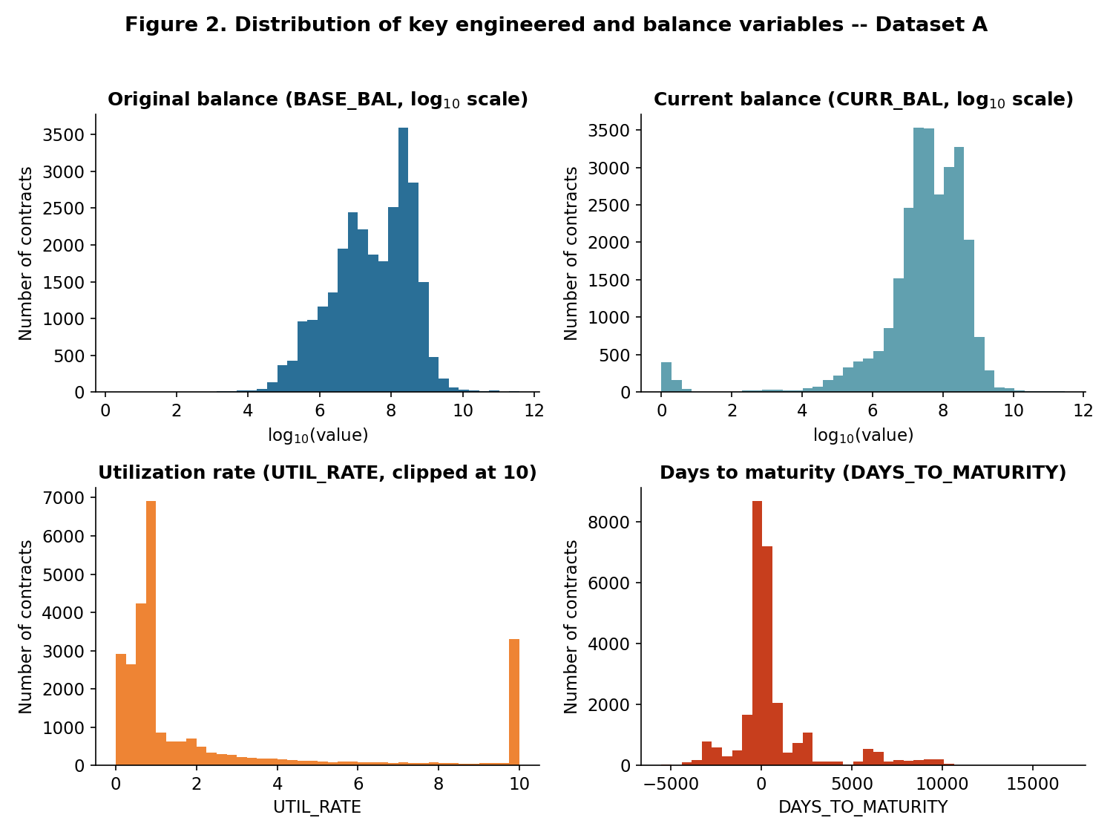
Figure 2. Distribution of key numeric variables in Dataset A. BASE_BAL and CURR_BAL are plotted on a log₁₀ scale to reveal their approximately log-normal shape; UTIL_RATE shows a visible spike at the clip boundary of 10, confirming that the clipping rule in Section 3.4 is binding for a non-trivial share of contracts; DAYS_TO_MATURITY is markedly bimodal around zero, separating loans already past their reference-date maturity from loans with substantial remaining tenor.

3.3 Leakage control
This stage addresses the third research gap identified in Section 2.5: prior Vietnamese credit-scoring studies rarely document an explicit diagnostic for predictors that may encode the outcome being modelled. The risk is especially material here because NHOMNOMOI is a regulator-defined debt-group classification and the source file contains neighbouring fields produced by the same credit-monitoring process. A model trained on a current or earlier debt-group field could achieve apparently strong out-of-sample scores by reproducing the bank’s classification rule, rather than by learning a relationship that would remain valid when the model is applied to genuinely new observations.
We therefore applied a two-part admissibility criterion before modelling: an input must be available no later than the intended classification point and must not be a direct or derived restatement of NHOMNOMOI. On this basis, NHOMNO was excluded because it is an alternate debt-group field with a Pearson correlation of 0.98 with the target, while NHOMNO_TCBS was excluded because it is a text-coded restatement of debt group. These exclusions are treated as leakage control, not ordinary feature selection: retaining either variable would compromise the validity of every subsequent comparison, irrespective of the algorithm used.
The remaining removals address redundancy and lack of usable information rather than target leakage. DUNO_QD duplicates the outstanding-balance information, MJACCTTYPDESC is a free-text description of the coded product field, and constant or near-uninformative fields cannot support stable discrimination. After these rules, 13 variables remain as the candidate-admissible pool. This initial screen is deliberately not presented as conclusive proof that every retained variable is leakage-free. Instead, it establishes an auditable first filter that is followed by the IV-based review in Section 3.5 and the ablation and reference-date checks in Section 4.2. The resulting sequence—semantic screening, quantitative flagging, and falsifiable robustness tests—is the study’s concrete methodological response to the leakage-diagnostic gap in the prior literature.

3.4 Feature engineering
Three engineered variables were constructed from the cleaned date and balance fields, using a fixed reference date d0 = 31 December 2021 so that results are reproducible across re-runs:
LOAN_TENURE_DAYSᵢ = max{0, dᵢᵐᵃᵗᵘʳᵢᵗʸ − dᵢᵒᵖᵉⁿ}
DAYS_TO_MATURITYᵢ = dᵢᵐᵃᵗᵘʳᵢᵗʸ − d0
UTIL_RATEᵢ = clip(CURR_BALᵢ / BASE_BALᵢ, 0, 10) if BASE_BALᵢ > 0; UTIL_RATEᵢ = 0 if BASE_BALᵢ ≤ 0
where clip(u; 0, 10) = min{max(u, 0), 10} caps the utilization ratio at ten times the original balance, preventing a small number of extreme ratios (from additional disbursements) from dominating the standardisation step used by the linear baseline. DAYS_TO_MATURITY has the highest IQR-outlier rate (23.08%) because it is legitimately bimodal — negative for loans already past maturity at the reference date and positive, sometimes far so, for long-tenor loans — a business feature, not a data error. LOAN_TENURE_DAYS and DAYS_TO_MATURITY are strongly correlated (r = 0.942), as expected since both derive from the same two date fields; BASE_BAL and CURR_BAL are similarly correlated (r = 0.923). No pair exceeds |r| = 0.95, so no variable was dropped purely on correlation grounds, but this correlation structure is kept in mind when interpreting tree-based importance measures in Section 4.
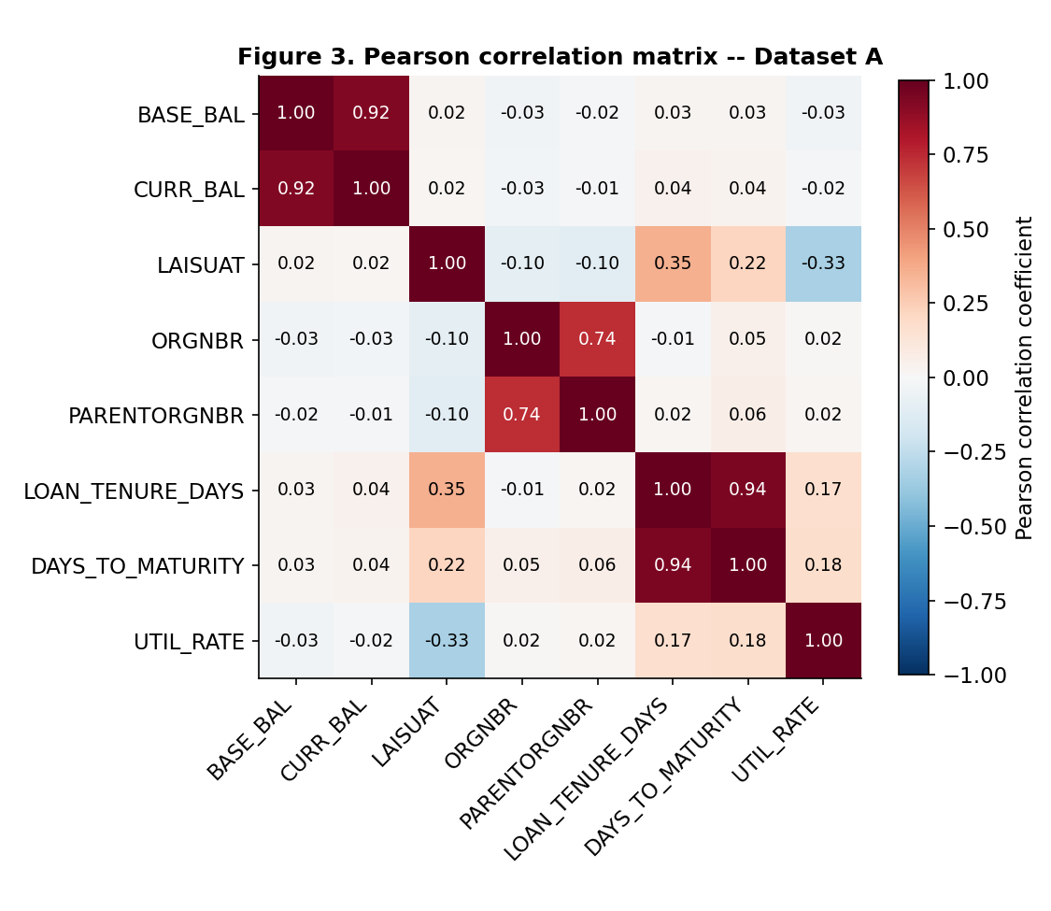
Figure 3. Pearson correlation matrix of the eight numeric variables of Dataset A. The three high-correlation pairs discussed in the text (LOAN_TENURE_DAYS–DAYS_TO_MATURITY, BASE_BAL–CURR_BAL, ORGNBR–PARENTORGNBR) stand out as the darkest off-diagonal cells. ORGNBR and PARENTORGNBR are shown here descriptively, as codes; the modelling in Section 3.6 treats them as nominal categorical variables rather than as quantities.
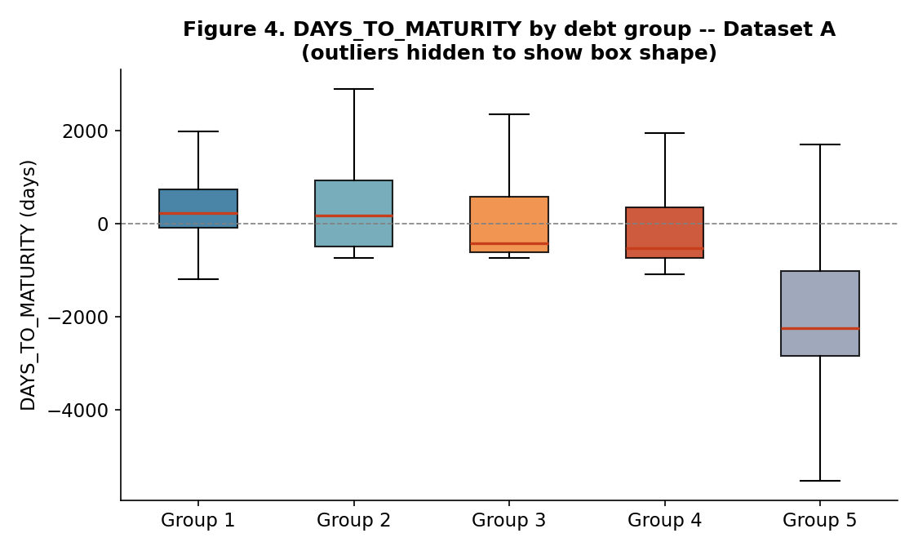
Figure 4. Distribution of DAYS_TO_MATURITY by debt group (outliers hidden to show box shape). The median falls fairly steadily from Group 1 to Group 4 and then drops sharply for Group 5, foreshadowing why this variable emerges as the dominant predictor in the SHAP analysis of Section 4.3 — while also showing that the relationship is not strictly monotonic, a caution against over-interpreting it causally.

3.5 Feature screening with Information Value (IV)
Following the WOE/IV convention (Siddiqi, 2006), IV was computed for all 13 admissible variables (Table 2). Five variables exceed the conventional IV = 1.0 threshold that flags a possible leakage risk. Rather than excluding them automatically, each was manually checked against the two-part admissibility criterion stated in Section 3.3 — availability at or before the classification date — and retained, because DAYS_TO_MATURITY, LOAN_TENURE_DAYS and UTIL_RATE are computed strictly from origination/maturity dates and balances known at scoring time, and CURRMIACCTTYPCD (31-category product sub-type) and MUCDICHVAY (79-category loan purpose) are contractual attributes fixed at origination, not outcomes of the classification process itself. This distinguishes them from NHOMNO/NHOMNO_TCBS, which were excluded in Section 3.3 precisely because they are restatements of the target. We report this distinction explicitly because it illustrates a governance point developed further in Section 4.6: an automatic IV-based leakage flag is a prompt for human review, not a substitute for it.
Table 2. Information Value of the 13-variable pool (Dataset A)
Feature | IV | Level
DAYS_TO_MATURITY | 4.554 | High IV — reviewed, retained (available at scoring time)
CURRMIACCTTYPCD | 1.992 | High IV — reviewed, retained
LOAN_TENURE_DAYS | 1.941 | High IV — reviewed, retained
MUCDICHVAY | 1.414 | High IV — reviewed, retained
UTIL_RATE | 1.333 | High IV — reviewed, retained
MJACCTTYPCD | 0.970 | Very strong
LAISUAT (interest rate) | 0.785 | Very strong
BASE_BAL | 0.536 | Very strong
PARENTORGNBR | 0.320 | Strong
CURR_BAL | 0.259 | Medium
ORGNBR | 0.182 | Medium
SEX | 0.008 | Useless
LOAIKH (customer type) | 0.000 | Useless
Because SEX and LOAIKH carry effectively no separating information, the main modelling configuration uses the remaining 11 features (the 13-variable pool minus these two), while the full 13-variable pool is retained for the top-k feature-efficiency experiment in Section 4.2.
A closer look at DAYS_TO_MATURITY. Its IV of 4.554 is markedly higher than any other admissible variable, and — as Section 4.3 shows — it is also the single dominant SHAP predictor under both models and both imbalance treatments. This combination warrants a direct check of whether the variable is a genuine, non-deterministic risk signal or, like NHOMNO in Section 3.3, effectively a restatement of the classification rule. Two definitional points bound the concern before turning to the data: DAYS_TO_MATURITY is computed from NGAYDENHAN, the loan's original contractual maturity date, not from a payment-due date; and the raw 21-column file contains no “days overdue on payment” / “days past due” field of any kind, so the two concepts cannot be compared directly — only inferred indirectly, as done here.
Table 2b reports the distribution of DAYS_TO_MATURITY by debt group and the share of each group already past its original maturity date (DAYS_TO_MATURITY < 0) as of the reference date.
Table 2b. DAYS_TO_MATURITY by debt group, and share already past original maturity
Group | Mean | Median | Min | Max | Share with < 0
1 (standard) | 1,112.0 | 224 | −3,252 | 16,798 | 35.1%
2 (special mention) | 733.2 | 172 | −724 | 6,549 | 44.2%
3 (sub-standard) | 327.8 | −418 | −727 | 6,547 | 60.3%
4 (doubtful) | 54.4 | −517 | −1,085 | 6,520 | 68.1%
5 (loss) | −1,884.8 | −2,236 | −5,513 | 6,495 | 92.1%
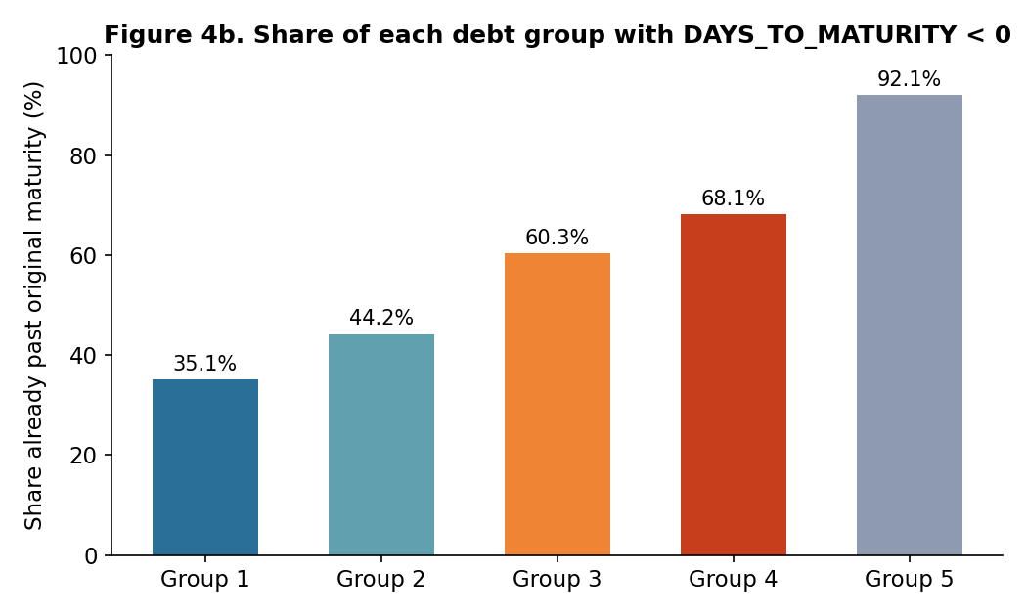
Figure 4b. Share of loans with DAYS_TO_MATURITY < 0 (already past their original contractual maturity date), by debt group. The share rises with risk but is far from a 0%/100% step function at any group boundary — over a third of Group-1 loans are already past original maturity, and almost 8% of Group-5 loans are not — the pattern discussed in the text.
The mean and median fall monotonically from Group 1 to Group 5, the pattern that motivates a leakage concern in the first place. However, two features of the table above argue against DAYS_TO_MATURITY being a simple restatement of the labelling rule. First, 35.1% of Group-1 (standard, lowest-risk) loans are already past their original maturity date yet remain classified as standard — plausibly short-term working-capital loans that were rolled over or renewed without a change in risk classification, a common practice in Vietnamese commercial lending. If the variable directly encoded the overdue-payment criterion used for classification, this share should be close to zero. Second, 7.9% of Group-5 (loss, highest-risk) loans are not past their original maturity, indicating that NHOMNOMOI also reflects information beyond original-maturity status (e.g., restructuring history or other qualitative criteria under Circular No. 11/2021/TT-NHNN, the framework applicable to this dataset per Section 2.3). As a more direct quantitative check, a univariate rule that predicts “non-performing” whenever DAYS_TO_MATURITY < 0 and “performing” otherwise reconstructs the binary good/bad split (Groups 2–5 vs. Group 1) with only 67.3% accuracy and an F1-score of 0.508 on the non-performing class over the full 27,001-record dataset — far from the near-perfect reconstruction that would indicate the variable is algebraically equivalent to the label, and in clear contrast to NHOMNO in Section 3.3, whose 0.98 correlation with the target was the basis for its exclusion.
Taken together, this evidence is consistent with DAYS_TO_MATURITY being a strong, economically plausible predictor — a loan sitting well past its original maturity without formal renewal is a reasonable indicator of distress — rather than a hidden copy of the classification outcome. It does not, however, amount to proof: the exact quantitative criteria the source bank uses to assign NHOMNOMOI are not documented in the dataset, so a residual possibility that part of the variable's predictive power reflects an unobserved overdue-payment field correlated with it cannot be fully excluded from the data alone. This is stated as an explicit limitation in Section 5, together with a recommendation to confirm the variable's relationship to the bank's internal classification methodology before any operational use.

3.6 Models, imbalance handling and evaluation
Six classifiers were trained and compared: Logistic Regression, Decision Tree, Random Forest, XGBoost, LightGBM and CatBoost, all trained and evaluated in a single software environment (scikit-learn 1.9.0, xgboost 3.3.0, lightgbm 4.7.0, catboost 1.2.10; full versions in the Reproducibility Statement) so that every number reported below is directly comparable. Hyperparameters were fixed a priori at the values below and were not tuned per configuration, so that the hold-out set and the cross-validation folds are never used for model selection: Logistic Regression, L2 penalty with C = 1.0 and lbfgs, max_iter = 1,000; Decision Tree, max_depth = 10 and min_samples_leaf = 10; Random Forest, 300 trees, max_depth = 15, min_samples_leaf = 5; XGBoost, 400 rounds, max_depth = 6, learning rate 0.05, subsample and colsample_bytree 0.8; LightGBM, the same settings with max_depth = 8; CatBoost, 400 iterations, depth 6, learning rate 0.05. The Decision Tree is therefore a pruned tree, not an unconstrained one — a point that matters for reading Section 4.4, where it carries the highest point estimate. Because no configuration received a tuning budget the others did not, the comparison is between algorithm families at sensible defaults rather than between fully optimised models, and Section 5 notes this as a limitation. All numerical preprocessing (imputation, standardisation) was fitted on the training partition only, to prevent information from the test partition from influencing model training.
Class imbalance was handled in two ways, and every model was run under both. The first treatment applies inverse-frequency class weights; the second applies no weighting at all. Reporting both for all six classifiers, rather than fixing one treatment and testing the other only where a model appeared to struggle, is what makes the comparison in Table 3 and Table 10 symmetric: the imbalance treatment is part of the configuration being compared, not a fixed background assumption. Five of eleven features are categorical, including nominal branch identifiers ORGNBR and PARENTORGNBR; these are not treated as continuous quantities. For non-CatBoost models they remain label-encoded, a limitation stated in Section 5. SMOTE was rejected because interpolation between encoded category values has no contractual meaning. Models were evaluated on the stratified 20% hold-out set using four metrics:
Accuracy = (Σₖ₌₁ᴷ Cₖₖ) / N F1macro = (1/K) Σₖ₌₁ᴷ F1ₖ
F1weighted = Σₖ₌₁ᴷ (nₖ/N)·F1ₖ AUCmacro,OvR = (1/K) Σₖ₌₁ᴷ AUC(y⁽ᵏ⁾, p̂⁽ᵏ⁾)
with K = 5 classes. Because Group 1 alone accounts for 77.65% of observations, Accuracy is reported for completeness but Macro-F1 is treated as the primary criterion, consistent with the imbalance literature reviewed in Section 2.2. Per-class Precision/Recall/F1 and the full 5 × 5 confusion matrix are also reported for the best hold-out configuration (Section 4.1), because Macro-F1 alone does not show which debt groups drive a model's score — nor, as Section 4.1 shows, whether a given score was obtained through precision or through recall. Because a single stratified split can make a small, split-specific gap between two close models look more decisive than it is, the single-split comparison in Table 3 is supplemented with a repeated stratified cross-validation check (5-fold, 5 repeats, 25 train/test partitions) in which all twelve configurations are evaluated on the identical folds, so that every pairwise difference is properly paired. Table 10 reports Macro-F1 as a mean ± standard deviation for each configuration, together with a corrected resampled paired t-test (Nadeau & Bengio, 2003) comparing the top configuration against every other one — an explicit correction for the fact that folds within repeated k-fold CV share data and are not independent, so a naive paired t-test or Wilcoxon test on the same folds understates variance and overstates significance (Section 4.4).
Feature importance was assessed with two independent measures: Gain (split-based importance native to the tree-boosting libraries) and mean absolute SHAP value (via TreeExplainer), computed on the full 5,401-observation test set for the 11-feature main configuration. Because the feature-analysis module in this pipeline defaults to XGBoost, the top-k curve and Gain/SHAP importance analysis are reported for both XGBoost and LightGBM, and under both imbalance treatments, throughout Section 4, so that the paper's feature-level conclusions do not rest on one algorithm's internal ranking behaviour. Three additional checks probe whether this ranking-based design is trustworthy: an ablation that removes the dominant predictor, DAYS_TO_MATURITY, from the feature set entirely (Section 4.2); a reference-date sensitivity check that re-derives DAYS_TO_MATURITY and refits the model under five different values of d0 (Section 4.2); and an embedded (in-fold) feature-selection variant of the top-k experiment, in which the ranking used to select the top 9 features is computed from each cross-validation fold's training partition only, rather than from a ranking that could be informed by repeated looks at the test partition (Section 4.2).

Results and Discussion
Results

4.1 Model comparison (RQ1)
Table 3. Hold-out results on the 11-feature main configuration: six classifiers × two imbalance treatments
Model | Imbalance treatment | Accuracy | Macro-F1 | Weighted-F1 | ROC-AUC (macro)
Logistic Regression | Class weighting | 0.6091 | 0.3946 | 0.6886 | 0.7744
Logistic Regression | No weighting | 0.8752 | 0.3628 | 0.8298 | 0.8083
Decision Tree | Class weighting | 0.6441 | 0.4962 | 0.7243 | 0.8647
Decision Tree | No weighting | 0.9082 | 0.6245 | 0.8907 | 0.8921
Random Forest | Class weighting | 0.7784 | 0.5699 | 0.8229 | 0.9071
Random Forest | No weighting | 0.9080 | 0.6149 | 0.8908 | 0.9239
XGBoost | Class weighting | 0.8298 | 0.5966 | 0.8556 | 0.9147
XGBoost | No weighting | 0.9113 | 0.6197 | 0.8942 | 0.9282
LightGBM | Class weighting | 0.8548 | 0.6044 | 0.8713 | 0.9128
LightGBM | No weighting | 0.9113 | 0.6248 | 0.8954 | 0.9246
CatBoost | Class weighting | 0.7730 | 0.5460 | 0.8192 | 0.9062
CatBoost | No weighting | 0.9093 | 0.6074 | 0.8911 | 0.9235

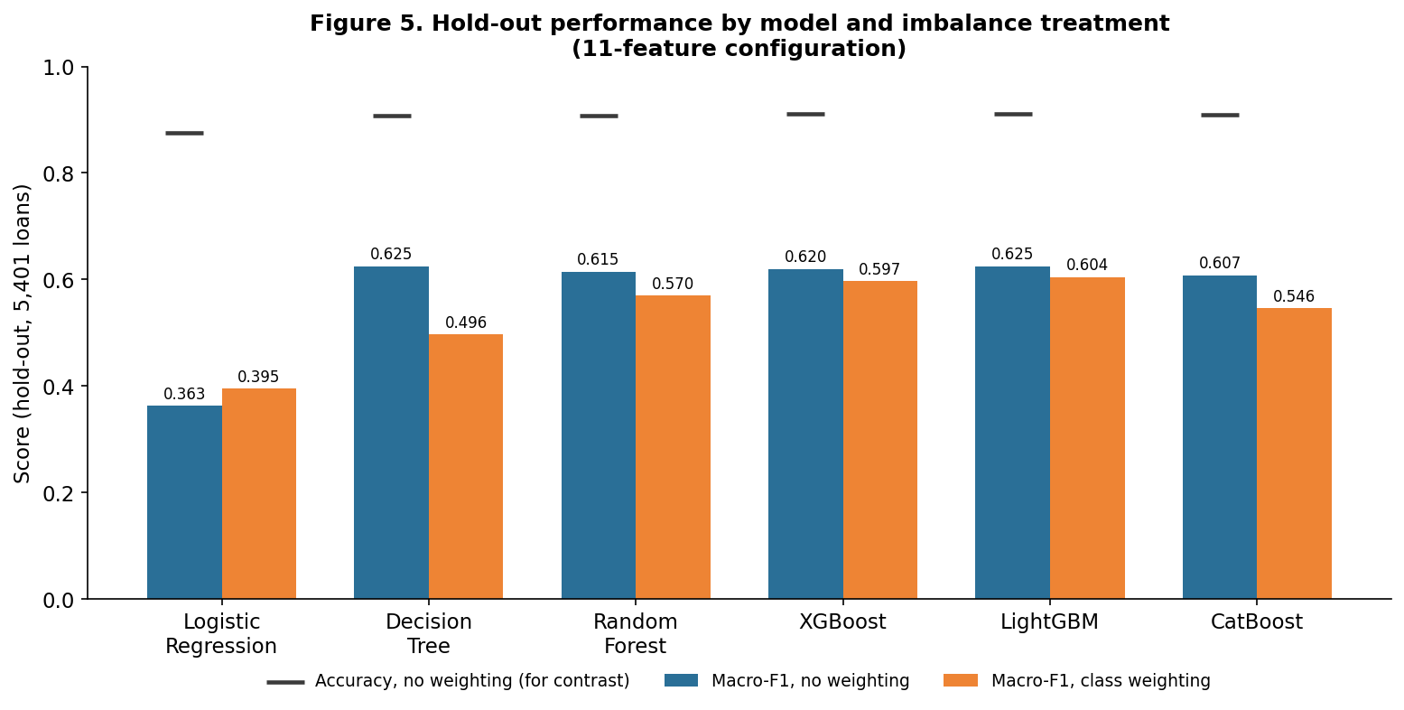
Figure 5. Macro-F1 on the hold-out set for the six classifiers under both imbalance treatments (Table 3). Removing class weighting
raises Macro-F1 for every tree-based model and lowers it only for Logistic Regression.
Three results stand out. First, the imbalance treatment matters more than the choice of algorithm across most of this grid: turning class weighting off raises hold-out Macro-F1 for all five tree-based models, by between 0.0204 and 0.1283 Macro-F1 points, so the class-weighted comparison alone would have ranked these models on a configuration none of them performs best in. Second, Logistic Regression is the sole exception: weighting improves it (0.3946 against 0.3628), and it remains far behind every tree-based configuration either way, so the general statement is that weighting is dominated for the tree ensembles rather than for all six models without qualification. Third, the leading configuration is unweighted LightGBM (Macro-F1 = 0.6248), but unweighted Decision Tree reaches 0.6245 on the same split — a gap far too small for one stratified split to resolve, which is why Section 4.4 re-estimates the entire grid under repeated cross-validation rather than declaring a winner here. Accuracy is a particularly poor guide in this table: unweighted CatBoost reaches 0.9093 Accuracy against 0.7730 when weighted, a gap that reflects the 77.65% Group-1 majority far more than any genuine improvement in distinguishing the risky groups.
Table 4. Confusion matrix and per-class metrics for the best hold-out configuration in Table 3, LightGBM without class weighting (11-feature configuration)
True \ Pred | 1 | 2 | 3 | 4 | 5 | Prec. | Recall | F1 | Support
1 | 4,153 | 22 | 6 | 3 | 10 | 0.921 | 0.990 | 0.954 | 4,194
2 | 195 | 47 | 10 | 3 | 2 | 0.603 | 0.183 | 0.281 | 257
3 | 68 | 3 | 38 | 10 | 2 | 0.613 | 0.314 | 0.415 | 121
4 | 59 | 2 | 7 | 73 | 16 | 0.652 | 0.465 | 0.543 | 157
5 | 33 | 4 | 1 | 23 | 611 | 0.953 | 0.909 | 0.931 | 672
Macro avg |  |  |  |  |  | 0.748 | 0.572 | 0.625 | 5,401
Rows are true debt groups, columns are predicted debt groups; e.g., row 3 shows that of the 121 loans truly in Group 3, the model predicted 38 correctly and assigned 68 to Group 1. The class-weighted counterpart of this table, which the discussion below compares against, is reported in Appendix B (Table B1).

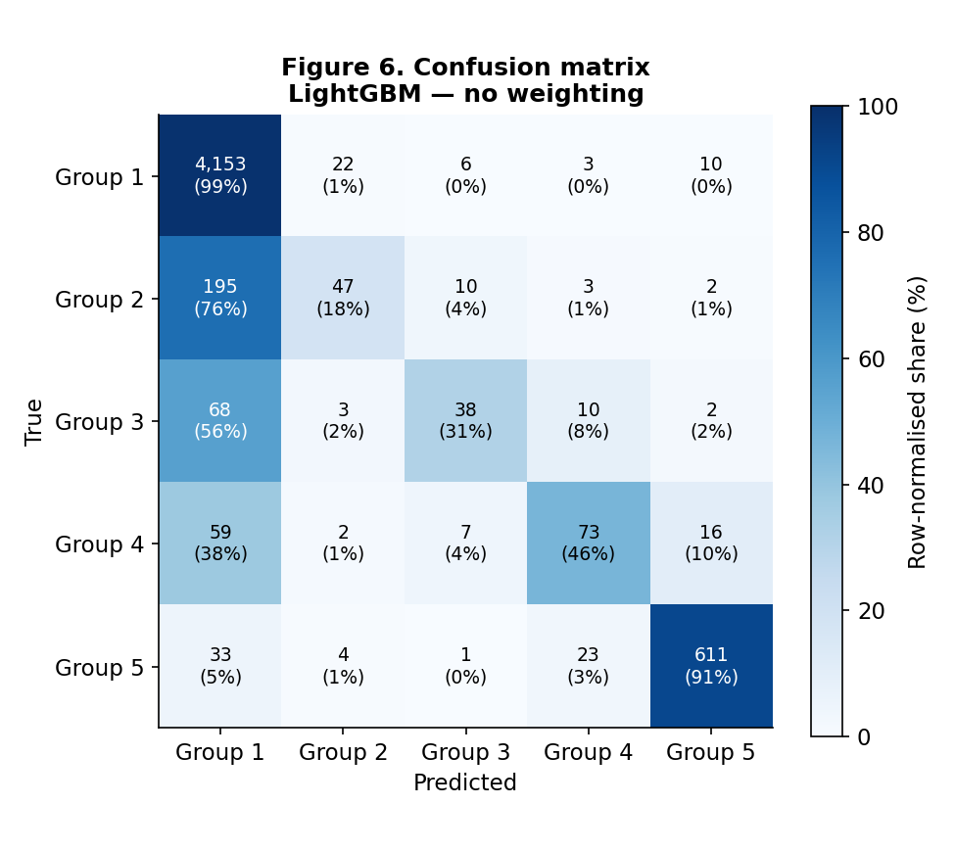
Figure 6. Row-normalised confusion matrix for the best hold-out configuration (Table 4). The darkest cells on the diagonal (Groups 1 and 5) show where the model is most reliable; the lighter diagonal cells for Groups 2–4, together with the heavy leakage of those rows into the Group-1 column, show where its flags require most caution.
The macro-averaged figure hides a sharp asymmetry. The unweighted model attains macro Precision 0.748 against macro Recall 0.572: when it flags a loan as Group 2, 3 or 4 it is usually right, but it misses most of the loans that genuinely belong there — Group-2 Recall is only 0.183, meaning roughly four in five special-mention loans are classified as standard. Errors are concentrated rather than spread across adjacent groups: 68 true Group-3 loans and 59 true Group-4 loans are assigned to Group 1, which is under-classification
of exactly the kind a provisioning process cannot absorb quietly. Table 5 shows that this is a property of the imbalance treatment rather than of LightGBM.
Table 5. Per-class Precision/Recall/F1 for LightGBM under both imbalance treatments (11-feature configuration, hold-out set)
Debt group | Prec. (none) | Recall (none) | F1 (none) | Prec. (weighted) | Recall (weighted) | F1 (weighted)
1 (standard) | 0.921 | 0.990 | 0.954 | 0.958 | 0.895 | 0.926
2 (special mention) | 0.603 | 0.183 | 0.281 | 0.245 | 0.471 | 0.323
3 (sub-standard) | 0.613 | 0.314 | 0.415 | 0.350 | 0.413 | 0.379
4 (doubtful) | 0.652 | 0.465 | 0.543 | 0.411 | 0.548 | 0.470
5 (loss) | 0.953 | 0.909 | 0.931 | 0.951 | 0.900 | 0.925
Macro avg | 0.748 | 0.572 | 0.625 | 0.583 | 0.645 | 0.604

The two configurations reach similar Macro-F1 by opposite routes. Class weighting raises Group-2 Recall from 0.183 to 0.471 and Group-4 Recall from 0.465 to 0.548, while cutting Group-2 Precision from 0.603 to 0.245. Neither configuration is better in the abstract: the unweighted model suits a process in which a flag triggers costly manual review and false positives waste scarce analyst time, whereas the weighted model suits a process in which missing a deteriorating loan is the more expensive error. This is a policy choice for the bank's credit-risk committee, and it should be recorded as one. Reporting Macro-F1 alone would have concealed it entirely, which is the governance point developed in Section 4.6.

4.2 Feature efficiency (RQ2)
DAYS_TO_MATURITY ablation. Table 6 refits the 11-feature main configuration with DAYS_TO_MATURITY removed (10 features), for both XGBoost and LightGBM and under both imbalance treatments, so that the ablation is not itself conditional on a treatment the model comparison rejects.
Table 6. Effect of removing DAYS_TO_MATURITY from the 11-feature configuration
Model | Treatment | Macro-F1 (11 feat.) | Macro-F1 (10 feat., no DTM) | Change | ROC-AUC (10 feat.)
XGBoost | No weighting | 0.6197 | 0.4776 | −0.1421 (−22.9%) | 0.8892
XGBoost | Class weighting | 0.5966 | 0.4995 | −0.0971 (−16.3%) | 0.8693
LightGBM | No weighting | 0.6248 | 0.4823 | −0.1424 (−22.8%) | 0.8826
LightGBM | Class weighting | 0.6044 | 0.5052 | −0.0992 (−16.4%) | 0.8673
Removing the leading SHAP variable costs 16–23% of Macro-F1 across the four model/treatment combinations, establishing a non-redundant predictive contribution that no remaining feature reproduces. It does not establish temporal admissibility or rule out proxy leakage; those questions require the bank's actual snapshot date and classification methodology.
Reference-date invariance. Only DAYS_TO_MATURITY, not LOAN_TENURE_DAYS, depends on d0. Changing d0 adds one constant to every record and therefore leaves the tree partitions unchanged: across the five candidate reference dates from 31 December 2020 to 31 December 2023, Macro-F1 is identical to four decimal places under both treatments (0.6248 unweighted; ROC-AUC 0.9246). This rules out tuning the numerical value of d0 to inflate tree performance, but does not establish the true snapshot date, temporal availability, or the absence of proxy leakage.
Embedded (in-fold) feature selection. The LightGBM ranking was recomputed inside every training fold, with k = 9 fixed before this verification, so the selected subset can never have been informed by the fold's test partition. Under no weighting the embedded result is 0.6147 ± 0.0102 against 0.6183 ± 0.0095 for the fixed 11-feature configuration; under class weighting, 0.5878 ± 0.0104 against 0.5917 ± 0.0089. Selecting features honestly in-fold therefore costs little in either treatment.
Table 7. Macro-F1 and ROC-AUC by number of top-k features (13-variable pool, no class weighting), XGBoost vs. LightGBM ranking
k | XGB Macro-F1 | XGB ROC-AUC | LGBM Macro-F1 | LGBM ROC-AUC
3 | 0.6043 | 0.8885 | 0.5909 | 0.9008
5 | 0.6061 | 0.9121 | 0.6205 | 0.9211
7 | 0.6241 | 0.9227 | 0.6119 | 0.9215
9 | 0.6139 | 0.9287 | 0.6147 | 0.9245
11 | 0.6197 | 0.9282 | 0.6234 | 0.9260
13 (full pool) | 0.6194 | 0.9288 | 0.6167 | 0.9264

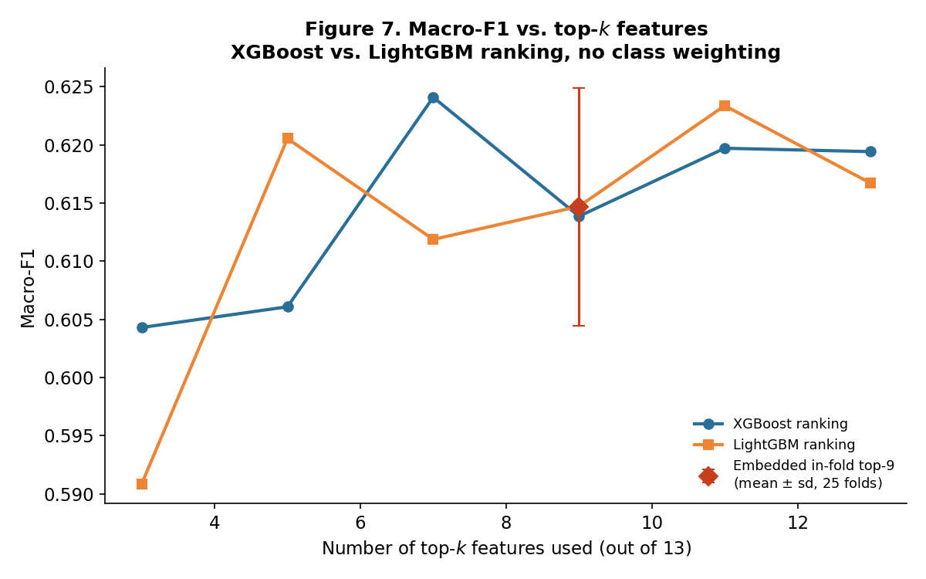
Figure 7. Macro-F1 as a function of the number of top-ranked features used, XGBoost vs. LightGBM ranking (Table 7), without class weighting.

Nine of the thirteen features recover 98–99% of each model's best hold-out Macro-F1 without class weighting, and 98% under class weighting, so the feature-efficiency conclusion does not depend on the imbalance treatment. The unweighted curve is flatter still: even three features — DAYS_TO_MATURITY, LOAN_TENURE_DAYS and one product or utilization variable — already recover 95–97%. Two qualifications belong with that number. The curve is not monotone, because each k refits a different model rather than pruning one, so small differences between adjacent k are noise rather than evidence of an optimum; and embedded in-fold verification was performed only for LightGBM. The curve therefore identifies a broad efficient region, not a unique best k, and the governance argument is for dropping features that are free to drop rather than for any specific count.

4.3 Contribution of business feature groups: Gain vs. SHAP (RQ3)
Table 8. Gain-based group importance share (%) — XGBoost vs. LightGBM, both imbalance treatments (13-variable pool)
Business group | XGBoost (none) | LightGBM (none) | XGBoost (weighted) | LightGBM (weighted)
Loan tenure / maturity | 43.1 | 60.0 | 31.7 | 49.3
Balance & utilization | 11.2 | 18.3 | 16.8 | 24.6
Branch / organisational unit | 7.6 | 9.1 | 11.2 | 12.5
Product & loan purpose | 24.7 | 7.1 | 21.7 | 5.7
Interest rate | 7.7 | 4.4 | 9.0 | 6.2
Demographics (low IV) | 5.6 | 1.1 | 9.7 | 1.6
Table 9. SHAP-based group importance share (%) — XGBoost vs. LightGBM, both imbalance treatments (11-feature main configuration)
Business group | XGBoost (none) | LightGBM (none) | XGBoost (weighted) | LightGBM (weighted)
Loan tenure / maturity | 40.8 | 41.2 | 42.0 | 42.8
Balance & utilization | 26.1 | 27.9 | 28.0 | 28.7
Branch / organisational unit | 14.8 | 14.1 | 13.9 | 13.7
Interest rate | 9.8 | 8.8 | 8.3 | 6.7
Product & loan purpose | 8.5 | 7.9 | 7.8 | 8.1

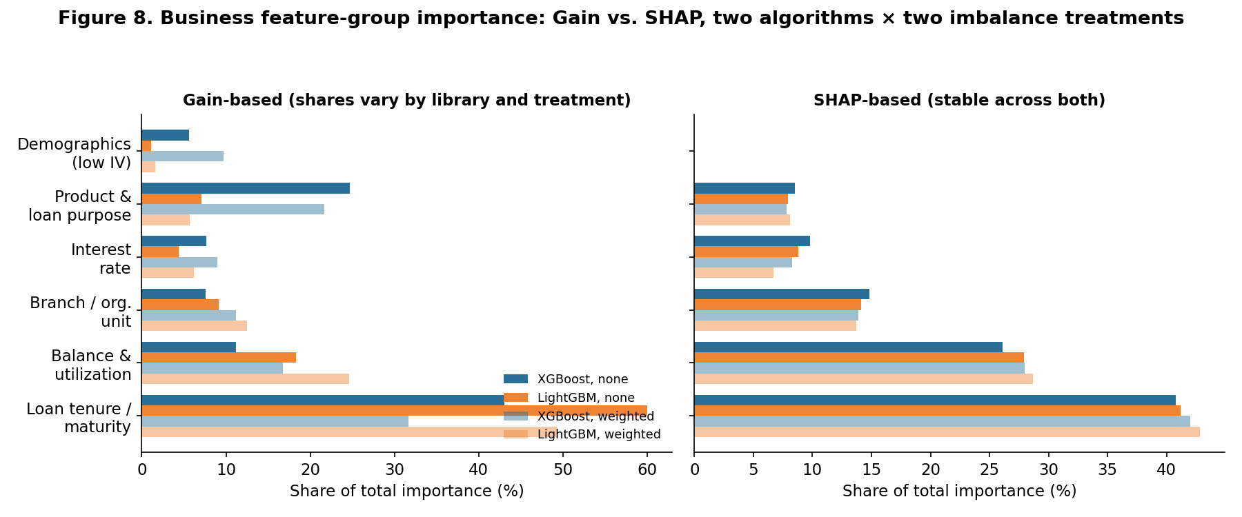
Figure 8. Gain-based (left) vs. SHAP-based (right) group importance share, XGBoost vs. LightGBM (Tables 8–9).
With LightGBM's importance_type set explicitly to "gain", so that both libraries report the same quantity, Gain agrees on the leading group — loan tenure/maturity — but not on anything below it. The share attributed to product and loan purpose ranges from 5.7% to 24.7% across the four model/treatment combinations in Table 8, a spread wide enough to reverse its rank. SHAP is markedly more consistent: loan tenure/maturity takes 40.8–42.8% and balance/utilization 26.1–28.7% across all four combinations, preserving the same ordering in every case.
This is read as evidence that Gain-based importance is not a stable property of the data — it depends materially on which tree-boosting implementation computed it and on the imbalance treatment in force — while SHAP, cross-checked across two algorithms and two treatments, is comparatively stable evidence for which information genuinely drives predictions. The practical implication for a bank is unchanged: a feature-importance-based data-investment decision should not be made from a single model's Gain ranking alone.

4.4 Statistical robustness: repeated cross-validation and a corrected paired test
Table 10 reports 5-fold × 5-repeat cross-validation for all twelve configurations on the identical 25 partitions, so every comparison is properly paired. The Nadeau–Bengio correction replaces the naive variance factor 1/25 = 0.04 with 1/25 + 1/4 = 0.29; Holm adjustment controls the family of eleven comparisons against the leading configuration.
Table 10. Repeated cross-validation (5-fold × 5-repeat, identical folds) and corrected paired t-test against Decision Tree–none
Configuration | Macro-F1 (mean ± sd) | Decision Tree–none minus comparator | t | Holm p
Decision Tree–none | 0.6271 ± 0.0109 | — | — | —
XGBoost–none | 0.6217 ± 0.0101 | +0.0053 | 0.81 | 0.7885
Random Forest–none | 0.6216 ± 0.0097 | +0.0054 | 0.87 | 0.7885
LightGBM–none | 0.6183 ± 0.0095 | +0.0088 | 1.26 | 0.6634
CatBoost–none | 0.6042 ± 0.0116 | +0.0229 | 3.42 | 0.0091
LightGBM–balanced | 0.5917 ± 0.0089 | +0.0354 | 5.51 | <0.0001
XGBoost–balanced | 0.5878 ± 0.0083 | +0.0392 | 6.50 | <0.0001
Random Forest–balanced | 0.5637 ± 0.0072 | +0.0634 | 10.98 | <0.0001
CatBoost–balanced | 0.5471 ± 0.0091 | +0.0800 | 13.11 | <0.0001
Decision Tree–balanced | 0.4990 ± 0.0144 | +0.1281 | 14.24 | <0.0001
Logistic Regression–balanced | 0.3876 ± 0.0055 | +0.2394 | 41.55 | <0.0001
Logistic Regression–none | 0.3699 ± 0.0089 | +0.2572 | 31.54 | <0.0001

The highest point estimate belongs to Decision Tree–none (0.6271 ± 0.0109), but the reading Table 10 actually supports is narrower than a ranking. After Holm adjustment, three of the eleven comparisons fail to reject at the 5% level (XGBoost–none, Random Forest–none, LightGBM–none), so the four configurations spanning Macro-F1 0.6183 to 0.6271 are statistically indistinguishable on this evidence. This paper therefore names no single best algorithm; a preference among these configurations has to rest on grounds other than Macro-F1 — training cost, interpretability, or the precision/recall profile in Table 5 — and stating which ground was used is itself part of the governance record. The remaining eight comparisons do reject. What survives correction is a treatment effect rather than an algorithm effect: every tree-based model beats its own class-weighted counterpart (all five within-model contrasts reject, the weakest at p = <0.0001), and the class-weighted configurations occupy the bottom of the table. Because every row of Table 10 is tested against the same reference configuration, a contrast between two non-reference rows cannot be read off the table, and an earlier version of this paper inferred one that way. The specific comparison between unweighted CatBoost and class-weighted LightGBM is therefore tested directly: it gives a difference of 0.0125 Macro-F1 in favour of CatBoost–none (t = 2.29, p = 0.0313 unadjusted, 0.0626 after Holm adjustment within the family of eight contrasts reported in this subsection). The direction asserted previously is therefore reproduced, but the evidence for it is weaker than a bare unadjusted p-value suggests and the claim is restated accordingly. Model ranking is inseparable from imbalance treatment, and any claim about one must name the other.
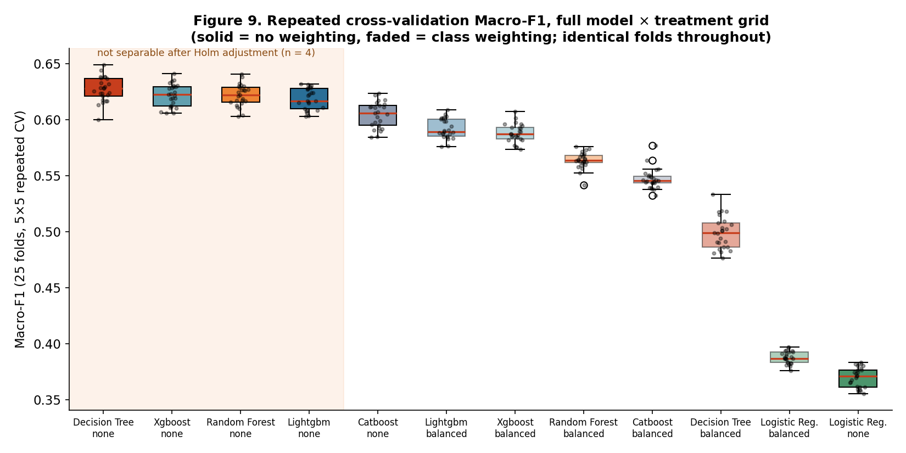
Figure 9. Distribution of Macro-F1 across the 25 repeated-CV folds for all twelve configurations, grouped by imbalance treatment.

4.5 Comparison with the literature
The results are consistent with, and extend, both the international benchmarking literature and the Vietnamese studies reviewed in Section 2.4. Consistent with Lessmann et al. (2015) and Baesens et al. (2003), every tree-based learner clearly outperforms Logistic Regression here, but their more specific caution — that no family dominates uniformly — holds in an unusually sharp form on this dataset: the highest repeated-CV Macro-F1 belongs to a depth-constrained single Decision Tree, and the three boosting and bagging ensembles are not statistically separable from it (Table 10). This is closer to Brown and Mues (2012), who found the best-performing algorithm changes with the degree of imbalance, than to any expectation that gradient boosting should lead by default. Consistent with Baesens et al. (2003), the gap between models narrows substantially on ROC-AUC relative to Macro-F1, illustrating that ranking quality and hard-classification performance diverge under class imbalance. This study adds a dimension those benchmarks largely hold fixed. The imbalance treatment moves Macro-F1 by 0.0266 to 0.1281 across the five tree-based models, while the entire spread among those five algorithms at their better treatment is 0.0229 — so on this dataset the treatment decision matters more than the algorithm decision, and a benchmark that fixes the treatment and ranks algorithms is measuring the smaller of the two effects. Relative to the Vietnamese studies reviewed in Section 2.4, this paper's central methodological contrast is the one developed across Sections 4.1–4.4: reporting Accuracy alongside Macro-F1, a confusion matrix (Table 4) and per-class metrics under both treatments (Table 5) shows a materially less optimistic picture of minority-class detection than Accuracy alone would suggest — precisely the gap this paper's contribution (Section 2.5) argues the existing literature has not yet closed.
Discussion

4.6 Implications for Sustainable Credit Governance
The results in Section 4 carry four concrete implications for how a bank should govern an AI-based credit-classification system in a way that supports sustainable finance development. They are stated here as conditional recommendations. Every empirical result behind them comes from a single institution and a single classification snapshot, evaluated by random stratified resampling of that snapshot; none of them has been validated out-of-time, on a later classification date, which is the test that would establish whether the relationships hold as the portfolio and the macroeconomic environment move. Each implication below should therefore be read as applying once out-of-time validation has been carried out and has confirmed the in-sample finding, and the ordering of the checks, rather than the specific coefficients, is what transfers.
First, imbalance-aware, multi-metric evaluation — including per-class figures and a confusion matrix, not only a single macro-averaged number — is a governance safeguard. Tables 4 and 5 show that two configurations of the same algorithm reach comparable Macro-F1 (0.6248 against 0.6044) while behaving in opposite ways: unweighted LightGBM flags Group-2 loans with Precision 0.603 but Recall only 0.183, whereas the class-weighted configuration reaches Recall 0.471 at Precision 0.245. A bank choosing between them on Macro-F1 alone would be choosing blind between a model that rarely raises a false alarm and one that rarely misses a deteriorating loan. Reporting per-class Precision/Recall/F1 and the confusion matrix alongside Macro-F1 is a low-cost practice with a direct operational reading: it tells a credit-risk unit which specific groups a model's flags can and cannot be trusted for, rather than only whether the model is “good” in aggregate.
Second, feature efficiency may lower governance cost. Nine of thirteen features recover 98–99% of the best hold-out Macro-F1, and the honest in-fold version of that selection costs little: 0.6147 ± 0.0102 against 0.6183 ± 0.0095 for the fixed 11-feature configuration. Each feature dropped is one fewer data feed to source, document, monitor for drift and explain to a supervisor. The evidence supports a flat efficiency region rather than a universal optimum, so the governance argument is for parsimony where it is free, not for a specific k.
Third, no single measure of model quality or feature importance should be trusted until checked against an independent one, and Section 4 shows this is inexpensive to do in practice. Gain-based importance alone would support different conclusions about which information group ranks second depending only on which tree-boosting library computed it and which imbalance treatment was in force (Table 8); only SHAP, checked across both algorithms and both treatments, supports “loan tenure/maturity dominates, balance/utilization second” as a property of the data (Table 9). The same discipline applies to model ranking, and here it overturns a claim this paper would otherwise have made. On the single hold-out split, LightGBM–none leads XGBoost–none (0.6248 against 0.6197), which invites the conclusion that LightGBM is the better algorithm here. Under repeated cross-validation the ordering reverses (0.6183 against 0.6217), and the corrected paired test on the difference gives p = 0.3844 — not close to rejecting in either direction. The apparent ranking was an artefact of one split. A test that fails to reject is as much a governance result as one that rejects, and a ranking that flips between two honest evaluation designs is a signal to report both rather than to pick the flattering one.
Fourth, a variable flagged by an automated screen should trigger a documented, falsifiable check, not only a plausible written justification. Section 3.5's leakage diagnostic and Section 4.2's ablation and reference-date checks together test, rather than assert, that DAYS_TO_MATURITY is a genuine risk signal: a univariate rule on the variable alone reconstructs the label at only 67.3% accuracy; removing it costs 16–23% of Macro-F1 rather than collapsing the model; and its predictive contribution is provably unaffected by the arbitrary reference-date convention used to compute it. None of these three results proves the variable is free of leakage — Section 5 restates this limitation plainly — but each is a test that could have gone the other way and did not, which is a materially stronger basis for a governance decision than a plausible narrative on its own.
Taken together, these points connect the technical results to the conference's private-sector-financing theme as scoped in Section 1: a credit-classification pipeline whose every non-trivial claim about model quality, feature importance and leakage risk has been checked against an independent test, rather than asserted, is a pipeline a bank can begin to govern responsibly. The qualification matters: on the evidence assembled here that verification is necessary but not sufficient, because a single-snapshot study cannot show that the relationships survive a change of classification date. Responsible governance of credit-risk classification is a precondition, not a substitute, for a bank's capacity to extend credit to private enterprises and households with confidence.

Conclusion
This study makes three principal contributions corresponding to RQ1–RQ3. First, the model comparison in RQ1 shows that algorithm performance cannot be separated from imbalance treatment, and that on this dataset the treatment is the better-identified of the two: for every tree-based classifier tested, turning class weighting off improves repeated-CV Macro-F1 and the improvement survives Holm adjustment, whereas the four leading configurations (Decision Tree–none, XGBoost–none, Random Forest–none, LightGBM–none, Macro-F1 0.6183–0.6271) cannot be separated from one another by the same corrected test. The highest point estimate is Decision Tree–none (0.6271 ± 0.0109) and the best hold-out configuration is LightGBM–none (0.6248); the paper reports both and claims neither as a winner. Logistic Regression is the one model class weighting helps, and it remains far behind either way. Second, the feature-efficiency analysis in RQ2 shows that nine-feature configurations retain 98–99% of the best hold-out Macro-F1, with the in-fold embedded analysis recording only a small further reduction, supporting a more parsimonious and auditable specification. Third, the explainability analysis in RQ3 shows that SHAP identifies loan maturity as the leading information group consistently across two algorithms and two imbalance treatments, while consistently defined Gain agrees on the leader but not on the ranks below it — demonstrating the value of triangulating importance measures before a data-investment decision. Together, these findings provide a verification-oriented framework in which predictive performance, feature economy, and interpretability are evaluated jointly rather than treated as separate governance objectives.
Limitations. Four limitations should be mentioned for this study. First, the small number of observations in some debt groups — only 121 Group-3 loans in the test set — introduces uncertainty into the per-class estimates in Tables 4 and 5; model comparisons should therefore rely primarily on the repeated cross-validation results in Table 10, and even there several configurations are statistically indistinguishable. Second, evidence from a single institution and a single classification snapshot limits external and temporal validity, and this bounds every governance claim in Section 4.6. Because the file records no classification date, all resampling in this paper is random rather than temporal; an out-of-time evaluation, training on an earlier classification date and testing on a later one, is the necessary next step before any operational use, and the Group-5 concentration documented in Section 3.1 suggests that a legacy loss stock may make in-sample performance flattering relative to what such a test would show. Third, categorical variables are label-encoded for the non-CatBoost models, which imposes an arbitrary ordering on nominal codes such as branch identifiers; native categorical handling was verified for CatBoost only. Fourth, hyperparameters were fixed a priori rather than tuned (Section 3.6). This keeps the comparison clean, since no configuration received a search budget the others did not and no evaluation partition was consumed by model selection, but it means the study compares algorithm families at sensible defaults rather than at their respective optima. A tuning budget could plausibly reorder the four configurations that the corrected test already cannot separate; it is less likely to overturn the treatment effect, which is an order of magnitude larger and consistent in sign across all five tree-based models. Forecasting future debt-group transitions remains a separate research task requiring longitudinal data.
Data Availability and Reproducibility
The raw dataset (Data_credit_rating_VN.xlsx) is proprietary loan-level data obtained from a Vietnamese commercial bank under an academic research arrangement. It is not publicly released, no copy is distributed with this paper, and no public link to it is provided. Researchers with a legitimate academic interest may approach the corresponding author, who will forward the request to the source institution; any access requires that institution's written approval and an appropriate data-sharing agreement. All preprocessing, feature-engineering, modelling and evaluation code is organised as a standalone Python package (config/, src/, pages/) built on pandas, scikit-learn, imbalanced-learn, xgboost, lightgbm, catboost and shap; a fixed random_state = 42 is used for every split, resample and model fit reported in this paper. Every number in Tables 3–10 and Appendix B was regenerated for this version in a single pass of one software environment (scikit-learn 1.9.0, xgboost 3.3.0, lightgbm 4.7.0, catboost 1.2.10, shap 0.52.0), with all twelve configurations evaluated on the identical 25 cross-validation partitions, so that every reported difference is properly paired and directly comparable. The scripts that produce each table, together with their console logs and CSV outputs, are retained alongside this paper for independent verification.
Ethics and Confidentiality Statement
The dataset contains no direct personal identifiers, and neither borrowers nor the source bank are identified. It was used solely for academic research; the resulting models were not used for lending decisions and require independent validation and institutional approval before any operational application.

References
Altman, E. I. (1968). Financial ratios, discriminant analysis and the prediction of corporate bankruptcy. The Journal of Finance, 23(4), 589–609.
Baesens, B., Van Gestel, T., Viaene, S., Stepanova, M., Suykens, J., & Vanthienen, J. (2003). Benchmarking state-of-the-art classification algorithms for credit scoring. Journal of the Operational Research Society, 54(6), 627–635.
Basel Committee on Banking Supervision. (2000). Principles for the management of credit risk. Bank for International Settlements.
Breiman, L. (2001). Random forests. Machine Learning, 45, 5–32.
Brown, I., & Mues, C. (2012). An experimental comparison of classification algorithms for imbalanced credit scoring data sets. Expert Systems with Applications, 39(3), 3446–3453.
Chawla, N. V., Bowyer, K. W., Hall, L. O., & Kegelmeyer, W. P. (2002). SMOTE: Synthetic minority over-sampling technique. Journal of Artificial Intelligence Research, 16, 321–357.
Chen, T., & Guestrin, C. (2016). XGBoost: A scalable tree boosting system. In Proceedings of the 22nd ACM SIGKDD International Conference on Knowledge Discovery and Data Mining (pp. 785–794). https://doi.org/10.1145/2939672.2939785
Dang, H. G., & Nguyen, T. P. D. (2020). Building credit scoring process in Vietnamese commercial banks using machine learning. Tạp chí Khoa học Kinh tế, 8(1), 1–12.
Friedman, J. H. (2001). Greedy function approximation: A gradient boosting machine. Annals of Statistics, 29(5), 1189–1232.
Hand, D. J., & Henley, W. E. (1997). Statistical classification methods in consumer credit scoring: A review. Journal of the Royal Statistical Society: Series A, 160(3), 523–541.
Hosmer, D. W., Lemeshow, S., & Sturdivant, R. X. (2013). Applied logistic regression (3rd ed.). Wiley.
Ke, G., Meng, Q., Finley, T., Wang, T., Chen, W., Ma, W., Ye, Q., & Liu, T.-Y. (2017). LightGBM: A highly efficient gradient boosting decision tree. In Advances in Neural Information Processing Systems (Vol. 30, pp. 3149–3157).
Lessmann, S., Baesens, B., Seow, H.-V., & Thomas, L. C. (2015). Benchmarking state-of-the-art classification algorithms for credit scoring: An update of research. European Journal of Operational Research, 247(1), 124–136.
Lundberg, S. M., & Lee, S.-I. (2017). A unified approach to interpreting model predictions. In Advances in Neural Information Processing Systems (Vol. 30, pp. 4765–4774).
Nadeau, C., & Bengio, Y. (2003). Inference for the generalization error. Machine Learning, 52(3), 239–281. https://doi.org/10.1023/A:1024068626366
Ngân hàng Nhà nước Việt Nam [State Bank of Vietnam]. (2005). Decision No. 493/2005/QĐ-NHNN on classification of debts, provisioning and use of provisions to handle credit risk in the banking activities of credit institutions, as amended by Decision No. 18/2007/QĐ-NHNN (2007).
Ngân hàng Nhà nước Việt Nam [State Bank of Vietnam]. (2013). Circular No. 02/2013/TT-NHNN on classification of assets, levels and methods of setting up risk provisions, and use of provisions against credit risks in the banking activities of credit institutions and foreign bank branches, as amended by Circular No. 09/2014/TT-NHNN (2014).
Ngân hàng Nhà nước Việt Nam [State Bank of Vietnam]. (2021). Circular No. 11/2021/TT-NHNN on asset classification, provisioning levels and methods, and use of provisions to handle risk in the operation of credit institutions and foreign bank branches. Effective 1 October 2021.
Ngân hàng Nhà nước Việt Nam [State Bank of Vietnam]. (2023). Circular No. 15/2023/TT-NHNN on credit information activities of the State Bank of Vietnam.
Ngân hàng Nhà nước Việt Nam [State Bank of Vietnam]. (2024). Circular No. 31/2024/TT-NHNN on asset classification in the operation of commercial banks, non-bank credit institutions and foreign bank branches, as amended by Circular No. 37/2025/TT-NHNN and consolidated in Document No. 27/VBHN-NHNN (21 November 2025).
Nguyen, N., & Ngo, D. (2025). Comparative analysis of boosting algorithms for predicting personal default. Cogent Economics & Finance, 13(1). https://doi.org/10.1080/23322039.2025.2465971
Nguyen, Q. H., Trinh, H. V., Phuong, T. V., & Ly, T. T. M. (2024). Early warning system for debt group migration: The case of one commercial bank in Vietnam. Foundations of Management, 16(1), 195–216. https://doi.org/10.2478/fman-2024-0012
Ohlson, J. A. (1980). Financial ratios and the probabilistic prediction of bankruptcy. Journal of Accounting Research, 18(1), 109–131.
Prokhorenkova, L., Gusev, G., Vorobev, A., Dorogush, A. V., & Gulin, A. (2018). CatBoost: Unbiased boosting with categorical features. In Advances in Neural Information Processing Systems (Vol. 31).
Quinlan, J. R. (1986). Induction of decision trees. Machine Learning, 1(1), 81–106.
Siddiqi, N. (2006). Credit risk scorecards: Developing and implementing intelligent credit scoring. John Wiley & Sons.
Thomas, L. C. (2000). A survey of credit and behavioural scoring: Forecasting financial risk of lending to consumers. International Journal of Forecasting, 16(2), 149–172.
Tran, V. T., & Nguyen Vuong, N. A. (2025). Development of a credit scoring model using machine learning for commercial banks in Vietnam. Advances and Applications in Statistics, 92(1), 107–120. https://doi.org/10.17654/0972361725006

Appendix A. Data Dictionary
Table A1. Raw and engineered variables, Dataset A
Variable | Type | Role | Description
MJACCTTYPCD | Categorical (3) | Retained | Major product/account type code
CURRMIACCTTYPCD | Categorical (31) | Retained | Detailed product sub-type code
MIACCTTYPDESC | Text | Dropped | Text label duplicating CURRMIACCTTYPCD
LOAIKH | Categorical | Retained (13-pool only) | Customer type code; IV = 0.000
SEX | Categorical | Retained (13-pool only) | Borrower gender code; IV = 0.008
BASE_BAL | Numeric | Retained | Original loan balance / credit limit
CURR_BAL | Numeric | Retained | Current outstanding balance
DUNO_QD | Numeric | Dropped | Duplicate of CURR_BAL
CURRENCYCD | Categorical | Dropped | Currency code; constant (VND only), IV = 0.00
OPEN_DATE | Date | Used, then dropped | Loan origination date
NGAYDENHAN | Date | Used, then dropped | Original contractual maturity date
ID_TIME | Categorical (3) | Dropped | Loan tenor category (short/medium/long-term); despite its name, not a reporting-period identifier (Section 3.1); IV = 0.006
DESC_TIME | Text | Dropped | Text label duplicating ID_TIME
MJACCTTYPDESC | Text | Dropped | Text label duplicating MJACCTTYPCD
ORGNBR | Categorical/code | Retained | Nominal branch identifier
PARENTORGNBR | Categorical/code | Retained | Nominal parent-branch identifier
LAISUAT | Numeric | Retained | Interest rate
MUCDICHVAY | Categorical (79) | Retained | Loan-purpose code
NHOMNO | Numeric | Dropped (leakage) | Alternate/earlier debt-group field; r = 0.98 with target
NHOMNOMOI | Numeric (1–5) | Target | Debt group under the classification framework in force (Section 2.3)
NHOMNO_TCBS | Text/code | Dropped (leakage) | Text-coded restatement of debt group
LOAN_TENURE_DAYS (eng.) | Numeric | Retained | max(0, NGAYDENHAN − OPEN_DATE)
DAYS_TO_MATURITY (eng.) | Numeric | Retained | NGAYDENHAN − d0; dominant predictor, subject to the leakage diagnostic in Section 3.5
UTIL_RATE (eng.) | Numeric | Retained | clip(CURR_BAL/BASE_BAL, 0, 10)
“Retained” indicates inclusion in the 13-variable admissible pool (Section 3.5); the 11-feature main configuration additionally excludes SEX and LOAIKH.

Appendix B. Supplementary Tables
Table B1. Confusion matrix and per-class metrics for LightGBM with class weighting, 11-feature main configuration
True \ Pred | 1 | 2 | 3 | 4 | 5 | Prec. | Recall | F1 | Support
1 | 3,755 | 323 | 54 | 47 | 15 | 0.958 | 0.895 | 0.926 | 4,194
2 | 99 | 121 | 21 | 15 | 1 | 0.245 | 0.471 | 0.323 | 257
3 | 24 | 27 | 50 | 18 | 2 | 0.350 | 0.413 | 0.379 | 121
4 | 31 | 13 | 14 | 86 | 13 | 0.411 | 0.548 | 0.470 | 157
5 | 11 | 9 | 4 | 43 | 605 | 0.951 | 0.900 | 0.925 | 672
Macro avg |  |  |  |  |  | 0.583 | 0.645 | 0.604 | 5,401
Table B2. SHAP individual-feature importance (mean |φⱼ| across all classes), 11-feature main configuration, no class weighting
Feature | XGBoost | LightGBM
DAYS_TO_MATURITY | 0.8665 | 1.1694
UTIL_RATE | 0.3134 | 0.4065
CURR_BAL | 0.2302 | 0.3146
LAISUAT | 0.2599 | 0.3019
ORGNBR | 0.2209 | 0.3009
LOAN_TENURE_DAYS | 0.2178 | 0.2424
BASE_BAL | 0.1508 | 0.2353
CURRMIACCTTYPCD | 0.1520 | 0.1806
PARENTORGNBR | 0.1728 | 0.1803
MUCDICHVAY | 0.0598 | 0.0756
MJACCTTYPCD | 0.0146 | 0.0158

