Qingyang Li

Report 1:

CS7646: ML4T: Spring 2019

Jan 20, 2019

**Question 1: In Experiment 1, estimate the probability of winning $80 within 1000 sequential bets. Explain your reasoning.**

Answer: The probability is very close to 100%. There are three evidence to support this conclusion: 1) I run the simulator 10 times and all the episode ends far before it reached the limitation of 1000 spins with a $80 win (Figure 1). 2) in the Monte Carlo simulation of 1000 times of running the simulator with a 1000 spin limit, both the mean (Figure 2) and median of the episode winnings converged at $80 long before the simulation reached the limit of the spin. The player who follows the strategy in the simple simulator is expected to win $80 before 200 spins, given there is no bank roll limit. 3) in the Monte Carlo simulation, all the 1000 simulation I run ended up with the player wins $80.

**Question 2: In Experiment 1, what is the estimated expected value of our winnings after 1000 sequential bets? Explain your reasoning. Go here to learn about expected value:** [**https://en.wikipedia.org/wiki/Expected_value**](https://en.wikipedia.org/wiki/Expected_value)

**Answer**: The simulation result (Figure 2) indicates that the sample mean converges to $80 long before it reaches 1000 times of spin, so the expected value is $80.

**Question 3: In Experiment 1, does the standard deviation reach a maximum value then stabilize as the number of sequential bets increases? Explain why it does (or does not).**

**Answer**: The standard deviation is very volatile for about the first 200 spins and then eventually become zero (Figure 2 and Figures). standard deviation is very volatile because the probability of winning or lose if very unpredictable for each spin. The standard deviation finally converges at 0 because simple simulator will eventually win given enough spins (the number of spins needed for winning is a finite number according to the simulation.)

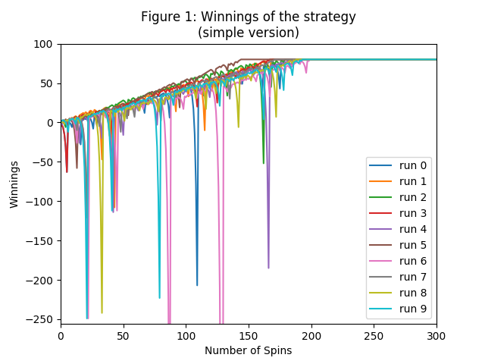

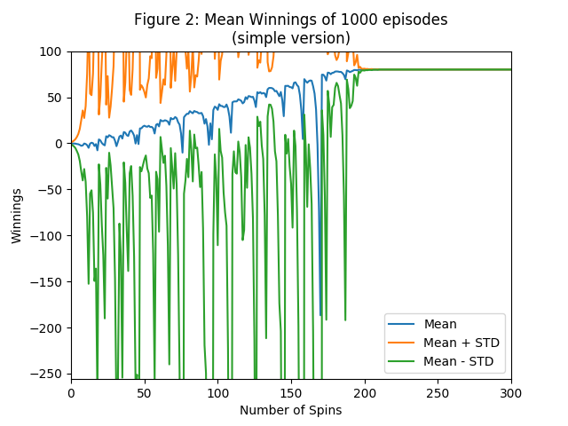**Question 4:** In Experiment 2, estimate the probability of winning $80 within 1000 sequential bets. Explain your reasoning.

**Question 5:** In Experiment 2, what is the estimated expected value of our winnings after 1000 sequential bets? Explain your reasoning.

**Question 6:** In Experiment 2, does the standard deviation reach a maximum value then stabilize as the number of sequential bets increases? Explain why it does (or does not).

Include figures 1 through 5.