|  |
| --- |
| Software design |
| Automated grading software |
| Version 1.0 |
| Prepared by class SE1436 Group 1  Nguyen Ba Trang  Nguyen Van Manh  Bien Van Cong  Nguyen Bac Quyet  July 10, 2021 |

Contents

Revision history 3

1. Document description 4

2. SRS overview 4

2.1. List of system users 4

2.2. List of use cases 4

2.3. Use case diagram 5

2.3.1. Preliminary use case diagram 5

2.3.2. Use case detail diagrams 5

2.4. Activity diagrams of use case scenarios 9

2.4.1. Activity diagram for use case “Login” 9

2.4.2. Activity diagram for use case “Load file student” 10

2.4.3 Activity diagram for use case “Auto Mark”. 11

2.4.4 Activity diagram for use case “Edit” 13

2.4.5 Activity diagram for use case “Register” 14

3. Data model 15

3.1. Entity Relationship Diagram 15

3.2. Table details/Chi tiết các bảng 15

3.2.1. Table name: : ScoreStudent 15

3.2.2. Table name: Class 16

3.2.3. Table name: Account 16

3.2.4. Table name: ExamCode 16

3.3. Database Diagram 17

4. Class diagram 17

4.1 List of classes in the Layers 17

5. User Interface Model Design 18

5.1 User interface model design 18

5.2 Interface Flow Diagrams 20

# Revision history

|  |  |  |  |
| --- | --- | --- | --- |
| **Date** | **Authors** | **Modifications** | **Version** |
|  |  |  |  |
|  |  |  |  |
|  |  |  |  |
|  |  |  |  |
|  |  |  |  |

# Document description

This document describes solution version 1.0 for Automated grading software. It is divided into the following sections:

* In the section 2 an overview of the Automated grading software’s requirements will be provided, including list of system users, use cases, use case diagram, and activity diagrams that describes the most important use case scenarios.
* In the section 3 an E-R diagram and all tables of the Automated grading software in detail will be presented.
* In the section 4 all classes organized in the layers and their behaviors (sequence diagrams) for the most important use cases will be presented.
* In the section 5 the most screen prototypes will be presented.

# SRS overview

## 2.1. List of system users

1. Teacher: The person that grade the exam

## 2.2. List of use cases

1. Login

2. Register

3. Load file student

4. Auto marks

5. Logout

## 2.3. Use case diagram

### 2.3.1. Preliminary use case diagram

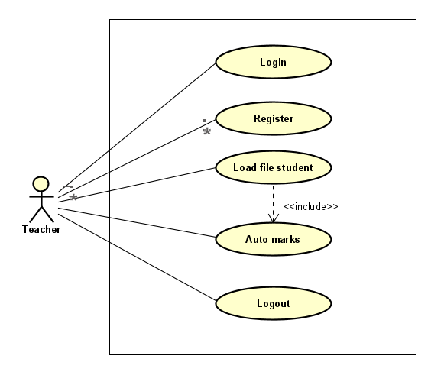

### 2.3.2. Use case detail diagrams

#### 2.3.2.1. Use case “Login”

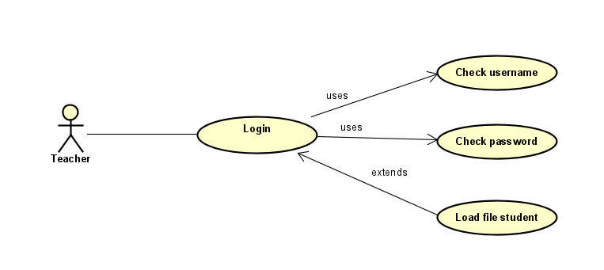

#### 2.3.2.2 Use case “Load file student”

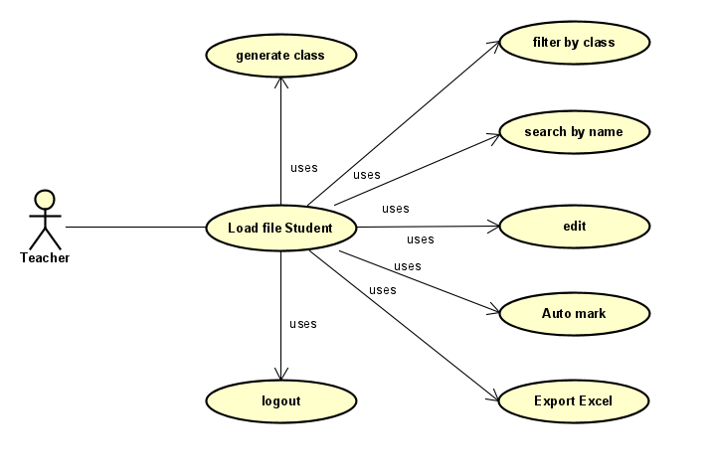

#### 2.3.2.3 Use case “Auto mark

#### 2.3.2.4 Use case “Edit”

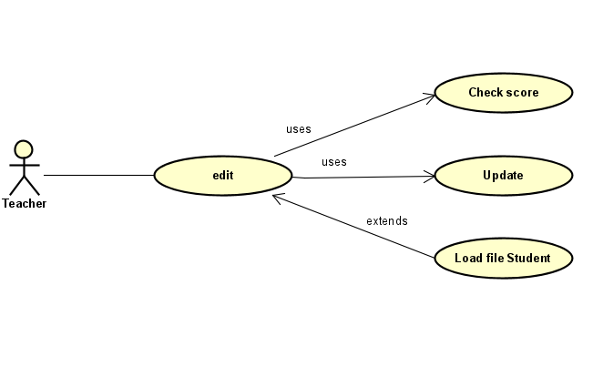

#### 2.3.2.5 Use case “Register”

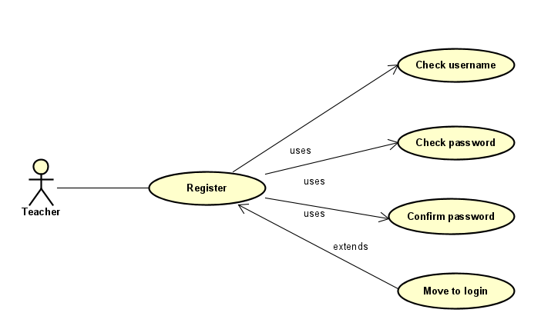

## 2.4. Activity diagrams of use case scenarios

### 2.4.1. Activity diagram for use case “Login”

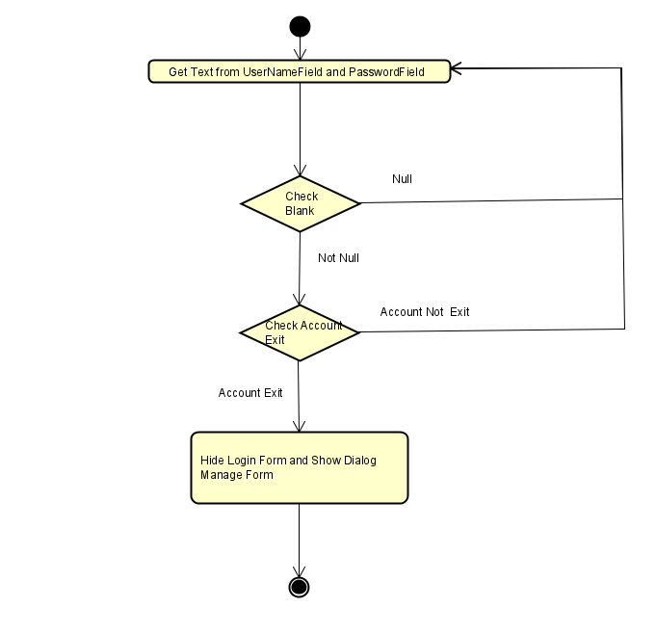

### 2.4.2. Activity diagram for use case “Load file student”

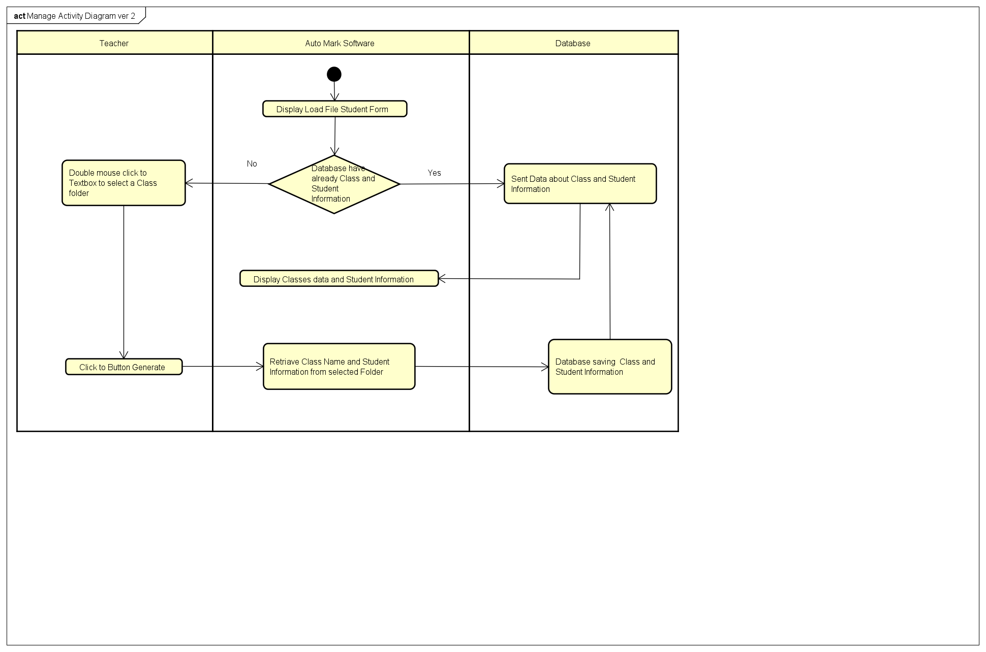

### 2.4.3 Activity diagram for use case “Auto Mark”.

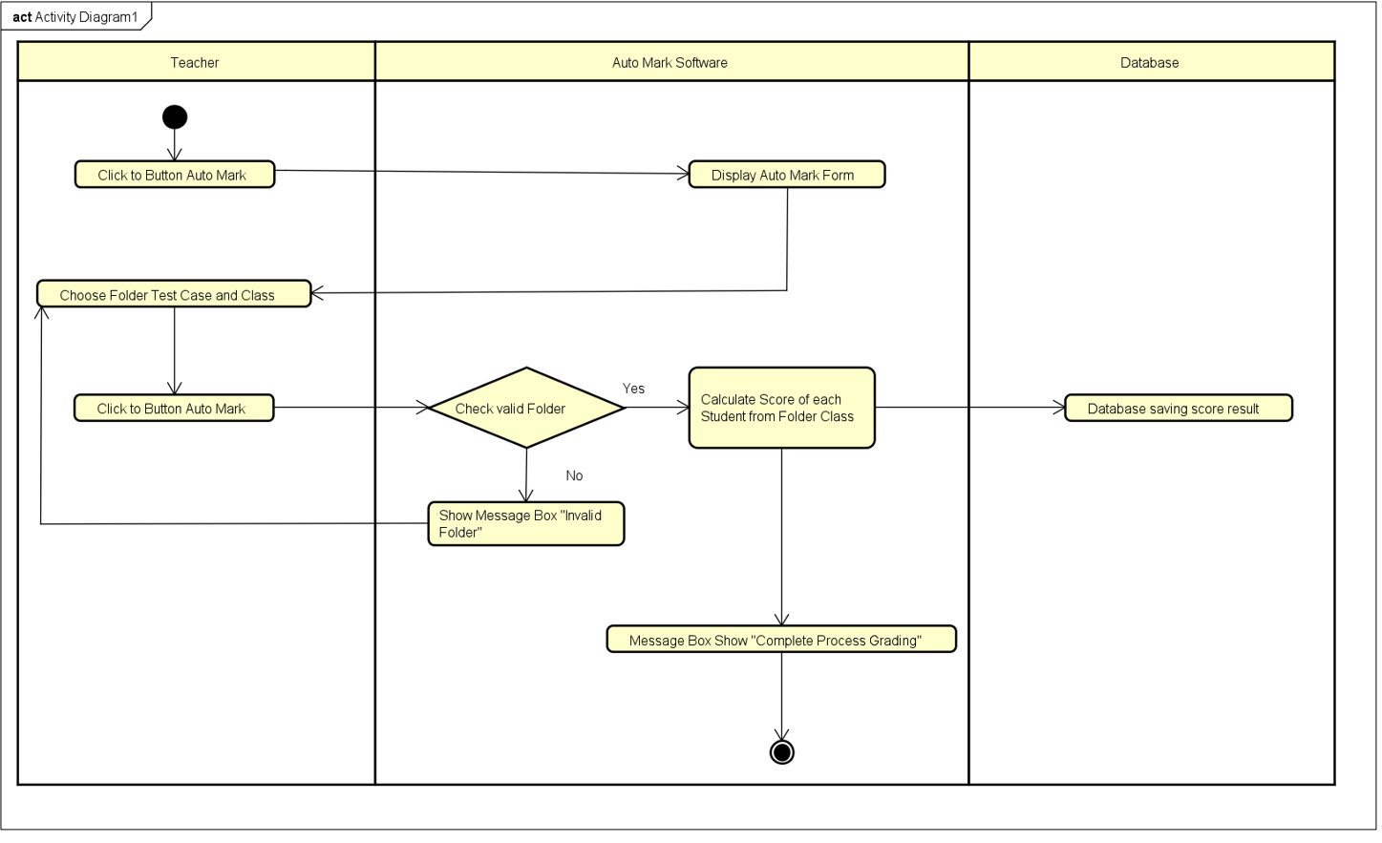

### 2.4.4 Activity diagram for use case “Edit”

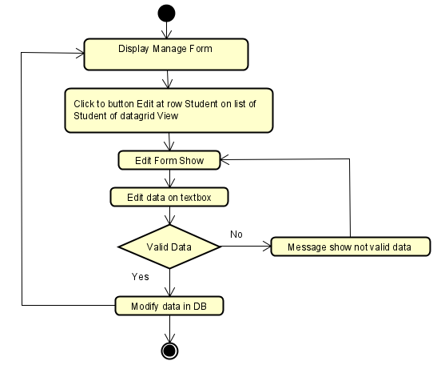

### 2.4.5 Activity diagram for use case “Register”

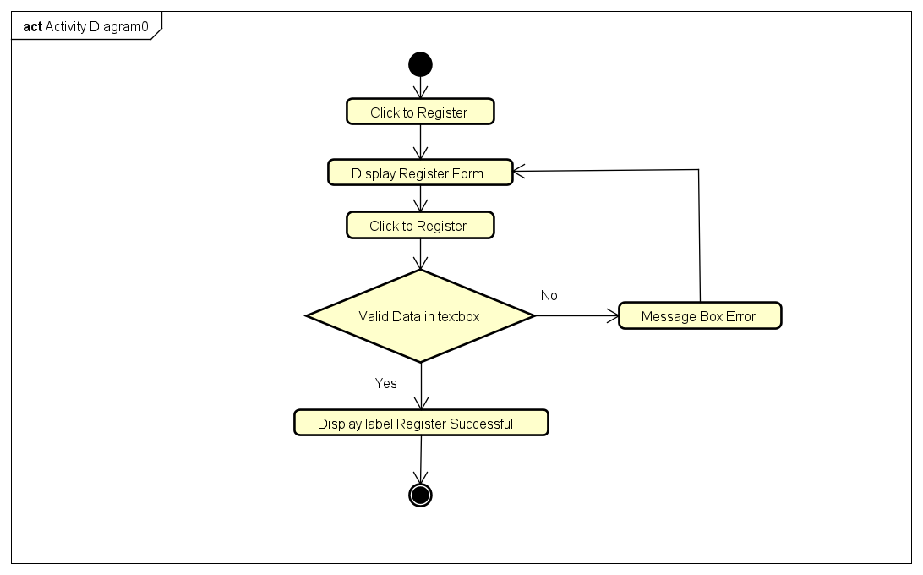

# Data model

## Entity Relationship Diagram

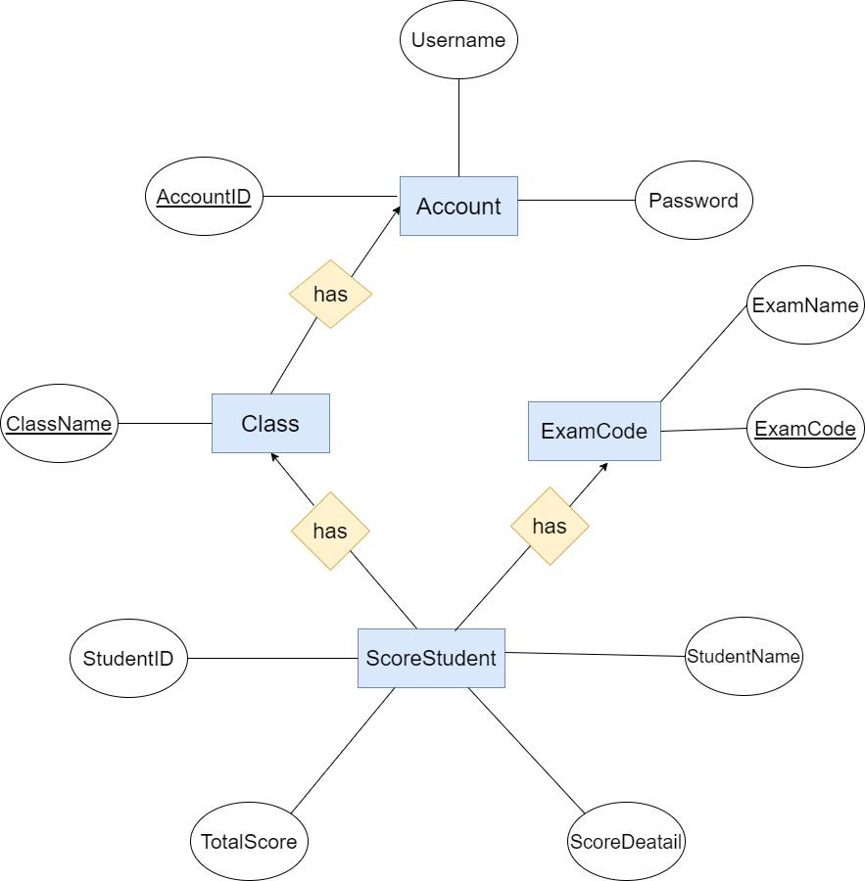

## Table details/Chi tiết các bảng

Note: Attribute with underline is Primary key

### Table name: : ScoreStudent

|  |  |  |  |
| --- | --- | --- | --- |
| **Field name** | **Type** | **Size** | **Note** |
| StudentID | String | 50 | Not null |
| ExamCode | Int | max | Foreign key, refers to ExamCode table |
| ClassName | String | max | Foreign key, refers to Class table |
| TotalScore | float | max | Allows null |
| ScoreDetail | String | max | Allows null |
| StudentName | String | 50 | Allows null |

### Table name: Class

|  |  |  |  |
| --- | --- | --- | --- |
| **Field name** | **Type** | **Size** | **Note** |
| ClassName | String | 50 | Primary key |
| AccountID | Int | max | Foreign key, refers to Account table |

### Table name: Account

|  |  |  |  |
| --- | --- | --- | --- |
| **Field name** | **Type** | **Size** | **Note** |
| AccountID | Integer | 10 | Primary key |
| Username | String | 50 | Not null |
| Password | String | 50 | Not null |

### Table name: ExamCode

|  |  |  |  |
| --- | --- | --- | --- |
| **Field name** | **Type** | **Size** | **Note** |
| examCode | Int | max | Primary key |
| examName | String | 50 | Allows null |

## Database Diagram

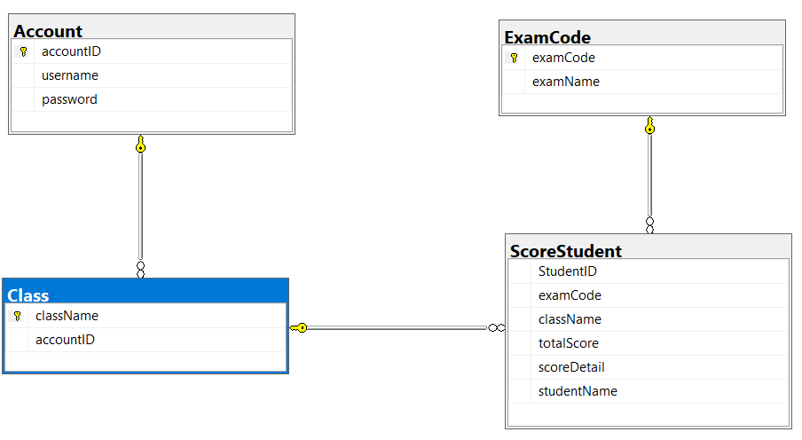

# Class diagram

## List of classes in the Layers

Auto Mark Database

Layer GUI

Layer DA

LoginGUI

RegisterGUI

Layer DT

Note: Allow to use

GUI: Graphic user interface DT: Data transfer

DA: Data access

LoadFileStudentGUI

UpdateGUI

Account

AutoMarkGUI

Class

Exam

Student

AccountDAO

ClassDAO

ExamDAO

StudentDAO

# User Interface Model Design

## User interface model design

* + 1. **Screen “Login”**

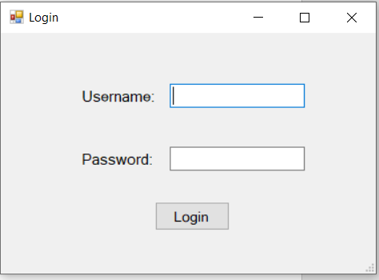

* + 1. **Screen “Load file student”**

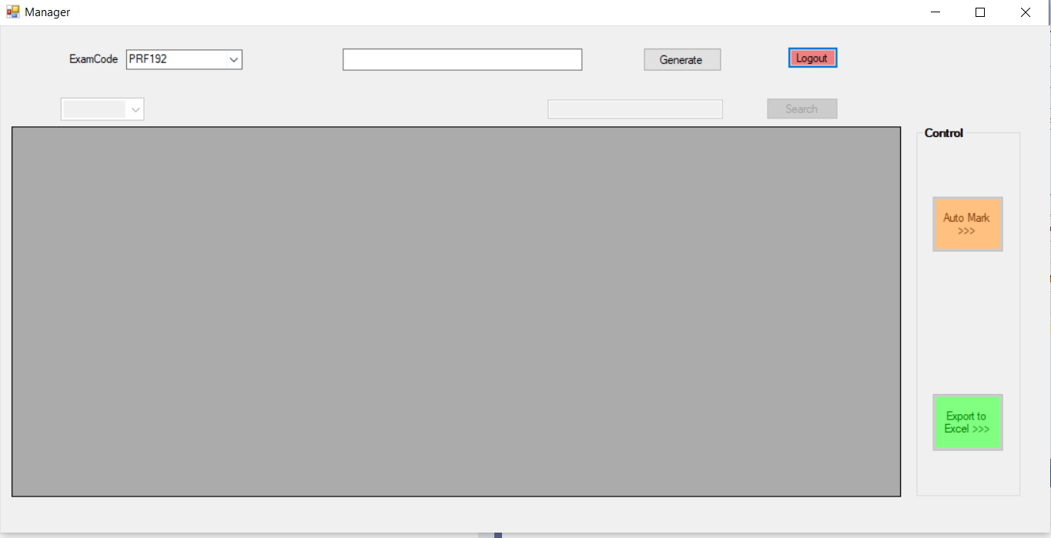

*Screen before generate class and student*

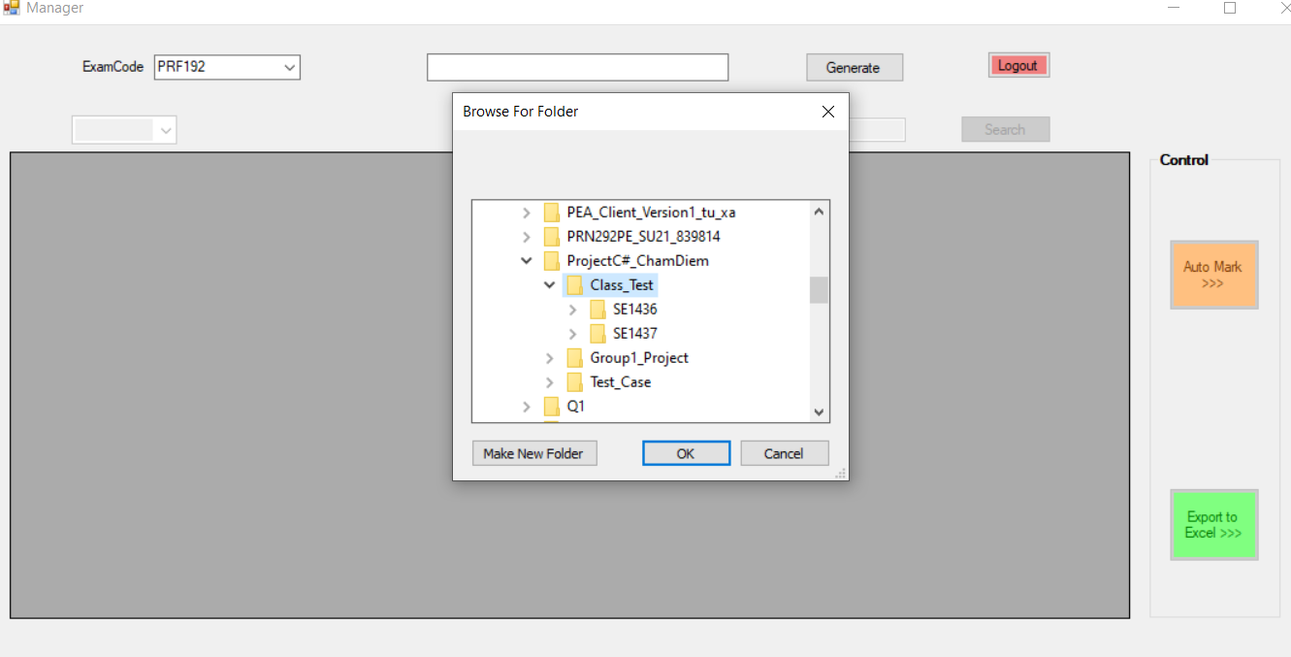

*Screen Choose Folder class want to generate*

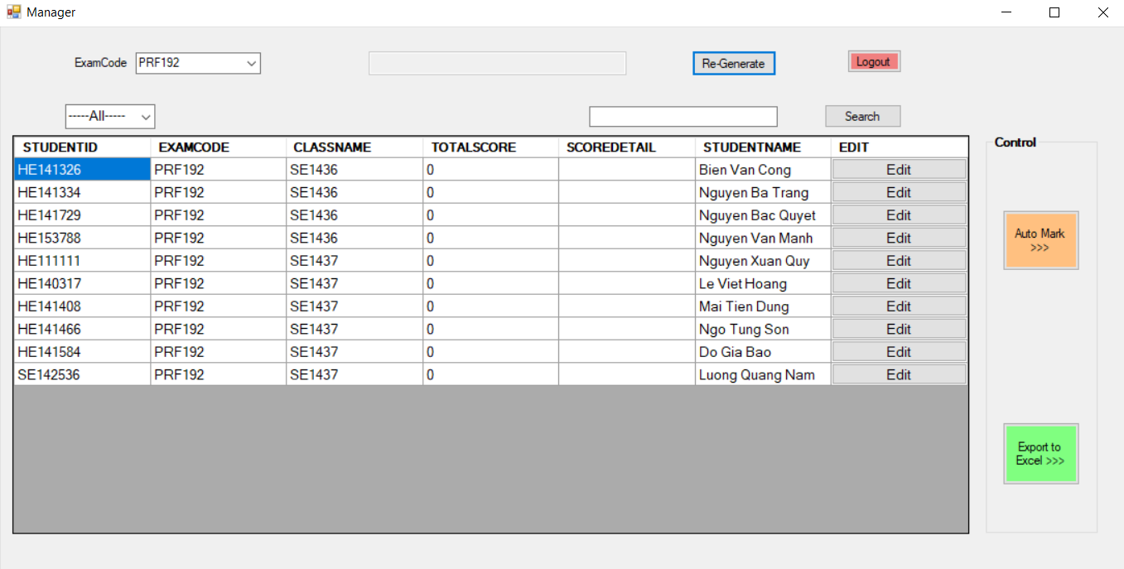

*Screen after generate class and student*

* + 1. **Screen “Auto Mark”**

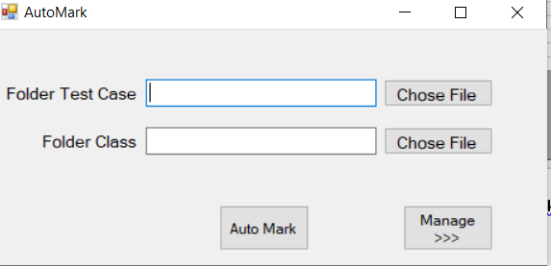

* + 1. **Screen “Edit mark”**

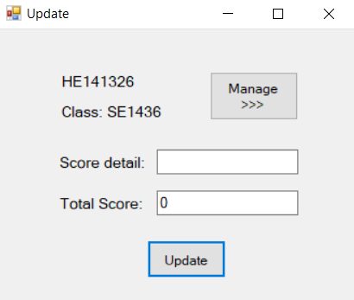

* + 1. **Screen “Register”**

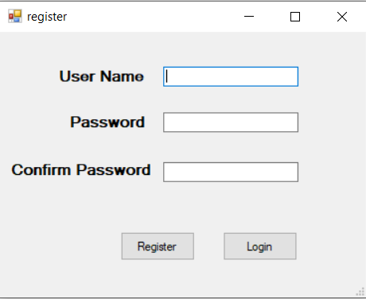

## Interface Flow Diagrams

Register Account

Login

Edit score

Mark the exam

Export to excel

Load file student

[Click Register]

[Click login]

[Click Export to Excel]

[Click Auto Mark] [Click Edit]