1. 设计一个用于注册的 Activity。要求界面中的注册项包括用户名、账号、密码、性别、出生年月日、爱好。用户名框中只能输人大字母;账号框只能输人数字;密码框不可显示明文;性别用单选按钮，默认选中“男”；出生年月日使用日期选择对话框输入,默认值为当前日期;爱好用多选框实现，至少要有4 个选项,默认选中第一个和第二个选项。界面中有一个“注册”按钮，“注册“按钮要水平居中。用户点击“注册”按钮后，显示状态栏提醒 Notification 消息，消息的标题为“注册完成”，消息中包括注册的用户名。

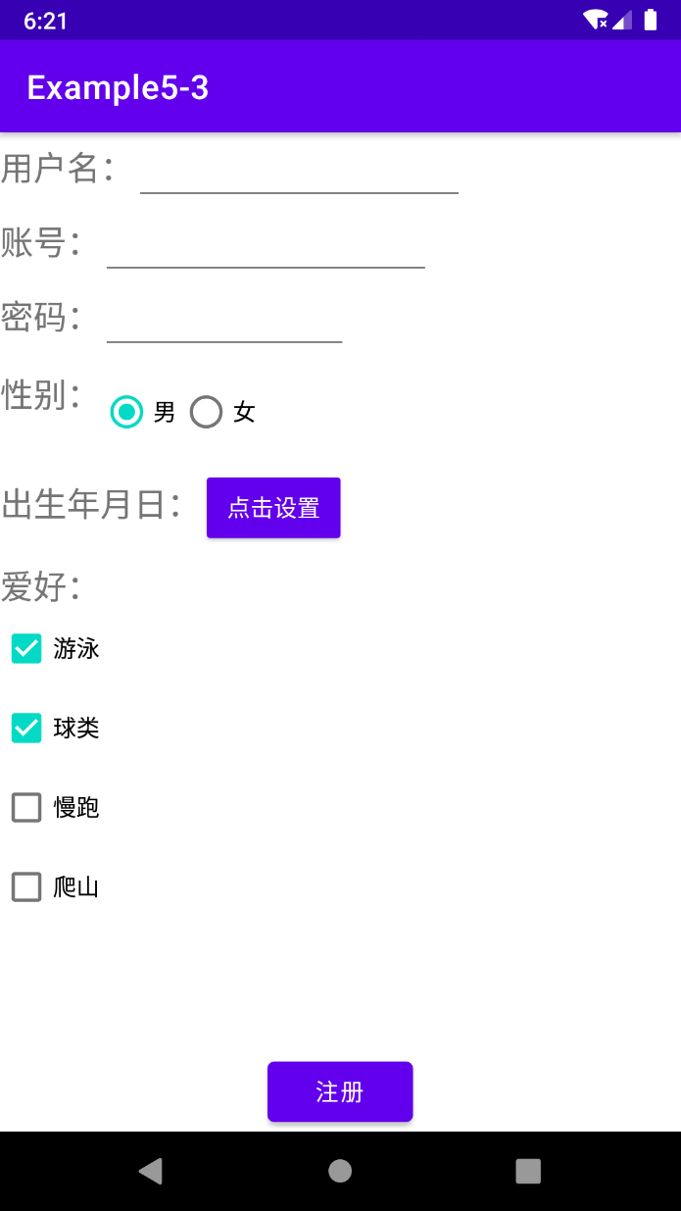

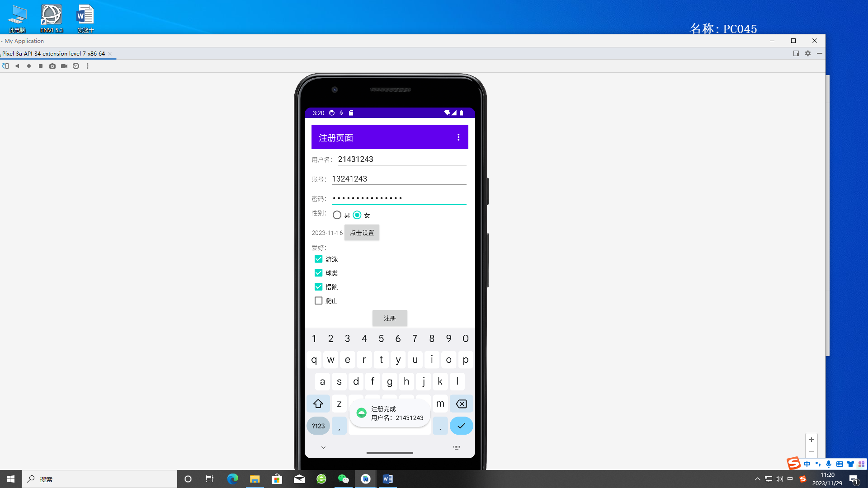

2、为上一题的 Activity 添加菜单，菜单项为“清空各选项”和“退出”。当用户选择“清空各选项”时，将所有文本输人框的文字清空，所有单选按钮和复选框设为启动时的默认选项。当用户选择“退出”时，弹出警告对话框，用户如果选择“确定”，则关闭 Activity。

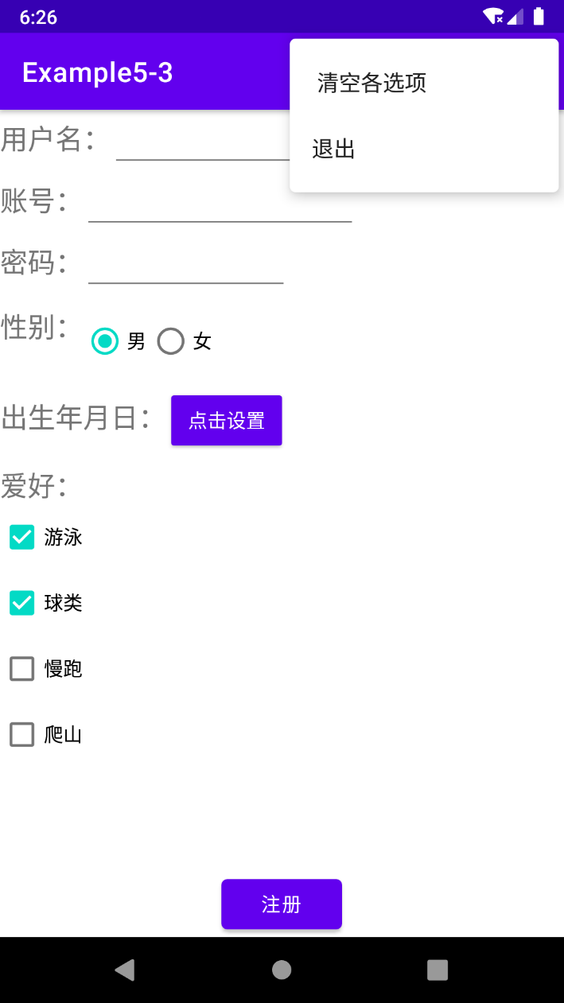

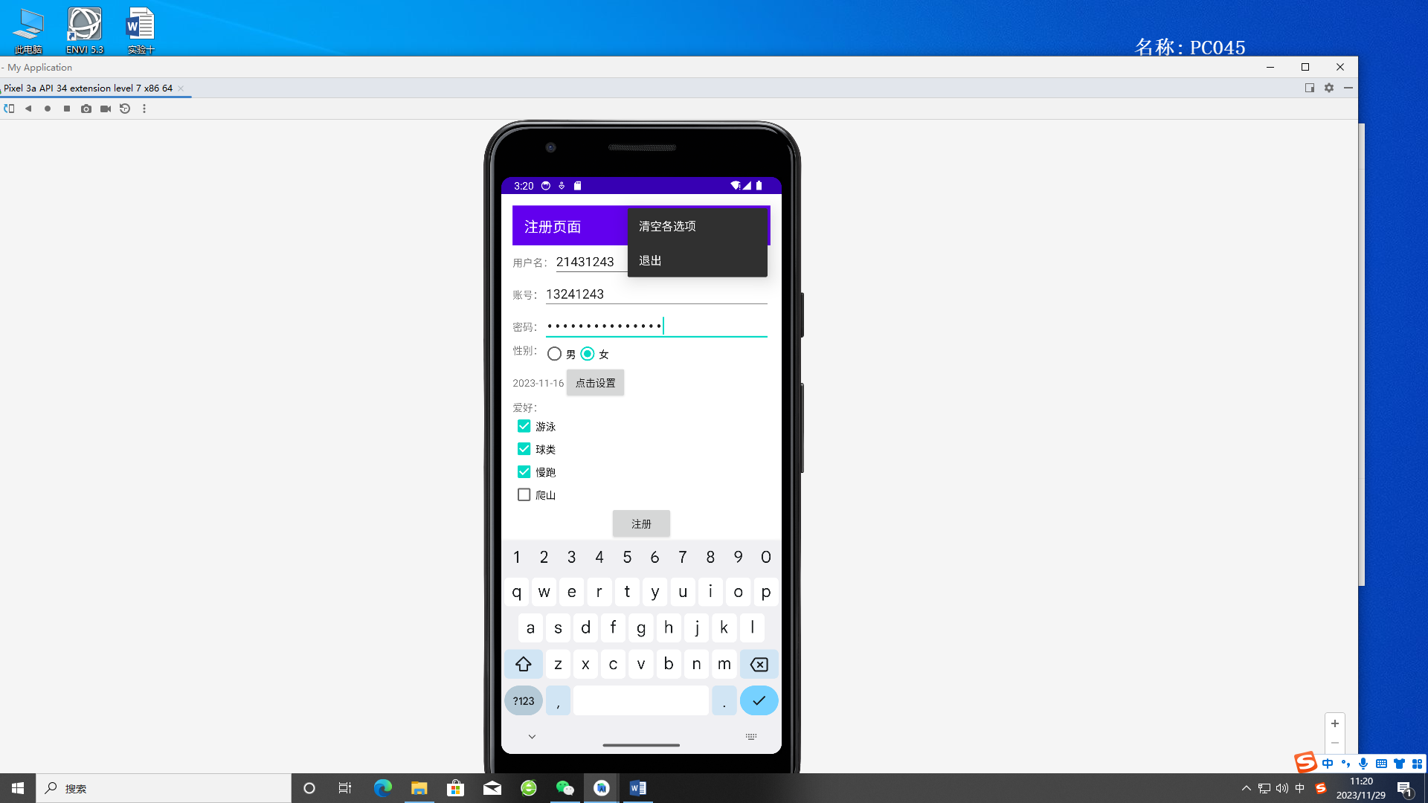

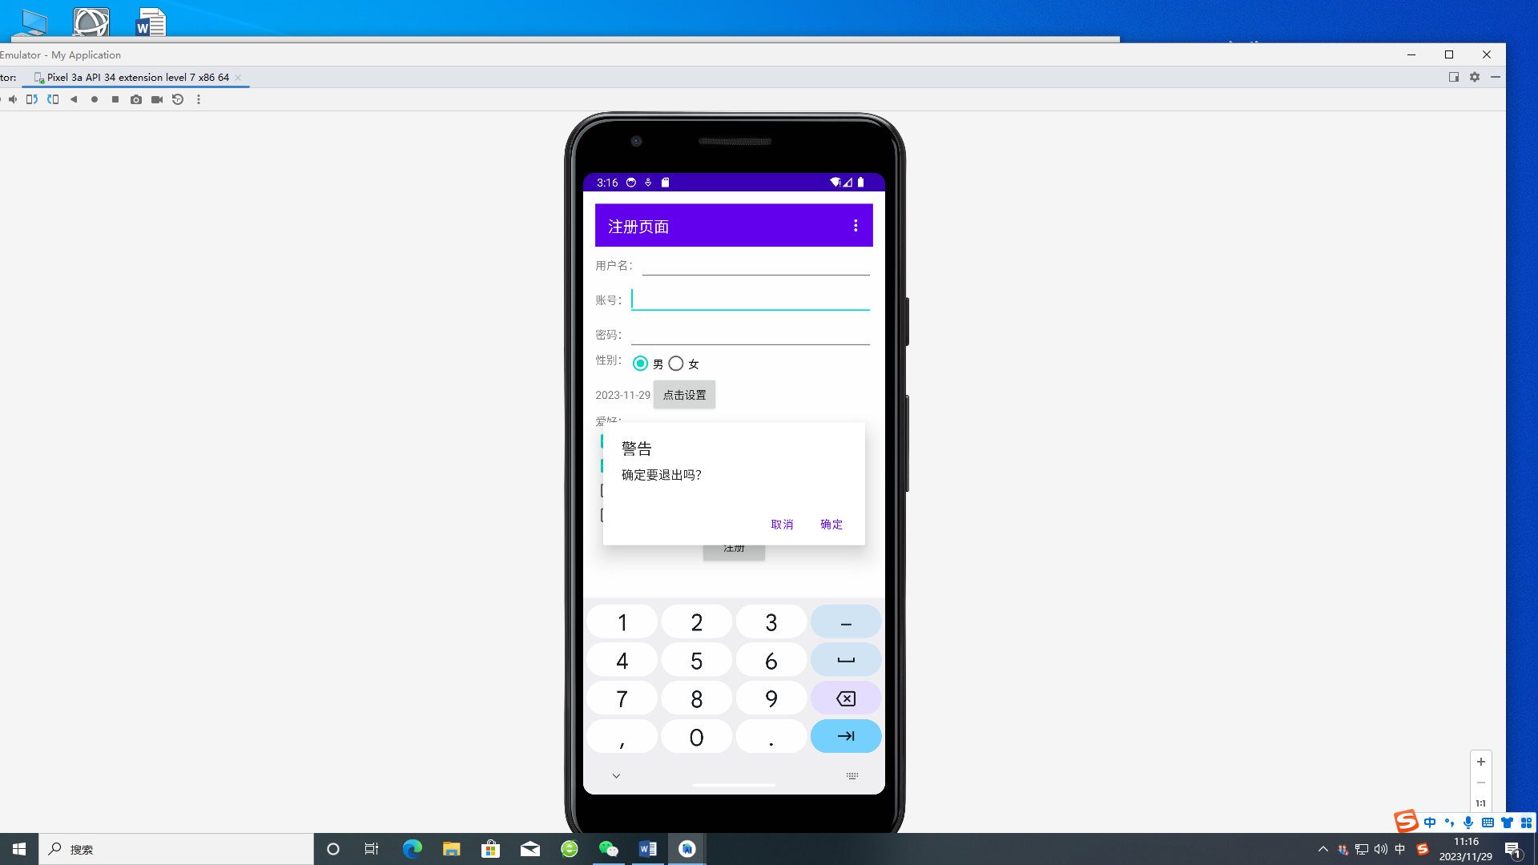

这里用的老的**Toolbar，**新的我这里好像有bug  
  
  
  
  
1. Xml

*<?***xml version="1.0" encoding="utf-8"***?>*<**LinearLayout  
 xmlns:android="http://schemas.android.com/apk/res/android"  
 xmlns:tools="http://schemas.android.com/tools"  
 android:layout_width="match_parent"  
 android:layout_height="match_parent"  
 android:orientation="vertical"  
 android:padding="16dp"  
 tools:context=".MainActivity10_1"**>  
  
 <**android.widget.Toolbar  
 android:id="@+id/toolbar"  
 android:layout_width="match_parent"  
 android:layout_height="?attr/actionBarSize"  
 android:background="?attr/colorPrimary"  
 android:theme="?attr/actionBarTheme"  
 android:title="注册页面"  
 android:titleTextColor="@android:color/white"** />  
  
 <**LinearLayout  
 android:layout_width="match_parent"  
 android:layout_height="wrap_content"  
 android:orientation="horizontal"**>  
  
 <**TextView  
 android:layout_width="wrap_content"  
 android:layout_height="wrap_content"  
 android:text="用户名："** />  
  
 <**EditText  
 android:id="@+id/usernameEditText"  
 android:layout_width="match_parent"  
 android:layout_height="wrap_content"  
 android:inputType="textCapCharacters"** />  
  
 </**LinearLayout**>  
  
 <**LinearLayout  
 android:layout_width="match_parent"  
 android:layout_height="wrap_content"  
 android:orientation="horizontal"**>  
  
 <**TextView  
 android:layout_width="wrap_content"  
 android:layout_height="wrap_content"  
 android:text="账号："** />  
  
 <**EditText  
 android:id="@+id/accountEditText"  
 android:layout_width="match_parent"  
 android:layout_height="wrap_content"  
 android:inputType="number"** />  
  
 </**LinearLayout**>  
  
 <**LinearLayout  
 android:layout_width="match_parent"  
 android:layout_height="wrap_content"  
 android:orientation="horizontal"**>  
  
 <**TextView  
 android:layout_width="wrap_content"  
 android:layout_height="wrap_content"  
 android:text="密码："** />  
  
 <**EditText  
 android:id="@+id/passwordEditText"  
 android:layout_width="match_parent"  
 android:layout_height="wrap_content"  
 android:inputType="textPassword"** />  
  
 </**LinearLayout**>  
 <**LinearLayout  
 android:layout_width="match_parent"  
 android:layout_height="wrap_content"  
 android:orientation="horizontal"**>  
  
 <**TextView  
 android:layout_width="wrap_content"  
 android:layout_height="wrap_content"  
 android:text="性别："** />  
 <**RadioGroup  
 android:id="@+id/genderRadioGroup"  
 android:layout_width="wrap_content"  
 android:layout_height="wrap_content"  
 android:orientation="horizontal"**>  
 <**RadioButton  
 android:id="@+id/maleRadioButton"  
 android:layout_width="wrap_content"  
 android:layout_height="wrap_content"  
 android:text="男"  
 android:checked="true"** />  
  
 <**RadioButton  
 android:id="@+id/femaleRadioButton"  
 android:layout_width="wrap_content"  
 android:layout_height="wrap_content"  
 android:text="女"** />  
 </**RadioGroup**>  
 </**LinearLayout**>  
  
<**RelativeLayout  
 android:layout_width="match_parent"  
 android:layout_height="wrap_content"**>  
  
 <**TextView  
 android:id="@+id/birthDateTextView"  
 android:layout_width="wrap_content"  
 android:layout_height="wrap_content"  
 android:layout_marginTop="15dp"  
 android:text="出生年月日："** />  
  
 <**Button  
 android:id="@+id/setBirthDateButton"  
 android:layout_width="wrap_content"  
 android:layout_height="wrap_content"  
 android:text="点击设置"  
 android:layout_toRightOf="@id/birthDateTextView"** />  
</**RelativeLayout**>  
  
<**TextView  
 android:layout_width="wrap_content"  
 android:layout_height="wrap_content"  
 android:text="爱好："** />  
  
<**LinearLayout  
 android:layout_width="match_parent"  
 android:layout_height="wrap_content"  
 android:orientation="vertical"**>  
  
 <**CheckBox  
 android:id="@+id/swimmingCheckBox"  
 android:layout_width="wrap_content"  
 android:layout_height="wrap_content"  
 android:text="游泳"  
 android:checked="true"** />  
  
 <**CheckBox  
 android:id="@+id/sportsCheckBox"  
 android:layout_width="wrap_content"  
 android:layout_height="wrap_content"  
 android:text="球类"  
 android:checked="true"** />  
  
 <**CheckBox  
 android:id="@+id/runningCheckBox"  
 android:layout_width="wrap_content"  
 android:layout_height="wrap_content"  
 android:text="慢跑"** />  
  
 <**CheckBox  
 android:id="@+id/hikingCheckBox"  
 android:layout_width="wrap_content"  
 android:layout_height="wrap_content"  
 android:text="爬山"** />  
</**LinearLayout**>  
  
<**Button  
 android:id="@+id/registerButton"  
 android:layout_width="wrap_content"  
 android:layout_height="wrap_content"  
 android:layout_gravity="center"  
 android:text="注册"** />  
  
</**LinearLayout**>

2. Java

**package** com.example.myapplication;  
  
**import** android.app.Activity;  
**import** android.app.AlertDialog;  
**import** android.app.DatePickerDialog;  
**import** android.content.DialogInterface;  
**import** android.os.Bundle;  
**import** android.view.Menu;  
**import** android.view.MenuInflater;  
**import** android.view.MenuItem;  
**import** android.view.View;  
**import** android.widget.Button;  
**import** android.widget.CheckBox;  
**import** android.widget.DatePicker;  
**import** android.widget.EditText;  
**import** android.widget.RadioButton;  
**import** android.widget.RadioGroup;  
**import** android.widget.TextView;  
**import** android.widget.Toast;  
**import** android.widget.Toolbar;  
  
**import** java.text.SimpleDateFormat;  
**import** java.util.Calendar;  
**import** java.util.Locale;  
  
**public class** MainActivity10_1 **extends** Activity {  
  
 **private** EditText usernameEditText, accountEditText, passwordEditText;  
 **private** RadioGroup genderRadioGroup;  
 **private** RadioButton maleRadioButton, femaleRadioButton;  
 **private** TextView birthDateTextView;  
 **private** Button setBirthDateButton, registerButton;  
 **private** CheckBox swimmingCheckBox, sportsCheckBox, runningCheckBox, hikingCheckBox;  
  
 **private** Calendar birthDateCalendar;  
  
 @Override  
 **protected void** onCreate(Bundle savedInstanceState) {  
 **super**.onCreate(savedInstanceState);  
 setContentView(R.layout.activity_main10_1);  
  
 *// 初始化控件* initializeViews();  
  
 *// 设置Toolbar* Toolbar toolbar = findViewById(R.id.toolbar);  
*// setSupportActionBar(toolbar); // 设置Toolbar作为ActionBar* setActionBar(toolbar);  
 *// 设置默认出生日期为当前日期* birthDateCalendar = Calendar.getInstance();  
 updateBirthDateTextView();  
  
 *// 设置点击设置按钮的事件* setBirthDateButton.setOnClickListener(**new** View.OnClickListener() {  
 @Override  
 **public void** onClick(View view) {  
 showDatePickerDialog();  
 }  
 });  
  
 *// 设置注册按钮点击事件* registerButton.setOnClickListener(**new** View.OnClickListener() {  
 @Override  
 **public void** onClick(View view) {  
 *// 处理注册按钮点击事件* handleRegistration();  
 }  
 });  
 }  
  
 *// 初始化控件的方法* **private void** initializeViews() {  
 *// 初始化所有控件* usernameEditText = findViewById(R.id.usernameEditText);  
 accountEditText = findViewById(R.id.accountEditText);  
 passwordEditText = findViewById(R.id.passwordEditText);  
 genderRadioGroup = findViewById(R.id.genderRadioGroup);  
 maleRadioButton = findViewById(R.id.maleRadioButton);  
 femaleRadioButton = findViewById(R.id.femaleRadioButton);  
 birthDateTextView = findViewById(R.id.birthDateTextView);  
 setBirthDateButton = findViewById(R.id.setBirthDateButton);  
 registerButton = findViewById(R.id.registerButton);  
 swimmingCheckBox = findViewById(R.id.swimmingCheckBox);  
 sportsCheckBox = findViewById(R.id.sportsCheckBox);  
 runningCheckBox = findViewById(R.id.runningCheckBox);  
 hikingCheckBox = findViewById(R.id.hikingCheckBox);  
 }  
  
 *// 显示日期选择对话框的方法* **private void** showDatePickerDialog() {  
 DatePickerDialog datePickerDialog = **new** DatePickerDialog(  
 **this**,  
 dateSetListener,  
 birthDateCalendar.get(Calendar.YEAR),  
 birthDateCalendar.get(Calendar.MONTH),  
 birthDateCalendar.get(Calendar.DAY_OF_MONTH)  
 );  
 datePickerDialog.show();  
 }  
  
 *// 更新出生日期文本的方法* **private void** updateBirthDateTextView() {  
 SimpleDateFormat sdf = **new** SimpleDateFormat(**"yyyy-MM-dd"**, Locale.getDefault());  
 birthDateTextView.setText(sdf.format(birthDateCalendar.getTime()));  
 }  
  
 *// 处理日期选择对话框设置的方法* **private** DatePickerDialog.OnDateSetListener dateSetListener =  
 **new** DatePickerDialog.OnDateSetListener() {  
 @Override  
 **public void** onDateSet(DatePicker datePicker, **int** year, **int** month, **int** day) {  
 birthDateCalendar.set(Calendar.YEAR, year);  
 birthDateCalendar.set(Calendar.MONTH, month);  
 birthDateCalendar.set(Calendar.DAY_OF_MONTH, day);  
  
 updateBirthDateTextView();  
 }  
 };  
  
 *// 处理注册按钮点击事件的方法* **private void** handleRegistration() {  
 *// 获取用户输入* String username = usernameEditText.getText().toString();  
 String account = accountEditText.getText().toString();  
 String password = passwordEditText.getText().toString();  
 String gender = maleRadioButton.isChecked() ? **"男"** : **"女"**;  
 String birthDate = birthDateTextView.getText().toString();  
  
 StringBuilder hobbies = **new** StringBuilder();  
 **if** (swimmingCheckBox.isChecked()) hobbies.append(**"游泳, "**);  
 **if** (sportsCheckBox.isChecked()) hobbies.append(**"球类, "**);  
 **if** (runningCheckBox.isChecked()) hobbies.append(**"慢跑, "**);  
 **if** (hikingCheckBox.isChecked()) hobbies.append(**"爬山"**);  
  
 *// 构建Notification消息* String notificationMessage = **"注册完成\n用户名："** + username;  
  
 *// 显示Notification消息* Toast.makeText(**this**, notificationMessage, Toast.LENGTH_SHORT).show();  
 }  
 *// 创建菜单的方法* @Override  
 **public boolean** onCreateOptionsMenu(Menu menu) {  
 MenuInflater inflater = getMenuInflater();  
 inflater.inflate(R.menu.register_menu, menu);  
 **return true**;  
 }  
  
 *// 处理菜单项的点击事件* @Override  
 **public boolean** onOptionsItemSelected(MenuItem item) {  
 **switch** (item.getItemId()) {  
 **case** R.id.menu_clear_options:  
 clearAllOptions();  
 **return true**;  
 **case** R.id.menu_exit:  
 showExitDialog();  
 **return true**;  
 **default**:  
 **return super**.onOptionsItemSelected(item);  
 }  
 }  
  
 *// 清空所有选项的方法* **private void** clearAllOptions() {  
 usernameEditText.setText(**""**);  
 accountEditText.setText(**""**);  
 passwordEditText.setText(**""**);  
 maleRadioButton.setChecked(**true**);  
 birthDateCalendar = Calendar.getInstance();  
 updateBirthDateTextView();  
 swimmingCheckBox.setChecked(**true**);  
 sportsCheckBox.setChecked(**true**);  
 runningCheckBox.setChecked(**false**);  
 hikingCheckBox.setChecked(**false**);  
 }  
  
 *// 显示退出对话框的方法* **private void** showExitDialog() {  
 AlertDialog.Builder builder = **new** AlertDialog.Builder(**this**);  
 builder.setTitle(**"警告"**)  
 .setMessage(**"确定要退出吗？"**)  
 .setPositiveButton(**"确定"**, **new** DialogInterface.OnClickListener() {  
 @Override  
 **public void** onClick(DialogInterface dialogInterface, **int** i) {  
 finish(); *// 关闭Activity* }  
 })  
 .setNegativeButton(**"取消"**, **null**)  
 .show();  
 }  
}

3. menu

<?xml version="1.0"?>

<menu xmlns:app="**http://schemas.android.com/apk/res-auto**" xmlns:android="**http://schemas.android.com/apk/res/android**"><item android:title="**清空各选项**" app:showAsAction="**never**" android:id="**@+id/menu_clear_options**"/><item android:title="**退出**" app:showAsAction="**never**" android:id="**@+id/menu_exit**"/></menu>