1. Boolean is a type of data whose value is either True or False. 3 different expressions that result a Boolean type:

5 >= 3

6 !=6

8 == 7

2. A flow chart is a diagram of the sequence of movements or actions of people or things involved in a system or activity. Draw the flow chart:

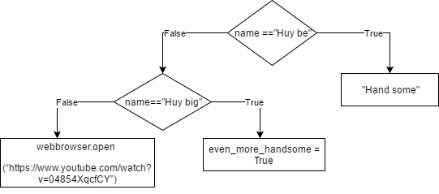

3. Nested conditionals are codes with conditional being nested within another. For example:

if x % 3 == 0:

print (x, “ is devisible by 3”)

else:

if x % 3 == 1:

print (x, “devising 3 leaves a remainder of 1”)

else:

print (x, “devising 3 leaves a remainder of 2”)