Feedback HTML delivery from Cong Danh

1

Overall the design needs to be more compact – to fit more on the same screen. Our systems have lots of information pieces on the same screen

Like in this:

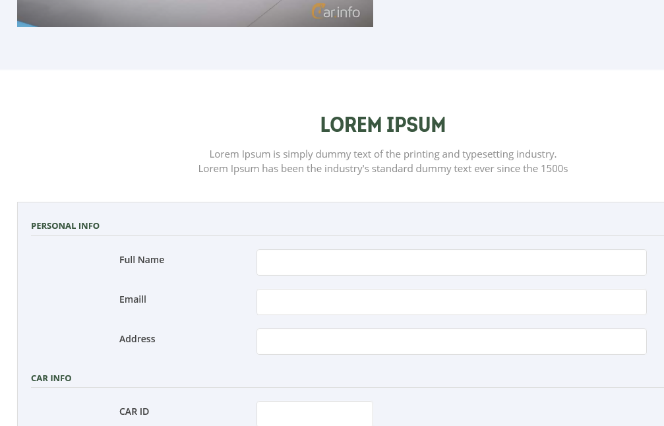

2

Favicon

3

The responsive menu that folds out must indicate very clearly which is the current menu item

4

OnClick colour of button at top does not go away until click elsewhere

4b

Can you please add a button with a secondary colour somewhere on screen

5

The first row should have two sections that together are wider than 1140px, see the prototype:

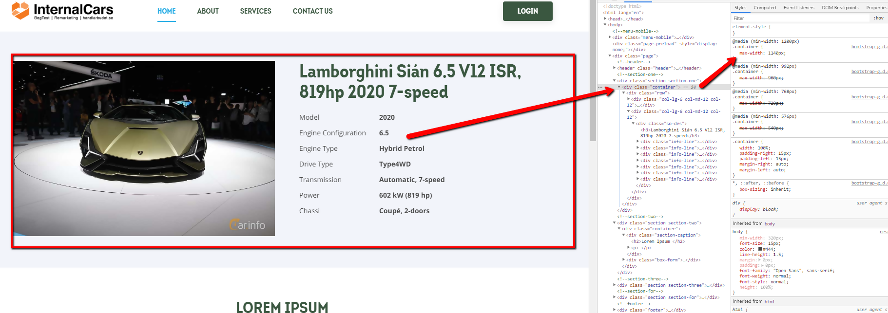

6

We need an error area, similar to:

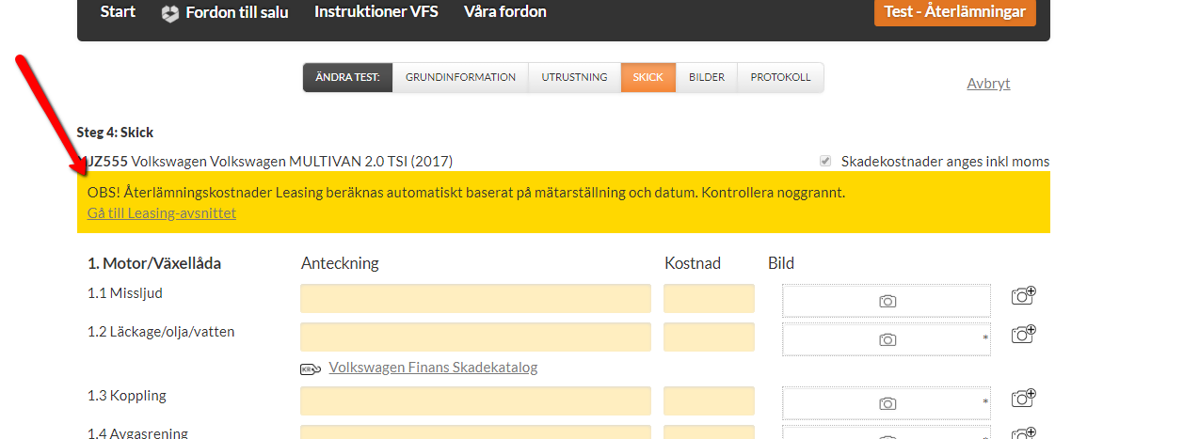

7

We need a warning area, similar to:

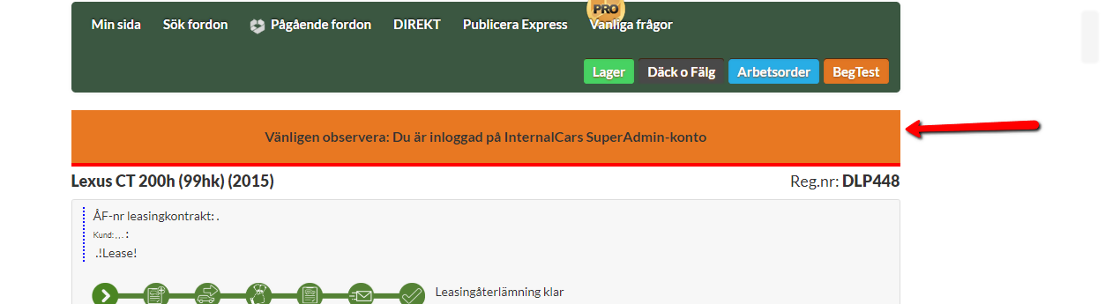

8

This heading bigger

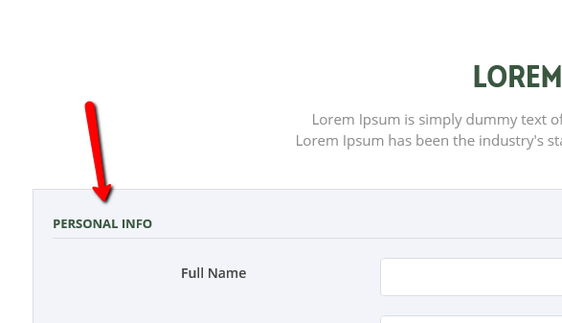

9

Can you please add to the form dropdowns, radiobuttons and checkboxes like the below:

Not exactly similar, but in your HTML style

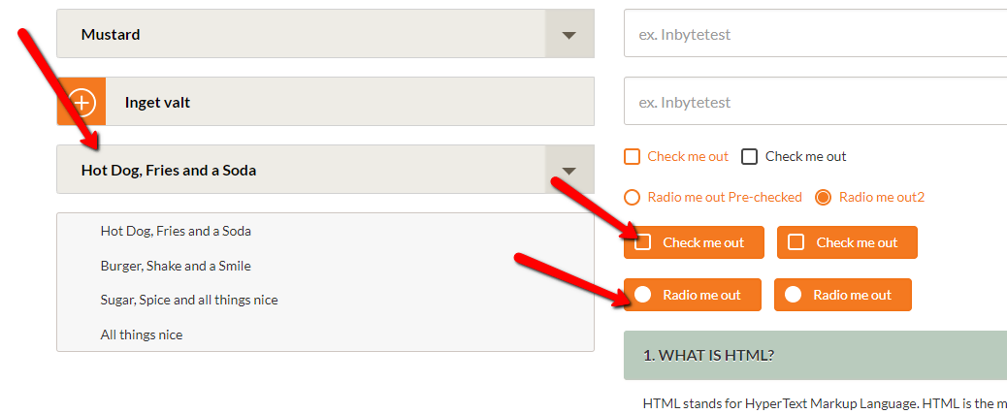

10

Need a clickable area to expand an area

The expansion should use javascript call, not automatic toggle CSS