Feedback HTML delivery from Cong Danh

4b

>Can you please add a button with a secondary colour somewhere on screen

I think the primary button Hover colour is not distinguished enough

9

Can you please add to the form dropdowns, radiobuttons and checkboxes like the below:

Not exactly similar, but in your HTML style

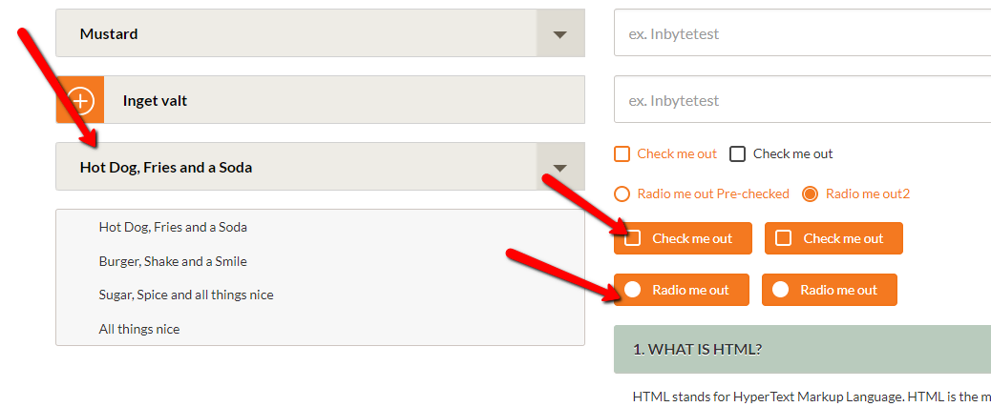

We also need, in addition to what you added,

Checkboxes and radiobuttons where they look like one big button: These are easy to press with finger on tablet. Like in example above

10

>Need a clickable area to expand an area. The expansion should use javascript call, not automatic toggle CSS

You used accordion which is exactly what we cannot use many times.

Keep the accordions on the page, but add a section like this:

JUST Example – you will do better on design than me!

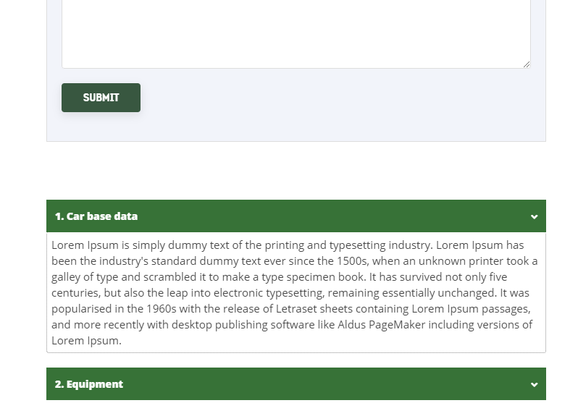

<div class="clickable_sections">

<div class="sectionheading" onclick="$('#section1').show();" style="

font-size: 14px;

font-weight: 900;

padding: 12px;

color: #fff;

background-color: #3b7136;

">

<p>1. Car base data</p>

<div class="icon" style="

float: right;

top: 0;

/* margin-bottom: 20px; */

margin-top: -20px;

">

<i class="fas fa-angle-down"></i>

</div>

</div>

<div class="sectiondata" id="section1" style="/* display: none; */padding: 6px;margin-bottom: 20px;border-left: 1px dotted #888;border-right: 1px dotted #888;border-bottom: 1px dotted #888;border-radius: 3px;">

<p>Lorem Ipsum is simply dummy text of the printing and typesetting industry. Lorem Ipsum has been the industry's standard dummy text ever since the 1500s, when an unknown printer took a galley of type and scrambled it to make a type specimen book. It has survived not only five centuries, but also the leap into electronic typesetting, remaining essentially unchanged. It was popularised in the 1960s with the release of Letraset sheets containing Lorem Ipsum passages, and more recently with desktop publishing software like Aldus PageMaker including versions of Lorem Ipsum.</p>

</div>

<div class="sectionheading active" style="

font-size: 14px;

font-weight: 900;

padding: 12px;

color: #fff;

background-color: #3b7136;

">

<p>2. Equipment</p>

<div class="icon" style="

float: right;

top: 0;

/* margin-bottom: 20px; */

margin-top: -20px;

">

<i class="fas fa-angle-down"></i>

</div>

</div>

<div class="sectiondata" id=”section2” style="display: block;">

<p>Lorem Ipsum is simply dummy text of the printing and typesetting industry. Lorem Ipsum has been the industry's standard dummy text ever since the 1500s, when an unknown printer took a galley of type and scrambled it to make a type specimen book. It has survived not only five centuries, but also the leap into electronic typesetting, remaining essentially unchanged. It was popularised in the 1960s with the release of Letraset sheets containing Lorem Ipsum passages, and more recently with desktop publishing software like Aldus PageMaker including versions of Lorem Ipsum.</p>

</div>

</div>