**CHARLES DICKENS**

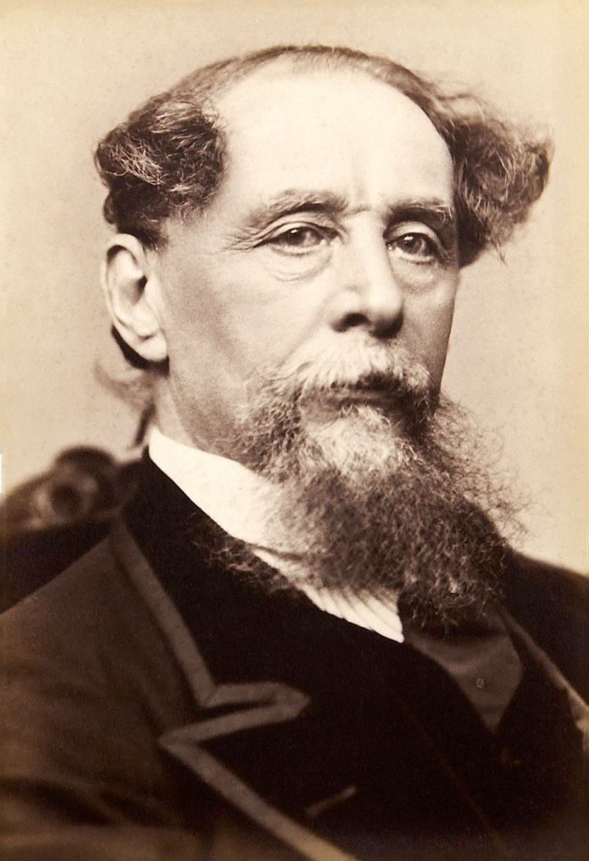

Charles John Huffam Dickens  7 February 1812 – 9 June 1870) was an English writer and social critic. He created some of the world's best-known fictional characters and is regarded by many as the greatest novelist of the [Victorian era](https://en.wikipedia.org/wiki/Victorian_era). His works enjoyed unprecedented popularity during his lifetime and, by the 20th century, critics and scholars had recognised him as a literary genius. **His novels and short stories are widely read today**

In 1832, at the age of 20, Dickens was energetic and increasingly self-confident. He enjoyed mimicry and popular entertainment, lacked a clear, specific sense of what he wanted to become, and yet knew he wanted fame. Drawn to the theatre – he became an early member of the [Garrick Club](https://en.wikipedia.org/wiki/Garrick_Club)– he landed an acting audition at Covent Garden, where the manager [George Bartley](https://en.wikipedia.org/wiki/George_Bartley_(comedian)) and the actor [Charles Kemble](https://en.wikipedia.org/wiki/Charles_Kemble) were to see him. Dickens prepared meticulously and decided to imitate the comedian Charles Mathews, but ultimately he missed the audition because of a cold. Before another opportunity arose, he had set out on his career as a writer.

**In 1833, Dickens submitted his first story, "A Dinner at Poplar Walk", to the London periodical**[***Monthly Magazine***](https://en.wikipedia.org/wiki/Monthly_Magazine)***.***

On 8 June 1870, Dickens suffered another stroke at his home after a full day's work on *Edwin Drood*. He never regained consciousness and, the next day, he died at Gads Hill Place. In his will, drafted more than a year before his death, **Dickens left the care of his £80,000 estate (£8,143,500 in 2021) to his long-time colleague John Forster and his "best and truest friend" Georgina Hogarth who, along with Dickens's two sons, also received a tax-free sum of £8,000 (equivalent to £814,000 in 2021**). Although Dickens and his wife had been separated for several years at the time of his death, he provided her with an annual income of £600 (£61,100 in 2021) and made her similar allowances in his will. He also bequeathed £19 19s (£2,000 in 2021) to each servant in his employment at the time of his death.

**The have been some works made from Charles Dickens’ novels**. One of them is GREAT EXPECTIATION – a film from Charles Dickens’ 13th Novel. This film is directed by Mike Newell and star actors Jeremy Irvine, Helena Bonham Carter, Holliday Grainger, etc.