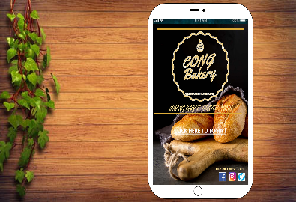“Cong Bakery”

A homepage System Website login interface with a concept Bakery Shop selling those breads, pastries, and cupcakes.

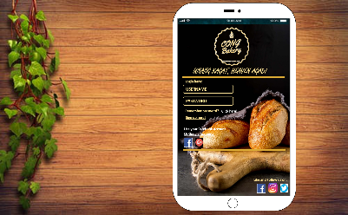

Login interface using login form account and you can use your FB account or google account and also you can sign up and then directly going to the another page of login interface to make you have a new account.

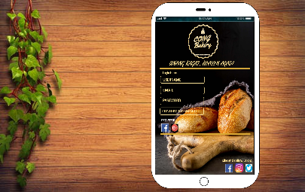

This Login interface will make you have a new account if you will see there is a username, email, and password so you filling it up and after that just click down below “register!” and done you are now officially registered at Cong’s Bakery.

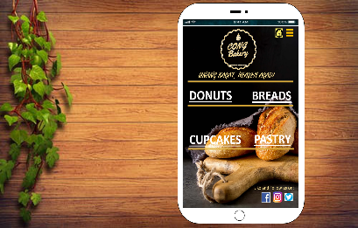

After login you will see some choices of Cong Bakery’s selling breads, pastries or donuts so you can choose easily. Example you choose donuts, only donuts you will see there no any brand.

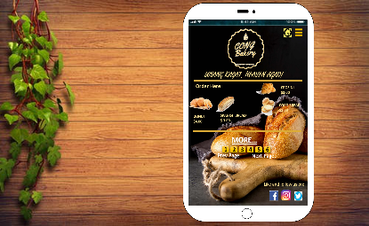

This page was selling assorted breads, donuts, cupcakes, and pastries.

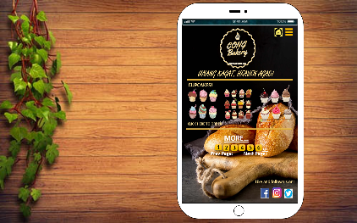

If you will see this page was full of donuts because he/she choose DONUTS