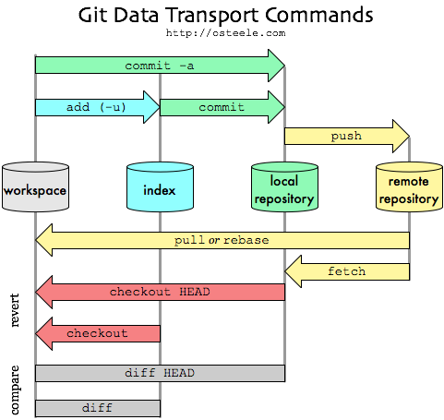

# First time setup

## Installing git

git-scm.com

## Check version

git –version

## Set config values

git config --global user.name = “Your name here”

git config --global user.email=”Email here”

# Initialize a repository from Existing code

git init

## Config a remote repository

git remote add <name> <url>

Default name of remote repo is **origin**

Example:git remote add origin https://github.com/congthanhbkit03/gitlearning.git

## Before first commit

git status

## Adding files to Staging area

git add –A

## Commit

git commit -m “Message here”

## Push to remote repository

git push <name> <branch>

Defaul branch is **master**

Example: git push origin master

# Cloning a Remote repo

git clone <url> <where to clone>

Example: git clone <https://github.com/ThanhBC/remote_clone.git> .

## View information about the remote repository

git remote -v

git branch -a

# Pushing changes

## Commit changes

git diff

git status

git add -A

git commit -m “Message here”

## Push

git pull origin master #get newest on remote

git push origin master #push

# Branch

## Create a Branch for desired feature

git branch newbranch #create branch with name newbranch

git checkout newbranch #now active branch is newbranch (HEAD point to newbranch instead of master)

## Check active branch

git branch -a #cho biết ở local và remote có những nhánh nào

Now all push from local will apply to newbrach

## Push branch to Remote

(thực hiện việc commit thì hiện tại chỉ có lưu trên local, để đưa lên remote cần push branch này lên remote)

git push -u origin newbranch

## Merge a branch

git checkout master #switch to master branch

git branch --merged #any branches have been merged?

git merge newbranch #merge newbranch to master

## Delete branch

git branch -d newbranch #delete branch on local

git push origin --delete newbranch #delete branch from remote repository