Programing Language.

32 Bài HackerRank

Bài 1: Say “Hello, World!” With Python.

Bài 2: Python If-Else

Bài 3: Arithmetic Operators

Bài 4: Python: Division

Bài 5: Loops

Bài 6: Leap year.

Bài 7: Print Function

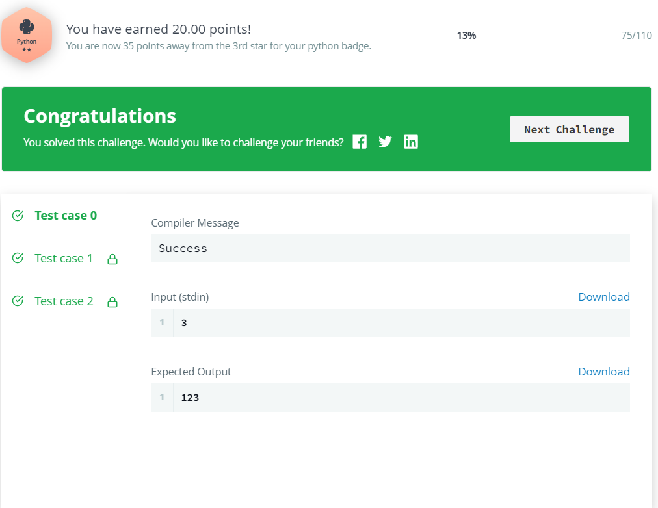

Bài 8: Hex Color Code

Bài 9: HTML Parser – Part 1.

Bài 10: List Comprehensions

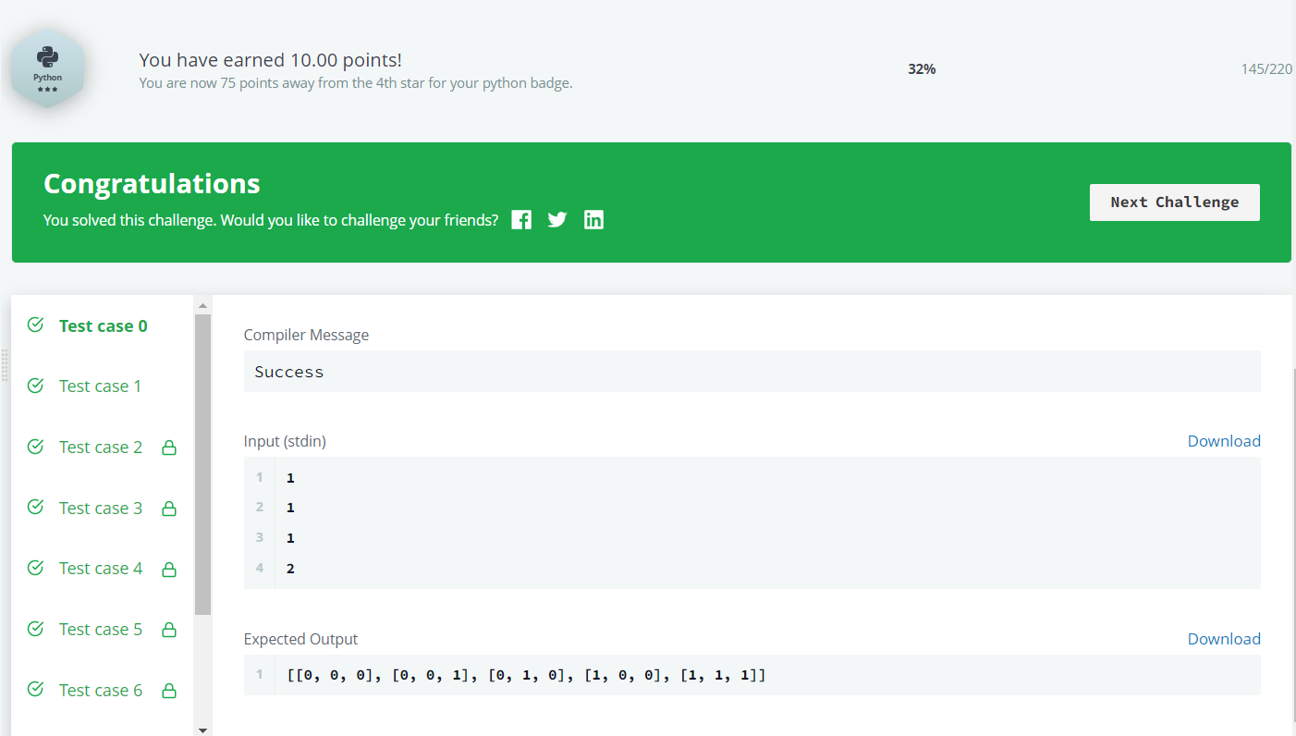

Bài 11: What’s your name?

Bài 12: Finding the percentage

Bài 13: Capitalize!

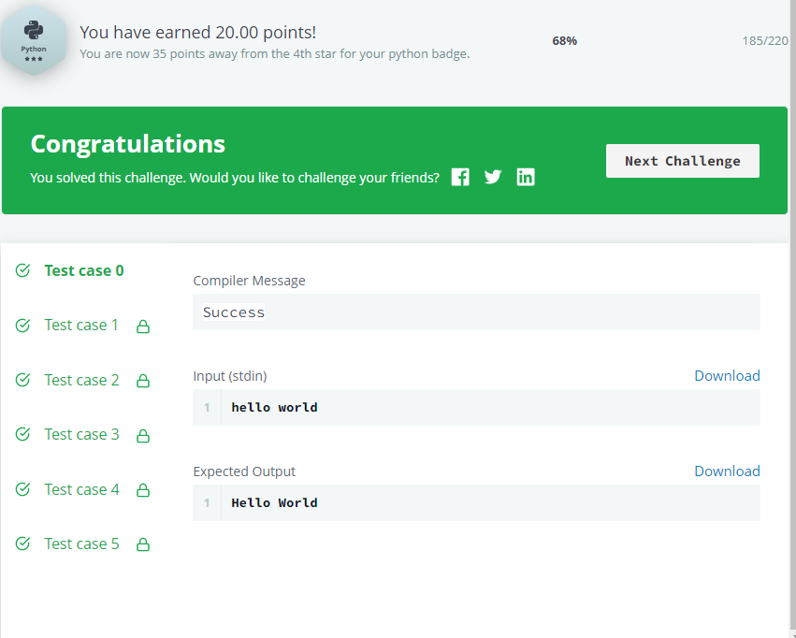

Bài 14: List

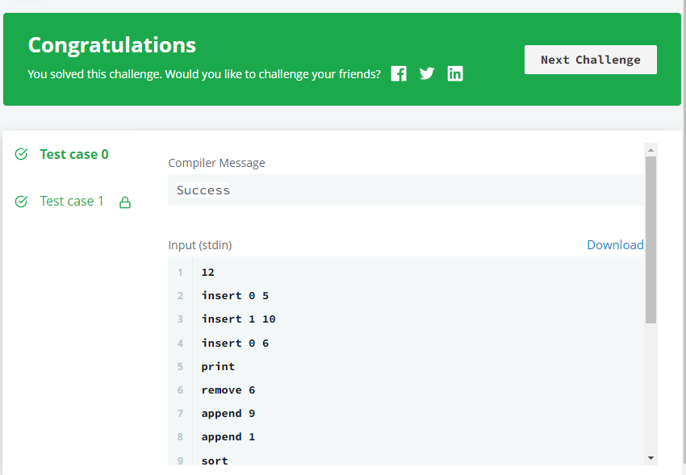

Bài 15: Tupe

