DUY TAN UNIVERSITY
Faculty of Information Technology
--------------ÐÑ¶ÐÑ-------------

CASE STUDY 1
PROPOSAL DOCUMENT
HUMAN RESOURCE AND PAYROLL INTEGRATED

Mentor: MSc. Nguyen Minh Nhat
Team member:
Group 03 : Phan Thanh Chien( leader) – 1053
Le Tran Binh An - 0401
Lam Son Nhat - 6761
Bui Nguyen Ngoc Thach - 4344
Trinh Quang Cong- 1087

Da Nang, September 23th, 2025

PROJECT INFORMATION

Project  Acronym | HR&PR System
Project Title | Human Resource And Payroll Integrated System
Start Date | September 23th, 2025 |  | End Date | 15th, 2025
Lead  Institution | International School, Duy Tan University
Project Mentor /Product Owner | Nhat Minh Nguyen, MSc.  Email: nhatnm2010@gmail.com  Phone: 0905125143
Project Manager & Contact Details | Phan Thanh Chien  Email:phanthanhchien@gmail.com  Phone: 0705292425
Partner  Organization | Duy Tan University
Project Web
URL
Team  Members | Cong, Trinh Quang | vovanan19971997@gmail.com |  |  | 0363636363
 | Thach, Bui Nguyen Ngoc | Thachdz@gmail.com |  |  | 090647956
 | An, Le Tran Binh | binhan@gmail.com |  |  | 036363636
 | Nhat, Son Lam | Lamnhat@gmail.com |  |  | 066606660

DOCUMENT NAME
Document Title | Proposal
Reporting Period | September 2025
Author(s) | Chien Phan Thanh
Date | September 2025 | Fieldname | SE01_Proposal_v2.0
URL
Access | Faculty of Information Technology

REVISION HISTORY

Version | Person | Date | Description
1.0 | HR&PR Team | Sep 01th, 2025 | Draft for Comment
2.0 | HR&PR Team | Sep 15th, 2025 | Release

SIGNATURE
Document Approvals: The following signatures are required for approval of this document.
Nhat Nguyen Minh, MSc.  Mentor |  | Date: …../……./2025
Chien Phan Thanh  Scrum Master |  | Date: …../……./2018
Cong Trinh Quang  Member |  | Date: …../……./2018
Thach Bui Nguyen Ngoc  Member |  | Date: …../……./2018
An Le Tran Binh  Member |  | Date: …../……./2018
Nhat Lam Son  Membẻ |  | Date: …../……./2018

TABLE OF CONTENTS

Introduction 6
1.1. Purpose 6
1.2. Scope 7
1.3. Definitions, Acronyms and Abbreviations 7
1.4. References 7
2 Project Overview 8
2.1. Problem statement 8
2.2. Prospects 8
2.3. Project Plan 9
2.3.1. Expected Time 9
2.3.2. Milestone 10
2.3.3. Cost 11
2.3.3.1. Product Cost 11
2.3.3.2. Total Cost 11
2.3.4. WBS (Work Breadown Structure) 12
2.4. Summary 12
3. Solution 14
3.1 Purpose 14
3.3. System Integrated Life Cycle (SILC) 17
4. Stakeholder and User Descriptions 18
4.1. Stakeholder summary 18
4.2. User summary 20
4.3. Stakeholder Profiles 20
4.3.1. CEO 20
4.3.2. Project Manager 21
4.3.3. Human Resource Manager 21
4.3.4. Payroll Manager 22
4.3.5. Project Team 22
4.4. User Profiles 23
4.4.1. CEO 23
4.4.2. Project Manager 23
4.4.3 Human Resources Manager 24
4.4.4. Payroll Manager 24
5. Benefit 26
6. Constrains 26
7. Development Process 26
7.1. Process Description 26
7.2. Operating principle 27
8. Organization Management 28
8.1. Human 28
9. Risk 28

Introduction
  - Purpose
- The goal of the project is to build a modern Integrated Human Resource Management System (IHRMS), providing business leaders with an overview, accurate and timely view of the human resource situation. IHRMS will be a centralized, intuitive dashboard that helps managers easily access, analyze and make decisions based on employee, payroll and benefits data.
- Specifically, the project will:
- Information integration: Connect data from existing systems to create a unified, easy-to-manage HR data warehouse.
- Provide visual reports: Display information in the form of easy-to-understand charts and statistical tables, helping leaders quickly grasp the personnel situation.
- Highly customizable: Allows users to customize reports and analyze data from many different -perspectives, meeting the needs of each department.
- Smart alerts: Automatically send alerts about important events related to employees, helping leaders be more proactive in managing human resources.
- Friendly interface: Intuitive interface design, easy to use, suitable for user needs.

  - Scope
-The IHRMS project scope focuses on developing an integrated human resource management system that provides businesses with a detailed view of employee data. The project includes collecting and standardizing data from the existing system, building a visual dashboard, and developing automatic reports. Including system integration with existing software and ensuring data security and accuracy. The ultimate goal is to create a system that effectively supports managers in making decisions and improving business efficiency.

1.3. Definitions, Acronyms and Abbreviations
Definitions:
- HRS: Human Resource System
- Payroll system: A system used to process employee salaries
- Integration: The process of combining two or more systems into a single, unified system.
- Data Consistency: Ensuring that data is accurate and consistent across different systems.
- Data Migration: The process of transferring data from one system to another.
- User Interface (UI): The visual elements of an application that a user interacts with.
Acronyms:
- CEO: Chief Executive Officer
- HR: Human Resources
- SILC: System Integration Life Cycle
Abbreviations
- ESB: Enterprise Service Bus
- API: Application Programming Interface

1.4. References
- Memo from CEO regarding system integration
- IEEE Template for case study reports

2 Project Overview

2.1. Problem statement
The problem of | Affects | The impact of which is | A successful solution would be
Managing separate HR and payroll systems | Staff, employers | Increased workload, inefficient processes, and data errors | Centralized access to data from both systems through the IHRMS dashboard
Lack of synchronization between HR and payroll | Employers | Employees in payroll not appearing in HR, and vice versa | Automatic synchronization between HR and payroll data
Inability to view comprehensive employee data | CEO | CEO cannot view employee status and payroll info together | Unified dashboard that combines all employee and payroll information
Need for multiple logins to view employee info | CEO, employers, staff | Time wasted logging into two separate systems | Single sign-on providing access to both HR and payroll systems
Maintaining integrity of HR and payroll systems | Both systems | Data inconsistencies and potential errors | Ensuring consistent data management across both systems
Handling sensitive information across systems | Both systems | Risk of exposing sensitive data between two platforms | Secure, efficient data transfer between the HR and payroll systems

2.2. Prospects
- Enhanced Decision-Making: By integrating the HR and Payroll systems into a single dashboard, the CEO and senior management will have comprehensive, real-time insights into employee and payroll data. This will enable more informed and timely decision-making.
- Increased Efficiency: Streamlining access to combined data from both systems will reduce the time and effort required to gather information. This will minimize delays in responding to internal and shareholder queries.
- Improved Data Accuracy: An integrated system will help ensure that employee and payroll data are synchronized and accurate, reducing the likelihood of discrepancies between the HR and Payroll systems.
- Proactive Management: The ability to set alerts for key events (such as employment anniversaries, excessive vacation days, and benefit

2.3. Project Plan

2.3.1. Expected Time
Task | Hour | Start | Finish
Requirement | 40 hours | 28/08/2025 | 06/09/2025
Analysis | 50 hours | 07/09/2025 | 20/10/2025
Design | 60hours | 21/10/2025 | 17/11/2025
Code & Test | 50 hours | 18/11/2025 | 12/12/2025
Maintain | 32 hours | 13/12/2025 | 21/12/2025
TOTAL | 232hours | 28/08/2025 | 21/12/2025

2.3.2. Milestone
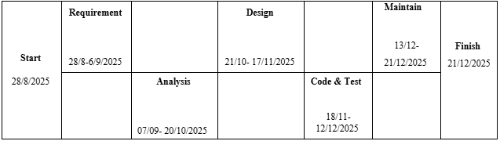

2.3.3. Cost

2.3.3.1. Product Cost
Task | Hour | Members | Cost/Hour/Person(VND) | Total(VND)
Requirement | 40 | Thach | 50.000 | 2.000.000
Analysis | 32 | An , Chien | 50.000 | 1.600.000
Design | 60 | Cong ,Thach | 50.000 | 3.000.000
Code & Test | 96 | Chien, Cong ,Thach | 50.000 | 4.800.000
Maintain | 24 | Nhat ,An | 50.000 | 1.200.000
Total | 252 |  | 50.000 | 12.600.000

2.3.3.2. Total Cost
Component | Cost (VND)
Product H&P | 50.400.000/project
Managements Cost | 20.000.000/project
Material Cost | 6.000.000/project
Maintains Cost | 5.000.000/project
Total Project Cost | 81.400.000

2.3.4. WBS (Work Breadown Structure)

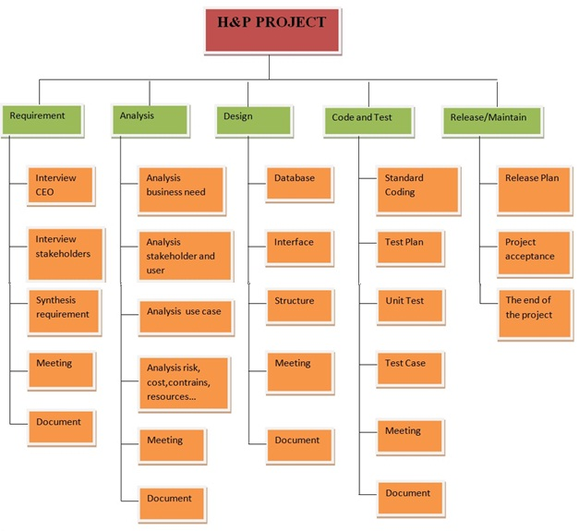

2.4. Summary
Customer Benefit | Supporting Features
CEO | CEO
- The total earnings by shareholder, gender, ethnicity, part-time, and full-time staff to date and the previous year, by department. | - Earnings Report by Shareholder, Gender, Ethnicity, Employee Type, Department
- Total number of vacation days taken by shareholder, gender, ethnicity, part-time, and full-time staff to date and the previous year. | - Vacation Days Report by Shareholder, Gender, Ethnicity, Employee Type
Average benefits paid to shareholders and non-shareholders to date by benefits plan. | - Benefits Summary Report by Plan
- Alerts for key events (e.g., employee approaching hiring anniversary, excess vacation days, changes in benefits plan affecting payroll, birthdays within the current month). | - Alert and Notification System for Key Events
Staff | Staff
- Alerts for staff approaching their hiring anniversary. | - Anniversary Alert System,  - Vacation Days Alert System,  - Benefits Plan Change Alert System,  - Birthday Alert System
- Notifications when staff accumulate more than a certain number of vacation days.
- Notifications for changes in benefits plans affecting payroll.
- Display of staff birthdays within the current month.
View personal salary information and special days (e.g., anniversaries). | - Personal Information Dashboard

3. Solution

3.1 Purpose
From CEO's request. Therefore, we need to us to use system integration techniques to integrate 2 systems: HR and PR System.
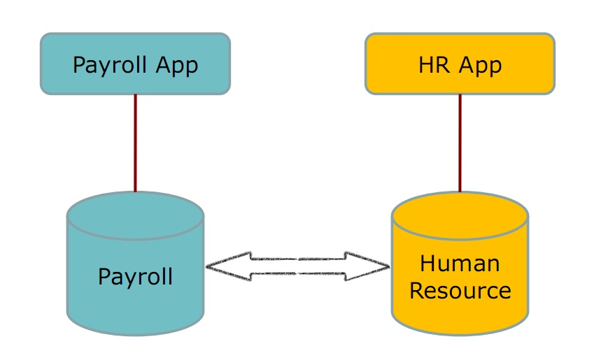
3.2. Integration solutions
- Solution 1: Representation integration
- Advantages and disadvantages
+ Advantages:
- Integration is quick and easy to implement, without major changes to the system structure.
- Users can access information from both systems through a common interface.
- Low cost because it does not require much in terms of software and hardware resources

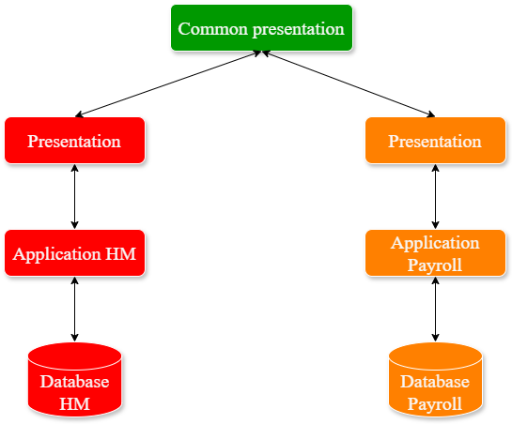

+ Disadvantages:
- Data is not really synchronized between the two systems, leading to the need to operate on both systems.
- Difficulty in ensuring data accuracy and consistency.
- Limited integration, not scalable for more complex requirements.
- Solution 2: Data integration
- Advantages and disadvantages
+ Advantages:
- Data from two systems is synchronized and easily accessible from both systems.
- Ensures data integrity and consistency.
- Deep integration, supports more complex requirements and is scalable.
+ Disadvantages:
- Higher costs due to the need for an intermediate system or database adjustments of two existing systems.
- Requires more complex skills and technology to deploy and maintain.
- Longer implementation time due to the need to synchronize data.

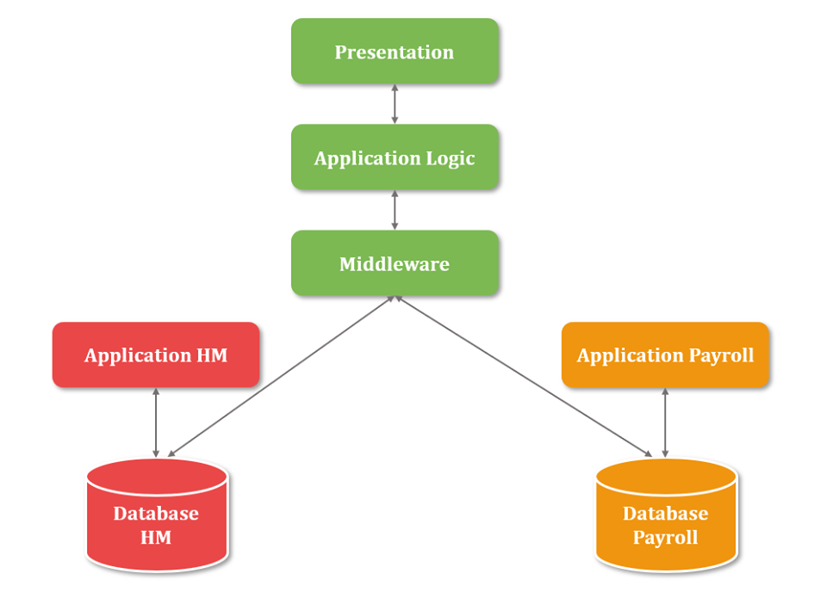

- Select solution:
+ After analysis, the data-layer integration solution (Solution 2) was considered more suitable, as it ensures data integrity and consistency between the two systems, and is more scalable and integrates better with other systems in the future. Although it is more expensive and complex, it meets the CEO's requirements for comprehensive HR and PR management.

3.3. System Integrated Life Cycle (SILC)
3.3.1. Waterfall Model
The Waterfall model is a traditional software development methodology where each phase is carried out sequentially: requirement → analysis → design → implementation → testing → maintenance.
Advantages:
- Clear structure and well-defined process, easy to manage the schedule.
- Suitable for projects with stable requirements and limited changes.
- Easier to estimate time and cost from the beginning.
- Comprehensive documentation, making maintenance and handover easier.
Disadvantages:
- Lacks flexibility, difficult to adapt when requirements change during development.
- Users can only see the product at the end, which increases the risk of not meeting actual needs.
- Errors may be detected late (in the testing phase), which requires more time and cost to fix.
Conclusion: Waterfall can be applied if the CEO’s requirements are stable and unlikely to change. However, for an integrated system with complex and frequently changing requirements, this model may not be optimal.
3.3.2. Scrum Model
Scrum is an Agile-based development framework that divides the project into short iterations (Sprints), typically 2–4 weeks, where each Sprint delivers a potentially usable product increment.
Advantages:
- Flexible and highly adaptable to changes in requirements from the CEO or end users.
- Continuous improvement of the product through frequent iterations reduces project risks.
- Stakeholders (e.g., CEO, managers) can directly participate and provide timely feedback.
- Transparency and better control of progress with daily meetings (Daily Scrum).
- Encourages collaboration, accountability, and motivation among team members.
Disadvantages:
- Difficult to estimate the total project cost and time precisely from the start.
- Requires experienced and disciplined team members familiar with Agile/Scrum.
- Active involvement of the CEO and stakeholders is necessary; lack of participation may reduce effectiveness.
Conclusion: Scrum is more suitable for the HR & Payroll Integration project because it supports continuous feedback, adapts to changes, and ensures that the final system meets the CEO’s expectations and business needs.
(Sinh viên phân tích đặc điểm của mỗi quy quy trình ưu, nhược điểm của nó để xác định quy trình tốt nhất cho quản lý dự án theo yêu cầu của CEO)

4. Stakeholder and User Descriptions

4.1. Stakeholder summary
Name | Represent | Role
CEO | CEO is person who will pay for this project. | Providing the requirements  Participating in developing project with the project team  The legal representatives in contracts.
Human Resources manager | Human Resources Department | Providing the information on operational procedures of Human Resources department
Payroll manager | Payroll Department Representative | Providing the information on operational procedures of Payroll department
Shareholders | Customer- Who have stock in company | Providing requirements, information about business process and existing systems.
Project Manager | Project development team management | Working with customers, negotiating to create the contract and planning, executing, controlling, monitoring the project to ensure the “Task Package” is delivered to user on time and within budget.
Project Team | Developer, tester, team leader, design architect, documentarian, coordinator | They are responsible for executing tasks and producing deliverables as outlined in the Project Plan directed by the Project Manager, at whatever level of effort or participation has been defined for them.

4.2. User summary
Name | Description
CEO | Accessing and looking for information, interacting with dashboard.
Senior managers | Managing the company's activities, responsible for separate parts
Human Resources Manager | Entering the data and process data in Human Resources Department.
Payroll manager | Entering the data and process data in Payroll Department.

4.3. Stakeholder Profiles

4.3.1. CEO
Representative | Name of the CEO
Description | Who understand the operational status and processes of the company
Type | User
Responsibilities | Communicating with sponsor and project manager to develop the project follow the plan
Success Criteria | His problems which his company is facing are solved
Involvement | Proving the requirements, solutions, information about his company
Deliverables | No
Comments / Issues | The problems in finance during developing the project

4.3.2. Project Manager
Representative | Name of Project manager
Description | Who is responsible for project development
Type | Manage project
Responsibilities | Responsible for activities and problems of the project
Success Criteria | The project is delivered to user on time and within budget
Involvement | Planning, executing, controlling, monitoring the project
Deliverables | No
Comments / Issues | The problems about the team members, …

4.3.3. Human Resource Manager
Representative | Name of Human Resources Manager
Description | Who manages the information about the staffs in company
Type | User
Responsibilities | Responsible for providing the information about the operating process of Human Resources Department
Success Criteria | Ensuring consistency of information , workflow fast and efficient
Involvement | Providing the information to project manager and support team project in developing the project
Deliverables | No
Comments / Issues | No

4.3.4. Payroll Manager
Representative | Name of Payroll Manager
Description | Who manages the information about the payroll in company
Type | User
Responsibilities | Responsible for providing the information about the operating process of Payroll Department
Success Criteria | Ensuring consistency of information , workflow fast and efficient
Involvement | Providing the information to project manager and support team project in developing the project
Deliverables | No
Comments / Issues | No

4.3.5. Project Team
Representative | Team members
Description | Who develops the project
Type | Developer
Responsibilities | Responsible for integrating the Human Resources and Payroll system
Success Criteria | Making the system meeting customer’s need on time
Involvement | Developing functions, applications, … for the project
Deliverables | No
Comments / Issues | No

4.4. User Profiles

4.4.1. CEO
Representative | Stakeholder CEO
Description | Who understand the operational status and processes of the company
Type | User
Responsibilities | Communicating with sponsor and project manager to develop the project follow the plan
Success Criteria | His problems which his company is facing are solved
Involvement | Proving the requirements, solutions, information about his company
Deliverables | No
Comments / Issues | The problems in finance during developing the project

4.4.2. Project Manager
Representative | Senior manager
Description | Who want to get information about the status of company
Type | User
Responsibilities | Providing the necessary information
Success Criteria | His problems which his company is facing are solved
Involvement | Proving the requirements, solutions, information about his company
Deliverables | No
Comments / Issues | No

4.4.3 Human Resources Manager
Representative | Stakeholder Human Resources Manager
Description | Who manages the information about the staffs in company
Type | User
Responsibilities | Responsible for providing the information about the operating process of Human Resources Department: changing employee information, changing status or of longer working employees, evaluating staffs…
Success Criteria | Ensuring consistency of information , workflow fast and efficient
Involvement | Providing the information to project manager and support team project in developing the project
Deliverables | No
Comments / Issues | No

4.4.4. Payroll Manager

Representative | Stakeholder Payroll Manager
Description | Who manages the information about the payroll in company
Type | User
Responsibilities | Responsible for providing the information about the operating process of Payroll Department: review staff’s salary, update salary’s information…
Success Criteria | Ensuring consistency of information , workflow fast and efficient
Involvement | Providing the information to project manager and support team project in developing the project

5. Benefit
- Saving time and costs in the process working.
- Data between two systems isurate and clear.
- CEO can see all the information of staffs and their payroll at the same time without losing much time.

6. Constrains
- Development Tools and Environment:
+ Visual Studio Code
+ Github
+ Database: Mongodb
+ Operation System: Window 10,11
- Open Sources:
+ JavaScript
+ HTML5, CSS, Json
- Proccess Model: (Water fall)
- Business Constraints
+ Resources: "The team consists of 5 members (1 leader and 4 developers/testers), with limitations in both manpower and practical experience."
+ Budget: 81.400.000
+ Time: 4 month

7. Development Process

7.1. Process Description
The development of the HR & Payroll Integrated System will follow the Waterfall model, a traditional software development methodology. In this approach, the project is divided into sequential phases, where each phase must be completed before moving to the next one:

- Requirement Analysis: Collect and document all requirements from stakeholders (CEO, HR Manager, Payroll Manager).
- System Design: Define the system architecture, database schema, and user interface design.
- Implementation (Coding): Develop the HR & Payroll modules based on the approved design.
- Testing: Verify and validate the system to ensure it meets the documented requirements.
- Deployment and Maintenance: Deliver the final product to the users and perform maintenance or updates when needed.
This structured process ensures that the development team follows a clear plan, with well-documented deliverables at the end of each phase. It is especially suitable for this project since the CEO’s requirements are stable and unlikely to change frequently.

7.2. Operating principle
The operating principle of the Waterfall model is based on linear and sequential development:
- Each phase has specific goals and deliverables that must be completed before moving to the next phase.
- Documentation is created at every step to ensure clarity and traceability of requirements, design, and implementation.
- Stakeholders are mainly involved at the beginning (requirement phase) and at the end (acceptance phase).
- Changes are minimized, as the system is built strictly according to the predefined requirements.
This principle provides a predictable schedule, clear cost estimation, and strong documentation, which ensures that the HR & Payroll Integrated System is delivered on time, within budget, and with stable quality.

8. Organization Management

Human
No. | Full Name | Cell-Phone | Email | Position
1 | Nhat Nguyen Minh |  | nhatnm2010@gmail.com | Mentor
2 | Chien Phan Thanh | 0705294925 | phanthanhchien@dtu.edu.vn | Product Owner & Developer
3 | Cong Trinh Quang |  | trinhquangcong@dtu.edu.vn | Waterfall master & Developer
4 | Thach Bui Nguyen Ngoc | 0906479546 | buinngocthach@dtu.edu.vn | Developer
5 | An Le Tran Binh | 0918355753 | Lean5076@gmail.com | Developer
6 | Nhat Lam Son |  | Lamsonnhat@gmail.com | Developer

Risk
Risk | Risk Description | Solution
Resource | Members are sick or absent | Over time and resource reserves
Technical - Technology | Technology is always changing and difficult to understand and absorb all | Staffs have been training on new techniques
Process | Some developers may not cooperate in common standards and processes | QA to check conformance, then discussions in development team meetings to change the standard or the actual practice as appropriate.
Scope | The total features requested may be beyond what the development team can deliver in the time available, | Assign levels of important to the use cases. Make the first review of project scope after 1 week.
Communication | Communication problems in development team: have not worked together before. | Use these tools to help communication. The main indicator of miscommunication will be software defects detected by our QA activity.
Estimate | The development team might not be able to estimate the work time, preventing customers from deciding priorities effectively. | The development team will gain experience in estimating the work, and deliver the first estimates after 1 month. We will compare estimated work to actual work.
Maintainability | The system as delivered might be hard to maintain | We will review the code for maintainability.
Finance | In the course of project, may provide financial interruption or delay caused the progress of the project activities were deplayed compared with the plan | Ensure the provision of financial resources are adequate and timely notice must be soon if supply is interrupted the project team to prepare palns.

