a//Table_name: id_name //Left

1 dog

1 cat

1 dog

2 pig

6 bettry

4 tiger

10 lion

4 snack

b//Table_name: id_name_null //Right

1 null

2 null

3 fish

4 snack

10 lion

/*INNER JOIN*/

/*1*/SELECT id_name.id, id_name.name FROM id_name INNER JOIN id_name_null ON id_name.id = id_name_null.id;

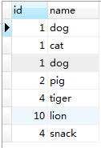

/*2*/SELECT id_name.id AS a_id, id_name.name AS a_name,id_name_null.id AS b_id,id_name_null.name AS b_name FROM id_name INNER JOIN id_name_null ON id_name.id = id_name_null.id;

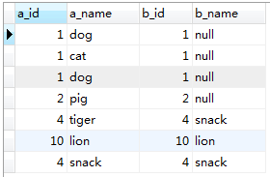

/*3*/SELECT DISTINCT id_name.id AS a_id, id_name.name AS a_name,id_name_null.id AS b_id,id_name_null.name AS b_name FROM id_name INNER JOIN id_name_null ON id_name.id = id_name_null.id;

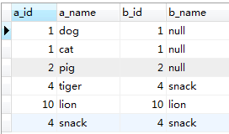

/**LEFT OUTER JOIN == LEFT JOIN */

/*4*/SELECT id_name.id, id_name.name FROM id_name LEFT OUTER JOIN id_name_null ON id_name.id = id_name_null.id;

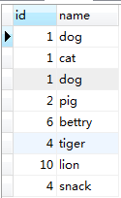

/**RIGHT OUTER JOIN == RIGHT JOIN */

* SELECT id_name.id, id_name.name FROM id_name RIGHT OUTER JOIN id_name_null ON id_name.id = id_name_null.id;

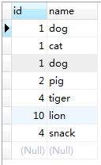

/*5*/SELECT id_name.id AS LOa_id, id_name.name AS LOa_name,id_name_null.id AS LOb_id,id_name_null.name AS LOb_name FROM id_name LEFT OUTER JOIN id_name_null ON id_name.id = id_name_null.id;

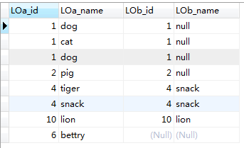

/*6*/SELECT DISTINCT id_name.id AS LOa_id, id_name.name AS LOa_name,id_name_null.id AS LOb_id,id_name_null.name AS LOb_name FROM id_name LEFT OUTER JOIN id_name_null ON id_name.id = id_name_null.id;

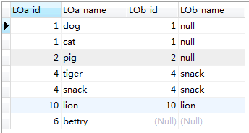

* SELECT id_name.id AS ROa_id, id_name.name AS ROa_name,id_name_null.id AS ROb_id,id_name_null.name AS ROb_name FROM id_name RIGHT OUTER JOIN id_name_null ON id_name.id = id_name_null.id;

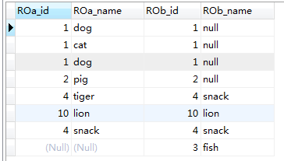

/*7*/SELECT id_name_null.id, id_name_null.name FROM id_name_null LEFT OUTER JOIN id_name ON id_name_null.id = id_name.id;

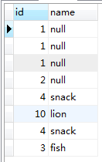

* SELECT id_name_null.id, id_name_null.name FROM id_name_null RIGHT OUTER JOIN id_name ON id_name_null.id = id_name.id;

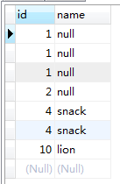

/*8*/SELECT id_name_null.id AS LOb_id, id_name_null.name AS LOb_name,id_name.id AS LOa_id,id_name.name AS LOa_name FROM id_name_null LEFT OUTER JOIN id_name ON id_name.id = id_name_null.id;

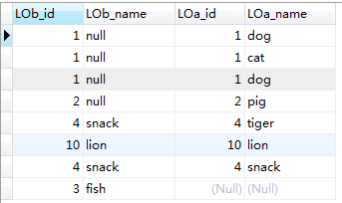

* SELECT id_name_null.id AS ROb_id, id_name_null.name AS ROb_name,id_name.id AS ROa_id,id_name.name AS ROa_name FROM id_name_null RIGHT OUTER JOIN id_name ON id_name.id = id_name_null.id;

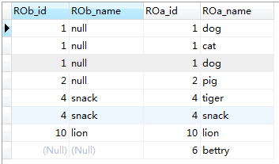

a//Table_name: id_name //Left

1 dog

1 cat

1 dog

2 pig

6 bettry

4 tiger

10 lion

4 snack

b//Table_name: id_name_null //Right

1 null

2 null

3 fish

4 snack

10 lion

c//Table name: table_null

null null

2 null

2 null

3 test

**/*LEFT(RIGHT) OUTER JOIN 或者LEFT(RIGHT) JOIN ，when one table（table_null） is null */**

1、SELECT id_name.id , id_name.name FROM id_name LEFT OUTER JOIN table_null ON id_name.id = table_null.id;

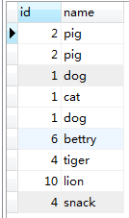

* SELECT id_name.id , id_name.name FROM id_name RIGHT OUTER JOIN table_null ON id_name.id = table_null.id;

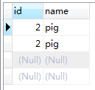

2、 SELECT id_name_null.id , id_name_null.name FROM id_name_null LEFT OUTER JOIN table_null ON id_name_null.id = table_null.id;

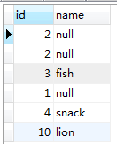

* SELECT table_null.id , table_null.name FROM id_name_null RIGHT OUTER JOIN table_null ON id_name_null.id = table_null.id;

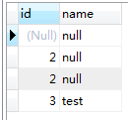

3、**/*group by Table：** id_name **\*/ ------>Group By本身就有Distinct的作用。**

SELECT id,name FROM id_name GROUP BY id,name;

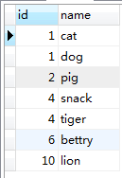

SELECT id,COUNT(name) FROM id_name GROUP BY id,name;

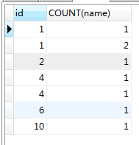

SELECT id,COUNT(name) AS name_cnt FROM id_name GROUP BY id;

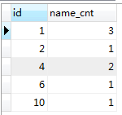

**/*group by Table：** id_name_null **\*/**

SELECT id,name FROM id_name_null GROUP BY id;

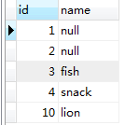

**/*group by Table：** table_null **\*/**

SELECT id,name FROM table_null GROUP BY id,name;

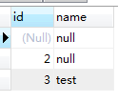

4、**/* group by & order by ---对比如下：*/**

SELECT id,name FROM id_name GROUP BY id,name;

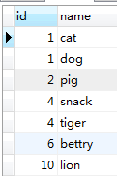

SELECT id,name FROM id_name GROUP BY id,name ORDER BY id DESC;

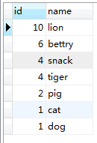

5、

Having与Where的区别：

where 子句的作用是在对查询结果进行分组前，将不符合where条件的行去掉，即在分组之前过滤数据，where条件中不能包含聚组函数，使用where条件过滤出特定的行。

having 子句的作用是筛选满足条件的组，即在分组之后过滤数据，条件中经常包含聚组函数，使用having 条件过滤出特定的组，也可以使用多个分组标准进行分组。

**/* Where、 group by、having：**id_name **\*/**

SELECT id,name FROM id_name WHERE id > 1;

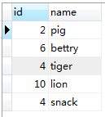

SELECT id,name FROM id_name WHERE id > 1 GROUP BY id,name;

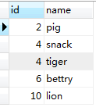

SELECT id,name FROM id_name GROUP BY id,name HAVING SUM(id) > 2;

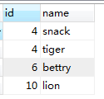

SELECT id,name FROM id_name WHERE id >4 GROUP BY id,name HAVING SUM(id) > 2;

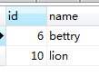

a//Table_name: id_name

1 dog

1 cat

1 dog

2 pig

6 bettry

4 tiger

10 lion

4 snack

d//Table name: id_name_score

1 zcw 90

1 stu 85

1 work 60

3 viver 10

3 viven 20

8 spring 60

8 spring 66

7 mvc 99

1. **/* group by、having：**id_name **&** id_name_score **对比如下：*/**

SELECT id,name FROM id_name GROUP BY id,name HAVING SUM(id) > 2;

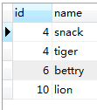

* SELECT id,name,score FROM id_name_score GROUP BY id,name HAVING SUM(id) > 2;

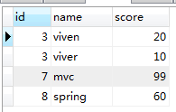

* SELECT id,name,score FROM id_name_score GROUP BY id,name HAVING SUM(score) > 15;

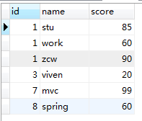

1. **/* Where、 group by、having、 order by：**id_name **&** id_name_score **对比如下：*/**

SELECT id,name FROM id_name WHERE id >3 GROUP BY id,name HAVING SUM(id) > 2 ORDER BY name;

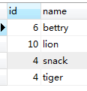

* SELECT id,name FROM id_name WHERE id >3 GROUP BY id,name HAVING SUM(id) > 2 ORDER BY name DESC;

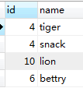

* SELECT id,name,score FROM id_name_score WHERE id >1 GROUP BY id,name HAVING SUM(score) > 10 ORDER BY name DESC;

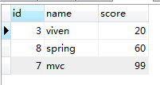

* SELECT id,name,score FROM id_name_score WHERE id >1 GROUP BY id,name,score HAVING SUM(score) > 10 ORDER BY name DESC;

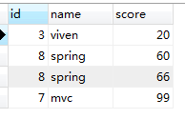

* SELECT id,name,score FROM id_name_score WHERE id <10 GROUP BY id,name,score HAVING SUM(score) > 10 ORDER BY score;

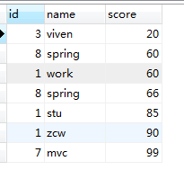

* SELECT id,name,score FROM id_name_score WHERE id <10 GROUP BY id,name HAVING SUM(score) > 10 ORDER BY score;

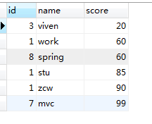 or: 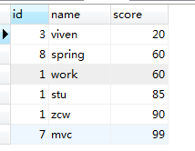

* SELECT id,name,score FROM id_name_score WHERE id <10 GROUP BY id,name HAVING SUM(score) > 10 ORDER BY name;

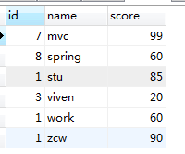

* SELECT id,name,score FROM id_name_score WHERE id <10 GROUP BY id,name,score HAVING SUM(score) > 10 ORDER BY name;

